***Case report***

**MULTIVARIANT PRESENTATION OF ODONTOGENIC KERATOCYST - A CASE SERIES**

**Abstract**  
Odontogenic keratocyst (OKC) is a distinct odontogenic cyst of the jaw , characterized by its aggressive behavior and high recurrence rate. OKC typically presents as a unilocular lesion, however bilateral or multiple OKCs are often associated with bifid-rib basal cell nevus syndrome (Gorlin syndrome). This case series includes one syndromic and four non-syndromic cases that met the histopathological criteria for OKC. The patients’ ages ranged from 17 to 50 years. Among the five cases, one syndromic case involved both the maxilla and mandible, one was limited to the maxilla, and the remaining three were confined to the mandible. Histopathological findings demonstrated all the classic features of parakeratinized OKC.

**Keywords**: odontogenic keratocyst, , nevoid basal cell syndrome , recurrence

**Introduction**  
The term odontogenic keratocyst (OKC) was first introduced by Philipsen with its features were later described by Pindborg and Hansen in 19631. According to the World Health Organization (WHO), OKC is defined as a benign, uni- or multicystic, intraosseous tumor of odontogenic origin (dental lamina and its remnants).2 It is characterized by a lining of parakeratinized stratified squamous epithelium and has a potential for aggressive and infiltrative behavior. OKCs are relatively common developmental odontogenic cysts, accounting for 10–12% of all jaw cysts3. They are most frequently found in the mandible, with a 2:1 ratio over the maxilla. The most common sites of occurrence include the mandibular third molar and ramus regions, followed by the anterior maxilla, maxillary third molar region, mandibular anterior region and mandibular premolar areas.

In case where multiple odontogenic keratocysts (OKCs) are present, they are often associated with Gorlin–Goltz syndrome. This syndrome was first reported by Jarish and White in 1984 and later described by Gorlin and Goltz, highlighting features of syndrome include multiple nevoid basal cell carcinomas (BCCs), bifid ribs, jaw cysts, and other associated anomalies. As a result,

the syndrome is referred to as Gorlin–Goltz syndrome, basal cell nevus syndrome, jaw cyst–bifid rib syndrome, or multiple nevoid BCC syndrome4. It is inherited in an autosomal dominant pattern.

The lesion is termed a keratocyst because of its epithelial lining that produces an abundance of keratin which nearly fills the cyst lumen3. Characteristic features include a flattened epithelium–connective tissue interface and palisading of basal cells, which resemble odontogenic epithelium. OKCs are known for their aggressive behavior and potential recurrence5.

The origin of OKCs can be traced to remnants of the dental lamina, basal cells of the overlying epithelium, or reduced enamel epithelium of the dental follicle6. These lesions are often detected incidentally during radiographic imaging, appearing as unilocular or multilocular radiolucencies with sclerotic borders. OKCs are usually asymptomatic, but larger lesions may present with pain and swelling.

**CASE PRESENTATION –**

Aim of this study aim to emphasize the clinical, radiologic, cytological features and Histopathological characterstics of OKC in both syndromic and non-syndromic cases.

Table 1 : **Presentation of the cases**

|  |  |  |  |  |  |
| --- | --- | --- | --- | --- | --- |
|  | **case 1** | **case 2** | **case 3** | **case 4** | **case 5** |
| **age / gender** | 35 /F | 27 /F | 17/M | 35/F | 40/F |
| **clinical feature**  **( figure A & figure B)** | Site – posterior mandible and maxilla  E/O – diffuse bony hard swelling in upper and lower jaw  I/O – swelling in left retromandibular region  Palmar pits | Site –mandible crossing midline E/O - Swelling with draining sinus on left side  I/O – tilting of lower anteriors , pus discharge buccally 37, missing 42 | Site –right side of mandible posterior  E/O – diffused bony hard Swelling sinus on left side  I/O –Draining sinus buccally to 46 | Site –right side of maxilla  E/O -swelling in upper right side of face  I/O- obliteration of buccal vestibule from 14 to 17 | Site – posterior mandible E/O - swelling on lower left side of face |
| **radiograohic feature**  **( figure C)** | OPG revealed multiple radiolucency with multilocular radiolucency in lower jaw on left side and unilocular radiolucency in maxilla bilaterally. Impacted tooth associated with radiolucency in left side of maxilla .  CT view of brain showed calcification of fax cerebri | OPG reveal multilocular radiolucency bilaterally crossing midline , impacted 42 seen. RCT treated 43 , Axial view of CBCT showed buccolingual expansion with thinning of Buccal and lingual cortical plate is seen . | Unilocular radiolucency extending anterioposteriorly from apically 46 to angle of right mandible with impacted 48 | unilocular radiolucency in right maxilla extending apical region of 15 to 17 | multilocular swelling in lower left side of mandible extending from 35 to ramus region .RCT treated 36,37 |
| **Cytological features**  **figure D)** | Caseous cheesy aspiration  Unstained smear showed cholesterol crystal and pus cells | Caseous cheesy aspiration  Unstained smear showed cholesterol crystal and pus cells | Blood aspirate showing pus cells and RBCs | Blood aspirate showing pus cells and RBCs | Caseous cheesy white aspiration  Unstained smear showed cholesterol crystal , RBCs and pus cells |
| **Incisional biopsy** | OKC | Infected dental cyst | Dentigerous Cyst | Infected odontogenic cyst | OKC |
| **Excisional biopsy**  **(figure E) Histopathological features** | Characterstic features of OKC – corrugated parakeratinized stratified squamous epithelium 8-10 cell layer thickness, basal tall columnar epithelium with palisaded appearance, flat epithelium -connective tissue interface . | | | | |

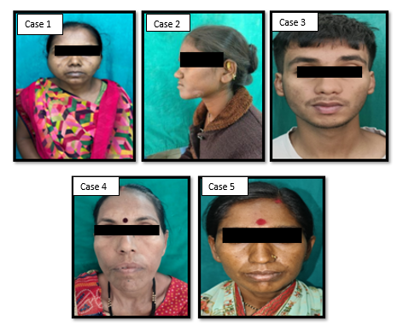

CASE 2

CASE 3

CASE 4

CASE 5

**Figure A - Extra oral features**

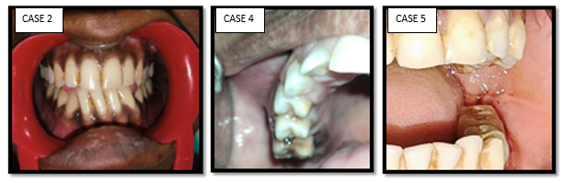

**Figure B - Intra oral features**

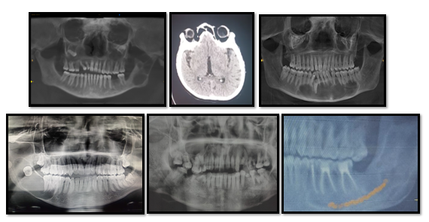

CASE 1

CASE 1

CASE 2

CASE 3

CASE 5

CASE 4

**Figure C - Radiographic features**

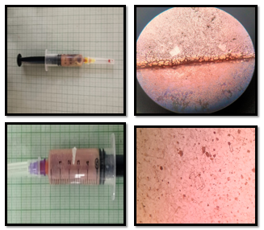

**Figure D - Cytological features**

CASE 2

CASE 1

CASE 3

CASE 5

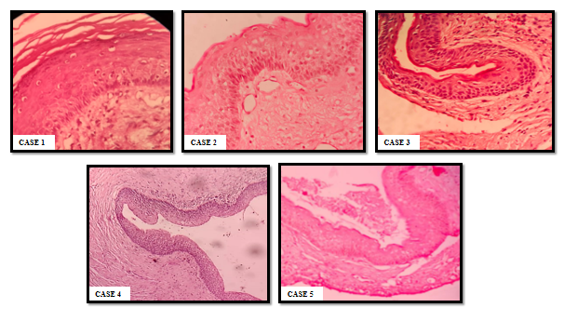

**Figure E -Histopathological features**

**DISCUSSION –**

Odontogenic keratocysts (OKCs) rank as the third most common developmental odontogenic cyst of the jaw. According to Neville et al. (2019), OKCs account for approximately 12–14% of all odontogenic cysts. In the WHO 2005 classification, OKCs were reclassified as keratocystic odontogenic tumors (KCOTs) due to their aggressive and infiltrating behavior, along with high recurrence rate of up to 62.5%. However, the WHO 2017 classification reverted OKCs to a cystic entity7.

OKCs are intrabony lesions, most commonly found in the mandible rather than the maxilla. Approximately 70% of mandibular OKCs occur in the posterior mandible, including the ramus and molar regions, while 6.9% involve the symphysis region of the mandible8. OKCs exhibit a male predilection and have a peak incidence in the second and third decades of life.

In our study, smaller lesions were usually asymptomatic. However, larger lesions, were presented with pain, swelling, jaw expansion, drainage, and cortical plate perforation. OKCs likely originate from epithelial remnants of the tooth germ in the mandible and maxilla or from the basal cell layer of the overlying surface epithelium.

OKCs typically appear as unilateral, unilocular cysts but can occasionally present as multilocular or bilateral cysts without a syndromic association9. In our study, one case involved bilateral swelling and crossing the midline. Similar findings has been reported by Hari Ram et al10. and Lakshmi et al11., where patients had bilateral OKCs without any associated syndrome.

Multiple OKCs are most commonly associated with nevoid basal cell carcinoma syndrome (NBCCS), also known as Gorlin–Goltz syndrome (GCS)12. NBCCS is the most well-recognized syndrome linked to multiple OKCs. Other syndromes, such as oral-facial-digital syndrome, Noonan syndrome, Ehlers-Danlos syndrome, and Simpson–Golabi–Behmel syndrome, may also present with multiple OKCs, though rarely4. Evans et al12. first established major and minor criteria for the diagnosis of the syndrome and later were modified by Kimonis et al13. in 2004.

**TABLE 2 – Gorlin Goltz Syndrome Diagnostic criteria**

|  |  |
| --- | --- |
| **Major criteria** | **Minor criteria** |
| 1. Multiple jaw keratocysts discovered in young adults ( below 20 years old)  2. Many basal cell carcinomas disproportionate to previous sun light exposure or in young adults below 20 years of age  3. Several tiny depressions of the palmar aspect of the hand and plantar aspect of the foot also known as plantar/palmar pits  4. Brain tumors, e.g. Medulloblastoma  5. Ectopic falx cerebri calcifcations  6. Bifid, fused, or markedly splayed ribs.  7. GG syndrome in a frst degree family | 1. Increased head circumference  2. Ocular anomalies (i.e. coloboma) , hypertelorism .  3. Multi organ fbromas ( i.e. cardiac or ovarian)  4. Rib abnormalities ( fused, Bifd, or splayed)  5. Other skeletal abnormalities (i.e. polydactyly or vertebral fusion)  6. Craniofacial malformations i.e. Cleft palate or lip  7. Lymphomesenteric cysts |

Requirements for diagnosing Gorlin–Goltz syndrome include:

1. Presence of at least one minor and two major diagnostic criteria.
2. Presence of at least three minor and one major diagnostic criteria.
3. A positive genetic test.

Based on these criteria, we diagnosed Gorlin–Goltz syndrome in one of the five cases.

Various studies have confirmed mutations involving the 9q22.3–q31 region containing the PTCH gene, which is typically more prominent in syndromic than in nonsyndromic OKCs4.

Radiologically, OKCs typically appear as a well-defined, corticated cystic cavity. Characteristic radiographic features of OKCs include corticated, often scalloped borders14. Although the cyst grows anteroposteriorly, it may cause cortical plate expansion toward the lingual side. Displacement of developing teeth, root resorption, or extrusion of teeth may also be observed. Multiple or bilateral cysts are suggestive of basal cell nevus syndrome. CT scans provide additional information regarding the lesions contents15 .

Around 30–40% of OKCs are associated with impacted teeth. In such cases, differential diagnosis should include dentigerous cysts (DC), adenomatoid odontogenic tumor (AOT), or unicystic ameloblastoma, as treatment modalities vary. In our study 3 out of the 5 cases were associated with impacted teeth, making DC a key differential diagnosis. One of these cases was initially misdiagnosed as a dentigerous cyst on incisional biopsy, but excisional biopsy, later confirmed diagnosis as OKC. Similar findings have been reported by Kaushal Nitin et al., Hemavathy S et al16., highlighting the importance of histopathological examination, particularly excisional biopsy.

When OKCs are located in the periapical region of a tooth or associated with nonvital teeth, they may mimic a radicular cyst. One case in our study involved a nonvital tooth, where the provisional diagnosis was a radicular cyst. The incisional biopsy result was inconclusive, but excisional biopsy confirmed the diagnosis of OKC. Similar cases have been reported by Essaket S et al17., Sharma H et al.18, and Avinash et al19.

Histopathologically, OKCs are most often characterized by the following microscopic features: 1) a thin, band-like lining of stratified squamous epithelium, a spinous cell layer of 6 to 8 cells in thickness

2) a corrugated keratinized lining

3) a thin connective tissue capsule

4) a lumen containing varying amounts of desquamated keratin.

5)A basal cell layer that is palisaded with hyperchromatic nuclei.

Parakeratinized epithelium predominates in the majority of OKCs (83% to 97%), and the parakeratinized variant typically represents more aggressively than the orthokeratinized variant24. The cystic lumen may contain - thick, caseous, cheesy, or straw-colored fluid. Electrophoretic analysis of aspirated cystic fluids reveals a lower soluble protein ratio compared to serum total protein content being <5 g/100 ml, with albumin levels ranging from 2 to 4 g/dl and globulin levels ranging from 0.5 to 2.5 g/dl20.

OKCs tends to grow anteroposteriorly following cancellous channels with minimal cortical expansion21. Several theories have been proposed to explain the expansion, including intraluminal hyperosmolality, active epithelial proliferation, collagenolytic activity within the cyst wall, and increased the synthesis of interleukins 1 and 6 by keratinocytes.

Transformation of OKCs into squamous cell carcinoma and ameloblastomas has been reported in the literature. Holmlund et al. described cases of ameloblastomatous transformation of OKC, though it is a rare occurrence. Numerous cases have reported OKCs mimicking other cystic lesions, such as radicular cysts (when associated with nonvital teeth) dentigerous cysts, AOT, or unicystic ameloblastomas when associated with impacted teeth.OKCs are among the most aggressive forms of odontogenic cysts due to their high recurrence rates, which result from the presence of epithelial remnants and satellite cysts in the osseous margins. Brannon proposed several reasons for recurrence, including surgical challenges leading to incomplete cyst removal, the thin and friable nature of the capsule, bony perforation, adherence to adjacent soft tissues, and activation of residual dental lamina epithelium in susceptible patients22. The parakeratinized variant has a higher recurrence rate than the orthokeratinized variant. The recurrence rate for OKCs ranges from 5% to 62.5%, with recurrence documented even after 5 years of follow-up25.

**CONCLUSION –**

OKC is an aggressive type of cyst with high rate of recurrence. These lesions shows diverse clinical presentation and can mimic other cystic and benign tumor lesions. When associated with an impacted tooth , differentiation from other cyst like dentigerous cyst , OOC , AOT , Unicystic or Multicystic ameloblastoma is crucial , as the treatment modalities varies for each condition. When OKC are associated with non vital teeth they mimic radicular cyst. Given the aggressive behavior and high recurrence rate of OKCs, accurate differentiation is essential. In cases where multiple OKCs are present , through clinical and radiological evaluation is necessary to rule out Gorlin Goltz Syndrome. A comprehensive diagnostic approach, including thorough clinical , radiological , cytological and histopathological examination is essential for accurate diagnosis of OKC. Excisional biopsy remains the gold standard for distinguishing OKCs from other similar lesions.

**REFRENCES -**

1. Phillipsen H (1956) On keratocysts in the jaws. Tandleagebladet 60:96
2. Hamied M, Al-Shaikhani S, Ali Z. Odontogenic Keratocyst (A Literature Review. Al-Kindy College Medical Journal. 2021;17(2):52-61
3. Blanchard SB. Odontogenic keratocysts: review of the literature and report of a case. Journal of periodontology. 1997 Mar;68(3):306-11.
4. Janjua OS, Tariq R, Khalid MU, Qureshi SM, Ali K. Presentation and management of syndromic and non-syndromic patients with multiple odontogenic keratocysts. Oral and Maxillofacial Surgery Cases. 2022 Jun 1;8(2):100253.
5. Parikh SJ, Patel H, Shah JS. An odontogenic keratocyst: Correlating histopathological and clinicoradiographic features avoids a diagnostic dilemma. J Oral Med Oral Surg Oral Pathol Oral Radiol. 2022:4.
6. Dhanrajanijani P. Odontogenic Keratocyst: Theory of Its Origin. Malaysian Dental Journal. 2024 Jul 1;47(2):58-61.
7. Passi D, Singhal D, Singh M, Mishra V, Panwar Y, Sahni A. Odontogenic keratocyst (OKC) or keratocystic odontogenic tumor (KCOT). Journey of OKC from cyst to tumour to cyst again: comprehensive review with recent updates on WHO Classifcation (2017). Int J Curr Res. 2017;9(07):54080–6.
8. Pindborg JJ, Hansen J. Studies on odontogenic cyst epithelium. II. Clinical and roentgenographic aspects of odontogenic keratocysts. Acta Patkol Microbiol Scand 1963;58:283-294.
9. Kavitha EG, Jayanthi P, Rathy R, Harish RK, Ameena M. Bilateral Odontogenic Keratocyst in a Nonsyndromic Patient: A Case Report and Review of Literature. Oral & Maxillofacial Pathology Journal. 2019 Jan 1;10(1).
10. Ram H, Mohammad S, Husain N, Gupta S, Kumar A. Bilateral odontogenic keratocyst of the mandible. Journal of maxillofacial and oral surgery. 2014 Sep;13:341-5.
11. Lakshmi C, Ramapuram C. Non-Syndromic Multiple Odontogenic Keratocyst–A Case Report And Literature.
12. Ahuja S, Ahuja US, Narang NP. Multiple odontogenic keratocyst: A case report and review of literature. Journal of Dental Specialities. 2020 Jan 1;8(1).
13. Evans DG, Ladusans EJ, Rimmer S, Burnell LD, Thakker N, Farndon PA. Complications of the naevoid basal cell carcinoma syndrome: Results of a population based study. J Med Genet 1993,30:460-4.
14. Kimonis VE, Mehta SG, Digiovanna JJ, Bale SJ, Pastakia B. Radiological features in 82 patients with nevoid basal cell carcinoma (NBCC or Gorlin) syndrome. Genet Med 2004;6:495-502.
15. Astuti ER, Sumarta NP, Putra RH, Pramatika B. Treatment evaluation of odontogenic keratocyst by using CBCT and fractal dimension analysis on panoramic radiograph. Journal of Indian Academy of Oral Medicine and Radiology. 2019 Oct 1;31(4):391-6.
16. Hemavathy S, Roy S. Follicular odontogenic keratocyst mimicking dentigerous cyst-report of two cases. Arch Oral Sci Res. 2011;1(2):100-3.
17. Essaket S, Benjelloun L, Chbicheb S. Odontogenic keratocyst mimicking a radicular cyst. Integrative Journal of Medical Sciences. 2021 Jan 15;8.
18. Sharma H, Phukan P, Goel S, Khan MS, Singh A. Odontogenic Keratocyst of Mandible Mimicking Radicular Cyst: A Case Report.
19. Avinash TM, Balaji BB, Malik AM. Keratocystic odontogenic tumor mimicking Radicular cyst: A Clinical dilemma. Indian Journal of Dental Advancements. 2010 Oct 1;2(4):387-91.
20. Prakash R, Shyamala K, Girish HC, Murgod S, Singh S, Rani PV. Comparison of components of odontogenic cyst fluids: A review. Journal of Medicine, Radiology, Pathology and Surgery. 2016 Mar 1;2(2):15-7.
21. Toller P. Origin and growth of cysts of the jaws. Ann R Coll Surg Engl 1967;40:306-336.
22. Brannon RB. The odontogenic keratocyst: A clinicopathologic study of 312 cases. Part I. Clinical features. Oral Surg Oral Med Oral Pathol 1976;42:54-72.
23. enon S. Keratocystic odontogenic tumours: Etiology, pathogenesis and treatment revisited. J Maxillofac Oral Surg. 2015;14(3):541
24. Payne TP. An analysis of the clinical and histopathologic parameters of the odontogenic keratocyst. Oral Surg Oral Med Oral Pathol 1972;33:538-546.
25. Browne, RM. The odontogenic keratocyst: clinical features. Br Dent J 1970;128:225-23