Original Research Article
Influence of weather parameters on population dynamics of litchi leaf roller, Dudua (=Platypeplus) aprobola (Meyrick) on litchi in Eastern plateau and Hill region of India

Abstract
The influence of weather factors on the population dynamics of the litchi leaf roller, Dudua (=Platypeplus) aprobola, was studied at ICAR RCER, Farming System Research Centre for Hill and Plateau Region (ICAR RCER, FSRCHPR), Ranchi during the years 2023- 2024. The relationship between temperature, rainfall, and leaf rollers was established. The population pattern of leaf rollers was observed more or less the same in both years. The highest incidence of the leaf roller occurred during the 40th and 41st standard meteorological weeks (SMW) in both years (1.6 to 2.5 rolled leaves per shoot). The correlation analysis between leaf roller and weather parameters showed a significant positive correlation with minimum temperature (p<0.01) and a negative with rainfall (p<0.05). The linear regression model is based on weather parameters as an independent variable and leaf roller population as dependent variables explained by 55 to 66 percent leaf roller population variability. Environmental factors played a determining factor in leaf roller population dynamics.
Keywords: Dudua aprobola; population dynamics; weather parameters; relationships
- Introduction
The litchi is a tropical fruit tree native to the Guangdong and Fujian provinces of China (Liang, 1981). Known for its juicy and aromatic fruits, it has gained popularity worldwide. However, litchi cultivation is often challenged by various pests and diseases, among which the leaf roller, Dudua (=Platypeplus) aprobola (Meyrick) is a notable threat to litchi cultivation (Srivastava and Choudhary, 2022). Leaf rollers refer to a variety of lepidopteron larvae that feed on the leaves of litchi trees. These pests primarily belong to the family Tortricidae, with the genus Cryptoblabes and Cydia being particularly significant in litchi cultivation (Prasad et al., 2017). The larval stage of these moths rolls and folds the leaves, creating a protective shelter while feeding on the foliage. These not only reduce the photosynthetic capacity but can also impair fruit development and overall tree health (Zhao et al., 2019). The infestation of leaf rollers can lead to significant economic losses for litchi growers. In severe cases, the pest can cause, defoliation, which can weaken the tree and make it more susceptible to other pests and diseases. Integrated pest management approaches focusing on monitoring, biological control, and judicious use of chemical insecticides have been recommended (Bhatnagar et al., 2018). In India, the incidence of leaf roller is found on litchi trees from July to February (Singh, 1971). The incidence was observed from the 26th SMW and continued until the 47th SMW (Kar et al. (2023). Research has shown that weather variables, such as temperature and rainfall, play a crucial role in shaping the population fluctuations of pest species (Moanaro and Choudhary, 2016). Thus, studying the relationship between weather factors and the population dynamics of the litchi leaf roller is essential for predicting outbreaks and informing integrated pest management practices. The current study aims to investigate the effects of meteorological factors on the population dynamics of litchi leaf roller, D. aprobola in litchi orchards in eastern plateau and hill region (EPHR) of India. Understanding the population dynamics is integral not only for enhancing agricultural productivity but also for contributing to the economic stability of litchi farmers.
- Materials and Methods
The experiment was conducted in a litchi orchard of age 25-30 years planted with a spacing of 10 x10 m² in ICAR RCER, FSRCHPR, Plandu, Ranchi (23º 45’ N; 85º 30’ E, Altitude 620 m above msl), Jharkhand during years 2023 and 2024. The Shahi variety available at the centre was considered for the observation of the pest population dynamics. The experiment was laid out in a randomized block design and 10 trees were randomly chosen for observations from the orchard. One shoot from each direction was taken for observation, i.e., 4 shoots/tree. The number of rolled leaves from each direction on one shoot of the selected tree was visually counted on a weekly interval basis. All the agronomic practices, except plant protection, were followed as per the recommended package and practices for litchi crops.
The weather data on rainfall and temperatures (maximum, minimum) were taken from the Automatic Weather Research Station installed at the centre. The mean and regression analyses were done using SPSS V. 21 in order to find the influence of weather parameters on leaf roller, D. aprobola incidence, and development. The correlation and plots were drawn using the corrplot package in R. The figures were drawn using Microsoft Office Excel 2010.
- Results and Discussion
The mean population of leaf roller, D. aprobola, was observed throughout the year on litchi in both the years (2023 & 2024), and incidence time with population and weather parameters recorded (Figures 1 & 2).

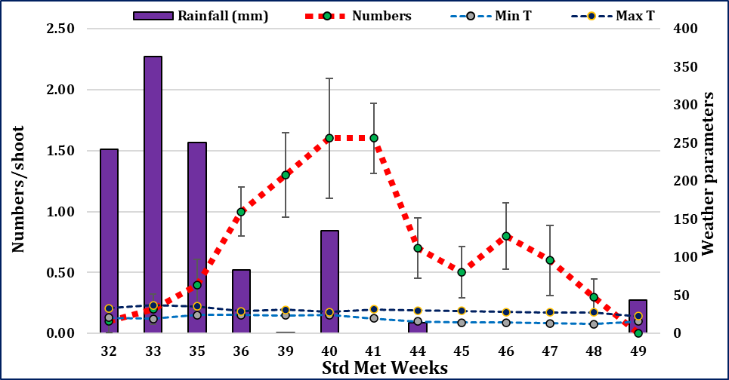
Figure 1: Leaf roller, D. aprobola population with respect to weather parameters (2023).
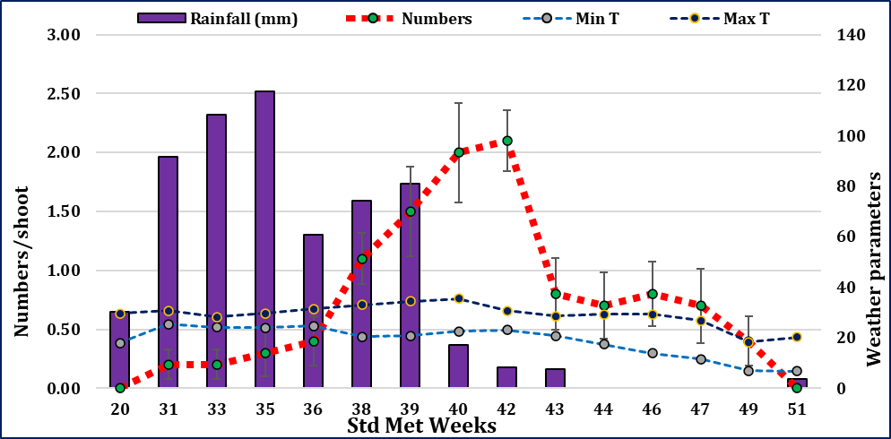
Figure 2: Leaf roller, D. aprobola population with respect to weather parameters (2024).
The population of leaf rollers was recorded as low to high, from 20 to 51 SMWs. Peak incidence was observed during the 40 to 41st SMWs, where 1.5 to 2.0 rolled leaves per shoot were observed. The present pest population observations were aligned with Singh (1971), Lall and Mallik (1976), Hameed et al. (1999), Chakraborty and Samanta (2015), Kar et al. (2023), Nair and Sahoo (2006), and Ray and Mukherjee (2012). Incidence of leaf rollers in north Bihar was observed from July to February, with peak infestations between December and February (Singh 1971). This infestation coincided with the pre-flowering season of litchi. Kar et al. (2023) reported from West Bengal that pest incidence was observed in the 26th standard week and continued until the 47th SMW, with peak incidence during the 33rd and 34th SMWs (43.75 and 48.25 percent rolled leaves, respectively). A second peak incidence was also noted at the panicle initiation stage. Ranjan et al. (2012) also noted that pest activity began in August, with the highest leaf infestation occurring in October.
Weather parameters were the major factors reported to influence the population fluctuation of the leaf roller, D. aprobola, in the EPHR region. The correlation coefficients between rolled leaves and weather parameters were found to be positive for minimum temperature (0.45), while a significantly negative correlation was observed with rainfall (-0.35) (Figure 3A).
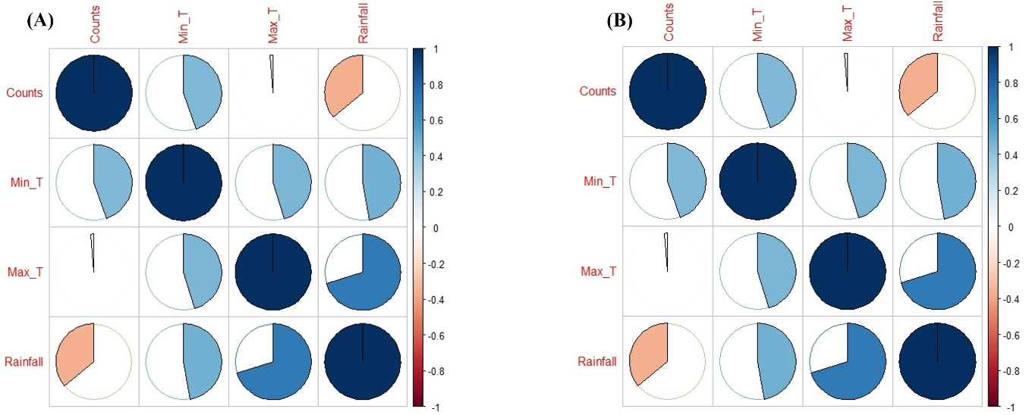
Figure 3: Correlation pie charts for understanding the influence of weather parameters on litchi leaf roller, D. aprobola population dynamics during 2023 (A) and 2024 (B).
During 2024, rolled leaves numbers were positive with minimum temperature (0.56), while a significantly negative correlation was observed with rainfall (Figure 3B). Nair and Sahoo (2006) found that the maximum leaf roller population observed in December positively correlated with average temperature, average relative humidity, and rainfall. Thus, the results of this study contribute to understanding the seasonal incidence of the pest throughout the year. Considering multiple weather parameters as independent variables and leaf roller population as dependent factors, linear regression analyses were carried out (Table 1).
Table 1: Regression model using leaf roller, D. aprobola population, and weather parameters in both the years (2023 & 2024).
Years | Regression equations | R²
2023 | Y= -1.89* + (0.09 T_{min}) + (0.04 T_{max}) – (0.004 RF) + 0.36** | 0.66
2024 | Y= -2.10* + (0.003 T_{min}) + (0.106 T_{max}) – (0.007RF) + 0.40** | 0.53
* value denotes constant estimated from data; ** random error term
These models explained 53 to 66% variability of leaf roller, D. aprobola population fluctuation in the EPHR region. So, it is suggested that an increase in leaf roller population in litchi orchards was associated with minimum temperature and rainfall which seems to be regulatory factors of population build-up. The present study result can aid in implementing timely pest management strategies to mitigate damage in litchi orchards.

References
Bhatnagar, A., Verma, P., and Singh, R. (2018). Integrated pest management approaches in sustainable agriculture: Monitoring, biological control, and judicious use of insecticides. International Journal of Pest Management, 64(2), 123-135.
Chakraborty, K. and Samanta A. (2005). Evaluation of litchi germplasms based on biochemical parameters along with the incidence of leaf roller Platypeplus aprobola Meyer.) and fruit borer (Conopomorpha cramerella Snellen). Annals of Plant Protection Sciences, 13(2): 338-342.
Charak A, Sharma D, and Bajiya, M.R. (2020). Effect of weather factors on the population dynamics of litchi leaf roller Platypeplus aprobola (Meyrick). Journal of Pharmacognosy and Photochemistry, 9(6):267-269.
Kar, A., Majhi, Chakarborti D. and Mishra, K. (2023). Species complex of leaf roller infesting litchi (Litchi Chinensis) in West Bengal with their seasonal incidence. Indian Journal of Entomology, 85(4):959-962.
Lall B. S. and Mallik S.N. (1976). Bionomics and control of litchi leaf roller (Platypeplus aprobola (Meyrick) Lepidoptera: Tortricidae. Proceeding of the National Academy of Science India, 22-23.
Liang, N. S. (1981). Influence of weather factors on the population dynamics of the litchi leaf roller (Perina nuda). Acta Entomologica Sinica, 24(1), 103-110.
Moanaro, L. and Choudhary, J. S. (2016). Influence of weather parameters on population dynamics of thrips and mites on summer season cowpea in Eastern Plateau and Hill region of India. Journal of Agrometeorology, 18 (2): 296-299.
Nair, N. and Sahoo, A.K. (2006). Binomics of the litchi leaf roller Platypelus leucaspis Meyr. Environment and Ecology, 24(3):763-766.
Prasad, R., Sharma, A., and Kumar, S. (2017). Significance of Cryptoblabes and Cydia in litchi cultivation: Pest management strategies. Journal of Entomological Research, 45(3), 123-135.
Ranjan, R., Ray, R. and Mukherjee, U. (2012). Effect of the abiotic factor on the incidence of litchi leaf roller Dudua aprobola. Pest Management in Horticultural Ecosystem, 18:210-212.
Singh MP. (1971). Occurrence of Platypeplus aprobola Meyrick (Tortricidae: Lepidoptera) on litchi in north Bihar. Indian Journal of Entomology, 33: 98.
Srivastava K. and Choudhary J S. (2022). Pests and their management in Litchi. In: Mani M. (eds.). Trends in Horticultural Entomology. Springer, Singapore. pp. 719-733.
Zhao, C., Li, Y., Ma, J., and Wang, J. (2019). Weather factors and population dynamics of the rice leaf roller, Cnaphalocrocis medinalis, in South China. Journal of Integrative Agriculture, 18(3), 643–650.

