***Original Research Article***

**Identifying the Economic and Ecological Potential of Tendu Leaves to Develop Innovative Value Addition Strategies in Chhattisgarh**

**Abstract**

Tendu leaves (*Diospyros melanoxylon*) are a critical non-timber forest product (NTFP) in India, particularly in Chhattisgarh, where they support the livelihoods of millions through traditional bidi production. We have explored opportunities to diversify the tendu leaf value chain beyond its traditional use, focusing on innovative strategies for sustainable rural development. This research investigates possible value additions in the Kondagaon region of Chhattisgarh, focusing on eco-friendly packaging, herbal products, artisanal crafts, and bio-materials. The study employs primary surveys, stakeholder interviews, and secondary data analysis to gather insights. The findings highlight the significant economic contributions of tendu leaves, particularly for women, while also identifying challenges such as market limitations, infrastructure deficits, and skill gaps. The study proposes implementation strategies involving pilot studies, technical collaboration, and local processing units to promote these innovative applications.

**Keywords:** Tendu Leaves, Value Addition, Rural Economies, Sustainability, Chhattisgarh, Non-Timber Forest Products.

**Introduction**

Tendu leaves (*Diospyros melanoxylon*) are among the most economically significant Non-Timber Forest Products (NTFPs) in India, playing a crucial role in the livelihoods of millions of forest-dependent communities ((Boaz, 2004; Mehta et al., 2020; Date et al., 2023; Singh & Kumar, 2018). The collection of Tendu leaves dates back to the British colonial period, when they were first commercially exploited for their utility in wrapping bidis (traditional hand-rolled cigarettes). Today, the collection and trade of these leaves remain a vital source of income, particularly for rural and tribal populations in central peninsular India. States such as Madhya Pradesh, Odisha, Chhattisgarh, Jharkhand, Maharashtra, and Andhra Pradesh are the primary producers of tendu leaves, with Madhya Pradesh and Chhattisgarh together contributing nearly 45% of the total national production (Sabar et al., 2016). Chhattisgarh, in particular, is recognized for producing high-quality tendu leaves, with an annual yield of approximately 16.72 lakh standard bags, accounting for nearly 20% of India's total production (Chhattisgarh Minor Forest Produce Federation, n.d.). Leaves are an important source of livelihood and economic potential for the rural areas of Chhattisgarh, due to their uses in bidi production (Sabar et al., 2016). The government also regulates the collection, pricing, and trade of tendu leaves in Chhattisgarh, indicating their economic importance as well. Indeed, due to policy reforms in place, especially the pre-sale of green leaves in 2004, trade efficiency, lower intermediaries, and better prices for collectors have become possible. As a result, forest-dependent communities are earning more, and the state has been able to generate more revenue.

The use of tendu leaves, while accounting for a significant share of the rural economy, is limited to the bidi sector, which in turn allows this estimate of forest products to remain under-utilized (Hunter, 1981; Mhaskey et al., 2023). There are some estimates at the state level, but no clear national estimates of total production and revenue from tendu leaves are available," the report said. If there is a different unit for a different state from cubic meters (in Karnataka) to standard bags (in Madhya Pradesh) and metric tonnes (in Odisha), making a credible database to rely on at the national level becomes even more difficult,” he said. Uncontrolled harvesting and illegal trade continue to pose important challenges for the sustainable management of tendu leaf resources (Lal & Wilson, 2012). So, a value addition option that can expand the economic value of the tendu leaves beyond its more or less exclusive use for bidi making needs to be explored and developed. There’s a lot of untapped potential in tendu leaves beyond their traditional use. Imagine replacing plastic with biodegradable packaging made from these leaves—an eco-friendly solution that’s both sustainable and practical. But that’s not all! Tendu leaves are packed with bioactive compounds that could be game-changers for the pharmaceutical and cosmetic industries, thanks to their antioxidant and medicinal properties. With the right innovation, these humble leaves could become valuable resources in multiple sectors. Tendu leaves hold incredible potential beyond their traditional uses. Handicrafts and artisanal products made from these leaves can open up new livelihood opportunities for rural communities, helping them earn a sustainable income. By integrating tendu leaf production into agroforestry models, farmers can not only diversify their income but also contribute to forest conservation. In Chhattisgarh, embracing such innovative strategies could boost rural employment, protect biodiversity, and position the state as a leader in sustainable non-timber forest product (NTFP) utilization. Our efforts focus on exploring creative ways to expand the tendu leaf value chain- introducing eco-friendly packaging, handicrafts, bio-materials, and herbal products. Our goal is to foster rural development while carefully preserving the delicate balance of our ecosystem.

**Study Area**

Chhattisgarh, located in central India, boasts extensive forest resources, diverse wildlife, and a large tribal community. Spanning around 135,192 square kilometres, nearly 44% of its area is covered by forests, positioning it as one of the most forest-rich states in India (Choudhury et al., 2024). The region has a tropical monsoon climate, with annual rainfall between 1,200 and 1,500 mm and temperatures that can range from 5°C to 45°C. These conditions support the growth of both dry and moist deciduous forests. The study area encompasses Kondagaon and its surrounding districts, situated in the Bastar Plateau of southern Chhattisgarh. This area features hilly terrain with elevations from 250 to 800 meters above sea level, providing an excellent ecological setting for forest development and biodiversity (Tamrakar et al., 2023). The forests of Kondagaon and the Bastar region are known for their mixed deciduous nature, with Tendu (Diospyros melanoxylon) standing out as a key species. It thrives alongside Sal (*Shorea robusta*), Mahua (*Madhuca longifolia*), Harra (*Terminalia chebula*), Baheda (*Terminalia bellirica*), and Amla (Phyllanthus emblica). Other important species in this ecosystem include Saja (*Terminalia tomentosa*), Dhawda (*Anogeissus latifolia*), and Bijasal (*Pterocarpus marsupium*), which is prized for its medicinal benefits. 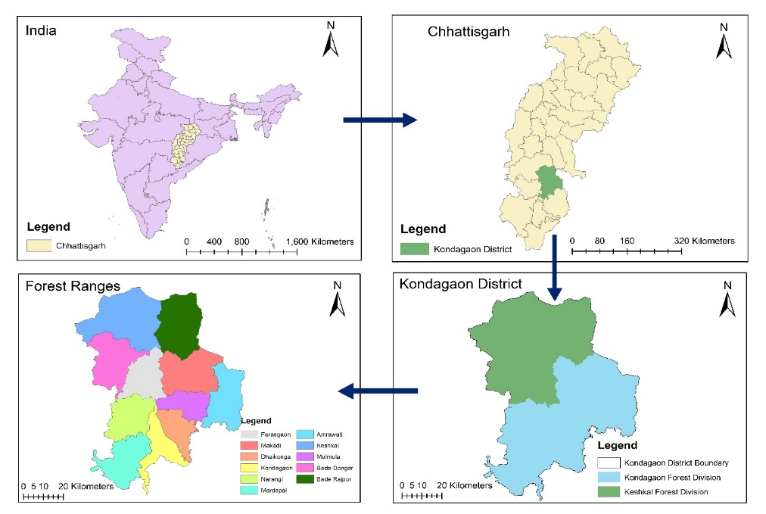

Figure -1: The Study Area's Map

**Materials and Methods**

A structured questionnaire survey that included both open-ended and closed-ended questions was conducted to collect primary data from local tendu leaf collectors, processors, and traders. The aim of the survey was to assess their economic activities, the challenges they encounter, and their views on potential value-added uses of tendu leaves. In-depth interviews were held with key stakeholders, including local craftspeople, forest officials, and representatives from non-governmental organizations (NGOs), to explore innovative usage strategies and identify barriers to their implementation. Furthermore, to gain empirical insights into the existing value chain, direct field observations were carried out to systematically document the processes of gathering, processing, and trading tendu leaves. To clarify the socioeconomic and policy context affecting tendu leaf management, the study utilized government reports on rural development and non-timber forest products (NTFPs) as secondary data. A review of academic literature and case studies related to value addition in NTFP-based industries was conducted to understand broader trends and strategies for product diversification. Additionally, to assess demand trends and opportunities for the sustainable commercialization of tendu leaves beyond their traditional use 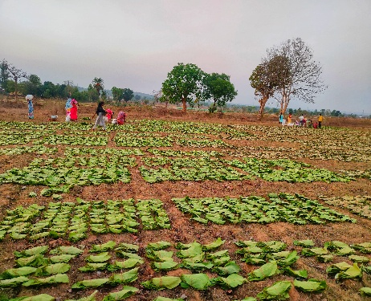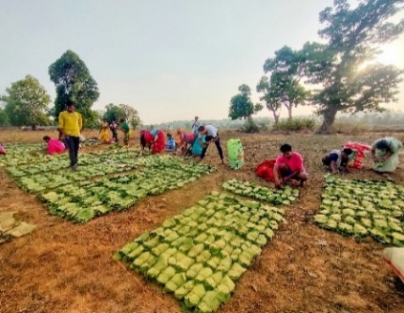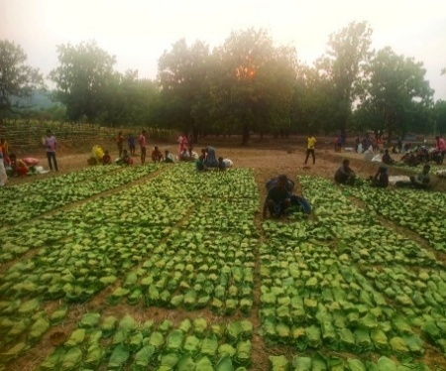in bidi production, market research and reports on eco-friendly products were analysed.

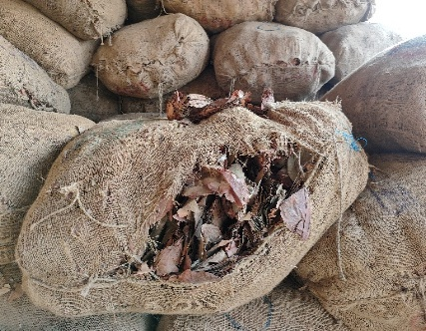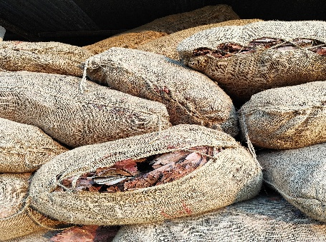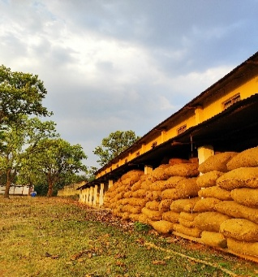Fig.3: Tendu leaf bags and storage space. Figure - 2: Tendu leaves are dried as part of primary processing

Figure - 3: Standard Tendu leaf bags and storage space

**Results and Discussion**

Bidi’s, a traditional hand-rolled cigarette, are traditionally rolled in India using tendu leaves (*Diospyros melanoxylon*) (Lal, 2011). There is a lot of room for creative value addition to increase the usefulness and financial advantages of tendu leaves, even though bidi production is still their major application. The study's conclusions highlight the vital role that women play in rural livelihoods by showing that they makeup almost 70% of the workforce in Kondagaon, Chhattisgarh's bidi-making sector. However, the remaining 30% of the workforce is made up of men and people in managerial positions, underscoring the gendered nature of the labour allocation in this industry. Bidi rolling is a significant source of revenue for women in the area, as seen by the high percentage of female engagement. But it also reflects systemic issues like socioeconomic vulnerabilities, occupational health hazards, and low pay.

Figure-4: Gender wise participation in Tendu leaves collection & Bidi Processing

**Value Addition of Tendu Leaves**

The value addition of tendu leaves (*Diospyros melanoxylon*) can be broadly classified into traditional value addition processes and innovative value addition opportunities (Fig-5). The traditional processes include drying and bundling, collection and sorting, bidi manufacturing, and herbal applications, which have been practiced for decades. Among these, bidi manufacturing remains the dominant economic activity, providing employment to a significant rural workforce, particularly women. However, these traditional practices face challenges such as low income, occupational health risks, and dependence on fluctuating bidi markets. On the contrary, innovative value addition opportunities present significant potential for economic diversification and environmental sustainability. Leaf-based craft items, such as biodegradable plates, decorative materials, and handmade artifacts, offer sustainable alternatives to plastic-based products. Similarly, eco-friendly packaging materials made from tendu leaves could cater to the growing demand for biodegradable packaging solutions. The development of value-added bidis, incorporating herbal ingredients or alternative compositions, could create niche markets and provide healthier alternatives. The utilization of tendu leaves in compost and biochar production presents opportunities for enhancing soil fertility and carbon sequestration, contributing to sustainable agriculture.

Figure - 5: Value addition of Tendu leaves

The analysis of the year-wise collection of tendu leaves in Chhattisgarh from 2001 to 2024, based on data from the Chhattisgarh Minor Forest Produce Federation, reveals significant fluctuations influenced by ecological, economic, and administrative factors. The initial years (2001-2004) exhibited an increasing trend, with collection peaking at 19.58 lakh standard bags, likely due to favourable climatic conditions, stable market demand, and active participation of collectors. However, from 2005 to 2010, the collection declined, reaching around 13.57 lakh standard bags in certain years, which may be attributed to climate variability, workforce shifts, and changes in regulatory frameworks affecting collection efficiency. Between 2011 and 2018, the collection remained relatively stable, fluctuating between 13.61 and 17.1 lakh standard bags, indicating a balance between forest productivity and market-driven extraction. A sharp decline was observed in 2020, with the lowest recorded value of 9.73 lakh standard bags, possibly due to COVID-19-related restrictions, workforce disruptions, or policy shifts. However, a gradual recovery followed, with collection increasing to 15.56 lakh standard bags in 2024, suggesting improved policy measures, better market conditions, and enhanced participation of collectors.

Figure - 6: Graphs showing year-wise collection of standard bags of Tendu Leaves (in Lakhs)

In the early years, the sale rate remained low, reflecting limited market demand and lower procurement prices. However, from 2010 onwards, a steady increase is observed, likely due to growing market competitiveness, inflation, and enhanced government interventions to ensure fair pricing for collectors.

A sharp spike is noticeable around 2016, where the sale rate reached its highest peak, which could be attributed to policy changes, increased demand, or a temporary scarcity in supply. Post-2017, the trend continues to rise, with occasional fluctuations, indicating dynamic market responses to supply-demand variations.

Figure - 7: Graph Showing wages collected in last 24 years (Rs. Crores)

Figure - 8: Graph showing average sale rate per standard bag in last 24 years

**Table-1:** SWOT Analysis for Innovative Value Addition Strategies for Tendu Leaves (Priyambada, 2016)

|  |  |
| --- | --- |
| **Category** | **Details** |
| **Strengths** | - Abundant availability of tendu leaves in Chhattisgarh. |
|  | - Low-cost raw material for value-added products. |
|  | - Strong traditional knowledge in tendu leaf collection. |
|  | - Biodegradable and eco-friendly properties appeal to modern markets. |
| **Weaknesses** | - Over-dependence on bidi production limits diversification efforts. |
|  | - Limited awareness of alternative uses among rural communities. |
|  | - Inadequate infrastructure for processing and production. |
|  | - Lack of technical skills for innovative product development. |
| **Opportunities** | - Growing demand for sustainable and eco-friendly products globally. |
|  | - Scope for diversification into crafts, packaging, and herbal products. |
|  | - Potential for export markets with premium branding. |
|  | - Supportive policies promoting NTFP value addition and rural development. |
| **Threats** | - Competition from synthetic and alternative materials. |
|  | - Price volatility in NTFP markets. |
|  | - Environmental risks like deforestation affecting tendu leaf availability. |
|  | - Resistance to change from traditional bidi-focused stakeholders. |

**Table-2:** Innovative and unexplored suggestions for value addition of tendu leaves

|  |  |  |  |  |
| --- | --- | --- | --- | --- |
| **S.no.** | **Suggestion** | **Concept** | **Process** | **Benefits** |
| 1. | Herbal Tea Bags or Wrapping Material for Edible Products | Use tendu leaves as a natural wrapper for tea bags, chocolates, or herbal medicinal products. | Sterilize and process leaves to make them food-safe and biodegradable. | Appeals to eco-conscious consumers and enhances the presentation of organic or artisanal products. |
| 2. | Natural Aroma Diffusers | Infuse tendu leaves with essential oils and use them as biodegradable aroma diffusers for homes or cars. | Soak the leaves in essential oils and dry them for slow fragrance release. | Creates a unique eco-friendly product targeting wellness and lifestyle markets. |
| 3. | Value-Added Bidis | Value-added bidis use herbal blends, eco-friendly packaging, and premium branding, offering healthier, sustainable alternatives to traditional bidi products. | Introduce flavoured or organic bidis by incorporating natural fragrances and organic tobacco. | Targets niche markets seeking premium or eco-friendly products. |
| 4. | Bio-Enzyme Extraction | Extract natural enzymes from tendu leaves for use in organic cleaning products. | Ferment the leaves with microbial cultures to produce bio-enzymes. | Supports the growing demand for chemical-free, eco-friendly cleaning solutions. |
| 5. | Sustainable Roofing Materials | To create lightweight, environmentally friendly roofing tiles, combine treated tendu leaves with composite materials. | Use natural resins to adhere tendu leaves to create long-lasting, insulating tiles. | particularly in rural regions, offers a sustainable substitute for traditional roofing. |
| 6. | Packaging for Luxury Goods or Cosmetics | For high-end or organic cosmetics, use tendu leaves as a premium biodegradable packaging material. | Leaves should be treated and sterilized to guarantee their longevity and beauty. | reduces environmental impact while improving product branding. |
| 7. | Bio-Plates and Eco-Cutlery | Mold tendu leaves into sturdy plates, bowls, or cutlery for single-use applications. | Use heat press and natural adhesives to create durable, biodegradable tableware. | Ideal for festivals, food services, and eco-friendly events, reducing plastic use. |
| 8. | Tendu Leaf Textiles | Explore blending tendu leaf fibres with other natural fibres like cotton or jute to create innovative textiles. | Extract fibres, blend them with traditional textiles, and treat them for durability and softness. | Offers a new avenue in sustainable fashion. |
| 9. | Carbon Credits and Biomass Energy | Utilize tendu leaf biomass for producing bioenergy or trading carbon credits through verified projects. | Use pyrolysis or fermentation technologies to convert leaves into biochar or bioenergy. | Supports green energy initiatives and offers economic benefits. |
| 10. | Artistic Products for Niche Markets | Develop hand-crafted items like decorative lampshades, jewellery, or wall hangings using tendu leaves. | Treat leaves for durability and Mold them into creative designs for premium art markets. | Targets high-value artisan and export markets. |

**Implementation Strategies**

1. Conduct pilot studies to test market feasibility.

2. Collaborate with research institutions for technical support.

3. Set up small-scale processing units in rural areas to benefit local communities.

4. Promote through eco-friendly product fairs and online marketplaces.

**Feasibility and Market Potential**

The feasibility of value addition to tendu leaves extends beyond traditional bidi production and encompasses a range of sustainable products, including biodegradable packaging, herbal applications, and artisanal crafts (Sadhukhan et al., 2008). With increasing global and national emphasis on eco-friendly alternatives, the market potential for such products is growing significantly (Ghosh et. al.,1996) Rising consumer awareness regarding environmental sustainability, along with policy support for biodegradable and organic products, has created a favourable environment for the commercialization of tendu leaf-based alternatives. Biodegradable packaging, for instance, is emerging as a viable substitute for single-use plastics. Given tendu leaves’ natural durability and flexibility, they can be processed into eco-friendly plates, food wraps, and disposable containers, which have high demand in urban markets, restaurants, and eco-conscious industries. Similarly, the medicinal and herbal applications of tendu leaves—such as their use in ayurvedic formulations, skincare products, and herbal remedies—present another untapped economic opportunity. Research indicates that tendu leaves possess medicinal properties, including antimicrobial and antioxidant benefits, which can be utilized in traditional and modern herbal industries. Additionally, tendu leaves can be integrated into handicrafts and artisanal products, such as decorative items, eco-friendly notebooks, and laminated sheets, enhancing their economic value (Singh and Das, 2018).

Despite this potential, several challenges hinder the widespread adoption of these value-added strategies. A primary limitation is the lack of technical training and skill development among forest-dependent communities, which restricts their ability to process tendu leaves into high-value products. Additionally, inadequate infrastructure, including processing units and storage facilities, leads to post-harvest losses and limits scalability. Establishing strong market linkages remains another crucial factor, as many collectors and artisans face difficulties in reaching broader consumer bases, including urban and international markets.

To overcome these challenges, targeted interventions are required, including capacity-building programs, investment in local processing facilities, and government support through subsidies or incentives for value-added enterprises. Strengthening market linkages through cooperative models, e-commerce platforms, and fair-trade networks can further enhance the economic viability of tendu leaf-based products.

**Conclusion**

This study highlights the economic and ecological significance of tendu leaves (*Diospyros melanoxylon*) in Chhattisgarh, emphasizing their pivotal role in rural livelihoods and the broader forest economy. While bidi manufacturing remains the primary application, the findings underscore the vast potential for innovative value addition strategies that can diversify income sources and promote sustainability. We identify biodegradable packaging, herbal applications, artisanal crafts, and bio-based materials as viable alternatives, aligning with global trends toward eco-friendly and sustainable products. Despite these opportunities, challenges such as inadequate infrastructure, limited technical expertise, and market accessibility hinder large-scale adoption. Addressing these barriers through targeted policy interventions, capacity-building initiatives, and investment in local processing facilities is essential for maximizing the economic benefits of tendu leaves while ensuring sustainable forest management. Integrating tendu leaf production into agroforestry models and promoting its commercialization through cooperative frameworks can further enhance its contribution to biodiversity conservation and rural development.

**References**

Boaz, A. A. (2004). Case study of tendu leaves (Diospyros melanoxylon) in Harda district, Madhya Pradesh, India. In Forest Products, Livelihoods, and Conservation: Case Studies of Non-timber Forest Product Systems (pp. 287-308).

Chhattisgarh Minor Forest Produce Federation. (n.d.). Trade of NWFP: Tendu. Retrieved from https://www.cgmfpfed.org/new/tradeofNWFP_Tendu.php on 02/03/2025.

Choudhury, S. R., Nirmalkar, Y., Singh, A. K., Singh, A. K., & Anand, A. (2024). Spider fauna of Chhattisgarh: An updated checklist of spiders of Chhattisgarh, India with new additions. SERKET: The Arachnological Bulletin of the Middle East and North Africa, 20(3), 311-334.

Date, A. A., Hiremath, A. J., Joshi, A. A., & Lele, S. (2023). Silvicultural practices in the management of Diospyros melanoxylon (Tendu) leaf production: Options and trade-offs. Economic Botany. Springer. https://link.springer.com/article/10.1007/s12231-023-09572-z.

Dixit, B. (2022). Community based natural resource management of edible mushroom and its significance for the livelihood of tribal women of Bilaspur, Chhattisgarh. Ecosystem services with sustainable development, 109.

Dixit, B. and Ekka, R. (2023). Mushroom diversity conservation through tribal women in AchanakmarAmarkantak Biosphere Reserve. Indian Journal of Traditional Knowledge (IJTK), 22(2): 444-449.

Dixit, B., Agrawal, R. and Ojha, B.M. (2005). Conservation of medicinal plants through joint forest management. Ecology environment and conservation, 11(2): 241.

Ghosh, R. C., Mathur, N. K., & Singh, R. P. (1976). Diospyros melanoxylon—its problems of cultivation.

Government of India. (2022). Report on Non-Timber Forest Products and Rural Development. Ministry of Environment, Forests & Climate Change.

Guleria, C., Gautam, K., & Gupta, H. (2021). NTFPs: A key tribal livelihood source: A case of tendu leaves. Agriculture & Forestry Journal.

Hunter, J. (1981). Tendu (Diospyros melanoxylon) leaves, bidi cigarettes, and resource management. Economic Botany, 35, 450-459.

Kerketta, J., Singh, S. K., & Kumar, B. (2018). Effect of silvicultural treatments on quantity and quality assessment of Tendu (Diospyros melanoxylon Roxb.) leaves. Journal of Pharmacognosy and Phytochemistry, 7, 1317-1322.

Lal, P., & Wilson, N. (2012). The perverse economics of the bidi and tendu trade. Economic and Political Weekly.

Mehta, N., Jain, A., & Rajkumar, M. (2020). Impact of pruning of Diospyros melanoxylon Roxb. (Tendu) bushes on yield and quality of leaves in Maharashtra. Journal of Pharmacognosy and Phytochemistry.

Mhaskey, A., Dhake, U. B., Goyal, K., Bohra, D., Upadhyay, S., Meena, M., & Meena, G. L. (2023). Collection and Marketing of Tendu Leaves in Rajasthan, India. *Asian J. Agric. Ext. Econ. Soc*, *41*(10), 247-252.

Priyambada, S. (2016). *Livelihood Dependence and Marketing of Kendu Leaves in Boudh District of Odisha* (Doctoral dissertation, Orissa Univesrity of Agriculture and Technology; Bhubaneswar).

Sabar, B., Nayak, N. S., & Achoth, L. (2016). Tendu leaves collection in India: Livelihood, rights, and challenges for alternative to tobacco – Evidences from five Indian states. Journal of Governance & Public Policy.

Sadhukhan, J., Mustafa, M. A., Misailidis, N., Mateos-Salvador, F., Du, C., & Campbell, G. M. (2008). Value analysis tool for feasibility studies of biorefineries integrated with value-added production. Chemical Engineering Science, 63(2), 503-519.

Singh, B., & Das, P. (2018). Innovations in eco-friendly packaging materials from forest products. Journal of Green Materials, 10(6), 759-766.

Singh, S., & Kumar, B. (2018). Effect of silvicultural treatments on quantity and quality assessment of Tendu (Diospyros melanoxylon Roxb.) leaves. Journal of Pharmacognosy and Phytochemistry.

Tamrakar, A., Dixit, B., Singh, S., & Chandrakar, S. (2023). Non-timber forest products: A route to the tribal economy at Kondagaon forest division, Chhattisgarh, India. Plant Archives, 23(2).

Tamrakar, A., Dixit, B., Singh, S., Prajapati, L., & Chandrakar, S. Forest Fires and Non-Timber Forest Products: Assessing Impacts and Management Strategies. *Tuijin Jishu/Journal of Propulsion Technology*, *45*(2), 2024.