**Inventory and taxonomy of the Loranthaceae of cocoa agrosystems in the peri-urban areas of Daloa (Centre-West, Côte d'Ivoire).**

**ABSTRACT**

Parasitic plants of the Loranthaceae family, hemiparasites living on the branches of many spontaneous or cultivated trees and shrubs, occur in clumps and are widespread in Côte d'Ivoire, particularly in agrosystems. The aim of this study is to assess the diversity and systematics of parasitic species in agrosystems of cacoa in the peri-urban areas of Daloa. Four species of Loranthaceae were identified during roving inventory surveys: *Globimetula dinklagei, Phragmanthera capitata, Tapinanthus bangwensis* and *T. globiferus*. Systematic analysis of the genera and species of these parasitic plants, based on morphological and taxonomic criteria, enabled them to be identified and classified within the Loranthaceae family. This study showed that the main parasitic species are *P. capitata* and *T. bangwensis*, with a high preponderance of T. bangwensis (2,634 clumps, or 48.87 %). Our results also showed that the attachment and development of these parasites in the canopy are influenced by light and shade. These results, discussed in relation to the biological diversity and systematics of Loranthaceae in agrosystems, suggest that surveys should be extended in order to improve taxonomic knowledge and strengthen control strategies.

*Keywords : Loranthaceae ; agrosystems ; taxonomic criteria ; systematics ; control strategies ; Daloa*

**1. INTRODUCTION**

The Loranthaceae are small epiphytic, chlorophyllous, sometimes slightly lianascent shrubs that live as hemiparasites on the branches of wild or cultivated trees and shrubs (Balle and Halle, 1961). These plants, which occur in clumps, constitute a particular biological entity in terms of certain aspects of their morphology, biology and ecology (Boussim, 2002). The appearance of these parasites is well known to all. They are conspicuous in the landscape for their matchstick-shaped flowers (Traoré et al., 2003). Loranthaceae are found in all the intertropical and temperate regions of the world: Africa, America, Asia and Australia (Barlow, 1987). There are 950 species in 77 genera (Polhill and Wiens, 1998). In Côte d’Ivoire, 24 species have been recorded. Although autonomous in terms of photosynthesis, these plants, which are implanted on the branches of their hosts by means of a sucker, establish a functional link with the latter's conducting apparatus (Sallé et al., 1998). In this way, they extract the water, mineral salts and organic supplements they need. For many authors (Bannister et al., 2002; Boussim and Nayéré, 2009), this trophic diversion causes considerable damage to many wild woody species and other fruit trees. Their distribution and the economic or ecological damage they cause vary widely. In Côte d'Ivoire, the work of Soro (2010) and Amon (2014) describes them as formidable enemies of crops and other woody species in agrosystems. They thus constitute a real scourge, making it essential to undertake a study aimed at gaining a better understanding of these Loranthaceae, their biology, their habitat and to analyse the systematics of the species encountered. The aim of this study was (1) to identify the various species of Loranthaceae present in the agrosystems of cacoa in the peri-urban areas of Daloa, (2) to analyse the systematics of the species encountered and (3) to note their mode of fixation in the tree.

**2. Materials and methods**

**2.1 Study area**

The study was carried out in 15 cocoa agrosystems in three rural localities in the commune of Daloa (Tagoura, Zakoua and Zapreguhe). Daloa is located between latitudes 6° 52‘ and 6.87° north and longitudes 6°27’ and - 6.45° west (Fig. 1). The region has a sub-equatorial climate, marked by four rainy seasons (Eldin, 1971) : a long rainy season from April to mid-July; a short dry season from mid-july to mid-september, acting as a transitional period; a short rainy season from mid-september to november and a long dry season from december to march.

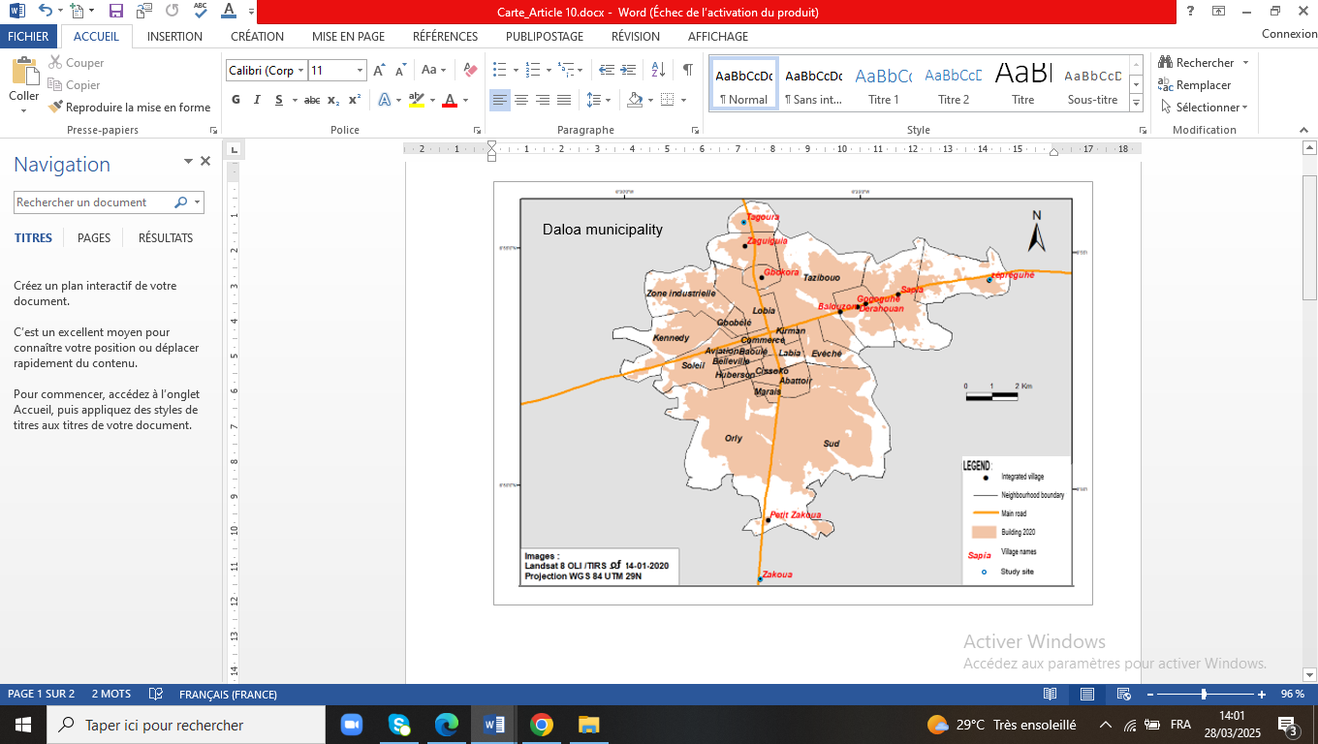

Fig. 1 : Mapping the study and collection area

Average annual rainfall is around 1,200 mm, while the average annual temperature is 27°C (SODEXAM, 2020).

**2.2 Materials**

The material used consisted of plant material and technical material. The plant material consisted of Loranthaceae and the technical material of a geographical positioning device (GPS), a digital camera, survey sheets, determination keys for Loranthaceae from Balle and Halle (1961), documents from Soro (2010), Amon (2014) and a collection of specimens of species from the herbarium of the Centre National de Floristique (CNF) to compare the species collected.

**2.3 Methods**

**2.3.1. Data collection**

The field surveys took place from june 2024 to march 2025. The roving inventory method was used to record the various Loranthaceae species present in the selected cocoa agrosystems. In each selected plantation, a roving survey was carried out by walking through all the cocoa plantations in all directions in order to record all the parasitic species encountered on the basis of their presence, without taking their abundance into account (Aké-Assi, 1984). Data was collected by direct observation. These observations were made not only on cocoa trees, but also on other parasitized and non-parasitized trees present in each selected plantation. They were recorded using observation sheets, including the following data :

- the name of the species or species of Loranthaceae encountered on each parasitized tree ;

- the type of leaves (simple, compound, etc.) and the phyllotaxis of these leaves (opposite, sub-opposite, etc.) for each parasitic species;

- the shape and colour of the ripe or unripe fruits of each parasitic species;

- the type and colour of the flowers of each parasitic species;

- the method of attachment and development of these parasites in the crown of the host tree.

**2.3.2 Identification of the species surveyed**

The samples of Loranthaceae encountered were identified mainly using the reference work by Balle and Hallé (1961) entitled : "Loranthaceae de la Côte d’Ivoire", the documents by Boussim (2002), Traoré et al. (2003), Soro (2010) and Amon (2014) and the collection of herbarium specimens at the Centre National de Floristique (CNF) in Abidjan, Côte d'Ivoire.

**2.4. Data processing**

The data collected were processed using the Microsoft Office 2016 Excel spreadsheet program to create tables.

**3. RESULTS AND DISCUSSION**

**3.1 Results**

**3.1.1. Loranthaceae species inventoried**

Four species of Loranthaceae were inventoried in the cocoa agrosystems of the peri-urban areas of Daloa, in central-western Côte d’Ivoire. They are : *Globimetula dinklagei* subsp. *assiana* (Engl.) Danser, *Phragmanthera capitata* (Spreng.) Ballé, *Tapinanthus bangwensis* (Engl. et K. Krause) Danser and *T. globiferus* (A. Rich.). They belong to three genera, the most species-rich of which is *Tapinanthus* with 2 species (*T. bangwensis* and *T. globiferus*). *Tapinanthus* is the most predominant genus. The other two are monospecific with one species each.

**3.1.2 Identification of the different Loranthaceae species**

**3.1.2.1. Descriptive key to genera and species**

Several morphological characteristics were observed to characterise the different genera and species of Loranthaceae inventoried.

Key to determining genera :

1. Corolla with 5-6 fused petals. Corolla tube almost equal in length to the lobes and split on one side at the anther. Lobes of anther not transversely divided :

2. Corolla lobes rolled externally over several turns of the anther. Threads without apical teeth........*Globimetul*a

2'. Corolla lobes erect or reflected at the anther. Filets extended ventrally by an apical tooth extending beyond the base of the anther......................*Tapinanthus*

1'. Corolla with 5-6 fused petals. Corolla tube almost equal in length to the lobes and split on one side at the anther. The anther cells are transversely divided into several superimposed cells. Filet generally without apical teeth…………………*Phragmanthera*

Species identification key :

1. Leaves simple, opposite or subopposite and ternate. Blades long with pinnate veins, often irregular. Inflorescences in axillary umbels of 5 reddish flowers. Corolla with 5 petals fused in the lower half. Fruits are globose, ellipsoid pseudo berries of varying reddish colour at maturity...............................*G. dinklagei*

1'. Leaves simple, opposite or subopposite. Blades thick and leathery, broadly ovate or elliptic, with obtuse or rounded apex. Pinnate venation often irregular. Inflorescences in axillary umbels of 4 to 5 flowers. Corolla of 5 to 6 yellow petals with pink or red tips. Fruits are oblong ovoid berries, bluish in colour when ripe........................................ *P. capitata*

2. Leaves simple, opposite or subopposite. Blades broadly ovate-elliptic, ovate-oblong with acute apex and wedge-shaped base. Median vein broadly protruding below. Inflorescences in axillary umbels of 6 to 8 flowers. Corolla with a globular or subglobose red base and a darker, wine-red top with blackish or dark vertical lines. Fruits are ellipsoidal, smooth berries, red when ripe....................................*T. bangwensis*

2'. Simple opposite or subopposite leaves of very variable size. Blades slightly cordate. Main vein not prominent but clearly visible. Inflorescences in umbels of 4 to 8 pale pink or purplish flowers often united in fascicles. Fruits are globose, ovoid, ellipsoid, sometimes pyriform berries, pink, red or orange-yellow when ripe.................*T. globiferus*

**3.1.3. Short botanical monograph of Loranthaceae species**

**3.1.3.1. *Globimetula dinklagei* subsp. *assiana***

Synonym : *Loranthus dinklagei* subsp. *assiana* Engl.

*Globimetula dinklagei* subsp. *assiana* is an entirely glabrous shrub (Fig. 2). The branches have leaves that are generally opposite or subopposite, rarely alternate or whorled.

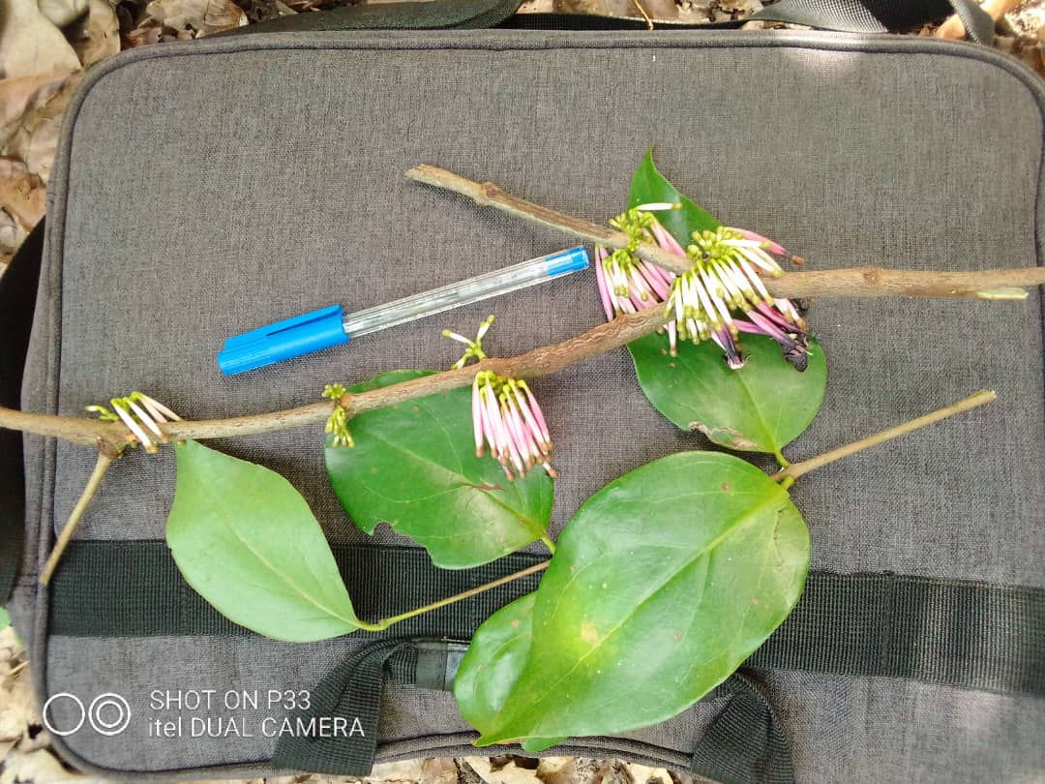

Fig. 2 : Flowering shoots of *Globimetula dinklagei*

The pinnately-veined, often irregular blades are broadly oval or elliptical, with an acute or subacute apex and pinnate, curved or subparallel venation. Inflorescences are in axillary umbels, isolated then fasciculated, of five flowers. The corolla measures 28 to 32 mm. It is pale pink. The stamens, with threads inserted near the base, are 8 mm long. The style is slightly keeled and strongly papillose on the edges of the neck. The fruit is a globular berry, 5 mm in diameter and firmly constricted under the cupule, which is 1 mm high. It is reddish in colour when ripe.

**3.1.3.2. *Phragmanthera capitata* (Spreng.) Ballé**

Synonym : *Loranthus capitatus* Engl.

*Phragmanthera capitata* (Fig. 3) is a sarmentose shrub covered on all sides with star-like hairs, deciduous on the vegetative organs but persistent on the underside of the leaf blades. The reddish-brown twigs, which sometimes hang down, can reach 70 cm in length. The branches are initially smooth, then covered with small lenticels. The leaves are simple, opposite or sub-opposite, with thick, leathery, broadly oval or elliptical blades, obtuse or rounded at the apex, with 2 to 7 pairs of clearly visible lateral veins. The inflorescence is an axillary umbel of 3 to 4 flowers. The corolla has 5 to 6 yellow petals with pink or red tips. The fruit is an ovoid, oblong berry, bluish in colour when yellow with a red tip. The fruit is an ovoid, oblong berry that is bluish when ripe. In Côte d’Ivoire, *P capitata* is widespread on several trees and shrubs, mainly cultivated species such as rubber, avocado, cocoa and citrus.

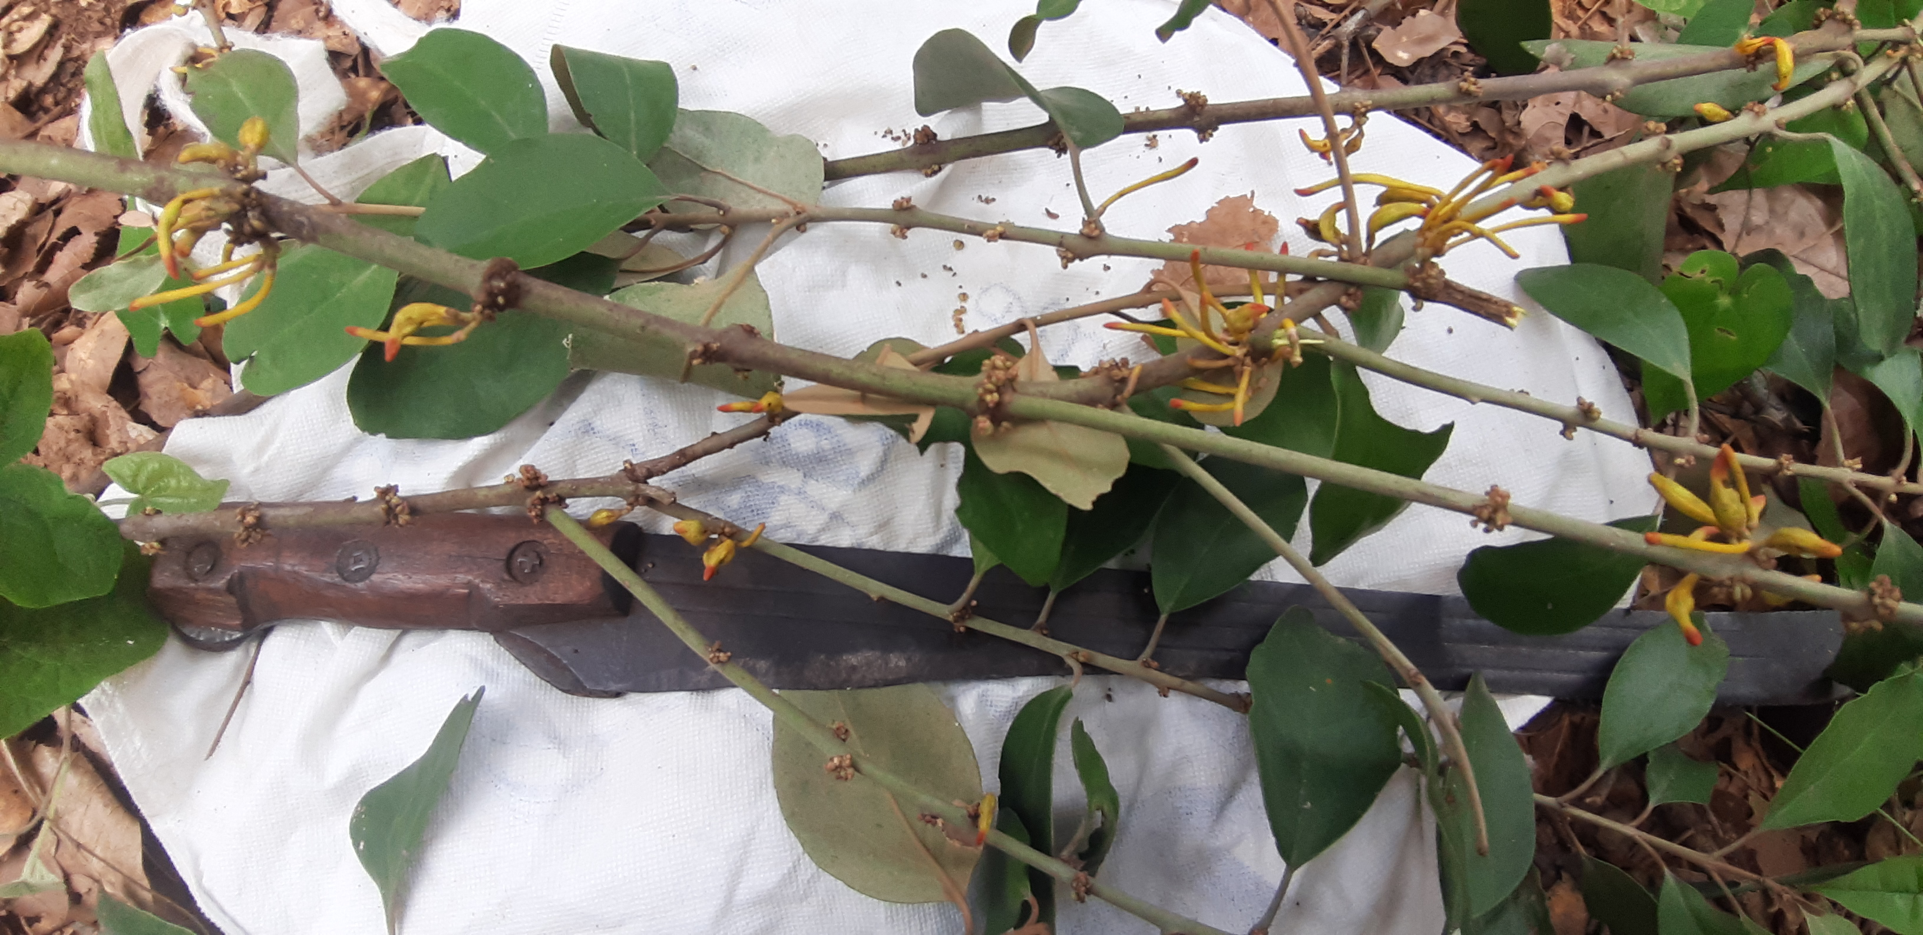

Fig. 3 : Flowering shoots of *P. capitata*

**3.1.3.3. *Tapinanthus bangwensis* (Engl. & K. Krause) Danser**

Synonym : *Loranthus bangwensis* Engl. & K. Krause

*Tapinanthus bangwensis* (Fig. 4), whose specific epithet comes from Bangwé, a locality in Cameroon where this species was first collected, is an entirely glabrous plant with hanging, moderately dense, liana-like branches up to 75 cm long. The leaves are simple, entire, opposite or sub-opposite. The semi-fleshy blades are broadly ovate-elliptic, ovate-oblong, with an acute apex and a wedge-shaped base, with a broadly protruding midrib below 3 to 7 visible oblique lateral veins. Inflorescences are axillary umbels of 6 to 8 flowers. Inflorescences are in axillary umbels of 6 to 8 flowers with a corolla with a globular or sub-globose base, red in colour with a darker, wine-red top with blackish or dark vertical lines. The fruit are smooth, ellipsoid berries, red when ripe, 7 to 9 mm long, with a cupule about 1 mm high. In Côte d'Ivoire, the species is parasitic on a wide variety of spontaneous or cultivated trees and shrubs.

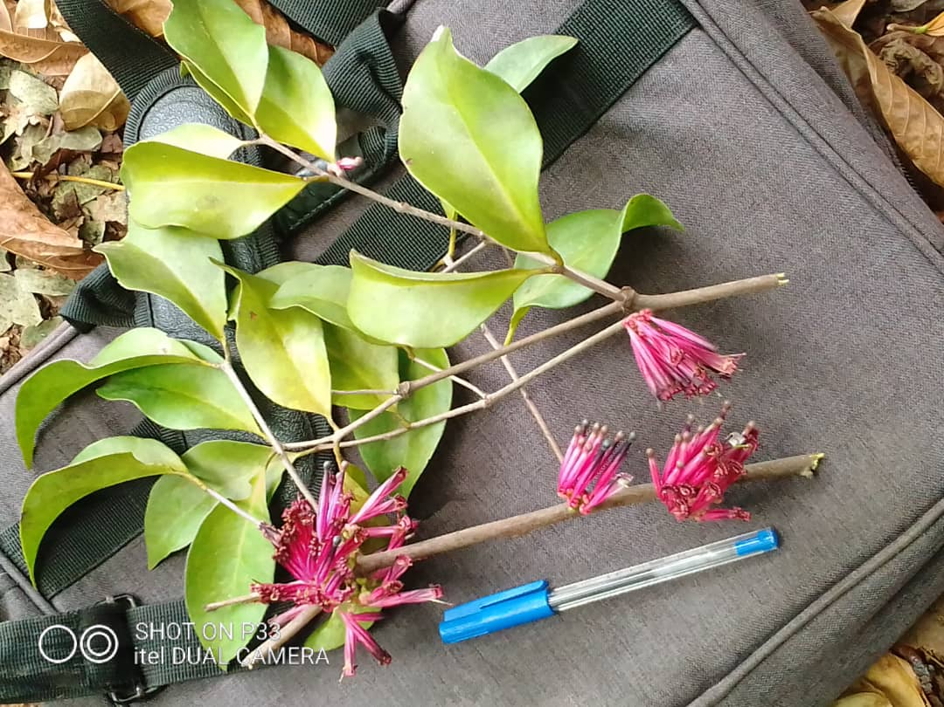

Fig. 4 : Flowering shoots of *Tapinanthus bangwensis*

**3.1.3.4. *Tapinanthus globiferus* (A. Rich.) Danser**

Synonym : *Loranthus globiferus* A. Rich.

*Tapinanthus globiferus* (Fig. 5) is an entirely glabrous hemiparasite with generally numerous branches. The leaves are opposite or sub-opposite and vary greatly in size. The slightly cordate leaf blades are 5 to 15 cm long and 2 to 5 cm wide, with the main veins not prominent but clearly visible. Inflorescences are axillary umbels of 4 to 8 pale pink or purplish flowers, often united in fascicles. The fruit are globular, ovoid, ellipsoid or sometimes pear-shaped berries, 6 to 9 mm long, pink, red or yellow-orange when ripe. In Côte d'Ivoire, this species is less widespread than the other, *T. bangwensis*.

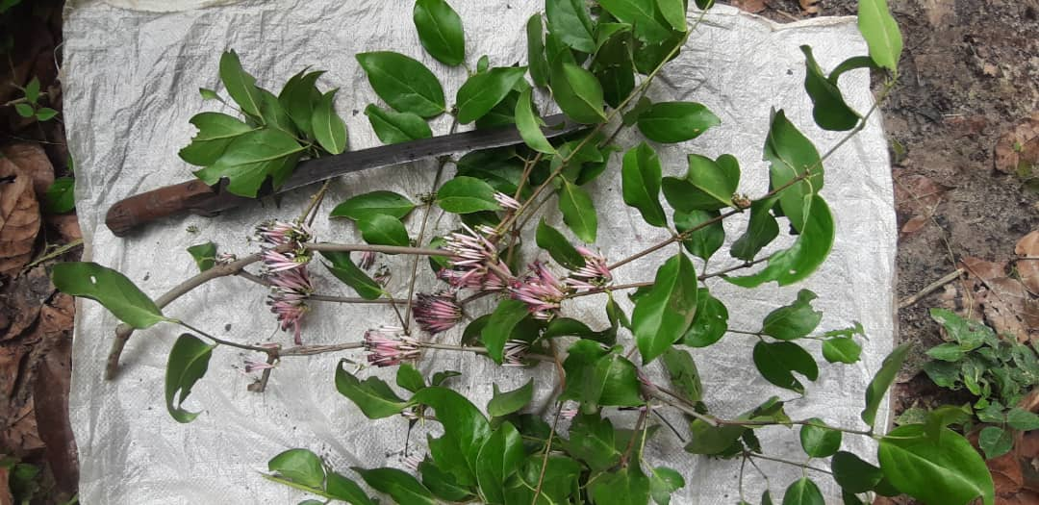

Fig. 5 : Flowering shoots of *T. globiferus*

**3.1.4. Distribution and ecological preferences of species**

The distribution of the various Loranthaceae species in agrosystems and their position in the crowns of the wild or cultivated woody plants they parasitise is influenced by their light requirements. Table 1 shows the light requirements and attachment modes of the various Loranthaceae species identified in the agrosystems studied. *Globimetula dinklagei* is an evergreen species described as sciaphilous, sometimes heliosciaphilous, preferring shady conditions. A total of 576 clumps, or 10.69 % of clumps, were recorded in the agrosystems studied. *Phragmanthera capitata* was observed in all the agrosystems, with a total of 1,795 clumps, or 33.31 % of the clumps. This semi-heliophilous species prefers moist, aerated areas in the crowns of the woody plants it parasitizes. It settles both outside and inside the crowns of host trees. *Tapinanthus bangwensis* was observed in all the agrosystems studied with 2,634 clumps, i.e. 48.87 % of clumps. It is a heliophilous species that settles and develops mainly on the periphery of the on

crown or the outside of the hosts.

Table 1: Ecological preferences and attachment strategies of Loranthaceae

|  |  |  |  |
| --- | --- | --- | --- |
| Parasitic species | Average number of clumps | Light requirements of species | Fixation mode of the parasite/habitat |
| *Globimetula dinklagei* subsp. *assiana* | 576 | Sciaphilous, sometimes heliophilous, but rarely heliophilous. | The species tends to develop almost inside the tree crowns of its hosts. |
| *Phragmanthera capitata* | 1795 | Very often heliophilous or semi-heliophilous on hosts, sometimes heliophilous on woody plants. | The species is found in moist, aerated areas of the host's crown. It attaches itself to both the outside and inside of the crown. |
| *Tapinanthus bangwensis* | 2634 | Heliophilous | The species settles and develops mainly on the edge of the crown or on the outside of the hosts. |
| *T. globiferus* | 384 | Heliophilous or semi-heliophilous | The species tends to grow in the shade (inside) as well as outside the crown of its hosts. |

**DISCUSSION**

The diversity of Loranthaceae in cocoa agrosystems in the peri-urban areas of Daloa is four species : *Globimetula dinklagei* subsp. *assiana*, *Phragmanthera capitata*, *Tapinanthus bangwensis* and *T. globiferus*. All four species have already been reported from other regions in Côte d'Ivoire (Soro, 2010; Amon et al., 2020). This number is close to the five species collected in agrosystems by Soro (2010) in the departments of Oumé, Gagnoa and Soubré, in the centre-west and south-west of the country, and similar to the four species already inventoried by Yao (2020) in cocoa plantations in the department of Daloa. The results showed that *T. bangwensis* is the most abundant parasitic species in all cocoa agrosystems. The high presence of this parasite in the agrosystems studied is not unusual. It is thought to be linked to its ubiquitous nature (Wood, 2008). This result corroborates that of Ondoua et al (2015) in Cameroon and Amon (2006) in Côte d'Ivoire, who have already reported this high presence of *T. bangwensis* on cocoa trees in agrosystems. The results also showed that the four parasites have different ecological requirements and that they do not develop everywhere in the tree crowns. We observed that *G. dinklagei, P. capitata* and *T. globifolius* are heliophilous species that develop both outside and inside the crowns of their woody hosts, while *T. bangwensis* showed heliophilous behaviour by attaching itself to the outside of the crowns of its hosts in agrosystems. These results are confirmed by those of other authors (Boussim, 2002 ; Soro, 2010 ; Koffi et al., 2014), who have studied Loranthaceae in sub-Saharan Africa.

**REFERENCES**

Aké-Assi, L. (1984). Flora of Côte d'Ivoire: A Descriptive and Biogeographical Study with Some Ethnobotanical Notes. Doctoral Thesis in Natural Sciences. Faculty of Science and Technology, National University, Abidjan, Côte d'Ivoire, 665 p.

Amon, A.D.E. (2006). Parasitic Vascular Plants of the Loranthaceae Family Found in the Grand-Bassam Department, Southern Côte d'Ivoire. Postgraduate Dissertation in Botany, University of Cocody, U.F.R. Biosciences, Abidjan, Côte d'Ivoire, 57 p.

Amon, A.D.E. (2014). Loranthaceae (mistletoes), vascular hemiparasites of trees and shrubs in agroecosystems in the South Comoé region, in the dense evergreen forest zone of Côte d'Ivoire. Thesis, Félix Houphouët-Boigny University, Agroforestry option, 213 p.

Balle, S. & Halle, N. (1961). The Loranthaceae of Côte d'Ivoire. Adansonia Publishing, 23 p.

Bannister, P., Graham, L., Strong & Inge A. (2002). Differential accumulation of nutrient elements in some New Zealand mistletoes and their hosts. Functional Plant Biology, 29(11), 1309-1318

Barlow, B.A. (1987). Biogeography of Loranthaceae and Viscaceae and its bearing on vegetation history in the Malesian Australian region, in: "Parasitic Flowering Plants". Weber, H. Chr. and W. Forstreuter, eds. Marburg., 805-817.

Boussim, I.J. & Nayere, M. (2009). Methods for controlling Loranthaceae. Flora et Vegetatio Sudano-Sambesica, 12, 27-35

Boussim, I.J. (2002). Parasitic Phanerogams of Burkina Faso: Inventory, Taxonomy, Ecology and Some Aspects of Their Biology. A Special Case of Loranthaceae Parasites of Shea Trees. State Thesis, University of Ouagadougou, 306 p.

Eldin, M. (1971). Climate. In: The Natural Environment of Côte d’Ivoire. ORSTOM Editions. Paris: 77-108. Armèle Affoué Koffi, Faustine Akossoua Kouassi, Serge Beranger Koua N’Goran, and Dodiomon Soro (2014). Loranthaceae, parasites of trees and shrubs: the case of the Katiola department, northern Côte d’Ivoire. Int. J. Biol. Chem. Sci. 8(6), 2552-2559

Ondoua, J.M., Dibong, S., Didier, T.V.D. & Ngotta, B.J.B. (2015). Parasitism of cocoa seed fields by Loranthaceae in the Nkoemvone area (southern Cameroon). Journal of Applied Biosciences, 85, 7794-7803.

Polhill, R. & Wiens, D. (1998). Mistletoes of Africa, The Royal Botanic, Kew, 370 p.

Salle, G. (2004). Parasitic Plants, 14 p. http://www.future-sciences.com/magazines/botany-plantesparasites (Accessed 07/15/2024).

SODEXAM (Airport, Aeronautical and Meteorological Operation and Development Company) (2020). Meteorological data from 2010 to 2020 collected at the Daloa weather station.

Soro, K. (2010). Loranthaceae or mistletoes, vascular plants parasitic on cultivated and uncultivated trees and shrubs in western Côte d'Ivoire: the case of the departments of Oumé, Gagnoa, and Soubré. Single Thesis in Plant Ecology, Agroforestry Option, University of Cocody (Abidjan, Ivory Coast), 189 p.

Traoré, D., Da, K.P. & Soro, D. (2003). Control of vascular plant parasites of shea in northern Ivory Coast. Case of the Tengrela Shea Natural Park, University of Cocody, Botanical Laboratory, PEP/AISA-CI Report, 116 p.

Wood (2008). Cocoa, Tropical Agriculture Series, John Wiley & Sons 6, 620 p.

Yao, K.M. (2020). Diversity and Extent of Loranthaceae Attacks in Cocoa (Theobroma cacao L.) Plantations in the Daloa Region (Central-West, Ivory Coast). Master’s thesis in Bioresources-Agronomy, UFR Agroforestry, Jean Lorougnon Guédé University (Daloa, Ivory Coast), 42 p.