**Agro-Technological Modernization and Its Role in Food Crop Production in the Buea Municipality, Cameroon**

**Abstract:**

There has been a significant increase in the human population worldwide in the 21st century, which has increased humanity's food needs. Attempts have been made to meet the food needs of the human population, among which is modernizing agrotechnology, particularly with the emergence of the Green/Agricultural revolution. This paper, therefore, examines agro-technological modernization and its role in food crop production in the Buea Municipality, Cameroon. The study used descriptive and experimental multidisciplinary research methods to collect and analyze primary and secondary data. The data were analyzed using elements of the statistical package for social sciences and Microsoft Excel software in conjunction with soil laboratory experiments. Maps were equally drawn using an Openstreet mapper to establish variations in agricultural land use in different periods. Results revealed that there had been significant spatial-technological changes in food crop production over time in the Buea Municipality. The findings are recommended to guide policymakers in making informed decisions about food crop production in Buea municipality and beyond.

**Keywords: Agro-Technological Modernization, Food Crop Production, Buea Municipality**

**Introduction**

Humans have been engaged in agriculture for livelihood sustenance since their emergence on planet Earth. From a global perspective, agriculture started in ancient times, in the Neolithic Era, some 12000 years ago (Abbas, 2011). The first development of farming practices emerged in the Epipaleolithic Near East. During this period (Middle Stone Age), agricultural practices were rudimentary and ecological, controlled by naturally occurring processes and exclusively rainfed. More so, fertilization was only by organic manure or fertilization; nonagrochemicalsls and machinery characterized farming (Harwood, 1998; Diamond & Bellwood, 2003; Altieri & Nicholls, 2005).

Over time, the human population began increasing exponentially due to improvements in healthcare facilities and services and the population policies adopted by governments of different countries. A rapidly growing population resulted in an increased demand for food as the number of mouths to feed rose rapidly (Worldometers, 2019).

This runaway population threatened food security as ecological farming seemed incommensurable to an unprecedented growing human population. Scientific and technological advances in agriculture heaved in sight to address such plausible outcomes, particularly with the advent of the Industrial Revolution (1760) in the wake of the industrial era in the latter half of the 18th century. The world's agricultural sector has witnessed enormous change, particularly with the Green Revolution, which brought research technology and innovative agricultural initiatives (Hazell, 2009).

The innovative initiatives resulted in adopting new agrotechnologies, high-yielding varieties (HYVS) of crops, chemical fertilizers and agrochemicals, irrigation techniques, mechanization and new cultivation methods (Hazell, 2009). These were practices to supplant 'traditional' agriculture to increase food production. The outcome is that world food production has kept up with rapid population growth, as gains have been especially dramatic in the past 50 years (Guy & Eduardo, 2010). Modern agro innovations are increasingly used worldwide (National Geographic, 2016).

In Africa, the 1980s marked a turning point for agricultural policy in most developing countries. The conventional states-ran agricultural policies were undergoing structural transformations and experiencing severe reversals (Chang, 2009). It is a well-known fact that agriculture has been, and is still the backbone of, Cameroon's economy, the primary sector which holds high ground with the highest GDP contribution, highest employing sector of the population and food supply. Transforming the agricultural sector was and is still vital in reforming and developing the entire economy (Wikipedia, 2025; Mukiibi, 2001).

It is highly gratifying that the Buea municipality is a favourable environment for farming, thus plays a predominant role in food production from rain-fed agriculture and contributes massively to the GDP of Cameroon (Wikipedia, 2025). Over time, the Buea municipality has witnessed population growth, which has raised the demand for food. Modern agrotechnology centred largely on introducing conventional farming practices has been adopted as a response. This study focuses on agricultural modernisation's role in food crop production in the Buea Municipality.

**2. Materials and Methods**

***2.1. Study Area***

Buea Municipality is found in the Fako Division in the South West Region of Cameroon. The municipality has a surface area of 870 sq/km. It is located on the east slope of Mount Cameroon between latitudes 4012 and 4031 north of the Equator and longitude 9009 to 9012 east of the Greenwich meridian (Mojoko, 2011). The municipality is bounded to the west by Mount Cameroon, to the east by Tiko Sub-Division, to the north by Muyuka Sub-Division and to the south by Limbe Sub-Division (Map 1). With humid tropical climatic conditions alongside rich volcanic soils, ideal conditions for cultivating cash and food crops are provided. Buea Municipality rests at an elevation of 1000 m above sea level on the south-eastern slopes of Mount Cameroon. Buea has an estimated population of over 176,000 inhabitants with a 5% growth rate (Regional Institute of Statistics, Buea cited in Tosam, 2012; Buea CVUC, 2019).

##### **Map 1: Location of: (a): South West Region in Cameroon; (b): Fako Division in South West Region; (c): Study sites in Buea Municipality in Fako Division**

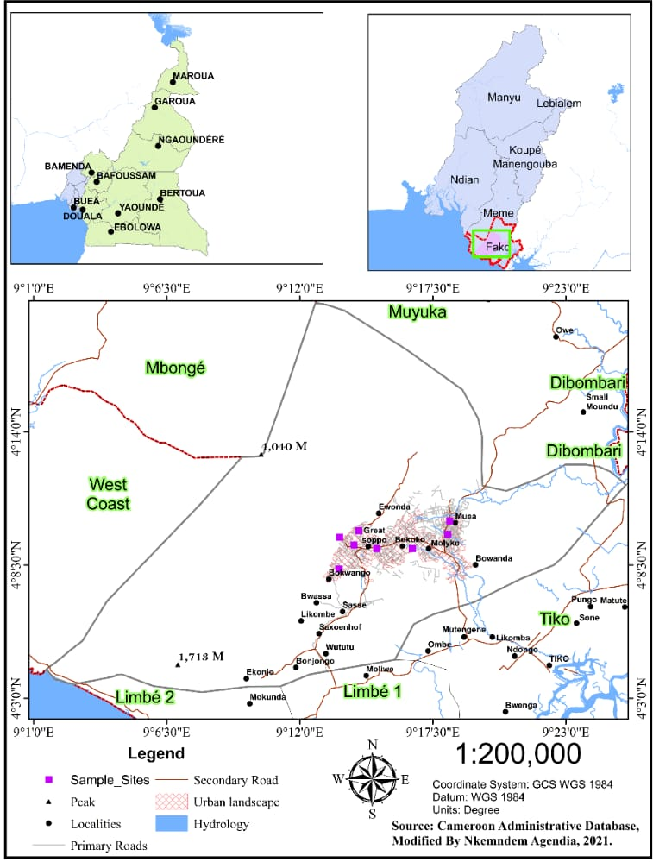

***2.2. Data Collection and Techniques of Analyses***

This study adopted a descriptive and experimental research design to examine how agriculture (food crop farming) has been modernized (agrotechnology) in the Buea Municipality. The social science methodology of data collection and analysis was used. Data were obtained from primary and secondary sources.

Primary data were obtained through questionnaires, interviews and soil samples with the help of a soil auger. 200 respondents were purposively and randomly sampled to acquire data relating to farming practices. The respondents sampled included 50 conventional farmers, 50 organic farmers, 25 stakeholders in agriculture and 75 inhabitants. Also, the study conducted random interviews with stakeholders in the agriculture sector, such as the sub-divisional delegate and some experts from the Sub-Divisional Delegation of Agriculture and Rural Development (MINADER), experts from South West Development Authority (SOWEDA), farmers and some individuals in Buea who are the consumers of the agricultural produce. Furthermore, a field survey was done to observe the different farming practices and collect soil samples from farming fields for laboratory testing. This was done to establish the amounts of soil nutrients available from organic and conventional sources.

Secondary data were obtained from both published and unpublished documents on agriculture. Data on farming inputs, practices and outputs were obtained from MINADER and SOWEDA reports. These data were used to describe the changes (modernization) which have occurred over time in the study area.

**2.2.1. *Examination of agricultural modernization***

To examine how agriculture has been modernized in Buea Municipality, this study considered spatio-technological changes. By this, land use maps were used to identify the surface area used for agriculture in the traditional (before modern agrotechnology) and modern (when modern technology was introduced) periods. Landsat images of the study area for the traditional and modern periods were obtained from the United States Geological Survey (USGS) website and used to produce land use maps. The images were imported into Arc GIS 10.0 (ESRI, 2010) software for geographical analyses. The different bands were modulated and corrected to reveal the various and most prominent land use types and geographic features using Arc GIS. Google Earth was then used for pattern recognition as the polygons representing the various land use parameters were measured with Arc GIS and computed using Microsoft Excel 2016. Proportion was used to analyze the percentages covered by each land use type.

Also, with regards to changes in the inputs and methods used in food crop farming, data were obtained from questionnaires responded to by farmers and interviews conducted with stakeholders, which were analyzed using proportions and the covariance statistical test. This is because it can establish the variation in methods of agriculture that have been employed at different times in the study, given that covariance measures the total variations from their expected values. Then, gauging the direction of the relationship is possible, whether it shows an inverse relation or a random relationship (David & Christopher, 2016). Time is the independent (X) variable, and methods are the dependent (Y) variables.

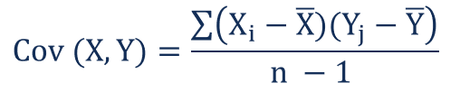

* + 1. ***Establishing soil nutrient availability from organic and conventional sources***

To establish the number of nutrients available in the farm fields, a soil auger was used to collect soil samples from a conventional farm (in Muea) where synthetic chemicals and fertilizers have been applied to the fields and from an organic farm (in Bokwaongo) where only natural elements for growth are being used for about 10 years respectively. In the collection process, the soil auger was used to dig the fields to a depth of 10-30cm from the farm surfaces into the ground, measured with a ruler to ensure that the samples taken represent the soil in the various farming fields. Soil samples were air-dried and ground to pass through a 2 mm sieve. For nitrogen (N) analysis, soils were further ground to pass through a 0.5 mm sieve. Total N was determined from a wet acid digest (Buondonno et al., 1995) and analyzed by colourimetric analysis (Anderson & Ingram, 1993). Exchangeable cations (Ca, Mg, K and Na) were extracted using ammonium acetate at pH seven and analyzed by atomic absorption spectrophotometry.

Total N expressed as %, Ca, Mg, K, Na, in cmol(+)/kg, the same as me/100g.

For quality control, the following were done:

1. Calibration standards prepared from certified standards
2. The inclusion of 5 internal reference samples in every batch analyzed
3. Four external reference samples from the international soil exchange program were analysed in every batch.

In this light, experimental laboratory analytical techniques and descriptive statistics were used to show the levels of concentration/availability of soil chemical properties in both samples.

1. **Results and Discussion**

## ***3.1. Examination of Agricultural Modernization***

The study used farm cover (spatial) and agrotechnology (inputs and methods) to achieve this.

### ***3.1.1. Spatial Modernization (Variability/Change)***

This entailed the proportion of agricultural land used in the traditional and modern periods. Worth noting is that there is no distinction between land used for food crops and cash crops exclusively. However, the study examines agricultural land in general. In this regard, 1990 was used as the base year before the introduction of modern agrotechnology in 1991. 2020 was later used to compare with 1990 in examining the difference in agricultural land use before and after the introduction of modern agrotechnology (Maps 2).

### **Map 2: Land use activities prior to (a)1990 (b) 2020 in Buea Municipality**

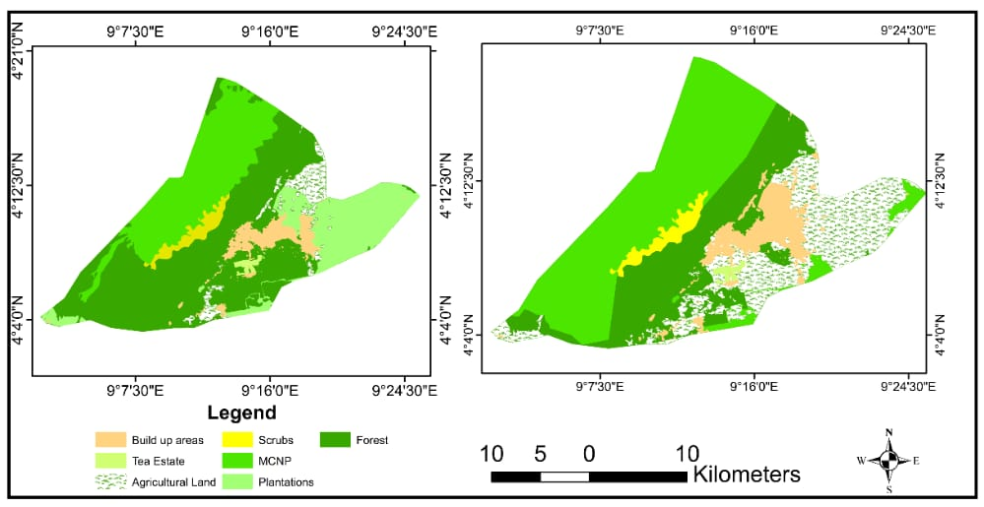

b

a

**Source: Adapted from Google Earth, USGS Landsat images and Openstreetmap, realized by Nkemdem & Chu, 2021.**

Map 2a presents the proportion of different land use activities that were predominant within Buea Municipality prior to 1991 (the traditional period). Map 2b illustrates phenomena similar to those of Map 2a before 2021, given that agriculture had experienced some degree of modernization as innovations heaved spatially and technically insight into the Buea Municipality.

##### **Table 1: land use and land cover statistics for the study periods in the Buea Municipality**

|  |  |  |  |  |
| --- | --- | --- | --- | --- |
|  | Prior to 1991 | | Prior to 2021 | |
| Land use type | Land coverage (km2) | Proportion (%/100) | Land coverage (km2) | Proportion (%/100) |
| Agriculture | 31.0499394 | 3.57 | 37.80966846 | 4.34 |
| CDC Plantation | 118.4395265 | 13.62 | 113.5666363 | 13.05 |
| Settlement | 18.13370586 | 2.08 | 46.12448812 | 5.30 |
| Forest | 343.8599217 | 39.52 | 331.398739 | 38.09 |
| Tea Estate | 4.85793323 | 0.56 | 4.85793323 | 0.56 |
| Mountain forest | 252.4762763 | 29.02 | 236.0851056 | 27.14 |
| Scrub | 101.182697 | 11.63 | 100.1574293 | 11.51 |
| Total | 870 | 100 | 870 | 100 |

**Source: Generated from map 2.**

Given the statistics in Table 1, forest vegetation was the most dominant land use type in both periods, with 39.52% and 38.09% land coverage, respectively. Agriculture accounted for 3.57% before the start of the modern era and 4.34% prior to 2021. Tea Estate was the least, with 0.56% of the total land coverage in Buea municipality.

Over time, significant changes have been in sight, evident by an increase in the proportion of land used for agriculture of about 6.76sq/km, representing a 0.78% increase in the spatial land coverage. This is explained by increased demand for food as the population increased, evident by the change in settlement land use from 2.08% prior to 1991 to 5.30% prior to 2021 in Buea Municipality. While settlement and agricultural land increased, forest land decreased.

### ***3.1.2. Technological modernization (Variability/Change)***

Technology is a very important factor in determining the outcome of an activity. Since it is an anthropogenic element, it is subject to change as man is also dynamic. Significant changes have occurred over the years concerning food crop production technology in the Buea municipality. From field investigations, it was obtained that innovations in the Buea Municipality in food crop production consist of the inputs and methods used in farming.Furthermore, the results presented on the perception of sampled respondents on the introduction of agro-technological changes in the area reveal the following: 94% of respondents maintained that there had been significant changes in agrotechnology. In comparison, the minority (6%) had a contrary view. This is like the situation in Mexico in the 1940s and other countries like China and America in the 1960s, where there were significant improvements and innovations in the agricultural sector as seeds became hybridized, machinery and synthetics used as well as changes in farm processes like ploughing replaced ridge making due to advancement in agricultural technology (Hazell, 2009).

#### **3.1.2.1. Inputs modernization (Variability/Change)**

Field findings showed significant changes in the inputs employed in food crop-producing farms in the study area over the years. They include seeds, farm tools, supplements, and labour. In this light, 100% of farmers and stakeholders expressed that hybrid seedlings are used mainly for crops like maize, even though some people still plant traditional seeds. Concerning farm tools, both rudimentary and modern tools like cutlasses, axes, and hoes are used together with manual and automated sprinklers.

Furthermore, a remarkable dynamism heaved in sight concerning farm supplements. They consist of soil and crop supplements ingested to meet deficiencies and reduce plant vulnerability to pests and diseases. In this light, supplements like animal droppings and plant residue were the first soil and crop supplements used in food crop farming in the Buea Municipality. However, with the emergence of innovation (modern agrotechnology), chemical fertilizers, insecticides, pesticides and fungicides are used.

Labour as an input has witnessed a change in the proportion of youths engaged in farming. It was obtained that, in the traditional period, both the old and youth were engaged in farming, which is like the situation in the modern period, even though the proportion of youths involved in the activity has increased. This was explained by the fact that technological improvements make it much easier to perform farming processes such as clearing grass, which is minimal today with the introduction and use of herbicides sprayed on grass.

Table 2 presents some hybrid seedlings distributed by SOWEDA to food crop farmers in the Buea Municipality in the modern area.

##### **Table 2: Improved (hybrid) food crop seedlings distributed by SOWEDA to farmers in 2012**

|  |  |  |  |  |
| --- | --- | --- | --- | --- |
| Seedling type | Quantity distributed | Quantity per hectare | Expected yield (kg) | Annual yield (kg) |
| Maize seedlings | 267275 | 20 | 13363.75 | 40091250 |
| Cassava cuttings | 9780328 | 10000 | 978.0328 | 24450820 |
| Plantain suckers | 247880 | 1111 | 223.1 | 5577858 |
| Yam setts | 1038726 | 10000 | 103.9 | 1558089 |

**Source: SOWEDA, 2012.**

The seedlings distributed were improved varieties to boost productivity. According to SOWEDA, the quantity of seedlings distributed must be cultivated on specific farm sizes and were expected to result in fruitful harvests. For instance, 267,275 sachets of maize seedlings were distributed to farmers, who were expected to plant/cultivate 20 sachets on a hectare of land that would produce 13,363.75kg of maize in a season while 40,091,250kg of maize was realized for the year 2012.

According to SOWEDA, the seedlings distributed are hybrid species and much more resistant to diseases when compared to non-hybrid species. Below are some food crop seedlings which are both hybrid and non-hybrid species.

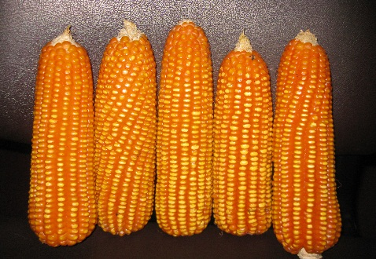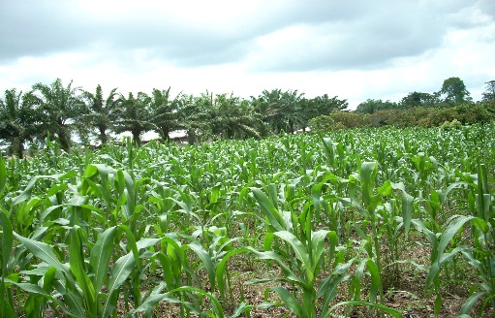

b

a

##### **Plate 1: a: Non-hybrid maize seedling. b: Maize farm cultivated with non-hybrid seedlings (N4⁰08’277’’, E9⁰13’902’’) (Likoko Membea).**

**Source: field survey, 2021.**

Plate 1a, non-hybrid maize seedlings used by some farmers, and 1b is a farm view of maize cultivated with non-hybrid seedlings.

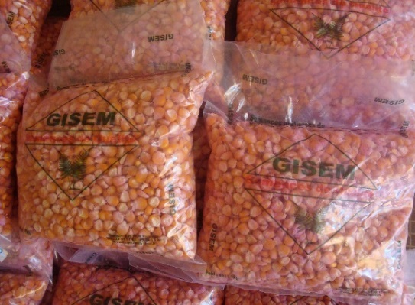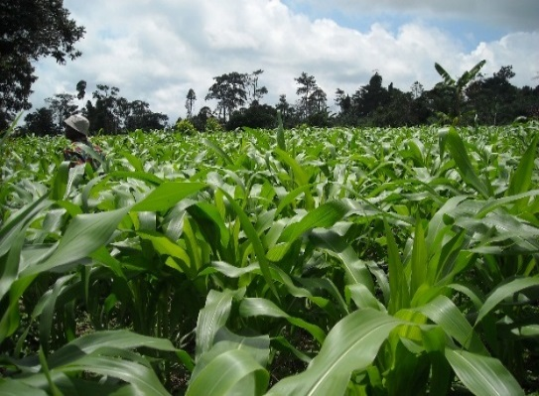

b

a

### **plate 2: a: hybrid maize seedling distributed by SOWEDA. b: maize farm cultivated with hybrid seedlings (Muea)**

**Source: SOWEDA, 2021.**

Plate 2a illustrates a sample of hybrid/improved maize seedlings, and 2b is a farm view of maize cultivated with hybrid maize seedlings.

Given plates 1 and 2 above, the hybrid maize species is healthy, as shown by the dark green nature of maize leaves indicating enough chlorophyll in the plants. As such, it was better than the non-hybrid species as the leaves were lighter in colour.

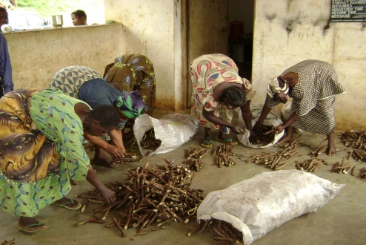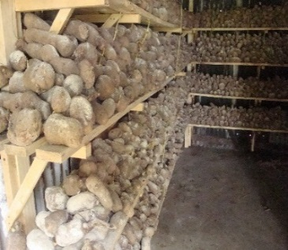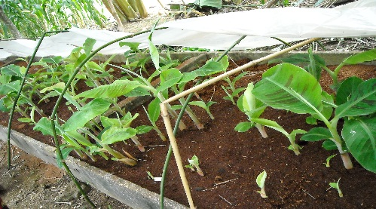

c

b

a

### **plate 3: hybrid species a: Cassava cuttings. b: Yam sets. c: Plantain plantlets (Lower farms).**

### **Source: SOWEDA, 2021.**

Plate 3 presents a sample of some improved/hybrid food crop seedlings (a: cassava cuttings, b: yam sets, c: plantain plantlets) prepared by SOWEDA/MINADER to distribute to farmers to cultivate to increase output.

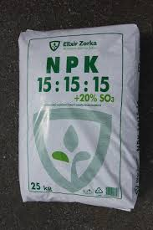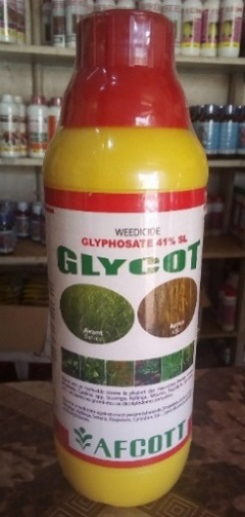

b

a

### **plate 4: Some agrochemicals employed in agriculture in Buea Municipality (a: chemical fertilizer. b: herbicide, pesticide and fungicide (Clerks Quarters-Buea).**

**Source: field survey, 2021.**

Plate 4 above portrays some agrochemicals used in agriculture in the Buea Municipality. Plate 4a is a type of chemical fertilizer composed of nitrogen (N), phosphorus (P) and potassium (K), which is a soil supplement to make up for deficiency and enhance plant growth. In contrast, plate 4b are herbicides, pesticides, insecticides and fungicides used to fight against pest, diseases and weed in farms.

#### **3.1.2.2. Methodological Variability/Change**

To further comprehend the dynamism of agro-technological modernization and innovations in food crop production in the study area, it was imperative to look at the methods and processes used in the different periods. In this perspective, field investigations found that enormous changes have been experienced in the processes performed on the farms, as expressed by 94% of the respondents. These range from the manner of application of inputs to farming systems. In applying supplements to soil and crops, spraying cans are used today and have replaced bare hands, albeit still in use, while cropping and farming systems have changed equally. Examples are the changes from manual to automated irrigation systems, shifting cultivation and bush-fallowing systems to sedentary farming. This is because land for agriculture is now in competition with other uses such as commerce, education, and construction, among others. As such, agricultural land is made use of at its maximum. Again, there has been a change from mix cropping to mono-cropping and extensive to intensive farming systems. These are explained by the fact that competition for land uses reduces the proportion that can be zoned for farming, as well as innovations making the performance of processes on farms much more efficient, even at a large scale, and more conveniently. As such, changes in farming methods were inevitable with advancements in agricultural technology in the Buea Municipality. Table 3 and Plate 5 below portray these phenomena.

##### **Table 3: Changes from Traditional to Modern Periods**

|  |  |  |
| --- | --- | --- |
| **Traditional Period**  **Inputs**  Non-hybrid seeds  Animal droppings  Plant residue  Fire ash  Cutlasses, axes, hoes  Small farm plots  Transformation/changes  No irrigation  Family labour  Farmers (youth and old)  **Methods/Processes**  Clearing/weeding  Ridge making  Extensive farming  Mixed cropping  Subsistence farming  Shifting cultivation  Bush following |  | **Modern Period**  **Inputs**  Hybrid seeds  Fertilizers  Plant residue  Insecticides/pesticides  Herbicides  Large farm plots  Manual/automated irrigation  Family/hired labour  Farmers (youth and old)  **Methods/Processes**  Spraying  Ridge making  Intensive farming  Mixed/mono cropping  Commercial farming  Sedentary farming |

**Source: field survey, 2021.**

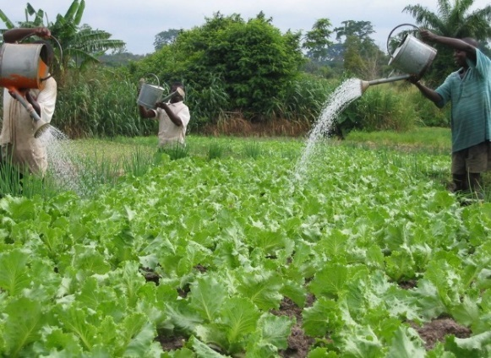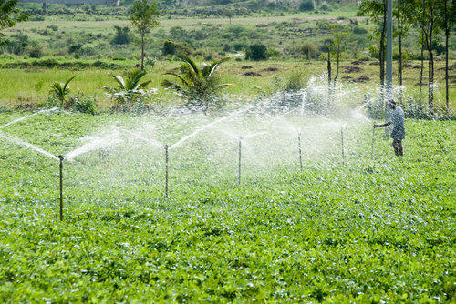

b

a

### **Plate 5: Methods of irrigation; a: manual irrigation (Wokoko-Buea) b: automated sprinkler irrigation (Muea-Buea)**

**a:(N4⁰09’169’’, E9⁰16’647’’), b:(N4⁰10’165’’, E9⁰17’670’’)**

**Source: field survey, 2021.**

Table 3 presents the inputs and processes employed in food crop production in the traditional period and the changes that occurred with the transition from 1991 to the modern period. Even though there was dynamism, some traditional inputs and techniques are still in use in the modern period. Plate 5a illustrates manual irrigation, which was principally the only method used in the traditional period, and plate 5b illustrates the automated irrigation method resulting from agro-technological modernization.

Given the above information, it is seen that there have been significant spatial-technological changes in food crop production in the study area. This has been further explained with the covariance analysis in Table 4, which reveals the views of respondents expressed in percentages that show the degree to which modernization (changes) have occurred in food crop production in the Buea Municipality.

### **Table 4: Covariance in respondents’ opinion on the degree to which change was introduced in the study area**.

|  |  |  |  |
| --- | --- | --- | --- |
| Periods (1960-2020) | Number of years (X) | Number of correspondents who acknowledged change per period (Y) | Proportion of respondents (%) |
| 1960-1970 | 11 | 2 | 1.06 |
| 1971-1980 | 10 | 3 | 1.60 |
| 1981-1990 | 10 | 8 | 4.26 |
| 1991-2000 | 10 | 38 | 20.21 |
| 2001-2010 | 10 | 45 | 23.94 |
| 2011-2020 | 10 | 92 | 48.94 |
| Total | 61 (Ẍ=10.17) | 188 (Ỹ=33.33) | 100 |

**Cov=-0.00008.**

**Source: Field survey, 2021.**

The analysis presented in Table 4 statistically shows a positive correlation. The degree to which changes were made is about time duration. Because of this, very few changes occurred between 1960 and 1970, as only 1.06% of the respondents expressed that some plantation farms had been established in the area. Unlike from 2011-2020, 48.94% of the respondents acknowledged significant changes to have been implemented in the activity. This corroborates Baku and Ravendra's (1992) view that the modernization of agriculture in India in 1970 brought about a tremendous industrial recession. With this, a new strategy for agricultural development was launched, focusing on modernizing the agricultural sector and improving farm productivity. It was referred to as the 'Green Revolution'. It contained a package of "*large scale application of modern science and technology to agriculture''* involving *"extensive and intensive use of improved production technology and high yielding varieties of seeds"* (CSSC, 1974) in Baku and Ravendra, (1992). They further explained that this package meant an introduction of high-yielding seed varieties for a broad range of crops, the creation and utilization of irrigation systems of various kinds to water the fields, the use of high doses of fertilizers and pesticides, as well as extensive usage of farm machinery geared towards improving productivity.

* 1. ***Establishing soil nutrient availability from organic and conventional sources***

Laboratory analytical techniques were used to establish the different amounts of nutrient concentration/availability in the soils in organic and conventional farms, as explained in the methodology and the results presented in Table 5 and Figure 1.

### **Table 5: Availability Levels of Soil Nutrients in Organic and Conventional Farms in Buea Municipality.**

|  |  |  |
| --- | --- | --- |
| Soil Chemical Properties | Organic farm (X) | Conventional farm (Y) |
| Total Nitrogen (N) % | 0.398 | 0.439 |
| Exchangeable calcium (Ca) cmol (+)kg-1 | 7.38 | 6.64 |
| Magnesium (Mg) cmol (+)kg-1 | 57.36 | 61.28 |
| Potassium (K) in cmol (+)kg-1 | 32.51 | 21.63 |
| Sodium (Na) cmol (+)kg-1 | 0.11 | 0.109 |
| Phosphoric acid (P Ass(mg/kg)Bray 2 | 40.949 | 38.806 |
| Exchangeable acid (AI*(cmol/kg) | 0.00 | 0.00 |
| AI*+H (cmol/kg) | 0.00 | 0.00 |
| Humidity % | 18.60 | 18.20 |
| Mat Org (g/kg) | 68.408 | 68.064 |
| Organic (g/kg) | 39.680 | 39.48 |
| Exchangeable bases T (CEC) (cmol/kg) | 38.355 | 36.480 |
| Acidity/Alkalinity Ph (H2O)-1:5 | 6.04 | 6.15 |
| PH(kci)-1:5 | 4.68 | 4.85 |

**Source: IRAD & IITA, 2021.**

### **Figure 1: Availability of nutrients in organic and conventional farms**

**Source: Generated from Table 5.**

Given the results from laboratory analyses on the concentration levels of different chemical properties in the soil, very trivial differences were recorded, as the results revealed. Conventional farms that used synthetic agro supplements had higher concentrations of nitrogen, sodium, acidity and soil pH, while the organic farms that used only organic supplements in the cases of exchangeable basis, soil humidity and potassium were in higher concentrations than conventional farms. It is worth noting that there are no standard quantifications for soil chemical properties to be present in the soil to make it agriculturally good or better than another, given that plants require different soil nutrients at varying amounts and at different levels of growth. For instance, a crop like maize would require about 160kg-210kg of nitrogen on a hectare of land. At the same time, phosphorus is essential at the early stages of root growth (55kg/ha) and potassium the most, requiring about 360kg/ha (8kg/daily) of which any deficiency or excess at a particular stage will adversely affect the crop's growth (Chu, 2028; McKenzie, 1998). As such, plants must be adequately supplied with these nutrients to ensure maximum productivity. However, this research aimed to establish the availability of soil nutrients from organic and conventional sources.

4. ***Conclusion***

The operation of agricultural systems in the Buea Municipality incorporates environmental and human components, all of which work synchronously. Given the dynamic nature of human beings, agricultural systems have experienced changes in the form of innovations introduced by humans as the activity is being modernized. Humanity has the responsibility of protecting and conserving the physical environment sustainably. Therefore, this study recommends that policymakers pay attention to innovations introduced in agriculture to ensure that the potential to meet the food needs of future generations while retaining a healthy and sustainable environment is not jeopardized.

# **REFERENCES**

Abbas A. (2011). *Introduction to Agriculture. Notes for Css, Fpsc & Pms Byphd. 1st Semester (Plant Pathology).* The University of Agriculture Peshawar Pakistan. Introductory Textbooks for Environmental Training. Research Gate Publishing.

Altieri M. A. and Nicholls Clara I. (2005). *Agroecology and the Search for a Truly Sustainable Agriculture 1st edition.* University of California, Berkeley. 12-16, 18-34p. *(*[www.researchgate.net/publication](http://www.researchgate.net/publication)).

Anderson J.M., and J.S.I. Ingram JSI (1993). Tropical soil biology and fertility*: a handbook of methods. Second edition. CAB International, The Cambrian News, Aberystwyth, United Kingdom. 221 p.*

Andrew S. (1998). Sustainable Rural Development*. Macmillan Press Ltd. ISBN, 0-333-66484-1.*

Baku H. D., and Ravendra H. D. (1992). Modernization of agriculture and economic development. The Indian Experience*.* (Indian Institute of Management, Ahmedabad, India). *Far and Business- The Journal of the Caribbean Agro-Economic Society, 1992, vol. 01, issue 1, 118.*

Bonabana-Wabbi J. (2002). Assessing Factors Affecting Adoption of Agricultural Technologies: The Case of Integrated Pest Management (IPM) in Kumi District*:* *MSc. Thesis Eastern Uganda*.

Buondonno, A., A.A. Rashad, and E. Coppola (1995). *Comparing tests for soil fertility. 11. The hydrogen peroxide/sulfuric acid treatment as an alternative to the copper/selenium catalyzed digestion process for routine determination of soil nitrogen-Kjeldahl.* Communications in Soil Science and Plant Analysis 26:1607-1619

Chang, Ha-Joon (2009). Rethinking Public Policy in Agriculture: Lessons from History, Distant and Recent’, *Journal of Peasant Studies, 36:3, pp. 477-515.*

Chu M., (2018). Constraints and implications of floriculture activities along the Buea Mile 14 – Mile 16 axis.

CVCU (United councils and cities of Cameroon) (February 2019). *Buea Council, Cameroon.* Google./Wikipedia.com

Dhanagare, D. N. (1988). The Green revolution and social inequalities in rural India. Bulletin of Concerned Asian Scholars. https://doi.org/10.1080/14672715.1988.10404444

David M.M and Christopher M. (2016). *open intro statistics 3rd edition*. Book review, UV4Plants Bulletin, 2016.

Diamond J., Bellwood P. (2003). *Farmers and their languages: The First Expansions*. Science 300 (5619): 597–603. Bibcode:2003sci…. 300..597D.

FAO (1996). Control of water pollution from agriculture*.* *FAO irrigation and drainage paper 55*. ISBN92-5-103875-9*.*

Green World’s Report of Rwanda (2014). *Impact of fertilizer use in Rwanda*. Green World Consult LTD. P.O. Box 816 Kigali, Rwanda. Our environment is our future publishing.

Guy H. and Eduardo J. T. (2010). *The knowledge-based bio-economy at work*: from extensive scale experiences to instruments for rural and local development. CIRAD / ProsPER Cerviño 3101, Planta Baja. (1425) Buenos Aires, Argentina. ** Grupo CEO S.A. Hipólito Yrigoyen 785 (1086) Buenos Aires, Argentina

Harwood R. R. (1998). *Sustainability in Agricultural Systems in Transition at What Cost?* Michigan State University December 1998. (Unpublished).

Hazell, P. B. R. (2009). The Asian Green Revolution. *IFPRI Discussion Paper. Intl Food Policy Res Inst*. GGKEY: HS2UT4LADZD

McKenzie R. (1998). *Alberta Agriculture, Food and Rural Development Lethbridge*: Research on soil fertility/crop nutrition.

MINADER (2017). *Annual Report of Activities for the 2017 Financial Year. Buea, Cameron.* (Unpublished).

MINADER (2019). *Annual Report of Activities for the 2019 Financial Year. Buea, Cameroon.* (Unpublished).

Mojoko, F. M. (2011). *Urban Development in Fako Division* (Unpublished M.Sc. Thesis). Department of Geography, University of Buea.

Mukiibi, J. K. (2001). *Agriculture in Uganda. Yield decline with continuous corn and soybean Kampala:* Fountain Publishers. Agron J 84:387–390.

National Geographic (2016). *The Development of Agriculture*. Archived from the original on April 14 2016. Retrieved June 15 2016.

SOWEDA (2012). *Serving the rural population of the South West through participatory development.* SOWEDA 25 years after (2012). (Unpublished report).

Tosam, H. N. (2012). An Analysis of Spatial Population Pattern and the Provision of Socio-Economic Infrastructure in Buea Sub-Division. *African Journal of Social Sciences, 3*(1), 116–128.

Wikipedia (2025). Facts and figures about Cameroon.

World Bank (2025) World Bank national accounts data, and OECD National Accounts data files from https://data.worldbank.org/indicator/NY.GDP.MKTP.CD?locations=CM

World Bank (2008). *Millennium Development Goals*. Retrieved on 22rd Nov, 2012 from [www.worldBank.org/mdgs/poverty](http://www.worldBank.org/mdgs/poverty) hunger.html*(*[www.researchgate.net/publication](http://www.researchgate.net/publication)).

Worldometers (2019). *World population clock*: sources and methodology. United Nations and U. S. Census Bureau.