Case report

Barosinusitis in Aviation Professionals: Two Illustrative Cases and a Literature Review

Abstract:
We present two cases of barosinusitis with distinct clinical presentations: a 33-year-old flight mechanic developing acute visual blurring from maxillary-ethmoidal-frontal sinusitis and a 30-year-old flight attendant with recurrent maxillary sinus pain exacerbated by allergic rhinitis. Both cases achieved complete resolution through conservative management including antibiotics, corticosteroids, and nasal irrigation. We further review the pathophysiology, clinical spectrum, and therapeutic approaches for barosinusitis, discussing both medical and surgical options. Finally, we emphasize crucial preventive strategies for high-risk populations.
Introduction:
barosinusitis represents a distinct type of sinusitis in which inflammation results from an inability to equalize pressure between the atmosphere and the air within the sinuses. It can occur during activities with rapid pressure fluctuations, notably in scuba diving and aviation [1]. Clinical presentations range from transient pain to severe complications like visual disturbances or intracranial sequelae. Despite its potential severity, diagnostic delays are common due to nonspecific symptoms and overlap with other sinusopathies. This article examines two clinical cases with distinct presentations, reviews contemporary diagnostic approaches, and synthesizes therapeutic guidelines. We further discuss preventive measures to reduce occupational risks in high-pressure environments.

Case Presentation
Case 1 :
A 33-year-old man, a flight mechanic, admitted to our department for sudden-onset visual blurring during a flight, occurring during descent. Neither any history of paranasal sinus nor nasal disease was reported. Moreover, no other ophthalmologic cause was admitted from the physical examination. Nasal endoscopy revealed pus in the middle meatus as well as a transparent polyp in the left middle meatus; the rest of the examination was normal. An MRI was performed, revealing left maxillary-ethmoidal-frontal sinusitis( Figure1). Conservative treatment was selected, including antibiotics (amoxicillin- Clavulanic acid), oral and topical steroids, Saline nasal wash, along with a one-month flight restriction. The outcome was marked by the resolution of rhinological abnormalities, disappearance of the polyp, and normalized sinus aeration on follow-up imaging (figure 2). The conditions resolved completely after two months, leading to an extension of the temporary flight restriction. Intranasal corticosteroid therapy was extended for several months to ensure sustained clinical improvement
Case 2
A 30-year-old female flight crew, with a history of allergic rhinitis, presented with recurrent right maxillary sinus pain during flights descent. The rest of her symptoms consisted of right ear pain, rhinorrhea and nasal obstruction. Clinical examination revealed pale nasal mucosa and Hypertrophied inferior turbinate with no signs of bleeding or pus, otoscopic evaluation shows grade III middle ear barotrauma, the rest of his physical examination was within normal findings. Total opacification of the right maxillary sinus was demonstrated by CT (Figure 3). The patient followed the same conservative treatment (local steroids Antibiotic, Nasal saline irrigation) with Temporary flight restriction. Follow-up after 3 months of treatment demonstrated significant clinical and imaging (CT scan) improvement. While surgical intervention (Functional endoscopic sinus surgery) was recommended in the second month of follow up, the patient elected to continue with medical management.
Discussion :
Barosinusitis, sinus barotrauma or aerosinusitis represents a distinct type of sinusitis in which inflammation results from an inability to equalize pressure between the atmosphere and the air within the sinuses. It can occur during activities with rapid pressure fluctuations, notably in scuba diving and aviation. It may occur in either phase of ambient pressure changes (during ascent or descent). Other activities involving pressure variations have been linked to barosinusitis include hyper baric oxygen therapy, Chinook wind, skydiving, aggressive Valsalva maneuvers, and nitrous oxide administration during general anesthesia [1].
Barosinusitis occurs via 1 of 3 mechanisms: squeeze, reverse squeeze, or mixed phenomenon. During descent, increased atmospheric pressure normally equalizes via open sinus ostia. If anatomical obstruction blocks drainage (due to inflammatory mucosal thickening, polyps, or other structural deviations), negative pressure develops in the sinus (squeeze), leading to mucosal edema, avulsion, or hemorrhage. During ascents, the opposite occurs, and ambient pressures decrease. If the sinuses cannot equalize pressures during ascent, the pressure within the sinuses increases resulting in expansile compression injury of the mucosa against the bony walls of the sinuses, rarely, sinus contents may extend into adjacent structures (orbit, brain). Squeeze or descent injury is almost 2 times more common than reverse squeeze or ascent injury. There can also be mixed injury to the mucosa with both ascent and descent.
barosinusis more frequently in males compared to females [2]. Patients are most commonly present with severe sudden onset pain that is typically unilateral and over the affected sinus [1,3,4,5]. most often involves the frontal sinus, then the maxillary sinus in descending frequency [2]. The second most common reported symptom is epistaxis, Other rare presentations have been reported within the literature, such as blurry vision and photophobia, brain abscess/cerebral empyema [6,7], pneumocephalus [8,9], blindness, paresthesia [10], and septal abscess [11].
Presence of a history of sinus and middle ear barotrauma or nasosinusal pathologic finding is very common among barotrauma patients. In addition, clinical examination supports the evidence of upper respiratory tract pathological finding in many cases [2] should always look for an associated ear barotrauma.
The Weissmann classification (1972) [12], though outdated, categorizes barotraumatic sinusitis (BTS) severity based on symptom duration, intensity, and radiographic findings. It defines three stages: Stage 1: Transient pain/discomfort with normal sinus radiographs; Stage 2: Pain lasting <24 hours with mucosal thickening on radiography; Stage 3: Severe, persistent pain (>24 hours) with complete sinus opacification on radiography. While standard sinus radiography is no longer routinely performed, this classification remains relevant for stratifying BTS based on symptom duration [1].
Although barosinusitis is largely a clinical diagnosis, objective findings on imaging can assist with diagnosis. include plain film records, CT, and magnetic resonance imaging. Mucosal thickening, fluid levels, polypoid masses, and complete sinus opacification are the most frequent pathologic findings. In literature, maxillary sinus, followed by the frontal, ethmoid, and sphenoid sinuses. There may also be signs of a submucosal hemorrhage, which is categorized as an non-enhancing lesion that is hyperintense on T1 and T2 MRI [2].
Treatment is guided by the patient’s presentation but typically begins with medical management, reserving surgery for refractory cases, complex presentations, or when symptoms significantly impact the patient’s career. For acute barosinusitis, initial therapy often includes: Analgesics, Topical steroids, Oral steroids, Oral antibiotics, Topical antihistamines, Topical decongestants. Surgery is considered only if conservative measures fail. The surgical approach depends on the affected sinuses and associated anatomical abnormalities. In most cases, functional endoscopic sinus surgery (FESS) is the preferred technique. A review found that complete FESS +/− DRAF IIa or III resolved symptoms in 100% of cases and allowed patients to return to work without any evidence of recurrent symptoms[2,13].
Prevention holds an important role in the management of barotrauma. The most significant precautionary consists of prohibiting all high-risk activities during an upper respiratory disease, sinusitis, or rhinitis [14]. using the Valsalva maneuver technique, commencing immediately before descent and then at regular intervals of 0.5 to 1 m during descent; feetfirst descent [15]; and slow descent and ascent rate [14,16]. Aviators or divers with nasal congestion of any cause (eg, upper respiratory tract infection, sinus infection, and allergy) should receive proper treatment consisting of decongestants and/or antibiotics [5]. These patients are warned that they may experience consistent difficulty in clearing the sinuses and that this difficulty could result in significant morbidity or disabling injury [17].
Conclusion:
Barosinusitis remains a clinically significant yet preventable condition, particularly in professions involving pressure fluctuations. Our cases underscore the efficacy of conservative management (antibiotics, steroids, and nasal irrigation) in uncomplicated presentations, while refractory cases may require functional endoscopic sinus surgery (FESS). Crucially, prevention through patient education (avoiding flights/dives during active sinusitis, proper decongestant use, and mastering pressure-equalization techniques) can avert disabling outcomes. Future studies should explore standardized protocols for high-risk populations and long-term outcomes of surgical interventions. Clinicians must maintain a high index of suspicion for barosinusitis in patients with occupational exposures to ensure timely diagnosis and mitigate complications.

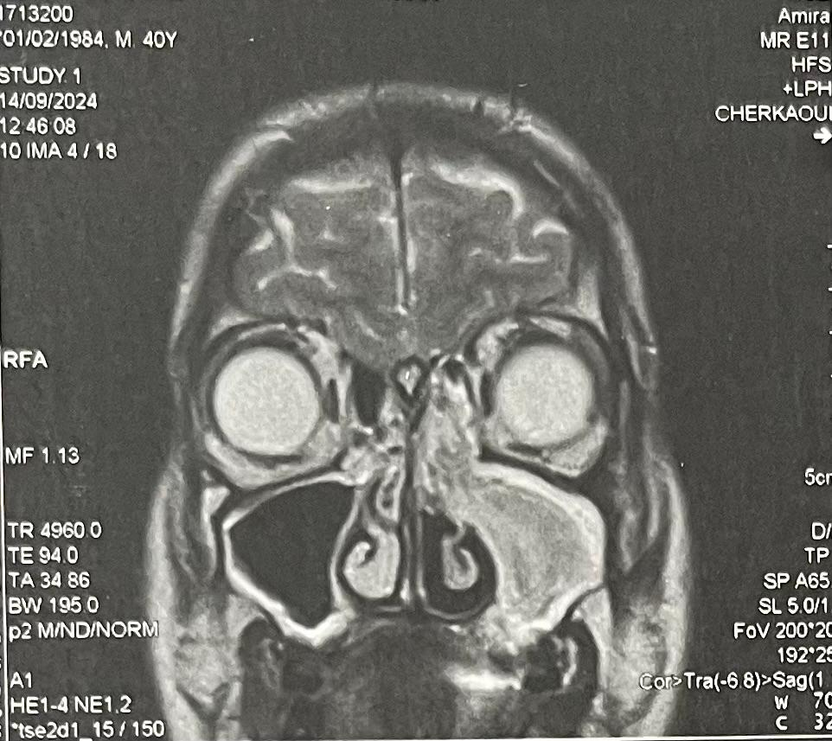

Fig .1 MRI image revealing left maxillary-ethmoidal-frontal sinusitis
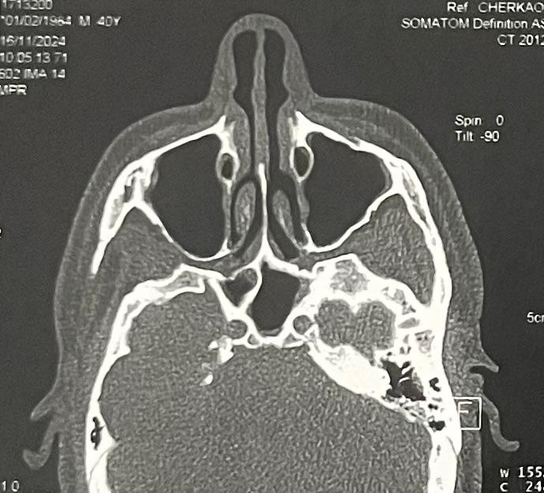

Fig.2 Medical imaging of case 1 showing normalized sinus aeration
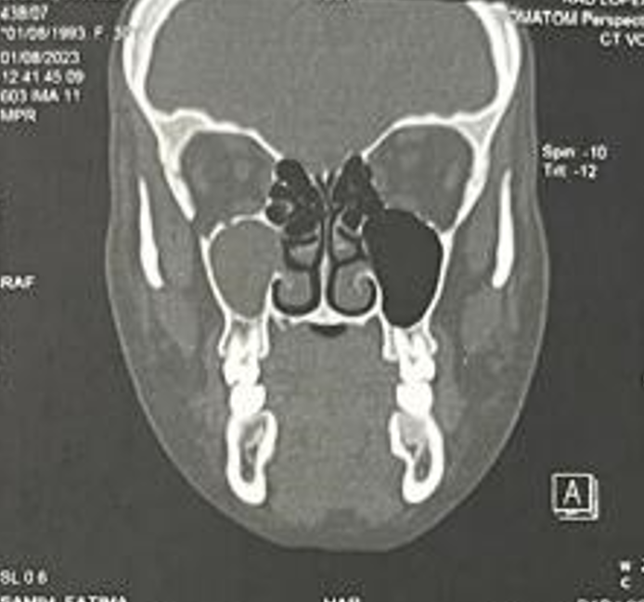

Fig.3 The CT image demonstrating total opacification of the right maxillary sinus
References
- Vaezeafshar R., Psaltis A.J., Rao V.K., Zarabanda D., Patel Z.M., Nayak J.V.: Barosinusitis: comprehensive review and proposed new classification system. Allergy Rhinol (Providence) 2017; 8: pp. 109-117.

- Chen T, Pathak S, Hong EM, Benson B, Johnson AP, Svider PF. Diagnosis and Management of Barosinusitis: A Systematic Review. Annals of Otology, Rhinology & Laryngology. 2022;132(1):50-62. doi:10.1177/00034894211072353

- Misirovs R, Mohamad S. Reverse squeeze maxillary sinus barotrauma. Ear Nose Throat J. 2020;99(1):NP9-NP10. doi: 10.1177/0145561319825556

- Singletary EM, Reilly JF. Acute frontal sinus barotrauma. Am J Emerg Med. 1990;8(4):329-331. doi:10.1016/0735- 6757(90)90088-h

- Fagan P, McKenzie B, Edmonds C. Sinus barotrauma in divers. Ann Otol Rhinol Laryngol. 1976;85(1 Pt 1):61-64. doi:10.1177/000348947608500110

- Sung J, Kwon O, Kim D, Kim K. Bilateral subdural empy emas with meningitis secondary to acute barosinusitis. Eur Ann Otorhinolaryngol Head Neck Dis. 2018;135(6):457-459. doi:10.1016/j.anorl.2018.03.006

- Buisson P, Darsonval V, Dubin J. Sinus infection and div ing (a case of cerebral empyema). Rev Laryngol Otol Rhinol (Bord). 1990;111(2):141-143.

- Mahabir RC, Szymczak A, Sutherland GR. Intracerebral pneumatocele presenting after air travel. J Neurosurg. 2004;101(2):340-342. doi:10.3171/jns.2004.101.2.0340

- Goldmann RW. Pneumocephalus as a consequence of barotrauma. JAMA. 1986;255(22):3154-3156.

- Murrison AW, Smith DJ, Francis TJ, Counter RT. Maxillary sinus barotrauma with fifth cranial nerve involvement. J Laryngol Otol. 1991;105(3):217-219. doi:10.1017/ s0022215100115415

- Jeong JH, Kim K, Cho SH, Kim KR. Sphenoid sinus baro trauma after scuba diving. Am J Otolaryngol. 2012;33(4): 477-480. doi:10.1016/j.amjoto.2011.10.017

- Weissman B., Green R.S., Roberts P.T.: Frontal sinus barotrauma. Laryngoscope 1972; 82: pp. 2160-2168.

- Boston AG, McMains KC, Chen PG, Weitzel EK. Algorithm for management of the refractive aerosinusitis patient. Mil Med. 2018;183(7-8):e246-e250. doi:10.1093/milmed/ usx222

- Edmonds C, LowryC, Pennefather J. Diving and subaquatic medicine. Oxford: Butterworth-Heinemann; 1998.

- Neblett LM. Otolaryngology and sport SCUBA diving update and guidelines. Ann Otol Rhinol Laryngol 1985;115(Suppl):1-12.

- Uzun C, Tas A, Yagiz R, et al. Otolaryngological problems in SCUBA divers, treatment and prevention methods. Kulak Burun Bogaz Ihtis Derg 2001;8:281-8 [in Turkish].

- Becker GD, Parrell GJ. Barotrauma of the ears and sinuses after scuba diving. Eur Arch Otorhinolaryngol 2001;258:159-63.

