***Case report***

**Neuro-Behçet's Syndrome Revealed by Horner Syndrome : Case Report**

**Abstract**

**Background :** Horner syndrome (HS), a rare neurological condition caused by disruption of the oculosympathetic pathway, can occasionally serve as an early indicator of systemic diseases such as neuro-Behçet syndrome (NBS). The latter represents a severe manifestation of Behçet syndrome (BS). It involves the central nervous system (CNS) and is associated with significant morbidity. Recognizing HS in NBS as a critical diagnostic and prognostic indicator remains important. **Case description :** This report describes an unusual case of NBS revealed by HS, emphasizing the diagnostic challenges and clinical implications. A 43-year-old male presented with progressive-onset left-sided ptosis, left-sided hemicranial headaches accompanied by homolateral carotidynia. The diagnosis of NBS revealed by HS was established after ruling out other potential differential diagnosis. Corticosteroids (CSs) and immunosuppressants (ISs) led to a significant clinical improvement. **Conclusion :** This case underscores the importance of considering atypical revelation’s mode of NBS and highlights the need for prompt diagnosis and intervention to prevent further neurological deterioration.

**Keywords :** Behçet syndrome, Neuro-Behçet syndrome, Horner syndrome, Case report.

**Introduction**

Behçet syndrome (BS) is a chronic multisystemic inflammatory disorder characterized by mucocutaneous lesions, ocular inflammation, and systemic vasculitis. While it commonly presents with oral aphthous ulcers and uveitis, its involvement in the central nervous system (CNS) can lead to diverse neurological symptoms. Neuro-Behçet syndrome (NBS) refers to neurological involvement occuring in approximately 5% to 59% of patients with BS [1]. These manifestations are divided into two main forms that are parenchymal lesions as meningoencephalitis and non-parenchymal lesions as cerebral venous thrombosis [2]. In rare instances, NBS might reveal itself through symptoms akin to Horner’s syndrome (HS). In NBS, brainstem or diencephalic lesions often resulting from inflammatory vasculitis, may impair sympathetic fibers and lead to HS. Such an atypical and rare mode of revelation is a marker of severe neurological involvement in BS necessitating prompt immunosuppressive therapy to mitigate inflammation and prevent further damage [3].

We present the case of 43-year-old male who presented with HS, ultimately leading to a diagnosis of BS. Treatment combining corticosteroids (CSs) and immunosuppressants (ISs) led to improvement in neurological symptoms.

**Case Description**

**1. Patient Presentation and Initial Symptoms**

The 43-year-old male agricultural worker from El Jadida presented with a progressive onset of left-sided hemicranial headaches over three months. These headaches were accompanied by left hemifacial pain, carotidynia, and left-sided ptosis. The symptoms occurred in the absence of fever but were associated with noticeable decline in his overall health status. Upon clinical examination, the patient exhibited signs of severe cerebral vascular involvement, including reactive myosis, left ptosis and pseudo-enophthalmos (Fig.1). Additionally, his lower limbs were large, symmetrical, warm, red and painful, though they did not exhibit pitting edema.



**Fig.1 :** The left HS (ptosis associated with pseudo-enophtalmos).

**2. Diagnostic Confirmation and Imaging Findings**

The diagnosis of BS was confirmed with a score of 6 points according to the ***International***

**List 1 : *Diagnostic Criteria for Behçet Syndrome* (ICBS)**

| **Symptom** |  | **Points** |
| --- | --- | --- |
| Oral Aphthosis |  | 2 points |
| Genital Aphthosis |  | 2 points |
| Pseudofolliculitis |  | 1 point |
| Vascular Lesions |  | 1 point |

Imaging studies were performed to further evaluate the extent of vascular involvement. A cervicoencephalic magnetic resonance angiography (MRA) revealed a sacciform aneurysm of the left internal carotid artery (Fig.2 and 3), with extensive thrombotic material extending from the carotid bulb to the cervical portion. Calcification of the intracavernous segment was also noted. Additionally, MRA showed extensive cerebral thrombophlebitis affecting the superior longitudinal sinus and lateral sinuses. Doppler ultrasound venous of the lower limbs detected deep vein thrombophlebitis in the iliofemoropopliteal region. Transthoracic echocardiography ruled out intracardiac thrombus, and thoracic angiography excluded pulmonary embolism.

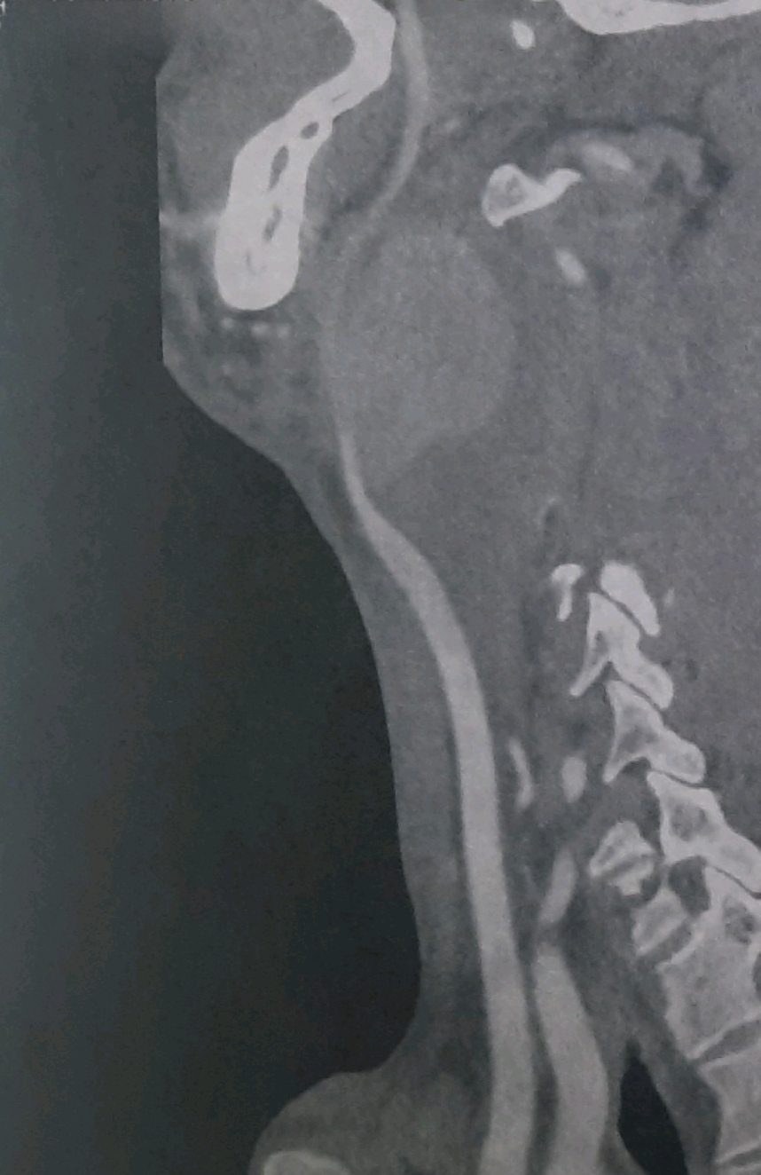

**Fig.2 :** Cervical MRI (sagittal view) with the red arrows showing left internal carotid aneurysm.

**Fig.3 :** MRA 3D of the Willis’s circle revealing the sacciform aneurysm of the left internal carotid artery

**3. Histopathology and Laboratory Findings**

A biopsy of the left aortic aneurysm was performed, which revealed fibrosis of the media and chronic inflammation with acute fibrinous exacerbation in the vascular wall. These findings were consistent with vasculitis and supported the diagnosis of BS. Laboratory tests confirmed a severe inflammatory syndrome, with C-reactive protein (CRP) level of 260 mg/L, hyperthrombocytosis (491,000/mm³), and hyperfibrinogenemia (6.3 g/L). Infectious workup, including retroviral serologies, tests for syphilis, hepatitis B and C, returned negative results, ruling out other potential causes.

**4. Treatment and Management**

The patient underwent surgical repair of the left carotid aneurysm using an inverted saphenous graft between the common carotid artery and external carotid artery. Postoperatively, he was started on venous compression therapy combined with anticoagulation using acenocoumarol (4 mg/day). Immunosuppressive therapy was initiated to manage the underlying vasculitis. This included methylprednisolone IV pulses (1g/day for 3 days), followed by a tapering course of oral CSs. The patient also received six cyclophosphamide IV boluses (1g every 3 weeks), transitioning to azathioprine maintenance therapy (150 mg/day).

**5. Outcome and Follow-Up**

The patient’s clinical and biological evolution improved significantly under the treatment regimen. Notably, the left HS has disappeared (Fig.4). The combination of surgical intervention, anticoagulation, and immunosuppressive therapy effectively addressed the severe vascular and neurological manifestations of BS.

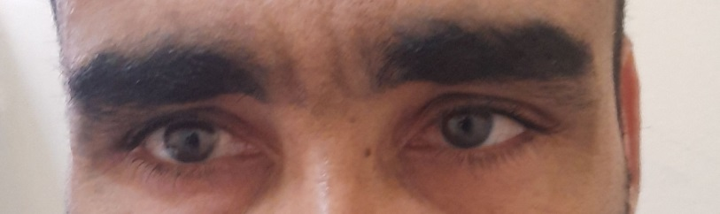

**Fig.4 :** Regression of the left HS in the patient after treatment.

**Discussion**

Johann Friedrich Horner, a Swiss ophthalmologist, is widely recognized for providing the first comprehensive description of HS in 1869 and accurately attributing it to oculosympathetic paresis [4]. This syndrome is resulting from disruption in the sympathetic pathways connecting the brain to the eye. The classic triad of symptoms includes ptosis, miosis, and pseudo-enophthalmos. Anhidrosis on the affected side may also occur but is not universally present [5]. The sympathetic pathway responsible for maintaining normal ocular function involves complex neural circuits originating from hypothalamic centers that descend through cervical spinal cord segments before synapsing in superior cervical ganglia. From there, postganglionic fibers travel along blood vessels to reach their target organs in the head. Disruption at any point along this pathway can lead to HS [6]. Causes are diverse and include central lesions affecting brainstem or spinal cord areas involved in sympathetic transmission, peripheral causes such as carotid artery dissection or tumors compressing nerves near superior cervical ganglia, and even iatrogenic causes like surgical damage during neck procedures [7]. BS, characterized by recurrent oral aphthous ulcers, genital ulcers, and uveitis, was first comprehensively described by Turkish dermatologist ***Hulusi Behçet*** in 1937. This landmark description marked the recognition of these symptoms as a distinct medical condition [8]. BS is known for its inflammatory-driven damage to blood vessels throughout the body. Neurological involvement can manifest either parenchymally with meningoencephalitis or non-parenchymally through cerebral venous thrombosis or arterial complications like aneurysms. In BS, inflammation primarily targets medium-sized arteries but can affect any size vessel leading to both arterial and venous complications. Neurological manifestations arise when these inflammatory processes disrupt normal vascular function within critical regions such as those supplying sympathetic nerves responsible for ocular control.

While direct evidence linking HS specifically as a revelation for BS might be limited compared to more common manifestations like oral ulcers or uveitis, understanding these complex interactions can enhance diagnostic acumen. The vasculitic nature of BS could theoretically disrupt sympathetic pathways leading to HS.

Recent case reports highlight the occurrence of HS in patients with BD, often associated with CNS involvement such as medullary ischemia, acute NBS’s attacks or bulbar lesions [3,9,10]. These cases illustrate the potential for vasculitic complications in BS to disrupt sympathetic pathways leading to HS, emphasizing the need for comprehensive diagnostic evaluation and tailored treatment strategies when such unusual manifestations occur.

The treatment of HS in the context of BS primarily focuses on managing the underlying inflammatory and vasculitic processes associated with this condition. Since HS often results from neurological involvement, addressing these manifestations is crucial.

For patients with NBS, which can include symptoms like those seen in HS due to CNS involvement, treatment typically involves CSs as a first-line approach. High-dose CSs such as methylprednisolone pulses are commonly used to reduce inflammation quickly [10]. Following initial pulse therapy, maintenance treatment often includes oral CSs like prednisone at doses adjusted based on clinical response. In cases where CS therapy alone is insufficient or for long-term management, ISs such as azathioprine or methotrexate may be added [11]. These drugs help control chronic inflammation and prevent further neurological damage. For high-risk patients or those with severe manifestations, intravenous cyclophosphamide may be considered alongside CSs. If these regimens fail to achieve desired outcomes, tumor necrosis factor-α (TNF-α) inhibitors like infliximab can be introduced as an additional therapeutic option [3,11].

**Conclusion**

Early recognition and treatment of NBS can significantly improve patient outcomes by reducing neurological complications and improving life’s quality. Therefore, clinicians should remain vigilant for signs like HS that may signal more severe systemic involvement in patients with suspected or confirmed BS. Future efforts should focus on early diagnosis using advanced tools and multidisciplinary teams for comprehensive care. Personalized treatment strategies as biological therapies are crucial and combination therapy trials should be explored. Further research is needed to better understand the mechanisms linking HS to NB and to refine therapeutic approaches for affected patients.

**Ethical Statement** :The authors are accountable for all aspects of the work in ensuring that questions related to the accuracy or integrity of any part of the work are appropriately investigated and resolved. All procedures performed in this study are in accordance with the ethical standards of the institutional and/or national research comittee(s). Written informed consent was obtained from the patient for publication of this case report and accompanying images.

**References**

[1] Borhani-Haghighi A, Samangooie S, Ashjazadeh N, Nikseresht A et al. Neurological manifestations of Behcet`s disease. Neurosciences (Riyadh). 2006;11(4):260-4.

[2] Al-Araji A, Kidd DP. Neuro-Behçet's disease: epidemiology, clinical characteristics, and management. Lancet Neurol. 2009 Feb;8(2):192-204.

[3] Matsui T, Ishida T, Tono T, Yoshida T, Sato S, Hirohata S. An attack of acute neuro-Behçet's disease during the course of chronic progressive neuro-Behçet's disease: report of two cases. Mod Rheumatol. 2010;20(6):621-6.

[4] Horner F. On a form of ptosis. Archives of Neurology. 1968;19(5):541-2.

[5] Walton KA, Buono LM. Horner syndrome. Curr Opin Ophthalmol. 2003;14:357–363.

[6] Khan Z, Bollu PC. Horner Syndrome. In: StatPearls. StatPearls Publishing, Treasure Island (FL); 2023. PMID: 29763176.

[7] Sabbagh MA, De Lott LB, Trobe JD. Causes of Horner Syndrome: A Study of 318 Patients. J Neuroophthalmol. 2020;40(3):362-369.

[8] Kocak Nuhoglu GE, Nuhoglu C, Osoydan M, Arslan B. Dr. Hulusi Behçet: A Pioneer in Dermatology and the Legacy of Behçet's Disease. Cureus. 2024;16(9):e69600.

[9] Kaido T, Otsuki T, Ogawa M, Takahashi A et al. Medullary ischemia due to vertebral arteritis associated with Behçet syndrome: a case report. Asian Pac J Allergy Immunol 2012;30:239-42.

[10] Certal M, Alves A, Santos MB et al. Neuro-Behçet Disease Presenting as a Bulbar Lesion: A Case Report. Cureus. 2014;16(8): e68236.

[11] Borhani Haghighi A. Treatment of neuro-Behçet's disease: an update. Expert Rev Neurother. 2009;9(4):565-74.