Original Research Article

Assessment of Groundwater Quality for Drinking and Irrigation in Motipur Block, Muzaffarpur District, Bihar

Abstract:
Groundwater is a vital resource for drinking and irrigation, yet its quality in rural regions like Motipur block, Muzaffarpur (Bihar), remains understudied. This study assessed groundwater suitability using 40 samples from hand pumps and tube wells, analyzed for pH, electrical conductivity (EC), bicarbonate (HCO₃⁻), chloride (Cl⁻), and total dissolved solids (TDS). Results indicated slightly alkaline water (pH 7.50–8.34, avg. 7.95), within WHO/BIS safe limits. However, EC exceeded 500 µS/cm (BIS threshold), and 23 samples surpassed WHO bicarbonate standards (350 mg/L). While TDS (300–1150 mg/L) mostly complied with BIS (500 mg/L), chloride levels (355–1136 mg/L) universally exceeded safe limits (250 mg/L). The findings highlight localized contamination risks, urging targeted interventions for sustainable water management in the region.
Key words: Groundwater quality, Drinking water, Irrigation suitability, Electrical Conductivity, Total Dissolved Solids, Chloride, Bicarbonate, Spatial mapping, Muzaffarpur

Introduction
Groundwater is a vital natural resource, essential for sustaining life, agriculture, and industrial development worldwide (Mariappan et al., 2005, Kumar et al., 2024). As the primary source of drinking water in both rural and urban communities, its quality directly impacts human health and ecosystem stability (Kumar et al., 2024a). However, increasing contamination from anthropogenic activities and inadequate water management practices have raised significant concerns about groundwater availability and safety (Kumar and Jha., 2021, Ajeet et al.,2021, Chattopadhyay et al., 2021 ). For instance, the U.S. Environmental Protection Agency (EPA) cautions against using water with total dissolved solids (TDS) exceeding 500 mg/L for drinking, underscoring the need for rigorous quality monitoring (Kumar et al., 2025). The chemical composition of groundwater is influenced by soluble ions such as calcium (Ca²⁺), magnesium (Mg²⁺), sodium (Na⁺), potassium (K⁺), chloride (Cl⁻), sulfate (SO₄²⁻), carbonate (CO₃²⁻), and bicarbonate (HCO₃⁻), along with trace elements like arsenic (As) and fluoride (F⁻) (Bangar et al., 2022). Elevated concentrations of electrical conductivity (EC), TDS, hardness (TH), and fluoride can render groundwater unsuitable for consumption, highlighting the importance of regular assessment (World Health Organization [WHO], 2011). In Bihar, India, salinization affects approximately 3.2 lakh hectares of land, particularly in districts like Muzaffarpur, where poor-quality irrigation water threatens soil health and crop productivity (Seleiman et al., 2022, Singh et al., 2025; Kumar et al., 2025). Inadequate drainage systems exacerbate soil salinization and alkalization, degrading physical soil conditions and reducing agricultural yields (Kamra, 2021, Zade et al., 2021). Furthermore, the indiscriminate use of groundwater contaminated by chemicals (Rekha et al., 2025) or sewage poses severe health risks and compromises its suitability for domestic, industrial, and agricultural purposes (Jha et al., 2000; Kumar ., 2016). To address these challenges, comprehensive datasets and standardized parameters-aligned with guidelines from the WHO, Bureau of Indian Standards (BIS), and Food and Agriculture Organization (FAO) are critical for evaluating water quality (Ashfaq & Ahmad, 2014; Deshmukh & Urkude, 2014). In Muzaffarpur’s Motipur block, where communities rely heavily on hand pumps and tube wells, awareness of water quality issues remains limited. This study aims to assess the suitability of groundwater for drinking and irrigation by analyzing physicochemical parameters, spatial variability, and compliance with international and national standards. By integrating GPS and GIS technologies, we provide a systematic evaluation to inform sustainable water management strategies in the region.
Materials and Methods:
Study Location: Motipur Block, Muzaffarpur District
The study was conducted in Bihar, a state located in eastern India with an area of 94,163 km², positioned between West Bengal (east) and Uttar Pradesh (west), and bordered by Nepal to the north and Jharkhand to the south. The geographic coordinates of Bihar range from 24°20’10” to 27°31’15” N latitude and 83°19’50” E longitude, with an average elevation of 52.73 meters above mean sea level (Bihar at a Glance, Directorate of Economics and Statistics, Bihar, Patna-2016). The specific study area, Motipur block in Muzaffarpur district, covers 3122.56 km² and lies between 25°54’ to 26°23’ N latitude and 84°53’ to 85°45’ E longitude.
Meteorological Data
Meteorological data, particularly rainfall records for 2023–24, were obtained from established weather stations in Motipur block, showing monthly rainfall ranging from 0 to 454.2 mm, with the distribution pattern depicted in Figure 1.
Water Sampling and Analysis
Water sampling was conducted in 2023, with samples collected randomly across the study area, and precise geo-coordinates were recorded using a GPS device. The study area and sampling locations are illustrated in Figures 1 & 2. For water quality assessment, 30 groundwater samples were collected from tube wells across Motipur and Kanti blocks at predetermined GPS-marked locations to evaluate spatial variability. Each sample consisted of 1 liter of water, stored in two high-density plastic bottles, and transported to the laboratory for analysis. The water quality parameters were analyzed following standard prescribed methods, as detailed in the accompanying table
The following methods used for the assessment of water quality attribute

TABLE 1. Methods used for the assessment of water quality attribute
SI. No. | Parameters | Method/Instrument | Reference
1. | pH | pH Meter | Richards, 1954
2. | EC (µS/cm) | Conductivity Meter | Richards, 1954
3. | Total Dissolved Solid (mg/L) | Conductivity Meter | Saxena, 1994/APHA,1994
4. | Chloride (mg/L) | Mohr’s Titration Method | Jackson, 1973
5. | Carbonate (mg/L) | Acidimetric Titration | Richards, 1954
6. | Bicarbonate (mg/L) | Acidimetric Titration | Richards, 1954

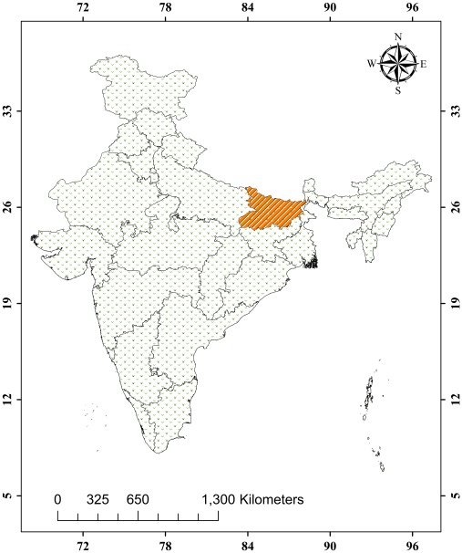
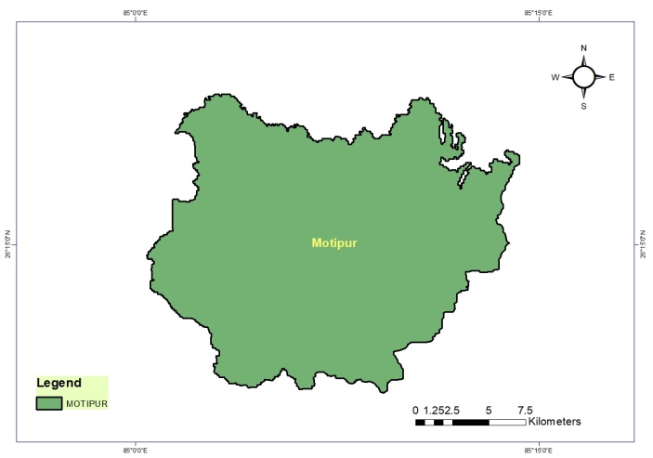
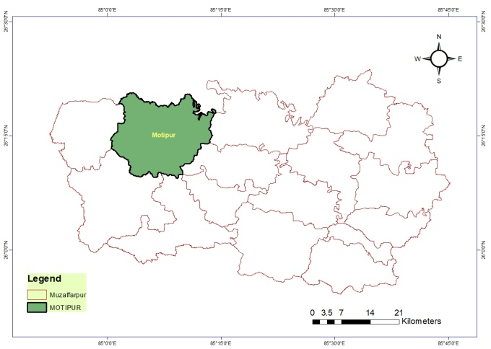

Map. 1 Map of the study area

Results and Discussion:
The received groundwater used for the analysis of various parameters for drinking and irrigation purposes was collected from different depths of the hand pump and tube wells, covering thirty locations across the study area of Motipur block of Muzaffarpur, district of Bihar.
The determined data of pH of the groundwater samples of the investigated sites is depicted in Table 1. The quality aspect in terms of pH associated with the Motipur block was noticed slightly alkaline in nature ranging from 7.50 to 8.34 with an average value of 7.95. The highest pH (8.34) was recorded in the analyzed sample of Baruraj village of Motipur located at 26.26125221 N latitude and 85.13605556 E longitude however, the lowest pH value (7.50) was obtained at Jathwalia village of Motipur block located at 26.22488889 N latitude and 85.03641667 E longitude respectively. The standard permissible limit of pH of drinking water ranges from 6.5 to 8.5 as a recommendation made by WHO & BIS (2011). In light of the standard, entire samples were found below the permissible level and found safe with regard to drinking and irrigation purposes as per WHO & FAO norms. The variability in pH is reflected by GPS and GIS-based maps of the study area which is denoted by various color notations that have been presented in map 1.

Fig. 1 pH value in groundwater samples of different villages at Motipur block

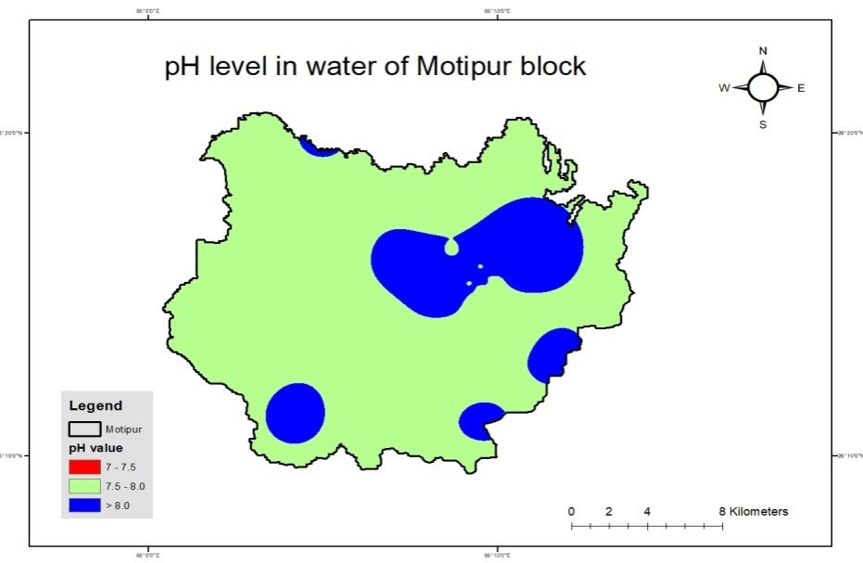
The pH value of groundwater samples observed higher due to the presence of bicarbonates in the form of HCO₃⁻ indicating alkaline nature of the samples (Adams et al., 2001). The results of the present investigation are also in collaboration to the findings of Ranjan et al., (2023), Zafar and Kumari (2024).
Table 1 presents the variable observations regarding salt concentration in
Map 2. Spatial distribution of pH in groundwater in the
study area (Motipur block

groundwater sample ranged from 547 to 1788 µS/cm with the mean value 750.4 µS/cm of Motipur block. The lowest electrical conductivity content was recorded (547 µS/cm) at Bariyarpur South village which located at 26.2727222 N latitude and 85.14463889E longitude and highest (1788 µS/cm) at Bansghat village located on 26.36288889 N latitude

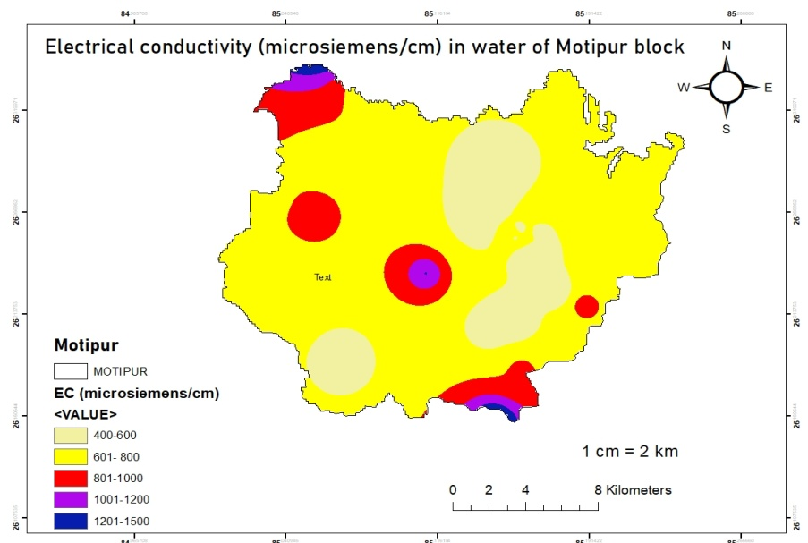
Fig. 2 Electrical conductivity (EC) in groundwater samples of different villages at Motipur block
and 85.0605833 E longitude of Motipur block. It reveals that total water samples found more than 500 µS/cm as per BIS, the EC across study area. As per BIS protocol for drinking water the EC value has a limit of 750 µS/cm which can be extended up to 3000 µS/cm in case of no alternate source. All the samples of Motipur and Kanti block were found within the BIS and WHO limit, hoever, as per the FAO irrigation water standard the EC
Map 3. Spatial distribution of EC in groundwater in the
study area (Motipur block

value less the 700 µS/cm in safe zone. The study showed only 50% water samples of motipur block found in this limit. The special distribution of EC map was generated using GPS and GIS techniques and it was showed with different colour variations in than map 3. EC is an important quality parameter which actually measures the capacity of water to conduct electricity that associated with the ions concentration present in the water if water contains more ions concentration in water indicating more EC (John & Das, 2020). Ranjan et al., (2013), Varol and Davraz (2015) and Pal et al., (2023) also showed the similar type of trend. The Total dissolved solids (TDS) content in groundwater used for drinking and irrigation of the Motipur block present in Table 1 ranged from 300 to 1150 mg/L, with the average value as 513 mg/L.
Fig. 3 Total dissolved solids (TDS) in groundwater samples of different villages at Motipur block

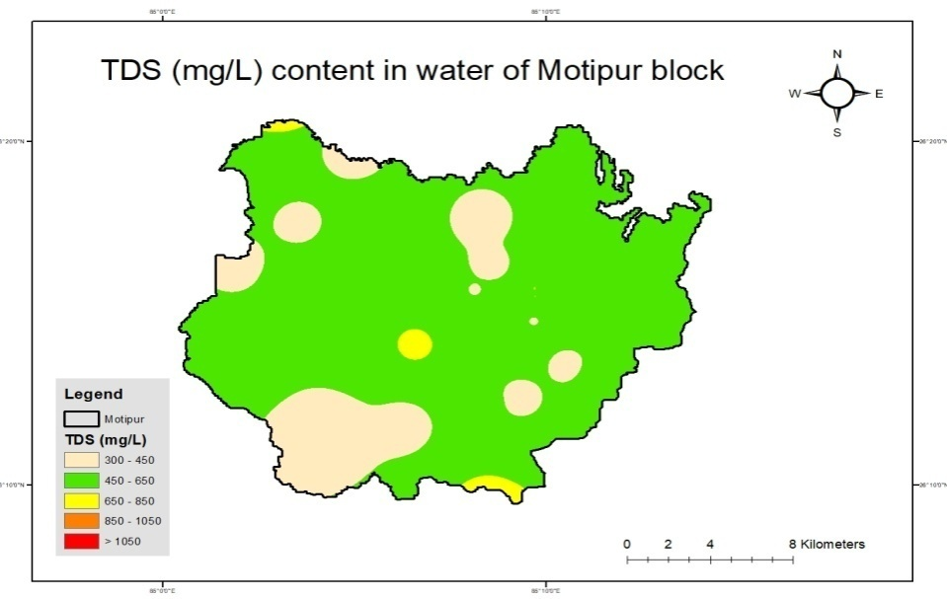
The lowest value obtained at Ranpur beriyahi which is 300 mg/L located on 26.19055556 N latitude and 85.07113889 E longitude. Whereas, highest value recorded at Bansghat (1150 mg/L) village located at 26.36288889 N latitude and 85.06058333 E longitude of Motipur block, Muzaffarpur, district. The BIS standard for TDS is 500 mg/L. Total 30 water samples of Motipur block out of 19 samples (63.33%) found below the BIS standard (500 mg/L) and rest 11 water samples (36.33%) above BIS standard value. According to WHO desirable limit of TDS is 1000 mg/L. Whereas, 29 water samples of Motipur block come under the WHO standard limit and one sample found above the limit. The variable distribution of

Map 4. Spatial distribution of EC in groundwater in the
study area (Motipur block

TDS showed in map, generated through GPS & GIS of different locations of study area has been depicted in the map 4. The amount of dissolved organic and inorganic elements in a given volume of water gives the TDS values and its high concentration in groundwater may be due to anthropogenic activities such as industrial discharge, application of chemical fertilizer, agricultural run-off, or natural activities as contributed by several minerals (Boyd 2000). Similar view of the groundwater TDS value was reported by Varol and Davraz (2015), Krishan et al., (2018), Kumar et al., (2022) and Pal et al., (2023).
Chloride content evaluated in the collected groundwater samples represented in the table 2. According to obtained result in the study area of Motipur block, chloride content varies from 355 to 1136 mg/L with a mean value of 657.93 mg/L.

Fig. 4 Chloride content in groundwater samples of different villages at Motipur block

The investigated result showed the lowest chloride content of Motipur block was recorded at Mahmada (355 mg/L) village situated at 26.33302778 N latitude and 85.08191667 E and the highest value 1136 mgL obtained at Barhmpur village which was located at 26.21827778 N latitude and 85.18897222 E longitude respectively. In the research, all 30 water samples of Motipur found above the WHO as well as BIS desirable limit (250 mg/L). The distribution of variability in chloride which is reflected by GPS and GIS based map for chloride which is denoted by different color of the study area has been presented in map 5.
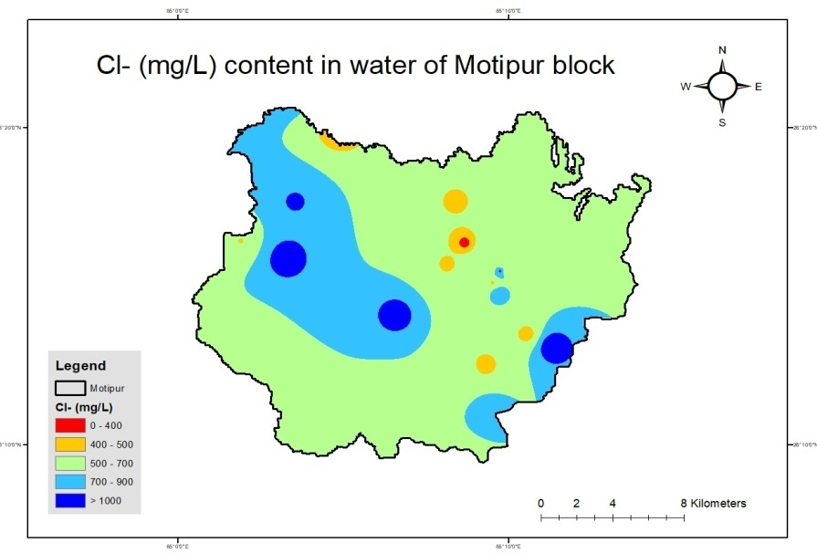
The origin of chloride may be attributed to the minerals as natural source and the use of inorganic fertilizers, landfill leachates septic tank effluents, animal feeds, industrial effluents, irrigation drainage as the anthropogenic sources (Kelly et al. 2012). Comparable finding were reported by Rawat and Singh (2018), Batarseh et al., (2021). The analysed samples showed results, there was no
.
Map 5. Spatial distribution of Chlorine in groundwater in the
study area (Motipur block)

carbonate content obtained in the study area. The result showed in respect to bicarbonate content in the groundwater used for the drinking and irrigation purpose which collected from different locations presented in table 2. The concentration ranging of Motipur block from 305.1 to 549.18 mg/L with an average value of 399.5 mg/L. Based on the result, the lowest (305.1 mg/L) bicarbonate concentration was recorded in Saraiya village which is located at 26.2554477 N latitude and 85.1535207 E longitude. However, the Mahmada village (549.18 mg/L) has highest bicarbonate concentration on geo-coordinates 26.33302778 N latitude and 85.08191667 E longitudes.
Fig. 5 Bicarbonate content in groundwater samples of different villages at Motipur block
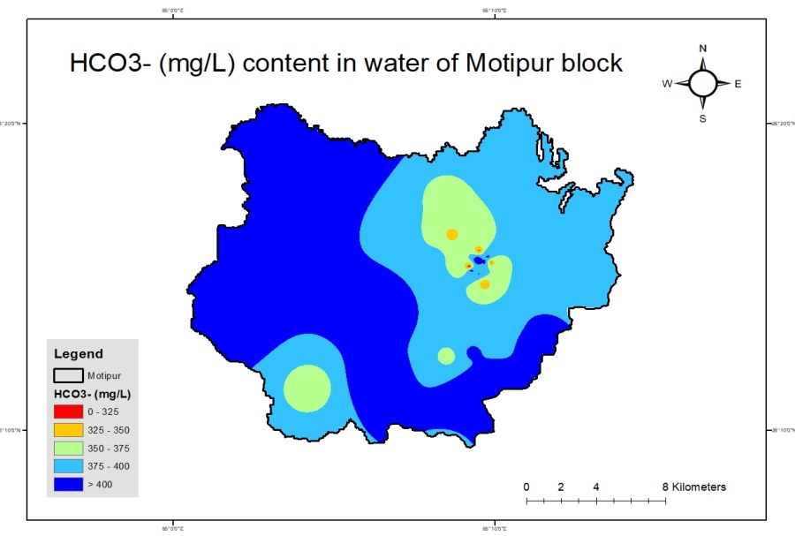
Few of the samples (seven) were found below the WHO (350 mg/L) range and rest 23 water samples got above the WHO limit. The elevated bicarbonate concentration in groundwater might be due to presence of carbonaceous minerals in the soil system. The origin of bicarbonate may be due to the decomposition of organic pollutants, results in production of carbon dioxide (CO₂), that react with soil and to release bicarbonate into groundwater (Kumar & Singh 2015). GPS and GIS based map were generated on distribution of bicarbonate of the study area which is indicated by various color notations has been presented in map 5 & 6.

Map 6. Spatial distribution of bicarbonate in groundwater in the
study area (Motipur block)

Similar finding is also made by Varol and Davraz (2015), Rawat and Singh (2018) and Mohammed et al., (2023).

Table 2. Data of ground water quality attributes (mg/L) in the study area (Motipur block)
SN.  No. | Locations | Geo-coordinates |  | pH | EC  (µS/cm) | TDS  (mg/L) | Cl⁻  (mg/L) | CO₃⁻²  (mg/L) | HCO₃⁻(mg/L)
SN.  No. | Locations | Latitude N | Longitude E
1. | Baruraj | 26.26125221 | 85.13605556 | 8.34 | 556 | 440 | 461.5 | 0 | 378.32
2. | Ratampura | 26.26122222 | 85.16294444 | 8.2 | 669 | 440 | 426 | 0 | 414.94
3. | Patti aswari | 26.18469444 | 85.15766667 | 8.1 | 828 | 490 | 816.5 | 0 | 463.75
4. | Brahmpur | 26.21827778 | 85.18897222 | 8.06 | 860 | 540 | 1136 | 0 | 427.14
5. | Bariyarpur | 26.29427778 | 85.14025331 | 7.85 | 598 | 360 | 461.5 | 0 | 366.12
6. | Bariyarpur North | 26.22486111 | 85.17597222 | 7.93 | 602 | 380 | 426 | 0 | 390.53
7. | Bariyarpur South | 26.27272222 | 85.14463889 | 7.98 | 547 | 310 | 355 | 0 | 341.71
8. | Jahangirpur | 26.20886111 | 85.15494444 | 7.97 | 604 | 380 | 426 | 0 | 402.73
9. | Mahmada | 26.33302778 | 85.08191667 | 8.04 | 714 | 340 | 355 | 0 | 549.18
10. | Ebrahimpur | 26.26455556 | 85.05466667 | 7.99 | 852 | 460 | 1029.5 | 0 | 414.94
11. | Mahmadpur Mahmada | 26.31533333 | 85.74630556 | 7.90 | 563 | 360 | 390.5 | 0 | 341.71
12. | Bansghat | 26.36288889 | 85.06058333 | 7.70 | 1788 | 1150 | 1065 | 0 | 512.57
13. | Parsouninth | 26.29438889 | 85.05927778 | 7.93 | 769 | 430 | 923 | 0 | 414.94
14. | Harnahi | 26.19522222 | 85.10561111 | 7.88 | 742 | 380 | 639 | 0 | 427.14
15. | Magurahan Tajpur | 26.27383333 | 85.03180556 | 7.86 | 782 | 420 | 497 | 0 | 451.55
16. | Jathwalia | 26.22488889 | 85.03641667 | 7.50 | 701 | 490 | 603.5 | 0 | 414.94
17. | Ranpur Beriyahi | 26.19055556 | 85.07113889 | 8.10 | 575 | 300 | 674.5 | 0 | 353.92
18. | Pagahia | 26.15641667 | 85.14386111 | 7.66 | 1293 | 920 | 639 | 0 | 390.53
19. | Thikaha | 26.20683333 | 85.14227778 | 7.68 | 566 | 490 | 603.5 | 0 | 366.12
20. | Jasauli | 26.23486111 | 85.11030556 | 7.90 | 1060 | 730 | 1065 | 0 | 463.75
21. | Singaila | 26.2516933 | 85.1586133 | 7.87 | 739 | 550 | 461.5 | 0 | 402.73
22. | Singaila Shankar Tola | 26.24645916 | 85.1613403 | 7.93 | 568 | 420 | 852 | 0 | 329.51
23. | Singaila | 26.2536931 | 85.1545163 | 8.05 | 653 | 525 | 639 | 0 | 414.94
24. | Saraiya | 26.2554477 | 85.1535207 | 7.98 | 784 | 568 | 532.5 | 0 | 305.10
25. | Baruraj Rd | 26.25904604 | 85.1579922 | 8.21 | 589 | 488 | 497 | 0 | 439.34
26. | Mahamadpur Balmi | 26.2642096 | 85.1586945 | 7.98 | 687 | 612 | 603.5 | 0 | 317.30
27. | Unnamad Rd | 26.261868 | 85.1619976 | 8.05 | 798 | 698 | 710 | 0 | 378.32
28. | Mahaveer Asthan | 26.2580892 | 85.16221453 | 8.12 | 784 | 684 | 852 | 0 | 451.55
29. | Ratanpura | 26.2580731 | 85.16271643 | 7.84 | 678 | 586 | 1065 | 0 | 341.71
30. | Niranjan Rd | 26.2578274 | 85.16469053 | 7.92 | 562 | 458 | 532.5 | 0 | 317.30
Mean value |  |  |  | 7.95 | 750.37 | 513.30 | 657.93 | 0 | 399.48

References:
Adams, S., Titus, R., Pietersen, K., Tredoux, G. and Harris, C. (2001). Hydrochemical characteristics of aquifers near Sutherland in the Western Karoo, South Africa. Journal of Hydrology, 241: 91–103
Ajeet Kumar, C.K. Jha, and K. Sunita (2021) बिहार की मक्का आधारित फसल प्रणाली में नाइट्रेट लीचिंग और भूजल संदूषण का खतरा (Nitrate leaching and ground water contamination in maize based cropping system of Bihar), “Krishisewa Magazine” 01 October 2021. Pg. 1-6. The url of the article is https://www.krishisewa.com/miscellaneous/1362-nitrate-leaching-and-ground-water-contamination-in-maize-based-cropping-system-of-bihar.html.
Ashfaq, A. and Ahmad, F. (2014). Quality of assessment ground water at Agra district, India. International journal of Current Research & Academic Review, 2(8): 304-308
Bangar, K. S., Narendra Kumawat, Tiwari, S. C., Kaledhonkar, M. J., Parmar, B. B. and Tagore, G. S. (2022). Groundwater Quality Assessment, Characterization and Mapping for Madhya Pradesh, India for Irrigation Purpose. Journal of Soil Salinity and Water Quality, 14(1): 33-52.
Batarseh, M., Imreizeeq, E., Tilev, S., Al Alaween, M., Suleiman, W., Al Remeithi, A.M., Al Tamimi, M.K. and Al Alawneh, M. (2021). Assessment of groundwater quality for irrigation in the arid regions using irrigation water quality index (IWQI) and GIS-Zoning maps: Case study from Abu Dhabi Emirate, UAE. Groundwater for Sustainable Development, 14: 100611.
Bureau of Indian Standard (BIS, 2012). Specification for drinking water IS 1000: New Delhi, India.
Chattopadhyay, S., Kumar, Ajeet., Singh, S. K. (2021) Nitrate Leaching and threat of Ground Water Contamination in Sugarcane Based Cropping System of Bihar. Agriculture & Food: E-Newsletter; 3 (11): 369-372. https://agrifoodmagazine.co.in/2021/volume-3-issue-11-november-2021/ ; ⟨hal-04935232⟩.
Deshmukh, C. K. and Urkude, R. N. (2014). Physico-chemical and microbial status of malkhed lake at chandur railway, district: Amravati. The Bioscan. 2: 677-682.
FAO-UN (1985). Water quality index for agriculture, Food and Agriculture Organization of the United Nation. Rome, Italy, 29.
Jha A. N and Verma, P. K. (2000). Physico–chemical property of drinking water in town area of Godda district under Santal Pargana, Bihar. Pollution Research. 19(2): 245–247.
Kamra, S. K. (2021). Subsurface drainage for saline and waterlogged alluvial soils. Managing salt affected soils for sustainable agricultue, 346-366.
Krishan, A., Mishra, R. K. and Mohan, D. (2018). Groundwater quality assessment: A case study of Manpur, India. Journal of Environmental Nanotechnology, 7(4): 25-33.
Kumar Ajeet and Jha C. K. (2021) Nitrate leaching and threat of ground water contamination in maize based cropping system of Bihar, Agriculture & Food: E-Newsletter. 3 (5): 144-147. ⟨hal-04936434⟩.
Kumar Ajeet, Bairwa Mohit, Meena Sunita Kumari, Singh Sanjay Kumar, Sinha S.K., Rana Lalita, Singh Yad Vir, Kumar Amrendra, Singh Harendra and Paswan Sudhir (2025) Nutrient Index Value as a Tool for Evaluating Soil Fertility in Diverse Agroecosystems of Indo-Gangetic plains of India. AATCC Review (Agriculture Association of Textile Chemical and Critical Reviews). Manuscript Number: AATCC_Review-YR-1581. (In Press).
Kumar Yadav, S., Kafle, K., Poudel, A., Gelal, R. and Adhikari, B. (2022). Use of Gis for Spatial Mapping of Soil Fertility in Dhanusha, Nepal. International Journal of Applied Biology, 6 (2): 1-13.
Kumar, A., Singh, S.K., Meena, S.K., Sinha, S.K., Rana, L., Singh, A.K., Kumar, A., Singh, H., & Paswan, S. (2025). A Comprehensive Review on Impact of Intensive Use of Nitrogenous Fertilizer on Nitrate Contamination in Groundwater under Sugarcane Based Cropping System in Indo-Gangetic Plains of India. International Journal of Environment and Climate Change, 15(2), 286–300. DOI: https://doi.org/10.9734/ijecc/2025/v15i24727.
Kumar, Ajeet (2016) Soil Health and Soil Quality: - The Fundamental Keys to a Sustainable and Productive Agriculture; Pg. 48-54; Souvenir of International Symposium on Management of Rice based agricultural system under stress prone environment; organized by Rajendra Agricultural University, Pusa, Samastipur, Bihar during 17-19 March, 2016. https://hal.science/hal-04972899.
Kumar, Ajeet. ., Singh, S. K. ., Meena, S. K. ., Sinha, S. ., Rana, L. ., Kumari, A. ., Singh, A.K ., & Kumar, A. . (2024). Human Health Risk Assessment of Nitrate-Contaminated Groundwater in North East Alluvial Plains of India. In Book: Geography, Earth Science and Environment: Print ISBN: 978-93-48388-08-7, Geography, Earth Science and Environment: Research Highlights Vol. 2, 1–26. https://doi.org/10.9734/bpi/geserh/v2/1424.
Kumar, Ajeet., Singh, S.K., Meena, S.K., Sinha, S.K. and Rana L (2024a) Groundwater contamination with nitrate and human health risk assessment of North East alluvial plains of Bihar. International Journal of Environment and Climate Change, 14(3), 17–31. https://doi.org/10.9734/ijecc/2024/v14i34016; https://hal.science/hal-04484961.
Mariappan, V., Prabakaran, P., Rajan, M. R. and Ravichandran, A. D. (2005). Systematic study of water quality index among the physico-chemical characterstics of groundwater in and around Thanjavur Town. Indian Journal of Environmental Protection, 25 (6): 551-555.
Mohammed, M. A., Kaya, F., Mohamed, A., Alarifi, S. S., Abdelrady, A., Keshavarzi, A., Szabó, N. P. and Szűcs, P. (2023). Application of GIS-based machine learning algorithms for prediction of irrigational groundwater quality indices. Frontiers in Earth science, 11: 1274142.
Pal, S., Singh, S. K., Singh, P., Pal, S. and Kashiwar, S. R. (2023). Spatial pattern of groundwater arsenic contamination in Patna, Saran, and Vaishali districts of Gangetic plains of Bihar, India. Environmental Science and Pollution Research, 1-15.
Ranjan, R. K., Ramanathan, A. L., Parthasarathy, P. and Kumar, A. (2013). Hydrochemical characteristics of groundwater in the plains of Phalgu River in Gaya, Bihar, India. Arabian Journal of Geosciences, 6: 3257-3267
Rawat, K. S. and Singh, S. K. (2018). Water Quality Indices and GIS-based evaluation of a decadal groundwater quality. Geology, Ecology, and Landscapes, 2(4): 240-255.
Rekha, R., Kumar, A., & Kumar, A. (2025). Integrated Assessment of Pesticide Efficacy Against Aceria litchii (Keifer) in Litchi Orchards of Bihar, India. Journal of Advances in Biology & Biotechnology, 28(4), 388–398. 10.9734/jabb/2025/v28i42200
Seleiman, M. F., Aslam, M. T., Alhammad B. A., Assan, M. U., Maqbool, A. and Chattha, M. U. (2022). Salinity stress in wheat: effects, machanisms and management strategies. Phyton-International Journal of Experimental Botany, 91(4): 0031-945.
Singh, Y.V., Goswami, S., Singh, S.K., Kumar, A., Bhartiya, P.K. and Singh. K. (2025). Impact of Nutrient Management Technologies on Soil Physico-Chemical Properties, Yield and Economics of Mustard under Irrigated Condition of Chandauli District, Uttar Pradesh, India. International Journal of Plant & Soil Science 37 (2):78-83. https://doi.org/10.9734/ijpss/2025/v37i25306.
Varol, S. and Davraz, A. (2015). Evaluation of the groundwater quality with WQI (Water Quality Index) and multivariate analysis: a case study of the Tefenni plain (Burdur/Turkey). Environmental earth sciences, 73: 1725-1744.
World Health Organization (2011). Guidelines for drinking-water quality. World health organization, 216: 303-304.
World Health Organization (2012). Rapid assessment of drinking-water quality: a handbook for implementation. World Health Organization.
Zade,S P., Gourkhede, P H., Vaidya, P.H., Singh, R. S.,.Sinha, S. K., Kumar, Ajeet., Kumar, Vipin., Brajendra (2021) PROBLEM SOILS AND THEIR MANAGEMENT PRACTICES. Pg 1-147. ISBN:978-81-925878-3-5, Edition-First –January 2021, Revised Second Edition-December,2021; Published by: Mr.Gajendra Parmar, Proprietor, Parmar Publication 854, KG Ashram, Bhuinphod, Govindpur Road, Dhanbad-828109, Jharkhand.
Zafar, M. M., Sulaiman, M. A., Prabhakar, R. and Kumari, A. (2024). Evaluation of the suitability of groundwater for irrigational purposes using irrigation water quality indices and geographical information systems (GIS) at Patna (Bihar), India. International Journal of Energy and Water Resources, 8(2): 241-254.

