Underutilized Vegetables of Kashmir Valley (India): Food for Future

Abstract
The Kashmir Valley, known for its rich biodiversity and temperate climate, hosts a variety of underutilized vegetables that can enhance food security and nutritional diversity. This study focuses on underexploited species in the Kupwara district, such as Guchhi (Morchella esculenta), Kong posh (wild leeks), and Rukh (wild greens), which are rich in nutrients but remain largely neglected in mainstream agriculture. These plants are well-suited to the region's marginal, stress-prone environments, offering resilience to climate change. The research explores the ecological benefits, cultivation practices, challenges, and economic opportunities associated with these crops. It proposes strategies for their conservation and integration into local farming systems, including domestication, standardized agronomic practices, and value chain development for better market access. The paper highlights the potential of these underutilized species in promoting sustainable agriculture and improving food security. It ties these efforts to several Sustainable Development Goals (SDGs), such as Zero Hunger, Good Health, Climate Action, and Responsible Consumption. Recommendations include raising awareness, providing policy support, and investing in research to unlock the full economic and ecological potential of these crops, ensuring their sustainable integration into local agricultural systems.
Keywords: underutilized vegetable species, food security and nutritional diversity, biodiversity, SDGs, Kashmir valley, Himalayan region.

Introduction

Vegetables are an essential component of the daily human diet, providing a wealth of
protective nutrients that enhance energy levels and vitality. The rich diversity of vegetables
available to us today is the result of extensive efforts in plant selection and domestication aimed
at improving the economic traits of various eatable plant species. Despite significant
advancements in crop cultivation techniques, much of nature remains unexplored, with many plant species still in the wild, holding tremendous potential. If properly utilized and cultivated, these species could greatly benefit future generations while addressing the nutritional needs of the current population. This understanding is vital for integrating wild bioresources into sustainable development initiatives and ensuring food and nutritional security. However, the importance and uses of these plants are often under recognized, with knowledge frequently limited to specific ethnic or tribal communities that live closely with the nature. Kumar and Hamal (2009) highlighted efforts to revitalize interest in these crops can strengthen local identities and traditions. As per Thakur et al. (2017), farmers often practice mixed cropping, which not only improves biodiversity but also enhances soil fertility (Gaur et al., 2024b). However, there is a need for modern agronomic techniques to optimize yields and encourage wider adoption among farmers.
The Kashmir Valley, located in the Western Himalayan region, is renowned for its unique climate, varied topography, and rich agricultural landscape. The Himalayas are not only a majestic mountain range but also a vital ecological region, home to four of the world’s 36 recognized biodiversity hotspots. This underscores the immense global significance of the region in terms of its rich and diverse ecosystems. The exceptional variety of plant and animal species found in these mountains highlights the urgent need for comprehensive conservation efforts to protect this invaluable natural heritage, which is under increasing threat from climate change, habitat loss, and human activities. Further, many nutritious vegetables that are traditionally cultivated in this region remain underutilized, leading to a decline in both biodiversity and nutritional diversity (Gaur et al., 2024a). The valley is home to a remarkable array of plant species, particularly in the Kupwara district, which boasts a temperate climate and lush forests (Lamo et al., 2012). The majority of the district's population relies on traditional agricultural practices for their livelihoods (Anonymous, 2011). Many ethnic and tribal communities in remote areas, where access to essential commodities is limited, maintain a deep connection with their natural surroundings and depend heavily on local resources. This close relationship with nature underscores the need to explore and enhance the use of under-appreciated plant species, ensuring that their benefits are recognized and utilized.
Phytogeography of Kupwara district
The Kashmir Valley, known for its diverse agricultural landscape, harbors a variety of underutilized vegetables that hold significant potential as future food sources. These crops, often neglected in mainstream agriculture, play a crucial role in the region's food security, nutrition, and cultural heritage (Zargar et al., 2021). The valley cultivates 75 crop species across 58 genera and 18 families, including cereals, pseudo-cereals, cash crops, vegetables, oilseeds, and fodder crops (Kumar and Sharma, 2021; Zargar et al., 2021). While staple crops like rice, maize, and wheat dominate Kashmir's agriculture, there is growing recognition of the importance of underutilized vegetables in diversifying the food basket and enhancing nutritional security (Akbar et al., 2011; Zargar et al., 2021; Dar and Dar, 2024). These crops are often well-adapted to marginal and stress conditions, making them resilient to climate change and environmental challenges (Singha et al., 2021; Thakur, 2014).
Kupwara district, located in the Jammu and Kashmir region of India, represents a rich phytogeographical diversity, including medicinal herbs, wild edible plants, and non-native species. Among the notable medicinal plants found in the area are Artemisia absinthium, Euphorbia wallichii, Rheum australe, and Sinopodophyllum hexandrum. Locally, approximately 70 species of wild edible plants are consumed, though their diversity is declining due to overexploitation. The district is also home to 67 alien species, with 25 classified as invasive, 35 naturalized, and 7 as casual introductions. The most prevalent families of these alien species include Asteraceae, Brassicaceae, Poaceae, Fabaceae, Chenopodiaceae and Ranunculaceae (Abdullah and Andrabi, 2021).
Kupwara's name, derived from "Kuferwari" meaning "land of skeptics," was coined by the esteemed saint Syed Mohammed Gabi. The district features a predominantly hilly and mountainous terrain, particularly in the northern, western, and eastern regions, with altitudes ranging from 2,000 to 3,500 meters above mean sea level. The region is also prone to landslides and soil erosion due to a network of subsidiary fault lines and lineaments. Kupwara lies between latitudes 34°19′49.2″ and 34°39′22.7″ North, and longitudes 73°45′20″ and 74°35′10.00″ East, with an average elevation of 1,615 meters.
Situated on the northwest side of the Kashmir Valley, Kupwara shares its borders with the Line of Control (LOC) separating India and Pakistan, and is bordered by Sopore, Badipora, and Baramulla to the southeast and southwest. The region experiences an average annual rainfall of 843 mm and an average temperature of 14.1°C, creating a temperate climate conducive to diverse flora. According to the 2011 census, Kupwara had a population of 870,354, accounting for 6.94% of the total population of Jammu & Kashmir. The district is home to ethnic Kashmiris as well as communities such as Pahari, Gujjar, and Bakerwal (Census Handbook of Kupwara district).
Kupwara's drainage system includes streams like Khamil, Pohru, Talri, Mawar, Hardahkhaer, and Varno-Lolab, which significantly shape the landscape and influence local biodiversity (Gaur et al., 2024b). Conservation efforts are crucial to protect the region's plant diversity and prevent the loss of indigenous species in this ecologically significant area (Kumar and Sharma, 2021; Gaur et al., 2024a).

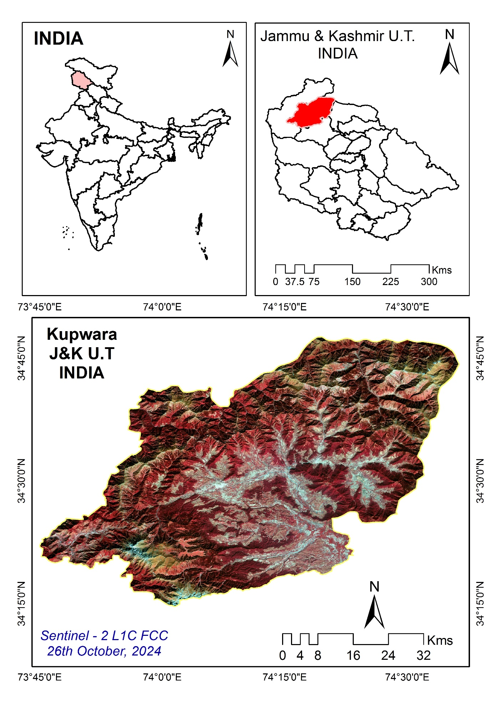
Figure 1. Location map of study area, Kupwara District

Figure 2. Rainfall trend of Kupwara district, India
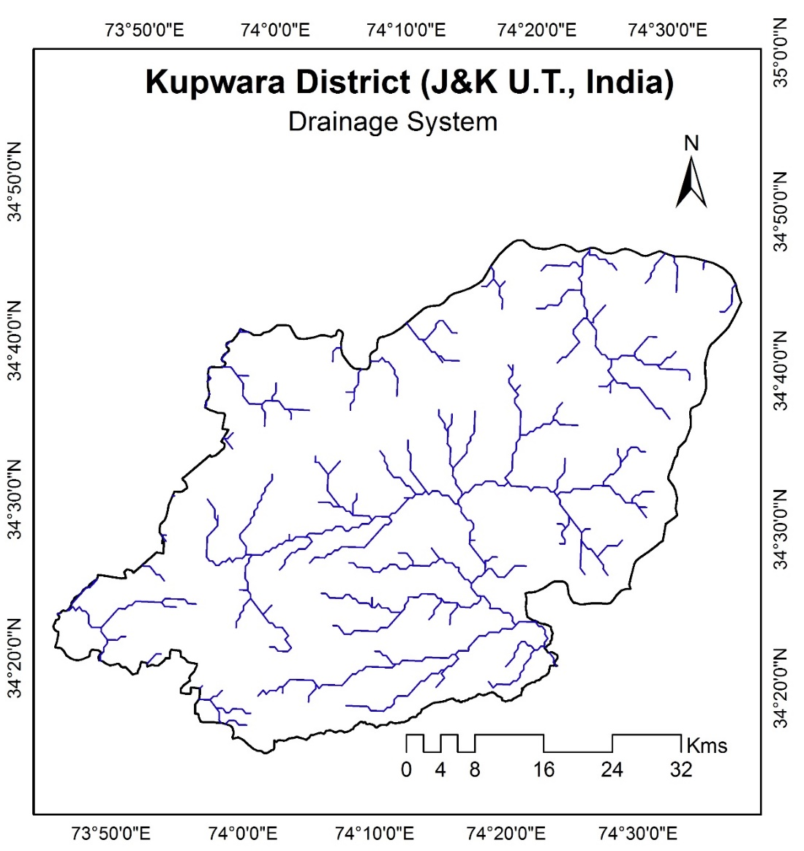
Figure 3. Drainage system of Kupwara District

Major Flora of Kupwara District
Kupwara district is home to a rich tapestry of forest types, including temperate, alpine, and subtropical forests. These forests provide a sanctuary for an array of flora, including conifers, deciduous trees, and numerous medicinal plants. The district's wooded areas are dominated by towering trees like Deodar, Kail, and Pine, along with walnuts and a host of other species. Notable coniferous plants found here include Deodar (Cedrus deodara) and Kail (Pinus wallichiana), which are characteristic of the temperate and alpine zones. Kupwara's diverse plant life is complemented by an abundance of wildflowers and shrubs, making it a significant area for both ecological preservation and botanical study.
The total forest area of Kupwara district spans 1,534.52 square kilometers, with varying densities of vegetation. Of this, approximately 760.06 square kilometers are classified as very dense forests, characterized by a rich and dense canopy. Around 423.61 square kilometers fall under moderately dense forest, where tree cover is relatively sparser but still substantial. The remaining 350.85 square kilometers are designated as open forests, where tree cover is more scattered and less dense. This diverse range of forest types contributes to the district's ecological richness, supporting a wide variety of plant and animal species across different habitats.
Objectives of the Study
- To identify the underutilized vegetables in the Kashmir Valley.
- To analyze their nutritional composition and benefits.
- To explore their potential roles in local food systems and economy.
- To propose strategies for the conservation and promotion of these vegetables.
Methodology
Data Collection
Field surveys and focused group discussions (FGDs) were conducted in various villages of Kupwara district to document the local knowledge and agricultural practices surrounding underutilized vegetables. This research is based on field surveys, interviews with local farmers, and the compilation of existing literature. Structured interviews with farmers, local markets, and consultation with agricultural experts provided qualitative data. Analysis related to selected underutilized vegetables were performed to assess their contribution to dietary needs (Lamo et al., 2012).
Data Analysis
Qualitative data were analysed thematically, to identify patterns in cultivation practices, market dynamics, and nutritional benefits. Quantitative data on nutrient composition were compared to commonly cultivated vegetables to demonstrate the potential benefits of underutilized species.

Results and discussion
Despite the abundance of underutilized vegetables such as Guchhi (wild mushrooms), Kong posh (wild leeks), and Rukh (wild green herbs), these species remain largely overlooked in mainstream agricultural practices. Recognizing and promoting these crops is essential for addressing food security challenges in the region (Eyzaguirre and Rubio, 2009). The present study aims to emphasize the significance and advocate for their cultivation as a sustainable food source for the future. The following highlights the importance of these underutilized vegetables (Kumar and Sharma, 2021):
- Guchhi (Morchella esculenta): Known as morels, this highly sought-after wild mushroom is celebrated for its unique flavor, culinary value, and medicinal properties. Guchhi is considered a seasonal delicacy, primarily harvested in the spring season. Their popularity in local cuisine underscores their importance, yet they remain under-appreciated in broader agricultural contexts.
- Kong posh (Allium spp.): Commonly referred to as wild leeks, Kong Posh thrives in the mountainous terrains of the region. Rich in vitamins, antioxidants, and minerals, these leeks are an essential part of traditional dishes. Despite their nutritional benefits, they are often over-shadowed by more commercially cultivated crops.
- Rukh (various species): This term encompasses several wild greens, including Himalayan spinach and wild mustard. Rukh is known for its high antioxidant content and micronutrient richness, making it a valuable dietary addition. Unfortunately, these greens are also frequently overlooked in favor of more popular vegetables.
The nutritional profiles of these underutilized vegetables are remarkable, often richer in essential vitamins and minerals compared to commonly cultivated varieties (Akbar et al., 2011). For example, Guchhi is particularly high in protein, fiber, and B vitamins, making it a valuable dietary addition. Kong posh is rich in vitamins A and C, as well as essential minerals like calcium and iron. Rukh greens are excellent sources of antioxidants and micronutrients, which are crucial for combating malnutrition. These vegetables not only play a significant role in local cuisine but also contribute to cultural practices (Kumar and Sharma, 2021), being integral to the identity of local communities.
Indigenous communities possess invaluable traditional knowledge (ITK) about plant species (Kumar and Sharma, 2021; Gaur et al., 2024b). In Kupwara, ethnic groups are expert foragers, utilizing various herbs for dietary and domestic purposes. This traditional practice of selecting and utilizing lesser-known plants is key to their domestication and cultivation, ultimately benefiting the wider population.

TABLE 1. Some underexploited plants and their edible parts
Sr No. | Common name | Botanical name | Family | Plant part used for dietary purpose
1 | Lessa | Amaranthuas caudatus L. | Amaranthaceae | Whole tender plant
2 | Sustcal | Malva sylvestris L. | Malvaceae | Leaves
3 | Gula | Plantago major L. | Plantaginaceae | Whole plant
4 | Abuj | Peimex acetora L. | Polygonaceae | Leaves
5 | Handh | Taraxacum officinalis Webber | Astraceae | Leaves
6 | Handiposh | Cichorium itiybus L. | Asteraceae | Whole plant
7 | Baber | Origanum vulgare L. | Laminaceae | Leaves/ seed

Numerous underexploited plant species still thrive in various biodiversity hotspots and hold significant potential for addressing the nutritional needs of growing population (Singh and Sinha, 2020, Gaur et al., 2024b). There is a pressing need to investigate these species and enhance their quality and production to foster overall prosperity.
These underutilized vegetables are crucial for food security and nutritional diversity in local communities (Rao and Rao, 2016). By promoting their cultivation, food security can be substantially improved, as these crops typically require fewer resources and are resilient to climate variability, making them a sustainable option for farmers (Reang et al., 2023). Additionally, these vegetables are deeply embedded in local cuisine and cultural practices, playing an integral role in traditional dishes and festivals. They serve as a vital link between cultural heritage and sustainable food systems. Furthermore, local markets remain largely untapped for these crops. Establishing value chains for these vegetables could generate additional income for farmers and invigorate local economies (Kumar and Sharma, 2021). Studies indicate that increased market access could lead to improved livelihoods for farmers and contribute to regional economic development (Singh et al., 2016).
Cultivating underutilized species also contributes to the preservation of the region’s agricultural biodiversity, which is essential for maintaining ecological balance and ensuring the sustainability of agricultural practices (Gaur et al., 2024a). By embracing these crops, we can enhance both nutritional security and the resilience of food systems.
Cultivation Practices
The cultivation of underutilized vegetables in the Kashmir Valley requires an
understanding of local agronomic practices and environmental conditions. Many of these crops
are well-suited to the region's temperate climate and rich soils, but traditional methods vary among
communities, with knowledge passed down through generations.
1. Sustainable Practices: Organic farming, minimal use of chemical fertilizers, and crop rotation can enhance soil health and yield. Agro-ecological practices also help conserve
local biodiversity (Gaur et al., 2024a).
2. Domestication Efforts: Domestication of underutilized species is key for future
development. This involves selecting plants for improved yield, disease resistance, and
flavor. Research into their genetic diversity can support domestication efforts.
3. Standardization of Agronomic Practices: Standardizing cultivation practices is essential to optimize production, including determining the best planting times, irrigation methods, and pest management strategies. Collaboration with local farmers can lead to improved yields and quality.
Economic Potential
The economic potential of underutilized vegetables in the Kashmir Valley is significant.
Local markets remain largely untapped, presenting an opportunity for farmers to diversify their
income sources. By developing value chains for these vegetables, farmers can benefit from
increased market access and higher prices.
1. Value Addition: Processing methods such as drying, pickling, or creating packaged
products can increase market appeal and profitability, benefiting farmers and creating local
jobs.
2. Promotion of Local Markets: Encouraging the sale of these vegetables in local markets
can stimulate economic growth. Farmers' markets and community-supported agriculture
initiatives can promote these crops and raise consumer awareness (Kaloo and Choure,
2015).
3. Government Support: Supportive policies, including subsidies, technical assistance, and training programs, are crucial for fostering the cultivation and commercialization of these crops.
Challenges
Despite their potential, several challenges hinder the widespread cultivation and
consumption of underutilized vegetables in the Kashmir Valley:
1. Lack of Awareness: Many farmers and consumers are unaware of the nutritional benefits
and culinary uses of these vegetables. Educational initiatives are needed to promote their
value.
2. Limited Research: More research is needed into the agronomy, nutritional profiles, and
market potential of these crops. Funding for research initiatives can help generate the
necessary data to inform cultivation practices.
3. Market Accessibility: Access to markets can be challenging due to infrastructure
limitations. Improving transportation and storage facilities is essential for ensuring these
crops reach consumers in good condition.
4. Cultural Factors: Overcoming ingrained dietary preferences may require time and
sustained educational efforts to encourage acceptance of these underutilized vegetables.
Thrust Areas
Focused efforts are needed in the following areas to capitalize on the potential of
underutilized vegetables in the Kashmir Valley:
• Identification of Underexploited Plant Species: Identifying plant species with culinary
value that are currently limited to specific ethnic groups or regions (Rao and Rao, 2016).
• Domestication for Future Selection: Domestication efforts should focus on improving
these species to meet the needs of a broader audience.
• Nutritional and Quality Evaluation: Evaluating the nutritional content and quality of
these plants will help determine their potential benefits for human consumption.
• Breeding for Specific Traits: Breeding programs should focus on developing varieties
with desirable traits, such as improved yield, disease resistance, and better flavor.
• Standardization of Agronomic Practices: Standardized cultivation methods will ensure
optimized yield and sustainability.
• Value Addition Opportunities: Exploring processing options such as drying, pickling,
and packaging can increase market appeal and profitability.
• Post-harvest Practices: Standardizing post-harvest practices will help reduce losses and
maintain crop quality throughout the supply chain.
• Promotion among Farming Communities: Engaging farming communities through
education and outreach will facilitate the adoption of these crops.
Role of Sustainable Development Goals (SDGs)
The promotion of these vegetables can play a significant role in achieving several Sustainable Development Goals (SDGs). From enhancing food security and public health to promoting sustainable agriculture and biodiversity conservation, these vegetables offer a promising pathway for addressing multiple interconnected global challenges. By aligning agricultural practices with the SDGs, particularly those related to poverty reduction, zero hunger, health, climate action, and sustainable consumption.
1. SDG 1: No Poverty
The cultivation of underutilized vegetables will improve the livelihoods of small-scale farmers in the Kashmir Valley. By promoting these vegetables, farmers can diversify their crops, increase income, and reduce vulnerability to market fluctuations. Such diversification offers economic resilience to poverty-stricken communities, particularly those dependent on traditional, less profitable crops. These vegetables may also require less external input (e.g., fertilizers, pesticides), thus reducing production costs and improving economic sustainability for farmers.
2. SDG 2: Zero Hunger
Many of these vegetables are highly nutritious, rich in essential micronutrients (such as vitamins, minerals, and antioxidants), and are adapted to local climatic conditions. Their promotion can directly contribute to improving the availability and diversity of nutritious food sources in the region, helping address hunger, especially in remote areas where access to conventional crops may be limited. By cultivating these vegetables, the Kashmir Valley could enhance its food system’s resilience, providing sustainable and diverse dietary options to local communities.
3. SDG 3: Good Health and Well-Being
There are immense health benefits of consuming underutilized vegetables, which are rich in vitamins, minerals, and antioxidants. These can help combat malnutrition-related diseases, improve immune function, and contribute to overall well-being. These vegetables offer an opportunity to promote a healthier, more balanced diet among local populations, especially in rural and underserved areas, where conventional vegetable varieties may not be as readily available or affordable. By advocating for the consumption of these nutrient-dense plants, will indirectly contributes to the overall public health goals of SDG 3.
4. SDG 12: Responsible Consumption and Production
Many of these plants require fewer resources such as water, pesticides, and synthetic fertilizers compared to high-input crops like wheat, rice, or commercial vegetables. Cultivating these crops in a sustainable way will reduce the environmental footprint of agriculture and promote responsible consumption patterns. Additionally, promoting these vegetables would help conserve local biodiversity by encouraging the cultivation of a wider range of species rather than focusing solely on a few high-yielding varieties.
5. SDG 13: Climate Action
Underutilized vegetables are often more resilient to climate change impacts than mainstream crops. The paper highlights how these crops are well-suited to the local climate conditions of the Kashmir Valley, where harsh winters, water scarcity, and other climatic challenges may limit the success of conventional crops. By promoting the cultivation of climate-resilient crops, will contribute to climate adaptation strategies in agriculture, helping communities better cope with changing weather patterns. These vegetables will also contribute to reducing the carbon footprint associated with the agricultural sector, as they may require fewer inputs and be more suited to local growing conditions.
6. SDG 15: Life on Land
These vegetables are traditional, indigenous species that are part of the region's agricultural heritage. By promoting these crops, the research supports the conservation of local plant biodiversity and the protection of traditional farming systems. This contributes to SDG 15, which emphasizes the importance of protecting and restoring ecosystems, enhancing biodiversity, and promoting sustainable land management. By diversifying the crops grown in the region, local farmers can help preserve the genetic diversity of plant species that are integral to their culture and food security.
7. SDG 17: Partnerships for the Goals
There is an importance of collaboration between researchers, government agencies, NGOs, local farmers, and community organizations to effectively promote the use of underutilized vegetables. These partnerships can help build awareness, share knowledge, and provide the necessary support for farmers to adopt sustainable agricultural practices. The success of such initiatives depends on collective action and the fostering of synergies among different stakeholders, aligning with SDG 17's goal of strengthening the means of implementation and revitalizing global partnerships for sustainable development.
Recommendations
The following recommendations are suggested to support the widespread cultivation and
use of underutilized vegetables:
• Awareness Campaigns: Initiatives should educate both farmers and consumers about the nutritional benefits, culinary versatility, and potential for enhancing local food security (Reang et al., 2023).
• Community Engagement: Collaborations with local organizations, NGOs, and research
institutions can empower communities and facilitate knowledge exchange.
• Policy Support: Advocate for government policies that provide subsidies, technical
assistance, and resources to support the cultivation and commercialization of these crops.
• Integration into Culinary Traditions: Working with chefs and culinary experts to create
recipes that highlight these vegetables will promote their use and appreciation.
• Sustainability Focus: Emphasizing the environmental benefits of cultivating
underutilized vegetables can attract environmentally conscious consumers.
• Research and Development: Invest in research on agronomy, cultivation methods, and
market potential, focusing on sustainable practices and innovative marketing strategies
(Kaloo and Choure, 2015).
Summary and Conclusion
The underutilized vegetables of the Kashmir Valley offer significant potential for enhancing food security, nutritional diversity, and sustainable agricultural practices. These neglected plant species have been integral to the tribal and rural communities of the region for generations (Mal, 2022; Palanisamy et al., 2019; Reang et al., 2023). By recognizing their value and integrating them into local diets and agricultural systems, these communities can strengthen their resilience against economic and environmental challenges.
Strategies must be developed to capitalize on the availability and preservation of these
underutilized vegetables, that enhance economic benefits while improving local livelihoods (Dar
and Dar, 2024; Mal, 2022). The future of food security in the region is closely linked to the rich
biodiversity that has historically been overlooked, yet holds immense potential (Singh and Sinha,
2020; Gaur et al., 2024b). Efforts to evolve these plant species to improve their economic traits
can lay the groundwork for effective programs that support their cultivation and use.
Investing in research, education, and supportive policies is key to unlocking the benefits of
these underutilized crops, ensuring they become a vital part of the Kashmir Valley's agricultural landscape. With collective efforts, these vegetables can be revitalized, contributing to healthier communities, a more sustainable food system, and the preservation of the unique cultural heritage associated with them. The research paper presents a holistic approach to fostering a more sustainable and resilient food system in the Kashmir Valley and beyond to fulfil SGDs.

Ethical Statement

Hereby, All Authors consciously assure that for the manuscript (Underutilized Vegetables of Kashmir Valley (India): Food for Future) the following is fulfilled:

1) This material is the authors' own original work, which has not been previously published elsewhere.

2) The paper is not currently being considered for publication elsewhere.

3) The paper reflects the authors' own research and analysis in a truthful and complete manner.

4) The paper properly credits the meaningful contributions of co-authors and co-researchers.

5) The results are appropriately placed in the context of prior and existing research.

6) All sources used are properly disclosed (correct citation).

7) All authors have been personally and actively involved in substantial work leading to the paper, and will take public responsibility for its content.

The Authors, with the above statements and declare that this submission follows the policies of the Journal as outlined in the Guide for Authors and in the Ethical Statement.

Conflicts of interest
The authors declare that they have no conflicts of interest.

Availability of data
The complete dataset produced or examined during the study has been incorporated into the referenced articles and is duly acknowledged in the reference section.

COMPETING INTERESTS DISCLAIMER:
Authors have declared that they have no known competing financial interests OR non-financial interests OR personal relationships that could have appeared to influence the work reported in this paper.

References
Abdullah, Aadil and Andrabi, S.A.H. (2021). Wild edible plants and fungi used by locals in the Kupwara district of Jammu and Kashmir, India. Pleione, 15(2): 179-189. doi:10.26679/Pleione.15.2.2021.179-189.
Akbar, Ishfaq, Jahangeer, P., Baba, A., Malik, A. R. and Lamo, Kunzang. (2011). Traditional and Underutilized Vegetables of Western Himalayan Region of India. International Journal of Current Agricultural Science, 1(1); 15-18.
Anonymous (2011). District census Handbook Kupwara, Part B. Census of India 2011(Report).
Dar, H., and Dar, M. A. (2024). Role of Gastronomic Tourism in Destination Image Recovery of Kashmir Valley (pp. 220–230). https://doi.org/10.4018/979-8-3693-3158-3.ch011
Eyzaguirre, P. B. and Rubio, J. (2009). The Role of Underutilized Species in Food Security and Sustainability. Journal of Food Security, 1(1), 37-48.
Gaur, Mahesh Kumar, Goyal RK, Kanwar MS, Singh N, Choudhary V, and Chichaghare A. 2024a. Prospects and Challenges for Biodiversity in the AnthropogenicInduced Cold Arid Landscape of Ladakh, India. Japan Journal of Research:5(6):041Pp. 1-15. DOI: 10.33425/2690-8077.1123.
Gaur, Mahesh Kumar, Goyal RK, Kanwar MS, Choudhary V, Singh N, Chichaghare A. and Raghuvanshi, M.S. 2024b. Traditional Ecological Knowledge and Natural Resource Management in the Cold Desert of Leh-Ladakh, India. Ecofeminism and Climate Change, 5(2): 81-88. https://efcc.com.my/archives/2efcc2024/2efcc2024-81-88.pdf and http://doi.org/10.26480/efcc.02.2024.81.88.
Kaloo, M.J. and Choure, T. (2015). Present status and future prospectus of agriculture in Jammu and Kashmir. IOSR-JHSS, 20, 62–67.
Kumar, S., and Hamal, I.A. (2009). Wild edibles of Kishtwar high altitude national park in northwest Himalaya, Jammu and Kashmir (India). Ethnobot Leaflet. 2009:23.
Kumar, S., and Sharma, A. (2021). Biodiversity and Conservation of Indigenous Vegetables in Jammu and Kashmir. Biodiversity and Conservation, 30(2), 327-342.
Lamo, Kunzang, Akbar, P Ishfaq, and Mir, M Saleem. (2012). Underexplored and Underutilized Traditional Vegetables of Cold Arid Ladakh Region of India. Vegetos:25(1): 271-273.
Mal, B. (2022). Conservation and Use of Underutilized Crops: Challenges and Way Forward. Indian Journal of Plant Genetic Resources, 35(3), 162–168. https://doi.org/10.5958/0976-1926.2022.00061.4
Palanisamy, A., Kannan, D., Ravindran, C., Kavitha, M., & Rajangam, J. (2019). Potential vegetable crops – need for exploration and conservation for nutritional security for rural livelihoods. Acta Horticulturae, 1241, 69–74. https://doi.org/10.17660/actahortic.2019.1241.11
Rao, S. R., and Rao, R. V. (2016). Traditional Vegetables of Kashmir Valley: Nutritional Value and Culinary Uses. Journal of Ethnic Foods, 3(4), 350-355.
Reang, M., Sarma, D., & Datta, B. K. (2023). Proximate composition and antioxidant potentiality of underutilized and neglected edible plants for sustainable development in food security. Research Square Platform. https://doi.org/10.21203/rs.3.rs-2885491/v1
Singh, A., and Sinha, A. (2020). Potential of Underutilized Vegetables in Nutritional Security. International Journal of Vegetable Science, 26(1), 15-28.
Singh, B., Sultan, P., Hassan, Q.P., Gairola, S., and Bedi, Y.S. (2016). Ethnobotany, traditional knowledge, and diversity of wild edible plants and fungi: a case study in the Bandipora district of Kashmir Himalaya. India J Herb Spi Med Plants. 22:247.
Singha, W. R., Kurmi, B., Sahoo, U. K., Sileshi, G. W., Nath, A. J., & Das, A. K. (2021). Parkia roxburghii, an underutilized tree bean for food, nutritional and regional climate security. Trees, Forests and People, 4, 100065. https://doi.org/10.1016/j.tfp.2021.100065
Thakur, D., Sharma, A., and Uniyal, S.K. (2017) Why they eat, what they eat: patterns of wild edible plants consumption in a tribal area of Western Himalaya. J Ethnobiol Ethnomed. 13:1.
Thakur, M. (2014). Underutilized food crops: treasure for the future India. Food Science Research Journal, 5(2), 174–183. https://doi.org/10.15740/has/fsrj/5.2/174-183
Zargar, S. A., Islam, T., and Magray, J. A. (2021, March 3). Agricultural Crop Diversity of Kashmir Valley. Biology and Life Sciences Forum 2(1):30 https://doi.org/10.3390/bdee2021-09396

