Original Research Article

Assessment of Climatic Variables for the Mahi River Basin in Western India

ABSTRACT

One of the major problems that humanity is currently facing is climate change, whose effects can be seen everywhere in the world. Climate change is a result of both natural and manmade factors. These alterations have been more pronounced since the start of the industrial revolution, which resulted in significant emissions of greenhouse gases into the atmosphere, obstructing the outflow of longwave radiation and causing an increase in global warming. An attempt has been made to investigate the variability in rainfall, mean temperature, potential evapotranspiration and aridity index in the context of climate change based on the historical as well as the future dynamically downscaled climate datasets of precipitation and temperature for Mahi basin in western India which presently falls in a semi-arid climate located in the water scarce region of the country. The analysis has been performed for three distinct time periods i.e. baseline period (1961-90); present period (1991-2005); and future time periods, 2006-40. The analysis suggests that the rainfall is projected to decrease, the mean temperature is projected to increase. It is clear that the climate change impacts are already visible in the baseline and present time periods and the increases in the future, decrease in rainfall may lead to drier conditions in the basin. Optimal use of the available water resources along with the conservation of the scarce water resources may be a strategy that may go a long way in addressing the projected future water shortages in the basin.

*Keywords: Rainfall, temperature, climate change, Mahi River basin*

1. **INTRODUCTION**

The changes in the atmospheric greenhouses gases and aerosols, changes in solar radiation and changes in land surface properties modify the stability of energy in climate system. The main challenges to sustainability facing mankind in the 21st century are climate change and related environmental changes [1,2,]. The global warming caused by emissions of GHGs is the major factor responsible for climate change. GHGs which absorbs the reflected solar energy (long-wave radiation) causes the earth’s atmosphere to get warmer. [3,4]. Some of the important GHGs include methane (CH4), carbon di-oxide (CO2), nitrous oxide (NO2) ozone (O3) etc. According to the fourth assessment report of the Intergovernmental Panel on Climate Change (IPCC), a 0.74 oC rise in the global mean surface temperature was reported in the last hundred years, with a rate of increase of 0.13 0C per decade [5,6]. and the global mean surface temperature is projected to increase approximately from 1.1 to 6.4 oC during the twenty-first century [7]. This increased global warming can impact the hydrological cycle, affecting water resources, public health, and industrial, and municipal water demands. [8]. According to Intergovernmental Panel on Change (IPCC) reports, climate change is occurring with varying consequences all over the world [9]. Due to the relationship between the hydrological cycle and climate system, change of climate parameters will affect hydrological variables such as precipitation and temperature, which directly affects water resources in a region and may lead to intensification of extreme events like droughts and floods [9,10]. Monitoring of these changes, and accordingly planning for the judicious management of water resources and appropriate adaptation measures will ensure food and livelihood security under future climate change scenario [11].

**1.1 Aridity**

Aridity is a term that evokes images of dry, desert lands with meagre natural surface-water bodies and rainfall with scant vegetation. In simple terms the deficiency of water is known as aridity. Aridity is defined by the shortage of moisture which is essentially a climatic phenomenon based on average climatic conditions over a region [12,13]. A climate can be considered as ‘moist’ or ‘dry’ depending on both (a) the amount of precipitation and (b) whether the precipitation is greater or less than the water requirement to offset the evaporation and plant transpiration, collectively termed evapotranspiration, [14,15]. The potential evapotranspiration (PET) is the potential amount of water transfer to the atmosphere that would be possible under ideal conditions of soil moisture and vegetation [15,16]. more precisely defined PET as ‘the amount of water transpired in a given time by a short green crop, completely shading the ground, of uniform height and with adequate water status in the soil profile’. In other words, aridity is a function of both precipitation and the potential evapotranspiration (PET). An additional factor effecting aridity is temperature and the annual timing of precipitation. [17]. The occurrence of rainfall during cold seasons, in areas with high temperature, may be beneficial for plant growth as less water is lost to direct evapotranspiration during cold season than in hot season [18,19].

Aridity is the deficit of rain for an extended period that causes a considerable hydrologic imbalance and consequently leads to water shortages, crop damages, stream flow reduction and depletion of soil moisture and groundwater. [20]. Aridity is generally taken as a period of an abnormally dry spell of weather, prolonged sufficiently due to lack of rain. A critical issue for arid regions is the difference between PET and the actual rate of evapotranspiration (AET). [21].The AET depends on the amount of available moisture. The AET rates are very low in warm arid land areas because of the paucity of water available for transfer to atmosphere. On the contrary, the AET rates of surface water bodies in arid lands are very high, approaching PET values. These very high AET rates results in a substantial loss of water from surface water bodies in arid areas. The problem due to aridity varies from area to area, depending on the quantum of precipitation and its variability and also on the water demands of the specified users. The changes in the aridity can be caused due to natural and/or anthropogenic factors. [22,23].It would be rather quite interesting to study the changes in the aridity of an arid or semi-arid region in the context of climate change, which is expected to change the rainfall pattern as well as the temperature pattern in such areas.

1. **STUDY AREA**

The Mahi basin extends over states of Madhya Pradesh, Rajasthan and Gujarat with a catchment area of 34842 sq. km [24,25]. with a maximum length of about 330 km and width of about 250 km. It lies between 72o21´ to 75o19´ East longitudes and 21o46´ ‘to 24 o30´ North latitudes. The basin is bounded in the north and the north-west by Aravalli hills, in the east by the Chambal basin, in the south by the Vindhyas and in the west by the Gulf of Khambhat. [26,27].

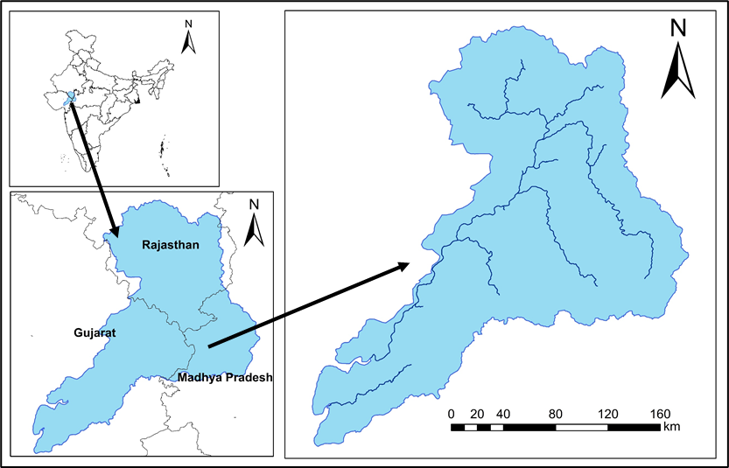

**Figure 3.1: Index map of Mahi basin**

**2.1 Climatic characteristics**

The Mahi basin experiences three marked seasons, summer (Mar-May), monsoon (Jun-Sep) and winter (Oct-Feb). The basin comprises of two climatic regions, the northern part of the basin comprises sub-tropical wet climate and the major part of basin comprises tropical wet climate caused mainly due to relatively high elevation in forest land, the area of basin near the origin of the river experiences relatively cooler and moderate rainfall climate which gradually changes to warm and dry climate as the river flows northwards entering into and flowing through Rajasthan. After the river bends south westwards and enters Gujarat the climate gradually changes towards tropical wet climate. [28,29,30].

**2.2 Rainfall**

The average rainfall in the Mahi basin is 785 mm. The south-west monsoon sets in by the middle of June and withdraws by the first week of October. [31,32,33]. About 90 % of total rainfall is received during the monsoon months of which 50% is received during July and August. The rainfall is mainly influenced by the south-west monsoon.

* 1. **Temperature**

May is generally the hottest month with mean maximum temperature of 39.8 °C and January is the coldest month with mean minimum temperature of 11.1 °C. The average annual minimum temperature (1969-2004) is 19.36 °C whereas the average annual maximum temperature for the same period is 32.82 °C. The average annual mean temperature for the period is 26.09 °C.

**2.4 Data Collection**

For the studying assessment of climatic variables for the mahi river basin at least 30 years or more data was required. The daily rainfall and temperature data for this study from 1951 to 2022 was obtained from the website of the Indian Meteorological Department (IMD) [33,34] and future data obtained with the CORDEX software. [35]

**3. MATERIALS AND METHODS**

* 1. **Rainfall**

The daily rainfall has been used for the computation of the monthly rainfall and the annual rainfall by summing it over the respective time periods. [36,37]. The formula used for the computation of the monthly rainfall is given in Equation 1, whereas the formula used for the computation of annual rainfall is given in Equation 2.

$P_{mon}=\sum_{i=1}^{i=n days}{P_{daily}}$…………… (1)

Pmon =Monthly rainfall (mm)

Pdaily =Daily rainfall (mm)

i = No. of day

n days = No. of days in a month i.e. 31 days for: January, March, July, August and 30 days for: April, June, September, Number and 28 or 29 days for February for non-leap and leap year respectively

$P_{annual}=\sum_{i=1}^{i=12}{P_{mon}}$……………… (2)

**3.2 Temperature**

The mean temperature is the average of the Tmax and Tmin which is calculated by the following formula:

$T_{mean}=\frac{T_{max+T_{min}}}{2}$……….… (3)

$T_{max}=\frac{Sum of all T_{max} values during the month}{Number of days of the month}$………… (4)

$T_{min}=\frac{Sum of all Tmin values during the month }{Number of days of the month}$………… (5)

**3.3 Potential Evapotranspiration**

Potential evapotranspiration (PET) is the potential water requirement for vegetation growth under no scarcity of water. The principal factors influencing evapotranspiration are temperature, wind velocity, humidity, and sunshine. In India, evapotranspiration varies with season. The rates of evapotranspiration reach peak during the summer months of April and May. The following methods have been used for the computation of PET.

**3.3.1** **Thornthwaite** **Equation**

Thornthwaite assumed that an exponential relationship existed between mean monthly temperature and mean monthly PET. The relationship was based largely on experience in the central and eastern United States. No allowance was made for different crops or varying land uses. The formula was originally developed for the purpose of rational classification of the climatic pattern of the world. Suitable coefficient therefore has been developed locally for reliable estimation of crop evapotranspiration values. Firstly, the monthly Thornthwaite Heat Index (i) is calculates using Equation 6,

$i={\left(\frac{t}{5}\right)}^{1.514}$…………… (6)

where, tis the mean monthly temperature.

The Annual Heat Index (I) is then calculated as the sum of the monthly heat indices using Equation 7,

$I=\sum_{i=1}^{12}{i}$…………… (7)

The PET is estimated for each month, considering a month of 30 days with 12 theoretical sunshine hours per day. The PET has been estimated using Equation 8,

${PET}_{non-corrected}=16{\left(\frac{10.t}{I}\right)}^{α}$…………… (8)

where α is given by Equation 9,

α=675*10-9*I3-771*10-7*I2+1792*10-5I+0.49239 …………… (9)

These estimate PET values are later corrected according to the actual number of days in a particular month and the theoretical sunshine hours for the latitude of interest (or actual sunshine hours, if available), using Equation 10,

$PET={PET}_{non-corrected}\left(\frac{N}{12}.\frac{d}{30}\right)$…………… (10)

where, Nis the theoretical sunshine hours for each month and *d* number of days for each month.

**3.4 Aridity indices**

**3.4.1 UNEP Aridity Index (AI)**

The United Nation Environmental Program [38].aridity index (AI) is based on the ratio of annual precipitation (P) and annual potential evapotranspiration (PET) calculated using Equation 11

$AI=\frac{P}{PET}$…………… (11)

where PET is calculated using the [15]. formula. [38].) proposed classification of climate zones based on AI index, in which arid regions are defined by aridity index values of less than 0.20. The UNEP classification is given in Table 1.

**Table 1: UNEP climate classification**

|  |  |
| --- | --- |
| Aridity Index (AI) | Climate Type |
| 0.050 ≤ AI < 0.20 | Arid |
| 0.20 ≤ AI < 0.50 | Semi-Arid |
| 0.50 ≤ AI < 0.65 | Dry Sub- Humid |

1. **RESULTS AND DISCUSSION**

**4.1 Rainfall Variation in Mahi Basin**

**4.1.1 Rainfall distribution during baseline period (1961-90)**

The average annual rainfall has been computed based on the five grids falling in and around the basin. The average annual rainfall during the baseline period varies between 478.2 mm during 1964 to 1602.0 mm during 1973. The mean rainfall during the baseline period is 866.9 mm. The temporal variation of the annual rainfall is given in Figure 1. It can be observed that the variability of the annual rainfall is very high. The coefficient of variability is 0.30 and this might be one of the reasons for the water stress being faced in the basin.

Figure 1: Temporal variation of annual rainfall in Mahi basin during the baseline period

The spatial distribution of the average rainfall over the baseline period for Mahi basin is given in Figure 2. The rainfall in the basin varies in the range of 600 mm to 1000 mm. The average rainfall varies in the range of 600 to 700 mm and 700 mm to 800 mm in the western parts of Udaipur district. However, the average rainfall in the range of 800 to 900 mm occurs in the north-western parts of the basin partly in the districts of Dungarpur, Nemmuch and Pratapgarh and in the western parts of the basin district partly in the districts of Jhabua, Dhar and Dahod. However, major portions of the basin located in the central parts as well as located near the coast receives higher rainfall in the range of 900 mm to 1000 mm.

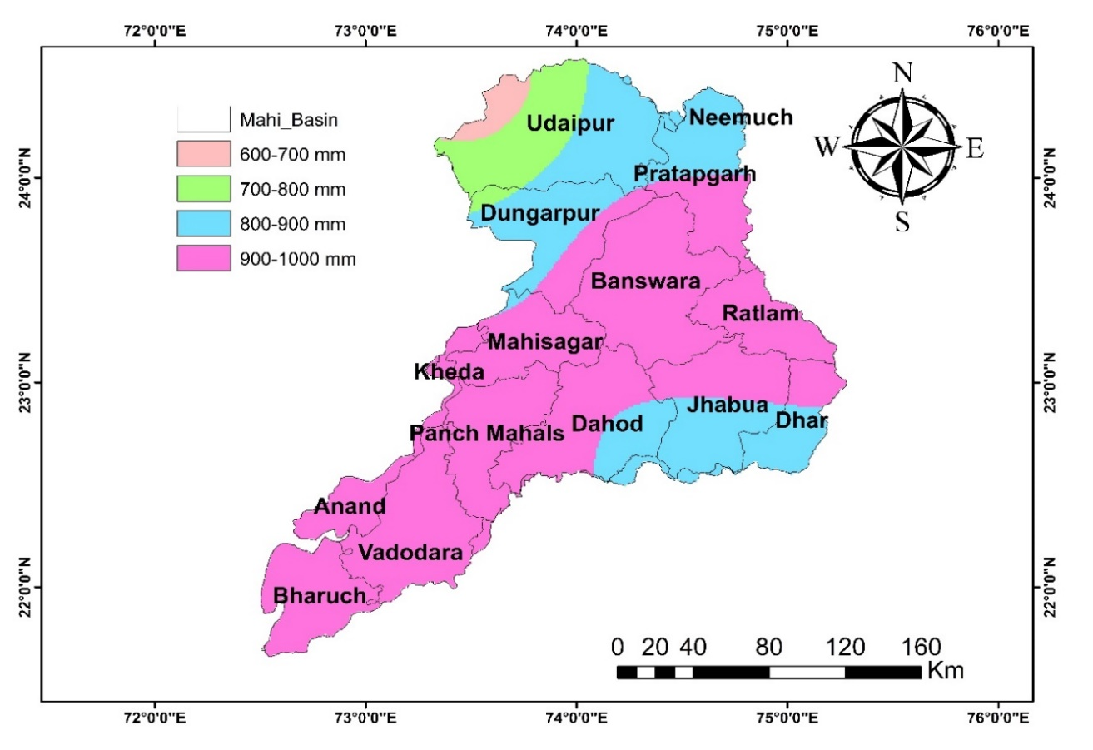**Figure 2: Rainfall distribution during baseline period**

The area under the various rainfall classes during baseline period is given in Table 2 and it can be observed that about 66% of the area receives rainfall in the range of 900 mm to 1000 mm. It will be interesting to study how the average rainfall is varying spatially and temporally during the present period as well as during the future time period. The average annual rainfall during the present period varies between 446.3 mm during 2000 to 1327.4 mm during 1994. The mean rainfall during the present period is 772.1 mm which is about 11% less than the baseline period.

**Table 2: Area under various rainfall classes during baseline period**

|  |  |  |
| --- | --- | --- |
| S. No. | Rainfall (1961-90) | Area (%) |
| 1 | 600-700 mm | 1.53 |
| 2 | 700-800 mm | 6.81 |
| 3 | 800-900 mm | 25.98 |
| 4 | 900-1000 mm | 65.67 |

**4.1.2 Rainfall distribution during present period (1991-2005)**

The annual rainfall peak during the present period has also decreased by 17% during the present period as compared to the base line period. The temporal variation of the annual rainfall is given in Figure 3. It can be observed that the variability of the annual rainfall is very high. The coefficient of variability is 0.28 during the present period which is again quite high.

**Figure 3: Temporal variation of annual rainfall in Mahi basin during the present** **period**

The spatial distribution of the average rainfall over the baseline period for Mahi basin is given in Figure 4. The rainfall in the basin varies in the range of 500 mm to 1000 mm. The average rainfall varies in the range of 500 to 600 mm and 600 mm to 700 mm in the central and western parts of Udaipur district. Dungarpur, Pratapgarh and Neemuch districts in the west and Jhabua and Dhar districts in the east received lesser rainfall in the range of 700 mm to 800 mm as compared to the baseline period. Reduced rainfall was also observed in the central districts of Banswara, Ratlam, Mahisagar, Kheda and Dahod compared to the baseline period and falling in the range of 800 mm to 900 mm. However, no changes in the average annual rainfall was observed for the coastal districts of Panch Mahal, anand and Vadodara. However, Bharuch district situated very near to the coast received lesser rainfall in the range of 800 mm to 900 mm. As such, it can be observed that most of the regions in Mahi basin except for the lower central zones received much lesser rainfall as compared to the baseline period. The average annual rainfall for Mahi basin reduced from 866.9 mm during the baseline period to 772.1 mm during the present period which is substantial (-11%).

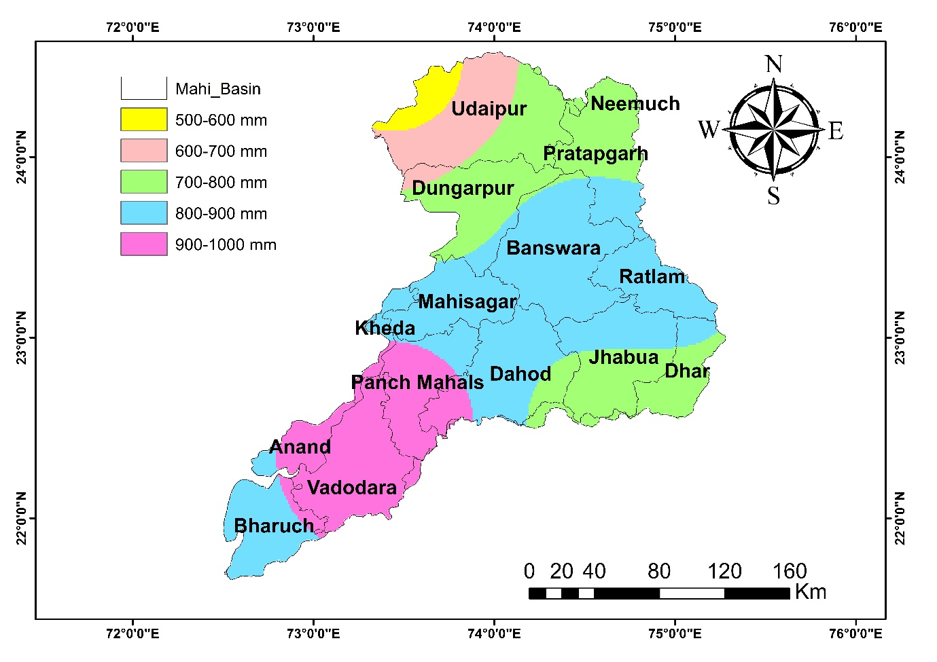

**Figure 4: Rainfall distribution during present period (1991-05)**

The area under the various rainfall classes during present period is given in Table 3 and it can be observed that the area receives rainfall in the range of 900 mm to 1000 mm has reduced from 66% during the baseline period to only about 18.7 % during the present period. Majority area received rainfall in the range of 800 mm to 900 mm (44%).

**Table 3: Area under various rainfall classes during present period (1991-05)**

|  |  |  |
| --- | --- | --- |
| S. No. | Rainfall (1991-05) | Area (%) |
| 1 | 500-600 mm | 2.17 |
| 2 | 600-700 mm | 7.63 |
| 3 | 700-800 mm | 27.41 |
| 4 | 800-900 mm | 44.08 |
| 5 | 900-1000 mm | 18.67 |

**4.1.3 Rainfall distribution during future period (2006-40)**

The CORDEX South Asia future climate data for the widely used Regional Climate Model (RCM) CCSM4 has been use for studying the changes in the rainfall and temperature during the future time periods and its effect on the aridity and its changes over the Mahi basin. The projected average annual rainfall during 2006-40 varies between 220.4 mm to 889.2 mm. The projected mean rainfall for the basin during the 2006-40 is 479.8 mm which is about 44% less than the baseline period. The annual rainfall peak during the 2006-40 is also projected to decrease by 44% as compared to the base line period. The temporal variation of the annual rainfall is given in Figure 5. It can be observed that the variability of the annual rainfall is very high. The coefficient of variability has increased from 0.28 during the present period to 0.34 during 2006-40 which is very high.

**Figure 5: Temporal variation of annual rainfall in Mahi basin during 2006-40**

The spatial distribution of the projected average annual rainfall during the period 2006-40 for Mahi basin is given in Figure 6. The rainfall in the basin varies in the range of 300 mm to 600 mm which is a considerable decrease. The average rainfall varies in the range of 400 to 500 mm in districts of Udaipur, Neemuch, Pratapgarh, Dungarpur and parts of Banswara and Mahisagar. The remaining districts falling in Mahi basin namely, Ratlam, Dhar, Jhabua, Dahod, Kheda, Panchmahal, Anand, Vadodara and Bharuch is expected to receive average annual rainfall in the range of 500-600 mm.

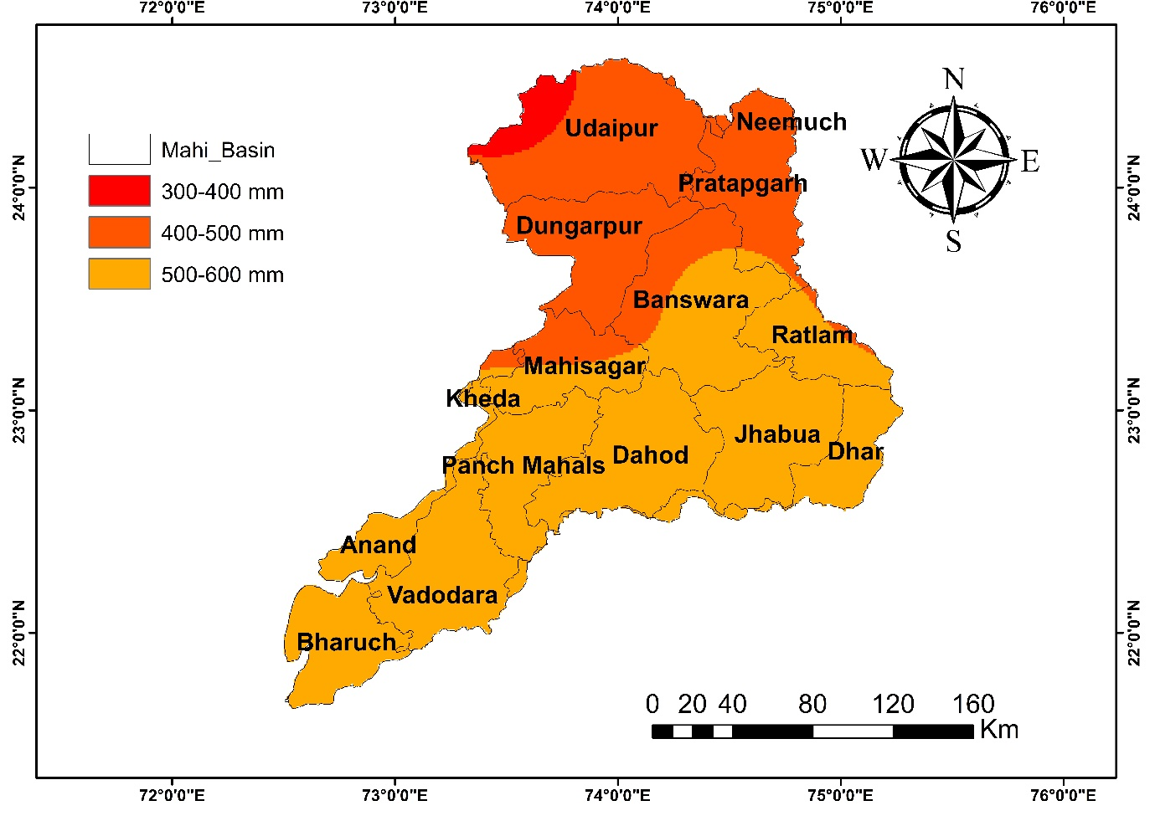

**Figure 6: Rainfall distribution during future period (2006-40)**

The area under the various rainfall classes during 2006-40 is given in Table 4. The majority areas in the basin (63.5%) fall in the class of 500-600 mm whereas during the baseline period, majority area (66%) was falling in the class of 900-1000 mm. Therefore, the average annual rainfall for Mahi basin has projected to reduce from 866.9 mm during the baseline period to 479.8 mm during 2006-40. This is a drastic shift and suggests towards water stress in future in the basin.

**Table 4: Area under various rainfall classes during future period (2006-40)**

|  |  |  |
| --- | --- | --- |
| S. No. | Rainfall (2006-40) | Area (%) |
| 1 | 300-400 mm | 2.18 |
| 2 | 400-500 mm | 34.31 |
| 3 | 500-600 mm | 63.49 |

**4.2 Temperature Variation in Mahi Basin**

The temporal variation in the annual mean temperature during the baseline period (1961-1990) is given in Figure 7. It can be observed that the mean temperature is increasing marginally in the basin. It can be observed that the temperature is increasing steadily in all time periods and the increase is more during the future time period (2006-2040) as displayed by the slopes of the trend lines.

**Figure 7: Temporal variation of annual temperature during the baseline period (1960-90)**

**Figure 8: Temporal variation of annual temperature during the present period (1991-2005)**

**Figure 9: Temporal variation of annual temperature during the future period (2006-40)**

* 1. **Potential Evapotranspiration**

**4.3.1 Potential Evapotranspiration** **during (1961-90)**

The PET estimates by the Thornthwaite method (PETTH) are directly proportional and very sensitive to the mean temperature. The spatial variation of the PET in Mahi basin during the baseline period as evaluated by the Thornthwaite method is shown in Figure 10. It can be observed that the PET varies between 1600-2000 mm in the basin. The PET in the upper reaches of the basin falls in the range of 1600-1800 mm whereas the PET in the lower reaches of the basin near the sea coast is having higher PET in the range of 1800-2000 mm.

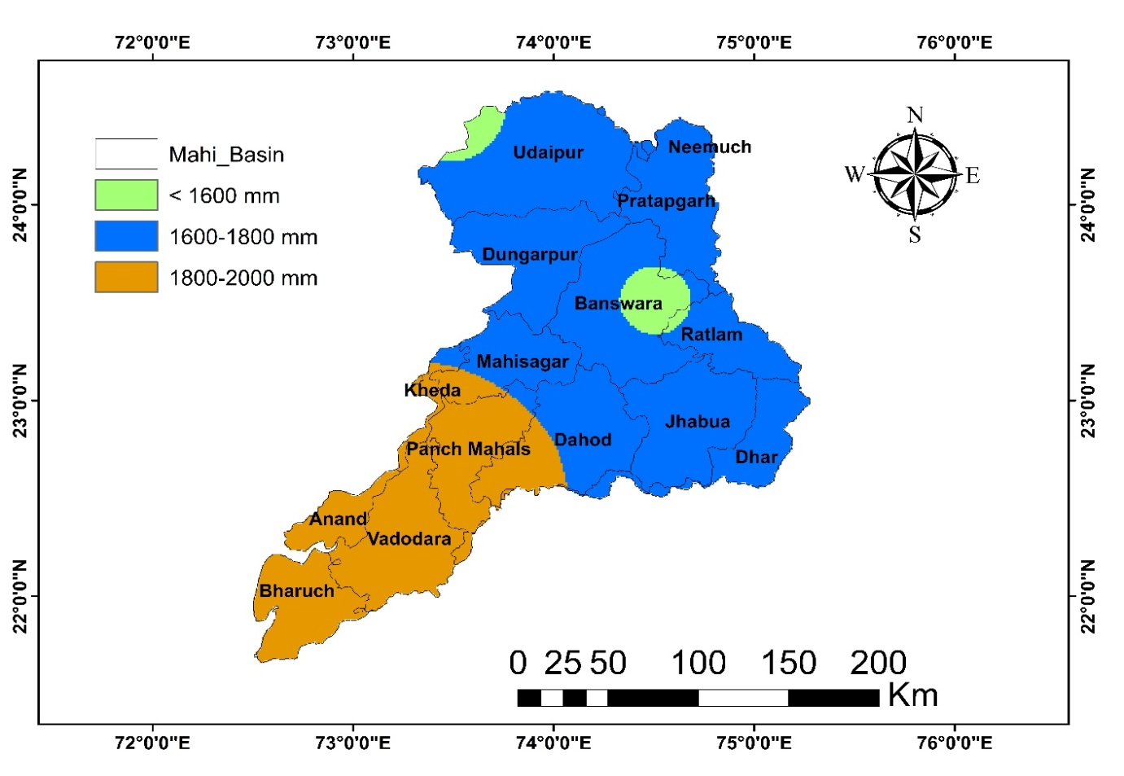

**Figure 10: Distribution of PETTH during baseline period (1961-90)**

The area under various PET classes during baseline period is given in Table 5. The PET in the major portion of the basin (67.3%) is under the 1600-1800 mm class whereas the remaining area (28.9%) is under 1800-2000 mm class with very less areas near the western part of Udaipur and some part of Banswara under less than 1600 mm class.

**Table 5: Area under various PETTH classes during baseline period (1961-90)**

|  |  |  |
| --- | --- | --- |
| Sl. No. | PET (1961-90) | Area (%) |
| 1 | < 1600 mm | 3.80 |
| 2 | 1600-1800 mm | 67.33 |
| 3 | 1800-2000 mm | 28.85 |

**4.3.2 Potential Evapotranspiration** **during (1991-05)**

The spatial variation of the PET in Mahi basin during the present period as evaluated by the Thornthwaite method is shown in Figure 11. It can be observed that the PET varies between 1600-2000 mm in the basin. The PET in the upper reaches of the basin falls in the range of 1600-1800 mm whereas the PET in the lower reaches of the basin near the sea coast is having Higher PET in the range of 1800-2000 mm.

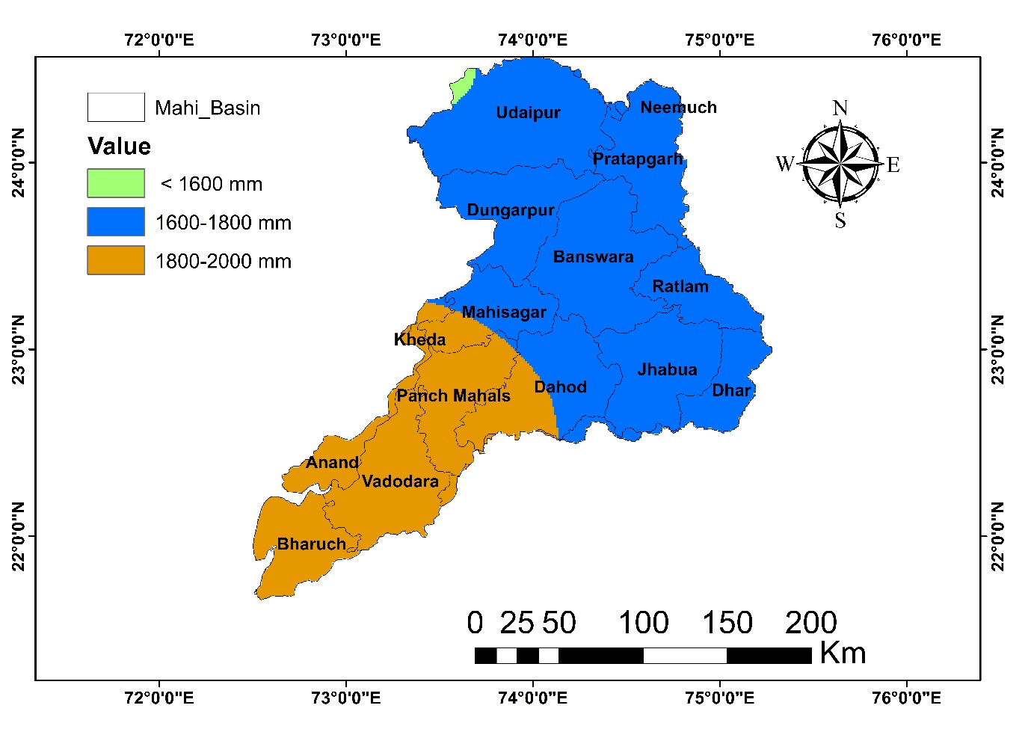

**Figure 11: Distribution of PET during present period (1991-05)**

The area under various PET classes during baseline period is given in Table 6. The PET in the major portion of the basin (68.9%) is under the 1600-1800 mm class whereas the remaining area (30.7%) is under 1800-2000 mm class with very less areas near the western part of Udaipur under less than 1600 mm class.

**Table 6: Area under various PETTH classes during present period (1991-05)**

|  |  |  |
| --- | --- | --- |
| Sl. No. | PET (1991-05) | Area (%) |
| 1 | < 1600 mm | 0.36 |
| 2 | 1600-1800 mm | 68.91 |
| 3 | 1800-2000 mm | 30.71 |

**4.3.3 Potential Evapotranspiration** **during (2006-40)**

The spatial variation of the PET in Mahi basin during 2006-40 as evaluated by the Thornthwaite method is shown in Figure 12. It can be observed that the PET varies between 2000-2600 mm in the basin. The PET in the northern parts of the basin in the districts of Udaipur and Neemuch falls in the range of 2000-2200 mm whereas the PET in the central parts of the basin falls in the range of 2200-2400 mm. The lower reaches of the basin near located the sea coast is having highest PET in the range of 2400-2600 mm. It can be observed that there is a considerable increase in all the PET classes during (2006-40) as compared to the baseline period due to the increases in the mean temperature projected during (2006-40).

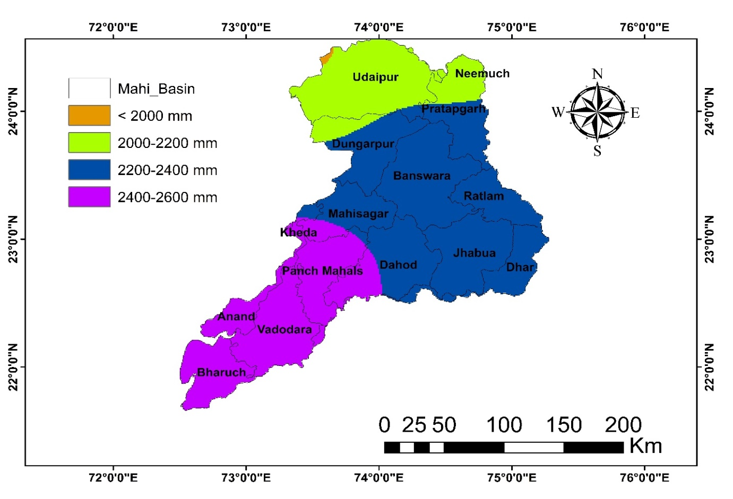

**Figure 12: Distribution of PETTH during future period (2006-40)**

The area under various PET classes during (2006-40) is given in Table 7. The PET in the major portion of the basin (52.1%) is under the 2200-2400 mm class followed by about 28.8% area falling in the PET range of 2400-2600 mm; 18.8% area falling in the 2000-2000 mm class and very less areas (0.15%) near the western part of Udaipur under less than 2000 mm class.

**Table 7: Area under various PET classes during future period (2006-40)**

|  |  |  |
| --- | --- | --- |
| Sl. No. | PET (2006-40) | Area (%) |
| 1 | < 2000 mm | 0.15 |
| 2 | 2000-2200 mm | 18.81 |
| 3 | 2200-2400 mm | 52.19 |
| 4 | 2400-2600 mm | 28.83 |

**4.4 Aridity Estimates for Mahi Basin**

**4.4.1 Aridity** **during baseline period (1961-90)**

The spatial variation of the UNEP Aridity index based on the Thornthwaite method of PET estimation during the baseline period is shown in Figure 13 and the area under the various aridity classes is given in Table 8.

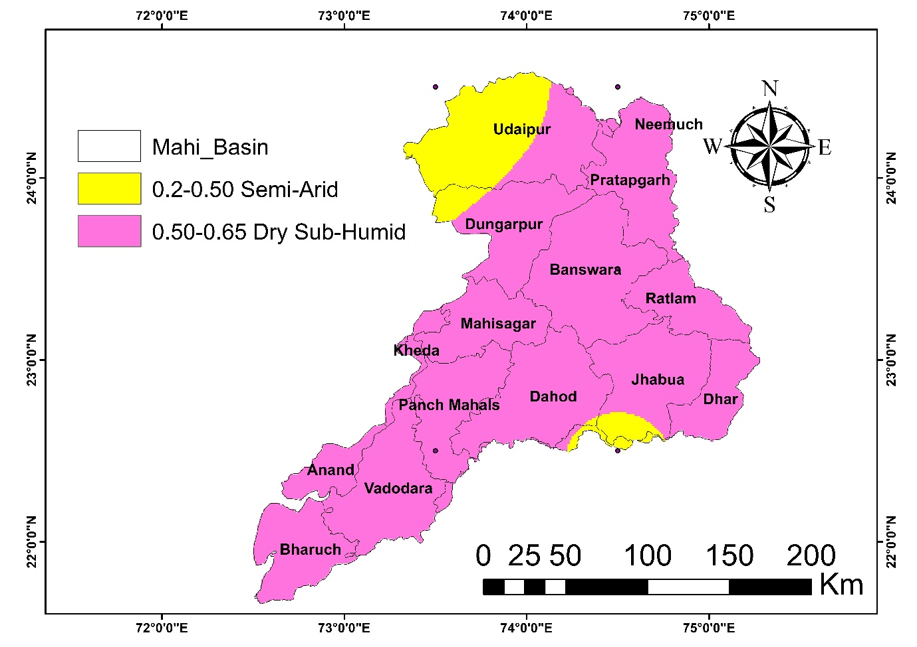

Figure 13: Area under various AI classes during (1961-90) using PETTH

It can be observed that the north western part of the basin located in Udaipur and small part of Jhabua district is under the semi-arid class whereas the remaining districts in the basin are mostly dry sub-humid.

Table 8: Area under various AI classes during (1961-90) using PETTH

|  |  |  |  |
| --- | --- | --- | --- |
| Sl. No. | AI (1961-90) | Aridity class | Area (%) |
| 1 | 0.2-0.50 | Semi-Arid | 9.71 |
| 2 | 0.50-0.65 | Dry Sub-Humid | 90.27 |

**4.4.2 Aridity** **during present period (1991-2005)**

The spatial variation of the UNEP Aridity index based on the Thornthwaite method of PET (PETTH) estimation during the present period is shown in Figure 14 and the area under the various aridity classes is given in Table 9.

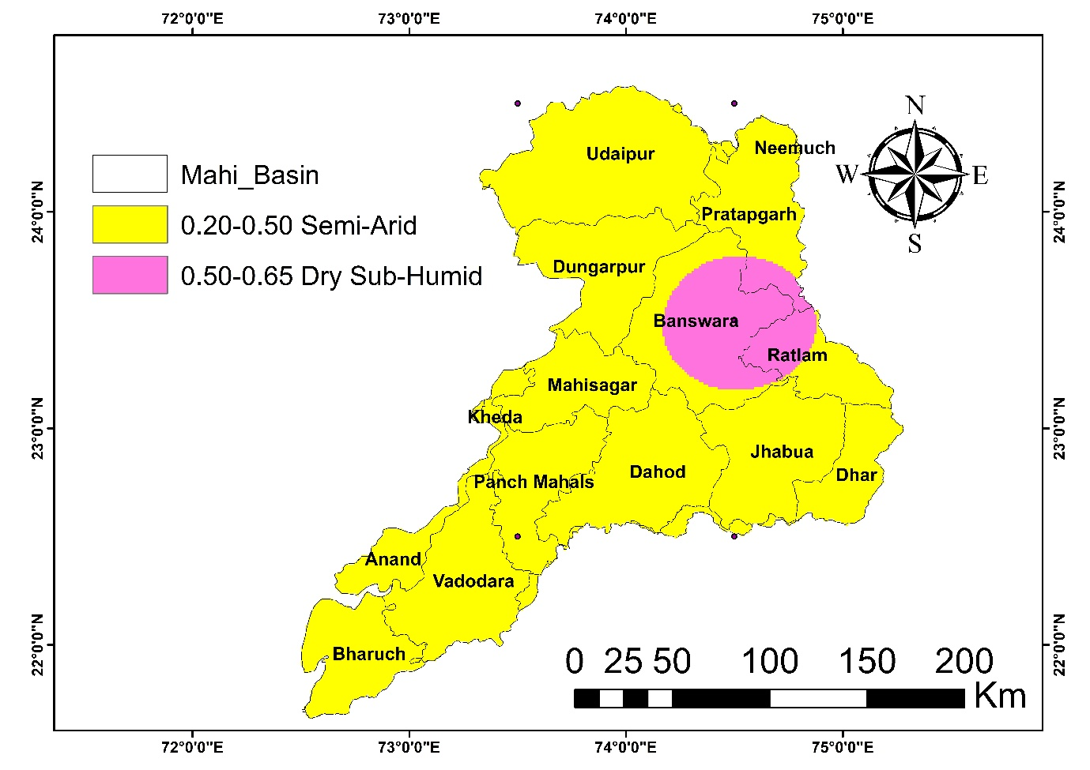

Figure 14: Area under various AI classes during (1991-05) using PETTH

It can be observed that most parts of the basin are under the semi-arid climate (90%) except for some areas with dry sub-humid climate located mostly in the districts of Banswara and Ratlam.

Table 9: Area under various AI classes during (1991-05) using PETTH

|  |  |  |  |
| --- | --- | --- | --- |
| Sl. No. | AI (1991-05) | Aridity class | Area (%) |
| 1 | 0.20-0.50 | Semi-Arid | 90.01 |
| 2 | 0.50-0.65 | Dry Sub-Humid | 9.97 |

**4.4.3 Aridity future period** **during (2006-40)**

The spatial variation of the UNEP Aridity index based on the Thornthwaite method of PET estimation during 2006-40 time period is shown in Figure 15 and the area under the various aridity classes is given in Table 10.

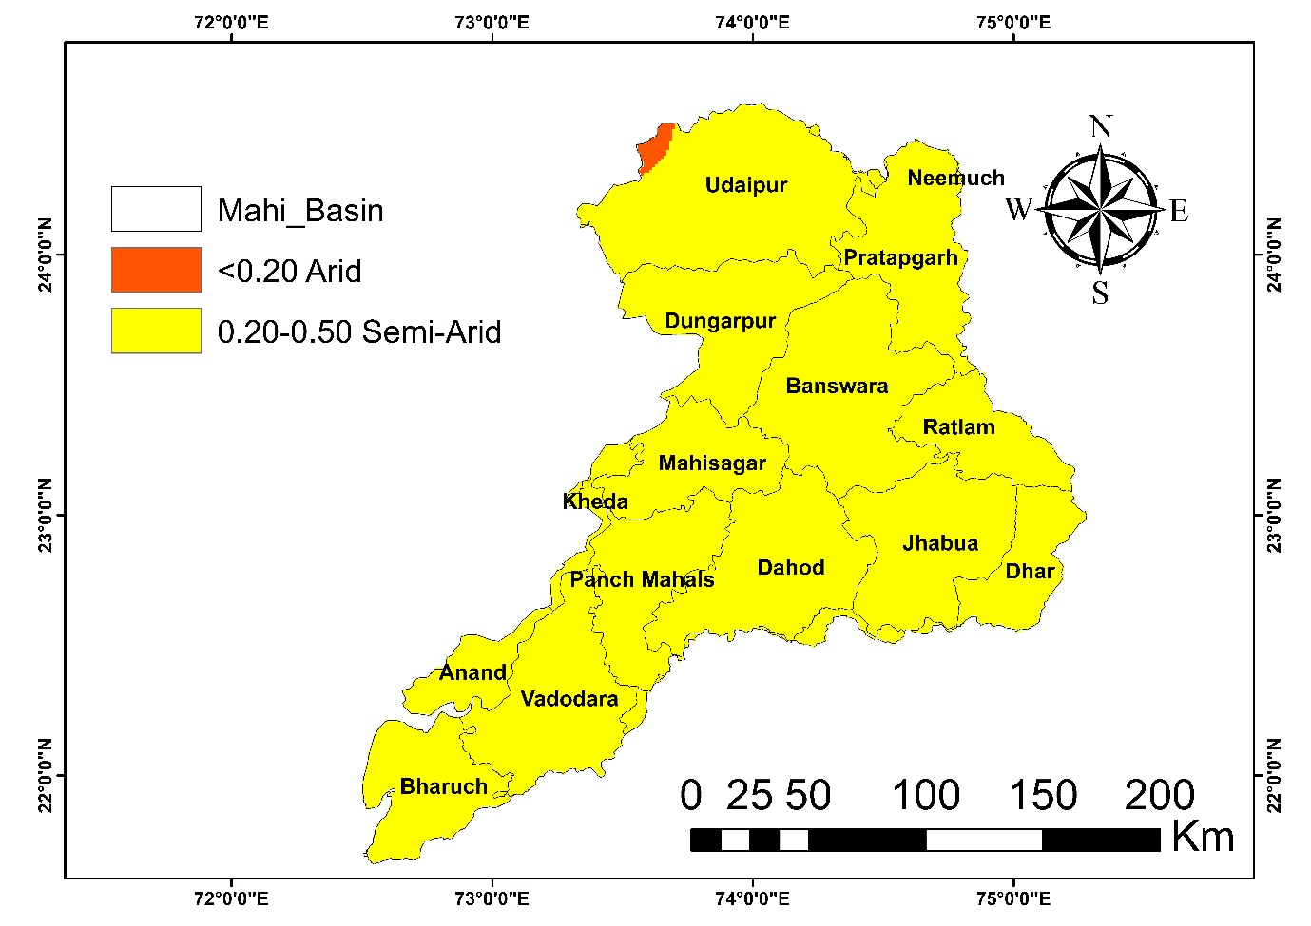

Figure 15: Area under various AI classes during (2006-40) using PETTH

It can be observed that the a very small part of the basin located in the north west in Udaipur district is projected to fall in the arid climate whereas the remaining districts in the basin are mostly semi-arid. This depicts a considerable change in the climate in Mahi basin which is projected to change form dry sub-humid to semi-arid in major portions of the study area. 99.52% of the basin is projected to have a semi-arid climate during (2006-40).

Table 10: Area under various AI classes during (2006-40) using PETTH

|  |  |  |  |  |
| --- | --- | --- | --- | --- |
| Sl. No. | AI (2006-40) | Aridity class | Area (%) | |
| 1 | < 0.20 | Arid | | 0.40 |
| 2 | 0.20-0.50 | Semi-Arid | | 99.52 |

1. **SUMMARY CONCLUSION**

The present study is an attempt to investigate the changes in the precipitation, temperature, potential evapotranspiration and aridity in the context of climate change for Mahi basin which is located in the semi-arid zone in India. The analysis has been carried out for three time periods viz., baseline period (1961-90); present period (1991-2005) and future time period (2006-40). The climate change impacts on the aridity are an interesting case as it involves both rainfall and potential evapotranspiration. The reduction in aridity has a direct implication on the availability of the water resources in the basin as either a decrease in the annual rainfall or an increase in the annual PET will lead to decrease in the aridity index which suggests of a drier climate. However, for Mahi basin, both the climate variables i.e. rainfall and PET have shown considerable changes. The annual rainfall is projected to decrease in future time horizons as compared to the baseline period whereas the PET is projected to increase substantially in future time periods due to the projected increase in the mean temperature in the basin. Since the aridity index is the ratio of annual rainfall to the annual PET, a decrease in the rainfall coupled with increase in PET has led to substantial changes in the aridity index. Moreover, the high variability of the annual rainfall (about 30%) is again a matter of concern and regular droughts and water stress conditions can be expected in future in the basin.

The spatio-temporal variation of the aridity has been studied to locate that may face drier climate under the impacts of climatic change. It has be observed that the western parts of the basin located in Udaipur district have lower rainfall and lower aridity index suggesting higher water stress as compared to other parts of the basins in most of the time periods. Aridity index suggests a considerable change in the aridity in Mahi basin with the climate change from dry sub-humid to semi-arid and arid climate for the future time period. The analysis of the future climate and its variability has been studied on the basis on CCSM4 RCM datasets. However, to address the issues of uncertainty it will always be better to analyse these changes based on multiple sets of GCMs and RCMs. The assessment of these changes on the variability in the future stream flows can be a future scope of work for the study area.It is necessary that a comprehensive climate change impact assessment study be carried out for Mahi basin along with the necessary adaptation strategies.

**Conflicts of Interest**

The authors declare no conflicts of interest.

**Declaration of using AI**

The Author, hereby declare that NO generative AI technologies have been used during writing or editing of manuscript.

**6. REFERENCES**

1. Zhang, B. (2020). The effect of aerosols to climate change and society. *Journal of Geoscience and Environment Protection*, *8*(08), 55.
2. Sarkar, D., Kar, S. K., Chattopadhyay, A., Rakshit, A., Tripathi, V. K., Dubey, P. K., & Abhilash, P. C. (2020). Low input sustainable agriculture: A viable climate-smart option for boosting food production in a warming world. *Ecological Indicators*, *115*, 106412.
3. Jain, N., Bhatia, A., Pathak, H., Gupta, N., Sharma, D. K., & Kaushik, R. (2015). Greenhouse gas emission and global warming. *Introduction to environmental sciences*, 379-411.
4. Gahlawat, I. N., & Lakra, P. (2020). Global Climate change and its effects. *Integrated Journal of Social Sciences*, *7*(1), 14-23.
5. Rajeevan, M. N., & Nayak, S. (Eds.). (2017). *Observed climate variability and change over the Indian region*. Springer.
6. Nawaz, A., & QBAhmed, A. A. N. Zarif, F. Ahmad and A. Karim. 2024. Trend analysis of climate variables in urban microclimate of Peshawar District. *Pakistan Journal of Forestry*, *74*(2), 9-17.
7. IPCC. 2007. Climate Change 2007: Climate Change Impacts, Adaptation and Vulnerability.
8. Borah, G. (2025). Urban Water Stress: Climate Change Implications for Water Supply in Cities. *Water Conservation Science and Engineering*, *10*(1), 20.
9. Karamouz, M., Imen, S., & Nazif, S. (2012). Development of a demand driven hydro-climatic model for drought planning. *Water Resources Management*, *26*(2), 329-357.
10. Qiu, J., Shen, Z., & Xie, H. (2023). Drought impacts on hydrology and water quality under climate change. *Science of the total environment*, *858*, 159854.
11. Das, U., & Ansari, M. A. (2021). The nexus of climate change, sustainable agriculture and farm livelihood: contextualizing climate smart agriculture. *Climate Research*, *84*, 23-40.
12. Agnew, R. (1992). Foundation for a general strain theory of crime and delinquency. *Criminology*, *30*(1), 47-88.
13. Nicholson, S. E. (2011). Dryland climatology
14. Katul, G. G., Oren, R., Manzoni, S., Higgins, C., & Parlange, M. B. (2012). Evapotranspiration: A process driving mass transport and energy exchange in the soil‐plant‐atmosphere‐climate system. *Reviews of Geophysics*, *50*(3).
15. Thornthwaite, C. W. (1948). An approach toward a rational classification of climate. *Geographical review*, *38*(1), 55-94.
16. Allen, R. G. (1986). A Penman for all seasons. *Journal of Irrigation and Drainage Engineering*, *112*(4), 348-368.
17. Li, R., & Wang, C. (2020). Precipitation recycling using a new evapotranspiration estimator for Asian-African arid regions. *Theoretical and Applied Climatology*, *140*, 1-13.
18. Reynolds, J. F., Kemp, P. R., & Tenhunen, J. D. (2000). Effects of long-term rainfall variability on evapotranspiration and soil water distribution in the Chihuahuan Desert: a modeling analysis. *Plant Ecology*, *150*, 145-159.
19. Harmsen, E. W., Miller, N. L., Schlegel, N. J., & González, J. E. (2009). Seasonal climate change impacts on evapotranspiration, precipitation deficit and crop yield in Puerto Rico. *Agricultural water management*, *96*(7), 1085-1095.
20. Seth, S. M. (2003). Human impacts and management issues in arid and semi-arid regions. *International Contributions to Hydrogeology*, *23*, 289-341.
21. Mishraa, A., Alnahitb, A., & Mukherjeea, S. (2022). Rainfall and droughts. *Rainfall: Modeling, Measurement and Applications*, 451.
22. Lian, X., Piao, S., Chen, A., Huntingford, C., Fu, B., Li, L. Z., ... & Roderick, M. L. (2021). Multifaceted characteristics of dryland aridity changes in a warming world. *Nature Reviews Earth & Environment*, *2*(4), 232-250.
23. Lickley, M., & Solomon, S. (2018). Drivers, timing and some impacts of global aridity change. *Environmental Research Letters*, *13*(10), 104010.
24. Jain, S. K., Agarwal, P. K., & Singh, V. P. (2007). *Hydrology and water resources of India* (Vol. 57). Springer Science & Business Media.
25. 25.Sharma, A., & Kumar, K. (2018). The mahi: an important west flowing river of central India. In *The Indian Rivers: Scientific and Socio-economic Aspects* (pp. 287-299). Singapore: Springer Singapore.
26. Raj, R., Maurya, D. M., & Chamyal, L. S. (1999). Tectonic geomorphology of the Mahi river basin, Western India. *Journal Geological Society of India*, *54*(4), 387-398.
27. 27 Nath, M. L. (1989). *The Upper Chambal Basin: A Geographical Study in Rural Settlements*. Northern Book Centre.
28. Pawar, U., Hire, P., Gunathilake, M. B., & Rathnayake, U. (2023). Spatiotemporal rainfall variability and trends over the Mahi basin, India. *Climate*, *11*(8), 163.
29. Sharma, A., Sharma, D., & Panda, S. K. (2022). Assessment of spatiotemporal trend of precipitation indices and meteorological drought characteristics in the Mahi River basin, India. *Journal of Hydrology*, *605*, 127314.

249-254.

1. 30. Maurya, S., Srivastava, P. K., Zhuo, L., Yaduvanshi, A., & Mall, R. K. (2023). Future climate change impact on the streamflow of Mahi River Basin under different general circulation model scenarios. *Water Resources Management*, *37*(6), 2675-2696.
2. Pawar, U., Hire, P., Gunathilake, M. B., & Rathnayake, U. (2023). Spatiotemporal rainfall variability and trends over the Mahi basin, India. *Climate*, *11*(8), 163.
3. Bhati, D. S., Dubey, S. K., & Sharma, D. (2021). Application of satellite-based and observed precipitation datasets for hydrological simulation in the Upper Mahi River Basin of Rajasthan, India. *Sustainability*, *13*(14), 7560.
4. Pai, D. S., Rajeevan, M., Sreejith, O. P., Mukhopadhyay, B., & Satbha, N. S. (2014). Development of a new high spatial resolution (0.25× 0.25) long period (1901-2010) daily gridded rainfall data set over India and its comparison with existing data sets over the region. *Mausam*, *65*(1), 1-18.
5. Srivastava, A. K., Rajeevan, M., & Kshirsagar, S. R. (2009). Development of a high resolution daily gridded temperature data set (1969–2005) for the Indian region. *Atmospheric Science Letters*, *10*(4),
6. Tangang, F., Chung, J. X., Juneng, L., Supari, Salimun, E., Ngai, S. T., ... & Kumar, P. (2020). Projected future changes in rainfall in Southeast Asia based on CORDEX–SEA multi-model simulations. *Climate Dynamics*, *55*, 1247-1267.
7. Srikanthan, R., & McMahon, T. A. (2001). Stochastic generation of annual, monthly and daily climate data: A review. *Hydrology and earth system sciences*, *5*(4), 653-670.\
8. Geng, S., de Vries, F. W. P., & Supit, I. (1986). A simple method for generating daily rainfall data. *Agricultural and Forest meteorology*, *36*(4), 363-376.
9. Eulefeld, G. (1979). The UNESCO‐UNEP programme in environmental education. *European Journal of Science Education*, *1*(1), 113-118.