**Review Article**

**ORGANIC FISH FARMING AND FUTURE ASPECTS: A REVIEW**

**ABSTRACT**

Fish produced under natural conditions according to the organic agricultural principles should not be exposed to any protective additives and should not be subjected to genetic modifications and certified by a control agency is called as ‘organic fish' (Kaur and Shah, 2018). Organic fish culture is an ecosystem-based farming strategy to improve environmental sustainability and reduce negative environmental consequences (IFOAM, 2014).

Organic fish production is a model of production which supplies animal’s lease with low stock density and attaches importance to human health without using any chemicals, pesticides or the products modified genetically (Arya *et al.*, 2017). This alternative model is used in many developed and developing countries in the world and the model comprises 0.01% of the world aquaculture production. However, organic aquaculture production has not been developed as rapidly as organic agriculture (Hilge, 2005). One of the most important reasons of this is the absence of international standards issued for organic aquaculture production.

Keywords: Organic, Aquaculture, Ecosystem, Certification, Biodiversity conservation

# INTRODUCTION

Organic aquaculture is the farming of aquatic animals like shrimp, fishes, bivalves etc. and aquatic plants without using antibiotics, chemicals and fertilizers by preserving the ecosystem and biodiversity (Kaur and Shah, 2018). Organic aquaculture practices would help in raising aquatic products in a human manner i.e. sustainable and pollution free. Organic feed optimizes the health of the animal and to reduce in reliance on drugs, including antibiotics **(**Sandhu *et al*., 2010).

Organic aquaculture is production of high-quality foods in a stable aquatic ecosystem by managing the natural resources and environment without any negative effects and to secure the genetic diversity and richness of species in a native system.

Organic aquaculture is the production process every stage of which is controlled and certificated by the control and/or certification agency according to the articles of regulation related to the organic agriculture, with such aims as supplying organic raw materials for the industries getting their raw materials from agriculture, from fish grown with organic agriculture method in seas, domestic waters, pools, net cages, barrages, lakes, ponds, fish traps, farms, aquatic plants and sponge.

Diminishing fishery harvest, wild fish food-safety issues, environmental concerns, increased fish consumption, and the increasing market share of organic foods have combined to focus attention on “organic aquaculture.” Consumer demand may well drive the organic production of finfish, shellfish and other aquatic species into the mainstream during the next decade. Organic aquaculture has attracted the attention of researchers from several academic disciplines as well as that of environmental advocates and entrepreneurial innovators. A small number of “certified” and non-certified organic fish and microalgae products have made it to the retail market place in the developed countries. While the regulatory specifics still need to be addressed, this new organic market niche has significant potential for growth in the future (Teclozan, 2023).

**Definition**

Conversion to organic aquaculture is a process of developing farming practices that encourage and maintain a viable and sustainable aquatic ecosystem. The time between the start of organic management and certification of the production is known as the conversion period.

Aquaculture production methods can vary widely according to biology of the organisms, technology used, geographical conditions, ownership structure, time span, etc. These aspects should be considered when the length of conversion is specified. The minimum conversion period set for the aquaculture production system is two years. The variety of species produced in aquacultural systems and vast differences in cultural requirements for finfish, shellfish, mollusks and aquatic plants add to the complexity of defining this sector. Some species and some production systems may prove quite difficult to adapt to a traditional “organic” system (Teclozan, 2023).

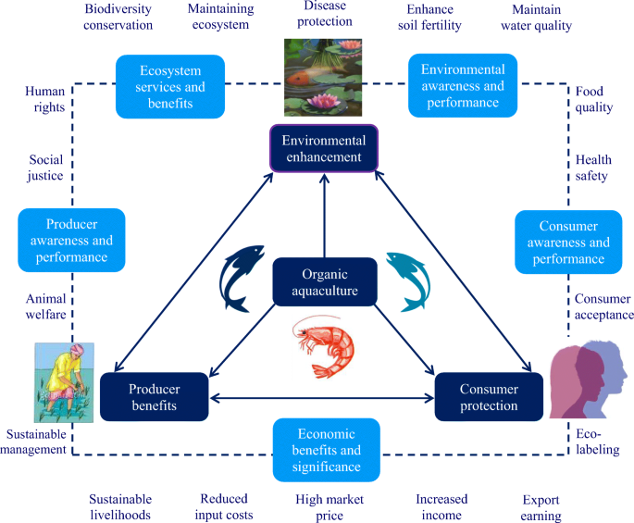

Fig. 1 Organic aquaculture

**History of Organic Aquaculture**

Organic aquaculture is based on the organic agriculture farming technology, and these root causes continue to shape the organic aquaculture sector in many ways. Organic farmers in Austria and Germany first started to develop extensive “organic” carp production system in the early nineties. The successful launch of organic salmon, first in Germany and later in the United Kingdom and France accelerated the development process of organic aquaculture initiatives throughout the world. A further milestone in the history of organic aquaculture was the development of standards for the production of organic shrimp.

INDOCERT (Indian organic certification) is an Indian certification body accredited as per National Programmed for Organic Production (NPOP), Govt. of India to carry out inspections and issue certificates for organic production systems. INDOCERT is offering certification for the domestic market based on the National Standards for Organic Production and certification for export markets based on USDA (United States Department of Agriculture) (IFOAM, 2002). Below is an overview of its history:

#### ****Early Aquaculture (Before Organic Practices)****

* **Ancient Times:** Aquaculture dates back thousands of years. The Chinese were cultivating carp in rice paddies as early as 2,500 BCE, while the Romans farmed fish in coastal lagoons.
* **Medieval Period:** Monasteries in Europe maintained fish ponds for sustainable food supply.
* **19th & 20th Century:** Aquaculture expanded globally, with industrialization leading to intensive fish farming, the use of synthetic feeds, antibiotics, and chemical additives.

#### ****Emergence of Organic Aquaculture (Late 20th Century)****

* **1970s-1980s:** Environmental awareness and the organic food movement grew, influencing fisheries and aquaculture practices.
* **1990s:** The first formal organic aquaculture guidelines emerged in Europe. Early adopters included organic salmon farms in Scotland and Norway.
* **2000s:** Various countries and organizations developed organic aquaculture standards. The EU, Canada, and the USA worked on regulations to ensure sustainable, chemical-free farming methods.

#### ****Modern Organic Aquaculture (2010s-Present)****

* **2010s:** The European Union officially recognized organic aquaculture, establishing strict rules on feed, water quality, and stocking density.
* **2020s:** More nations adopted organic certification standards, and consumer demand for organic seafood increased. Innovations in plant-based and sustainable fish feed continued to evolve.

## ****Types of Organic Aquaculture Systems****

1. **Pond-Based Organic Farming:** Uses natural filtration and vegetation to maintain water quality. **ond-based organic farming** is a natural and eco-friendly method of aquaculture that utilizes earthen ponds to raise fish and other aquatic organisms without synthetic chemicals, antibiotics, or artificial feeds. This approach mimics natural aquatic ecosystems, ensuring sustainable fish production while preserving environmental balance.
2. **Recirculating Aquaculture Systems (RAS):** Uses minimal water exchange and biological filtration. **Recirculating Aquaculture Systems (RAS)** are innovative, land-based aquaculture methods that recycle and filter water to create a controlled, eco-friendly fish farming environment. This technology allows fish to be grown in tanks with minimal water usage, reducing environmental impact while ensuring high productivity.
3. **Cage & Offshore Organic Aquaculture:** Operates in clean, open waters with low fish densities. **Cage and offshore organic aquaculture** is a method of raising fish in open waters using floating cages or net enclosures while adhering to organic farming principles. This approach allows fish to grow in a natural environment with continuous water exchange, reducing artificial interventions and ensuring sustainability.
4. **Integrated Rice-Fish Farming:** Fish raised in flooded rice fields, benefiting both crops and fish. **Integrated rice-fish farming** is a traditional and eco-friendly farming system that combines rice cultivation with fish farming in the same field. This method maximizes land and water use efficiency, enhances biodiversity, and provides both rice and fish as food sources while reducing the need for chemical fertilizers and pesticides.

**Conventional Aquaculture:**

Aquaculture is defined as the production of aquatic animals and plants under controlled conditions for all or part of their lifecycle. The combination of the environment, equipment and techniques selected for the farming of an aquatic species is referred to as the aquaculture production or cultural system. Several different types of systems have been developed based on availability of environmental resources and the type of species being raised. Environmental factors that can influence aquacultural system and species selection include salinity of the water (marine, brackish and fresh), seasonal climate, watershed drainage, and tides. The major aquaculture systems are pond culture, cage culture, raceway, recirculating and integrated. Each of these systems has characteristics that may lead to consideration for organic production.

The outlook for aquaculture worldwide is growing. In 2010, aquaculture used 18.8 million hectares globally (2014). Organic aquaculture farms on 209,900 hectares generated 162,878 ton in 2018 (Willer *et al.,* 2021).

## ****Key Features of Conventional Aquaculture****

### **Intensive Farming Practices**

* High stocking densities in ponds, tanks, or cages.
* Controlled water conditions (temperature, salinity, oxygen levels).
* Use of artificial feeds for rapid growth.

### **Use of Chemicals & Antibiotics**

* Antibiotics used to prevent diseases.
* Chemical treatments for parasites and water quality management.
* Synthetic fertilizers in pond systems to enhance productivity.

### **Selective Breeding & Genetic Modification**

* Fast-growing and disease-resistant fish strains developed.
* Some species genetically modified for higher yield (e.g., transgenic salmon).

### **Types of Conventional Aquaculture Systems**

1. **Pond Systems** – Used for fish like tilapia, catfish, and carp.
2. **Cage Culture** – Offshore net pens for salmon, seabass, and trout.
3. **Recirculating Aquaculture Systems (RAS)** – Land-based tanks with controlled environments.
4. **Open-Water Aquaculture** – Marine farms in coastal waters.

## ****3. Environmental & Health Concerns****

### **Negative Impacts**

* **Water Pollution:** Excess nutrients, chemicals, and waste discharge harm ecosystems.
* **Disease Spread:** High-density farming increases risk of infections.
* **Escape of Farmed Fish:** Can disrupt local ecosystems and threaten wild species.
* **Overfishing for Feed:** Some conventional farms rely on wild fish as feed (fishmeal & fish oil).

### **Efforts to Improve Sustainability**

* Development of **biofloc technology** and **integrated multi-trophic aquaculture (IMTA)** to reduce waste.
* Shift towards **plant-based and insect-based feeds**.
* Stricter regulations and certifications (ASC, BAP) to promote responsible practices.

Conventional aquaculture remains the dominant method of seafood production worldwide, but sustainability concerns are pushing the industry toward greener alternatives like **organic aquaculture and eco-friendly innovations**.



**Fig 2.** Schematic diagram showing the inputs in OCS and CCS.

**ORGANIC FARMING IN INDIA**

The All-India Federation of Organic Farming (AIFOF) accepts the standards document of the International Federation of organic Agriculture Movement (IFOAM, 2002) which gives the following description.

1. To work as much as possible within a closed system, and to draw upon local resources.
2. To maintain the long-term fertility of soils.
3. To avoid all forms of pollution that may result from agricultural techniques.
4. To produce the use of foodstuff of high nutritional quality and sufficient quantity.
5. To reduce the use of fossil energy in agricultural practice to a minimum.
6. To make it possible for agricultural producers to earn a living through their work and develop their potentialities as human beings.

**To which AIFOF has added the following:**

1. To use and develop appropriate technology based on an understanding of biological systems.
2. To use decentralized systems for processing, distributing and marketing of products.
3. To create a system this is aesthetically pleasing to both those within and outside the system.
4. To maintain and preserve wildlife and their habitats

**CURRENT STATUS OF ORGANIC AQUACULTURE IN INDIA**

Compared to organic agriculture, organic aquaculture is far behind in the organic niche of the country. The brackish water area available in India for shrimp farming includes the existing traditional prawn filtration fields also, which are located in West Bengal (46100 ha) and Kerala (10700 ha). These vast filtration areas are actually paddy fields, belonging to several entrepreneurs, who do salt resistance paddy cultivation by themselves and later auction the area, after paddy cultivation for doing the seasonal traditional prawn filtration, when the water become saline in nature due to inundation. The traditional type of prawn filtration system is highly environment-friendly as they use no antibiotics, chemicals and hence the paddy fields can easily be adopted for organic aquaculture. Organic products have become very popular now a days due to rise in health and environmental awareness, concerns on food safety and there is a growing demand in developed countries, especially; US and EU. All the big super markets, Coop (Switzerland), Aimara (Austria), and Birstall Bay (USA) are searching for organic product supply throughout the world. India is one of the richest in terms of shrimps and fish resources in the world. Organic aquaculture ensures that the farming activity is in harmony with the nature, with due care for the good health and welfare of the cultured organisms. The Indian Organic Aquaculture Project was first initiated in January 2007 in the maritime States of Andhra Pradesh and Kerala with technical consultancy from M/s Blue you. Certification is mandatory for selling organic products across the world and Naturland of Germany has been chosen as the certifying agency and Inducer in Kerala is the inspection body for the project. Farmers, hatcheries, feed mill and processors are motivated for organic conversion to produce organic products for exporting from India. MPEDA proposed to implement organic aquaculture in India by availing the consultancy and technical collaboration from the Swiss Import Promotion Programme (SIPPO), Switzerland. In this context, MPEDA has signed a MoU with SIPPO in January, 2007 at Chennai during INDAQUA 2007 to launch the programme. MPEDA conducted earlier three workshops exclusively for Organic aquaculture; one each in the States of Kerala, West Bengal and Andhra Pradesh in association with INFOFISH and Naturland, where technical sessions were held by the concerned technical officials, to create awareness among the entrepreneurs about organic farming. The proposal submitted by MPEDA to the Ministry of Commerce & Industry, Govt of India, envisages the implementation of organic aquaculture project for brackish water shrimp *Penaeus monodon* (tiger shrimp) and the fresh water giant prawn, *Macrobrachium rosenbergii* (scampi), in the States of Kerala, West Bengal and Andhra Pradesh, initially. SIPPO will extend technical assistance through its consultant, Blue you by conducting a few training programmes followed by demonstration for organic tiger shrimp and scampi cultures in Kerala and Andhra Pradesh. Capacity building in organic aquaculture for MPEDA technical officials will be a key component by making use of the expertise to be acquired during the programme. At later stage MPEDA will implement the programme in West Bengal under the supervision of the SIPPO technicians.

***Organic Scampi Aquaculture in Andhra Pradesh***

The National Centre for sustainable Aquaculture (NaCSA) and India Organic Aquaculture Project (IOAP), MPEDA took up organic fresh water prawn (*M. Rosenbergii*) farming in two societies of West Godavari District of Andhra Pradesh. A total of 27 farmers, from Sri Venkateswara Aqua Farmers Welfare Society, Matsyapuri and Sri Sainadha Aqua Farmers Welfare Society, Velivela were involved in the project covering 31 ha area.

**Importance of organic aquaculture**

Organic aquaculture has become more important as consumers have become more conscious about environment, sustainability and harmful impacts of intensive and unsustainable aquaculture. Organic aquaculture aims to provide fish and fishery products that are ecologically, economically and socially viable. From various experiments, it is obvious that the diversity at the levels of species, ecosystem, management and culture system in aquaculture demands enormous efforts to utilize the immense potential of organic aquaculture.

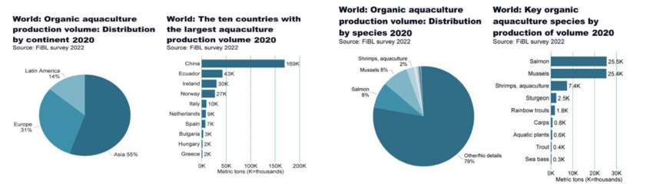

Fig.3 World Organic aquaculture production

**Principles of organic aquaculture**

Organic aquaculture is rooted in four principles: (1) health, (2) ecology, (3) fairness and (4) care (Ahmed *et al.* 2020).

The main principles of organic aquaculture are as follows:

* Monitoring of environmental impact.
* Natural breeding procedures without use of hormones and antibiotics.
* No use of inorganic fertilizers.
* No synthetic pesticides and herbicides.
* Feed and fertilizer from certified organic agriculture and fisheries.
* Organic criteria of sustainability for fishmeal sources.
* Absence of GMOs (Genetically Modified Organisms) in stocks and feed.
* Stocking density limits.
* Restriction of energy consumption (e.g. regarding oxygenation).
* Preference for natural medicines.
* Processing in approved organic facilities.

**Conversion period**

1. Adoption of organic aquaculture requires an interim period, ‘the conversion period’. Commencement of the conversion period shall be taken as the date of first inspection by the accredited Certification Body.
2. The conversion shall take into account the species-specific needs like the husbandry practices and management system, past use of the site with respect to waste and sediment, and water quality for welfare of the animal. Adequate separation between the organic and non-organic production unit should be maintained.
3. The length of the conversion period would vary depending on the species, method of production, location and local conditions. Generally, for drainable systems where cleaning and disinfection is carried out, the conversion period shall be 6 months/ crop whichever is longer and in case of drainable the conversion period shall be 12 months. In case of non-drainable systems which cannot be disinfected, the conversion period shall be 24 months (freshwater prawn, carps). In case of open water farming, the conversion period shall be considered as 3 months (bivalves).
4. In a hatchery/farm practicing parallel production, the producer shall keep the organically produced and in-conversion animals separate and maintain adequate records to show the separation.

**Ecosystem management**

1. Conversion of mangrove ecosystem to aqua pond is prohibited. Mangrove destruction is also prohibited while constructing water intake channels, approach road etc for farming.
2. In existing coastal farms, where ever possible, due consideration may be given for planting mangroves as a means for ecosystem restoration and conservation.
3. Care shall be taken during construction of the ponds so as not to create water logging condition in the adjacent area that would affect surrounding ecosystems or result in conditions not conducive for
4. A buffer zone of at least 10 m should be left between farms following organic farming principles and conventional farming. The size of the buffer zone could be increased based on the natural situation, water distribution system, tidal flow, the upstream and downstream locations of organic production unit. The buffer zone could be a barren piece of land or a pond/cultivated land. The production of this buffer zone shall follow organic principles but the produce will be treated as conventional.
5. Salination of adjacent agriculture land and drinking water sources by way of organic shrimp farming is strictly prohibited. Wherever saline water culture is adopted, a buffer zone of around 200 m should be left between the pond and adjacent agriculture land/drinking water source.
6. Exposed area of the farm should be planted with native vegetation to prevent soil erosion and to enhance natural ecosystem dynamics. Farms located in areas free from vegetation (dunes, desert) may be excluded from this requirement.
7. Adequate steps are required to minimize nutrient discharge and/or suspended solids to water bodies especially during harvesting. Release of toxic or otherwise harmful substances in the pond, channels or the banks should be prevented. Care should be taken while handling equipment’s and machineries such as pumps, generators and aerators to avoid any leakage of fuels and lubricant.
8. Care should be taken so that the materials and substances used in the construction should not affect the biodiversity and environment.
9. Specific measures should be adopted to minimize negative environmental impact including escape of farmed stock.
10. Killing predatory birds and animals are prohibited. Scaring devices/protective fencing etc, are allowed to save crops.

**Selection of site**

1. In selecting the site, ensure that the surrounding aquatic and terrestrial ecosystems are not adversely affected through modifications brought about by construction of the farm.
2. Areas with known record of contamination with heavy metals or industrial pollution may be avoided. Testing is required to be carried out for record of the contaminants in an ISO17025 approved and APEDA /recognized laboratory.
3. Soil quality should be conducive for culture and extreme conditions like high saline or acid soil may be avoided.
4. Forest area or land with thick vegetation should not be used for construction of new farms.
5. In developing new farms or expanding existing farms, the producer should ensure that the natural vegetation is protected. Care should be taken to have significant coverage of bund area with vegetation.
6. Use of ground water for the culture purpose of tiger shrimps is prohibited. For other species the groundwater should be avoided.
7. In case of the bivalve farm, the location of the farm should be as close as possible to the sea to ensure maximum circulation of sea water.

**Choice of breeds and strains**

1. Endemic species is preferred over exotic species. If exotic species are to be selected, their impact on endemic species and environment should be ascertained.
2. Any kind of genetically engineered stock is prohibited. Stocks obtained through selective breeding are permitted, but seed production in this case should be based on organic principles.

**Source of seed and breeding**

1. Breeds and the breeding techniques appropriate for the species, environment, production systems and local conditions should be followed for minimizing stress to the brood stock.
2. Collection of wild seed for selective stocking is prohibited (except for bivalves). In traditional farming systems passive entry of wild seeds is allowed as it ensures species diversity in farming operation.
3. Organically certified seed should be used. When organic seed is not available, the certifying body would prescribe a time limit for use of non-organic seed depending upon the species.

**Feeding Management**

1. Maximum advantage of the natural productivity of the pond should be exploited in order to reduce the dependence on supplementary feed.
2. The natural feeding behaviour of the animal should be explored to meet the nutritional and dietary need of the species for all its life stages. To meet requirements beyond the portion met by the natural productivity, certified organic feed should be provided. The non-organic feed is permitted only if organic feed is not available till initial one year of farming. Record should be maintained regarding the source of the feed/ingredients.
3. Farm made feeds can be used provided that the ingredients are from organic sources. The accredited Certification Body shall verify the record of the authenticity of the ingredients.
4. Culture of live fish food organisms, like algae, rotifers, artemia etc., for shrimp hatchery may be carried out in accordance with principles of organic agriculture wherever possible, otherwise permission should be obtained.

**Health Management**

1. Use of human excrement and sewage should be prohibited. There should be routine health monitoring of stocked animals and this should be documented.
2. ‘Prevention is better than cure’ should be the guiding principle for seed production as well as grow-out farming.
3. Chemotherapeutics with allopathic veterinary drugs, and other harmful chemicals are prohibited. Herbal formulation and homeopathic medicines are allowed.
4. Yeast based organic preparations and probiotics of certified origin are permitted to improve water/animal-rearing condition and to control pathogens. GMO based preparations are not permitted.

**Organic aquaculture and the environment**

In marked contrast to the freshwater-dependent terrestrial agricultural production systems, aquaculture (including organic aquaculture) can also be realised within marine and/or brackish water environments. Organic aquaculture is a holistic approach to farm management and food production that combines best environmental practices, maintains biodiversity, conserves natural resources, and requires high fish welfare with the preference of certain consumers (Biao, X. (2008); Mente *et al.* 2011). Globally organic aquaculture represents just 1.12%of aquaculture area, returning 0.20% of total fish production. The highest volume of organic aquaculture production was found in Europe (56%), followed by Asia (mainly China) (Mente *et.al*, 2011). Organic fish culture plays a key role in reducing environmental impacts related to intensive production (IFOAM EU Group 2010), and it is an ecological management system approach to foster and maintain biodiversity (Bergleiter *et al.* 2015). it has been shown that, compared with conventional farming, organic management has beneficial effects on biotic abundance and richness (Smith *et al*. 2019).

For the organic aquaculture sector to successfully co-exist with other food production sectors, it will have to successfully source its own organic feed and nutrient resources.

**Organic certification and standards**

Certified "Organic" assures that products were produced and/or processed under conditions required by National Standards and/or international standards for Organic Production.

Standards are guidelines for the management of the whole production process, including post-harvest and sometimes social aspects. Standards can also serve as information for the consumer. Standards should be based on scientific knowledge or at least not in opposition to it. Organic Aquaculture Standard have been developed and many are still in draft form.

**Steps to organic aquaculture certification**

1. **Exchange of information**

The first step towards certification is the exchange of information. This provides detailed information about technical and formal aspects of certification. A basic questionnaire surveys.

1. **Pre-evaluation visit**

The purpose of the visit is to get an impression of the situation on site and to discuss the steps for the conversion period.

1. **Inspection**

Before the inspection is scheduled, cost estimation will be issued by the inspection body. Following the inspection, the inspector will issue the inspection report to certificate agency for listing and evaluating the findings.

1. **Contracts**

Towards conversion with all parties involved, setting up the conversion plan Assuming a positive decision by the certification committee, a contractual partnership between a farm and the standard setting organization can be established.

1. **Certification**

The inspection report, together with further data and information, is forwarded to the Certification Committee. The committee’s decision is communicated to the farm by the certification letter, containing also the conditions that to which the certification is subjected to.

**Approved List of Aquaculture Inputs**

**Piscicides of Herbal Origin**

* Mahua Oil Cake (B*assia latifolia*)
* Tea Seed Cake (*Camellia sinensis*)
* Neervalam (*Crotelaria tigilum*)
* Derris root powder (*Linchocarpus* sp.)

**Water/Soil reformers/conditioners**

* Agri lime (CaCO3)
* Quick Lime

**Biofertilizers /manures/nutrients (from organic sources)**

* Compost from FYM
* Vermi-Compost
* Cow-dung
* Biodegradable processing by-products of animal/plant origin
* Micronutrients and essential chemical fertilizer for micro algal culture
* Mushroom spent wash

**Chelating Agents**

* EDTA

**Disinfectants**

* Iodine (IP Grade)

**Live feed from hatchery**

* Micro Algae
* Artemia
* Moina
* Branchionus
* Copepodes

**Seed**

* Seed material from Certified Organic Hatchery (as 1st choice)
* Seed from conventional hatcheries (in the absence of certified organic hatchery)

**Feed**

* Compounded feed from Certified organic feed-mill with certified ingredient from organic agriculture
* Live feed reared under the principles of organic agriculture/aquaculture

**Processing:**

***Cleaning Compounds***

* Tea pol (Labolene)

***Sanitizers***

* Chlorine

***Processing Additives***

* Food Grade Oxygen (O2)
* Carbon Dioxide (CO2)
* Nitrogen (N2)

***Taste/Flavouring agents***

* Table Salt

**Prohibited List of Aquaculture Inputs**

* All synthetic weedicides, piscicides, pesticides and insecticides
* Chemical fertilizers
* Wild seeds and seeds from GMO’s and their derivatives
* Synthetic hormones
* Processing chemicals such as Ethylene oxide, Methyl bromide, Aluminium phosphide, Hexachlorocyclohexane (HCH) Lindane, Pyrethrum extract and Sulphite.

**Advantages of organic aquaculture**

onsideration for the environment is possible by means of monitoring programs to

* Will help in reducing the environmental footprint.
* Feed Management is ensured through monitoring as well as adequate feed supply.
* The managed environment reduces disease problems and would help.
* To maintain a healthy water condition.

**Disadvantages of organic aquaculture**

* Strict farming regulations
* Low yield and low income compared to the intensive farming practices
* Narrow market
* Limited services for organic aquaculture
* Complex procedures for implementing rules, and strict regulations
* The cost of production and premium prize will keep away farmers and
* Strict farming regulations
* Low yield and low income compared to the intensive farming practices
* Narrow market
* Limited services for organic aquaculture
* Complex procedures for implementing rules, and strict regulations
* The cost of production and premium prize will keep away farmers and consumers

**Challenges and Future Prospects**

A variety of species produced in aquatic systems and vast difference in cultural requirements for fin fishes, shellfishes, mollusks, and aquatic plants add to the complexity of defining organics for this sector. For the organic aquaculture sector to successfully co-exist with other food production sectors, it will have to effectively source its own organic feed and nutrient resources.

Conscious customers who consume aquatic goods and are interested in consuming nutritious organic food produced in sustainable ecosystems by farmers who earn a respectable livelihood are driving demand for organic aquaculture products (sethi *et al*., 2023).

Most of the concerns at the farming level will be on:

* Difficulty in sourcing and certifying organic juveniles.
* 35-40% higher feed cost for the farming.
* Time and cost of the certification process.
* A higher risk of diseases, and uncertain benefits.
* Whether a product derived from wild caught animals can be certified.
* Levels of fish meal or fish oil is that can be used within certified organic feeds Aquatic species, both animal and plant.

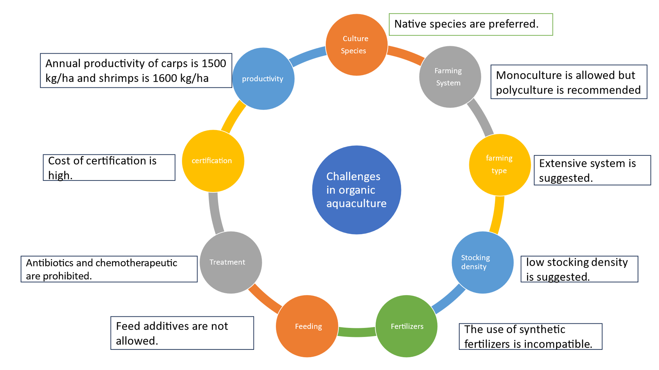

Fig no. 4 Challenges in organic aquaculture

**Conclusion**

Many organic aquaculture issues still need to be resolved. Steps should be taken to encourage and enhance the biological cycles with respect to nutrients management and to retain the integrity of the organic product from farmer to consumer and conversion requirement for moving conventional aquaculture system into organic system. For the answer to this question NGOs academia, government and organic sector have to work closely following the necessary guidelines. With continue emphasis on worldwide, aquaculture will emerge as the most environmentally friendly and efficient form of agriculture and as a partner in sustainable development.

DISCLAIMER (ARTIFICIAL INTELLIGENCE)

Author(s) hereby declare that NO generative AI technologies such as Large Language Models (ChatGPT, COPILOT, etc) and text-to-image generators have been used during writing or editing of this manuscript.

COMPETING INTERESTS

Authors have declared that no competing interests exist.

**COMPETING INTERESTS DISCLAIMER:**

Authors have declared that they have no known competing financial interests OR non-financial interests OR personal relationships that could have appeared to influence the work reported in this paper.

## References

Ahmed, N., Thompson, S. and Turchini, G. M. (2020). Organic aquaculture productivity, environmental sustainability, and food security: insights from organic agriculture. *Food Security*, **12**(6): 1253-1267.

Arya, P., Chauhan, R. S., Khati, A. and Nazir, I. (2017) Organic aquaculture: A boon to fisheries industry. *International Journal of Fauna and Biological Studies* **5**(1): 62-66.

Bergleiter, S. and Meisch, S. (2015). Certification standards for aquaculture products: Bringing together the values of producers and consumers in globalised organic food markets. *Journal of Agricultural and Environmental Ethics*, **28**: 553–569.

Biao, X. (2008). The development of and prospects for organic aquaculture worldwide. *Outlook on Agriculture*,**37**: 255–260.

Hilge V., (2005). Organic aquaculture in the world.*" Organic Aquaculture in the European Union*, **7**: 12-13

IFOAM, 2002 from: <http://www.fao.org/docrep/005/Y4137E/y4137e06.htm>

IFOAM, 2014. Norms for Organic Production and Processing. <http://www.ifoamhiifoamstandardww.ifoam.bio/en/default/files/draft_minutes_ga_2017_short_v9_0.pdf>.

Kaur R. and Shah, T.K. (2018). Organic fish farming: a pioneer approach towards sustainable fish farming. *Indian Farming* **68**: 34–36

Mente, E., Karalazos, V., Karapanagiotidis, I. T. and Pita, C. (2011). Nutrition in organic aquaculture: an inquiry and a discourse. *Aquaculture Nutrition*, **17(**4): 798-817.

Sandhu, H. S., Wratten, S. D. and Cullen, R. (2010). Organic agriculture and ecosystem services. *Environmental science and policy*, **13**(1): 1-7.

Sethi, S.N., Meena, D.K., Sahoo, A.K., Nayak, A.P., Sahoo, S.N., Tiwari, P.K. and Swain, S.K. (2023). Organic aquaculture: an overview 2nd Edn., *Advances in Resting-state Functional* *MRI*, pp 561-598.

Smith, O.M., Cohen, A.L., Rieser, C.J., Davis, A.G., Taylor, J.M., Adesanya, A.W. and Crowder, D.W. (2019). Organic farming provides reliable environmental benefits but increases variability in crop yields: A global meta-analysis. *Frontiers in Sustainable Food Systems*,**3**: 82**.**

Tasbozan, O. (2023). Organic Aquaculture and Organic Feeds. *Turkish Journal of Agriculture-Food Science and Technology*, **11**(4): 774-779.