Deficit Irrigation and Source of water: Possible Mitigation Option of Arsenic Load in Fodder Maize and Cowpea in Lower Gangetic Plain Zone of West Bengal, India

Abstract
Farmers of West Bengal grow fodder crops like maize, cowpea, lucerne, etc. in arsenic (As) contaminated areas during winter season (November to March) under irrigated condition. The experiment was executed in the arsenic contaminated village (Ghentugachhi) with Latitude of N 23º1′19.9′′ and Longitude of E 88º34′31.8′′, West Bengal, India during winter seasons 2017-18, 2018-19 and 2019-20. The total arsenic (As) found with the shallow tube well water was 0.120 mg L⁻¹ (mean value) and total arsenic content in pond water was 0.040 mg L⁻¹ (mean value). The experiment was planned in factorial experiment in split-split plot design. Number of crops was two (fodder maize and cowpea), source of irrigation was two and frequency of irrigation was three. The crops were, therefore, tested against two source of irrigations viz.: (i) Pond water and (ii) shallow tube well water; and frequency of irrigation water viz.: (i) Irrigation at 20 DAS, (ii) Irrigation at 20 and 35 DAS and (iii) Irrigation at 20, 35 and 50 DAS. The cowpea fodder crop received comparatively less arsenic uptake than maize fodder. Pond water irrigated fodder crops shows significantly less arsenic concentration in plant parts comparatively to shallow tube well water irrigated fodder crops. The frequency of irrigation considerably showed the variation of arsenic concentration in fodder crops. The crops irrigated with single irrigation showed less arsenic uptake in plant parts than the two or three irrigation. Among the edible parts leaf arsenic uptake is less than the shoots.
Key Words: Arsenic, mitigation, maize, cowpea, pond water, shallow tube well water and deficit irrigation
Introduction
In West Bengal, most of the rural farmers’ are depending on the mix-farming (crop + livestock) for their livelihood. And the state ranked fourth in the number accounting 37.48 million livestock in the country (Roy et al., 2021). However, the current production of fodder crops cannot provide the required feed demand for overall livestock production of the state as the availability of land for grazing/pasture is limited. In the state, mainly fodder crops like ricebean, fodder oat, fodder lathyrus, fodder maize, fodder cowpea etc., are grown. Mostly they are cultivated after paddy as their growing period is short which can be harvested within 60 DAS. In West Bengal, winter fodder crops are generally grown under fully irrigated condition. The farmers depend upon underground sources of water for irrigation purpose and the issue has acquired a serious attention due to uptake, translocation and biomagnifications of arsenic in various vegetables and food crops (Chakraborty et al., 2014) The world’s biggest health issues allied with arsenic are consuming contaminated aquifers water in Bangladesh and West Bengal, India, potentially infecting millions of individuals (Anawar et al., 2002). Green fodder is an important component of livestock feed and nutrition. Soil and water arsenic concentration lead its deposition in parts of plant fodder and forage crops which are found beyond the permissible limit set by European Union (EC 2003) standardized as maximum acceptable concentration (MAC) of 2 mg kg⁻¹ for arsenic in complete feedstuffs. In recent times, pollution of groundwater with arsenic (As) groundwater in the Gangetic alluvial zone of West Bengal (covering about 39,000 sq. km area) has arrested considerable amount of attention as millions (9-10 Millions) of individuals are suffering from this menace . The As concentration in groundwater (0.05 – 1.6 mg L⁻¹), published from the contaminated regions of West Bengal, are several degrees of magnitude higher than the set Indian standard for the admissible limit in drinking water (0.05 mg L⁻¹), which is also the maximum acceptable concentration, MAC, for drinking water in Bangladesh and other countries, besides the WHO guideline value i.e., 10 μg L⁻¹ (Edition, 2011). Bhattacharya et al., (2012) declared that the utilization of rainwater for irrigation in aerobic paddy was some attainable ways to reduce the extent of bio magnification of arsenic. Fodder crops grown in contaminated areas later fed to milch animals and subsequently, the milk is polluted by the contaminants i.e. As (Zubair et al., 2017) and is transported to other metro cities. Thereby widening its effect from affected to unaffected areas. The principal objective of our experiment was to reduce arsenic uptake in fodder crops by managing through frequency of irrigation water and sources
Materials and Methods
Location of the trial
The assessment was conducted in the farmer’s field located (latitude is N 23º1′19.9′′ and longitude is E 88º34′31.8′′) in an a village, Ghentugachhi, West Bengal, India, an area already contaminated with arsenic, in the winter seasons of 2017-18, 2018-19 and 2019-20. The content of total arsenic (As) in the shallow tube well water was in the extent of 0.116-0.127 mg L⁻¹ with an average value of 0.120 mg L⁻¹ and total arsenic content in pond water was in order of 0.039-0.041 mg L⁻¹ with average value 0.040 mg L⁻¹.
Soil and climate
The soil fundamental properties of the study location are given in Table i. Arsenic status in the contaminated areas was taken in four samples before sowing of the fodder crops viz. 14.32, 15.49, 14.45 and 15.90 mg kg⁻¹ in the same experimental plot at different location with average value of 15.04 mg kg⁻¹.

Details of crop types, variety, sowing and harvesting
The variety of fodder maize and cowpea, Ganga- 5 and CO-9, respectively, which are extensively grown in the arsenic concerned area of West Bengal, were chose for the study. The fodder crops were planted in first week (4th, Dec.) of December after harvesting of rice.

West Bengal
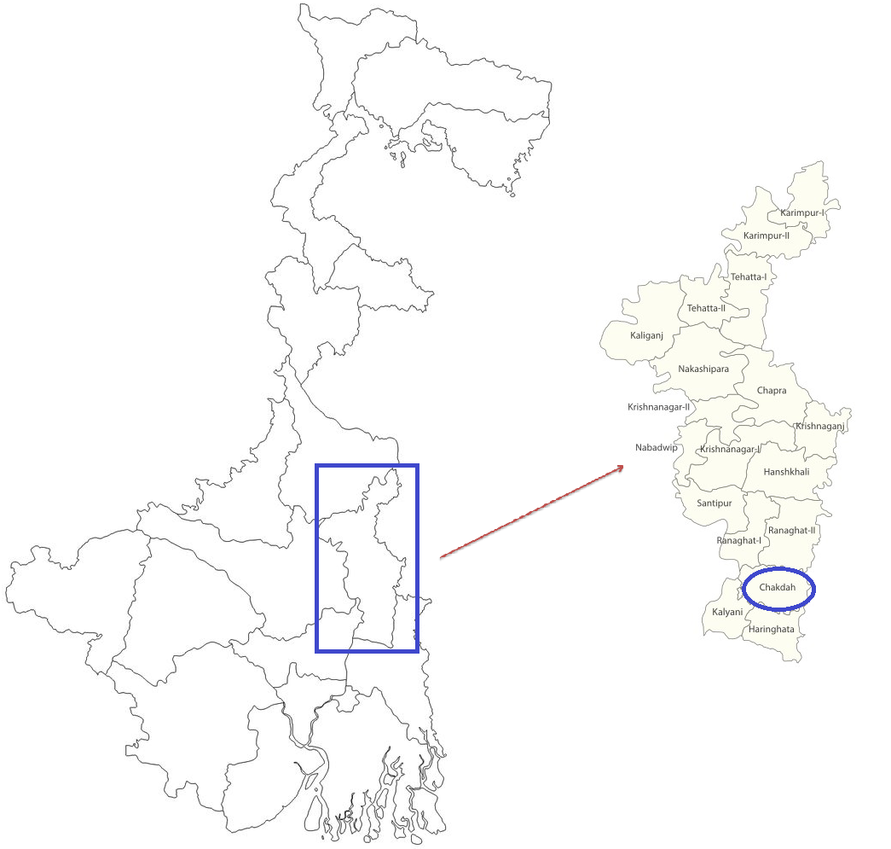

Fig.1 Map of West Bengal, district Nadia and Chakdaha block (Source: By author)
West Bengal

Experimentation
The assessment was carried out in factorial experiment in split-split plot design. Number of crops was two (fodder maize and cowpea), source of irrigation was two and frequency of irrigation was three. The crops were, therefore, tested against two sources of irrigations viz.: (i) Pond water and (ii) shallow tube well water; and three frequency of irrigation water viz.: (i) Irrigation at 20 DAS, (ii) Irrigation at 20 and 35 DAS and (iii) Irrigation at 20, 35 and 50 DAS. So, for the experiment, number of total treatments was 12 and replicated three times. The net plot size was 4m × 5m.
Nadia
Arsenic analysis
Samples (whole plant) were taken at different growth period, i.e., at 30, 45, 60 DAS and later root, shoot and leaf were separated each other. Samples of soil were air-dried and followed by ground and sieved through a sieve of 2 mm and kept in airtight polythene bags. For twenty four hours, the sampled plants were oven dried at 105◦C, ground and packed in airtight polythene bags. For determination of total arsenic, sampled plants were digested with tri-acid mixture which was made in the ratio of 10: 1: 4 by volume (HNO₃: H₂SO₄: HClO₄) and kept overnight before pre-digestion. With Whatman no. 24 filter paper, the solution was then filtered and volume was made up to desired amount. Later the solution was reduced with 5% mixture of KI and ascorbic acid after sufficient dilution, if required, prior to analysis and finally observed for total As by a Perkin Elmer AANALYST 200 AAS coupled with Flow Injection Analysis System (FIAS 400).
Statistical analysis
The data taken earlier were subjected to statistical analysis by the ANOVA method. And by Error of Mean Square through Fisher and Snedecor’s ‘F’ test at probability level 0.05 (Fisher and Yate,1963), the significance of different sources of variations were tested.
Results and Discussion
Accumulation of arsenic in different plant parts
Temporal variation in arsenic (As) content of various parts like root, shoot and leaf of fodder crops were estimated on 30, 45 and 60 DAS. Data base was generated for three consecutive years. Irrespective of treatments, pattern of accumulating arsenic was noticed in the order of root> shoot> leaf. This trend supported the outcomes of Sinha et al., (2011) and Sarkar et al., (2012) respectively for sesame and rice crops, grown in the same location. The bioavailability of arsenic depends on various factors. Like higher pH leads to increase in bioavailability of arsenic in plants (Huq et al., 2009).
The root As (arsenic) content at harvest was observed maximum with fodder maize at with values pooled over three years of 21.35 g ha⁻¹ which was 40.10 % higher than the other fodder i.e. cowpea. Arsenic content in roots (mg kg⁻¹) showed that among the fodder crops, maize fodder arsenic content was observed more than cowpea. Among the source of irrigation, root arsenic content was recorded more with irrigation from shallow tube well water (18.87 g ha⁻¹) than pond water (17.72 g ha⁻¹). Likewise, the arsenic content in roots was significantly different with different levels of irrigation. Fodder crops exhibited lower As accumulation with I₁ and I₂ than with I₃. Root arsenic content reduction with irrigation at 20 DAS (I₁) was 34.48% whereas in irrigation at 20 DAS and 35 DAS (I₂), the root arsenic content was found only 15.79% at harvest stage of crops from the arsenic content in roots with irrigation at 20 DAS, 35 DAS and at harvest i.e. 60 DAS. This might be the resultant effect of arsenic present in soil and irrigation water, higher it’s content, more will be absorbed by the crops (Bergqvist, 2011 and Rajmohan and Prathapar, 2014). Likewise different researchers had already concluded that arsenic concentration in root was much higher than any other plants parts. Hedayetullah et al., (2023) also postulated that arsenic present in soil leads to bioaccumulation of arsenic in lucerne fodder. Chaturvedi (2006) reported that arsenic extraction by plants increased with increasing soil arsenic concentration. Arsenic was predominantly concentrated in roots and less accumulation was observed in shoots (Devi et al., 2023).
The shoots As content observed in maize crop at harvest stage i.e.60 DAS with values pooled over three years was 12.55 g ha⁻¹ (Table ii). Whereas in cowpea crops, the shoots As content observed at harvest stage with pooled value over three years was 8.25 g ha⁻¹. The lower arsenic content was recorded in cowpea with value 8.00 g ha⁻¹ in 2017-18 at harvest stage (Table ii) and cowpea had pooled arsenic content in shoots of 34.26% reduction from maize crop. Arsenic in shoots (g ha⁻¹) showed that among the fodder crops, maize fodder observed more than cowpea in shoots. Arsenic was distributed in roots, shoots and leaves, as root>lower leaf>stalk>middle leaf>upper leaf (Cao et al., 2019; Chang et al., 2012 and Devi et al., 2023).Similarly, arsenic content in shoots was exhibited more with irrigation from shallow tube well water (10.69 g ha⁻¹) than pond water (10.11 g ha⁻¹). The arsenic content in shoots was significantly different with different levels of irrigation. Fodder crops exhibited lower As accumulation with I₁ and I₂ irrigation levels than with I₃ as more irrigation with polluted water will eventually increased the uptake of arsenic and its availability in shoots (Rajmohan and Prathapar, 2014). The shoots arsenic content reduction with irrigation at 20 days after sowing (I₁) was 35.93 % whereas irrigations given at 20 and 35 DAS (I₂) exhibited shoots arsenic content of 17.53 % at harvest stage of crops than the arsenic content recorded with I₃.
The leaves As content was observed with maize at 30, 45 DAS and harvest stage respectively with values pooled over three years r of 0.794 mg kg⁻¹, 1.552 mg kg⁻¹ and 1.670 mg kg⁻¹. Whereas in cowpea fodder crops, leaves As content was taken at 30, 45 DAS and 60 DAS with pooled value over three years of 0.689 mg kg⁻¹, 1.364 mg kg⁻¹ and 1.494 mg kg⁻¹ respectively (Table iii). The lowest arsenic content was recorded in cowpea with value 1.492 mg kg⁻¹ in 2019-20 at harvest stage. Arsenic in leaves (mg kg⁻¹) showed that among the fodder crops, maize got arsenic content more than cowpea. Similarly, at harvest the arsenic content in leaves was recorded more from irrigation with water from shallow tube well (1.626 mg kg⁻¹) than that of pond (1.537 mg kg⁻¹). Hedayetullah et al., (2011) disclosed that content of arsenic in leaves and shoots was more in more irrigation water from shallow tube well. Accumulation of arsenic present in leaves was noticed 5.47 % less in plot where crops were irrigated with PW (Pond water) than with STW (shallow tube well).The arsenic content in leaves was significantly different with different levels of irrigation. Hossain et al., (2008) disclosed that arsenic concentrations in Boro rice post harvest straw was increased significantly with increasing amount of As in water for irrigation. Fodder crops exhibited lower As accumulation with I₁ (1.492 mg kg⁻¹) and I₂ (1.592 mg kg⁻¹) levels than with I₃ (1.661 mg kg⁻¹). Leaves arsenic content reduction with irrigation at 20 DAS (I₁) was 10.17 % whereas in two irrigations levels, leaves arsenic content was only 4.15 % at harvest stage of crops than with I₃.
The arsenic in roots shoots and leaves of fodder crops were affected by the various sources water for irrigation and its frequency of irrigation. From the observations recorded, there was significant interaction effect among the treatments on arsenic concentration in roots, shoots and leaves of fodder crops at the time of harvest (60 DAS) only. The lowest arsenic in roots, shoots and leaves were present in cowpea fodder with pond water and irrigation at 20 DAS, 35 DAS and 50 DAS. The minimum was found with C₂×S₁×I₁ with 11.49 g ha⁻¹ and 6.00 g ha⁻¹ for roots, shoots and leaves respectively (Fig.2). This might be the results of less deposition of arsenic from source and frequency of irrigation water into soil (Hedayetullah et al., 2024).
Conclusions
The present experiment indicated that the cowpea legumes fodder crop observed comparatively less arsenic uptake than maize fodder crop. Pond water irrigated fodder crops showed significantly less arsenic concentration in plant parts comparatively to shallow tube well water irrigated fodder crops. The frequency of irrigation (deficit irrigation) considerably showed variation of arsenic concentration in fodder crops. The fodder crops irrigated with single irrigation showed less arsenic uptake in plant parts than the two or three irrigation levels. Among the edible parts, leaf arsenic uptake was less than the shoots. So, leaf arsenic concentration was always below safe limit or MAC in both fodder crops. Shoot arsenic was not safe, as its concentration has increased with increasing age of the fodder crops.

Table i Important physical chemical of aspects of soil
Particulars | Value
Mechanical constitution  Sand (g kg⁻¹)  Silt (g kg⁻¹)  Clay (g kg⁻¹) | 248.00  397.00  355.00
pH | 7.50
OC (g kg⁻¹)  Availability | 5.6
Nitrogen (kg ha⁻¹) | 220
Phosphorus (kg ha⁻¹) | 57
Potassium (kg ha⁻¹) | 190
Olsen extractable As (mg kg⁻¹) | 3.29
Total As (mg kg⁻¹) | 15.04

- Table ii Effects of fodder crops, source and frequency of irrigation on arsenic content of roots and shoots (g ha⁻¹) at harvest i.e. 60 DAS
Arsenic uptake in plant parts at harvest stage (g ha⁻¹)
Treatments | Root As |  |  |  | Shoot As
Treatments | 2017-18 | 2018-19 | 2019-20 | Pooled | 2017-18 | 2018-19 | 2019-20 | Pooled
Fodder crops
C₁ | 21.40 | 21.41 | 21.25 | 21.35 | 12.25 | 12.73 | 12.66 | 12.55
C₂ | 15.28 | 15.02 | 15.40 | 15.24 | 8.00 | 8.14 | 8.61 | 8.25
S. Em ± | 0.30 | 0.26 | 0.25 | 0.27 | 0.19 | 0.04 | 0.12 | 0.12
C.D (5 %) | 1.81 | 1.60 | 1.55 | 1.65 | 1.13 | 0.27 | 0.72 | 0.71
Sources of irrigation
S₁ | 17.76 | 17.69 | 17.69 | 17.72 | 9.81 | 10.23 | 10.31 | 10.11
S₂ | 18.92 | 18.74 | 18.96 | 18.87 | 10.44 | 10.65 | 10.97 | 10.69
S. Em ± | 0.06 | 0.10 | 0.02 | 0.06 | 0.08 | 0.04 | 0.01 | 0.05
C.D (5 %) | 0.26 | 0.41 | 0.06 | 0.24 | 0.32 | 0.17 | 0.05 | 0.18
Frequency of irrigation
I₁ | 14.45 | 14.29 | 14.45 | 14.40 | 7.97 | 8.30 | 8.05 | 8.11
I₂ | 18.50 | 18.35 | 18.68 | 18.51 | 10.09 | 10.40 | 10.83 | 10.44
I₃ | 22.07 | 22.02 | 21.84 | 21.98 | 12.33 | 12.61 | 13.03 | 12.66
S. Em ± | 0.26 | 0.18 | 0.41 | 0.28 | 0.21 | 0.24 | 0.09 | 0.18
C.D (5 %) | 0.77 | 0.53 | 1.22 | 0.84 | 0.64 | 0.71 | 0.28 | 0.54

C₁= Maize, C₂= Cowpea, S₁= Pond water, S₂= Shallow tube well water, I₁= Irrigation at 20 DAS, I₂= Irrigation at 20 DAS and 35 DAS, I₃= irrigation at 20 DAS, 35 DAS and 50 DAS, , NS= Not significant, DAS= Days after sowing.

Table iii Impacts of fodder crops, source and frequency of irrigation on arsenic content of leaves (mg kg⁻¹) at various stages of crop growth
Treatments | Arsenic in leaves (mg kg⁻¹)
Treatments | 30 DAS |  |  |  | 45 DAS |  |  |  | 60 DAS (Harvest stage)
Treatments | 2017-18 | 2018-19 | 2019-20 | Pooled | 2017-18 | 2018-19 | 2019-20 | Pooled | 2017-18 | 2018-19 | 2019-20 | Pooled
Fodder Crops
C₁ | 0.795 | 0.798 | 0.789 | 0.794 | 1.552 | 1.552 | 1.552 | 1.552 | 1.704 | 1.659 | 1.647 | 1.670
C₂ | 0.689 | 0.686 | 0.691 | 0.689 | 1.361 | 1.369 | 1.362 | 1.364 | 1.494 | 1.496 | 1.492 | 1.494
S. Em ± | 0.004 | 0.005 | 0.007 | 0.005 | 0.004 | 0.004 | 0.002 | 0.003 | 0.032 | 0.009 | 0.005 | 0.016
C.D (5 %) | 0.025 | 0.028 | 0.041 | 0.031 | 0.024 | 0.023 | 0.014 | 0.020 | 0.196 | 0.054 | 0.033 | 0.094
Source of irrigation
S₁ | 0.698 | 0.696 | 0.691 | 0.695 | 1.402 | 1.413 | 1.404 | 1.407 | 1.551 | 1.536 | 1.525 | 1.537
S₂ | 0.786 | 0.787 | 0.788 | 0.787 | 1.511 | 1.508 | 1.511 | 1.510 | 1.646 | 1.619 | 1.614 | 1.626
S. Em ± | 0.007 | 0.003 | 0.004 | 0.005 | 0.011 | 0.009 | 0.005 | 0.008 | 0.003 | 0.005 | 0.003 | 0.004
C.D (5 %) | 0.029 | 0.012 | 0.015 | 0.019 | 0.041 | 0.036 | 0.021 | 0.033 | 0.012 | 0.020 | 0.010 | 0.014
Frequency of irrigation
I₁ | 0.745 | 0.744 | 0.740 | 0.743 | 1.381 | 1.389 | 1.383 | 1.384 | 1.494 | 1.497 | 1.485 | 1.492
I₂ | 0.745 | 0.734 | 0.741 | 0.740 | 1.494 | 1.501 | 1.494 | 1.496 | 1.609 | 1.589 | 1.579 | 1.592
I₃ | 0.737 | 0.747 | 0.738 | 0.741 | 1.494 | 1.491 | 1.496 | 1.494 | 1.693 | 1.646 | 1.645 | 1.661
S. Em ± | 0.007 | 0.008 | 0.007 | 0.008 | 0.007 | 0.006 | 0.009 | 0.007 | 0.010 | 0.005 | 0.005 | 0.006
C.D (5 %) | NS | NS | NS | NS | 0.021 | 0.017 | 0.026 | 0.021 | 0.029 | 0.014 | 0.015 | 0.019
C₁= Maize, C₂= Cowpea, S₁= Pond water, S₂= Shallow tube well water, I₁= Irrigation at 20 DAS, I₂= Irrigation at 20 DAS and 35 DAS, I₃= irrigation at 20 DAS, 35 DAS and 50 DAS, DAS= Days after sowing, NS= Not significant.

Contd.
Treatment combinations | Arsenic content in leaves (mg kg⁻¹)
Treatment combinations | 30 DAS |  |  |  | 45 DAS |  |  |  | 60 DAS (Harvest stage)
 | 2017-18 | 2018-19 | 2019-20 | Pooled | 2017-18 | 2018-19 | 2019-20 | Pooled | 2017-18 | 2018-19 | 2019-20 | Pooled
Fodder Crops × Source of Irrigation × Frequency of Irrigation
C₁×S₁×I₁ | 0.750 | 0.756 | 0.740 | 0.749 | 1.448 | 1.442 | 1.446 | 1.445 | 1.585 | 1.558 | 1.539 | 1.561
C₁×S₁×I₂ | 0.757 | 0.750 | 0.745 | 0.750 | 1.533 | 1.551 | 1.530 | 1.538 | 1.663 | 1.635 | 1.623 | 1.641
C₁×S₁×I₃ | 0.741 | 0.751 | 0.738 | 0.744 | 1.537 | 1.534 | 1.532 | 1.534 | 1.751 | 1.700 | 1.684 | 1.712
C₁×S₂×I₁ | 0.842 | 0.846 | 0.824 | 0.837 | 1.528 | 1.532 | 1.531 | 1.530 | 1.658 | 1.629 | 1.627 | 1.638
C₁×S₂×I₂ | 0.832 | 0.840 | 0.848 | 0.840 | 1.632 | 1.625 | 1.637 | 1.631 | 1.765 | 1.717 | 1.702 | 1.728
C₁×S₂×I₃ | 0.850 | 0.842 | 0.838 | 0.844 | 1.636 | 1.630 | 1.638 | 1.635 | 1.798 | 1.715 | 1.709 | 1.741
C₂×S₁×I₁ | 0.657 | 0.637 | 0.657 | 0.650 | 1.202 | 1.244 | 1.226 | 1.224 | 1.264 | 1.324 | 1.313 | 1.300
C₂×S₁×I₂ | 0.654 | 0.626 | 0.630 | 0.636 | 1.348 | 1.368 | 1.343 | 1.353 | 1.460 | 1.474 | 1.452 | 1.462
C₂×S₁×I₃ | 0.631 | 0.657 | 0.638 | 0.642 | 1.346 | 1.340 | 1.347 | 1.344 | 1.581 | 1.524 | 1.539 | 1.548
C₂×S₂×I₁ | 0.731 | 0.737 | 0.739 | 0.736 | 1.346 | 1.338 | 1.327 | 1.337 | 1.466 | 1.477 | 1.459 | 1.468
C₂×S₂×I₂ | 0.737 | 0.721 | 0.741 | 0.733 | 1.464 | 1.461 | 1.464 | 1.463 | 1.548 | 1.528 | 1.539 | 1.538
C₂×S₂×I₃ | 0.725 | 0.737 | 0.739 | 0.734 | 1.458 | 1.462 | 1.467 | 1.462 | 1.643 | 1.647 | 1.647 | 1.645
S. Em (±) (C×S) | 0.010 | 0.004 | 0.005 | 0.007 | 0.015 | 0.013 | 0.008 | 0.012 | 0.004 | 0.007 | 0.004 | 0.005
C.D (5 %) | NS | NS | NS | NS | NS | NS | NS | NS | 0.127 | 0.040 | 0.024 | 0.064
S. Em (±) (C×I) | 0.010 | 0.012 | 0.010 | 0.011 | 0.010 | 0.008 | 0.012 | 0.010 | 0.014 | 0.007 | 0.007 | 0.009
C.D (5 %) | NS | NS | NS | NS | NS | NS | NS | NS | 0.102 | 0.031 | 0.023 | 0.052
S. Em (±) (S×I) | 0.010 | 0.012 | 0.010 | 0.011 | 0.010 | 0.008 | 0.012 | 0.010 | 0.014 | 0.007 | 0.007 | 0.009
C.D (5 %) | NS | NS | NS | NS | NS | NS | NS | NS | 0.035 | 0.023 | 0.018 | 0.025
S. Em (±)(C×S×I) | 0.015 | 0.017 | 0.014 | 0.015 | 0.014 | 0.011 | 0.017 | 0.014 | 0.020 | 0.009 | 0.010 | 0.013
C.D (5 %) | NS | NS | NS | NS | NS | NS | NS | NS | 0.059 | 0.028 | 0.029 | 0.039
C₁= Maize, C₂= Cowpea, S₁= Pond water, S₂= Shallow tube well water, I₁= Irrigation at 20 DAS, I₂= Irrigation at 20 DAS and 35 DAS, I₃= irrigation at 20 DAS, 35 DAS and 50 DAS, NS= Not significant, DAS= Days after sowing

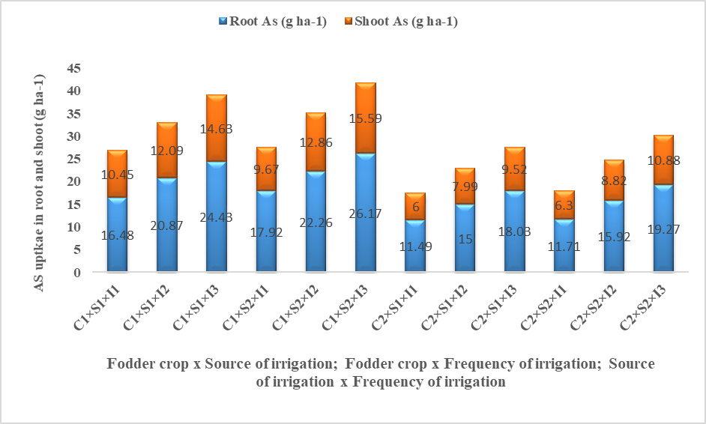
Fig. 2 Interaction effects on the As uptake in root and shoot at harvest stage (pooled over three years i.e.2017-18, 2018-19 and 2019-20)

References
Anawar, H.M., Akai, J., Mostofa, K.M.G., Safiullah, S. and Tareq, S.M. (2002). Arsenic poisoning in groundwater: health risk and geochemical sources in Bangladesh. Environment International. 27(7):597-604. https://doi.org/10.1016/S0160-4120(01)00116-7
Bergqvist, C. (2011). Arsenic accumulation in various plant types. [Doctoral dissertation, Department of Botany, Stockholm University].
Bhattacharya, S., Gupta, K., Debnath, S., Ghosh, U.C., Chattopadhyay, D. and Mukhopadhyay, A. (2012). Arsenic bioaccumulation in rice and edible plants and subsequent transmission through food chain in Bengal basin: a review of the perspectives for environmental health. Toxicological & Environmental Chemistry. 94(3): 429-441. https://doi.org/10.1080/02772248.2012.657200
Cao, X., Bai, L., Zeng, X., Zhang, J., Wang,Y., Wu, C. and Su, S. (2019). Is maize suitable for substitution planting in arsenic contaminated farmlands? Plant Soil & Environment. 65(9). https://doi.org/10.17221/155/2019
Chakraborty, S., Alam, M. O., Bhattacharya, T. and Singh, Y. N. (2014). Arsenic accumulation in food crops: a potential threat in Bengal delta plain. Water Quality, Exposure and Health. 6: 233-246. https://link.springer.com/article/10.1007/s12403-014-0122-x
Chang, S.C.S., Jia, J. D., Tian, T.Z. and Ma, X.M.X. (2006). Effects of arsenic application on absorption, accumulation and distribution of arsenic in flue-cured tobacco. Journal of Henan Agricultural University. 40 (5): 486-489. https://doi/full/10.5555/20073191062
Devi, N. M., Kundu, C.K., Ghosh, M., Bhattacharyya, K., Banerjee, H. and Majumder, A. (2023). Arsenic acquisition pattern in different plant parts of aromatic rice cultivars. Environment Conservation Journal. 24(1): 238-242. https://doi.org/10.36953/ECJ.12932366
EC European Commission .(2003). Opinion of the scientific committee on animal nutrition on undesirable substances in feed. Brussels, European Commission of Health and Consumer Protection Directorate.
Edition, F. (2011). Guidelines for drinking-water quality. WHO chronicle. 38(4): 104-8.
Fisher, R. A. and Yates, F. (1963). Statistical tables for biological, agricultural and medical research, edited by ra fisher and f. yates. Edinburgh: Oliver and Boyd.
Ghosh K, Das I, Saha S, Banik G C, Ghosh S, Maji N C, Sanyal S K (2004) Arsenic chemistry in groundwater in the Bengal Delta Plain: Implications in agricultural system. Journal of Indian Chemical Society. 81(12):1063-1072.
Hedayetullah, M., Kundu, C. K., Basu, B., Sarkar, S. (2011). Effect of sources of irrigation water on growth and arsenic content in different fodder crops. Journal Crop and Weed. 7 (2): 244-246.
Hedayetullah, M., Kundu, C. K., Rajbanshi, B., Tamang, D., Mondal, S., Akhtar, J., Mondal, B., Das, S., Devi, N. M. and Hossain, S. S. (2024). Reduction of Arsenic Load in Winter Fodder Crops as Influenced by Shallow Tube Well and Pond Water Irrigation. International Journal of Environment and Climate Change. 14(8):314-320. https://doi.org/10.9734/ijecc/2024/v14i84352
Hossain, M., Islam, M. R., Jahiruddin, M., Abedin, A., Islam, S., Meharg, A. A. (2008). Effects of arsenic contaminated irrigation water on growth, yield and nutrient concentration in rice. Communications in Soil Science and Plant Analysis. 39 (1/2): 302-313. https://doi.org/10.1080/00103620701759335
Huq S I, Parvin K, Rahman S, Joardar J C (2009) Response of cowpea (Vigna sinensis L.) to arsenic. Canadian Journal of Pure and Applied Sciences, 897.
Raichev, T., Arsova, A., Popandova, S., Sokolowska, Z., Hajnos, M. and Jozefaciuk, G. (2001). Effect of coal powder and liming on arsenic uptake by alfalfa from Cu and As polluted acidic soil. Polish Journal of Soil Science. 34: 13-17. cabidigitallibrary.org/doi/full/10.5555/20023011507
Rajmohan, N. and Prathapar, S. A. (2014). Extent of arsenic contamination and its impact on the food chain and human health in the eastern Ganges Basin: A review.
Roy, B.C., Mondal, B., Majumder, D., Biswas, R. K. and Roy, A. (2021). Agro-economic research assessment of livestock feed and fodder in the state of West Bengal. Agricultural Situation in India. 36-40. cabidigitallibrary.org/doi/full/10.5555/20220029195
Sarkar, S., Basu, B., Kundu, C. K. and Patra, P. K. (2012). Deficit irrigation: An option to mitigate arsenic load of rice grain in West Bengal, India. Agriculture, Ecosystems and Environment. 146(1): 147-152. https://doi.org/10.1016/j.agee.2011.10.008
Sinha, B., Bhattacharyya, K., Giri, P. K. and Sarkar, S. (2011). Arsenic contamination in sesame and possible mitigation through organic interventions in the lower Gangetic Plain of West Bengal, India. Journal of the Science of Food and Agriculture. 91(15): 2762-2767. https://doi.org/10.1002/jsfa.4519
Zubair, M., Martyniuk, C. J. and Shaheen, A. (2018). Rising level of arsenic in water and fodder: a growing threat to livestock and human populations in Pakistan. Toxin Reviews. 37(3): 171-181. https://doi.org/10.1080/15569543.2017.1348360
Conflicts of interest statement
The authors whose name are listed immediately below certify that they have ‘No’ affiliations with or involvement in any organization or entity with a financial or non-financial interest in the subject matter or materials discussed in this manuscript.

