**Assessing the impacts of land use land cover changes and rainfall trends in the Ken River Basin, India**

**Abstract**

The aim of this research was to assess the Land Use Land Cover (LULC) changes and predict the historical and future trends in rainfall for the Ken Basin in India. The study utilized various data sources, including Landsat imagery, to analyze LULC changes. Future rainfall predictions were based on daily bias-corrected datasets from the INMCM5 climate model under the Shared Socioeconomic Pathway 585 (SSP585), which represents a scenario of high fossil fuel development. The results revealed that, among the six land use classes, forests and agriculture were the predominant land cover types, comprising 50.32% and 25.89%, respectively, in 2006. However, by 2022, the agricultural land increased to 58.22%, while the forest area significantly declined to only 7.79%. The change matrix analysis indicated that the majority of forested land had been converted into open forests, which raises concerns for the region's ecological stability. In terms of rainfall, historical data from 1982 to 2018 showed a decreasing trend, with a Sen slope value of -4.9493 mm/year. In contrast, future rainfall predictions for the period 2019-2055 indicated an increasing trend, with a Sen slope value of 7.1491 mm/year. The combined loss of forest land and the anticipated increase in rainfall presents significant challenges for the study area, emphasizing the need for integrated land and water management strategies. The findings of this research provide valuable insights for planners and policymakers, offering a framework for future conservation efforts in similar basins.

Key word: LULC, Rainfall, Trend analysis, Sen slope

1. **Introduction**

Land use/cover (LULC) and climate are two critical environmental factors that influence ecosystems across global, regional, and local scales (Zhang et al.,2016; Wang et al., 2014; Kumar et al.,2023; He et al.,2019; Tuohetahong et al., 2024). Changes in land use/cover composition are dynamic, widespread, and accelerating processes primarily driven by both natural phenomena and anthropogenic activities, which ultimately affect an ecosystem (Tang et al., 2006; Southworth et al., 2004; Kamusoko and Aniya., 2007; Günlü et al., 2009). In contrast, changes in land surface characteristics directly affect land surface-atmosphere interactions, thereby altering atmospheric properties, which in turn contribute to climate variability and unpredictable rainfall patterns (Yin et al., 2017; Hajihosseini et al., 2019; Alemayehu et al., 2023). Also, changes in land-use practices impact the energy budget of the land surface, evapotranspiration, groundwater percolation, and runoff, which in turn influence the regional climate system (Alemayehu et al.,2023). Recent research also suggests that LULC changes affect temperature and precipitation extremes (Gogoi et al., 2019; Nayak and Mandal 2019). LULC change and climate change are interconnected, as alterations in land cover impact the atmospheric energy balance, influencing rainfall and temperature patterns, while, conversely, LULC is also affected by changes in weather patterns (Kayitesi et al., 2022). Changes in land use and land cover at local scale gradually extend to regional and even larger scales, ultimately contributing to significant alterations in the global environment (Minale and Rao 2012; Laux et al., 2017). Therefore, it is essential to first consider local and regional LULC changes to understand their effects on the corresponding climate at these scales.

As land use is dynamic in nature, an understanding of underlying processes requires regular monitoring to detect areas of rapid change and to ascertain reasons and drivers of change (Dimobe et al., 2015). In order to understand land use changes, the use of remote sensing data coupled with appropriate classification methods is essential ([Roy et al., 2014](https://www.sciencedirect.com/science/article/pii/S0034425722003728" \l "bb0835) ; Singh et al., 2016; Kumar et al., 2018; Ustin and Middleton, 2021). Remote sensing satellite images provide a tremendous capability to observe and capture the different processes occurring on the earth surface at regular intervals of time, and with high spatial resolution whereas land use classification is a method used to delineate and differentiate various land use types ([Belward and Skøien, 2015](https://www.sciencedirect.com/science/article/pii/S0034425722003728" \l "bb0040); [Ustin and Middleton, 2021](https://www.sciencedirect.com/science/article/pii/S0034425722003728" \l "bb1020);  [Kennedy et al., 2014](https://www.sciencedirect.com/science/article/pii/S0034425722003728" \l "bb0445); [Zhu, 2017](https://www.sciencedirect.com/science/article/pii/S0034425722003728" \l "bb1205); [Shang et al., 2022](https://www.sciencedirect.com/science/article/pii/S0034425722003728#bb0925); Zhu et al., 2022). Over time, several classification and change detection techniques have been developed, enabling the generation and visualization of land use information through maps for relevant stakeholders ([Singh, 1989](https://www.sciencedirect.com/science/article/pii/S0034425722003728" \l "bb0935); [Wulder et al., 2018](https://www.sciencedirect.com/science/article/pii/S0034425722003728" \l "bb1105); [Kennedy et al., 2009](https://www.sciencedirect.com/science/article/pii/S0034425722003728" \l "bb0455); [Vogelmann et al., 2016](https://www.sciencedirect.com/science/article/pii/S0034425722003728" \l "bb1045) ).

On the other hand, understanding of climatic variability is necessary to appreciate the impacts of climate change (Jain and kumar 2012;).Although climate change is vast area, the changing patterns of rainfall emerge as a particularly critical topic within this field that deserves urgent and systematic attention, since it affects both the availability of freshwater and food production ((Dore, 2005; Kumar et al., 2010). The importance of nonparametric Mann–Kendall (MK) test (Kendall, 1975; Mann, 1945) is most frequently used method to understand the rainfall trend at global, continental, regional and local scales (Jain & Kumar, 2012; Kumar el.al., 2016; Pant & Kumar, 1997; Mahato et al., 2021).

Many earlier studied on LULC change and climatic variable at various spatio-temporal scales using geospatial technology to understand and quantify the change in recent past (Kayitesi et al., 2022; Alemayehu et. al., 2023; Kumar et al.,2023).

The study area has been identified as a mostly dominated by agriculture and forest land. Understanding the human impact and important climatic variables in this part of the world is a big challenge for researcher. Time to time change in LULC and rainfall of Ken basin need to be evaluated as this basin reported more runoff during monsson season (Murty et al.,2014).

The LULC change, past and future trend of rainfall could reveal valuable and detailed information of land and climate condition. Such information can lead in formulating appropriate policies/suggestions toward better management of the resources including water and agriculture in the study area. Hence, the present study was conducted with the following objectives to (1) to find the LULC change and change matrix of the area (2) determine the magnitude of trend, slope and its statistical significance of past rainfall data, and (3) find out the future prediction of rainfall and its trend to understand the pattern of future rainfall.

**2. Material and Method**

**Study area**

The Ken River Basin, situated in central India, spans across Madhya Pradesh and Uttar Pradesh, covering approximately 28,058 km2. Geographically, it is positioned between latitudes 23°20′N to 25°20′N and longitudes 78°30′E to 81°10′E (Fig.1). Basin is originating near Ahirgawan village in Katni district, Madhya Pradesh, and flows northward for 427 km, eventually merging with the Yamuna River in Banda district, Uttar Pradesh. The basin's topography is diverse, featuring plateaus, plains, and the Vindhyan Range to the west. It exhibits a dendritic drainage pattern, fed by major tributaries such as the Kuthar, Bearma, Sonar, and Urmil rivers. The region experiences a subtropical climate, characterized by hot summers, a distinct monsoon season, and mild winters, with an average annual rainfall ranging from 800 to 1,200 mm. Ecologically, the basin holds great significance, being home to the Panna Tiger Reserve and unique geological formations like the Raneh Falls, renowned for its volcanic rock structures. Furthermore, the Ken-Betwa River Linking Project is a pivotal initiative aimed at enhancing water availability, irrigation, and regional water security.

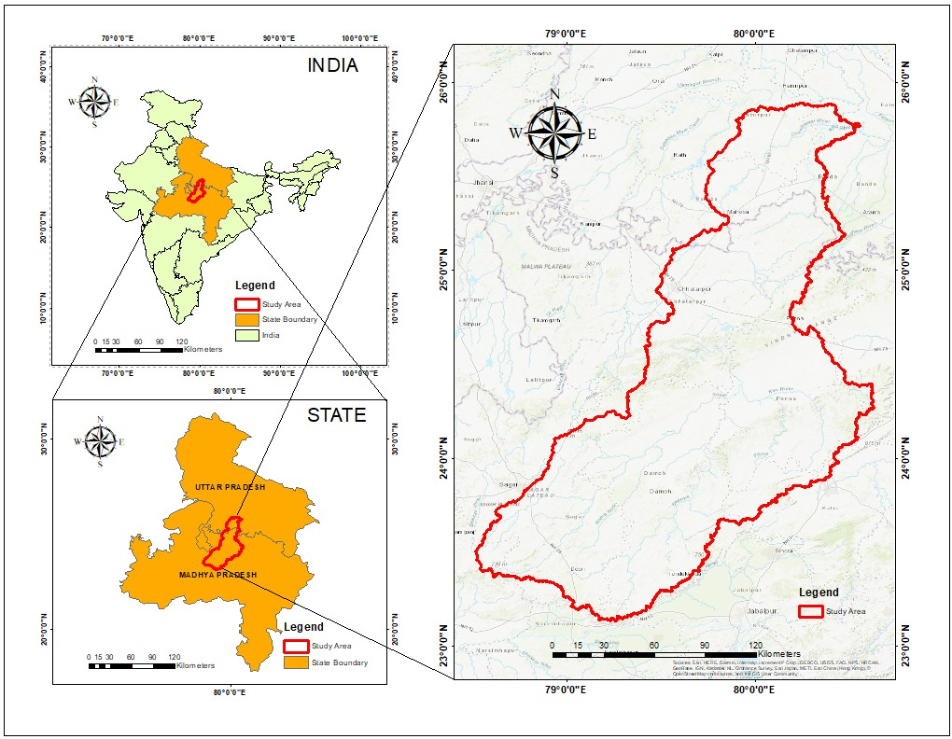

Fig1: Map of the Ken basin, the Ken basin lies in state Uttar Pradesh and Madhya Pradesh, India.

**Data use**

Table 1 shows the dataset used in this study. Geometrically corrected Landsat satellite images of month/ year, February 2006, and February 2022, were procured from USGS site (USGS; http:// www. usgs. gov/ in) and details of the satellite data are shown in Table 2.

**Table 1 Data used and their sources**

|  |  |  |  |
| --- | --- | --- | --- |
| SI. no | Parameters | Year | Procured |
| 1. | Land use/land cover | 2006, 2022 | http://www.usgs.gov/in |
| 2. | Meteorological data | 1982-2018 | http://gisserver.civil.iitd.ac.in/grbmp/downloaddataset.aspx |

**Table 2 Details of Landsat satellite images**

|  |  |  |  |  |
| --- | --- | --- | --- | --- |
| Satellite | Date & Year | Path/Row | Band Used | Spatial Resolution (m) |
| Landsat 5 | 5th and 21st Feb 2006 | 144/42,43,44 | 1,2,3,4,5 | 30 |
| Landsat 8&9 | 16th ,17th, 24th ,26th Feb 2022 | 144/42,43,44 | 2,3,4,5,6 | 30 |

**Methodology**

The geometrically and radiometrically corrected Landsat images were applied to prepare a thematic land use map employing on-screen visual interpretation in ArcGIS Pro 3.01. To maintain consistency, the visual interpretation was carried out at 1:50,000 scale. The identification and classification of different features were conducted based on fundamental image characteristics like tone, texture, association shape, size, pattern, shadow, and location (Table 3).

Table 3: Interpretation key used in this study

|  |  |  |  |  |  |  |  |
| --- | --- | --- | --- | --- | --- | --- | --- |
| **S N** | **LU/LC Category** | **Tone** | **Size** | **Shape** | **Texture** | **Pattern** | **Association** |
| **1** | Agriculture | Autunite Yellow | Small to big | Regular to  irregular | Medium  to smooth | Contiguous to noncontiguous | Proximity to  rivers/canal/streams and settlements |
| 2 | Bare Ground | Cabernet | Small to big | Regular to  irregular | Medium  to smooth | Contiguous to noncontiguous | Amidst or near to crop land |
| 3 | Built up Land | Mars Red | Small to big | Irregular | Coarse &  mottled | Clustered to  scattered | Surrounded by  agricultural lands,  forest cover,  wastelands, river, road, and rail etc. |
| 4 | Forest | Fir Green | Varying in  size | Irregular | Smooth to  medium  depending  on crown | Contiguous to noncontiguous | With different forest types and species in undulating areas |
| 5 | Open Forest | Tarragon Green | Varying in  size | Regular to  irregular | coarse | Contiguous to noncontiguous | Forest fringes and amidst forest areas |
| 6 | Water | Light blue to dark  blue | Long  narrow to  wide | Irregular  sinuous | Smooth to  medium | Contiguous,  non-linear to  dendritic/  subdendritc | hill slopes, flood  plains, uplands etc., |

As an initial processing step, a detailed land use map of 2006 and 2022 was prepared using visual digitization. The satellite image of the winter season (February), which is characterized by maximum rabi crop stand on the agricultural land, was used to digitize the different land use classes. After that visually digitized images for both the year were overlaid and changes in land use classes were observed on the satellite imagery. Those polygons where no changes were detected remained constant boundaries (same class) whereas change polygons were identified and edited in different land use classes.

## **Pixel based comparison (cross tabulation)**

In time series land use change, there will be two possibilities: (i) Portion of land use class (or complete land use) for a specific area will change from one class to another or (ii) there will be no land use change. Cross tabulation is a means to determine amounts of conversions from a particular Land cover to the other Land cover categories at later date. In order to detect the areas of change and no change and further to estimate the change in proportion of area from one class to another class, classified images in pairs (2002-2022), using pixel-based comparison (cross-tabulation) method was performed.

**Future prediction of climatic variables**

The INMCM5 climate model, developed by the Institute of Numerical Mathematics (INM) of the Russian Academy of Sciences, is widely used for climate predictions and has been employed in this study to understand future climate conditions, particularly under various greenhouse gas emission scenarios. For the current study, daily bias-corrected and spatially disaggregated data of precipitation was obtained from Mishra et al. (2020).

**MK Test**

In this study, the trends in past and future rainfall were detected using the nonparametric MK test (Mann, 1945; Kendall, 1975) because it exhibits a better performance than the parametric test (Nalley et al., 2012). The details and various steps of this method have been discussed in numerous studies (Yue et al., 2002; Nalley et al., 2012; Suryavanshi et al., 2014; Mahato et al., 2021). The MK test has been employed by several researchers to understand the trend in climatological data (Zhang et al., 2022; Jiqin et al., 2023)

The Mann–Kendall test is based on the statistic S, which is calculated using the formula

$$S=\sum_{i=1}^{n-1}{\sum_{j=i+1}^{n}{a_{ij}}}$$

Where,

$a_{ij}=sgn\left(x_{j}-x_{i}\right)=\left\{\begin{aligned} 1 x_{j}<x_{i} \\ 0 x_{j}=x_{i} \\ 1 { x}_{j}˃ x_{i}\end{aligned}\right\}$ (1)

and Ri and Rj are the ranks of observations xi and xj of the time series, respectively.

It has been documented that when n ≥10, the statistic S is approximately normally distributed with the mean zero and a variance is

$VAR\left(S\right)=\frac{n\left(n-1\right)\left(2n+5\right)-\sum_{i=1}^{m}{t_{i}\left(t_{i}-1\right)\left({2t}_{i}+5\right)}}{18}$ (2)

Where n is the number of data points, m is the number of tied groups (a tied group is a set of sample data having the same value), and ti is the number of data points in the ith group. A very high positive value of S is an indicator of an increasing trend, and a very low negative value indicates a decreasing trend.

The standardized test statistic Z is computed as follows:

$Z=\left\{\begin{aligned}\frac{S-1}{\sqrt{VAR(S)}} if S>0 \\ 0 if S=0 \\ \frac{S+1}{\sqrt{VAR (S)}} if S<0\end{aligned}\right.$ (3)

The null hypothesis, H0, meaning that no significant trend is present, is accepted if the test statistic Z is not statistically significant, i.e. –Zα/2< Z< Zα/2, where Zα/2 is the standard normal deviate. In this study, three different significance levels i.e. 1%, 5% and 10% is considered.

**3. Result and discussion**

**3.1 Spatial extent of land use land cover change**

LULC change throughout the study period is presented in Table 4 and Fig. 2, respectively. In year 2006, forests and agricultural areas were the dominant land use and land cover class. However, by year 2022, agricultural land had expanded, while forest areas had decreased. The area dedicated to agriculture grew from 14440.46 km2 in 2006 to 16709.64 km2 in 2022. In contrast, dense forests have been in sharp decline, with their area shrinking by 7.79% in 2022 which was 25.89% by 2006. The primary drivers of this forest loss and fragmentation include the expansion of settlements, the conversion of land for agriculture, and various developmental activities. This increase in agricultural land can be attributed to the rising human population in the region, which relies heavily on agriculture and related industries for both economic development and sustenance. The findings of this research are supported by numerous studies worldwide, which indicate that the expansion of agricultural land and urban areas are key proximate causes of forest degradation (Southworth et al., 2004; Abdullah and Nakagoshi, 2007; WoldeYohannes et al.,2018; Kumar et al.,2018; Dibaba et al.,2020a). Additionally, built-up areas increased to 813.26 km2 during the study period, reflecting urban expansion. As the population continues to grow, the agricultural sector is under pressure to meet the increasing demand for food. To accommodate this, more land has been converted to agricultural use. Meanwhile, open forest experienced significant growth, increasing from 3217.77 km2 to 8527.56 km2 over the studied period. This expansion could be attributed to the conversion of other land types into grazing areas to support the growing demand for livestock production, as well as possible afforestation initiatives or changes in land management practices.

Table 4: Temporal LULC change analysis

|  |  |  |  |  |  |
| --- | --- | --- | --- | --- | --- |
| LULC Class | **2005** | | **2022** | | **Change (km2)** |
| **Area (km2)** | **% area** | **Area (km2)** | **% area** |
| **Agriculture** | 14440.46 | 50.32 | 16709.56 | 58.22 | -2269.18 |
| **Bare ground** | 3108.09 | 10.83 | 2.81 | 0.01 | 3105.28 |
| **Built-up** | 81.86 | 0.29 | 895.21 | 3.12 | -813.26 |
| **Forest** | 7431.74 | 25.89 | 2236.38 | 7.79 | 5195.25 |
| **Open forest** | 3217.77 | 11.21 | 8527.56 | 29.71 | -5309.69 |
| **Water** | 425.09 | 1.46 | 333.49 | 1.14 | 91.599 |
|  | 28705.02 | 100 | 28705.02 | 100 |  |

|  |  |
| --- | --- |
| (a) | (b) |

Fig.2 Classified imagery for the year (a) 2006 (b) 2022 using on screen visual interpretation.

**3.2 Change matrix (2006 to 2022)**

Land cover change matrix using the classified data for the years 2006 and 2022 is presented in Table 5 and fig. 3. It is apparent that the total area (7431.74 km2) of forest land during 2006–2022 has been converted to open forest (5063.559 km2), built up land (12.9483 km2), and water body (16.49 km2) ultimately reducing the forest area to 2035.17 km2. In case of agriculture land 1018.62 km2 land is converted into open forest, 105.63 km2 area into waterbody and 605.63 km2 area into built up land and 12669.77 km2 area is left as agriculture land. Whereas LULC class Bare ground 2555 km2, forest 319 km2, open forest 964 km2 submerge to agriculture land. It has also been absorbed that most of the bare land is converted into either agriculture land or water body.

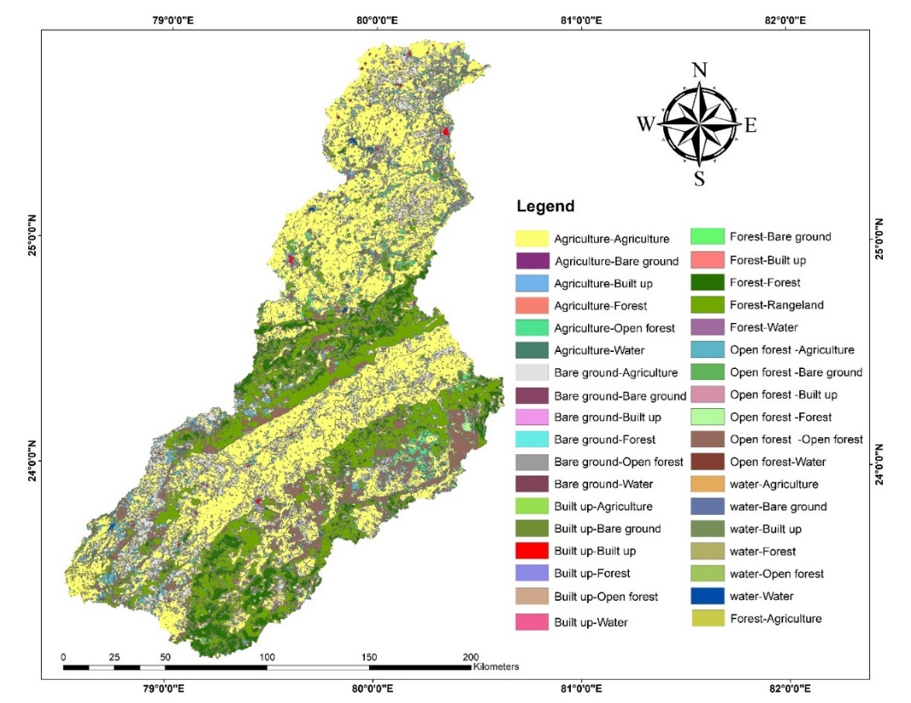

Fig3: Change in LULC map for the year 2006-2022

Table 5Change matrix on land cover class between the year 2006 and 2022

|  |  |  |  |  |  |  |  |  |  |
| --- | --- | --- | --- | --- | --- | --- | --- | --- | --- |
| **LULC Classes** | | 2022 | | | | | | | |
| Agriculture | Bare ground | Built up | Forest | Open forest | Water | **Total** |
| 2006 | Agriculture | 12669.77 | 5.86 | 605.63 | 34.96 | 1018.62 | 105.63 | 14440.47 |
| Bare ground | 2555.00 | 1.38 | 126.71 | 9.12 | 385.25 | 30.64 | 3108.09 |
| Built up | 20.59 | 5.13 | 54.33 | 0.39 | 4.85 | 1.58 | 86.86 |
| Forest | 319.00 | 2.09 | 12.95 | 2017.66 | 5063.56 | 16.49 | 7431.74 |
| Open forest | 964.00 | 2.93 | 87.36 | 168.92 | 1964.32 | 30.24 | 3217.78 |
| Water | 175.68 | 0.97 | 8.30 | 4.13 | 87.15 | 143.85 | 420.09 |
|  | **Total** | 16704.03 | 18.36 | 895.28 | 2235.17 | 8523.76 | 328.44 | 28705.03 |

**3.3 Trend analysis of Rainfall**

Yearly rainfall was analyzed for a period of (1982-2018) and (2019-2055) using MK Test. Lag1 serial correlation coefficient, the MKz value and significant level of trends, slope, intersection, and Total change has been presented in Table 6.

**Table: 6 Rainfall trend of Ken basin for the 1982-2018 and 2019-2055**

|  |  |  |  |  |  |
| --- | --- | --- | --- | --- | --- |
| **Rainfall data** | **r1** | **zmk** | **Trend** | **Sen slope (mm/year)** | **Total Change(mm)** |
| 1982-2018 | -0.2704 | -1.3733 | 0 | -4.9493 | -183.124 |
| 2019-2055 | -0.1039 | 1.5564 | 0 | 7.1491 | 264.5167 |

For the year 1982-2018 zmk value of -1.3733 (a negative value) indicates that the trend is decreasing, but because the trend value is "0," it suggests that this decrease is not statistically significant. Therefore, it is concluded that there is a strong trend in either direction. The value of Sen slope -4.9493 mm/year, represents a decreasing rainfall trend over time. Specifically, this means that, on average, the measured value is decreasing by 4.9493 perm/year. In the context of environmental or geographical measurements, a negative Sen slope indicates a downward trend in the data and this decrease is happening at a rate of approximately 4.95 mm per year.

For the future rainfall predicted data (2019-2055) zmk is 1.5564, which indicates a positive trend (an increase), but again, the Trend is 0, suggesting that the increase is not statistically significant. Therefore, although there is an upward trend, it does not meet the threshold for being significant based on the MK test. The Sen Slope value of 7.1491 mm/year with an increasing trend indicates that the measured value is increasing by 7.1491 mm per year on average. This positive value suggests that rainfall is rising over time at a rate of approximately 7.15 mm per year.

**4. Conclusion**

In this study, Landsat images were used to assess the LULC change in the Ken Basin from 2006 to 2022. Additionally, historical, and future rainfall data spanning thirty-six years were analyzed to understand rainfall trends using the Mann-Kendall (MK) test. The results of the LULC analysis indicated that land cover classes within the basin underwent significant transformations. Among the various land cover types, agriculture, built-up areas, and forests showed the most considerable changes. Agricultural land and built-up areas have expanded, while forest cover has decreased substantially, raising significant concerns for the region. The rainfall trend analysis was conducted for both the historical period (1982-2018) and future projections (2019-2055). The Sen Slope method suggested an increase in future rainfall for the basin. This predicted rise in rainfall, combined with the ongoing deforestation, raises concerns about potential impacts on soil erosion, groundwater recharge, and evapotranspiration (ET) in the region. The results of this study are critical for the development and implementation of effective forest conservation programs and climate adaptation strategies within the study area to support sustainable development. Furthermore, the findings will be valuable for policymakers to understand land use changes and potential climate-related hazards in the near future. The use of remote sensing data and rainfall projections for both the past and future provides reliable information that can support regional government agencies, developers, and policymakers in making informed decisions.

**COMPETING INTERESTS DISCLAIMER**:

Authors have declared that they have no known competing financial interests OR non-financial interests OR personal relationships that could have appeared to influence the work reported in this paper.

**Reference**

1. Abdullah, S. A., & Nakagoshi, N. (2007). Forest fragmentation and its correlation to human land use change in the state of Selangor, peninsular Malaysia. Forest Ecology and Management, 241(1–3), 39–48. <https://doi.org/10.1016/j.foreco.2006.12.016>​
2. Belward, A. S., & Skøien, J. O. (2015). Who launched what, when and why; trends in global land-cover observation capacity from civilian earth observation satellites. ISPRS Journal of Photogrammetry and Remote Sensing, 103, 115–128.
3. Dibaba, W. T., Demissie, T. A., & Miegel, K. (2020a). Drivers and implications of land use/land cover dynamics in Finchaa catchment, Northwestern Ethiopia. Land, 9(4), 113. <https://doi.org/10.3390/land9040113>​
4. Dimobe, K., Ouédraogo, A., Soma, S., Goetze, D., Porembski, S., & Thiombiano, A. (2015). Spatio-temporal dynamics of land use and land cover in the commune of Dori, Burkina Faso. Journal of Agriculture and Environment for International Development (JAEID), 109(1), 23–40. <https://doi.org/10.12895/jaeid.20151.251>
5. Dore, M. H. I. (2005). Climate change and changes in global precipitation patterns: What do we know? Environment International, 31(8), 1167–1181. <https://doi.org/10.1016/j.envint.2005.03.004>
6. Gogoi, P. P., Vinoj, V., Swain, D., & Roberts, G. (2019). "Land use and land cover change effect on surface temperature over Eastern India." Scientific Reports, 9,
7. Günlü, A., Demir, N., & Yıldız, N. D. (2009). "Land use changes and their effects on water resources in the Ergene Basin." Water Resources Management, 23(4), 747–760. <https://doi.org/10.1007/s11269-008-9292-6>​
8. Hajihosseini, M., Darvishi Boloorani, A., & Alavipanah, S. K. (2019). "Assessing the impact of land use changes on climate variability in arid regions using remote sensing data." Remote Sensing Applications: Society and Environment, 13, 318–327. <https://doi.org/10.1016/j.rsase.2018.12.004>
9. He, C., Liu, Z., Tian, J., & Ma, Q. (2019). "Urban expansion dynamics and natural habitat loss in China: A multiscale landscape perspective." Global Change Biology, 25(12), 717–727. <https://doi.org/10.1111/gcb.14455>
10. <https://doi.org/10.1016/j.isprsjprs.2014.03.009>
11. Jain, S. K., & Kumar, V. (2012). Trend analysis of rainfall and temperature data for India. Current Science, 102(1), 37–49.
12. Jiqin, X., Yusof, K. W., & Fattah, M. Y. A. (2023). Application of Mann–Kendall trend test and Sen's slope estimator to measure impact of climate change on the adoption of conservation agriculture in Ethiopia. Journal of Water and Climate Change, 14(3), 977–991. <https://doi.org/10.2166/wcc.2022.450>
13. Kamusoko, C., & Aniya, M. (2007). "Land use/cover change and landscape fragmentation analysis in the Bindura District, Zimbabwe." Land Degradation & Development, 18(2), 221–233. <https://doi.org/10.1002/ldr.777>
14. Kayitesi, C., Zhang, J., & Ndayisaba, F. (2022). Land use land cover change in the African Great Lakes Region: A spatial-temporal analysis and future predictions. Environmental Challenges, 7, 100495. <https://doi.org/10.1016/j.envc.2022.100495>
15. Kayitesi, N. M., Guzha, A. C., & Mariethoz, G. (2022). "Impacts of Land Use Land Cover Change and Climate Change on River Hydro-morphology: A Review of Research Studies in Tropical Regions." Journal of Hydrology, 613, 128438. <https://doi.org/10.1016/j.jhydrol.2022.128438>
16. Kendall, M. G. (1975). Rank Correlation Methods (4th ed.). London: Charles Griffin.
17. Kennedy, R. E., Townsend, P. A., Gross, J. E., Cohen, W. B., Bolstad, P., Wang, Y. Q., & Adams, P. (2009). Remote sensing change detection tools for natural resource managers: Understanding concepts and trade-offs in the design of landscape monitoring projects. Remote Sensing of Environment, 113(7), 1382–1396. <https://doi.org/10.1016/j.rse.2008.07.018>
18. Kennedy, R. E., Yang, Z., & Cohen, W. B. (2014). Detecting trends in forest disturbance and recovery using yearly Landsat time series: 1. LandTrendr — Temporal segmentation algorithms. Remote Sensing of Environment, 151, 57–71. <https://doi.org/10.1016/j.rse.2014.09.021>
19. Kumar, M., Denis, D. M., Singh, S. K., Szabó, S., & Suryavanshi, S. (2018). Landscape metrics for assessment of landcover change and fragmentation of a heterogeneous watershed. Remote Sensing Applications: Society and Environment, 10, 224-233. <https://doi.org/10.1016/j.rsase.2018.04.002>
20. Kumar, M., Singh, S. K., & Kumar, P. (2023). Advanced CMD predictor screening approach coupled with cellular automata-Markov chain model for urban growth prediction. Journal of Cleaner Production, 365, 132689. <https://doi.org/10.1016/j.jclepro.2022.132689>
21. Kumar, P., Rani, M., & Krishna, A. P. (2018). Land use and land cover change detection using remote sensing and GIS: A case study of Vijayawada city, Andhra Pradesh, India. The Egyptian Journal of Remote Sensing and Space Science, 21(3), 251–259. <https://doi.org/10.1016/j.ejrs.2017.11.003>
22. Kumar, S., Patil, P. B., & Sharma, A. (2023). "Assessing the impact of land use land cover changes on climate variability in the Indian Himalayan region." Journal of Environmental Management, 325, 116504. <https://doi.org/10.1016/j.jenvman.2022.116504>
23. Kumar, S., Rani, A., & Jain, S. K. (2016). Trend analysis of rainfall and temperature data for India. Current Science, 102(1), 37–49.
24. Kumar, S., Reddy, C. S., Krishna, P. H., & Jha, C. S. (2018). Decadal change in forest fragmentation in India. Environmental Monitoring and Assessment, 190(10), 589. <https://doi.org/10.1007/s10661-018-6922-9>
25. Kumar, V., Jain, S. K., & Singh, Y. (2010). Analysis of long-term rainfall trends in India. Hydrological Sciences Journal, 55(4), 484–496. <https://doi.org/10.1080/02626667.2010.481373>
26. Laux, P., Wagner, S., Wagner, A., Jacobeit, J., & Kunstmann, H. (2017). Assessing the impact of climate change on high- and low-flow characteristics in the Volta Basin under future emission scenarios. Environmental Earth Sciences, 76(2), 1–17. <https://doi.org/10.1007/s12665-016-6316-9>
27. Mahato, S., Pal, S., & Ghosh, K. G. (2021). Analysis and interpretation of rainfall trend using Mann-Kendall's and Sen's slope method in Midnapore, West Bengal, India. Indian Journal of Ecology, 48(2), 453–457.
28. Mann, H. B. (1945). Nonparametric tests against trend. Econometrica, 13(3), 245–259. <https://doi.org/10.2307/1907187>
29. Minale, A. S., & Rao, K. N. (2012). Hydrological dynamics and human impact on ecosystems of Lake Tana, Northwestern Ethiopia. Ethiopian Journal of Environmental Studies and Management, 5(1), 56–64. <https://doi.org/10.4314/ejesm.v5i1.7>
30. Mishra, V., Vellore, R., & Kumar, D. (2020). Bias-corrected climate projections for South Asia based on the Coupled Model Intercomparison Project 6 (CMIP6). Scientific Data, 7, 320. <https://doi.org/10.1038/s41597-020-00681-1>
31. Murty, P. S., Pandey, A., & Suryavanshi, S. (2014). Application of a semi-distributed hydrological model for basin-level water balance of the Ken Basin in Central India. Hydrological Processes, 28(4), 1032–1043. <https://doi.org/10.1002/hyp.9950>
32. Nalley, D., Adamowski, J., & Khalil, B. (2012). Using discrete wavelet transforms to analyze trends in streamflow and precipitation in Quebec and Ontario (1954–2008). Journal of Hydrology, 475, 204–228. <https://doi.org/10.1016/j.jhydrol.2012.09.049>
33. Nayak, S., & Mandal, M. (2019). "Impact of land use and land cover changes on temperature trends over India." Land Use Policy, 89, 104238. <https://doi.org/10.1016/j.landusepol.2019.104238>
34. Pant, G. B., & Kumar, R. K. (1997). Climatic signals from long-term Indian hydrometeorological series analysed by the ‘wavelet transform’ method. Hydrological Sciences Journal, 42(2), 147–164. <https://doi.org/10.1080/02626669709492019>
35. Roy, D. P., Wulder, M. A., Loveland, T. R., et al. (2014). Landsat-8: Science and product vision for terrestrial global change research. Remote Sensing of Environment, 145, 154–172. <https://doi.org/10.1016/j.rse.2014.02.001>
36. Shang, R., Liu, Z., & Zhang, Y. (2022). Consistent land use and land cover classification across 20 years of GlobeLand30 for global change studies. Environmental Challenges, 7, 100495. <https://doi.org/10.1016/j.envc.2022.100495>
37. Singh, A. (1989). Digital change detection techniques using remotely-sensed data. International Journal of Remote Sensing, 10(6), 989–1003. <https://doi.org/10.1080/01431168908903939>
38. Singh, P., Singh, A., Thakur, J. K., & Ramanathan, A. (2016). Accuracy assessment of land use/landcover classification using remote sensing and GIS techniques: A case study of the Mula-Mutha River basin, Pune, India. The Egyptian Journal of Remote Sensing and Space Science, 19, 125–131. <https://doi.org/10.1016/j.ejrs.2016.02.001>
39. Singh, P., Singh, S. K., & Singh, A. K. (2016). Land use/land cover change detection analysis using remote sensing and GIS of Koti watershed, India. Environmental Earth Sciences, 75, 1221. <https://doi.org/10.1007/s12665-016-6025-8>
40. Southworth, J., Munroe, D. K., & Nagendra, H. (2004). Land cover change and landscape fragmentation—Comparing the utility of continuous and discrete analyses for a western Honduras region. Agriculture, Ecosystems & Environment, 101(2–3), 185–205. <https://doi.org/10.1016/j.agee.2003.09.011>
41. Suryavanshi, S., Reddy, M. J., & Kumar, D. N. (2014). Trend analysis of rainfall and temperature over Narmada River Basin. ISH Journal of Hydraulic Engineering, 20(2), 176–183. <https://doi.org/10.1080/09715010.2014.963185>
42. Tang, Z., Fang, J., & Sun, J. (2006). "Temporal and spatial patterns of land use and land cover changes in the Yangtze River Basin during the past 50 years." Journal of Geographical Sciences, 16(2), 157– 168. <https://doi.org/10.1007/s11442-006-0207-2>
43. Tuohetahong, D., Zhang, Y., & Li, X. (2024). "Impacts of land use and land cover changes on regional climate in Central Asia." Climate Dynamics, 62(4), 2235–2250. <https://doi.org/10.1007/s00382-023-06578-9>
44. Ustin, S. L., & Middleton, E. M. (2021). Current and near-term advances in Earth observation for ecological applications. Ecological Processes, 10, 1. <https://doi.org/10.1186/s13717-020-00262-3>
45. Vogelmann, J. E., Xian, G., Homer, C., & Tolk, B. (2016). Monitoring U.S. National Parks with Landsat data: Past and present. Remote Sensing of Environment, 185, 81–94. <https://doi.org/10.1016/j.rse.2015.10.028>
46. Wang, J., Rich, P. M., & Price, K. P. (2014). "Temporal responses of NDVI to precipitation and temperature in the central Great Plains, USA." International Journal of Remote Sensing, 24(11), 2345–2364. <https://doi.org/10.1080/0143116031000150077>
47. WoldeYohannes, T., Cotter, M., Kelboro, G., & Dessalegn, W. (2018). Land use and land cover changes and their effects on the landscape of Abaya-Chamo Basin, Southern Ethiopia. Land, 7(1), 2. <https://doi.org/10.3390/land7010002>
48. Wulder, M. A., Coops, N. C., Roy, D. P., White, J. C., & Hermosilla, T. (2018). Land cover 2.0. International Journal of Remote Sensing, 39(12), 4254–4284. <https://doi.org/10.1080/01431161.2018.1452075>
49. Yin, S., Zheng, X., & Wu, S. (2017). "Effects of land use/cover change on terrestrial carbon stocks in the Yangtze River Basin, China." Environmental Science and Pollution Research, 24(4), 3617–3627. <https://doi.org/10.1007/s11356-016-8102-2>
50. Yue, S., Pilon, P., & Cavadias, G. (2002). Power of the Mann–Kendall and Spearman's rho tests for detecting monotonic trends in hydrological series. Journal of Hydrology, 259(1–4), 254–271. <https://doi.org/10.1016/S0022-1694(01)00594-7>
51. Zhang, G., Dong, J., Xiao, X., & Hu, Z. (2016). "Land-cover change and its impact on the ecosystem carbon balance in China's grasslands." Environmental Research Letters, 11(3), 034001. <https://doi.org/10.1088/1748-9326/11/3/034001>
52. Zhang, Q., Xu, C.-Y., Zhang, Z., & Chen, Y. D. (2009). Spatial and temporal variability of precipitation over China (1951–2005). Theoretical and Applied Climatology, 95, 53–68. <https://doi.org/10.1007/s00704-007-0364-3>
53. Zhu, X. X., Tuia, D., Mou, L., et al. (2022). Deep Learning in Remote Sensing: A Comprehensive Review and List of Resources. IEEE Geoscience and Remote Sensing Magazine, 5(4), 8–36. <https://doi.org/10.1109/MGRS.2017.2762307>
54. Zhu, Z. (2017). Change detection using Landsat time series: A review of frequencies, preprocessing, algorithms, and applications. ISPRS Journal of Photogrammetry and Remote Sensing, 130, 370–384. <https://doi.org/10.1016/j.isprsjprs.2017.06.013>