Phytochemical Profiling and Ethnobotanical Study of (Podophyllum hexandrum

Royle.); insights from Langate forest division, Jammu and Kashmir

ABSTRACT
May Apple (Podophyllum hexandrum Royle.) a critically endangered Himalayan medicinal herb possesses huge medicinal potential. The study was conducted in the Langate forest division (LFD). Information was gathered about the use of medicinal plants, methods of administration, and the specific plant parts used for treating various ailments by field survey. GC-MS (Gas Chromatography-Mass Spectrometry) analysis was used to examine the phytochemical profile of specimens to combine ethnobotanical knowledge with scientific validity. The study revealed that the herb has a variety of ethno-veterinary and therapeutic applications. The plant's therapeutic properties include using rhizomes, resin pastes, decoctions, and powders to treat wounds, warts, gastroenterological disorders, and joint pain. Its resin has a significant amount of podophyllotoxin, a potent anti-cancer drug. The GC-MS analysis of the methanolic rhizome extract found ten distinct bioactive chemicals with anti-inflammatory, anti-cancer, and antioxidant properties, including beta-sitosterol (13.72%) and podophyllotoxin (18.24%). Key threats to (Podophyllum hexandrum Royle.) include overharvesting, habitat loss, climate change, and a lack of awareness.

Keywords: Langate forest division, Himalayan medicinal herb, GC-MS analysis, podophyllotoxin, anti-cancer, overharvesting, habitat loss

- INTRODUCTION

Medicinal plants have been used for efficient therapeutic interventions in healthcare over time (Ahire et al., 2023; Dar et al., 2023). Traditional medical practices all across the globe use these plants due to their medicinal properties, affordability and cultural value (Nargawe, 2023; Ajewole, 2024). Medicinal plants play an essential role in sustainable development and biodiversity conservation with their economic opportunities in rural areas (Kingston, 2010). Plant-based molecules are essential resources for contemporary drugs, and many contemporary drugs are rooted in medicinal plants (Ajani, 2022). Medicinal plants have gained importance in medical research and are advancing world health as the use of natural medicines and holistic health practices increased (Sharma, 2024). Numerous secondary metabolites, such as tannins, terpenoids, alkaloids, flavonoids, phenols, steroids, glycosides, saponins, and anthraquinones, are found in medicinal plants (Cowan, 1999). These bioactive substances support a wide range of health benefits.

The Himalayan May apple, also known as the Indian May apple (Podophyllum hexandrum Royle.) is a perennial herb found across the lower Himalayan regions, spanning Afghanistan, Pakistan, India, Nepal, Bhutan, and Southwestern China. In India, this species thrives at elevations ranging from 3,000 to 4,000 meters in specific high-altitude areas, including Jammu and Kashmir, Himachal Pradesh, Uttarakhand, Sikkim, and Arunachal Pradesh (Kumar et al., 1997). The primary bioactive compounds present in (Podophyllum hexandrum Royle.) include podophyllotoxin, quercetin, lignans, and kaempferol. These compounds possess significant anticancer, antirheumatic, radioprotective, antimicrobial, and antihelminthic properties (Nag et al., 2013; Chaurasia et al., 2011). The people of ancient Himalayan regions used the herbal plant (Podophyllum hexandrum Royle.) in traditional Ayurveda and folk medicines for hundreds of years (Chaudhari, 2014). This herb contains podophyllotoxin and derivatives which fight cancer cells while protecting against viral infections and supporting our immune system (Giri and Lakshmi Narasu, 2000).

Gas chromatography-mass spectrometry (GC-MS) is widely employed in medicinal plant research to analyze and identify bioactive phytochemicals (Kotowska et al., 2011; Brettell & Lum, 2018). Ethnobotanical studies are necessary to acquire the knowledge and practices of local people on the use of plants as well as to conserve biodiversity (Chaiyong et al., 2023). These studies document indigenous knowledge and inventory of useful plants and reveal ancient traditions salient in regions like Asia, where medicinal plants have been part of cultural practice (Jatoi et al., 2007). Additionally, ethnobotanical research bridges the gap between conventional understanding and contemporary scientific authentication, offering valuable perspectives on developing medicines. Multiple issues, like excessive harvesting of plants and damaged ecological environments, disturb our ability to keep these resources safe for future generations (Sheng, 2001). To ensure that medicinal plants thrive sustainably, efforts must be made to protect intellectual property rights and to limit the unregulated plant trade (Yingam, 2024). The study will contribute to the UN's Decade on Ecosystem Restoration (2021–2030) objectives and guide policy frameworks under the CBD's Nagoya Protocol and India's National Biodiversity Action Plan. Therefore, the present study bridges critical gaps in ethnobotany, ecology, and pharmacognosy, offering a blueprint for conserving (Podophyllum hexandrum Royle.) in an era of ecological and economic uncertainty.

- Materials and Methods
  - Study area
This study was carried out at the Langate Forest Division (LFD), which is located at an elevation of 2000–3500 meters above sea level and is located at latitude 34°15'22" N and longitude 74°07'52" E. It covers a total area of 36,061 ha and is situated on the northeastern slopes of the Kazinag and Shamsabari ranges. Haril in the region mainly has east-facing open slopes with most of its drainage to the east. The area is mountainous with a temperate and sub-alpine climatic condition with an average annual rainfall of 66-167 mm. The temperature ranges from -10°C minimum to 35°C maximum (Romshoo et al., 2020).
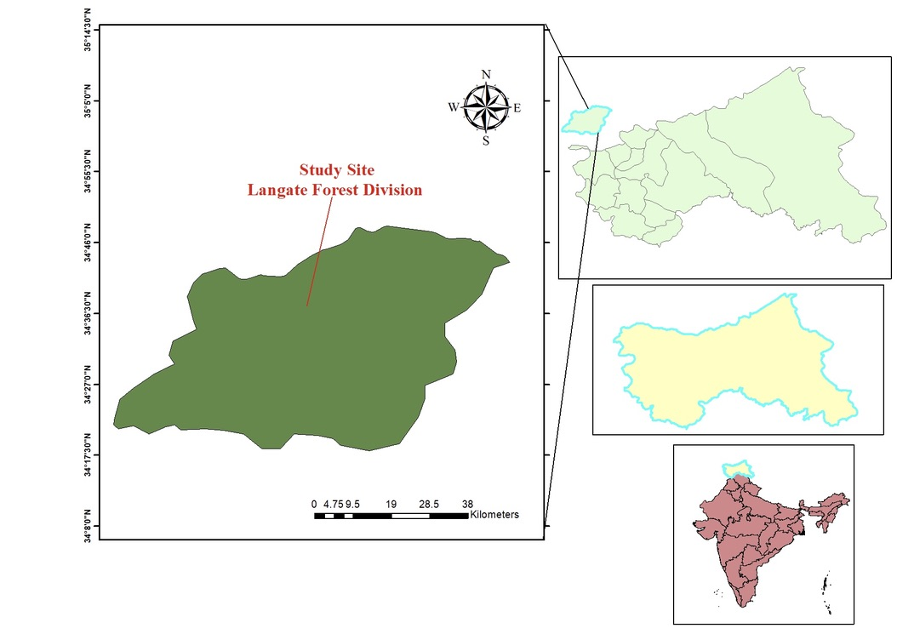
Fig1. Study area map of Langate Forest Division

  - Ethnobotanical studies
To get firsthand information about (Podophyllum hexandrum Royle.) a field investigation was conducted at the study site. Ethnobotanical information was provided by Gujjars, village heads, and elders. Data regarding the use of medicinal plants, methods of administration, and therapeutic plant parts were gathered by field survey (Focho et al., 2009).
  - Collection of plant specimens
Rhizomes of this species were gathered from the wild to perform extraction and chemical characterisation experiments in the lab.
  - Phytochemical Screening
The rhizomes of (Podophyllum hexandrum Royle.) were subjected to GC-MS analysis in order to identify all of the bioactive compounds present. The rhizomes were first dried before being ground into a fine powder, and then the extract was filtered and condensed. The GC-MS was used to identify chemicals present in the sample (Parveen et al., 2016). The methanolic extract was analysed using a gas chromatograph-mass spectrometer at a predetermined temperature. Retention time and area percentage values were used to identify chemicals in the chromatograms generated by the GC-MS analysis (Sebastian et al., 2020; Biswal & Kumar Panda, 2023). The biological activities of the identified compounds were reviewed from the literature to relate them to the traditional uses reported by local communities.
- Results:
  - Ethno-botanical Uses
The Langate area in District Kupwara Kashmir utilises (Podophyllum hexandrum Royle.) as a multi-purpose herb for veterinary and medicinal treatments. The rhizome paste with resin helps to treat warts, skin infections and wounds and shows anti-cancer properties. The rhizome's extract or powdered form facilitates the treatment of digestive issues along with its pain-relieving properties during arthritis conditions through topical applications. (Table 1).
  - Phytochemical Screening
GC-MS study of a methanolic extract of the rhizomes of (Podophyllum hexandrum Royle.) revealed ten phytochemicals. These ten chemicals are primarily composed of beta-sitosterol (13.72%) and podophyllotoxin (18.24%). Apart from Podophyllotoxin and Beta-sitosterol, several other chemicals were identified. Campesterol, Retinol, Ethyliso-allocholate, and octadecanoic acid were identified as minor compounds with distinct concentration levels. The additional compounds found were 2,2'-Benzylidene bis (3-methyl benzofuran), D-allose, and (9Z)-octadec-9-enoic acid (Fig. 2) (Table 2). These chemicals exhibit anti-cancer effects and also function as antioxidants and anti-inflammatory agents, suggesting high potential applications in medicine (Table 3).

Table1. Ethnobotanical uses of (Podophyllum hexandrum Royle.) in Langate forest division

Use Category | Specific Use | Part of Plant Used | Preparation  Method
Medicinal | Treatment of warts, skin infections, and  Wounds | Rhizome, Resin | Paste or poultice applied topically
Medicinal | Anti-cancer  properties (source of podophyllotoxin) | Rhizome | Extracted resin used in modern medicine
Medicinal | Treatment of gastrointestinal disorders (e.g., diarrhea,  constipation) | Rhizome | Decoction or powder consumed orally
Medicinal | Anti-inflammatory and analgesic(joint  pain,arthritis) | Rhizome, Leaves | Paste applied to affected areas
Ethnoveterinary | Treatment of parasitic infections/antiseptic  in livestock | Rhizome | Mixed with fodder or applied topically

Table 2. Phytochemicals Identified by GC-MS Analysis of Methanolic Extract of (Podophyllum hexandrum Royle.) Rhizomes

Peak Name | Retention time | Area % | Name of compound | Molecular Formula | Molecular Weight
1 | 17.413 | 10.97 | Campesterol | C₂₈H₄₈O | 400.69 g/mol
2 | 21.299 | 18.24 | Podophyllotoxin | C₂₂H₂₂O₈ | 414.41 g/mol
3 | 26.073 | 13.72 | Beta-sitosterol | C₂₉H₅₀O | 414.71 g/mol
4 | 29.346 | 4.16 | Octadecanoic acid | C₁₈H₃₆O₂ | 284.48 g/mol
5 | 31.649 | 8.01 | D-allose | C₆H₁₂O₆ | 180.16 g/mol
6 | 31.904 | 7.51 | (9Z)-octadec-9-enoicacid | C₁₈H₃₄O₂ | 282.47 g/mol
7 | 33.588 | 3.81 | Retinol | C₂₀H₃₀O | 286.45 g/mol
8 | 34.106 | 12.38 | 2,2'-Benzylidenebis(3-methylbenzofuran) | C₂₆H₂₂O₂ | 382.46 g/mol
9 | 36.032 | 7.88 | Sucrose | C₁₂H₂₂O₁₁ | 342.30 g/mol
10 | 37.764 | 10.32 | Ethyl iso-allocholate | C₂₆H₄₄O₅ | 436.63 g/mol

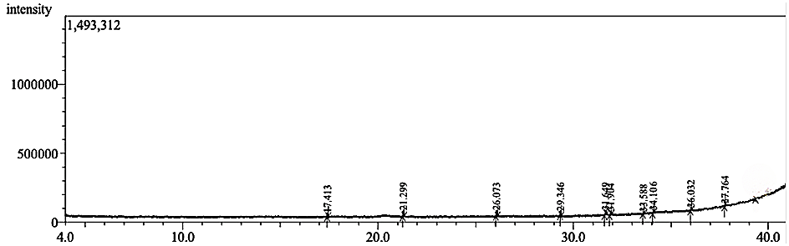
Fig.2. GC-MS Chromatogram of methanolic extract of (Podophyllum hexandrum Royle.)

Table 3. Bioactive Compounds Identified by GC-MS in (Podophyllum hexandrum Royle.) Rhizomes: Structures and Therapeutic Uses

Compound Name | Therapeutic Uses | References | Structure
Campesterol | Cholesterol-lowering effects, Anti-cancer properties, Antiangiogenic | (Choi et al 2007;Vanmierlo et al., 2012; Bae et al., 2021), | 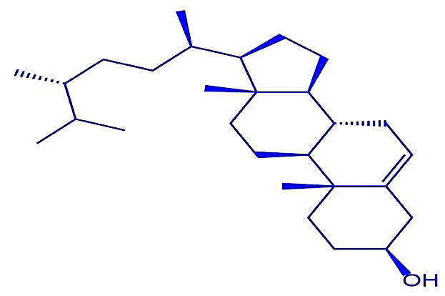
Podophyllotoxin | Used to treat genital warts, Anticancer, Antiviral | (Giri and Narasu, 2000; Edwards et al., 1988) | 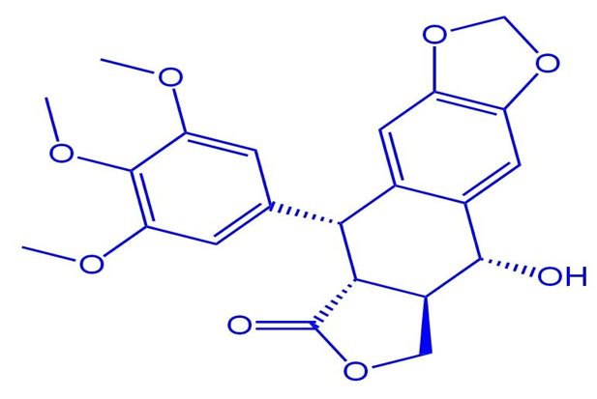
Beta-sitosterol | Antioxidant, Cholesterol-lowering agent, Food fortification | (Patch et al., 2006; Arivarasu, 2023; Abumweis & Jones, 2008). | 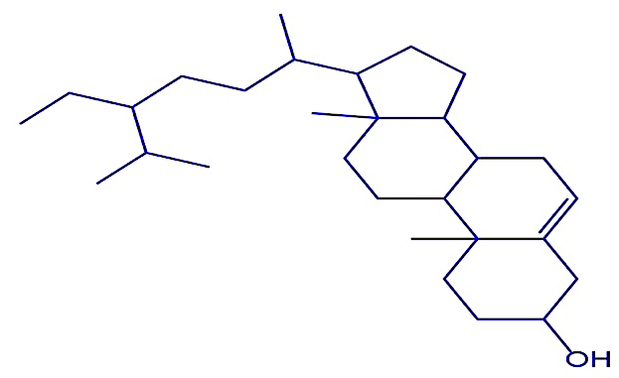
Octadecanoic acid | Antimicrobial, Anti-inflammatory and Anticancer | (Yonezawa et al., 2008; Desbois and Smith; Harvey et al., 2010) | 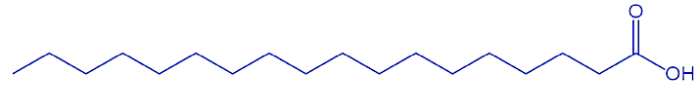
D-allose | Anti-cancer, Anti-tumor, Anti-inflammatory, Anti-oxidative, Anti-hypertensive | (Zare et al., 2023; Lim & Oh, 2011). | 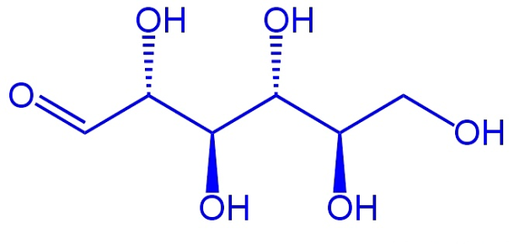
(9Z)-octadec-9-enoicacid | Cardiovascular benefits and Skin-conditioning properties | (Harvey et al., 2010; Subramanian et al., 2019). | 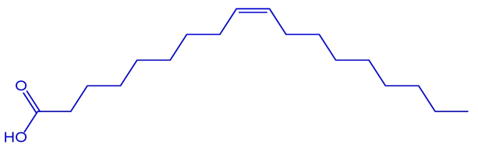
Retinol | Essential for vision, Immune function, and Skin health | (Jun et al., 2021; Sorg et al., 2006; Hammerling, 2016). | 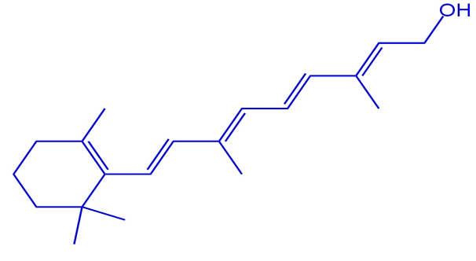
2,2'-Benzylidenebis(3-methylbenzofuran) | Antidiabetic, Antioxidant | (Li et al., 2013; Akinmoladun et al., 2021) | 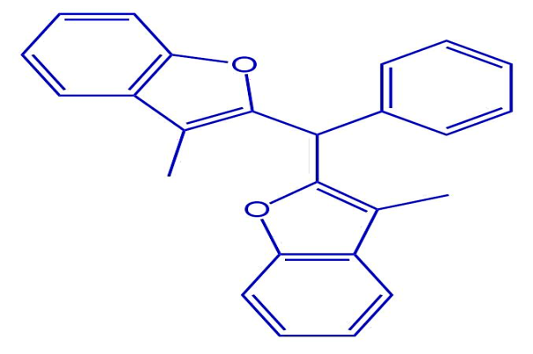
Sucrose | Immunomodulatory, Hypertonic, Stabilizer and Cryoprotectant | (Struck et al., 2014; Tomaszewska et al., 2018) | 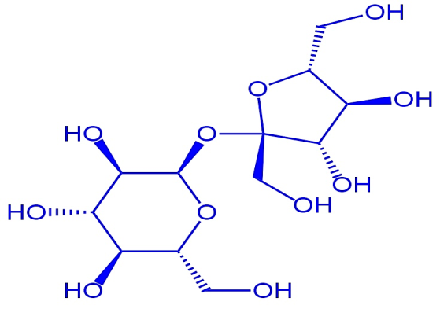
Ethyl iso-allocholate | Antimicrobial, Antioxidant, Anti-inflammatory,Anticancer, Antitumor, Antiarthritic, and Antibacterial | (Tyagi & Agarwal, 2017) | 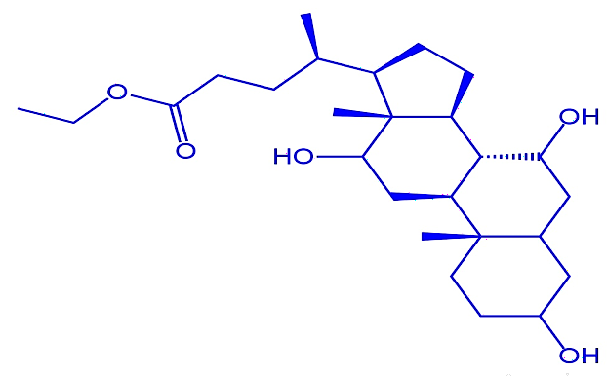

- Discussion
This study investigates the traditional applications and phytochemical composition of (Podophyllum hexandrum Royle.) within the Langate Forest Division of District Kupwara in Kashmir. The study reveals the importance of this endangered species in terms of cultural history as well as its usage in medicine, and its role in the ecosystem.
4.1 Traditional Uses
In the Langate area of Kashmir, locals depend on the Himalayan May apple (Podophyllum hexandrum Royle.) for medicinal purposes since it aids in the healing of both humans and animals. Podophyllotoxin has antiviral and anticancer characteristics; people use the plant's rhizome and resin to treat wounds and skin-related conditions. It is used to make the cancer drugs teniposide and etoposide. (Giri & Narasu, 2000; Kumar et al., 2015). In addition to its established veterinary use, (Podophyllum hexandrum Royle.) has been used traditionally in cattle to heal wounds and parasites because of its inherent antifungal properties (Kumar et al., 2015). The increasing demand for podophyllotoxin and the plant's endangered status highlight the need for sustainable production methods, such as cell cultures or biotransformation, to protect this valuable resource (Farkya et al., 2004; Giri & Narasu, 2000).
  - Phytochemical Profiling (GC-MS Analysis)
GC-MS analysis reveals the rhizomes of (Podophyllum hexandrum Royle.) contain a variety of bioactive compounds. The most common compound identified, accounting for 18.24% of the sample, is the cancer-preventive compound podophyllotoxin (Jiang et al., 2007; Qadir et al., 2020). The presence of significant levels of other secondary metabolites, such as campesterol, beta-sitosterol, and D-allose in (Podophyllum hexandrum Royle.) rhizomes may contribute to its medicinal potential. Research supports D-allose's anti-ageing properties (Eun et al., 2020). Though the amount generated will depend on culture and extraction techniques, it might yield a range of beneficial chemical compounds (Bhattacharyya et al., 2013; Qadir et al., 2020). Further research is needed to optimize extraction for industrial use in cancer drug production.
- Threats, Conservation Challenges and Recommendations
Threats to medicinal plants and their conservation illustrate how humans impact the environment and climate change. Improper harvesting regulations allow individuals to overharvest medicinal plants, endangering their population (Shafi et al., 2021). In addition to the limited distribution and high economic value of (Podophyllum hexandrum Royle.) there are continuous threats to species (Kala, 2005; Maqbool, 2011; Rana and Samant, 2011; Banerjee et al., 2017; Nag et al., 2020). Market trends indicate that prices will remain high because demand for this species exceeds production volume (Chaurasia et al., 2012). The species is likely to encounter habitat loss, regardless of the lack of knowledge on the implications of climate change. It is at elevated risk from climate change since its ability to survive mostly depends on winter temperatures (Banerjee et al., 2017) and because winter temperatures rise more rapidly (Telwala et al., 2013). 74% of the Himalayan Mayapple's present range will no longer be readily accessible by 2050 (Shrestha et al., 2022). The research recommends developing strategies for cultivation and strengthening harvesting regulations to safeguard the species. Our findings are reinforced by the study of (Ebeling and Yasué, 2008), who illustrated how effectively we can protect forest areas through a decrease in deforestation activities. Various studies indicate that habitat loss, which occurs when humans destroy forests to make space for roads and farms, represents the greatest threat to protected areas. 11 million hectares of protected areas in the humid tropics are under serious risk from both deforestation and climate change, which calls for immediate landscape solutions (Tabor et al., 2018). Climate change may cause between 14% and 75% of Madagascar's suitable ruffed lemur habitat to disappear by 2070 (Morelli et al., 2019). To tackle this, it is essential to do a study to track the effects of climate change adaptive management into place (Ebeling & Yasué, 2008; Kingsford, 2011; Shafi et al., 2021) and encourage climate-resilient behaviours (Li et al., 2022). Tackling these interrelated challenges would require enhancing governance and putting strict restrictions on the overharvesting of medicinal plants (Kingsford, 2011).
Conclusion
In Kashmir's Langate Forest Division, a study shows the ethnobotanical usage of (Podophyllum hexandrum Royle.) in addition to its vital ecological relevance and therapeutic benefits. The plant's therapeutic characteristics, particularly in the treatment of cancer, are supported by podophyllotoxin and other bioactive components. Ethnobotanical research indicates that traditional consumers of this herb have been using it for hundreds of years, but overharvesting and habitat damage pose a serious threat to its sustainability. Appropriate preventive measures must be put in place right away to preserve this vital species. The study shows that combining ancient knowledge with contemporary scientific methods is necessary to address future sustainable depletion. Fostering cultivation and enacting stringent laws for collecting in the wild are essential to the protected conservation of (Podophyllum hexandrum Royle.)

DISCLAIMER (ARTIFICIAL INTELLIGENCE)
Author(s) hereby declare that NO generative AI technologies have been used during the writing or editing of this Manuscript.

COMPETING INTERESTS DISCLAIMER:
Authors have declared that they have no known competing financial interests OR non-financial interests OR personal relationships that could have appeared to influence the work reported in this paper.

REFERENCES

- Abumweis, S. S., & Jones, P. J. H. (2008). Cholesterol-lowering effect of plant sterols. Current Atherosclerosis Reports, 10(6), 467–472. https://doi.org/10.1007/s11883-008-0073-4
- Ahire, M., Bhande, J., Kate, K., Vikhe, D., & Indrekar, A. (2023). Modern Developments in the Growing of Medicinal Plants. BOHR Journal of Pharmaceutical Studies, 1(2), 40–46. https://doi.org/10.54646/bjops.2023.06
- Ajani, E. O. (2022). Medicinal Plants and Drug Discovery (pp. 21–49). Bentham Science. https://doi.org/10.2174/9789815050622122010005
- Ajewole, S. (2024). The Role of Medicinal Plants in Nigerian Traditional Medicine. ScienceOpen. https://doi.org/10.14293/pr2199.001210.v1
- Akinmoladun, F. O., Olaleye, T. M., Komolafe, T. R., & Komolafe, B. O. (2021). GC-MS and Molecular Docking Studies of Hunteria umbellata Methanolic Extract as a Potent Anti-Diabetic. Journal of Ethnopharmacology, 265, 113-120.
- Arivarasu, L. (2023). In-Vitro Antioxidant Potential of Beta-Sitosterol: A Preface. Cureus, 15(9). https://doi.org/10.7759/cureus.45617
- Bae, H., Yang, C., Song, G., Park, S., & Lim, W. (2021). Disruption of Endoplasmic Reticulum and ROS Production in Human Ovarian Cancer by Campesterol. Antioxidants, 10(3), 379. https://doi.org/10.3390/antiox10030379
- Bhattacharyya, D., Datta, R., Hazra, S., Chattopadhyay, S., & Sinha, R. (2013). De novo transcriptome analysis using 454 pyrosequencing of the Himalayan Mayapple, Podophyllum hexandrum. BMC Genomics, 14(1). https://doi.org/10.1186/1471-2164-14-748
- Bisht, A.S., & Chauhan, R.S. (2016). Ethnomedicinal, ethnopharmacological, phytochemical properties and conservation issues of Podophyllum hexandrum Royle (Berberidaceae). Medicinal Plants- International Journal of Phytomedicines and Related Industries, 8(4), 287–293.
- Biswal, B., & Kumar Panda, S. (2023). GC-MS Analysis of the Methanolic extract of Cuscuta reflexa Roxb. and Gymnema sylvestre (Retz.) R. Br. ex. Sm. Research Journal of Pharmacy and Technology, 18–22. https://doi.org/10.52711/0974-360x.2023.00004
- Brettell, T. A., & Lum, B. J. (2018). Analysis of Drugs of Abuse by Gas Chromatography-Mass Spectrometry (GC-MS). Methods in Molecular Biology (Clifton, N.J.), 1810, 29–42. https://doi.org/10.1007/978-1-4939-8579-1_3
- Chaiyong, S., Pongamornkul, W., Inta, A., & Panyadee, P. (2023). Uncovering the ethnobotanical importance of community forests in Chai Nat Province, Central Thailand. Biodiversitas Journal of Biological Diversity, 24(4). https://doi.org/10.13057/biodiv/d240415
- Chandra, N., Singh, G., Lingwal, S., Rai, I.D., & Tewari, L.M. (2021). Alpine medicinal and aromatic plants in the Western Himalaya, India: An ecological review. Indian Journal of Ecology, 48(1), 319–331.
- Chaudhari, S. K. (2014). Podophyllum hexandrum: An endangered medicinal plant from Pakistan. Pure and Applied Biology, 3(1), 19–24. https://doi.org/10.19045/bspab.2014.31003
- Chaudhari, S.K., & Yamin Bibi, M.A. (2021). Podophyllum hexandrum: An endangered medicinal plant from Pakistan. Pure and Applied Biology (PAB), 3(1), 19–24.
- Chaurasia, O.P., Ballabh, B., Tayade, A., Kumar, R., Kumar, G.P. and Singh, S.B., 2012. Podophyllum L.: An endergered and anticancerous medicinal plant–An overview.
- Chaurasia, O.P., Ballabh, B., Tayade, A., Kumar, R., Kumar, G.P., & Singh, S.B. (2012). Podophyllum L.: An endangered and anticancerous medicinal plant–An overview. Indian Journal of Traditional Knowledge, 11(2), 234–241.
- Choi, J., Baek, N., Song, M., Lee, H., Ahn, K., Kim, S., Kim, K., Shim, B., Kim, N., & Lee, E. (2007). Identification of campesterol from Chrysanthemum coronarium L. and its antiangiogenic activities. Phytotherapy Research, 21(10), 954–959. https://doi.org/10.1002/ptr.2189
- CITES. (2021). CITES Species Database. Available at: http://speciesplus.net/.
- Cowan, M.M., 1999. Plant products as antimicrobial agents. Clinical microbiology reviews, 12(4), pp.564-582.
- Dar, R. A., Shahnawaz, M., Majid, I. U., & Ahanger, M. A. (2023). Exploring the Diverse Bioactive Compounds from Medicinal Plants: A Review. The Journal of Phytopharmacology, 12(3), 189–195. https://doi.org/10.31254/phyto.2023.12307
- Desbois, A. P., & Smith, V. J. (2010). Antibacterial free fatty acids: Activities, mechanisms of action, and biotechnological potential. Applied Microbiology and Biotechnology, 85(6), 1629-1642.
- Ebana, R.U.B., Madunagu, B.E., Ekpe, E.D. and Otung, I.N., 1991. Microbiological exploitation of cardiac glycosides and alkaloids from Garcinia kola, Borreria ocymoides, Kola nitida and Citrus aurantifolia. Journal of Applied Microbiology, 71(5), pp.398-401.
- Ebeling, J., & Yasué, M. (2008). Generating carbon finance through avoided deforestation and its potential to create climatic, conservation and human development benefits. Philosophical Transactions of the Royal Society B: Biological Sciences, 363(1498), 1917–1924. https://doi.org/10.1098/rstb.2007.0029
- Edwards, A., Thin, R. N., & Atma-Ram, A. (1988). Podophyllotoxin 0.5% v podophyllin 20% to treat penile warts. Sexually Transmitted Infections, 64(4), 263–265. https://doi.org/10.1136/sti.64.4.263
- Eun, C.-H., Kim, I.-J., & Kang, M.-S. (2020). Elastase/Collagenase Inhibition Compositions of Citrus unshiu and Its Association with Phenolic Content and Anti-Oxidant Activity. Applied Sciences, 10(14), 4838. https://doi.org/10.3390/app10144838
- Farkya, S., Srivastava, A. K., & Bisaria, V. S. (2004). Biotechnological aspects of the production of the anticancer drug podophyllotoxin. Applied Microbiology and Biotechnology, 65(5). https://doi.org/10.1007/s00253-004-1680-9
- Focho, D. A., Anjah, M. G., Newu, M. C., Ambo, F. B., & Nwana, F. A. (2009). Ethnobotanical survey of trees in Fundong, Northwest Region, Cameroon. Journal of Ethnobiology and Ethnomedicine, 5(1). https://doi.org/10.1186/1746-4269-5-17
- Giri, A., & Lakshmi Narasu, M. (2000). Production of podophyllotoxin from Podophyllum hexandrum: a potential natural product for clinically useful anticancer drugs. Cytotechnology, 34(1/2), 17–26. https://doi.org/10.1023/a:1008138230896
- Hammerling, U. (2016). Retinol as electron carrier in redox signaling, a new frontier in vitamin A research. Hepatobiliary Surgery and Nutrition, 5(1), 15–28. https://doi.org/10.3978/j.issn.2304-3881.2016.01.02
- Harvey, K. A., Walker, C. L., Xu, Z., Whitley, P., Pavlina, T. M., Hise, M., Zaloga, G. P., & Siddiqui, R. A. (2010). Oleic acid inhibits stearic acid-induced inhibition of cell growth and pro-inflammatory responses in human aortic endothelial cells. Journal of Lipid Research, 51(12), 3470–3480. https://doi.org/10.1194/jlr.m010371
- Husain, A. (1983). Conservation of Genetic resources of medicinal plants in India. In: S.K. Jain & K.L. Mehra (eds), Conservation of Tropical plant resources. Proceedings of the Regional Workshop on Conservation of Tropical Plant Resources in South-East Asia, New Delhi, March 8-12, 1982, pp. 110–117. Botanical Survey of India Department of Environment Govt. of India, Howrah.
- IUCN. (2024). The IUCN Red List of Threatened Species. Version 2024-1. Available at: www.iucnredlist.org. (Accessed: 27 June 2024).
- Jatoi, S. A., Kikuchi, A., Watanabe, K. N., & Gilani, S. A. (2007). Phytochemical, pharmacological and ethnobotanical studies in mango ginger (Curcuma amada Roxb.; Zingiberaceae). Phytotherapy Research, 21(6), 507–516. https://doi.org/10.1002/ptr.2137
- Jiang, R.-W., Zhou, Y., Zhou, J.-R., Li, S.-L., Shaw, P.-C., Hon, P.-M., Ye, W.-C., Xu, H.-X., Li, L.-L., & But, P. P.-H. (2007). Lignans from Dysosma versipellis with Inhibitory Effects on Prostate Cancer Cell Lines. Journal of Natural Products, 70(2), 283–286. https://doi.org/10.1021/np060430o
- Jun, S.-H., Song, J. E., Lee, H., Kang, N.-G., Kim, H., & Park, S. G. (2021). Synthesis of Retinol-Loaded Lipid Nanocarrier via Vacuum Emulsification to Improve Topical Skin Delivery. Polymers, 13(5), 826. https://doi.org/10.3390/polym13050826
- Kala, C.P. (2005). Indigenous uses, population density, and conservation of threatened medicinal plants in protected areas of the Indian Himalayas. Conservation Biology, 19(2), 368-378.
- Kimura, S., Nakagawa, T., Miyanaka, H., Zhang, G.-X., Tokuda, M., Miyatake, A., Nagai, Y., Nagai, T., Nishiyama, A., Abe, Y., & Fujisawa, Y. (2005). D-allose, an all-cis aldo-hexose, suppresses development of salt-induced hypertension in Dahl rats. Journal of Hypertension, 23(10), 1887–1894. https://doi.org/10.1097/01.hjh.0000182523.29193.e3
- Kingsford, R. T. (2011). Conservation management of rivers and wetlands under climate change - a synthesis. Marine and Freshwater Research, 62(3), 217. https://doi.org/10.1071/mf11029
- Kingston, D. G. I. (2010). Modern Natural Products Drug Discovery and Its Relevance to Biodiversity Conservation. Journal of Natural Products, 74(3), 496–511. https://doi.org/10.1021/np100550t
- Kotowska, U., Żalikowski, M., & Isidorov, V. A. (2011). HS-SPME/GC–MS analysis of volatile and semi-volatile organic compounds emitted from municipal sewage sludge. Environmental Monitoring and Assessment, 184(5), 2893–2907. https://doi.org/10.1007/s10661-011-2158-8
- Kumar, P., Pal, T., Kumar, V., Sharma, N., Sood, H., & Chauhan, R. S. (2015). Expression analysis of biosynthetic pathway genes vis-à-vis podophyllotoxin content in Podophyllum hexandrum Royle. Protoplasma, 252(5), 1253–1262. https://doi.org/10.1007/s00709-015-0757-x
- Kumar, S., Singh, J., Shah, N.C. and Ranjan, V., 1997. Indian Medicinal Plants Facing Genetic Erosion.–205 pp. Central Institute of Medicinal & Aromatic Plants, Lucknow, CSIR.
- Li, B. V., Jenkins, C. N., & Xu, W. (2022). Strategic protection of landslide vulnerable mountains for biodiversity conservation under land-cover and climate change impacts. Proceedings of the National Academy of Sciences, 119(2). https://doi.org/10.1073/pnas.2113416118
- Li, M., Zhou, L., Yang, D., Li, T., & Li, W. (2013). Biochemical composition and antioxidant capacity of extracts from Podophyllum hexandrum rhizome. Journal of Medicinal Plants Research, 7(1), 45-52.
- Lim, Y.-R., & Oh, D.-K. (2011). Microbial metabolism and biotechnological production of d-allose. Applied Microbiology and Biotechnology, 91(2), 229–235. https://doi.org/10.1007/s00253-011-3370-8
- Maher, K. D., Gray, M. R., Bressler, D. C., & Kirkwood, K. M. (2008). Pyrolytic Decarboxylation and Cracking of Stearic Acid. Industrial & Engineering Chemistry Research, 47(15), 5328–5336. https://doi.org/10.1021/ie0714551
- Malathi, K., Ramaiah, S., & Anbarasu, A. (2016). Ethyl Iso-allocholate from a Medicinal Rice Karungkavuni Inhibits Dihydropteroate Synthase in Escherichia coli: A Molecular Docking and Dynamics Study. Indian Journal of Pharmaceutical Sciences, 78(6). https://doi.org/10.4172/pharmaceutical-sciences.1000184
- Manchego, C. E., Espinosa, C. I., Günter, S., Cueva, J., Hildebrandt, P., & Stimm, B. (2017). Climate change versus deforestation: Implications for tree species distribution in the dry forests of southern Ecuador. PLOS ONE, 12(12), e0190092. https://doi.org/10.1371/journal.pone.0190092
- Maqbool, M. (2011). Mayapple: A review of the literature from a horticultural perspective. Journal of Medicinal Plants Research, 5(7), 1037–1045.
- Molan, P. C. (2006). The evidence supporting the use of honey as a wound dressing. International Journal of Lower Extremity Wounds, 5(1), 40-54.
- Morelli, T. L., Lehman, S. M., Randrianarimanana, H. L. L., Balko, E. A., Ratsimbazafy, J., Baden, A. L., King, T., Louis, E. E., Federman, S., Mancini, A. N., Farris, Z., Murphy, A., Dolch, R., Holmes, S. M., Borgerson, C., Jacobs, R. L., Razafindratsima, O. H., Golden, C. D., Smith, A. B., … Johnson, S. (2019). The fate of Madagascar’s rainforest habitat. Nature Climate Change, 10(1), 89–96. https://doi.org/10.1038/s41558-019-0647-x
- Nag, A., Bhardwaj, P., Ahuja, P.S. and Sharma, R.K., 2016. Identification and characterization of novel UniGene-derived microsatellite markers in Podophyllum hexandrum (Berberidaceae). Journal of genetics, 93, pp.4-7.
- Nag, A., Choudhary, S., Masand, M., Parmar, R., Bhandawat, A., Seth, R., Singh, G., Dhyani, P., & Sharma, R.K. (2020). Spatial transcriptional dynamics of geographically separated genotypes revealed key regulators of podophyllotoxin biosynthesis in Podophyllum hexandrum. Industrial Crops and Products, 147, 112247.
- Nargawe, L., C S, V., Upadhyay, L., & Malathi, G. (2023). Ethnobotanical Survey of Medicinal Plants Used in Traditional Medicine in Africa. Plant Science Archives, 8(4), 26–28. https://doi.org/10.51470/psa.2023.8.4.26
- Parveen, S., Upadhyay, A., Shahzad, A., & Yadav, V. (2016). GAS CHROMATOGRAPHY-MASS SPECTROMETRY ANALYSIS OF METHANOLIC LEAF EXTRACT OF CASSIA ANGUSTIFOLIA VAHL. Asian Journal of Pharmaceutical and Clinical Research, 9(9), 111. https://doi.org/10.22159/ajpcr.2016.v9s3.14512
- Patch, C. S., Williams, P. G., Tapsell, L. C., & Gordon, M. (2006). Plant sterols as dietary adjuvants in the reduction of cardiovascular risk: theory and evidence. Vascular Health and Risk Management, 2(2), 157–162. https://doi.org/10.2147/vhrm.2006.2.2.157
- Qadir, A., Ahmad, S., Khan, N., Ahmad, F. J., Aqil, M., Ali, A., & Arif, M. (2020). GC-MS analysis of the methanolic extracts of Smilax china and Salix alba and their antioxidant activity. TURKISH JOURNAL OF CHEMISTRY, 44(2), 352–363. https://doi.org/10.3906/kim-1907-5
- Ritz, B. W., & Gardner, E. M. (2006). Malnutrition and energy restriction differentially affect viral immunity. Journal of Nutrition, 136(5), 1141-1144.
- Romshoo, S.A., Rashid, I., Altaf, S. and Dar, G.H., 2020. Jammu and Kashmir state: an overview. Biodiversity of the Himalaya: Jammu and Kashmir State, pp.129-166.
- Sebastian, R., V, G., & B, J. (2020). Phytochemical screening and GC MS analysis of methanolic extract of Abelmoschus moschatus. International Journal of Research in Pharmaceutical Sciences, 11(SPL4), 3049–3052. https://doi.org/10.26452/ijrps.v11ispl4.4604
- Shafi, A., Khanday, F. A., Hassan, F., Zahoor, I., & Majeed, U. (2021). Biodiversity, Management and Sustainable Use of Medicinal and Aromatic Plant Resources (pp. 85–111). Springer. https://doi.org/10.1007/978-3-030-58975-2_3
- Sharma, D. N. (2024). NATURAL REMEDIES. Amkcorp Research Technologies Private Limited. https://doi.org/10.61909/isbn.978-81-966743-4-2.amkedtb122305
- Sheng-Ji, P. (2001). Ethnobotanical Approaches of Traditional Medicine Studies: Some Experiences From Asia. Pharmaceutical Biology, 39(sup1), 74– https://doi.org/10.1076/phbi.39.s1.74.0005
- Sorg, O., Saurat, J.-H., Kaya, G., & Antille, C. (2006). Retinoids in cosmeceuticals. Dermatologic Therapy, 19(5), 289–296. https://doi.org/10.1111/j.1529-8019.2006.00086.x
- Struck, S., Brennan, C. S., Rohm, H., & Jaros, D. (2014). Sugar replacement in sweetened bakery goods. International Journal of Food Science & Technology, 49(9), 1963–1976. https://doi.org/10.1111/ijfs.12617
- Subramanian, C., Frank, M. W., Batte, J. L., Whaley, S. G., & Rock, C. O. (2019). Oleate hydratase from Staphylococcus aureus protects against palmitoleic acid, the major antimicrobial fatty acid produced by mammalian skin. Journal of Biological Chemistry, 294(23), 9285–9294. https://doi.org/10.1074/jbc.ra119.008439
- Tabor, K., Tien, H., Williams, J. W., Hewson, J., González-Roglich, M., & Hole, D. (2018). Tropical Protected Areas Under Increasing Threats from Climate Change and Deforestation. Land, 7(3), 90. https://doi.org/10.3390/land7030090
- Tomaszewska, J., Bieliński, D., Binczarski, M., Berlowska, J., Dziugan, P., Piotrowski, J., Stanishevsky, A., & Witońska, I. A. (2018). Products of sugar beet processing as raw materials for chemicals and biodegradable polymers. RSC Advances, 8(6), 3161–3177. https://doi.org/10.1039/c7ra12782k
- Tyagi, T., & Agarwal, M. (2017). GC-MS ANALYSIS OF INVASIVE AQUATIC WEED, PISTIA STRATIOTES L. AND EICHHORNIA CRASSIPES (MART.) SOLMS. International Journal of Current Pharmaceutical Research, 9(3), 111. https://doi.org/10.22159/ijcpr.2017.v9i3.19970
- Vanmierlo, T., Maier, W., Hartmann, T., Stoffel-Wagner, B., Bertsch, T., Von Bergmann, K., Popp, J., Mulder, M., Jessen, F., Lütjohann, D., Friedrichs, S., Steinbusch, H., & Kölsch, H. (2011). The plant sterol brassicasterol as additional CSF biomarker in Alzheimer’s disease. Acta Psychiatrica Scandinavica, 124(3), 184–192. https://doi.org/10.1111/j.1600-0447.2011.01713.x
- Yingngam, B. (2024). Ethnobotanical Insights Into the Bioactive Properties of Commercially Important Spice Seeds (pp. 123–190). IGI Global. https://doi.org/10.4018/979-8-3693-6105-4.ch006
- Yonezawa, T., Katoh, K., & Obara, Y. (2008). Existence of GPR40 functioning in a human breast cancer cell line, MCF-7. Biochemical and Biophysical Research Communications, 365(2), 221-227.
- Zare, M., Razban, V., Zare, M., Panahi, G., Tahami, S. M., Khajeh, S., & Ganjavi, M. (2023). D-allose: Molecular Pathways and Therapeutic Capacity in Cancer. Current Molecular Pharmacology, 16(8). https://doi.org/10.2174/1874467216666221227105011
- Zhang, L., Somogyi, A., Maier, R. M., Veres-Schalnat, T. A., & Pemberton, J. E. (2012). Fatty Acid Cosubstrates Provide β-Oxidation Precursors for Rhamnolipid Biosynthesis in Pseudomonas aeruginosa, as Evidenced by Isotope Tracing and Gene.

