Minireview Article

Nutritional Impact of Vegan Diet in Comparison to Milk: A Review

.

ABSTRACT

|  |
| --- |
| The rise in veganism has raised significant interest and debate regarding its impact on human health and nutrition. Veganism, a stricter form of vegetarianism, excludes all animal products, including dairy, eggs and honey. While the vegan population continues to grow globally, misconceptions about its nutritional adequacy remain prevalent. A comprehensive approach to the nutritional aspects of veganism, compares it with traditional milk-based diets and highlights the challenges of maintaining adequate nutrition on a vegan diet. While vegan diets can offer health benefits, they often lack essential nutrients such as vitamin B12, vitamin D, calcium and certain protein, which are readily available in dairy products. Milk, often referred to as ‘nature's most perfect food’, provides high-quality proteins, essential fatty acids, vitamins and minerals crucial for overall health. Notably, the absence of dairy in a vegan diet can lead to deficiencies, especially in vulnerable populations such as infants, children, elderly persons, pregnant women and athletes. Hence, experimental evidences and research needs to be conducted to better understand the clinical relevance of the vegan diet. In addition, detailed guidelines should be established to accommodate the various dietary compositions across the vegan spectrum. Also, correct information relating to vegan food products is needed to be spread to public through various resources of communication. |

*Keywords: Vegan; Veganism; Vegetarian; Milk Nutrition; Dietary Deficiencies; Health Impact.*

1. INTRODUCTION

People's interest in veganism is rising since the beginning of the twenty-first century. Nowadays, more and more people all around the world are choosing to adopt or switch to a vegan diet (Craig et al., 2021). Recently, the year 2019 was declared as the “year of the vegan” by many economists (Anonymous, 2019). Globally, the vegan population is estimated to be around 79 million, which is approx. one percent of the total population (Anonymous, 2025). However, there are also many common misconceptions about vegan foods among the general public and medical professionals. Two criteria are typically used to determine if a diet is healthy i.e. (1) General healthfulness of dietary pattern and (2) Adequacy of the diet in terms of certain major nutrients. But vegan diet limits complete fulfillment of these criteria.

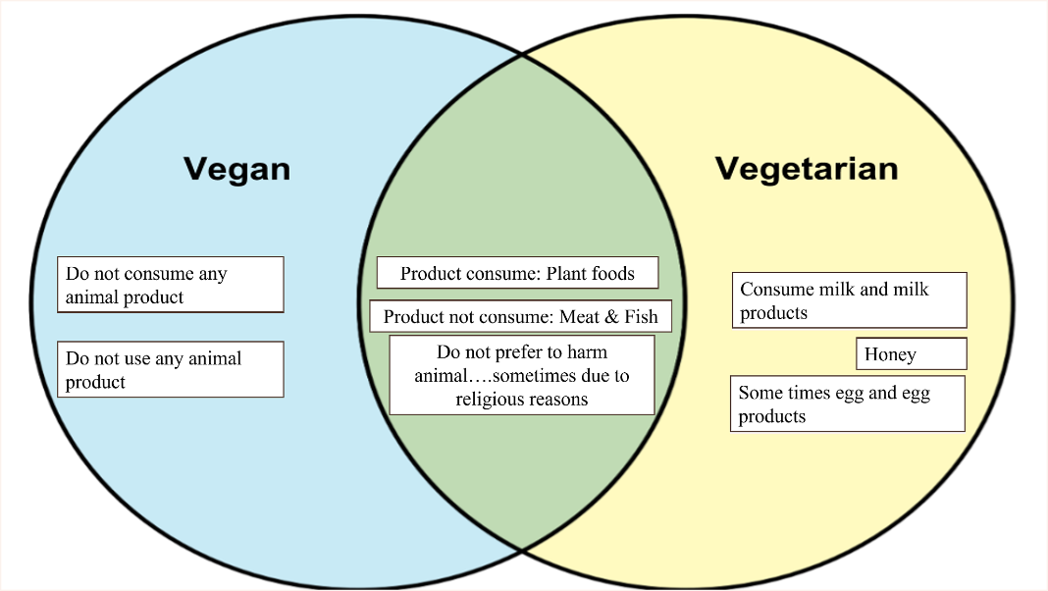

**Fig. 1. Difference between Vegan and Vegetarian**

Vegetarians and vegans do not eat meat, fish, chicken and other animal derived products. Conversely, veganism is more stringent and forbids the use of dairy, honey, eggs and other products made from animal sources, including leather and silk. Donald Watson first used the term "veganism" in 1944 to refer to a non-violent lifestyle and the voluntary avoidance of foods produced from animals. Vegan Society was established nearly 80 years ago. The vegan society’s history gets back much earlier when meat, dairy and other animals derived products were stopped for consumption (Anonymous, 2025).

India has diverse food habits in different parts of the country. India is the largest producer of milk and other dairy products. In 2022-2023, India produced 230.58 million tons of milk. Uttar Pradesh (15%), Rajasthan (14%), Madhya Pradesh (8%), Gujarat (7%) and Andhra Pradesh (6%) are the major production area of milk in India (APEDA, 2025).

2. Concept of Vegetarian and vegan

According to the Vegetarian Society, a vegetarian is someone who does not eat any meat, poultry, fish, shellfish or by-products of animal slaughter. Vegetarian diets contain various levels of fruits, vegetables, grains, pulses, nuts and seeds. Inclusion of dairy, honey and eggs depends on the type of diet (Jyoti, 2021). Vegetarianism is generally less strict than veganism, so there are several well-known types of the vegetarian diet. Accordingly, vegetarians are classified into four groups: (1) Lacto-vegetarian, (2) Lacto-ovo vegetarian, (3) Ovo vegetarian and (4) Pescatarian (Kubala, 2023).

Veganism is a stricter form of vegetarianism. Vegans avoid consuming or using any animal products or byproducts. The Vegan Society define veganism as “a way of living, which seeks to exclude, as far as is possible and practicable, all forms of exploitation of and cruelty to animals for food, clothing or any other purpose”. According to FSSAI “Vegan Food” means those foods or food ingredients that have not made use of any ingredients, additives and processing aids of animal origin including milk and milk products, fish, poultry and meat, egg or egg products, honey or honey bee products, materials of insect origin like silk, dyes, chitin/chitosan, etc or ingredients that are clarified using animal-sourced products e.g., bone char used in sugar bleaching, etc. (FSSAI, 2025).

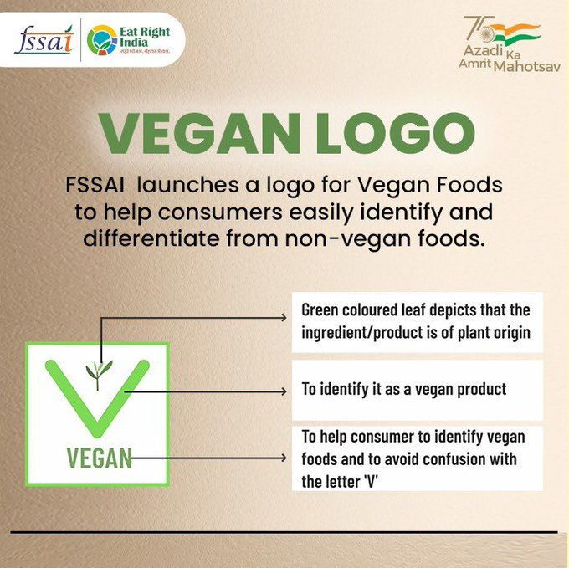

**Fig. 2. Vegan Logo according to FSSAI**

3. Limitations of Vegan DIET Against Milk Nutrition

Healthy people, continuing veganism will eventually start having deficiency of vit. A, vit. D, vit. B12, calcium etc. These nutrients are essential for human body as they contain micronutrients and minerals that provide immunity to fight diseases. While veganism is propagated as a healthy and moral diet; it may not really benefit in maintaining weight as it claims. People with bone diseases or diabetes must have balanced nutrition which is not found in the vegan diet (Anthony, 2019). Vegan side effects sometimes include anemia, disruptions in hormone production and depression. Vegans are at a high risk for cobalamin and calcium deficiency and an increased risk for inadequate levels of vitamin D and iodine, unless proper food planning including supplements and/or fortified foods are utilized. Nutritionists often refer to certain groups in the population, such as infants, growing children (including adolescents), elderly and pregnant/lactating women as being nutritionally vulnerable to vegan diet (Lillian, 2022).

**3.1 Limitations of Vegan Diets for Specific Groups**

Veganism can be a healthy choice for some people, but it presents certain challenges for specific groups of people, as discussed below:

* **Infants**: For infants, vegan diets pose significant challenges due to their low nutrient density and high bulkiness (Kiely, 2021). Infants need high energy and nutrients for growth, particularly in the early stages of life. Vegan foods may not fulfil these demands, lacking key nutrients like protein, vitamin B12, vitamin D, zinc, iron and calcium which are essential for rapid growth phases, such as infancy and the pubertal growth (Soliman et al., 2014).
* **Children and Teenagers**: Children and teenagers following a vegan diet may struggle to meet their increased nutritional needs. Vegan children typically require higher amounts of protein depending on their age, but they are often lighter and slightly smaller than non-vegan (Sutter and Bender, 2021). Low intake of calcium can be particularly problematic for growing children and teens, as their bones are still developing and require adequate calcium for strength. Moreover, vegan diets are often devoid of certain nutrients that are crucial for the physiological functions of teenagers, such as vitamin B12, omega-3 fatty acids and zinc (Craig et al., 2021).
* **Elderly Persons**: The caloric needs of elderly person typically decrease with age, but the demand for certain nutrients may rise. This makes it essential for older adults to opt for nutrient-dense foods. Additionally, some studies suggest that protein utilization becomes less efficient with age. The elderly often has lower calorie intakes and their consumption of protective nutrients like calcium, zinc, vitamin D and vitamin B12 may also decrease. At the same time, their nutritional needs can increase due to the prevalence of chronic diseases that rise with age, but a vegan diet may not provide these nutrients in sufficient levels (Melina et al., 2016).
* **Pregnant and Lactating Women**: Pregnant and lactating women needs higher nutritional support for their own as well as their baby’s health (Picciano, 2003). Pregnant women need increased iron intake after the second trimester (30 mg iron, maintains maternal blood hemoglobin level at 10.5 g/d), but plant sources of iron are less bioavailable in vegan diet. While a vegan mother’s breast milk is comparable to non-vegan milk in many ways, it tends to contain less saturated fat and omega−3 fatty acid (eicosapentaenoic acid-EPA), but higher amounts of linoleic and linolenic acids, which could affect the baby’s development. Ensuring the right balance of nutrients is crucial for the health of both mother and child (Karcz and Krolak, 2020).
* **Athletes**: Athletes may face challenges in fulfilling their higher calorie and nutrient needs in a vegan diet. These diets are often lower in essential nutrients such as calories, protein, fat, vitamin B12, calcium and iodine, which are crucial for optimal performance and recovery. Additionally, the body may not absorb certain nutrients from plant-based sources as efficiently as from animal-based ones like milk (Rogerson, 2017). Vegan athletes may need to supplement their diet with substances like creatine and β-alanine, which could enhance performance in those with lower pre-existing levels of these compounds. However, further research is needed to better understand the impact of these supplements on athletic performance (Bresnahan et al., 2016)

**3.2 Nutritional Deficiency in Vegan Diet with special reference to milk**

Milk and dairy products are integral part of human nutrition and they are considered as the carriers of higher biological value proteins, calcium, essential fatty acids, amino acids, fat, water soluble vitamins and several bioactive compounds that are highly significant for several biochemical and physiological functions. According to Bhava Prakasha, milk can help those with chronic conditions like epilepsy, jaundice, heart problems, spleen enlargement, piles and the suppression of diarrhea and urine. Ayurveda places a strong emphasis on milk's capacity to restore the body's energy system. The main food product that has been found to have the greatest potential to improve human health is milk (Sabikhi and Mathur, 2004). Milk proteins contain several components that may help the human body protect itself against toxins, bacteria and viruses. Whereas dairy fat especially linoleic acid reduces CHD risks in human. Lactoferrin improves immunity, promotes the growth of good bacteria in the gastrointestinal system and boosts iron absorption and transport. Milk is the main dietary source of calcium. Muscle contraction, neuronal transmission, glandular secretion and vascular contraction and vasodilation are all affected by calcium (Nagpal et al., 2012). The nutritional ingredients found in milk can be enhanced and/or further modified to give the best benefit to the consumers. Also, India is one of the leading exporters of dairy products and therefore, the increasing trend of veganism may have an adverse impact on India's dairy sector.

***3.2.1 Milk Protein: A High-Quality Protein***

High quality protein intake protects body against bone and muscle loss (Volpi, 2004). RDI for protein intake is 0.8 g high quality protein/kg body weight/d which needs to be increased to ~1-1.2 g/kg/d for vegans. However, recent evidence shows inadequate high quality protein intake in vegans (Koeder and Perez, 2022). Milk proteins are highly bioavailable, meaning they are easily absorbed and utilized by the body. They also contain all essential amino acids, making milk a complete protein source. Milk proteins possess many functions ranging from antimicrobial activity, killing or stopping growth of unwanted microorganisms, to aiding in absorption of nutrients (Hoffman and Falvo, 2004). Milk proteins have received increasing attention as potential ingredients of health promoting functional foods targeted at diet-related chronic diseases such as cardiovascular disease, type 2 diabetes and obesity (Petrotos et al., 2014).

* Casein: The Bioactive Protein in Milk

Casein, a protein found only in milk and it accounts for about 80% of the total milk protein. Casein is also known as a phospho-protein and it is considered as a valuable protein for human health. Bioactivity of casein is expressed mainly through fragments of its molecular structure, which are called peptides (Petrotos et al., 2014). Casein contains the amino acid tryptophan, which helps to promote sleep. So, it is recommended to have a casein protein shake for better sleep at night. Casein is an excellent source of calcium, supplying about 50% of the daily value per serving. Casein contains bioactive peptides that have been shown to lower blood pressure (Kubala, 2023).

* Whey Protein: A Powerful Source of Health Benefits

Whey proteins and peptides have many functions that include: antimicrobial, antiviral and antibacterial properties. In addition, it also shows anti-inflammatory action; antithrombotic action; protection against metabolic syndrome, e.g., hypertension, serum lipid levels, glucose balance and body mass index; and protection against cancer and obesity (Petrotos et al., 2014). Whey proteins are utilized to produce natural pharmaceutical products having high value for human health. Health benefits of whey protein have a growing commercial interest in context of developing health-promoting functional foods. Whey components, particularly the proteins and peptides, are increasingly preferred as an ingredient for functional foods and nutraceuticals as active medical agents (Solak and Akin, 2012).

***3.2.2 Lactose: A Unique Carbohydrate with Health Benefits***

Lactose is the most prominent carbohydrate of milk of most species and it contributes to the nutritive value of milk. Lactose is a special ingredient of milk, infant formulas and dairy products and it is widely used in pharmaceutical products (Shendurse and Khedkar, 2016). Lactulose is widely used in the treatment of patients with hepatic encephalopathy and chronic constipation. GOS are identified as prebiotics that stimulates the growth of bifidobacterial. It also helps in calcium absorption, relief of constipation and colon cancer (Wang et al., 2024).

***3.2.3 Essential Vitamins & Minerals: vit. B12, vit. D, vit. A, Calcium and Iodine***

Milk is a rich source of several vitamins, each playing an essential role in maintaining health.

* **Vitamin B12** is crucial for the synthesis of red blood cells and the upkeep of healthy nerve function. As vitamin B12 is not found in plant-based foods, vegans often struggle to meet their daily requirements (Martens et al., 2002). Milk provides a significant source of vitamin B12, with just one cup of low-fat milk supplying 50% of the daily recommended intake (Zhao et al., 2005), As per FSSAI, RDA of vit. B12 is 2.2 μg/d in India (FSSAI, 2022). A lack of vitamin B12 can cause a wide range of imprecise symptoms (Rizzo et al., 2016). Since even mild vitamin B12 deficiency seems to be linked to an increased risk of CVD, including stroke and probably reduced brain function. Milder vit. B12 deficiency may also be harmful, particularly in the long term (Green and Miller, 2022). Severe deficiency can result in nerve damage, with possible symptoms including paraesthesia, forgetfulness, psychosis and paralysis (Cebi et al., 2022).
* **Vitamin D**, often referred to as the "sunshine vitamin," is essential for calcium absorption and bone health (Nair and Maseeh, 2012). Non-fortified vegan foods are usually deficient in vitamin D, although mushrooms exposed to sunlight or UVB lamps do contain significant levels of the vitamin D (Wa and Daba, 2023). Vit. D deficiency adversely affects bones and can (in severe situations) even be life-threatening in infants. Milder deficiency may still be harmful to bone health and mental health and may increase the risk of CVD and cancer (Pardhan et al., 2021).
* **Vitamin A** is vital for vision, immune function and skin health. Milk, particularly fermented dairy products, is a good source of preformed vitamin A (Koeder and Perez, 2022), which is more bioavailable than plant-derived provitamin A (Yao et al., 2021).
* **Calcium**: Vegan diet eliminates milk products, which are good sources of calcium. High calcium intake appears to lower colon cancer risk and might lower the risk of other diseases, including breast cancer, lung cancer, kidney stones, dyslipidemia hypertension and CHD (Pana, 2021). Low calcium consumption increases the risk of bone fractures by negatively affecting bone mineral density and bone microstructure. Milk calcium is readily absorbed by the body, while vit. D plays role in increasing the calcium absorption & its utilization (Nagpal et al., 2012).
* **Iodine**:The two main food sources of iodine that are excluded from a vegan diet are dairy products and seafood and mild iodine deficiency is widespread throughout the world (Dineva et al., 2021). Iodine excess and shortage can both have negative effects on the thyroid gland, cause goiter and raise the risk of CVD (Vacante et al., 2019). Vegans are at a higher risk of iodine insufficiency since the range between inadequate and excessive iodine intake is quite limited (10–20 μg/d to >600 μg/d) (Zimmermann et al., 2012).

4. Future Prospects and Conclusion

Further experimental evidences must be collected and research needs to be conducted to better understand the clinical relevance of the vegan diet. Ethno-geographically diverse followers are required to assess the public health implications. Detailed guidelines should be established to accommodate the various dietary compositions across the vegan spectrum. Correct information relating to vegan food products is needed to be spread to public through various means of communication. Moreover, in the name of vegan trend, people are being fed with the improper and incomplete information about vegan diet and habits, while some others are being pressured for becoming vegan. So, government agencies need to keep an eye on such incidences.

Now-a-days social media is playing a considerable role in spreading of veganism. Also, some fake video clips are shared extensively on these platforms generating a misconception about veganism among people. Many individuals having inappropriate knowledge of vegan diet, switches to veganism but struggle with the sudden changes in stricter dietary patterns, including meal composition, preparation and shopping routines. Hence, experimental evidences and research needs to be conducted to better understand the clinical relevance of the vegan diet. In addition, detailed guidelines should be established to accommodate the various dietary compositions across the vegan spectrum.

References

Anonymous, (2019). The Year of the Vegan” Announced by The Economist Magazine. <https://veggiefestchicago.org/the-year-of-the-vegan-announced-by-the-economist-magazine/>

Anonymous, (2025). Definition of veganism. <https://www.vegansociety.com/go-vegan/definition-veganism>

Anonymous, (2025). Worldwide growth of veganism. <https://www.vegansociety.com/news/media/statistics/worldwide>

Anthony, W. (2019). Advantages and disadvantages of Veganism. <https://vaya.in/news/advantages-disadvantages-veganism/>

APEDA, (2025). Dairy Products. <https://apeda.gov.in/DairyProducts>

Bresnahan, M., Zhuang, J., & Zhu, X. (2016). Why is the vegan line in the dining hall always the shortest? Understanding vegan stigma. *Stigma and Health, 1*(1), 3.

Cebi, M., Metin, B., & Tarhan, N. (2022). The association between vitamin B12 and plasma homocysteine levels with episodic memory and the volume of memory related brain structures in middle-aged individuals: a retrospective correlational study. *Brain structure & function, 227*(6), 2103–2109.

Craig, W.J., Mangels, A.R., Fresan, U., Marsh, K., Miles, F.L., Saunders, A.V., Haddad, E.H., Heskey, C.E., Johnston, P. & Larson-Meyer, E. (2021). The safe and effective use of plant-based diets with guidelines for health professionals. *Nutrients 13*(11):4144.

Dineva, M., Rayman, M. P., & Bath, S. C. (2021). Iodine status of consumers of milk-alternative drinks v. cows’ milk: data from the UK National Diet and Nutrition Survey. *British Journal of Nutrition, 126*(1), 28-36.

FSSAI, (2022). <https://fssai.gov.in/upload/advisories/2022/03/62414c50d2342Direction_RDA_03_02_2022.pdf>

FSSAI, (2025). <https://fssai.gov.in/upload/uploadfiles/files/Draft%20FSS_Vegan%20Foods_Amendment%20Reg_2025.pdf>

Green, R., & Miller, J. W. (2022). Vitamin B12 deficiency. *Vitamins and hormones, 119*, 405-439.

Hoffman, J. R., & Falvo, M. J. (2004). Protein - Which is Best?. *Journal of sports science & medicine, 3*(3), 118–130.

Jyoti, (2021). Explained: What Is Veganism And How Different Is It From Vegetarianism. <https://www.indiatimes.com/explainers/news/veganism-and-vegetarianism-554099.html>

Karcz, K., & Krolak-Olejnik, B. (2020). Vegan or vegetarian diet and breast milk composition – a systematic review. *Critical Reviews in Food Science and Nutrition*, 1–18.

Kiely, M. E. (2021). Risks and benefits of vegan and vegetarian diets in children. *Proceedings of the Nutrition Society, 80*(2), 159–164.

Koeder, C., & Perez, F. J. (2022). Vegan nutrition: a preliminary guide for health professionals. *Critical reviews in food science and nutrition, 64*(3), 670-707.

Kubala, (2023). 6 Types of Vegetarian Diets: A Dietitian Explains. <https://www.healthline.com/nutrition/types-of-vegetarians>

Lillian. (2022). Veganism Pros & Cons: A Review of the Scientific Evidence. <https://becomevegetarian.org/studies/veganism-pros-cons-a-review-of-the-scientific-evidence>

Martens, J. H., Barg, H., Warren, M. A., & Jahn, D. (2002). Microbial production of vitamin B 12. *Applied microbiology and biotechnology, 58*, 275-285.

Melina, V., Craig, W., & Levin, S. (2016). Position of the Academy of Nutrition and Dietetics: Vegetarian Diets. *Journal of the Academy of Nutrition and Dietetics, 116*(12), 1970–1980.

Nagpal, R., Behare, P.V., Kumar, M., Mohania, D., Yadav, M., Jain, S., Menon, S., Parkash, O., Marotta, F., Minelli, E., Henry, C. J. & Yadav, H. (2012). Milk, milk products and disease-free health: an updated overview. *Critical reviews in food science and nutrition, 52*(4), 321–333.

Nair, R., & Maseeh, A. (2012). Vitamin D: The "sunshine" vitamin. *Journal of pharmacology & pharmacotherapeutics, 3*(2), 118–126.

Pana, T. (2021). "Calcium intake and its impact on colon cancer risk and other diseases: A comprehensive review." *Nutritional Health and Disease Prevention Journal, 45*(1), 78-89.

Pardhan, S., Smith, L., & Sapkota, R. P. (2021). Vitamin D deficiency as an important biomarker for the increased risk of coronavirus (COVID-19) in people from Black and Asian ethnic minority groups. *Frontiers in Public Health, 8*, 613462.

Petrotos, K., Tsakali, E., Goulas, P., & Alessandro, A. G. (2014). Casein and whey proteins in human health. *Milk and dairy products as functional foods*, 94-146.

Picciano, M. F. (2003). Pregnancy and lactation: physiological adjustments, nutritional requirements and the role of dietary supplements. *The Journal of nutrition, 133*(6), 1997S-2002S.

Rizzo, G., Laganà, A. S., Rapisarda, A. M. C., La Ferrera, G. M. G., Buscema, M., Rossetti, P., & Vitale, S. G. (2016). Vitamin B12 among vegetarians: status, assessment and supplementation. *Nutrients, 8*(12), 767.

Rogerson, D. (2017). Vegan diets: practical advice for athletes and exercisers. *Journal of the International Society of Sports Nutrition, 14*(1).

Sabikhi, L., & Mathur, B. N. (2004). Dairy products in human health: Traditional beliefs versus established evidence. *Indian Dairyman, 56*, 61-66.

Shendurse, A. M., & Khedkar, C. D. (2016). Glucose: Properties and Analysis. *Encyclopedia of Food and Health*, 239–247.

Solak, B. B., & Akin, N. (2012). Health benefits of whey protein: a review. *Journal of Food Science and Engineering, 2*(3), 129.

Soliman, A., De Sanctis, V., Elalaily, R., & Bedair, S. (2014). Advances in pubertal growth and factors influencing it: Can we increase pubertal growth?. *Indian journal of endocrinology and metabolism, 18*(1), 53-62.

Sutter, D. O., & Bender, N. (2021). Nutrient status and growth in vegan children. *Nutrition Research, 91*, 13–25.

Vacante, M., Biondi, A., Basile, F., Ciuni, R., Luca, S., Di Saverio, S. & Borzi, A. M. (2019). Hypothyroidism as a Predictor of Surgical Outcomes in the Elderly. *Frontiers in endocrinology, 10*, 258.

Volpi, E. (2004). Muscle tissue changes with aging. *Current opinion in clinical nutrition and metabolic care, 7*(4), 405–410.

Wa, E., & Daba, G. M. (2023). Vitamin D enriched edible mushrooms: A review. *Open Access Journal of Mycology & Mycological Sciences, 6*, 000170.

Wang, K., Duan, F., Sun, T., Zhang, Y., & Lu, L. (2024). Galactooligosaccharides: Synthesis, metabolism, bioactivities and food applications. *Critical reviews in food science and nutrition*, *64*(18), 6160–6176.

Yao, K., McClements, D. J., Yan, C., Xiao, J., Liu, H., Chen, Z., & Liu, X. (2021). In vitro and in vivo study of the enhancement of carotenoid bioavailability in vegetables using excipient nanoemulsions: Impact of lipid content. *Food Research International, 141*, 110162.

Zhao, Y., Martin, B. R., & Weaver, C. M. (2005). Calcium Bioavailability of Calcium Carbonate Fortified Soymilk Is Equivalent to Cow's Milk in Young Women12. *The Journal of nutrition, 135*(10), 2379-2382.

Zimmermann, M. B., & Andersson, M. (2012). Update on iodine status worldwide. *Current Opinion in Endocrinology, Diabetes and Obesity, 19*(5), 382-387.