Effect of Dietary Incorporation of Moringa oleifera Leaf Meal on Carcass Characteristics, Cut-up parts, and Weights of Organs Parameters of Broiler Japanese Quail

ABSTRACT
A feeding trial was conducted to discern the influence of dietary incorporation of Moringa oleifera leaf meal on carcass characteristics, cut-up parts, and weights of organs parameters of broiler Japanese quail. A total 288 day-old Japanese quail chicks were randomly distributed into eight treatments of 36 Japanese quail chicks per treatment with three replicates of 12 quail in each. Japanese quail of treatment T₁ (control group) were fed a basal diet (starter and finisher), whereas in treatment group T₂ basal diet was incorporated with Vitamin C @200 mg/kg, T₃ basal diet was incorporated with Vitamin E @10 IU/kg, and in diets T₄, T₅, T₆, T₇, and T₈, the basal diet was incorporated with 1.0%, 3.0%, 5.0%, 7.0% and 9.0% Moringa oleifera leaf meal, respectively. Results showed that non-significant (P≥0.05) difference were noticed in the dressing percentage without giblet, with giblet, cut-up parts viz., neck, back, wing, breast, thigh and drumstick, weights of organs in broiler Japanese quail when Japanese quail was fed diet with different levels of Moringa oleifera leaf meal. But significantly (P≤0.05) higher meat-bone ratio was seen in T₅ group while lower was seen in T₈ treatment group as compared to control. It can be concluded that 3.0 % Moringa oleifera leaf meal can be incorporated in feed for improvement of carcass characteristics of the broiler Japanese quail.
Keywords: Carcass characteristics, dressing percentage, Japanese quail, Moringa oleifera leaf meal

1. INTRODUCTION
Poultry production is a rapidly growing sector within agriculture, driven by the increasing demand to meet the nutritional needs of a growing global population. According to the 20th Livestock Census of 2019, India recorded a poultry population of 851.81 million birds. Among the diverse poultry species, commercial quail farming is gaining momentum and is being promoted in several Asian and European nations, with recent interest also emerging in Africa (RSPCA, 2011). The quail, scientifically referred to as Coturnix Coturnix Japonica (family Phasianidae, genus Coturnix Bonnaterre), is a small-sized bird often referred to as "bater" in Hindi. Quail meat and eggs are increasingly recognized for their rich nutritional profile, offering a high concentration of antioxidants, proteins, minerals, and vitamins, as highlighted by Bao et al. (2020). Furthermore, the National Research Council (NRC) in 1994 noted that quails require a higher protein intake than chickens, underlining the importance of quail products as a valuable source of nutrient-dense protein. Given the rising global demand for alternative protein sources, quail farming presents an opportunity to meet this need with locally available, high-protein alternatives.
In pursuit of cost-effective protein sources for poultry nutrition, the leaf meal derived from the tropical browse plant, Moringa oleifera, emerges as a promising candidate. Renowned for its robust nutritional profile, Moringa oleifera leaf meal boasts substantial levels of crude protein ranging from 22% to 30%, alongside essential amino acids, minerals, carotenoids, and vitamins ( Lata et al. 2024; Lu et al. 2016). The current study was conducted to evaluate the effect of dietary incorporation of Moringa oleifera leaf meal on carcass characteristics, cut-up parts, and weights of organs parameters of broiler Japanese quail.
2. MATERIALS AND METHODS
2.1 Experimental Location
The experimental trial was conducted to discern the effect of dietary incorporation of Moringa oleifera leaf meal on carcass characteristics, cut-up parts, and weights of organs parameters of broiler Japanese quail. The entire study was conducted at Instructional Poultry Farm (I.P.F.) and Department of Animal Nutrition, College of Veterinary and Animal Sciences, G.B. Pant University of Agriculture and Technology, Pantnagar located at latitude of 28⁰53’24” North, longitude of 77⁰34’27” East at an altitude of 243.84 meters above Mean Sea Level.
2.2 Experimental Birds and Housing Management
For this experimental trial, two hundred and eighty eight (288 Nos.), day-old Japanese quail chicks were hatched and reared at Instructional Poultry Farm (I.P.F), Nagla, Govind Ballabh Pant University of Agriculture and Technology, Pantnagar. Each treatment comprised of three replicates consisting of 12 Japanese quails per replicate. Japanese quail were reared in a cage system using standard management and health care practices. The quail chicks were fed ad libitum feed and had access to clean and fresh water in suitable troughs to all quail chicks during the experimental feeding trial. Throughout the trial, adequate light (for 18 hours) and proper ventilation was provided to the all quail chicks. The quail chicks were fed ad libitum feed and had access to clean and fresh water in suitable troughs to all quail chicks during the experimental feeding trial. The experiment was conducted in strict compliance with the guidelines of ‘Institutional Animal Ethics Committee (IAEC)’, GBPUAT, Pantnagar, India.
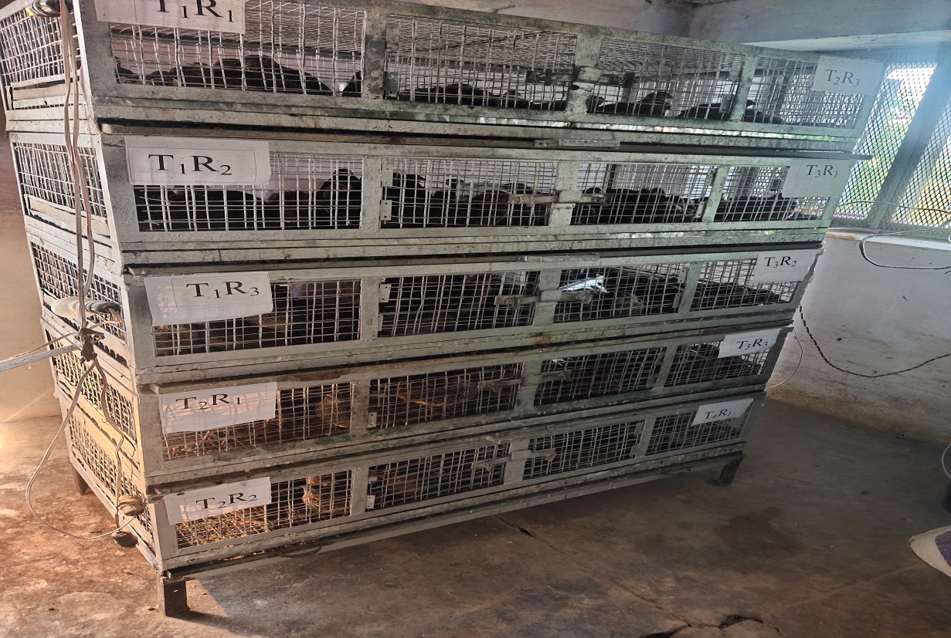
Pic1: Cage system rearing of broiler Japanese quail

2.3 Procurement of Moringa oleifera leaves and preparation of leaf meal
Moringa oleifera leaves also known as Sahjan or Drumstick was harvested preferably young ones from the trees in the local area of Pantnagar in the month of November 2021. The cut branches were spread out on a concrete floor and allowed to dry for a period of 5-6 days under well-aerated shade. The leaves were then separated from the twigs manually before oven drying. The leaves were then kept into hot air oven at 50⁰Cfor 3-4 hours to make them crispy for easy blending. The dried leaves were then run through a hammer mill sieve with a size of 4-5mm to produce the Moringa oleifera leaf meal and then stored in air tight polythene bags in a cool and dry place to prevent it from moisture.
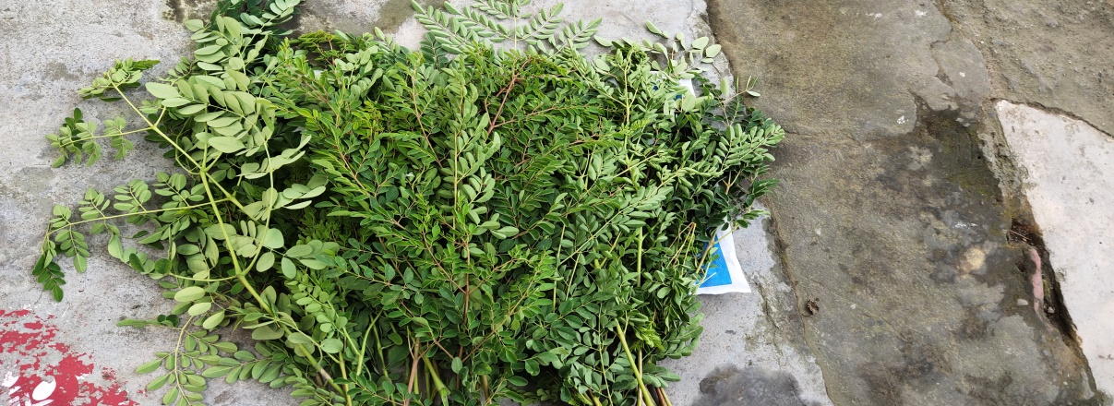
Pic 2: Harvesting of young M. oleifera leaves from the tree
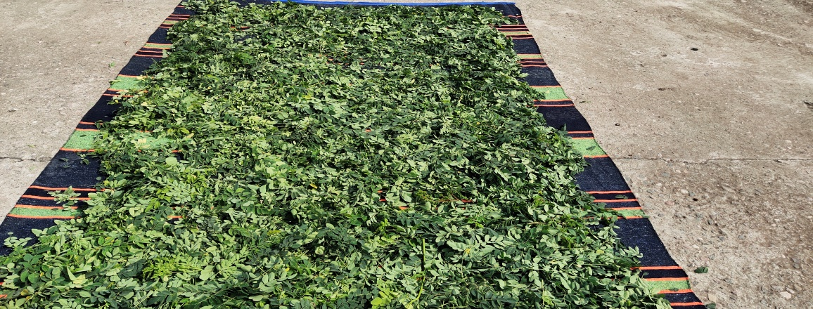
Pic 3: Separation of young M. oleifera leaves from the twig
2.4 Procurement of feed ingredients and supplements
Feed ingredients required for the formulation of the experimental ration were procured from the feed unit and all the ingredients were ground in feed mill before mixing at feed unit of the Instructional Poultry Farm (IPF), GBPUAT, Pantnagar. α- tocopherol (Evion-400) and Vitamin C required for the feeding trial was procured from local market Pantnagar.
2.5 Experimental design and treatments:

Groups | Treatment | No. of birds/ replicate | No. of replicates | Total No. of birds
T₁ | Control (Basal ration) | 12 | 03 | 36
T₂ | Basal ration with Vitamin C (200 mg/kg) | 12 | 03 | 36
T₃ | Basal ration with Vitamin E (10 IU/kg) | 12 | 03 | 36
T₄ | Basal ration with 1% Moringa oleifera leaf meal | 12 | 03 | 36
T₅ | Basal ration with 3% Moringa oleifera leaf meal | 12 | 03 | 36
T₆ | Basal ration with 5% Moringa oleifera leaf meal | 12 | 03 | 36
T₇ | Basal ration with 7 %Moringa oleifera leaf meal | 12 | 03 | 36
T₈ | Basal ration with 9 % Moringa oleifera leaf meal | 12 | 03 | 36

2.6 Experimental diet
For the experiment, two types of basal diets were prepared to meet the nutrient requirement of Japanese quail, i.e., starter (0-3 weeks) and finisher (3-6 weeks) as per ICAR (2013).
Ingredients (%) | Japanese quail starter  (0-3 weeks) (kg) | Japanese quail finisher (3-6 weeks) (kg)
Yellow Maize | 42.00 | 55.00
Soybean meal (Solvent extracted) | 33.00 | 24.00
Deoiled Groundnut cake | 15.00 | 11.00
Rice polish | 08.00 | 08.00
Dicalcium phosphate | 01.00 | 01.00
Lysine | 00.20 | 00.20
DL-methionine | 00.10 | 00.10
Choline chloride | 00.05 | 00.05
Mineral and Vitamin mixture | 00.20 | 00.20
Common salt | 00.30 | 00.30
Hepatocare | 00.10 | 00.10
Coccidiostats | 00.05 | 00.05
Total | 100.00 | 100.00
Chemical composition (% DM basis ) (calculated)
Crude Protein (%) | 25.02 | 20.94
Metabolisable Energy (kcal/kg) | 2851.50 | 2954.03

2.7 Carcass Quality Traits
For carcass trait assessments, two representative Japanese quail chicks from each replicate of all treatment groups were euthanized at the conclusion of the 6th week of the experimental trial to evaluate various carcass characteristics, including cut-up parts, organ weights, and processing losses. A 12-hour fasting period was enforced prior to slaughter. Prior to the slaughter procedure, each quail was weighed individually. The euthanasia process involved cervical dislocation to ensure humane treatment of the birds. Following dislocation, complete exsanguination was performed by making an incision in the jugular vein to facilitate thorough blood drainage.
2.8 Carcass Yields:
- Pre-slaughter live weight (g)
The body weight of each individual Japanese quailwas recorded prior to the slaughter process.
- Eviscerated weight

- Dressing Yield
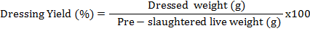
2.9 Carcass cut up parts
a) Breast
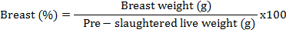
b) Thigh
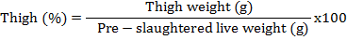
2.10: Meat to bone ratio
The skin was removed and its concarves were disserted and meat was separated and scrapped off the bone. The weight of meat and bone was separately recorded and the ratio was calculated as:
Meat to bone ratio = 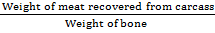

2.11: Organs weight
The organ weight of different slaughtered birds was expressed on live weight per cent basis.
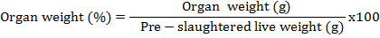
2.12: Statistical Analysis
Statistical analysis was done using SPSS software.
3. RESULTS
The mean values of carcass characteristics (% live weight) are given in Table 1.
3.1 Carcass characteristics (% live weight)
A) Pre-slaughter weight
Significant (P≤0.05) differences in average pre-slaughter weight (g) were observed when Japanese quail chicks were fed diet with incremental level of MOLM during 42th days of experimental period. The average pre-slaughter weight during this experimental period were noted as 202.00±7.63, 190.00±2.08, 195.83±15.38, 219.83±4.08, 227.17±5.34, 209.00±7.76, 184.33±2.96, and 179.33±0.88 g for T₁, T₂, T₃, T₄ T₅, T₆, T₇ and T₈ treatment groups respectively. Significantly (P≤0.05) higher pre-slaughter weight was noticed in T₅ (227.17g) group than control group and lowest weight in T₈ (179.33g) group. However values were noted to be statistically similar in T₁, T₂, and T₃treatment group.
Table 1: Average values of carcass characteristics (% live weight) in Japanese quail chick during finisher phase (at 6 weeks of age) fed diets incorporated with Moringa olifera leaf meal

Attributes | Carcass Characteristics (% live weight)
Attributes | T₁ | T₂ | T₃ | T₄ | T₅ | T₆ | T₇ | T₈ | SEm | P- Value
Pre-slaughter weight (g) | 202.00±7.63^{bcd} | 190.00±2.08^{cd} | 195.83±15.38^{cd} | 219.83±4.08^{ab} | 227.17±5.34ª | 209.00±7.76^{abc} | 184.33±2.96^{d} | 179.33±0.88^{d} | 3.92 | 0.002
Dressing percentage without giblet | 67.21±3.43 | 66.22±2.31 | 67.19±3.01 | 67.82±1.54 | 68.53±3.72 | 66.10±3.39 | 63.39±0.45 | 61.87±2.05 | 0.91 | 0.662
Dressing Percentage with giblet | 70.35±3.38 | 69.28±2.37 | 69.85±3.14 | 70.38±1.69 | 71.49±3.87 | 69.13±3.46 | 66.73±0.56 | 65.41±1.85 | 0.90 | 0.789
Bone yield (%) | 40.65±1.47 | 33.68±5.04 | 34.02±0.66 | 37.35±4.0 | 36.38±0.57 | 43.35±0.01 | 40.05±3.33 | 40.01±3.33 | 1.07 | 0.275
Meat- bone ratio | 3.34±0.21^{bcd} | 3.86±0.41^{abc} | 3.83±0.04^{abc} | 4.08±0.42^{ab} | 4.28±0.26ª | 3.19±0.23^{bcd} | 2.96±0.28^{cd} | 2.79±0.15^{d} | 0.13 | 0.013
{T₁ : Control ;T₂ :Basal diet with Vitamin C (200 mg/kg); T₃ : Basal diet with Vitamin E (10 IU/kg); T₄ :Basal diet with 1% MOLM;T₅: Basal diet with3% MOLM; T₆ : Basal diet with 5% MOLM; T₇ : Basal diet with 7% MOLM; T₈ : Basal diet with 9%MOLM}
Means with different superscripts ^{(a, b, c, d )} in a row differ significantly (P≤ 0.05) from each other

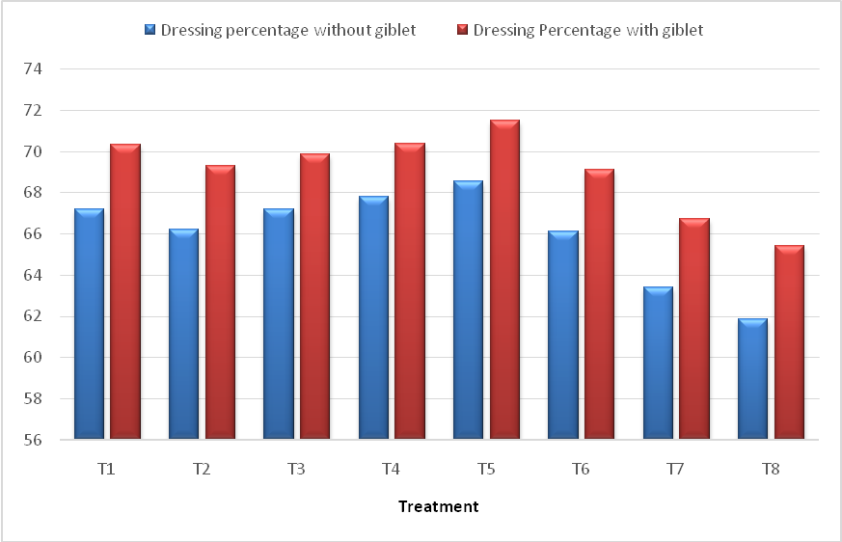
Fig. 1: Average values of carcass characteristics (% live weight) in Japanese quail chick during finisher phase (at 6 weeks of age) fed diets incorporated with Moringa olifera leaf meal
B) Dressing Percentage without giblet
Non-significant (P≥0.05) difference was noticed in the dressing percentage without giblet of Japanese quail chicks fed diet incorporated with different level of Moringa oleifera leaf meal. The mean dressing percentage without giblet values were noted as 67.21±3.43, 66.22±2.31, 67.19±3.01, 67.82±1.54, 68.53±3.72, 66.10±3.39, 63.39±0.45, and 61.87±2.05% for T₁, T₂, T₃, T₄ T₅, T₆, T₇ and T₈ treatment groups respectively.
C) Dressing Percentage with giblet
Non-significant (P≥0.05) effect on mean dressing percentage with giblet values was observed when Japanese quail was fed diet with various levels of Moringa oleifera leaf meal. The value were obtained as 70.35±3.38, 69.28±2.37, 69.85±3.14, 70.38±1.69, 71.49±3.87, 69.13±3.46, 66.73±0.56, and 65.41±1.85% for T₁, T₂, T₃, T₄ T₅, T₆, T₇ and T₈ treatment group respectively.
D) Bone yield (%)
A non-significant (P≥0.05) difference was observed in the bone yield of the Japanese quail chicks fed diet incorporated with different level of Moringa oleifera leaf meal.
E) Meat -bone ratio
Significant (P≤0.05) differences in average meat-bone ratio were observed when Japanese quail chicks were offered incremental level of MOLM during 42th days of experimental period. Significantly (P≤0.05) higher meat-bone ratio was seen in T₅ (4.28) group while lower was seen in T₈ (2.79) treatment group as compared to control. However values were noted to be statistically similar in T₂, T₃, and T₄ treatment group respectively.
The results showed that an elevation in dressing percentage in groups of birds received 1.0 and 3.0% MOLM in diet. Similar results have been obtained by Baloch et al. (2021) who reported that there was significant (P≤0.05) difference in dressing percentage between those fed the 2.5% Moringa oleifera leaf meal in broiler diet. In the present study, dressed weight was reduced with 5.0, 7.0 and 9.0% Moringa oleifera leaf meal incorporation in diet of birds. Similarly Hamad et al. (2018) also noticed that quail chicks fed diets with M. oleifera at level of 6 and 3 g/kg diet showed the highest significant relative weights of carcass and total edible parts. Also Karthivashan et al. (2015) observed that 1.0% of MOLM extracts supplementation had significantly (P≤0.05) highest dressing percentage in broiler. Ologhobo et al. (2014) showed higher mean values of slaughter weights were recorded for broiler fed diets containing Moringa oleifera leaf meal. Contrary to the current findings, Sebola et al. (2015) in their experiment was shown a non-significant (P≥0.05) difference in dressing percentage, organ weight together on the inclusion of M. oleifera leaf meal at 2.5 to 10.0% in the diets of Ovambo, Potchefstroom Koekoek and Black Australorp chicken. This result was agreement with Khalifa et al. (2018) reported that by using 20% MOLM in diet of birds increased the weight of heart and liver significantly (P≤0.05) than other treatment groups, but there were non- significant (P≥0.05) differences in gizzard, carcass and edible parts weights of the growing Japanese quail atincreasing level 5.0, 10.0, 15.0 and 20.0% MOLM. The present study showed an influences in dressing percentage received vitamin C (200mg/kg) and vitamin E (10IU/kg) in diet of Japanese quail chicks. This study was in agreement with Sahin and Kucuk (2001) who found that dietary vitamin E inclusions resulted in a better carcass quality in broiler Japanese quails reared under heat stress (34⁰C). Similarly Sigolo et al. (2019) reported that supplementation of vitamin E and C at different levels could enhanced Japanese quail production and got more profit. Likewise Kumar et al. (2020) recommended that Moringa oleifera aqueous leaf extract and ascorbic acid supplementation having improved meat quality and economic in production. Furthermore Bushwereb et al. (2023) revealed that supplementation of vitamins C @ 250 mg/kg and vitamin E @ 200 mg/kg in diet of broiler chicken significantly (P≤0.05) increased carcass yields in comparison to the control diet.
3.2 Cut-up parts and Weights of organs
The mean values of carcass characteristics of cut-up parts viz., neck, back, wing, breast, thigh and drumstick, weights of organs of Japanese quail chicks of different treatment groups due to incorporation of Moringa oleifera leaf meal in the diet are shown in Table 2 and expressed as percent of pre-slaughter live weight basis.

Table 2. Average values of cut-up parts and organ weight (% live weight) of Japanese quail chick during finisher phase (at 6 weeks of age) fed diets incorporated with Moringa olifera leaf meal
Attributes | Cut-up parts
Attributes | T₁ | T₂ | T₃ | T₄ | T₅ | T₆ | T₇ | T₈ | SEm | P- Value
Neck | 2.62±0.33 | 2.99±0.04 | 2.67±0.23 | 2.95±0.21 | 2.90±0.16 | 2.67±0.10 | 2.26±01.0 | 2.36±0.07 | 0.07 | 0.09
Wing | 6.70±0.26 | 6.36±0.72 | 6.37±0.35 | 5.97±0.55 | 6.35±0.53 | 5.59±0.42 | 6.44±0.74 | 6.14±0.31 | 0.16 | 0.87
Back | 17.33±2.16 | 13.84±0.79 | 13.75±1.03 | 13.35±2.01 | 13.73±1.27 | 12.96±0.89 | 13.20±1.32 | 11.98±0.37 | 0.50 | 0.30
Breast | 29.52±0.23 | 27.35±0.84 | 27.77±2.01 | 25.72±1.92 | 26.42±1.40 | 23.93±1.40 | 27.31±1.93 | 27.31±1.36 | 0.54 | 0.37
Thigh | 14.54±1.88 | 13.67±0.68 | 13.09±1.61 | 13.67±1.29 | 13.91±0.76 | 12.72±0.23 | 14.27±0.24 | 14.31±0.56 | 0.34 | 0.93
Drumstick | 4.87±0.03 | 5.04±0.22 | 4.90±0.25 | 4.46±0.19 | 4.47±0.20 | 4.30±0.22 | 4.70±0.24 | 4.55±0.68 | 0.10 | 0.69
Giblet
Heart | 0.58±0.09 | 0.52±0.01 | 0.53±0.01 | 0.45±0.01 | 0.44±0.01 | 0.47±0.02 | 0.54±0.01 | 0.55±0.01 | 0.01 | 0.09
Liver | 1.06±0.04 | 1.13±0.07 | 1.07±0.03 | 0.98±0.05 | 1.06±0.07 | 0.98±0.02 | 1.08±0.01 | 1.20±0.09 | 0.02 | 0.21
Gizzard | 1.48±0.10 | 1.39±0.21 | 1.35±0.18 | 1.27±0.13 | 1.16±0.03 | 1.21±0.09 | 1.26±0.04 | 1.24±0.13 | 0.04 | 0.74
Lymphoid organs
Bursa | 0.06±0.01 | 0.07±0.01 | 0.07±0.01 | 0.06±0.01 | 0.08±0.01 | 0.07±0.01 | 0.08±0.01 | 0.06±0.01 | 0.01 | 0.22
Spleen | 0.07±0.01 | 0.07±0.01 | 0.08±0.01 | 0.08±0.01 | 0.08±0.01 | 0.08±0.01 | 0.08±0.01 | 0.08±0.10 | 0.01 | 0.82
Thymus | 0.03±0.01 | 0.02±0.01 | 0.02±0.01 | 0.03±0.01 | 0.03±0.01 | 0.03±0.01 | 0.03±0.01 | 0.03±0.01 | 0.01 | 0.87
{T₁ :Control ; T₂ :Basal diet with Vitamin C (200 mg/kg); T₃ : Basal diet with Vitamin E (10 IU/kg); T₄ :Basal diet with 1% MOLM;T₅: Basal diet with3% MOLM; T₆ : Basal diet with 5% MOLM; T₇ : Basal diet with 7% MOLM; T₈ : Basal diet with 9%MOLM}
A non-significant (P≥0.05) difference was found in the cut-up parts viz., neck, back, wing, breast, thigh and drumstick of the Japanese quail chicks fed diet incorporated with different level of Moringa oleifera leaf meal during 42th days of study period.
A non-significant (P≥0.05) difference was also observed in the weights of giblet (% live weight) such as gizzard, heart and liver of the Japanese quail chicks diet incorporated with different level of Moringa oleifera leaf meal during this period.
A non-significant (P≥0.05) difference was observed in the weights of lymphoid organs (% live weight) such as bursa, spleen and thymus of the Japanese quail chicks fed diet incorporated with different level of Moringa oleifera leaf meal during 42th days of study period.
The results recorded the mean values for neck, wing, back, thigh, breast and drumstick were within the normal range. But El Tazi (2014) showed that dietary herbal supplement of Moringa leaf (0.2, 0.4 and 0.6%) levels improved the breast and drumstick of broiler chicks. The present study showed non-significant (P≥0.05) difference in giblet weight percentage (gizzard, heart, liver) with incorporation of 1.0, 3.0, 5.0, 7.0, and 9.0% MOLM in diet of Japanese quail chicks during experimental period of 42 days. This result was similar to the finding of Zanu et al.(2012) observed that none of the parameter measured for carcass characteristics were affected in birds fed diets containing 5.0, 10.0 and 15.0% Moringa oleifera leaf meal. Likewise El Tazi (2014) reported adietary herbal supplement of 0.1% of Moringa in broilers increased the gizzard fat content also non-significant difference in abdominal fat, heart, liver, head and shanks percentages.But Ologhobo et al. (2014) observed in their study that the relative weight of the gizzard decreased significantly by increasing the supplementation levels of the M. oleifera leaves meal @ 0.04% and 0.06% in diet as compared with control group in broiler birds.
CONCLUSION
Based on the findings of the research, it can be concluded that 3% Moringa oleifera leaf meal can be incorporated in feed for improvement of carcass characteristics of the broiler Japanese quail.
Future scope
Similar type of work will be conducted in different species of poultry.
Conflict of Interest. None.
DISCLAIMER (ARTIFICIAL INTELLIGENCE)
Author(s) hereby declare that NO generative AI technologies such as Large Language Models (Chat GPT, COPILOT, etc) and text-to-image generators have been used during writing or editing of this manuscript.
COMPETING INTERESTS
Author has declared that no competing interests exist.
REFERENCES:
Baloch, F.N., Baloch, H.N. & Mughal, G.A. (2021). Replacement of sunflower meal with Moringa oleifera leaves on growth performance of broiler. Approaches in Poultry, Dairy & Veterinary Sciences, 8(2), 756-762.
Bao, Z., Kang, D., Li, C., Zhang, F. & Lin, S. (2020). Effect of salting on the water migration, physicochemical and textural 435 characteristics, and microstructure of quail eggs. LWT-Food Science and Technology, 132, 1-8.
Bushwereb, M., Bentaher, F., Elraghig, M. & Mansur, M. (2023). Performance, lymphoid organ, and carcass characteristics of broiler chicken as affected by feed supplementation with vitamin C, and vitamin E. Global Journal of Animal Scientific Research, 11(1), 89-103.
El-Tazi, S.M. (2014). Effect of feeding different levels of Moringa oleifera leaf meal on the performance and carcass quality of broiler chicks. International Journal of Scientific Research, 3(5), 147-151.
Hamad, O. K., El- Gendi, G.M., El-Garhy, O.H. & Aljumaili, T.K. (2018). Effect of supplementing Moringa (Moringa oleifera) leaves meal to quail diets on productive performance. Annals of Agricultural Science, Moshtohor, 56 (4), 997 – 1004.
Karthivashan, G., Arulselvan, P., Alimon, A., Ismail, I.S. & Sharida Fakurazi, S. (2015). Competing role of bioactive constituents in Moringa oleifera extract and conventional nutrition feed on the performance of Cobb 500 broilers. BioMed Research International, 970398, 1-13.
Khalifa, W.H., Ghada, E., Abusinaa, G.M., Elmallah, S.A. and Yassein, A.A., Elghamry, A. & Maghraby, N.A. ( 2018). Effect of using different levels of Moringa oleifera meal in the diets of japanese quails on their productive performance. Egyptian Journal of Nutrition and Feeds , 21 (2), 529-535.
Lata, Manju., & B.C. Mondal. (2024). Moringa oleifera Leaf Meal: A sustainable approach for poultry production: A review. Archives of Current Research International, 24 (11), 176-85.
Lu, W., Wang, J., Zhang, H.J., Wu, S.G. & Qi, G.H. (2016). Evaluation of Moringa oleifera leaf in laying hens: Effects on laying performance, egg quality, plasma biochemistry and organ histopathological indices. Italian Journal of Animal Science, 15, 658–665.
NRC. (1994). National Research Council. Nutrient requirements for poultry. 9th revised edition National Academy Press, Washington, DC. USA.
Ologhobo, A.D., Akangbe, E.I., Adejumo, I.O. & Adeleye, O. (2014). Effect of Moringa oleifera leaf meal as replacement for oxytetracycline on carcass characteristics of the diets of broiler chickens. Annual Research & Review, 4(2), 423-431.
RSPCA. (2011). Royal Society for the Prevention of Cruelty to Animals Quail: Good practice for housing and care. Research Animals Department .4th edition. West Sussex.
Sahin, K., Sahin, N., Onderci, M., Yaralioglu, S. & Kucuk, O. (2001). Protective role of supplemental vitamin E on lipid peroxidation, vitamins E, A and some mineral concentrations of broilers reared under heat stress. Veterinární medicína-Czech, 46 (5), 140-144.
Sebola, N. A., Mlambo, V., Mokoboki, H.K. & Muchenje, V. (2015). Growth performance and carcass characteristics of three chicken strains in response to incremental levels of dietary Moringa oleifera leaf meal. Livestock Science, 178, 202–208.
Sigolo S, Khazaei R, Seidavi A, Gallo A, & Prandini A. (2019). Effects of supra-nutritional levels of vitamin E and vitamin C on growth performance and egg production traits of Japanese quails. Italian Journal of Animal Science, 18(1), 480-487.
Zanu, H.K., Asiedu, P., Tampuori, M., Asada, M. & Asante, I. (2012). Possibilities of using Moringa (Moringa oleifera) leaf meal as a partial substitute for fishmeal in broiler chickens diet. Online Journal of Animal and Feed Research, 2 (1), 70-75.

