**Application of Data Analytics in Food Quality Control: Enhancing Decision-Making for Contamination Prevention**

**ABSTRACT**

|  |
| --- |
| **Objective:** This study examines the growing need for the application of data analytics in making food quality control easier, better and safer. It looks into how new tools like predictive modeling, machine learning, and blockchain-based traceability systems can help prevent contamination and reduce foodborne outbreaks.  **Study Design:** A detailed review of existing literature, case studies, and relevant industry reports between 2019 and 2025 was carried out to assess the existing and potential impact of data analytics on food quality control and food safety.  **Methodology:** The research employs a qualitative approach, drawing insights from peer-reviewed journals, WHO outbreak records, industry whitepapers, and global case studies. Data visualization was also included to show relevant trends, technology gaps, and outbreak frequency.  **Results:** The research shows a rise in foodborne outbreaks due to a number of reasons like; poor data infrastructure, low use of predictive technology, and disconnected traceability systems. Using predictive analytics tools effectively can help detect issues early, track contamination as it happens, and maintain a strong supply chain.  **Conclusions:** The applicaton of data analytics is no longer a luxury, it is now necessity, that must be maximized to make food safer. As the global food industry becomes more complex and prone to contamination, using AI-driven predictive systems, blockchain traceability, and real-time analytics can significantly reduce outbreak risks. The future of food quality control relies on active data management, collaboration across sectors, and increased investment in smart farming technologies.  . |

***Keywords:*** *Food Safety, Quality Control, Data Analytics, Predictive Analytics, Machine Learning,*

1. **INTRODUCTION**

Food safety is the extent to which requirements relating to the characteristics of foods that have the potential to cause illness are met. [1]. Access to safe, healthy, and adequate food is fundamental for the increasing world population. The food sector faces increasing issues in maintaining food safety, quality, and supply due to escalating population demands and constantly evolving consumer tastes. [2] According to the World Health Organization (WHO), over 600 million people catch foodborne illnesses annually, with 420,000 of them losing their lives to ailments [2]. Currently, the mortality rate from foodborne illnesses makes up 7.5 % of all global deaths, with bacteria causing most foodborne illnesses, followed by viruses and parasites [2]. Considering that many of these foodborne diseases can be prevented, the high number of illnesses and deaths linked to contaminated food highlights the importance of food safety and the pressing need for systematic and sustainable approaches to combating foodborne pathogens.

Owing to this pressing need, we have seen some advancement in the employed approach to ensuring food safety, and one of the significant advancements in the food sector is the application of data analytics and artificial intelligence (AI), which improves various elements of food safety and production and resolves challenging issues. The ability of AI to process large volume sets of data and detect complex patterns has opened up new possibilities for developing innovations in preventing contamination, quality assurance, and food processing. This introduction shows the transformative impact of data analytics and artificial intelligence (AI) in the food sector, highlighting its applications, benefits, and challenges of implementation.

Historically, the food industry has immensely depended on labor and the expertise of skilled individuals for the purposes of quality assurance and control, up until the need for data-driven decision-making became inevitable. Data analytic techniques are those used to collect, process, and analyze data to provide meaningful information that can support decision-making.  Fundamentally, the application of data analytic techniques (regression, correlation, principal component analysis, Monte Carlo simulation, etc.) in food safety and risk assessment to achieve various objectives is not new. The use of data analytics has changed the odds towards a more proactive stance, enhancing the seamless anticipation and mitigation of potential contamination risks before they manifest. By leveraging the vast amounts of data generated across the food production process, data analytics facilitate the identification of patterns and abnormalities that indicate there is a quality issue.

Subsequently, we will discuss in detail the impact some of the data analytics techniques and AI applications have had, one of which is how AI-powered systems are employed to detect microbial contamination, chemical residues, and physical adulterants in food products, thereby enhancing proactive risk mitigation strategies.

It is also important to note that, with advances in data-driven inspection technology and improvements in regulation methods, the size and diversity of food safety data have exploded, posing emerging challenges to data analysis techniques. [3]. For one thing, human experience and knowledge have not been considered in most automated analysis methods; meanwhile, the process of food safety, risk analysis, and decision-making cannot be fully separated from the participation of domain experts. [4]. To bridge the gap, visual analytics has emerged in recent years, using visual interactive interfaces as a channel to integrate human and machine intelligence into the data analyzing process in a visual way. It helps people explore, understand, and analyze large-scale data with speed and accuracy to accomplish analytical reasoning and decision-making. [5]. Furthermore, visual analytics is a human-in-the-loop approach, and analysts can interact with the visual data interface through rich interactive tools to understand the distribution of food safety risks and assist in making regulatory decisions. It provides new ideas for food safety data analysis and has gradually become an important tool for food safety regulations. [6]

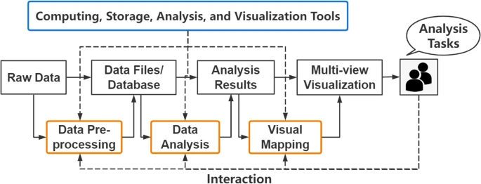

**Fig 1: The complete visual analytics pipeline. [6]**

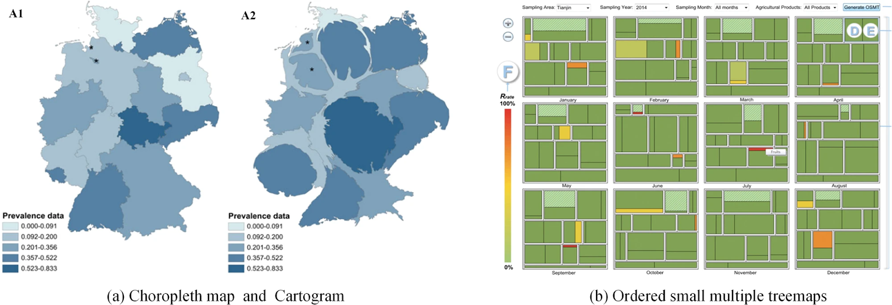

**Fig 2:** **Examples of spatial-temporal data visualization  [6]**

1. **METHODOLOGY**

This research employs a systematic literature review approach to evaluate the current body of literature on food safety and quality, particularly from the lens of recent research and real-world case studies between 2019 and 2025. The objective was to analyze the impact of data analytics in ensuring adherence to quality control and safety through data-driven decision-making for contamination prevention.

In order to have a comprehensive analysis and considering the interdisciplinary nature of the topic, a systematic and methodical search of relevant academic and industry literature was carried out. The subsequent digital repositories and databases were employed to obtain relevant scholarly material; i.e., an extensive literature search was conducted on leading academic databases including ScienceDirect, PubMed, SpringerLink, IEEE Xplore, Scopus, Web of Science, Google Scholar, and Wiley Online Library. Additionally, some relevant articles such as government reports, WHO and FAO briefings, CDC outbreak summaries, and industry whitepapers were also reviewed with a view to supplement context with informative case studies and real-world uses of data analytics. Research was conducted with various permutations of the following keywords: "data analytics in food quality control," "food safety + machine learning," and "forecasting techniques in the food sector." "Monte Carlo simulation + food safety" and "principal component analysis (PCA) + food quality." "Artificial Intelligence in food quality control," "Foodborne outbreaks + data analytics," "Big data in food science," and Digital transformation in food industry" Boolean operators (AND, OR) and filters (year: 2019–2025, peer-reviewed only) were used to narrow results.

To ensure inclusion and to remain focused on the subject, studies were selected by the following: peer-reviewed academic journals published from  2019 to  2025; Literature specifically applying data-driven approaches (ML, regression, PCA, etc.) to food quality and safety; Publications providing case studies, performance measures, or methodological frameworks; Excluded were experiments not related to food safety or quality; articles mentioning data analytics only in passing with no real application; pre-2019 sources unless heavily cited or foundational; and non-English papers.

Initial screening of titles and abstracts was carried out to exclude irrelevant papers. This was followed by a full-text screening of the shortlisted research. Duplicate records were removed, and papers were categorized into thematic clusters by the technique employed (e.g., regression, PCA, ML models, etc.) and area of application (e.g., microbial contamination, shelf-life prediction, traceability systems, etc.). 29 papers were ultimately included in the review following a strict screening process. A further 6 real-world outbreak case studies (2019–2024) were chosen to connect theoretical frameworks with actual practice and demonstrate how data analytics could have mitigated or forecasted these occurrences.

It is important to note that there are some limitations to this method even with the thorough selection process. One of which is reliance on limited databases, which, although extensive, may not include all relevant research on the topic. Some important articles could be found in other databases or institutional repositories that were not searched. The exclusion of non-English publications also means that potentially valuable contributions from studies reported in non-English-speaking countries may have been omitted. Finally, while the research attempts to encapsulate recent developments from 2019 onwards, certain older core research that would still be relevant to the topic was not considered. However, this study remains a detailed and organized review of the application of data analytics in food quality control and is relevant enough to provide practical recommendations for implementing real-time analytics platforms in food production, which informs food safety professionals, regulatory agencies, and manufacturers.

1. **RESULTS AND DISCUSSION**

|  |  |  |  |
| --- | --- | --- | --- |
| **Year** | **Outbreak** | **Impact** | **Source** |
| 2019 | Listeria in Enoki Mushrooms | 36 illnesses, 4 deaths across 17 states in the USA | [7] |
| 2020 | Salmonella in Red Onions | 1,127 cases, 167 hospitalizations across 48 states in the USA. | [8] |
| 2021 | E. coli in Baby Spinach | 15 illnesses and 4 hospitalizations across 10 states in the USA. | [9] |
| 2022 | Listeria in Enoki Mushrooms | 5 illnesses, 5 hospitalizations across 4 states in the USA. | [10] |
| 2023 | Salmonella in cantaloupes | 407 cases, 158 hospitalizations, 6 deaths across 44 states in the USA. | [11] |
| 2024 | Salmonella in Cucumbers | 68 illnesses and 18 hospitalizations across 19 states in the USA and Canada. | [12] |

**Table 1: Real life foodborne illness outbreaks from 2019 to 2024**

**Global Trends in Food Contamination Events (2019–2024)**

The increasing frequency of foodborne outbreaks over the past six years highlights persistent vulnerabilities in worldwide food quality control systems. A review of high-profile outbreaks between 2019 and 2024 reveals a disturbing trend of repeat contamination incidents linked to dairy, poultry, and fresh produce. Table 1 provides a chronological overview of such high-profile incidents, ranging from Listeria monocytogenes in deli meats to Salmonella in onions and powdered infant formula.

Recent events reveal that worldwide food safety standards continue to have issues. However, advances in technology and data analysis provide promising ways to minimize these risks. This report examines specific outbreaks, studies how they develop, and assesses the effectiveness of technology-driven solutions in preventing them from occurring in the future.

1. **Listeria in Deli Meats (2019–2020) Outbreak Details:**

In April 2019, the CDC reported that people in four states got sick from Listeria bacteria found in deli-sliced meats and cheeses. Ten individuals were affected, and all needed to go to the hospital. Unfortunately, one person did not survive. The investigation could not find one supplier to blame, showing that the contamination was widespread in deli products. Another outbreak occurred in October 2020, with 12 people from four states getting sick. Each of these cases landed in hospitals, and one person died. The evidence suggested deli meats were to blame, but investigators could not name a specific brand or supplier responsible for the outbreak.

**Evolution and Challenges**: Listeria keeps reappearing in deli meats, which shows how difficult it is to keep cleanliness during slicing and packing. Sticky layers called biofilms can form on equipment, and germs can spread from one place to another, making these risks persist over time.

**Technological Solutions**: By using programs to monitor the environment and employing rapid detection methods like real-time PCR tests, Listeria can be identified more easily in food processing areas. Moreover, blockchain technology can track where food comes from, helping to quickly manage recalls and pinpoint the sources of contamination. [13]

1. **Salmonella in Onions (2020–2021) Outbreak Details:**

In 2020, a major outbreak of Salmonella Newport was traced back to red onions from a California farmer. This outbreak spread to 48 states, making 1,127 people sick, and 167 of them ended up in the hospital.

The following year, in 2021, another outbreak, this time Salmonella Oranienburg, was linked to fresh whole onions imported from Chihuahua, Mexico. This incident affected 1,040 people, with 260 hospitalized. It spread across 39 states, the District of Columbia, and Puerto Rico.

**Evolution and Challenges:**

These incidents highlight the difficulty of finding contamination in produce that is distributed widely. The global supply chain complicates the task of tracking and cleaning raw foods like onions, which is a significant challenge.

**Technological Advancements:**

Advancements like whole genome sequencing (WGS) are now helping health authorities track the exact source of outbreaks. In addition, Internet of Things (IoT) devices can offer constant monitoring of growing and storage conditions, helping to spot and reduce the risk of contamination. [14]

1. **Cronobacter sakazakii in Powdered Infant Formula (2021–2022) Outbreak Details:**

In 2021 and 2022, many infants became seriously ill due to a bacteria called Cronobacter sakazakii. This was traced back to powdered infant formula and contaminated feeding tools. These infections are especially dangerous for newborn babies, leading to severe health problems like meningitis and sepsis, and can even result in death.

**Challenges and Risks:**

Powdered infant formula is prone to contamination, making it a health risk. The bacteria are tough and can survive in dry conditions, which makes them even harder to manage. Failing to properly clean feeding equipment adds to the danger.

**Technological Solutions:**

To tackle this problem, new rapid testing methods, including nanoparticle-based tests, are being developed to quickly detect Cronobacter in factories. Also, maintaining strict hygiene standards and using data analytics to track and predict contamination points can significantly improve safety measures. [15]

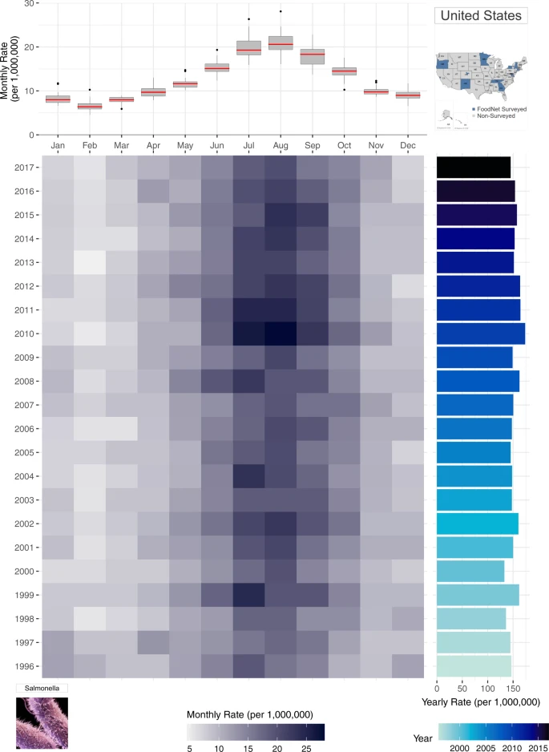

**Fig 3: Monthly rates of salmonellosis in the US from 1996–2017. [29]**

**Predictive Analysis in Food Safety**

Predictive analytics is not used as much as it could be in food safety, showing a big gap in how we control food quality today. Techniques like Monte Carlo simulations, principal component analysis (PCA), and machine learning algorithms are really powerful tools. They can help a lot in stopping contamination and making sure our food is safe. In this section, we will look at how these methods are used specifically in dairy and poultry production. We'll talk about how effective they are and back it up with relevant research studies

**Monte Carlo Simulation in Dairy Production:**

In predicting milk spoilage, Monte Carlo simulations help us understand risk and uncertainty in systems that predict future outcomes. In dairy production, these simulations predict when pasteurized milk might spoil due to contamination after pasteurization, often involving gram-negative bacteria. [15]. A study in the Journal of Dairy Science used a Monte Carlo simulation to estimate bacterial growth in milk over time. It examined 17 types of bacteria commonly found in spoiled milk, considering initial contamination levels and storage temperatures. The study discovered that two main factors influenced bacterial growth: the maximum rate at which bacteria multiply and the storage temperature of the milk. These factors determined the number of milk containers with unsafe bacterial levels by days 7 and 10. This model allows scientists to simulate different scenarios, such as less frequent contamination or better temperature control during storage, helping improve milk quality and extend its freshness. [16].

**Evaluating Meat Quality with Principal Component Analysis in Poultry Processing:**

Principal Component Analysis (PCA) is a method used to make complex data easier to understand by focusing on the most important factors. In the poultry industry, PCA is used to study meat quality, with a special focus on juiciness. [17]. A study published in British Poultry Science applied PCA to investigate the effects of different cooking times on chicken breast meat quality. Key aspects they examined included the meat's shrinkage during cooking, its water-holding ability, and sensory attributes like the feeling of moisture release and mouthfeel. All these elements play a critical role in determining how juicy the meat is. By applying PCA, researchers were able to clearly differentiate meat quality based on cooking duration. This demonstrates the effectiveness of PCA in systematically assessing and understanding meat quality in poultry processing. [17]

**Machine Learning for Keeping Food Safe from Contamination Making Detection of Harmful Germs Better and Assessing Risks:**

Machine learning (ML) consists of computer programs that are very useful in checking for and predicting food safety issues. These programs can handle huge amounts of information to find patterns and odd signs that might indicate a contamination risk. [18]. A detailed study in the journal Comprehensive Reviews in Food Science and Food Safety explored the use of ML in food safety. It showed how ML helps predict antibiotic resistance, trace the origins of harmful germs, and identify outbreaks of food-related illnesses. [19]. The study pointed out that ML models, including Bayesian networks and neural networks, have effectively predicted chemical hazards like pesticide residues and mycotoxins found in fruits and vegetables. These models rely on data from food safety alerts, farming statistics, and weather reports to improve how we assess risks. [20]

**Integration with IoT for Real-Time Monitoring:**

Combining machine learning (ML) with the Internet of Things (IoT) has improved the way we monitor food safety in real-time. [21]. A study in the journal Sensors discusses a new system that uses RFID and IoT technology, enhanced by ML, to detect food contamination. This innovative system employs affordable, inkjet-printed UHF RFID tags, which monitor environmental conditions and identify signs of contamination. This combination of ML and IoT helps us manage food safety more effectively and take preventive measures to ensure food remains safe. [22].

**Correlation Between Outbreak Frequency and Lack of Data Infrastructure**

The food industry still struggles with many foodborne outbreaks, mainly due to poor data systems. These data systems are important because they allow for real-time monitoring of food, tracking its origins, and quickly dealing with contamination problems. Unfortunately, many countries, especially those still developing, find it difficult to adopt these systems, leading to more food safety issues. A study in the British Food Journal explored how new food tracking technologies influence the occurrence of foodborne diseases. It discovered that countries like the USA and Germany have invested heavily in tracking technologies such as radiofrequency identification (RFID) and wireless sensor networks, and as a result, they have seen a decrease in foodborne outbreaks. This indicates that having advanced data systems can significantly enhance food safety. [23].

**Barriers to Data Infrastructure Adoption in the Food Industry**

Even with the aforementioned and obvious benefits, there are several challenges that prevent the wide use of data infrastructures:

Financial Issues: The excessive associated high costs make it hard for many businesses, especially small and medium (SME) ones, to adopt new technology. [24]

Skill Gap: The food industry lacks enough professionals skilled in modern data technologies, making it difficult to implement and manage these systems effectively.

Poor IT Systems: Rural and less developed regions often have inadequate technology systems. This makes adopting Internet of Things (IoT) solutions, important for collecting and monitoring data in real-time, more challenging. [25]

Regulatory and Legal Problems: There is a lack of clear rules and legal guidelines for managing and sharing data. This complicates the integration of data systems across different parts of the supply chain. [26]

**Challenges in Adopting Food Technology in Developing Economies**

There are also some challenges to using new technologies in developing countries, such as:

Limited Awareness and Training: Many farmers and food producers do not know about digital technologies, which leads to few people using them. [27]

Lack of Infrastructure: Problems like unreliable electricity and poor internet connection make it hard to set up and maintain data systems.

Cultural and Socioeconomic Factors: People often resist change. Money and social issues can also make them hesitant to try new technologies. [28]

1. **CONCLUSION**

Over the years, we have experienced a noticeable increase in foodborne outbreaks. This trend reveals the significant problems associated  with food safety globally, especially concerning poultry, dairy, and fresh produce. Instances like Listeria in deli meats and Cronobacter in baby formula show that we still face some challenges in preventing contamination. They also highlight that we are not fully taking advantage of new technologies that could identify these risks sooner and more accurately.

Between 2019 and 2024, studies of real-world outbreaks have shown that traditional methods of food quality checks are not enough. Supply chains are more complex, and consumers are demanding higher standards. Predictive analytics, including artificial intelligence (AI), machine learning (ML), and data visualization, offer a new approach. They provide real-time information and can spot problems early. For example, Monte Carlo simulations are useful for the dairy industry, PCA helps in poultry processing, and blockchain can track food products effectively. These technologies can play a key role in minimizing risk and increasing transparency.

However, not all countries are adopting these technologies equally, especially poorer countries. They face obstacles such as poor data systems, high costs, and a lack of technical expertise. It is important to address these challenges to improve food safety globally. As the food industry becomes more digital, investing in well-organized data, compatible systems, and accessible tools is crucial. This will help expand the use of AI in quality control.

Finally, it is essential for all stakeholders involved, such as food scientists, technology experts, policymakers, and regulators, to work together. By applying data analytics, AI, and predictive analytics to food quality checks, the food industry can switch from reacting to problems to preventing them altogether. This forward-thinking approach can reduce financial losses, save lives, and rebuild consumer trust.

**COMPETING INTERESTS DISCLAIMER:**

Authors have declared that they have no known competing financial interests OR non-financial interests OR personal relationships that could have appeared to influence the work reported in this paper.

**REFERENCES**

1. E. O. Benefo, S. Karanth, and A. K. Pradhan, “Applications of advanced data analytic techniques in food safety and risk assessment,” *Current Opinion in Food Science*, vol. 48, p. 100937, Sep. 2022, doi: 10.1016/j.cofs.2022.100937.
2. Lee, H., & Yoon, Y. (2021). Etiological agents implicated in foodborne illness worldwide.  Food science of Animal Resources, 41(1), 1.
3. Jin, C. Y. et al. Big Data in food safety-a review. *Curr. Opin. Food Sci.* 36, 24–32 (2020)
4. Zhou, L., Zhang, C., Liu, F., Qiu, Z. J. & He, Y. Application of Deep Learning in Food: A Review. *Compr. Rev. Food Sci. Food Safe.* 18, 1793–1811 (2019).
5. Chen, W., Zhao, Y., Zhang, S. & Lu, A. D. Introduction to Visualization (Higher Education Press, Beijing, 2020).
6. Chen, Y., Wu, C., Zhang, Q. *et al.* Review of visual analytics methods for food safety risks. *npj Sci Food* 7, 49 (2023). <https://doi.org/10.1038/s41538-023-00226-x>
7. Centers for Disease Control and Prevention (CDC 2020) [https://archive.cdc.gov/#/details?url=https://www.cdc.gov/listeria/outbreaks/enoki-mushrooms-03-20/index.html](https://archive.cdc.gov/#/details?url=https:/www.cdc.gov/listeria/outbreaks/enoki-mushrooms-03-20/index.html)
8. Food and Drug Administration (FDA 2020) <https://www.fda.gov/food/outbreaks-foodborne-illness/outbreak-investigation-salmonella-newport-red-onions-july-2020>
9. Centers for Disease Control and Prevention (CDC 2022) <https://archive.cdc.gov/#/details?url=https://www.cdc.gov/ecoli/2021/o157h7-11-21/index.html>
10. Centers for Disease Control and Prevention (CDC 2022) <https://www.cdc.gov/listeria/outbreaks/enoki-mushrooms-11-22.html>
11. Centers for Disease Control and Prevention (CDC 2024) <https://www.cdc.gov/salmonella/outbreaks/cantaloupes-11-23/index.html>
12. Food and Drug Administration (FDA 2024) <https://www.fda.gov/food/outbreaks-foodborne-illness/outbreak-investigation-salmonella-cucumbers-november-2024>
13. Wang, L., He, Y., & Wu, Z. (2022). Design of a Blockchain-Enabled Traceability System Framework for Food Supply Chains. *Foods*, 11(5), 744.[https://doi.org/10.3390/foods11050744​](https://doi.org/10.3390/foods11050744%E2%80%8B)
14. Li, K., Lee, J.-Y., & Gharehgozli, A. (2023). Blockchain in food supply chains: a literature review and synthesis analysis of platforms, benefits and challenges. *International Journal of Production Research*, 61(11), 3527–3546.[https://doi.org/10.1080/00207543.2021.1970849​](https://doi.org/10.1080/00207543.2021.1970849%E2%80%8B)
15. McCormic, Z. D., Patel, K., Higa, J., Bancroft, J., Donovan, D., Edwards, L., Cheng, J., Adcock, B., Bond, C., Pereira, E., Doyle, M., Wise, M. E., & Gieraltowski, L. (2022). Bi-national outbreak of Salmonella Newport infections linked to onions: the United States experience. *Epidemiology and Infection*, *150*. <https://doi.org/10.1017/s0950268822001571>
16. J. C. Haston *et al.*, “Cronobacter sakazakii Infections in Two Infants Linked to Powdered Infant Formula and Breast Pump Equipment — United States, 2021 and 2022,” *MMWR Morbidity and Mortality Weekly Report*, vol. 72, no. 9, pp. 223–226, Mar. 2023, doi: 10.15585/mmwr.mm7209a2.
17. S. Lau, A. Trmcic, N. H. Martin, M. Wiedmann, and S. I. Murphy, “Development of a Monte Carlo simulation model to predict pasteurized fluid milk spoilage due to post-pasteurization contamination with gram-negative bacteria,” *Journal of Dairy Science*, vol. 105, no. 3, pp. 1978–1998, Dec. 2021, doi: 10.3168/jds.2021-21316.
18. F. -j. Tan *et al.*, “Application of principal component analysis with instrumental analysis and sensory evaluation for assessment of chicken breast meat juiciness,” *British Poultry Science*, vol. 63, no. 2, pp. 164–170, Jul. 2021, doi: 10.1080/00071668.2021.1955330.
19. X. Wang, Y. Bouzembrak, A. O. Lansink, and H. J. Van Der Fels‐Klerx, “Application of machine learning to the monitoring and prediction of food safety: A review,” *Comprehensive Reviews in Food Science and Food Safety*, vol. 21, no. 1, pp. 416–434, Dec. 2021, doi: 10.1111/1541-4337.12868.
20. W. Mu *et al.*, “Making food systems more resilient to food safety risks by including artificial intelligence, big data, and internet of things into food safety early warning and emerging risk identification tools,” *Comprehensive Reviews in Food Science and Food Safety*, vol. 23, no. 1, Jan. 2024, doi: 10.1111/1541-4337.13296.
21. H. Onyeaka *et al.*, “Advancing food Security: The role of Machine Learning in Pathogen Detection,” *Applied Food Research*, p. 100532, Sep. 2024, doi: 10.1016/j.afres.2024.100532.
22. A. Sharif *et al.*, “Machine learning enabled food contamination detection using RFID and internet of things system,” *Journal of Sensor and Actuator Networks*, vol. 10, no. 4, p. 63, Nov. 2021, doi: 10.3390/jsan10040063.
23. A. E. V. Magalhães, A. H. G. Rossi, I. C. Zattar, M. A. M. Marques, and R. Seleme, “Food traceability technologies and foodborne outbreak occurrences,” *British Food Journal*, vol. 121, no. 12, pp. 3362–3379, Oct. 2019, doi: 10.1108/bfj-02-2019-0143.
24. M. Rahman, Md. E. H. Emon, M. H. Antor, S. A. Haque, and S. Talapatra, “Identification and prioritization of barriers to Industry 4.0 adoption in the context of food and beverage industries of Bangladesh,” *Benchmarking an International Journal*, Feb. 2024, doi: 10.1108/bij-06-2023-0371.
25. S. Khan, R. Singh, S. Khan, and A. H. Ngah, “Unearthing the barriers of Internet of Things adoption in food supply chain: A developing country perspective,” *Green Technologies and Sustainability*, vol. 1, no. 2, p. 100023, Mar. 2023, doi: 10.1016/j.grets.2023.100023.
26. D. Cuellar and Z. Johnson, “Barriers to implementation of blockchain technology in agricultural supply chain,” *arXiv (Cornell University)*, Jan. 2022, doi: 10.48550/arxiv.2212.03302.
27. Encouraging technology adoption: Evidence from Africa, South Asia, and Southeast Asia | Food Security Portal,” *Food Security Portal*. <https://www.foodsecurityportal.org/node/1977>
28. M. Sarr *et al.*, “Adoption of processing technologies and innovative food preservation techniques: findings from smallholders in the Lindi Region in Tanzania,” *Frontiers in Sustainable Food Systems*, vol. 7, Jan. 2024, doi: 10.3389/fsufs.2023.1169578.
29. Simpson, R.B., Zhou, B., Alarcon Falconi, T.M. *et al.* An analecta of visualizations for foodborne illness trends and seasonality. *Sci Data* 7, 346 (2020). https://doi.org/10.1038/s41597-020-00677-x