The Role of Analytical Chemist and Chemical Engineering in Optimizing Food Safety: A Process Control Approach to Reducing Contamination Risks

.
ABSTRACT

Aim: To examine the role of analytical chemist and chemical engineering in optimizing food safety focusing on a process control approach that can be employed in reducing contamination risks.

Problem Statement: Various health related problems as a result of human exposure to chemical contaminants in food have been observed by studies. It is imperative to have broad knowledge about the sources and the consequential health problems when exposed in order to prevent and mitigate hazardous exposure to chemical contaminants in food.
Significance of Study: The article discusses the issue of chemical contamination in food, which has become a rising worry due to its potential harm to human health. It is imperative for Analytical Chemists and Chemical Engineers to play active role optimizing food safety via the application of optimization process control techniques that can minimize the contamination risks.
Methodology: The applicable tools adopted in writing this review article include published articles, recent research write-ups and relevant books retrieved from google, scopus and other research journal database in the area of food safety, sustainability and contaminants minimization.
Discussion: This review article covers different sources of chemical contamination, the health challenges that can occur when exposed to these contaminants, and the availability of naturally occurring contaminants in food. It was stated that the food production process involving packaging, processing, transportation and storage can seriously contribute to food contamination. In this article, the pivotal roles of Analytical Chemists and Chemical Engineers to optimize food safety via optimization process control techniques in order to reduce the contamination risks are also discussed within. Among the suggested steps to minimize food contamination include taking appropriate legislative measures and strong enforcement and surveillance. To attain this, the article emphasizes the need for continuous food production with minimal chemical contamination.
Conclusion: It is imperative to consider the economic influence of diseases caused by harmful chemical exposure in food alongside best practices goals and global sustainability. In conclusion, the active roles of Analytical Chemists and Chemical Engineers in controlling and minimizing contaminants in food cannot be underestimated.

Keywords: Analytical Chemist, Food Safety, Chemical Engineering, Contamination Risks, Process Control

1. INTRODUCTION

The practice via which hazards related to all types of food are controlled in the process of food processing and handling in order to ascertain that it is safe for consumption by human without posing any risks to human health is referred to as food safety [1]. This is becoming progressively significant due to reduction in the use of preservatives, improvement in the consumption of minimally processed foods and heightened consumer awareness. About 420,000 deaths and 600 million cases of food‐borne disease have been linked to the consumption of unsafe food on an annual basis [2]. Foodborne diseases remain persistent globally despite the existing accepted regulations, standards and guidelines like Codex Alimentarius, European Hygienic Engineering Design Group, 3‐A Sanitary Standards, Hazard Analysis Critical Control Point and many more. Many challenges are usually being faced by many food processing companies in order to ensure their products safety. This begins from the raw materials to product delivery to the consumer. Certainly, food hazards can find their way into the food chain via different pathways due to their widespread in the food industry. Food processing is executed in a sealed and controlled environment in a closed food processing equipment [3]. However, when an open food processing equipment is adopted, there is exposure of the food and its contact surfaces to the surrounding environment which increases food contamination risk. Thus, food products can be contaminated by biological, physical and chemical hazards via different pathways such as pests, ventilation systems, waste management, human activities and building design [2].
The main aim of processing food is to transform fresh raw materials into marketable food products. It is essential that food products have the required organoleptic attributes and meet high standards of safety and quality. This objective is vital to alleviate consumers health risk, the product reputational risk and economic which can have harmful effects on a company’s business together with causing food loss. Furthermore, guaranteeing the accessibility and availability of nutritious and safe food is imperative in addressing the global food security challenge and meeting the Sustainable Development Goals [4]. Systems that are against potential hazards of food contamination must be implemented with preventive measures in order to minimize food contamination risks. With reference to this, various management systems which handle issues related to food safety like hygienic design practices and Good Manufacturing Practices have been developed and are widely applied. These are preventive approaches for control and identifying food hazards [5]. The Good Manufacturing Practices is a management system linked with safe food production. Provision of a preemptive technique to food contamination via structuring out possible food contamination risks in the course of designing new food processing facilities and equipment is often intended by hygienic design practices [6].
There is rise in the possibility for a practical food processing environment that is free from hazard by ascertaining resistant and easily cleanable equipment as well as a factory design to reduce contamination risk. Prevention of chemical contaminants in food is now a major problem in the food processing industries because they pose risks to human health causing different effects ranging from slight symptoms such as nausea and headaches to more severe conditions such as developmental disorders, birth defects and even cancer [4]. The origins of these contaminants include pesticides, environment, storage and food processing. Despite the existing efforts for contamination prevention, the issue still persists. Factors such as food manufacturing, globalization and climate change have been contributory to the rising predominance of chemical contaminants in the food supply. This reveals the necessity for a detailed technique to curb chemical contamination in food that integrates the newest sustainable agricultural practices, technological innovations and effective regulations [7].
The major cause of outbreaks and foodborne diseases is the availability of chemical contaminants in food in concentrations more than what is measured to be safe. An extreme safety level needs to be strictly followed when substantial chemicals are used to meet the requirements of communities around the world [8]. Two main concerns are very vital which include inadequate chemicals assessment for which information is available and insufficient scientific data to execute risk analysis especially in developing countries. The water we drink and the food we eat are both susceptible to toxic chemicals infiltration. These chemicals can both be inorganic or organic and come from different origins including the environment [9].
There is increasing need to transit to a better sustainable food production system that protects consumers’ health and the environment and also meets food demand. This requires a collective effort between the scientific community, government regulators, and food industry to execute effective techniques to curb chemical contamination in food [3]. The prospects for sustainable and safe food production are encouraging, as advancements in risk assessment, food technology and regulatory frameworks enable new avenues for ensuring food supply safety. It is vital that there is continuous investigation through thorough research on how toxicants are transported to the fork from the farm, especially in underdeveloped countries in order safeguard consumers from chemical contamination in food.
The effect of chemical contaminants on human health is multifaceted and sophisticated. The harmful effects of these substances can differ based on the contaminant dose and immunity of individual to the toxic effects. Some pollutants such as lead, mercury and arsenic have been connected to increased risk of particular kinds of cancer which are skin, stomach and liver cancer [10]. Documentation of chemical contamination in a broad range of food products such as seafood, vegetables and fish has been executed alongside the potential health impacts on human health. No universally safe level of chemical contaminants exposure is in existence but there are permissible exposure levels for different contaminants, below which there is no observation for any toxic effects. The ingested dose, the contaminant nature and the individual’s biology are the contributing factors to evaluate the exposure’s toxic effects. Figure 1 presents the contamination points and contaminants during food production. The major identified points include growing, processing, packaging, storage and transportation which are connected to different contaminants such as toxin chemicals, maillard reaction products, metallic ions, plasticisers, gasoline and diesel [11].
In recent time, the increase in the environmental pollution due to industrialization has equally made chemical contamination of food to be a serious subject of discussion. For instance, approximately 500 deaths were recorded in 2010 in Nigeria as a result of lead poisoning outbreak leading to children exposure to lead-contaminated food. The risks of digestive disorders and chemical contamination are increased due to food scarcity in underdeveloped countries especially for those who depend majorly on aquatic food [12]. Staple crops such as maize and wheat are essential for national diets but can also expose susceptible groups to chemical contaminants in developing countries. Logistics and transportation systems are ineffective and insufficient in many underdeveloped countries with reference to reducing distances while transporting food. Food chemical contamination has traditionally been linked with weaker public health interventions or inadequate management systems, which are connected with most regions in developing nations [13].
To curb the aforementioned challenges emanating for food contamination, the roles of professionals such as chemical engineers and analytical chemists cannot be underestimated. Chemical Engineers role in the beverage and food industry is vital in order to ensure the products quality and safety. In South Africa for example, high standards of food quality and safety is being maintained by Chemical Engineers because the Food industry forms a major part of the economy [14]. Also, processing techniques are designed and optimized by Chemical Engineers in order to guarantee food safety. These techniques include irradiation, sterilization and pasteurization; which elimination of deadly microorganisms is done while extending shelf life. They also guarantee that production processes fulfill the international and local food safety regulations which include Hazard Analysis and Critical Control Points (HACCP) protocols. These manage and identify the potential dangers in the process of food production. Also, there is need for efficient packaging in order to protect food from spoilage and contamination. With this, the development of advanced technologies and packaging materials that put preservation of food quality and its safety into consideration is executed by Chemical Engineers. This review article addresses the chemical contaminants present in food and their respective sources. The role of Analytical Chemist/Chemical Engineering in optimizing the food is discussed as a process control technique to lower contamination risks [15].
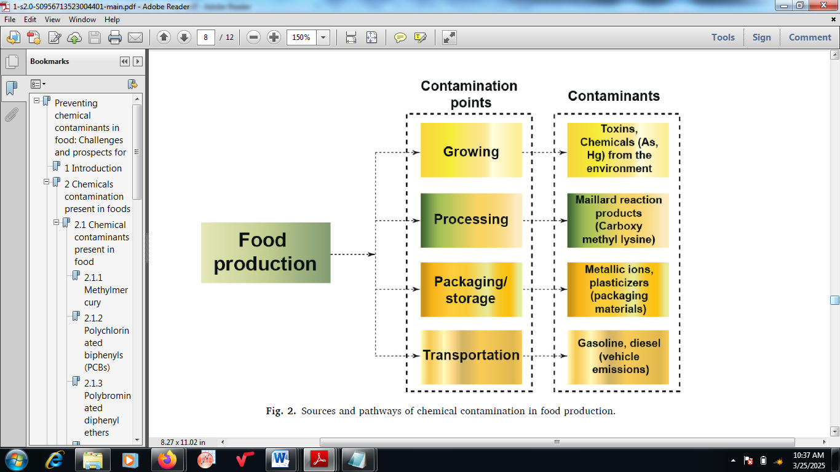
Figure 1: Contamination points and contaminants during food production

2.0 Chemical contaminants present in food

The risk level emanating from food contamination differs with the concentration of chemical contaminant in the food and the volume of food consumed. These contaminants have been known to cause health challenges such as cancer, developmental and neurological problems [11]. The various chemical contaminants present in food include:

- Methylmercury
Methylmercury is a toxic type of mercury which is produced via the bacterial transformation of mercury that is deposited in water bodies. One of the peculiar food origins of methylmercury is fish. Methylmercury has been identified to be neurotoxic and has harmful effects on human development based on the published information from the Environmental Protection Agency [16]. Despite its adverse effects, fish is still an essential food source, especially for children and infants, due to its rich beneficial levels of omega-3 fatty acids. However, it is vital to give consideration to the fish species type and portion size as the contributing factors to omega-3 fatty acids and methylmercury concentrations in the fish. It is essential to consider these factors and control the consumption rate in order to optimize the health benefits attached to fish consumption.
- Polychlorinated biphenyls
The usually applied in industrial applications such as paints, flame retardants and electrical equipment are called Polychlorinated biphenyls (PCBs). However, they can be accumulate in animal tissues and remain persistent in the environment. A broad range of adverse health effects have been linked with Polychlorinated biphenyls’ exposure especially those that are related to neurological development. In recent years, the exposure levels of children to PCBs have drastically reduced asides their exposure to low levels of these chemicals. In recent time, several kinds of ailment conditions have been linked with PCBs such as endometriosis. Factors influencing the varying effects of PCBs exposure on populations and individuals include exposure duration and dose alongside health and age [17]. Other prevailing chemicals that can be found in animal foods include organochlorine pesticides and dibenzofurans They can increase the associated health risks and general exposure.
- Bisphenol A
The major origin of bisphenol A (BPA) exposure is via the diet and this happens when chemical moves from drink and food containers, particularly in heated containers. BPA has been investigated to be an endocrine disruptor which obstructs the ideal functioning of hormones and other potential harms linked with this chemical have raised serious debates. BPA exposure during infancy, fetal development and childhood may result into adverse effects on the prostate gland, behavior and brain. Legislation was introduced by the US Food and Drug Administration in 2021 to restrict and prohibit BPA utilization in consumer products and food containers as a result of the uncertainty surrounding BPA safety. This signals the necessity to the worries of the public regarding the possible injury caused by BPA [9].
- Polybrominated diphenyl ethers
Polybrominated diphenyl ethers (PBDEs) are a set of persistent organic pollutants (POPs) which are broadly dispersed in the environment and can accumulate in different food items’ fat tissue such as dairy products, meats, fish, poultry, and even human breast milk. A high risk is posed by these contaminants to people of all ages because PBDEs’ exposure has been connected to numerous adverse health effects such as interference of the endocrine and nervous systems [12]. Endocrine disruption is now an area of rising worries because of the possible long-term impacts on human health such as developmental problems, hormonal balances, and other serious health outcomes.

- Phthalates
Phthalates are a set of poisonous chemicals that are usually found in different forms of fatty foods such as seafood, fish, dairy products and oils. In infants, the exposure to these chemicals happens via infant formula and breast milk consumption which can be contaminated with phthalates. The characteristics of endocrine-alteration of phthalates on human health have been a subject of discussion in many studies. Studies have revealed that phthalates can be the major causative of different kinds of developmental and reproductive effects in laboratory animals which reflects that similar adverse effects may be observed in humans [1]. These results thus reiterate the urgency for continuous research into phthalates effects on human health and the significance of lowering exposure to these harmful chemicals, particularly in prone environments having numerous infants. With reference to this, low molecular weight phthalates like di-butylphthalate, di-(2-ethylhexyl) phthalate, diisononyl phthalate and butylbenzylphthalate were developed because of their similar hazard pattern with probable indistinguishable mode of action [14].
- Perchlorate
In the United States, this is a broadly available chemical contaminant existing in various kinds of drinking and food sources. The perchlorate sources include vegetables, dairy products, human breast milk, surface and groundwater and many other produce [8]. The main worry about perchlorate is its potential to cause disorderliness in the normal functioning of the thyroid gland. The iodide inhibition uptake by the thyroid glands results into decrease in the thyroid hormone production which hinders its function. This poses a substantial health hazard to pregnant women who eat perchlorate contaminated food. The developing foetus is predominantly susceptible to the negative effects of perchlorate exposure which substantiate the need to control and monitor the availability of this chemical in the food supply. It is imperative to be cautious and take essential measures to safeguard public health with reference to the stated perchlorate exposure implications [18].

2.1 food contamination Sources

It is necessary to examine the origins of chemical contaminants in food in order to have deep knowledge of their sources. In some cases, a vital role may be played by the environment in food contamination. Figure 2 presents the pathways of food contamination between utilizing raw materials to make finished and consumable products. Factors like human activities, point sources and soil conditions can result into building up of metals in the environment with operations like mining which potentially release toxic chemicals like arsenic and mercury into the environment. Other chemical toxicants like dioxins, polychlorinated biphenyls and lead may find their ways into food via environmental sources [16].
In agriculture, using pesticides may be contributory to food contamination. Furthermore, pollution of waterways may emanate from the utilization of medications in both livestock and humans posing serious threat to human health via consumption of food. Also, procedures required in food packaging can be the origin of food contamination resulting from migration of chemicals present in the packaging materials into the food and thus, contaminate it. Oligomers in human blood, food and plastics have been identified by high-resolution mass spectrometry [11]. It has been confirmed that transfer of oligomers from both recycled and newly produced plastic packaging materials into food is possible. The recycling technologies’ effects on oligomers safety, migration and production in food and its packaging remains vague due to lack of scientifically proved information. The presence of these pollutants in food may result into both acute and chronic toxicity. Urban gardens and farms may also stance further concerns as a result of the availability of metal pollutants [18].
Nonetheless, contamination of drinking water is possible which may cause marine biota pollution and compromising seafood for human consumption. Those who eat a high volume of seafood may have high levels of these pollutants in their body system. Human exposure to contaminants may also occur due to occupational exposure such as lead because workers in high-risk fields like vehicle repair may unintentionally consume lead after hand-to-mouth contact [6].
Microplastics presence in food and its influence in ascertaining food safety and sustainable production is a subject of great importance. These minuscule plastic particles, which emanate from various origins such as synthetic textile fibers, microbeads and degraded plastics can penetrate into the environment and finally find their route into the food chain. Microplastics can be ingested by marine organisms resulting into their accumulation in seafood while crops and soil can also become polluted [10]. Microplastics ingestion raises worries regarding its potential health dangers because of their potential to carry other contaminants together with them.
Nonetheless, formation of Maillard reaction products (MRPs) may result from the way foods are cooked or processed at high temperature which could either be beneficial or toxic to human health. The production of MRPs is via reducing sugars interaction with amino acids, which is a non-enzymatic browning reaction, resulting into the formation of different brown colour and odour [19]. The MRPs specifically carboxy methyl lysine may result into cardiovascular diseases and diabetes while acrylamide acts as a carcinogen.
Antimicrobial and antioxidative effects of melanoidins belonging to MRPs have been notably revealed. To avoid this challenge, there is rising demand for using instant meal instead of the traditional cooking. Remarkably, studies have equally revealed that people eating high volume of processed pizza, meat or snacks develop metabolic syndrome and resistance to insulin in comparison with people consuming high amount of low processed food and fresh vegetables [5]. Many of the food contamination sources still remain unidentified despite numerous known sources. However, technological advancements have made convenient to detect these sources resulting to the significance of constant surveillance for food safety [8].

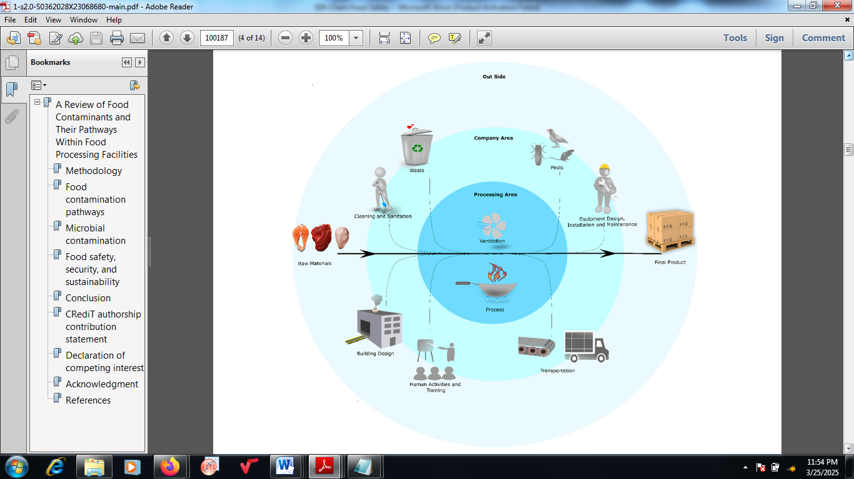
Figure 2: Food contamination pathways.

3.0 The Role of Analytical Chemist/Chemical Engineering in Optimizing Food Safety
Food safety is a multidisciplinary area of specialization that specifically handles how food safety and food hygiene, food poisoning prevention and decreasing of hidden diseases can be attained during food processing, sales and storage. Thus, food safety is very vital. Food safety involves safeties during production, results analysis, business planning and processing; and also future and current safeties must be put into consideration. Food safety implies that the food is harmless and non-toxic, does not cause any chronic harm to human health and meets nutritional requirements [20]. However, numerous problems have evolved in recent years despite the continuous development of food safety management and rapid advancement of the food industry. The recent occurrence include the malachite green incident, melamine incident, Clenbuterol incident, Sudan red incident and the recent African swine fever incident which made consumers to be worried about the food safety environment. Thus, the speedy detection of hazards emanating from food safety has become a necessity for food safety [12].
The adoption of reliable, efficient and quick analysis and detection technique to know harmful substances and illegal additives in food, and simultaneously judging with reference to the equivalent national standards by the activities of an Analytical Chemist and a Chemical Engineer is very important. Without this, harsh penalties are awaiting manufacturers for producing unqualified foods [8]. Chemical engineering role in food processing is key to the ability of the industry to produce high-quality and safe products. The principles of biology, chemistry and physics are applied in this field in developing the processes that convert the raw ingredients into consumable goods while still ensuring that sustainability and efficiency are being maintained. Via the use of advanced methodologies, chemical engineers significantly contribute to the optimization of processes involved in food manufacturing [6].
Analytical Chemist ensures the quality and food safety are not jeopardized and are made to be of paramount significance within the industry. Persistence of worries based on spoilage, contamination and nutritional value occur and this becomes major challenges. Assuring that rigorous safety standards are met by food products is essential for the well-being of consumers. Thus, efficient Quality Control measures are vital in the ensuring that products are both consistent in quality and safe to consume [21]. There is substantial connectivity between Analytical Chemist and Chemical Engineer. Chemical engineers usually collaborate with Analytical Chemist to improve and innovate processing techniques. Complex issues that are related to shelf-life, food preservation and raw material optimization are addressed via leveraging their expertise in Process Engineering. The incorporation of these disciplines nurtures a holistic methodology to producing food that addresses consumer preferences and satisfies regulatory demands. Chemical Engineering discipline comprises different principles including mass and energy balances which assist in calculating the essential inputs and outputs during production. Furthermore, the knowledge of thermodynamics is applied to study the effects of pressure and temperature on food stability. The characteristics of final product are ultimately influenced by the robust understanding of the concepts behind the efficient design of processes [22].
Furthermore, Chemical Engineer engages in the monitoring and surveillance of processing conditions to ensure food safety. This entails steady assessment of parameters such as humidity, pressure and temperature. Any aberrations from the established standards can cause potential safety issues that need instant attention. Additionally, audits and routine inspections are usually conducted by Chemical Engineers in order to foster an environment of continuous improvement and adequate accountability [23]. The building blocks of food processing are the unit operations and thus, Chemical Engineers handle the quality control to ensure adequate monitoring of each production stage reliably. Also, critical parameters are being tracked with the aid of advanced instrumentation in order to ensure consistency in product quality. The incorporation of principles of chemical engineering in food processing addresses consumer safety worries and also enhances the efficiency. Continuous innovations assist in tackling food spoilage which thereby minimizing waste and extending shelf life [12].
3.1 STeps to reduce Contamination Risks In food and future prospects

Chemical contaminants monitoring in food products is a vital aspect of ascertaining food quality and safety. However, there are noteworthy gaps during chemical contaminant control and monitoring. One of these is lack of legislation and clear guidance stating the relevant permissible limits for various kinds of food contaminants. Nonetheless, even where there is existence of legislation, there is usually inadequate robust monitoring program to substantiate the quantity and presence of chemical contaminants in various food products. This makes it challenging to guarantee that the food we eat is not having harmful chemicals. Moreover, further research and more investigation into the toxicological significances of food contamination are needed in many developing countries [24]. This entails studying of transmission of chemicals toxicants from farms to plates and comprehending environmental factors impact on food contamination. It is imperative to establish threshold limits for toxicants at reduced concentrations and evaluation of national food safety management systems is also crucial. Compliance promotion and improved oversight of controlling chemical in agriculture intensive countries is required [19].
There are also noteworthy gaps in risk assessment process as a result of poor data availability and quality; resources scarcity; obsolete regulatory frameworks; inadequate experience and infrastructure; and competing agendas. Also, there is discrepancy in the risk assessment steps for chemical contaminants in food between nations. Thus, there is further hindrance of effective risk evaluations due to inconsistent legislation and insufficient data. Risk assessment plays a vital role in ascertaining there is food safety via evaluation of potential hazards linked with chemical contaminants in food products [21]. Regulatory bodies and policymakers, via execution of risk assessments, can make informed decisions regarding development of adequate control measures and food safety standards to safeguard public health. Lastly, it is imperative for government to take action in order to reduce chemical contamination in food. There is need to develop methods that will capture the economic effects of the accorded illnesses and this information must be connected to world sustainable best goals and practices. It is also crucial to understand the worries of food producers regarding systems that can be adopted in producing food with minimal contamination for food quality and safety [25].
4. Conclusion

Over the years, there has been increasing worries about availability of chemical contaminants in food as a result of harm that the chemical contaminants cause to human health. Chemical contaminants enter the food supply chain which when ingested with food could cause injury to the consumers. There is need to adopt safer methods such as thorough equipment cleaning and using organic or natural cleaning solutions (such as baking soda or vinegar) to remove harmful microorganisms effectively without leaving harmful residues in the food. The use of chemicals to remove food borne pathogens can leave harmful residues in food. Adopting the technique of cooking at lower temperature such as boiling or steaming is advised as alternative to high cooking temperatures that can generate harmful compounds such as acrylamide, PAHs, nitrosamines, chloropropanols and furanes which are detrimental to human health. This review article critically explores the fundamental principles behind food contamination considering their sources, pathways and different kinds of contaminants that can be found within. The roles of Analytical Chemist and Chemical Engineer in optimizing and managing control of food contaminants to ensure food safety are discussed within. There is need for Governments to improve their oversight and enhance compliance in industries in order to prevent chemical contamination and guaranteed that food products are safe for consumption by consumers.

References

1. Bayram, H. M., & Ozturkcan, A. (2022). Intake and risk assessment of nine priority food additives in Turkish adults. Journal of Food Composition and Analysis, 114.

2. Belias, A., Sullivan, G., Wiedmann, M., & Ivanek, R. (2022). Factors that contribute to persistent Listeria in food processing facilities and relevant interventions: A rapid review. Food Control, 133.

3. DeFlorio, W., Liu, S., White, A. R., Taylor, T. M., Cisneros-Zevallos, L., Min, Y., & Scholar, E. M. A. (2021). Recent developments in antimicrobial and antifouling coatings to reduce or prevent contamination and cross-contamination of food contact surfaces by bacteria. Comprehensive Reviews in Food Science and Food Safety, 20(3), 3093–3134.

4. Fan, M., Xu, X., Lang, W., Wang, W., Wang, X., Xin, A., Zhou, F., Ding, Z., Ye, X., & Zhu, B. (2023). Toxicity, formation, contamination, determination and mitigation of acrylamide in thermally processed plant-based foods and herbal medicines: A review. Ecotoxicology and Environmental Safety, 260.

5. Poissant, R., Mariotti, F., Zalko, D., & Membré, J.-M. (2023). Ranking food products based on estimating and combining their microbiological, chemical and nutritional risks: Method and application to Ready-To-Eat dishes sold in France. Food Research International, 169.

6. Qian, J., Dai, B., Wang, B., Zha, Y., & Song, Q. (2022). Traceability in food processing: Problems, methods, and performance evaluations—A review. Critical Reviews in Food Science and Nutrition, 62(3), 679–692.

7. Rahaman, M. S., Mise, N., & Ichihara, S. (2022). Arsenic contamination in food chain in
Bangladesh: A review on health hazards, socioeconomic impacts and implications. Hygiene and Environmental Health Advances, 2.

8. Warmate, D., & Onarinde, B. A. (2023). Food safety incidents in the red meat industry: A review of foodborne disease outbreaks linked to the consumption of red meat and its products, 1991 to 2021. International Journal of Food Microbiology, 398.

9. Shamsan, A. Q. S., Fouad, M. R., Yacoob, W. A. R. M., Abdul-Malik, M. A., & Abdel-Raheem, S. A. A. (2023). Performance of a variety of treatment processes to purify wastewater in the food industry. Current Chemistry Letters, 12(2), 431–438.

10. Qian, J., Dai, B., Wang, B., Zha, Y., & Song, Q. (2022). Traceability in food processing: Problems, methods, and performance evaluations—A review. Critical Reviews in Food Science and Nutrition, 62(3), 679–692.

11. Rahaman, M. S., Mise, N., & Ichihara, S. (2022). Arsenic contamination in food chain in
Bangladesh: A review on health hazards, socioeconomic impacts and implications. Hygiene and Environmental Health Advances, 2.

12. Lebelo, K., Malebo, N., Mochane, M. J., & Masinde, M. (2021). Chemical contamination pathways and the food safety implications along the various stages of food production: A review. International Journal of Environmental Research and Public Health, 18(11).

13. Neethirajan, S., Ragavan, V., Weng, X., & Chand, R. (2018). Biosensors for sustainable food engineering. Challenges and Perspectives. Biosensors (Basel), 8(1).

14. Eyvazi, S., Baradaran, B., Mokhtarzadeh, A., Guardia, M., & d. l. (2021). Recent advances on development of portable biosensors for monitoring of biological contaminants in foods. Trends in Food Science & Technology, 114, 712–721.

15. Hassan, A., Fauziah, S. H., Pariatamby, A., Nurul Shamsinah, M. S., Noor Maiza binti, M. R., Kimberly, N. H. L., & Mohan, P. (2023). Bioaugmentation-assisted bioremediation and biodegradation mechanisms for PCB in contaminated environments: A review on sustainable clean-up technologies. Journal of Environmental Chemical Engineering, 11, 3.

16. Alfei, S., Marengo, B., & Zuccari, G. (2020). Nanotechnology application in food packaging: A plethora of opportunities versus pending risks assessment and public concerns. Food Research International, 137, 109664.

17. Kwon, J. H., Kim, J. W., Pham, T. D., Tarafdar, A., Hong, S., Chun, S. H., Lee, S. H., Kang, D. Y., Kim, J. Y., Kim, S. B., & Jung, J. (2020). Microplastics in food: A review on analytical methods and challenges. International Journal of Environmental Research and Public Health, 17(18), 6710.

18. Lowe, K., & McLaughlin, E. (2015). ‘Caution! The bread is poisoned’: The Hong Kong mass poisoning of january 1857. Journal of Imperial and Commonwealth History, 43(2), 189–209.

19. Samir, A., Ashour, F. H., & Hakim, A. A. A. (2022). Recent advances in biodegradable
polymers for sustainable applications. Npj Mater Degrad, 6, 68.

20. Mihai, F.-C., Gündo˘gdu, S., Markley, L. A., Olivelli, A., Khan, F. R., Gwinnett, C., Gutberlet, J., Reyna-Bensusan, N., Llanquileo-Melgarejo, P., & Meidiana, C. (2021). Plastic pollution, waste management issues, and circular economy opportunities in rural communities. Sustainability, 14(1), 20.

21. Ng, S., Shao, S., & Ling, N. (2022). Food safety risk-assessment systems utilized by China, Australia/New Zealand, Canada, and the United States. Journal of Food Science, 87
(11), 4780–4795.

22. Nayak, R., Manning, L., & Waterson, P. (2022). Exploration of the fipronil in egg contamination incident in The Netherlands using the Functional Resonance Analysis Method. Food Control, 133, 108605.

23. Schreier, V. N., Ç¨orek, E., Appenzeller-Herzog, C., Brüschweiler, B. J., Geueke, B., Wilks, M. F., & Odermatt, A. (2023). Evaluating the food safety and risk assessment evidence-base of polyethylene terephthalate oligomers: A systematic evidence map. Environment International, 176, 107978.

24. Yuan, Y., Gao, R., Liang, Q., Song, L., Huang, J., Lang, N., & Zhou, J. (2020). A foodborne bongkrekic acid poisoning incident—heilongjiang province, 2020. China CDC Weekly, 2(51), 975.

25. Zhao, X., Wang, Y., Chen, X., Yu, X., Li, W., Zhang, S., & Zhu, H. (2023). Sustainable bioplastics derived from renewable natural resources for food packaging. Matter, 6(1), 97–127.

