***Case report***

**Carcinoid Syndrome-Induced Multi-Valvular Heart Disease: A Rare Cause of Heart Failure in a 45-Year-Old Woman**

.

ABSTRACT

|  |
| --- |
| **Aims:** This case report aims to highlight the rare association between carcinoid syndrome and multi-valvular heart disease as a cause of heart failure, emphasizing diagnostic challenges and multidisciplinary management strategies.  **Presentation of Case:** A 45-year-old woman with a history of non-malignant left oophorectomy presented with heart failure symptoms (progressive dyspnea, edema) and carcinoid syndrome features (flushing, diarrhea). Clinical examination revealed jugular distension, bilateral crackles, and valvular murmurs. Echocardiography demonstrated severe tricuspid, aortic, and mitral stenosis/regurgitation with valve thickening. Thoraco-abdomino-pelvic CT identified a neuroendocrine tumor, while elevated plasma serotonin and urinary 5-hydroxyindoleacetic acid confirmed carcinoid syndrome.  **Discussion:** Carcinoid heart disease arises from serotonin-induced valvular fibrosis, predominantly affecting right-sided valves. Left-sided involvement, as seen here, is rare and suggests advanced disease or altered serotonin metabolism (e.g., via shunts or metastases). Management combines heart failure therapy (diuretics, beta-blockers) and tumor control (somatostatin analogs). Valve surgery, though high-risk due to fibrosis, may be necessary. Early diagnosis is critical, as delayed intervention worsens outcomes.  **Conclusion:** This case underscores the importance of recognizing carcinoid syndrome in patients with unexplained multivalvular heart disease. A multidisciplinary approach—integrating cardiology, oncology, and surgery—is essential for optimizing outcomes. Timely biomarker assessment and tumor localization can facilitate targeted therapy, potentially halting disease progression. |

*Keywords:* Carcinoid Heart Disease, Multi-Valvular Disease, Serotonin-Induced Fibrosis, Case report

1. INTRODUCTION

Multiple valvular heart diseases are a common cause of heart failure, but their association with carcinoid syndrome is a rare and poorly understood phenomenon [(1)](https://www.zotero.org/google-docs/?3mvYMJ). Carcinoid syndrome is a neuroendocrine disorder that can induce valvular heart lesions through the excessive release of serotonin and other vasoactive mediators [(2)](https://www.zotero.org/google-docs/?4SKhQ3). This condition leads to progressive fibrosis of the valves, predominantly affecting the right-sided valves, although the left-sided valves may also be involved in advanced cases [(3)](https://www.zotero.org/google-docs/?pjyvsn).

We present the case of a 45-year-old female patient admitted for heart failure decompensation, revealing multi-valvular disease with tricuspid, aortic, and mitral involvement suggestive of carcinoid heart disease. This case report explores the diagnostic and therapeutic challenges of this rare condition, highlighting its clinical and paraclinical features as well as the multidisciplinary management options.

2. Case presentation

The 45-year-old patient had undergone left oophorectomy three years ago due to a suspicious adnexal mass, which, upon histological analysis, did not reveal malignancy at the time. She had no known cardiovascular history.

She presented with progressively worsening exertional dyspnea, associated with lower limb edema, palpitations, and significant fatigue. She also reported recurrent skin flushes and hot flashes, accompanied by intermittent diarrhea, symptoms suggesting a potential carcinoid origin.

On clinical examination she had bilateral peripheral edema, jugular venous distension, and a 3/6 systolic murmur at the tricuspid and aortic areas. Pulmonary auscultation revealed bilateral crackles.

The transthoracic echocardiography revealed a left ventricle (LV) of normal size, with a left ventricular end-diastolic diameter (LVEDD) of 45 mm. There was minimal left ventricular hypertrophy (LVH), with an interventricular septum (IVS) thickness of 11 mm and a posterior wall (PW) thickness of 11 mm. Both global and segmental contractility were preserved, with a left ventricular ejection fraction (LVEF) of 55%. The left atrium (LA) is ectatic, with a left atrial surface area (LASA) of 91 cm², and the right atrium (RA) is dilated with a right atrial surface area (RASA) of 62 cm². Both atria show spontaneous contrast, but no thrombus is visualized (Figure 1).

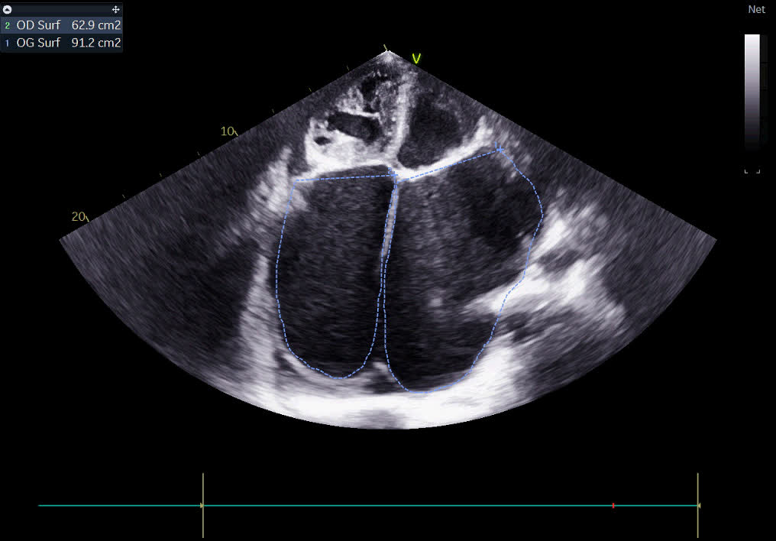

Figure 1: Echocardiographic image showing biatrial dilation with spontaneous contrast.

The mitral valve is thickened and infiltrated, with severe mitral stenosis (MS). The minimal surface area (MSA/planimetry) is 0.3 cm², with a mean gradient (MG) of 11.3 mmHg and a mitral annular thickness (MAT) of 7 mm (Figure 2). Moderate mitral regurgitation (MR) is also observed.

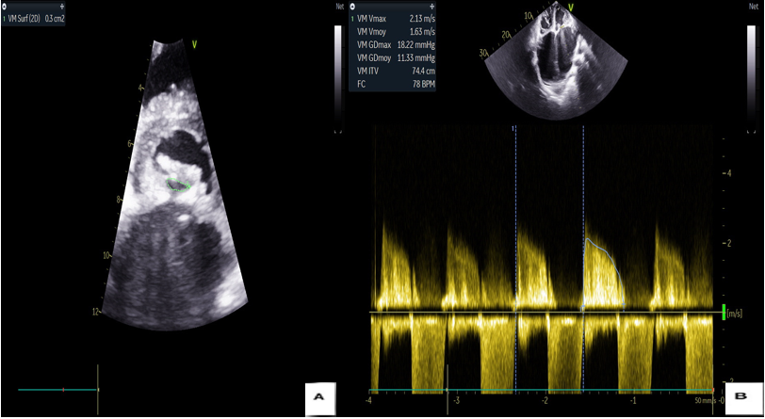

Figure 2: Echocardiographic images showing the mitral surface by planimetry (A) and the mean gradient by continuous-wave Doppler (B).

The aortic valve (AV) is tricuspid, thickened, and infiltrated, with severe aortic stenosis (AS). The aortic surface area (ASA) is 0.8 cm², with a mean gradient of 43 mmHg (Figure 3). Moderate aortic regurgitation (AR) is also present.

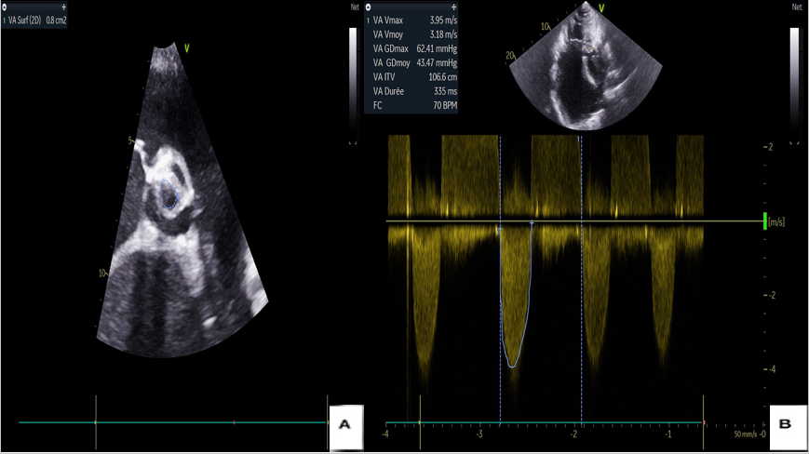

Figure 3: Echocardiographic images showing the aortic surface by planimetry (A) and the mean gradient by continuous-wave Doppler (B).

The right ventricle (RV) is dilated, but its longitudinal systolic function remains good, with a longitudinal contraction velocity of 10 cm/s and a tricuspid annular plane systolic excursion (TAPSE) of 20 mm.

The tricuspid valve shows remodeling, is thickened, and exhibits significant tricuspid stenosis, with a mean gradient (MG) of 6.6 mmHg (Figure 4). Massive tricuspid regurgitation (TR) is also observed due to a defect in leaflet coaptation.

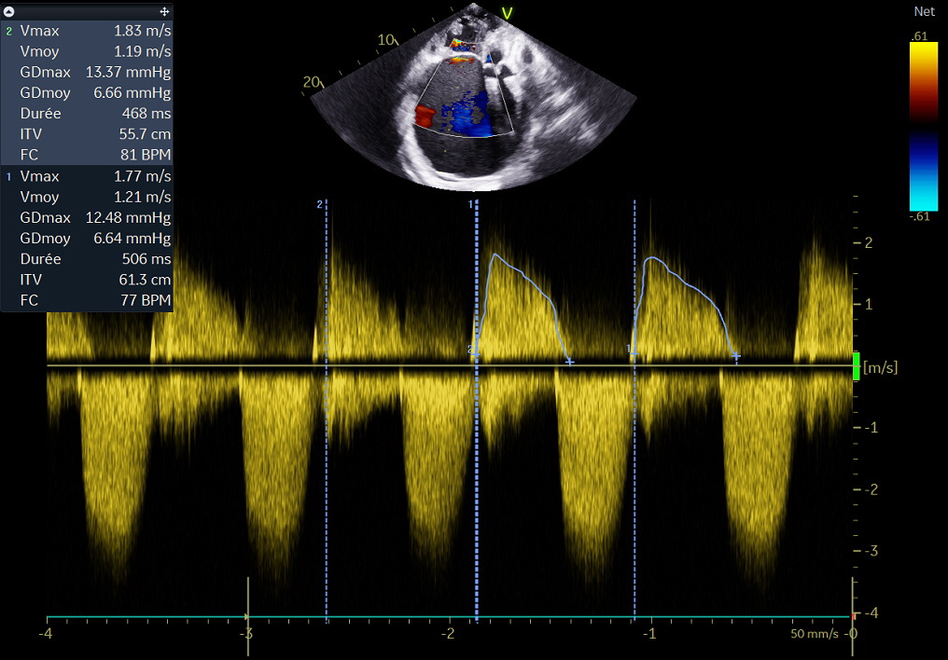

Figure 4: Echocardiographic image of significant tricuspid stenosis with a mean gradient of 6.6 mm Hg.

A thoraco-abdomino-pelvic CT scan with contrast injection revealed a suspicious digestive mass, likely of neuroendocrine origin, suggesting a primary carcinoid tumor. Plasma serotonin levels and urinary metabolites (5-hydroxyindoleacetic acid) were elevated, confirming the diagnosis of carcinoid syndrome.

The diagnosis was confirmed as severe multi-valvular disease with a carcinoid appearance, complicated by global heart failure.

The patient was admitted to the cardiology intensive care unit. Symptomatic management, including diuretics, beta-blockers, and somatostatin analogs, was initiated. A multidisciplinary discussion was held to assess the feasibility of valve surgery, considering the carcinoid background.

3. discussion

Heart failure due to poly valvulopathy with a carcinoid appearance is a rare but particularly interesting clinical presentation due to the complex interaction between cardiac pathologies and carcinoid neoplasia. This condition is often the result of carcinoid syndrome, which is characterized by the secretion of vasoactive mediators, primarily serotonin, by neuroendocrine tumors, thus affecting cardiac function [(4)](https://www.zotero.org/google-docs/?9X9GvV).

Carcinoid tumors, although frequently found in the gastrointestinal tract or lungs, can lead to heart failure due to the harmful effects of the vasoactive substances they secrete, particularly serotonin [(5)](https://www.zotero.org/google-docs/?HtkoRL). This excessive secretion has a major impact on the walls of the cardiac valves, especially the tricuspid and pulmonary valves. Vasoactive mediators can induce cardiac remodeling characterized by valve fibrosis, leading to stenosis and/or valvular insufficiency [(6)](https://www.zotero.org/google-docs/?EXVCsy).

In carcinoid-like poly valvulopathy, the involvement of the cardiac valves is essentially a fibrotic phenomenon, manifested by thickening of the valvular tissues and restriction of their mobility. This fibrosis results from the activation of fibroblasts by mediators such as serotonin, bradykinin, and histamine, which promote collagen production and the establishment of this fibrosis [(7)](https://www.zotero.org/google-docs/?x7ktg9).

Patients with carcinoid poly valvulopathy often complain of symptoms of heart failure, such as shortness of breath, fatigue, peripheral edema, and, in advanced cases, cardiogenic shock. Pulmonary hypertension secondary to pulmonary valve stenosis can worsen right heart failure, leading to isolated right heart failure [(8)](https://www.zotero.org/google-docs/?rlejYW).

The clinical history is also marked by episodes of flushing (facial redness), diarrhea, and hypoglycemic symptoms, which are classic signs of carcinoid syndrome. The combination of systemic symptoms with cardiac signs strongly suggests the diagnosis of heart failure due to a carcinoid process.

The diagnosis of heart failure in this context relies on a combination of clinical, biological, and imaging criteria. Echocardiography remains the key examination, allowing visualization of the thickening of the cardiac valves, restriction of their mobility, and, in some cases, valvular regurgitation or stenosis [(9)](https://www.zotero.org/google-docs/?KBkTCz) .

Doppler echocardiography also allows quantification of pulmonary hypertension and assessment of overall cardiac function. However, confirming the diagnosis of carcinoid syndrome also requires measuring serotonin metabolites, such as 5-hydroxyindoleacetic acid (5-HIAA) in the urine, as well as imaging studies to locate the primary carcinoid tumor, often performed using CT or MRI. [(10)](https://www.zotero.org/google-docs/?m3Z7BR) [(11)](https://www.zotero.org/google-docs/?d7j41u)

The treatment of this rare form of heart failure relies on two main axes: the management of the carcinoid tumor and the correction of heart failure.

The treatment of the carcinoid tumor itself typically involves surgical management of the primary tumor when possible, along with medical treatment aimed at controlling the secretion of vasoactive mediators. Somatostatin analogs (such as octreotide) are used to inhibit the secretion of serotonin and bradykinin, which can reduce valve fibrosis and improve symptoms. [(12)](https://www.zotero.org/google-docs/?XsKYbg)[(13)](https://www.zotero.org/google-docs/?ZFQ69i)Regarding heart failure, the treatment is similar to that of right heart failure, with diuretics to control edema and vasodilators to treat pulmonary hypertension. In some cases, surgical intervention to repair or replace the damaged valves may be considered, although intense fibrosis often makes this intervention challenging.

 In severe cases where fibrosis is extensive and irreversible, heart transplantation may be an option, although the presence of carcinoid tumors can complicate perioperative management due to the risk of tumor emboli.

The prognosis of patients with heart failure due to carcinoid-like poly valvulopathy largely depends on the early management of the carcinoid tumor and valve fibrosis. If the tumor is well controlled and medical management improves cardiac function, long-term outcomes can be enhanced. However, irreversible valve damage and the development of tumor-related complications can lead to an unfavorable outcome.

4. Conclusion

Heart failure due to carcinoid-like poly valvulopathy is a rare but clinically significant condition, characterized by complex mechanisms between the carcinoid tumor and cardiovascular effects. Management involves not only treating the carcinoid tumor but also optimal management of the associated cardiac complications, requiring a multidisciplinary approach, combining oncologists, cardiologists, and cardiac surgeons.

**DISCLAIMER (ARTIFICIAL INTELLIGENCE)**

Author(s) hereby declare that NO generative AI technologies such as Large Language Models (ChatGPT, COPILOT, etc) and text-to-image generators have been used during writing or editing of manuscripts.

**AVAILABILITY OF DATA AND MATERIAL**

All data generated or analysed during this study are included in this published article.

**CONSENT**

Written informed consent was obtained from the patients for publication of this case report and any accompanying images.

**ETHICAL APPROVAL**

As per international standards or university standards written ethical approval has been collected and preserved by the author(s).

**COMPETING INTERESTS DISCLAIMER:**

Authors have declared that they have no known competing financial interests OR non-financial interests OR personal relationships that could have appeared to influence the work reported in this paper.

References

[1. Yuan SM. Valvular Disorders in Carcinoid Heart Disease. Braz J Cardiovasc Surg. 2016;31(5):400‑5.](https://www.zotero.org/google-docs/?Nal7T7)

[2. What Is Carcinoid Syndrome? A Critical Appraisal of Its Proposed Mediators | Endocrine Reviews | Oxford Academic [Internet]. [cité 20 mars 2025]. Disponible sur: https://academic.oup.com/edrv/article/45/3/351/7457297](https://www.zotero.org/google-docs/?Nal7T7)

[3. Mota JM, Sousa LG, Riechelmann RP. Complications from carcinoid syndrome: review of the current evidence [Internet]. 2016 [cité 20 mars 2025]. Disponible sur: http://ecancer.org/en/journal/article/662-complications-from-carcinoid-syndrome-review-of-the-current-evidence](https://www.zotero.org/google-docs/?Nal7T7)

[4. Ghanta SN, Vallurupalli S. Carcinoid Heart Disease – A Review of Pathophysiology, Clinical Manifestations, Diagnosis and Management. Cardiovasc Innov Appl. 13 juin 2023;8:979.](https://www.zotero.org/google-docs/?Nal7T7)

[5. Aluri V, Dillon JS. Biochemical Testing in Neuroendocrine Tumors. Endocrinol Metab Clin North Am. sept 2017;46(3):669‑77.](https://www.zotero.org/google-docs/?Nal7T7)

[6. Kostiainen I, Karppinen N, Simonen P, Rosengård-Bärlund M, Lindén R, Tarkkanen M, et al. Arterial function, biomarkers, carcinoid syndrome and carcinoid heart disease in patients with small intestinal neuroendocrine tumours. Endocrine. juin 2022;77(1):177‑87.](https://www.zotero.org/google-docs/?Nal7T7)

[7. Jin C, Sharma AN, Thevakumar B, Majid M, Al Chalaby S, Takahashi N, et al. Carcinoid Heart Disease: Pathophysiology, Pathology, Clinical Manifestations, and Management. Cardiology. 2021;146(1):65‑73.](https://www.zotero.org/google-docs/?Nal7T7)

[8. Carcinoid heart disease. Clinical and echocardiographic spectrum in 74 patients. | Circulation [Internet]. [cité 20 mars 2025]. Disponible sur: https://www.ahajournals.org/doi/10.1161/01.cir.87.4.1188](https://www.zotero.org/google-docs/?Nal7T7)

[9. Diagnosing and Managing Carcinoid Heart Disease in Patients With Neuroendocrine Tumors: An Expert Statement | JACC [Internet]. [cité 20 mars 2025]. Disponible sur: https://www.jacc.org/doi/10.1016/j.jacc.2016.12.030](https://www.zotero.org/google-docs/?Nal7T7)

[10. Rossi RE, Lavezzi E, Jaafar S, Cristofolini G, Laffi A, Nappo G, et al. Urinary 5-Hydroxyindolacetic Acid Measurements in Patients with Neuroendocrine Tumor-Related Carcinoid Syndrome: State of the Art. Cancers. 11 août 2023;15(16):4065.](https://www.zotero.org/google-docs/?Nal7T7)

[11. Kema IP, de Vries EG, Schellings AM, Postmus PE, Muskiet FA. Improved diagnosis of carcinoid tumors by measurement of platelet serotonin. Clin Chem. avr 1992;38(4):534‑40.](https://www.zotero.org/google-docs/?Nal7T7)

[12. Management of carcinoid syndrome: A systematic review and meta-analysis | Request PDF [Internet]. [cité 20 mars 2025]. Disponible sur: https://www.researchgate.net/publication/330128723_Management_of_carcinoid_syndrome_A_systematic_review_and_meta-analysis](https://www.zotero.org/google-docs/?Nal7T7)

[13. Binas D. Perioperatives Management bei Patienten mit Karzinoidsyndrom/Neuroendokriner Neoplasie. Binas Schubert AK Wiese Wulf H Wiesmann T Perioper Manag Bei Patienten Mit KarzinoidsyndromNeuroendokriner Neoplasie. 13 janv 2020;(01‑2020):16‑24.](https://www.zotero.org/google-docs/?Nal7T7)