SOME EXACT SOLUTIONS FOR THE FIFTH-ORDER KdV EQUATION WITH CONSTANT COEFFICIENTS BY THE LIE SYMMETRIES

.

ABSTRACT

|  |
| --- |
| In this work, we use the Lie symmetries to obtain particular solutions for the fifth-order Korteweg de Vries equation. Our original equation is a nonlinear partial differential evolution equation (PDEE). We convert this equation to the nonlinear ordinary differential equation by changing the variables. We determine the solution of the initial equation by using the solution obtained via the Lie symmetry method of the nonlinear ordinary differential equation. |

*Keywords: Fourth-Order Nonlinear Ordinary Differential Equation, Characteristic Variable, Travelling Wave, Invariant Solution, fifth-order Korteweg de Vries Equation, Lie Symmetries.*

1. INTRODUCTION

In nature and in several fields of science and technology, many physics problems involve nonlinear evolution. These include propagation waves andthe theory of gravitational fields [1, 2]. Nonlinear partial differential evolution equations (NPDEEs) serve as mathematical models for describing many physical phenomena. Amongthese equations are the Korteweg de Vries (KdV) equations and their high-order type(such as the fifth-order KdV and seventh-order KdV), the nonlinear Schrödinger equations (NLS), the Sine Gordon equations (SG), etc.

The KdV-type equations have many applications in both the physical sciences and engineering fields [3]. For example, they describe long waves in shallow waters and deep oceans [4, 5]. The following fifth-order KdV (fKdV) equation

$$u_{t}+α_{1}uu_{x}+α_{2}u^{2}u_{x}+α_{3}u_{x}u_{xx}+α_{4}u_{xxx}+α_{5}uu_{xxx}+α_{6}u_{xxxxx}=0 (1.0)$$

describes, particularly the propagation of shallow water waves over a flat surface and gravity-capillary waves [6].This equation contains more terms than the fifth-order KdV equation in [7,8], whose Lie symmetry reduction with respect to an optimal set of one-dimensional subgroups of its full symmetry Lie group was carried out in [8]. However, this last equation contains the more general terms ${ u}^{p}u_{x}$

Equation (1.0) includes one evolution term $u_{t}$, four nonlinear terms ($uu_{x}, u^{2}u_{x}, uu_{xxx}, u_{x}u_{xx}$*)* and two dispersive terms $u_{xxx}$ and ${ u}_{xxxxx}$. The coefficients $α_{1}, α_{2}, α_{4}, α_{5}$ and $α_{6}$ are all nonzero constants. $u\left(t,x\right)$ is a differentiable function of time $t$ and space $x$ which are independent variables.

In [6], a soliton solution is sought by transforming the equation into a nonlinear ordinary differential equation (ODE), followed by the formulation of ansatz. The main objective of this work is to obtain particular solutions to this equation, referred to as invariant solutions.

In general, equation (1.0) is not integrable [6, 9]. Consequently, we cannot seek a soliton invariant solution using the Lie symmetry method. Instead, our aim is to explore alternative solutions via this method.

The paper is organized as follows. Section 2 covers the transformation of the initial equation into a nonlinear ordinary differential equation (ODE). In section 3, we use the Lie symmetry method to solve the nonlinear ODE. In section 4, we solve the characteristic equation for a generator, leading to a particular solution. In section 5, Section 5 presents some illustrative examples. Lastly, Section 6 concludes the paper.

2. TRANSFORMATION TO THE NONLINEAR ODE

To transform equation (1.0) into a nonlinear ODE, we introduce infinitesimal generators, which help define the characteristic variable [3, 9]. The Lie symmetry analysis of KdV equations with constant coefficients has at least two vector fields generating the group of symmetries of space and time translation |1, 10].By combining these symmetries, we can construct a new variable that links the spatial and temporal variables. As an example, see references [1, 9-12].

These symmetries are defined by the following infinitesimal generators:

$$G_{1}=\frac{∂}{∂x}, { G}_{2}=\frac{∂}{∂t} (2.0)$$

Taking a linear combination of these two generators [10-13], we obtain:

$$G=βG_{1}+ G_{2} (2.1)$$

where $β$ is a constant.

The corresponding characteristic equation for (2.1) is given by [3, 11]:

$$\frac{dx}{β}=\frac{dt}{1}=\frac{du}{0} (2.2)$$

Solving this equation provides the invariant solution, which introduces the characteristic variable [9]

$$z=x-β t=x-V t \left(2.3\right)$$

Here, $z$ is known as the wave variable [14], and $β=V$ is a constant representing the wave speed.

Applying this transformation, we derive the travelling wave reductions [1, 8, 9, 14 and 15].

$$u\left(x,t\right)=u\left(x-Vt\right)=u\left(z\right) (2.4)$$

Now we can transform equation (1.0) into a nonlinear ODE.

Applying the characteristic variable $z$ from equation (2.3) the following derivatives hold:

$$\frac{∂z}{∂t}=-V , \frac{∂z}{∂x}=1 (2.5)$$

that is,

$$\frac{∂}{∂t}=-V\frac{∂}{∂z}, \frac{∂}{∂x}=\frac{∂}{∂z} (2.6)$$

Consequently, the derivatives of $u$ with respect to time and space transform as:

$${ u}_{t}=-V u_{z}{, u}_{x}=u_{z}, u_{xx}=u_{zz}, ⋯, u_{xxxxx}=u_{zzzzz} (2.7)$$

Substituting these into equation (1.0), we obtain the fifth-order nonlinear ODE:

$$-Vu_{z}+α_{1}{uu}_{z}+α_{2}u^{2}u_{z}+α_{3}u_{z}u_{zz }+α_{4}u_{zzz}+α_{5}{uu}_{zzz}+α_{6}u_{zzzzz}=0 (2.8)$$

We can reduce the order of the fifth-order ODE by applying known derivative relations. Specifically, we have:

$$α_{1}uu_{x}=\frac{1}{2}α_{1}{\left(u^{2}\right)}_{x} , α_{2}u^{2}u_{x}=\frac{1}{3}α_{2}{\left(u^{3}\right)}_{x} , α_{3}u_{x}u_{xx}=\frac{1}{2}α_{3}{\left(u_{x}^{2}\right)}_{x} , α_{4}u_{xxx}=α_{4}{\left(u_{xx}\right)}_{x} ,$$

$$α_{5}uu_{xxx}=α_{5}{\left(uu_{xx}\right)}_{x}-\frac{1}{2}α_{5}{\left(u_{x}^{2}\right)}_{x} , α_{6}u_{xxxxx}=α_{6}{\left(u_{xxxx}\right)}_{x} (2.9)$$

it follows that

$$α_{1}uu_{z}=\frac{1}{2}α_{1}{\left(u^{2}\right)}_{z} , α_{2}u^{2}u_{z}=\frac{1}{3}α_{2}{\left(u^{3}\right)}_{z} , α_{3}u_{z}u_{zz}=\frac{1}{2}α_{3}{\left(u_{z}^{2}\right)}_{z} , α_{4}u_{zzz}=α_{4}{\left(u_{zz}\right)}_{z} ,$$

$$α_{5}uu_{zzz}=α_{5}{\left(uu_{zz}\right)}_{z}-\frac{1}{2}α_{5}{\left(u_{z}^{2}\right)}_{z} , α_{6}u_{zzzzz}=α_{6}{\left(u_{zzzz}\right)}_{z} (2.10)$$

Using (2.9), we can rewrite equation (1.0) in the form

$$\frac{∂u}{∂t}+\frac{∂}{∂x}\left[\frac{1}{2}α_{1}u^{2}+\frac{1}{3}α_{2}u^{3}+\frac{1}{2}α_{3}u_{x}^{2}+α_{4}u_{xx}+α_{5}{uu}_{xx}-\frac{1}{2}α_{5}u_{x}^{2}+α_{6}u_{xxxx}\right]=0 (2.11)$$

Using (2.10) with (2.7), (2.11) becomes

$$-V\frac{∂u}{∂z}+\frac{∂}{∂z}\left[\frac{1}{2}α_{1}u^{2}+\frac{1}{3}α_{2}u^{3}+\frac{1}{2}α_{3}u_{z}^{2}+α_{4}u_{zz}+α_{5}{uu}_{zz}-\frac{1}{2}α_{5}u_{z}^{2}+α_{6}u_{zzzz}\right]=0 (2.12)$$

We can then rearrange the equation, moving the operator to the right-hand side:

$$\frac{∂}{∂z}\left[-Vu+\frac{1}{2}α_{1}u^{2}+\frac{1}{3}α_{2}u^{3}+\frac{1}{2}α_{3}u_{z}^{2}+α_{4}u_{zz}+α_{5}{uu}_{zz}-\frac{1}{2}α_{5}u_{z}^{2}+α_{6}u_{zzzz}\right]=0 (2.13)$$

By integrating equation (2.13) with respect to $z$, we derive the fourth-order nonlinear ODE:

$$-Vu+\frac{1}{2}α_{1}u^{2}+\frac{1}{3}α_{2}u^{3}+\frac{1}{2}α_{3}u_{z}^{2}+α_{4}u_{zz}+α_{5}{uu}_{zz}-\frac{1}{2}α_{5}u_{z}^{2}+α_{6}u_{zzzz}=α_{0}≠0 (2.14)$$

where $á_{0}$ is the integration constant.

**Remark 1**

Since equation (1.0) is not integrable $α_{0}≠0$. If $α_{0}=0$, this would imply that equation (1.0) admits an invariant solution corresponding to a solitary wave [6].

In its reduced form, equation (2.14) becomes

$$u_{zzzz}=\frac{α_{0}}{α_{6}}+\frac{V}{α_{6}}u+\left(-\frac{1}{2}\frac{α_{1}}{α_{6}}\right)u^{2}+\left(-\frac{1}{3}\frac{α_{2}}{α_{6}}\right)u^{3}+\left(-\frac{α_{4}}{α_{6}}\right)u_{zz}+\left(-\frac{α_{5}}{α_{6}}\right){uu}_{zz}+\left[\frac{1}{2}\left(\frac{α_{5}-α_{3}}{α_{6}}\right)\right]u_{z}^{2} (2.15)$$

Or, in a simplified form

$$ω≡u_{zzzz}=a_{0}+a_{1}u+a_{2}u^{2}+a_{3}u^{3}+a_{4}u_{zz}+a_{5}{uu}_{zz}+a_{6}u_{z}^{2} (2.16)$$

where the constants are:

$$a_{0}=\frac{α_{0}}{α_{6}} , a_{1}=\frac{V}{α_{6}}, a_{2}=\left(-\frac{1}{2}\frac{α_{1}}{α_{6}}\right), a_{3}=\left(-\frac{1}{3}\frac{α_{2}}{α_{6}}\right), a_{4}=\left(-\frac{α_{4}}{α_{6}}\right), a_{5}=\left(-\frac{α_{5}}{α_{6}}\right) , a_{6}=\frac{1}{2}\left(\frac{α_{5}-α_{3}}{α_{6}}\right) (2.17)$$

that is

$$α_{6}=\frac{V}{a_{1}}, α_{5}=-V\frac{a_{5}}{a_{1}}, α_{4}=-V\frac{a_{4}}{a_{1}}, α_{3}=-V \left[\frac{a_{5}+2a_{6}}{a_{1}}\right], α_{2}=-3V\frac{a_{3}}{a_{1}}, α_{1}=-2V\frac{a_{2}}{a_{1}}, α_{0}=V\frac{a_{0}}{a_{1}} (2.18)$$

**3. SOME LIE POINT SYMMETRIES OF THE FOURTH-ORDER ODE**

Let us consider a one-parameter Lie group of infinitesimal transformations on the space of independent and dependent variables:

$$\hat{z}\left(z,u;ε\right)=z+εξ\left(z,u\right)+O\left(ε\right),$$

$$\hat{u}\left(z,u;ε\right)=u+εη\left(z,u\right)+O\left(ε\right) (3.0)$$

where $ε$ is the group parameter.

**3.1. General Vector Field**

The general vector field associated with these transformations is given by:

$$X=ξ\frac{∂}{∂z}+η\frac{∂}{∂u} (3.1)$$

**3.2. Prolongation of the Vector Field**

The prolongation formula of the vector fields [18] is defined as:

$$pr\left(X\right)=X+\sum_{k=1}^{n}{η^{\left(k\right)}\frac{∂}{∂u^{\left(k\right)}}} (3.2)$$

Which explicitly expands as:

$$pr\left(X\right)=ξ\frac{∂}{∂z}+η\frac{∂}{∂u}+η^{\left(1\right)}\frac{∂}{∂u_{z}}+η^{\left(2\right)}\frac{∂}{∂u_{zz}}+⋯+η^{\left(n\right)}\frac{∂}{∂u^{\left(n\right)}} (3.3)$$

where $\left(η^{\left(1\right)}, η^{\left(2\right)},⋯,η^{\left(k\right)}\right)$ are specific functions of $u$ and $z$.

**3.3. Recursive Formula for Higher-Order Prolongations**

Generally, the expression for the $k$ th-order [16-18] is as follows:

$$η^{\left(k\right)}=D_{z}\left(η^{\left(k-1\right)}\right)-\frac{d^{k}u}{dz^{k}}D_{z} \left(3.4\right)$$

Here, $D_{z}$ denotes the total derivative operator [13, 17, 18]:

$$D_{z}=\frac{∂}{∂z}+u_{z}\frac{∂}{∂u}+u_{zz}\frac{∂}{∂u_{z}}+⋯+u^{\left(n\right)}\frac{∂}{∂u^{\left(n-1\right)}} (3.5)$$

**3.4. Explicit Expressions for Fourth-Order Prolongations**

For 4th order, we have the following expressions:

$$η^{\left(1\right)}=D_{z}\left(η^{\left(0\right)}\right)-\frac{du}{dz}D_{z}ξ=D_{z}\left(η\right)-u_{z}D_{z}ξ (3.6)$$

$$η^{\left(2\right)}=D_{z}\left(η^{\left(1\right)}\right)-\frac{d^{2}u}{dz^{2}}D_{z}ξ=D_{z}\left(η^{\left(1\right)}\right)-u_{zz}D_{z}ξ (3.7)$$

$$η^{\left(3\right)}=D_{z}\left(η^{\left(2\right)}\right)-\frac{d^{3}u}{dz^{3}}D_{z}ξ=D_{z}\left(η^{\left(2\right)}\right)-u_{zzz}D_{z}ξ (3.8)$$

$$η^{\left(4\right)}=D_{z}\left(η^{\left(3\right)}\right)-\frac{d^{4}u}{dz^{4}}D_{z}ξ=D_{z}\left(η^{\left(3\right)}\right)-u_{zzzz}D_{z}ξ (3.9)$$

Since $ξ$ and $η$ depends only on $z$ and $u$, we use:

$$D_{z}=\frac{∂}{∂z}+u_{z}\frac{∂}{∂u} (3.10)$$

The calculation of the functions $\left(η^{\left(1\right)}, η^{\left(2\right)},η^{\left(3\right)},η^{\left(4\right)}\right)$ gives

$$η^{\left(1\right)}=η_{z}+\left(η_{u}-ξ_{z}\right)u_{z}-ξ_{u}u_{z}^{2} (3.11)$$

$$η^{\left(2\right)}=η_{zz}+\left(2η_{zu}-ξ_{zz}\right)u_{z}+\left(η_{u}-2ξ_{z}\right)u_{zz}-{3ξ}_{u}u_{z}u_{zz}+\left(η_{uu}-2ξ_{zu}\right)u_{z}^{2}-ξ_{uu}u_{z}^{3} (3.12)$$

$$η^{\left(3\right)}=η_{zzz}+\left(3η_{zzu}-ξ_{zzz}\right)u_{z}+\left(3η_{zu}-3ξ_{zz}\right)u_{zz}+\left(η_{u}-3ξ_{z}\right)u_{zzz}-{3ξ}_{u}u_{zz}^{2}-{4ξ}_{u}u_{z}u_{zzz}$$

$$+\left(3η_{zuu}-3ξ_{zzu}\right)u_{z}^{2}+\left(3η_{uu}-9ξ_{zu}\right)u_{z}u_{zz}-6ξ_{uu}u_{z}^{2}u_{zz}+\left(η_{uuu}-3ξ_{zuu}\right)u_{z}^{3}-ξ_{uuu}u_{z}^{4} (3.13)$$

$$η^{\left(4\right)}=η_{zzzz}+\left(4η_{zzzu}-ξ_{zzzz}\right)u_{z}+\left(3η_{zzu}-ξ_{zzz}\right)u_{zz}+\left(3η_{zzu}-3ξ_{zzz}\right)u_{zz}+\left(4η_{zu}-6ξ_{zz}\right)u_{zzz}+\left(η_{u}-4ξ_{z}-5ξ_{u}u_{z}\right)u_{zzzz}-{10ξ}_{u}u_{zz}u_{zzz}+\left(6η_{zzuu}-4ξ_{zzzu}\right)u_{z}^{2}+\left(12η_{zuu}-18ξ_{zzu}\right)u_{z}u_{zz}+\left(3η_{uu}-12ξ_{zu}\right)u_{zz}^{2}+\left(4η_{uu}-16ξ_{zu}\right)u_{z}u_{zzz}-6ξ_{zuu}u_{z}^{2}u_{zz}-12ξ_{uu}u_{z}u_{zz}^{2}-10ξ_{uu}u_{z}^{2}u_{zzz}+\left(4η_{zuu}-6ξ_{zzuu}\right)u_{z}^{3}+3\left(η_{uuu}-3ξ_{zuu}\right)u_{z}^{2}u_{zz}-ξ_{zuuu}u_{z}^{4}-4ξ_{uuu}u_{z}^{3}u_{zz}-{3ξ}_{uu}u_{z}u_{zz}^{2}+\left(3η_{uuu}-9ξ_{zuu}\right)u_{z}^{2}u_{zz}-6ξ_{uuu}u_{z}^{3}u_{zz}+\left(η_{uuuu}-3ξ_{zuuu}\right)u_{z}^{4}-ξ_{uuuu}u_{z}^{5} (3.14)$$

Using the reduced form (2.15), the symmetry condition gives:

$$pr\left(X\right)ω=ξ\frac{∂ω}{∂z}+η\frac{∂ω}{∂u}+η^{\left(1\right)}\frac{∂ω}{∂u_{z}}+η^{\left(2\right)}\frac{∂ω}{∂u_{zz}}+η^{\left(3\right)}\frac{∂ω}{∂u_{zzz}}=η^{\left(4\right)}\frac{∂ω}{∂u_{zzzz}}=η^{\left(4\right)} (3.15)$$

where

$$\frac{∂ω}{∂z}=0 ; \frac{∂ω}{∂u}=a_{1}+2a_{2}u+3a_{3}u^{2}+a_{5}u_{zz}; \frac{∂ω}{∂u_{z}}=2a_{6}u_{z} ; \frac{∂ω}{∂u_{zz}}=a_{4}+a_{5}u ; \frac{∂ω}{∂u_{zzz}}=0 (3.16)$$

Using (3.11), (3.12), (3.13), (3.14) and (3.16) the equality (3.15) becomes:

$$a_{1}η+2a_{2}ηu+3a_{3}ηu^{2}+a_{5}ηu_{zz}+2a_{6}η_{z}u_{z}+2a_{6}\left(η_{u}-ξ_{z}\right)u_{z}^{2}-2a_{6}ξ_{u}u_{z}^{3}+a_{4}η_{zz}+a_{4}\left(2η_{zu}-ξ_{zz}\right)u_{z}+a_{4}\left(η_{u}-2ξ_{z}\right)u_{zz}-{3a_{4}ξ}_{u}u_{z}u_{zz}+a_{4}\left(η_{uu}-2ξ_{zu}\right)u_{z}^{2}-a_{4}ξ_{uu}u_{z}^{3}+{a_{5}η}_{zz}u+a_{5}\left(2η_{zu}-ξ_{zz}\right){uu}_{z}+a_{5}\left(η_{u}-2ξ_{z}\right)uu_{zz}-{3a_{5}ξ}_{u}{uu}_{z}u_{zz}+a_{5}\left(η_{uu}-2ξ_{zu}\right){uu}_{z}^{2}-a_{5}ξ_{uu}{uu}_{z}^{3}=η_{zzzz}+\left(4η_{zzzu}-ξ_{zzzz}\right)u_{z}+\left(3η_{zzu}-ξ_{zzz}\right)u_{zz}+\left(3η_{zzu}-3ξ_{zzz}\right)u_{zz}+\left(4η_{zu}-6ξ_{zz}\right)u_{zzz}+\left(η_{u}-4ξ_{z}\right)\left(a_{1}u+a_{2}u^{2}+a_{3}u^{3}\right)+a_{4}\left(η_{u}-4ξ_{z}\right)u_{zz}+a_{5}\left(η_{u}-4ξ_{z}\right)uu_{zz}+a_{6}\left(η_{u}-4ξ_{z}\right)u_{_}^{2}-5\left(a_{0}+a_{1}u+a_{2}u^{2}+a_{3}u^{3}\right)ξ_{u}u_{z}-5a_{4}ξ_{u}u_{z}u_{zz}-5a_{5}ξ_{u}uu_{z}u_{zz}-5a_{6}ξ_{u}u_{z}^{3}-{10ξ}_{u}u_{zz}u_{zzz}+\left(6η_{zzuu}-4ξ_{zzzu}\right)u_{z}^{2}+\left(12η_{zuu}-18ξ_{zzu}\right)u_{z}u_{zz}+\left(3η_{uu}-12ξ_{zu}\right)u_{zz}^{2}+\left(4η_{uu}-16ξ_{zu}\right)u_{z}u_{zzz}-6ξ_{zuu}u_{z}^{2}u_{zz}-12ξ_{uu}u_{z}u_{zz}^{2}-10ξ_{uu}u_{z}^{2}u_{zzz}+\left(4η_{zuuu}-6ξ_{zzuu}\right)u_{z}^{3}+3\left(η_{uuu}-3ξ_{zuu}\right)u_{z}^{2}u_{zz}-ξ_{zuuu}u_{z}^{4}-4ξ_{uuu}u_{z}^{3}u_{zz}-{3ξ}_{uu}u_{z}u_{zz}^{2}+\left(3η_{uuu}-9ξ_{zuu}\right)u_{z}^{2}u_{zz}-6ξ_{uuu}u_{z}^{3}u_{zz}+\left(η_{uuuu}-3ξ_{zuuu}\right)u_{z}^{4}-ξ_{uuuu}u_{z}^{5} (3.17)$$

By Identifying (3.17), we obtain the following determining equations:

$$η_{zzzz}+\left(η_{u}-4ξ_{z}\right)\left[a_{0}+a_{1}u+a_{2}u^{2}+a_{3}u^{3}\right]=a_{1}η+2a_{2}ηu+3a_{3}ηu^{2}+{a_{5}η}_{zz}u+a_{4}η_{zz} (3.18)$$

$$+\left(4η_{zzzu}-ξ_{zzzz}\right)u_{z}-5a_{1}ξ_{u}uu_{z}-5a_{2}ξ_{u}u^{2}u_{z}-5a_{3}u^{3}ξ_{u}u_{z}+a_{5}\left(2η_{zu}-ξ_{zz}\right){uu}_{z}$$

$$=2a_{6}η_{z}u_{z}+a_{4}\left(2η_{zu}-ξ_{zz}\right)u_{z} (3.19)$$

$$+\left(6η_{zzuu}-4ξ_{zzzu}\right)u_{z}^{2}+a_{6}\left(η_{u}-4ξ_{z}\right)u_{z}^{2}+a_{5}\left(η_{uu}-2ξ_{zu}\right){uu}_{z}^{2}$$

$$=2a_{6}\left(η_{u}-ξ_{z}\right)u_{z}^{2}+a_{4}\left(η_{uu}-2ξ_{zu}\right)u_{z}^{2} (3.20)$$

$$+\left(4η_{zuuu}-6ξ_{zzuu}\right)u_{z}^{3}-5a_{6}ξ_{u}u_{z}^{3}-a_{5}ξ_{uu}{uu}_{z}^{3}=-2a_{6}ξ_{u}u_{z}^{3}-a_{4}ξ_{uu}u_{z}^{3} (3.21)$$

$$+\left(η_{uuuu}-4ξ_{zuuu}\right)u_{z}^{4}=0 (3.22)$$

$$-ξ_{uuuu}u_{z}^{2}=0 (3.23)$$

$$+\left(3η_{zzu}-ξ_{zzz}\right)u_{zz}+\left(3η_{zzu}-3ξ_{zzz}\right)u_{zz}+a_{4}\left(η_{u}-4ξ_{z}\right)u_{zz}+a_{5}\left(η_{u}-4ξ_{z}\right)uu_{zz}$$

$$=a_{4}\left(η_{u}-2ξ_{z}\right)u_{zz}+a_{5}ηu_{zz}+a_{5}\left(η_{u}-2 _{z}\right)uu_{zz} (3.24)$$

$$+\left(4η_{zu}-6ξ_{zz}\right)u_{zzz}=0 (3.25)$$

$$-5a_{4}ξ_{u}u_{z}u_{zz}+\left(12η_{zuu}-18ξ_{zzu}\right)u_{z}u_{zz}-5a_{5}ξ_{u}uu_{z}u_{zz}-{3a_{5}ξ}_{u}{uu}_{z}u_{zz}=-{3a_{4}ξ}_{u}u_{z}u_{zz} (3.26)$$

$$-{10ξ}_{u}u_{zz}u_{zzz}=0 (3.27)$$

$$+\left(3η_{uu}-12ξ_{zu}\right)u_{zz}^{2}=0 (3.28)$$

$$+\left(4η_{uu}-16ξ_{zu}\right)u_{z}u_{zzz}=0 (3.29)$$

$$\left({6η}_{uuu}-24ξ_{zuu}\right)u_{z}^{2}u_{zz}=0 (3.30)$$

$$-15ξ_{uu}u_{z}u_{zz}^{2}=0 (3.31)$$

$$-10ξ_{uu}u_{z}^{2}u_{zzz}=0 (3.32)$$

$$-10ξ_{uuu}u_{z}^{3}u_{zz}=0 (3.33)$$

From equations (3.27), (3.31), (3.32) and (3.33), we obtain:

$$ξ_{u}=0 (3.34)$$

Integrating equation (3.34) with respect to $u$, we get:

$$ξ=f\left(z\right) (3.35)$$

where $f\left(z\right)$ is the function to be determined

Consequently, the system is reduced to:

$$η_{zzzz}+\left(η_{u}-4ξ_{z}\right)\left[a_{0}+a_{1}u+a_{2}u^{2}+a_{3}u^{3}\right]=a_{1}η+2a_{2}ηu+3a_{3}ηu^{2}+{a_{5}η}_{zz}u+a_{4}η_{zz} (3.36)$$

$$+\left(4η_{zzzu}-ξ_{zzzz}\right)u_{z}+a_{5}\left(2η_{zu}-ξ_{zz}\right){uu}_{z}=2a_{6}η_{z}u_{z}+a_{4}\left(2η_{zu}-ξ_{zz}\right)u_{r} (3.37)$$

$$+\left(6η_{zzuu}-4ξ_{zzzu}\right)u_{z}^{2}+a_{6}\left(η_{u}-4ξ_{z}\right)u_{z}^{2}+a_{5}\left(η_{uu}-2ξ_{zu}\right){uu}_{z}^{2}$$

$$=2a_{6}\left(η_{u}-ξ_{z}\right)u_{z}^{2}+a_{4}\left(η_{uu}-2ξ_{zu}\right)u_{z}^{2} (3.38)$$

$$+\left(4η_{zuuu}-6ξ_{zzuu}\right)u_{z}^{3}=0 (3.39)$$

$$+\left(η_{uuuu}-4ξ_{zuuu}\right)u_{z}^{4}=0 (3.40)$$

$$+\left(3η_{zzu}-ξ_{zzz}\right)u_{zz}+\left(3η_{zzu}-3ξ_{zzz}\right)u_{zz}+a_{4}\left(η_{u}-4ξ_{z}\right)u_{zz}+a_{5}\left(η_{u}-4ξ_{,}\right)uu_{zz}$$

$$=a_{4}\left(η_{u}-2ξ_{z}\right)u_{zz}+a_{5}ηu_{zz}+a_{5}\left(η_{u}-2ξ_{z}\right)uu_{zz} (3.41)$$

$$+\left(4η_{zu}-6ξ_{zz}\right)u_{zzz}=0 (3.42)$$

$$+\left(12η_{zuu}-18ξ_{zzu}\right)u_{z}u_{zz}=0 (3.43)$$

$$+\left(3η_{uu}-12ξ_{zu}\right)u_{zz}^{2}=0 (3.44)$$

$$+\left(4η_{uu}-16ξ_{zu}\right)u_{z}u_{zzz}=0 (3.45)$$

$$\left({6η}_{uuu}-24ξ_{zuu}\right)u_{z}^{2}u_{zz}=0 (3.46)$$

Using equations (3.40), (3.44), (3.45), and (3.46), we obtain:

$$η_{uu}-4ξ_{zu}=0 or η_{u}-4ξ_{z}=g\left(z\right) (3.47)$$

The function takes the form:

$$η=\left[4f^{'}\left(z\right)+g(z)\right]u+h\left(z\right) (3.48)$$

where $g(z)$ and $h(z)$ are functions to be determined.

Consequently, the system is reduced to:

$$η_{zzzz}+\left(η_{u}-4ξ_{z}\right)\left[a_{0}+a_{1}u+a_{2}u^{2}+a_{3}u^{3}\right]=a_{1}η+2a_{2}ηu+3a_{3}ηu^{2}+{a_{5}η}_{zz}u+a_{4}η_{zz} (3.49)$$

$$\left(4η_{zzzu}-ξ_{zzzz}\right)u_{z}+a_{5}\left(2η_{zu}-ξ_{zz}\right){uu}_{z}=2a_{6}η_{z}u_{z}+a_{4}\left(2η_{zu}-ξ_{zz}\right)u_{z} (3.50)$$

$$\left(6η_{zzuu}-4ξ_{zzzu}\right)u_{z}^{2}+a_{6}\left(η_{u}-4ξ_{z}\right)u_{z}^{2}+a_{5}\left(η_{uu}-2ξ_{zu}\right){uu}_{z}^{2}$$

$$=2a_{6}\left(η_{u}-ξ_{z}\right)u_{z}^{2}+a_{4}\left(η_{uu}-2ξ_{zu}\right)u_{z}^{2} (3.51)$$

$$\left(3η_{zzu}-ξ_{zzz}\right)u_{zz}+\left(3η_{zzu}-3ξ_{zzz}\right)u_{zz}+a_{4}\left(η_{u}-4ξ_{z}\right)u_{zz}+a_{5}\left(η_{u}-4ξ_{z}\right)uu_{zz}$$

$$=a_{4}\left(η_{u}-2ξ_{z}\right)u_{zz}+a_{5}ηu_{zz}+a_{5}\left(η_{u}-2ξ_{z}\right)uu_{zz} (3.52)$$

$$\left(4η_{zu}-6ξ_{zz}\right)u_{zzz}=0 (3.53)$$

$$\left(12η_{zuu}-18ξ_{zzu}\right)u_{z}u_{zz}=0 (3.54)$$

Equation (3.53) gives:

$${4η}_{zu}-6ξ_{zz}=16f^{''}\left(z\right)+4g^{'}\left(z\right)-6f^{''}\left(z\right)=10f^{''}\left(z\right)+4g^{'}\left(z\right)=0 (3.55)$$

that is

$$g^{'}\left(z\right)=-\frac{5}{2}f^{''}\left(z\right) (3.56)$$

From equation (3.51), we have:

$$a_{6}\left(η_{u}-4ξ_{z}\right)=2a_{6}\left(η_{u}-ξ_{z}\right) (3.57)$$

which simplifies to:

$$η_{u}-4ξ_{z}=2η_{u}-2ξ_{z} (3.58)$$

Thus

$$g\left(z\right)=-6f^{'}(z) (3.59)$$

We substitute $g\left(z\right)$ in (3.48) for (3.59) and obtain:

$$η=\left[4f^{'}\left(z\right)+g(z)\right]u+h\left(z\right)=-2f^{'}\left(z\right)u+h\left(z\right) (3.60)$$

Deriving (3.59) with respect to $z$ results in

$$g^{'}\left(z\right)=-6 f^{''}\left(z\right) (3.61)$$

Identifying (3.56) by (3.61), we find:

$$g\left(z\right)=-\frac{5}{2}f^{'}\left(z\right)+c=-6f^{'}\left(z\right) (3.62)$$

Thus, solving for $c$:

$$c=-\frac{7}{2}f^{'}(z) (3.63)$$

where $c$ is constant and consequently, the function $f^{'}(z)$ is constant.

The system simplifies to:

$$η_{zzzz}+g\left(z\right)\left[a_{0}+a_{1}u+a_{2}u^{2}+a_{3}u^{3}\right]=a_{1}η+2a_{2}ηu+3a_{3}ηu^{2}+{a_{5}η}_{zz}u+a_{4}η_{zz} (3.64)$$

$$\left(4η_{zzzu}-ξ_{zzzz}\right)u_{z}+a_{5}\left(2η_{zu}-ξ_{zz}\right){uu}_{z}=2a_{6}η_{z}u_{z}+a_{4}\left(2η_{zu}-ξ_{zz}\right)u_{z} (3.65)$$

$$\left(6η_{zzu}-4ξ_{zzz}\right)u_{zz}+a_{4}g\left(z\right)u_{zz}+a_{5}g\left(z\right)uu_{zz} =a_{4}\left(η_{u}-2ξ_{z}\right)u_{zz}+a_{5}ηu_{zz}+a_{5}\left(η_{u}-2ξ_{z}\right)uu_{zz} (3.66)$$

Solving (3.66), we obtain:

$$\left(6η_{zzu}-4ξ_{zzz}\right)+a_{4}g\left(z\right)+a_{5}g\left(z\right)u=a_{4}\left(η_{u}-2ξ_{z}\right)+a_{5}η+a_{5}\left(η_{u}-2ξ_{z}\right)u (3.67)$$

and using (3.59), we have:

$$-6a_{5}f^{'}\left(z\right)u-6a_{4}f^{'}\left(z\right)=-4a_{5}f^{'}\left(z\right)u-4a_{4}f^{'}\left(z\right)-2a_{5}f^{'}\left(z\right)u+a_{5} h\left(z\right) (3.68)$$

Which simplifies to:

$$-6a_{4}f^{'}\left(z\right)=-4a_{4}f^{'}\left(z\right)+a_{5} h\left(z\right) (3.69)$$

Therefore, we obtain the expression of $h(z)$

$$h\left(z\right)=-2\frac{a_{4}}{a_{5}}f^{'}\left(z\right) (3.70)$$

**3.5. Final Expression for $η$**

Substituting $h(z)$ into (3.60):

$$η=-2f^{'}\left(z\right)u-2\frac{a_{4}}{a_{5}}f^{'}\left(z\right)=-2f^{'}\left(z\right)\left[u+\frac{a_{4}}{a_{5}}\right] (3.71)$$

We see those expressions (3.35) and (3.71) satisfy (3.65).

For (3.64), we replace the function $η$ with the expression (3.71). Here, $η_{zz}$ and $η_{zzzz}$ are zero. We obtain the following equation

$$g\left(z\right)\left[a_{0}+a_{1}u{+a}_{2}u^{2}+a_{3}u^{3}\right]=η\left[a_{1}+2a_{2}u+3a_{3}u^{2}\right] \left(3.72\right)$$

Expanding (3.72) and using $g\left(z\right)=-6f^{'}(z)$ and substituting the expression for $η$, we obtain:

$$-6a_{0}f^{'}\left(z\right)-6a_{1}f^{'}\left(z\right)u{-6a}_{2}{f^{'}\left(z\right)u}^{2}-6a_{3}f^{'}\left(z\right)u^{3}=$$

$$-2a_{1}\left(\frac{a_{4}}{a_{5}}\right)f^{'}\left(z\right)-2a_{1}f^{'}\left(z\right)u-4a_{2}\left(\frac{a_{4}}{a_{5}}\right)f^{'}\left(z\right)u-4a_{2}f^{'}\left(z\right)u^{2}-6a_{3}\left(\frac{a_{4}}{a_{5}}\right)f^{'}\left(z\right)u^{2}-6a_{3}{f^{'}\left(z\right)u}^{3} (3.73)$$

By simplifying $f^{'}\left(z\right)$ and regrouping the terms of $u^{0}, u^{1}, u^{2}$ and ${ u}^{3}$, we obtain:

$$\left[{-6a_{0}+2a}_{1}\left(\frac{a_{4}}{a_{5}}\right)\right]u^{0}+2\left[a_{2}\left(\frac{a_{4}}{a_{5}}\right)-a_{1}\right]u+\left[3a_{3}\left(\frac{a_{4}}{a_{5}}\right){-a}_{2}\right]u^{2}=0 (3.74)$$

We assume that $u(z)$ is not constant function. Therefore, the coefficients of $u^{0}, u^{1}$ and $u^{2}$ in equation (3.74) should be zero. In this case, we obtain three algebraic relationships.

$${a_{0}=\frac{1}{3}a}_{1}\left(\frac{a_{4}}{a_{5}}\right) (3.75)$$

$$a_{1}= a_{2}\left(\frac{a_{4}}{a_{5}}\right) (3.76)$$

$$a_{2}= 3a_{3}\left(\frac{a_{4}}{a_{5}}\right) (3.77)$$

Rewriting (3.75) and (3.76) in terms of ${ a}_{3}, a_{4}$ and $a_{5}$, we obtain:

$$a_{0}=a_{3}{\left(\frac{a_{4}}{a_{5}}\right)}^{3} (3.78)$$

$$a_{1}=3a_{3}{\left(\frac{a_{4}}{a_{5}}\right)}^{2} (3.79)$$

$$a_{2}= 3a_{3}\left(\frac{a_{4}}{a_{5}}\right) (3.80)$$

These relationships are considered conditions for the solution of (2.16).

**3.6. General Expression for $ξ$ and $η$**

Now, we have the general expressions of $î$ and $ç$, where $f^{'}(z)$ is constant. The function $f\left(z\right)$ and its derivative take the form

$$f\left(z\right)=c_{1} z+c_{2} (3.81)$$

$${ f}^{'}\left(z\right)=c_{1} (3.82)$$

where ${ c}_{1}$ and $c_{2}$ are real constant.

Therefore, the expressions of $ξ$ and $η$ are:

$$ξ=f\left(z\right)=c_{1} z+c_{2 } (3.83)$$

$$η=-2f^{'}\left(z\right)\left[u+\frac{a_{4}}{a_{5}}\right]=-2c_{1}\left[u+\frac{a_{4}}{a_{5}}\right] (3.84)$$

As a result, we obtain the following Lie point symmetries:

$$X_{1}=z\frac{∂}{∂z}-2\left[u+\frac{a_{4}}{a_{5}}\right]\frac{∂}{∂u} (3.85)$$

$$X_{2}=\frac{∂}{∂z} (3.86)$$

The linear combination of (3.85) and (3.86) is

$$X=\sum_{i=1}^{n=2}{c_{i}X_{i}}=c_{1}X_{1}+c_{2}X_{2}=c_{1}z\frac{∂}{∂z}-2c_{1}\left[u+\frac{a_{4}}{a_{5}}\right]\frac{∂}{∂u}+c_{2}\frac{∂}{∂z} (3.87)$$

That is

$$X=\left(c_{1}z+c_{2}\right)\frac{∂}{∂z}-2c_{1}\left[u+\frac{a_{4}}{a_{5}}\right]\frac{∂}{∂u} (3.88)$$

**4. PARTICULAR SOLUTIONS OF THE FOURTH-ORDER NONLINEAR ODE**

For the invariant solution, the characteristic equation of the main group is

$$\frac{du}{-2c_{1}\left[u+\frac{a_{4}}{a_{5}}\right]}=\frac{dz}{c_{1} z+c_{2 }} (4.0)$$

**Case 1: when $c_{1}≠0$ and $c_{2}=0$**

Using $X_{1}$, (4.0) simplifies to:

$$\frac{du}{\left[u+\frac{a_{4}}{a_{5}}\right]}=-2\frac{dz}{z} (4.1)$$

Integrating both sides, we obtain:

$$ln\left|u+\frac{a_{4}}{a_{5}}\right|=ln\left|z^{-2}\right|+c_{3}=ln\left[C'z^{-2}\right] (4.2)$$

where $c_{3}$ is a real constant and we define ${ C}^{'}=e^{c_{3}}$.

Thus, the invariant solution is

$$u\left(z\right)=\frac{C'}{z^{2}}-\left(\frac{a_{4}}{a_{5}}\right) (4.3)$$

**4.1. Determination of the Constant $C'$**

Substituting (4.3) into the main fourth-order nonlinear ODE (2.16), we obtain:

$$120\frac{C}{z^{6}}=a_{0}-a_{1}\left(\frac{a_{4}}{a_{5}}\right)+a_{2}{\left(\frac{a_{4}}{a_{5}}\right)}^{2}-a_{3}{\left(\frac{a_{4}}{a_{5}}\right)}^{3}+a_{1}\frac{C}{z^{2}}-2 a_{2}\left(\frac{a_{4}}{a_{5}}\right)\frac{C}{z^{2}}+a_{2}\frac{C^{2}}{z^{4}}+a_{3}\frac{C^{3}}{z^{6}}-3 a_{3}\frac{a_{4}}{a_{5}}\frac{C^{2}}{z^{4}}+3 a_{3}{\left(\frac{a_{4}}{a_{5}}\right)}^{2}\frac{C}{z^{2}}+6 a_{4}\frac{C}{z^{4}}-6 a_{4}\frac{C}{z^{4}}+6 a_{5}\frac{C^{2}}{z^{6}}+4 a_{6}\frac{C^{2}}{z^{6}} (4.4)$$

By identifying (4.4), we obtain the following system of equations

$$\left\{\begin{matrix}120\frac{1}{z^{6}}-a_{3}\frac{C^{2}}{z^{6}}-6 a_{5}\frac{C}{z^{6}}-4 a_{6}\frac{C}{z^{6}}=0 (4.5) \\ \left[a_{2}C-3a_{3}\left(\frac{a_{4}}{a_{5}}\right)C+6a_{4}-6a_{4}\right]\frac{C}{z^{4}} =0 (4.6) \\ \begin{matrix}\left[a_{1}-2a_{2}\left(\frac{a_{4}}{a_{5}}\right)+3a_{3}{\left(\frac{a_{4}}{a_{5}}\right)}^{2}\right]\frac{C}{z^{2}} =0 (4.7) \\ a_{0}-a_{1}\left(\frac{a_{4}}{a_{5}}\right)+a_{2}{\left(\frac{a_{4}}{a_{5}}\right)}^{2}-a_{3}{\left(\frac{a_{4}}{a_{5}}\right)}^{3}=0 (4.8)\end{matrix}\end{matrix}\right.$$

 For simplification, we have :

$$\left\{\begin{matrix}120-a_{3}C^{2}-\left(6 a_{5}+4 a_{6}\right)C =0 (4.9) \\ \left[a_{2}-3a_{3}\left(\frac{a_{4}}{a_{5}}\right)\right]C =0 (4.10) \\ \begin{matrix}a_{1}-2a_{2}\left(\frac{a_{4}}{a_{5}}\right)+3a_{3}{\left(\frac{a_{4}}{a_{5}}\right)}^{2} =0 (4.11) \\ a_{0}-a_{1}\left(\frac{a_{4}}{a_{5}}\right)+a_{2}{\left(\frac{a_{4}}{a_{5}}\right)}^{2}-a_{3}{\left(\frac{a_{4}}{a_{5}}\right)}^{3}=0 (4.12)\end{matrix}\end{matrix}\right.$$

Solving (4.9), we have two roots nonzero:

$$C_{1}^{'}=-\frac{\left(6a_{5}+4a_{6}\right)+\sqrt{{\left(6a_{5}+4a_{6}\right)}^{2}+480a_{3}}}{2a_{3}} (4.13)$$

$$C_{2}^{'}=-\frac{\left(6a_{5}+4a_{6}\right)-\sqrt{{\left(6a_{5}+4a_{6}\right)}^{2}+480a_{3}}}{2a_{3}} (4.14)$$

To ensure real solutions for $C_{1}^{'}$ and ${ C}_{2}^{'}$, we impose the condition:

$${\left[6a_{5}+4a_{6}\right]}^{2}+480 a_{3}>0 (4.15)$$

or equivalently:

$$-\frac{{\left[6a_{5}+4a_{6}\right]}^{2}}{480}<a_{3} (4.16)$$

The other equations verify the algebraic relations (3.78) (3.79) and (3.80).

**Case 2: when $c_{1}=0$ and $c_{2}≠0$**

Using ${ X}_{2}$, (4.0) becomes:

$$\frac{du}{0}=\frac{dz}{c_{2}} (4.17)$$

We obtain the trivial solution of (2.7)

$$u\left(z\right)=C^{''} (4.18)$$

where $C^{''}$ is constant.

**4.2. Determination of the Constant $C''$**.

From equation (4.18), this leads to:

$$u_{z}=u_{zz}=u_{zzzz}=0 (4.19)$$

Substituting in (2.16), and using (4.18), the equation reduces to:

$$a_{0}+a_{1}C^{''}+a_{2}{\left(C^{''}\right)}^{2}+a_{3}{\left(C^{''}\right)}^{3}=0 (4.20)$$

In equation (4.20), let us substitute $a_{0}, a_{1}$ and $a_{2}$ with their corresponding expressions (3.78), (3.79) and (3.80). Upon solving, we obtain:

$$u\left(z\right)=C^{''}=-\frac{a_{4}}{a_{5}} (4.21)$$

**Case 3: when $c_{1}≠0$ and $c_{2}≠0$**

Using the general symmetry generator $X$, equation (4.0) takes the form:

$$\frac{du}{\left[u+\frac{a_{4}}{a_{5}}\right]}=-2\frac{c_{1}}{c_{1} z+c_{2 }} dz (4.22)$$

Integrating (4.22), we obtain

$$ln\left|u+\frac{a_{4}}{a_{5}}\right|=-2 ln\left|c_{1} z+c_{2 }\right|+c_{4} (4.23)$$

$$u\left(z\right)+\frac{a_{4}}{a_{5}}=e^{c_{4}}{\left|c_{1} z+c_{2 }\right|}^{-2}=C'''{\left|c_{1} z+c_{2 })\right|}^{-2} (4.24)$$

where $C^{'''}=e^{c_{4}}$ is a constant.

Thus

$$u\left(z\right)=\frac{C'''}{{\left[c_{1} z+c_{2 }\right]}^{2}}-\left(\frac{a_{4}}{a_{5}}\right) (4.25)$$

We rewrite it in a simplified form:

$$u\left(z\right)=\frac{k}{{\left(z+δ\right)}^{2}}-\left(\frac{a_{4}}{a_{5}}\right) (4.26)$$

where

$k=\frac{C^{'''}}{{c_{1}}^{2}}$*, $δ=\frac{c_{2}}{c_{1}} (4.27)$*

**4.3. Determination of the Constant $k$**.

Substituting (4.26) into the main fourth-order nonlinear ODE (2.16), we obtain:

$$\frac{120k}{{(z+δ)}^{6}}=a_{0}+a_{1}\frac{k}{{(z+δ)}^{2}}-a_{1}\left(\frac{a_{4}}{a_{5}}\right)+a_{2}\frac{k^{2}}{{(z+δ)}^{4}}+a_{2}{\left(\frac{a_{4}}{a_{5}}\right)}^{2}-2a_{2}\left(\frac{a_{4}}{a_{5}}\right)\frac{k}{{(z+δ)}^{2}}+a_{3}\frac{k^{3}}{{(z+δ)}^{6}}-3a_{3}\left(\frac{a_{4}}{a_{5}}\right)\frac{k^{2}}{{(z+δ)}^{4}}+3a_{3}{\left(\frac{a_{4}}{a_{5}}\right)}^{2}\frac{k}{{(z+δ)}^{2}}-a_{3}{\left(\frac{a_{4}}{a_{5}}\right)}^{3}+a_{4}\frac{6k}{{(z+δ)}^{4}}+a_{5}\frac{6k^{2}}{{(z+δ)}^{6}}-a_{5}\left(\frac{a_{4}}{a_{5}}\right)\frac{6k}{{(z+δ)}^{4}}+\frac{4k^{2}}{{(z+δ)}^{6}} (4.28)$$

By identifying (4.28), we obtain the following system of equations

$$\left\{\begin{matrix}a_{3}k^{3}+\left(6a_{5}+4a_{6}\right)k^{2}-120k=0 (4.29) \\ \left[a_{2}-3a_{3}\left(\frac{a_{4}}{a_{5}}\right)\right]k^{2} =0 (4.30) \\ \begin{matrix}\left[a_{1}+3a_{3}{\left(\frac{a_{4}}{a_{5}}\right)}^{2}-2a_{2}\left(\frac{a_{4}}{a_{5}}\right)\right]k=0 (4.31) \\ a_{0}-a_{1}\left(\frac{a_{4}}{a_{5}}\right)+a_{2}{\left(\frac{a_{4}}{a_{5}}\right)}^{2}-a_{3}{\left(\frac{a_{4}}{a_{5}}\right)}^{3}=0 (4.32) \end{matrix}\end{matrix}\right.$$

Here we have the same system as in the first case, so we obtain the same constants, that is:

$$C^{'}=k=\frac{-\left[6a_{5}+4a_{6}\right]±\sqrt{{\left[6a_{5}+4a_{6}\right]}^{2}+480 a_{3}}}{{2a}_{3}} (4.33)$$

**Remark 2**

We see that the first case is identical to the third case. The profile of their solutions is therefore the same.

Then, the solution of the nonlinear ordinary equation (2.16) is:

$$u\left(z\right)=\left[\frac{-\left[6a_{5}+4a_{6}\right]±\sqrt{{\left[6a_{5}+4a_{6}\right]}^{2}+480 a_{3}}}{2 a_{3}}\right]\frac{1}{{\left(z+δ\right)}^{2}}-\left(\frac{a_{4}}{a_{5}}\right) (4.34)$$

**4.4. Final Solution Expression**

We return to the initial form of equation (1.0) and using (2.17), obtain the solution according to their variables and their coefficients.

We call back that

$$u_{t}+α_{1}uu_{x}+α_{2}u^{2}u_{x}+α_{3}u_{x}u_{xx}+α_{4}u_{xxx}+α_{5}uu_{xxx}+α_{6}u_{xxxxx}=0 (1.0)$$

and

$$a_{0}=\frac{α_{0}}{α_{6}} , { a}_{1}=\frac{V}{α_{6}}, { a}_{2}=\left(-\frac{1}{2}\frac{α_{1}}{α_{6}}\right), { a}_{3}=\left(-\frac{1}{3}\frac{α_{2}}{α_{6}}\right), { a}_{4}=\left(-\frac{α_{4}}{α_{6}}\right), a_{5}=\left(-\frac{α_{5}}{α_{6}}\right), { a}_{6}=\frac{1}{2}\left(\frac{α_{5}-α_{3}}{α_{6}}\right) (2.17)$$

Using (2.17), the solution of (1.0) is

$$u\left(x,t\right)=\left[\frac{\left(4α_{5}+2α_{3}\right)±\sqrt{{\left[4α_{5}+2α_{3}\right]}^{2}-160α_{2}α_{6}}}{-\frac{2}{3}α_{2}}\right]\frac{1}{{\left(x-Vt+δ\right)}^{2}}–\left(\frac{α_{4}}{α_{5}}\right) (4.35)$$

and with the relations (3.74), (3.75) and (3.76), we obtain:

$$α_{0}=-\frac{1}{3}α_{2}{\left(\frac{α_{4}}{α_{5}}\right)}^{3} (4.36)$$

$$V=-α_{2}{\left(\frac{α_{4}}{α_{5}}\right)}^{2} (4.37)$$

$$α_{1}=2α_{2}\left(\frac{α_{4}}{α_{5}}\right) (4.38)$$

**Remarks 3**

* To obtain the real solution, we assume that ${ α}_{2}α_{6}<0$ and that ${ α}_{5}≠0$.
* The relationships (4.36), (4.37) and (4.38) are considered as conditions of the solution for (1.0).
* For ${ α}_{0}=0$, so $V=0$, leading to a constant solution.
* For $V≠0$, we require $α_{2}≠0$ and ${ α}_{4}≠0$, ensuring that $α_{0}$ and $α_{1}$ are nonzero.
* To keep the fifth order in equation (1.0) $,α_{6}$ should not be zero.

In summary, to maintain the fifth-order nature of equation (1.0), $α_{1}, α_{2}, α_{4}, α_{5}$ and $α_{6}$ should all be different from zero.

We have another possibility to determine the solution of (1.0). We take (1.0) according to (2.18).

The equation (1.0) becomes

$$u_{t}+\left[-2V \frac{a_{2}}{a_{1}}\right]uu_{x}+\left[-3V\frac{a_{3}}{a_{1}}\right]u^{2}u_{x}+\left[-V\left(\frac{a_{5}+2a_{6}}{a_{1}}\right)\right]u_{x}u_{xx}+\left[-V\frac{a_{4}}{a_{1}}\right]u_{xxx}+\left[-V\frac{a_{5}}{a_{1}}\right]uu_{xxx}+\left[\frac{V}{a_{1}}\right]u_{xxxxx}=0 (4.39)$$

Therefore, the corresponding solution is

$$u\left(x,t\right)=\left[\frac{-\left[6a_{5}+4a_{6}\right]±\sqrt{{\left[6a_{5}+4a_{6}\right]}^{2}+480a_{3}}}{2 a_{3}}\right]\frac{1}{{\left(x-Vt+δ\right)}^{2}}-\left(\frac{a_{4}}{a_{5}}\right) (4.40)$$

**5. ILLUSTRATIONS BY SOME EXAMPLES**

For the following examples, we take $δ=1$

**Example 4**

We directly determine the solution of the $fKdV$ equation (1.0) by choosing the values of $α_{2}, α_{3}, α_{4},α_{5 }$ and $α_{6}$.

We choose $α_{2}=-1, α_{3}=0, α_{4}=4, α_{5}=2$ and ${ α}_{6}=1$. Using (4.37) and (4.38), we obtain $α_{1}=-4$ and $V=4$*.*

The expression (1.0) becomes

$$u_{t}-4uu_{x}-u^{2}u_{x}+4u_{xxx}+2uu_{xxx}+u_{xxxxx}=0 (5.0)$$

The solutions of (5.0) are

$$u\left(x,t\right)=\frac{12+6\sqrt{14}}{{\left(x-4t+1\right)}^{2}}-2 \left(5.1\right)$$

$$u\left(x,t\right)=\frac{12-6\sqrt{14}}{{\left(x-4t+1\right)}^{2}}-2 \left(5.2\right)$$

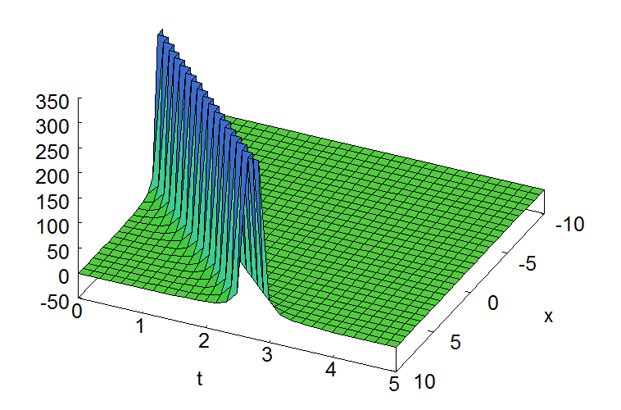

Fig 1: the graph of (5.1) in 3D, the range of $x∈[-10, 10]$ and $t∈[0, 5]$

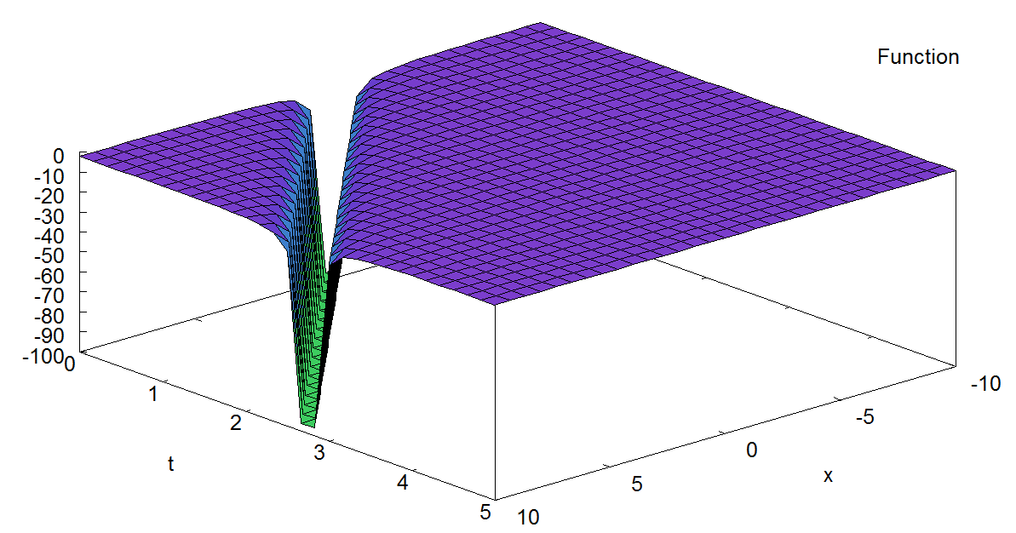

Fig 2: the graph of (5.2) in 3D, the range of $x∈[-10, 10]$ and $t∈[0, 5]$

**Exemple 5**

We determine the solution of (1.0) in passing by the nonlinear EDO (2.16).

For the nonlinear EDO, we choose

$a_{3}=\frac{1}{3} , a_{4}=4, a_{5}=2$ and ${ a}_{6}=-3 (5.3)$

Thus, we obtain the other values

$a_{0}=\frac{8}{3}, a_{1}=4$ and ${ a}_{2}=2 (5.4)$

The expression (2.16) becomes

$$u_{zzzz}=\frac{8}{3}+4u+2u^{2}+\frac{1}{3}u^{3}+4u_{zz}+2uu_{zz}-3u_{z}^{2} (5.5)$$

The solutions of (5.5) are:

$$u\left(z\right)=\frac{6\sqrt{10}}{{\left(z+1\right)}^{2}}-2 (5.6)$$

$$u\left(z\right)=-\frac{6\sqrt{10}}{{\left(z+1\right)}^{2}}-2 \left(5.7\right)$$

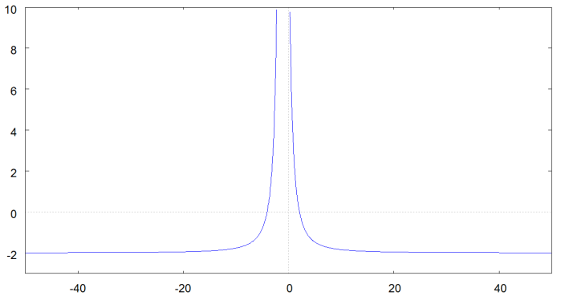

Fig 3: the graph of (5.6) in 2D, $z∈[-50, 50]$

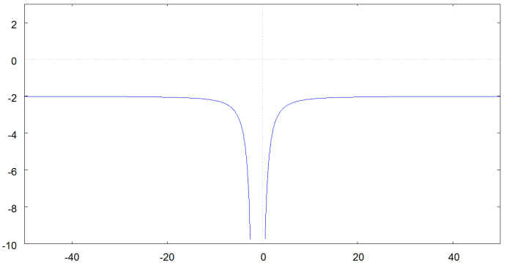

Fig 4: the graph of (5.7) in 2D, $z∈[-50, 50]$

With the coefficients (5.3) and (5.4), we obtain the coefficient (1.0) via the relationship (2.17).

We have:

$α_{0}=\frac{8}{3}α_{6}, α_{1}=-4α_{6} ,{ α}_{2}=-α_{6} ,α_{3}=4α_{6} ,{ α}_{4}=-4α_{6}, { α}_{5}=-2α_{6 }$ and $V=4α_{6} (5.8)$

We see that these coefficients are dependent on $α_{6}$. We choose

$$α_{6}=1 (5.9)$$

We obtain:

$α_{0}=\frac{8}{3}, α_{1}=-4, α_{2}=-1, α_{3}=4, α_{4}=-4, α_{5}=-2$ and $V=4 (5.10)$

The expression of (1.0) becomes

$$u_{t}-4uu_{x}-u^{2}u_{x}+4u_{x}u_{xx}-4u_{xxx}-2uu_{xxx}+u_{xxxxx}=0 (5.11)$$

Using (4.35), the solutions of (5.11) are

$$u\left(x,t\right)=\frac{6\sqrt{10}}{{\left(x-4t+1\right)}^{2}} –2 (5.12)$$

$$u\left(x,t\right)=-\frac{6\sqrt{10}}{{\left(x-4t+1\right)}^{2}}–2 (5.13)$$

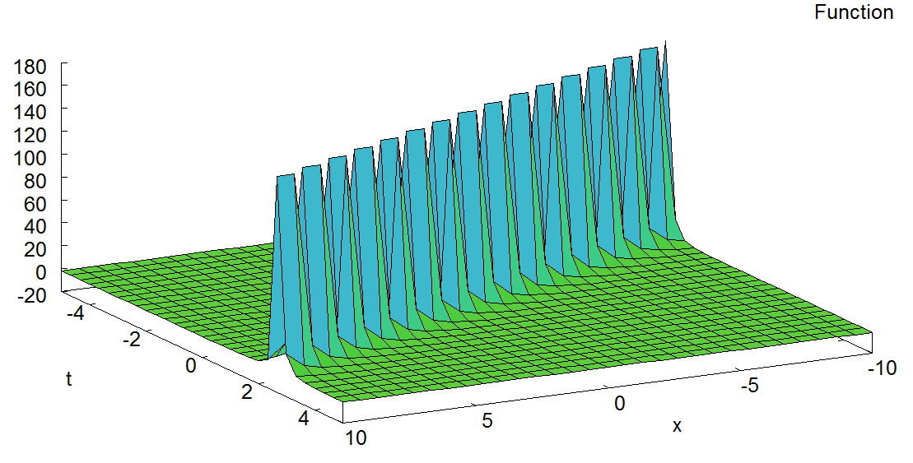

Fig 5: the graph of (5.12) in 3D, the range of $x∈[-10, 10]$ and $t∈[-5, 5]$

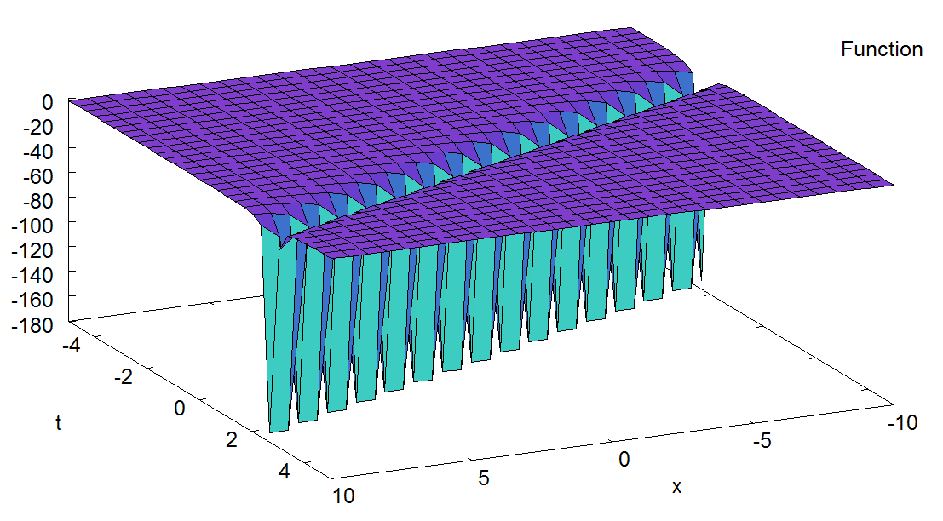

Fig 6: the graph of (5.13) in 3D, he range of $x∈[-10, 10]$ and $t∈[-5, 5]$

**6. CONCLUSION**

In this work, we derived two nontrivial invariant solutions for the fifth-order Korteweg–de Vries (fKdV) equation. Our analysis revealed that the existence of solutions for the associated fourth-order nonlinear ordinary differential equation (ODE) depends on specific algebraic relationships between the coefficients. In particular, we established that the coefficients $a_{3}$ and $a_{5}$ must be nonzero to ensure a valid solution.

For the fKdV equation, we identified necessary conditions on its coefficients, demonstrating that most of them must be nonzero, except for ${ α}_{3}$. Furthermore, we showed that three key coefficients are interdependent, and their relationships serve as constraints that allow the existence of invariant solutions.

This study highlights the effectiveness of **Lie symmetry analysis** as a powerful method for solving nonlinear differential equations. By leveraging symmetry-based approaches, we obtained exact solutions that can contribute to a deeper understanding of the underlying physical phenomena modeled by the fKdV equation.

Future research could explore the application of this method to other classes of nonlinear partial differential equations, investigate additional symmetry reductions, or extend the analysis to more complex boundary conditions and perturbations.

References

[1] M.S. Bruzon, T.M. Garrido And R.de La Rosa, Symmetry Reductions For A Generalized Fifth Order KdV Equation. Applied Mathematics and Nonlinear Sciences, 2(2): 485-494, doi:10.1042/AMNS.2017.2.00040, 2017.

[2] Einstein, A. (1905), The Field Equations of Gravitation, On a Heuristic Point of View about the Creation and Conversion of Light, Annalen der Physik 322(6): 132-148. doi 10.1002/andp.19053220607

[3] Yehui Huang, Wei Li, Guo WangandXuelin Yong, Lie symmetry analysis of the deformed KdVequation,Modern Physics Letters B,Vol. 31, No. 30, 1750275 (2017), DOI: 10.1142/S021798491750275X.

[4] G. Das and J. Sarma, A new mathematical approach for finding the solitary waves in dusty, *Phys. Plasmas* **6** (1999) 4394.

.

# [5] A. Osborne, The inverse scattering transform: Tools for the nonlinear Fourier analysis and filtering of ocean surface waves, *Chaos Soliton. Fract.* 5 (1995) 2623,[doi :10.1016/0960-0779(94)E0118-9](https://doi.org/10.1016/0960-0779(94)E0118-9).

[6] Karina Khusnutdinova, Matthew Tranter, Yury Stepanyants, Solitons Solutions To The Fifth-Order Korteweg-De Vries Equation And Their Applications To Surface And Internal Waves, Physics Of Fluids, doi:10.1063/1.5009965, January 2018.

[7] R. P. Malik, 0n fifth order KdV-type equation, arXiv:solv-int/9710010v1.

[8] M. N. Hounkonnou and P. A. DkengneSielenou, *Int. J. Contemp. Math. Sciences, Vol. 4, 2009, no. 35, 1719 – 1738.*

[9] SatyanadKichenassamy and Peter J.Olver, Existence and Nonexistence of Solitary Wave Solutions To Higher-Order Model Evolution Equations, Society for Industrial and Applied Mathematics. Vol.23, No 5, pp. 1141-1166, September 1992.

[10] Gang-wei Wang, Xi-qiang Liu, Ying-Yaun Zhang, New explicit solutions of the fifth-order KdV equation with variable coefficients, Bulletin of the Malaysian Mathematical Sciences Society, (2) 37(3) (2014), 769-778.

[11] Cesar A, Gomez Sierra, MotlatsiMolati, MotlatsiP.Ramollo, Exact Solutions of Generalized KdV-mKdV Equation, International Journal of Nonlinear Science, Vol.13(2012) No.1, pp.94-98.

[12] Hanze Liu, Jibin Li, Lei Liu, Lie Symmetry Analysis, optimal systems and exact solutions to the fifth-order KdV types of equations, Journal of Mathematic Analysis and Applications. 368(2010) 551-558.

[13] Ahmed M.Thabt, Exact Solution and Conserved Vectors of Fifth-Order Korteweg-De Vries Equation Obtained by Lie Symmetry Analysis, MAYFEB, Vol 1 (2016)-Pages 1-10.

[14] Abdul-Majid Wazwaz, Partial Differential Equations and Solitary Waves Theory, Springer 2009, pp. 484-491.

[15] J.Banasiak, INTRODUCTION TO NONLINEAR PARTIAL DIFFERENTIAL EQUATIONS, School of Mathematical Sciences, University of KwaZulu-Natal. Durban. South Africa, Chap 5.

[16] Mahomed, F. M., and Leach P G L. (1990). Symmetry Lie algebras of nth order ordinary differential equations, Journal Mathematical Analysis Applications. 151. 80-107.

[17] Frida Granström, Symmetry Methods And Some Linear Differential Equations (Background And Illustrative Examples), Doctorate thesis, Faculty of Health, Science and Technology, Karlstads University January 2017.

[18] Ruth Steinhour, The Truth About Lie Symmetries: Solving Differential Equations Symmetry Methods, Senior Independent Study Theses. The College of Wooster Libraries, Paper 949, 2013.