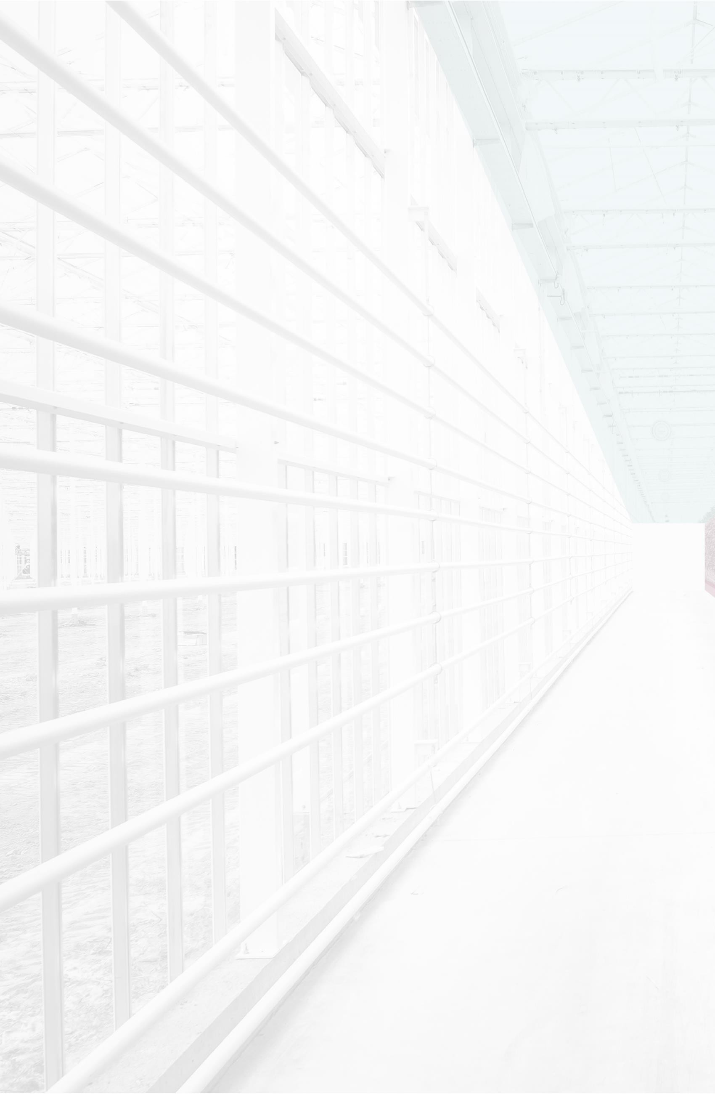

**FRIEZE AND WALLPAPER PATTERNS OF BANIG DESIGNS IN NORTHERN SAMAR**

**Abstract:** The study aimed to identify the symmetry group type of patterns found in the designs of the banig/mats from two barangays in Northern Samar. It specifically sought to achieve two objectives: (1) identify the symmetry group type for the frieze patterns in the design of the mats and (2) identify the symmetry group type for the wallpaper pattern in the design of the mats. To accomplish the objectives, the researchers analyzed the frieze patterns of the banig designs from Brgy. Bukid, Las Navas, and the wallpaper patterns of the entire banig design from Brgy. Bantayan, San Roque, Northern Samar. After analyzing the patterns in the mats, the researchers identified two frieze patterns in five mats from Brgy. Bukid, Las Navas, and two wallpaper patterns in two mats from Brgy. Bantayan, San Roque, Northern Samar. There is a need to research and use these designs so that the weavers can find new buyers and inspire new Nortehanon product designs that are commercially available within the province and the whole region. Based on the findings, it is recommended to analyze the color symmetry of the banig/mat designs used in this study and find other banig/mat designs made by the same weavers.

**Keywords:**  weaving, design, symmetry, patterns, tradition

# Introduction:

In an ever-changing society, people constantly look for consistency and balance, particularly about the things surrounding them. One of which that left people wondering about is the banig, which is a handwoven mat commonly used for sleeping, particularly in the warm and humid tropics. It is made from dried leaves which remain cool in the heat of the day and are porous enough to let ventilation through. These dried up leaves are cut into strips and woven into mat. The most common type of these leaves in the country are buri (*coryphe*), rattan (*calameae),* a palm tree (*Coryha elata Roxb*), and tikog, a tall coarse Philippine sedge (*Fimbristylis spp*).

Banig weaving is a traditional livelihood in many Philippine provinces, especially in Northern Samar, passed down through generations. The designs vary by region, showcasing creativity and craftsmanship. This study aims to reveal underlying symmetry patterns in Northern Samar's woven mats using mathematical concepts.

Symmetry, a property found in nature and cultures worldwide, is analyzed here through group theory and transformation geometry. The study focused on patterns from two municipalities, Las Navas and San Roque, to highlight the mathematical connection in banig designs, which is often unknown to the weavers. Researchers documented and classified these patterns based on their symmetry group types.

**II. Objectives**

This study aims to find symmetry in the patterns found in the banig from Northern Samar. Specifically, it aims to:

1. identify the symmetry group type for the frieze pattern present in the design of the banig;

2. identify the symmetry group type for the wallpaper pattern present in the design of the banig.

**III. Methodology**

In this study, the researchers classified the repeated patterns appearing in a given banig design based on its respective symmetry group, and the symmetries present. Symmetry is an underlying mathematical principle for the analysis of a repeated pattern in a textile or fabric. Symmetry is an isometry which sends a pattern to itself. An isometry of the plane is a linear transformation which preserves length. There are four types of isometries namely: reflection; rotation; translation; and glide reflection.

The researchers divided the sets of banig into two areas namely Area 1 and Area 2. Area 1 were the banig from Brgy. Bukid and Area 2 were the banig from Brgy. Bantayan. The researchers analyzed the frieze patterns and wallpaper patterns found on the designs of the banig from Area 1 and Area 2, respectively.

**Area 1 (Brgy. Bukid, Las Navas, Northern Samar)**

This study adopted the international symbol, ***p,x,y,z***, to name the seven patterns as identified by Washburn and Crowe in their study “Symmetry of Culture”. Each name starts with

the letter **p.** The following symbols were used to derive the rest of the four-symbol notation for each symmetry group for frieze patterns.

x= $\begin{matrix}m, & if there is vertical reflection \\ 1, & if there is no reflection\end{matrix}$

y= $\begin{matrix}m, & if there is horizontal reflection \\ g, & if there is a glide reflection \\ 1, & if there is no horizontal and glide reflection\end{matrix}$

z= $\begin{matrix}2, & if there is a half turn \\ 1, & if there is no rotation symmetry\end{matrix}$

The table below shows the seven frieze patterns. The first column is the example of each type of symmetry group. The second column is the classification of the symmetry group type.

Table 1. Seven One-dimensional Patterns with Illustrations (archive.bridgesmathart.org/2001/bridges2001-1.pdf)

|  |  |  |
| --- | --- | --- |
| **Figure** | **Symmetry**  **Group** | **Isometries present**  **(Beside translate on)** |
|  | p111 | No other isometry except translation |
|  | p112 | Rotation (180º) |
|  | pm11 | Vertical reflection |
|  | p1m1 | Horizontal reflection |
|  | pmm2 | Vertical and horizontal reflection; rotation (180º) |
|  | pmg2 | Vertical reflection; glide reflection; rotation (180º) |
|  | p1g1 | Only glide reflection |

**Area 2 (Brgy. Bantayan, San Roque, Northern Samar)**

The classification of wallpaper patterns is more complicated than the frieze pattern. Taking into account that there are more possible translations, rotations, reflections and glide reflections. Fortunately, it is not quite that complicated because of the so-called "crystallographic restriction"

(http://www.math.nus.edu.sg/asiaksen/projects/rp-urops.pdf).

The minimal positive angles of rotations that can be symmetries of a wallpaper pattern are 60º, 90º, 120º, and 180º. All other angles of rotation for a given wallpaper pattern are multiples of the minimum angle. The names of the wallpaper groups are not simple as the frieze group.

The number 2, 3, 4, and 6 refer to the maximum number of rotations around a center of rotation (<http://www.math.nus.edu.sg/asiaksen/projects/rp-urops.pdf>).

The names for the symmetry groups describing Wallpaper Patterns or Crystallographic Patterns, like the frieze patterns, adopt a four-symbol notation ***q, r, s, t*.** The notation comes from crystallographers who used it to classify crystals. The interpretation of the crystallographic notation is as follows:

q = $\begin{matrix}p, & if the primitive cell is not a centred cell \\ c, & if the primitive cell is a centred cell\end{matrix}$

r = n, the highest order of rotation

*s* denotes a symmetry axis normal to the left edge of the primitive or centered cell. This left edge is known as the x-axis.

s = $\begin{matrix}m & if there is a reflection axis \\ g & if there is no reflection axis,but a glide reflecton axis \\ 1 & if there is no symmetry axis\end{matrix}$

t denotes a symmetry axis at angle θ (≤ 180º) to the x-axis. In particular, θ = 180º if n = 1 or 2; θ = 45º if n = 4; θ = 60º if n = 3 or 6

t = $\begin{matrix}m & if there is a reflection axis \\ g & if there is no reflection axis but a glide reflection axis \\ 1 & if there is no symmetry axis\end{matrix}$

No symbols in (s) and (t) indicate that the group contains neither reflections nor glide-reflections ([www.math.nus.edu.sg/aslaksen/projects/rp-urops.pdf](http://www.math.nus.edu.sg/aslaksen/projects/rp-urops.pdf)).

Table 2: Flowchart for determining the type of any of the seventeen two-dimensional patterns (archive.bridgesmathart.org/2001/bridges2001-1.pdf)

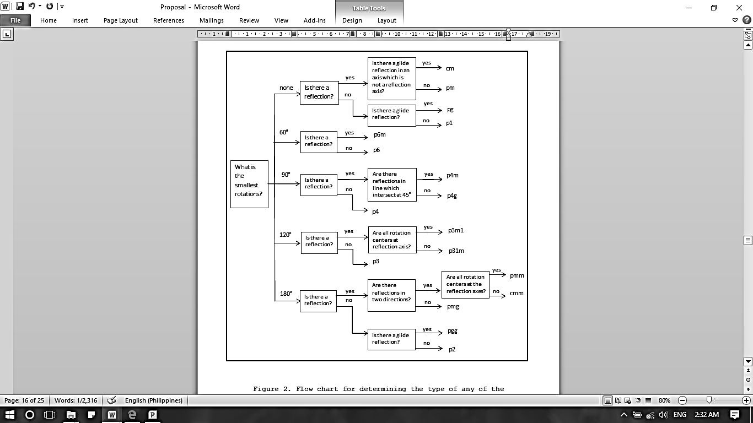

The following flowchart is used for determining the type of the seventeen two-dimensional patterns. The notations are standard wallpaper symbols. Unfortunately, in contrast to the one-dimensional case, there is no really simple recipe for deriving these symbols, though with use one begins to recognize some significance to the symbols. For example, a number occurring in the name indicates the presence of the corresponding rotation; the occurrence of m or g indicates the presence of reflections (m for mirror, g for glide reflection); and a c indicates a "half-drop" in the language of some designers (archive.bridgesmathart.org/2001/bridges2001-1.pdf).

The table below shows the characteristics of the seventeen two-dimensional symmetry groups.

Table 3: The 17 symmetry groups of the two-dimensional pattern (<http://www.clarku.edu/~djoyce/wallpaper/>).

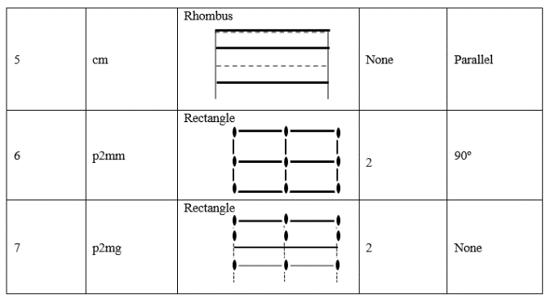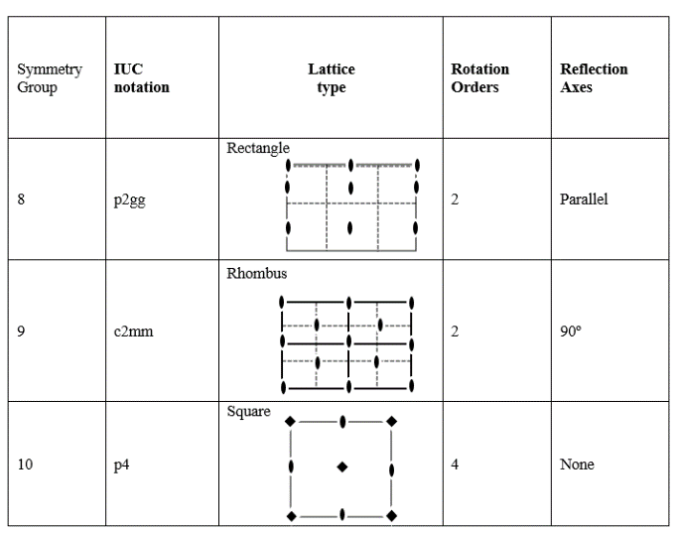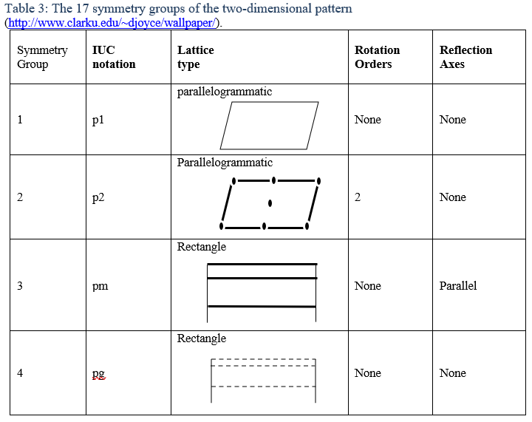

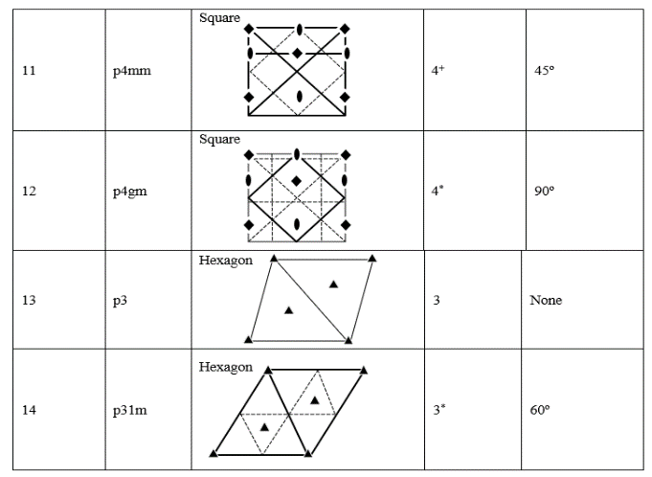

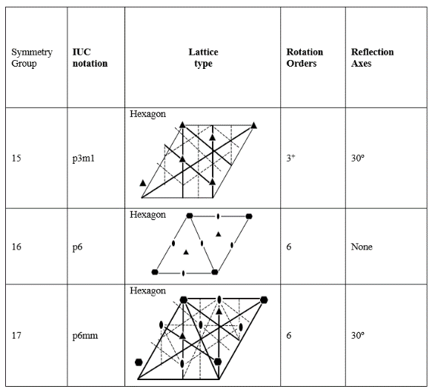

The IUC notation is the notation for the symmetry group adopted by the International Union of Crystallography in 1952(http://www.clarku.edu/~djoyce/wallpaper/).

The table below are symbols in identifying the centers of rotation, axis of reflection, and axis of glide reflection. The number of folds shows the degree or number of rotations, the thin line for the unit cell, bold line for the reflection axis, and the broken line shows the glide-reflection axis.

Table 4: Labels of the figures from the Lattice Type column (Table 3) ([www.encyclopediaofmath.org/crystallographic_group.pdf](http://www.encyclopediaofmath.org/crystallographic_group.pdf))

|  |  |  |  |
| --- | --- | --- | --- |
|  | one-fold axis |  | unit cell |
|  | two-fold axis |  | mirror/ reflection line |
|  | three-fold axis |  | position of glide line |
|  | four-fold axis | + = all rotation centers lie on reflection axes | |
|  | Six-fold axis | * = not all rotation centers on reflection axes | |

**IV. Results & Discussion**

In this chapter, the researchers have come up with the result of the on-site research from two selected barangays in the province of Northern Samar, namely: Brgy. Bantayan, San Roque and Brgy. Bukid, Las Navas.

**Area 1- Frieze Pattern**

The banig weavers from Brgy.Bukid, Las Navas N. Samar use tikog as their main material for making banig. Most of their mat designs are border motif with either letters or objects in the center like figure 3 which has the word ‘souvenir’ at the center and figure 5 which consists of peacocks and flowers. The main color of the banig is either green or red or sometimes just the natural color of the material.

The researchers focused more on the border designs since these are the ones with the frieze patterns. The figure shown below is the banig from Brgy. Bukid, Las Navas N. Samar. In this figure the researchers used the border design of the banig and analyzed the frieze pattern using the basic unit and the symmetry group it belongs.

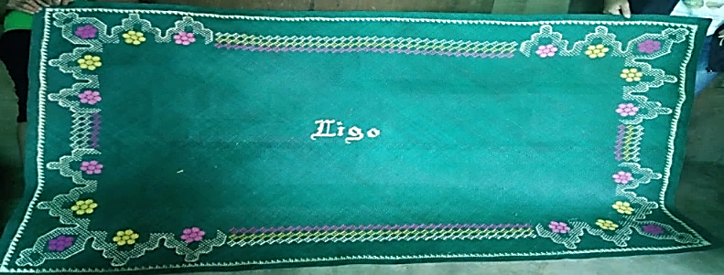

### Figure 1. Picture of the whole banig with Frieze Pattern at the border

The left picture below is the enlarge view of the border with frieze pattern and the right is the illustration of the pattern.

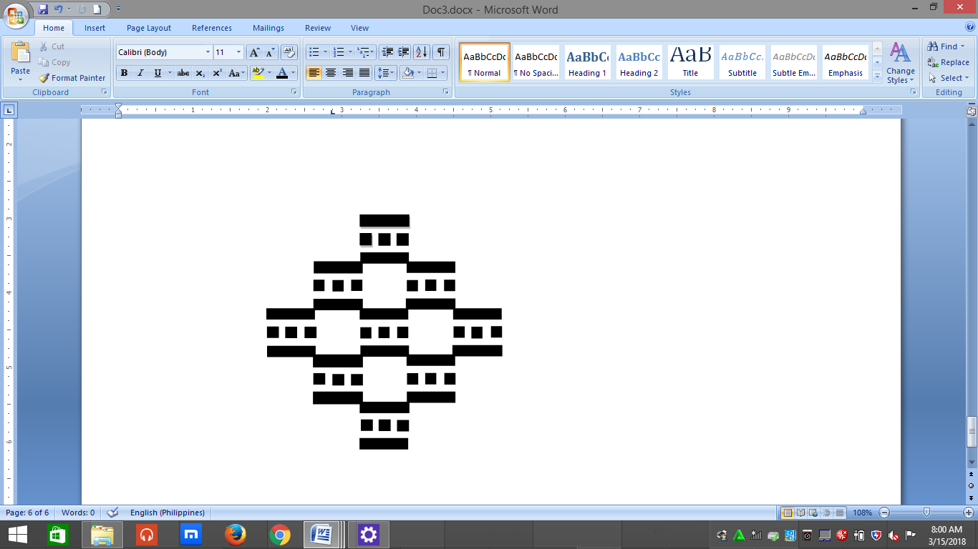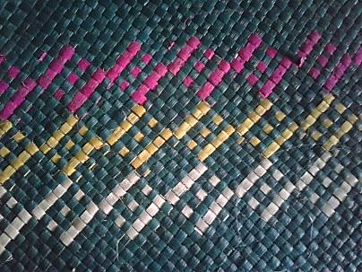

Figure 1.a. Picture of the Frieze pattern Figure 1.b is the basic unit taken

found in Figure 1 from Figure 1.a

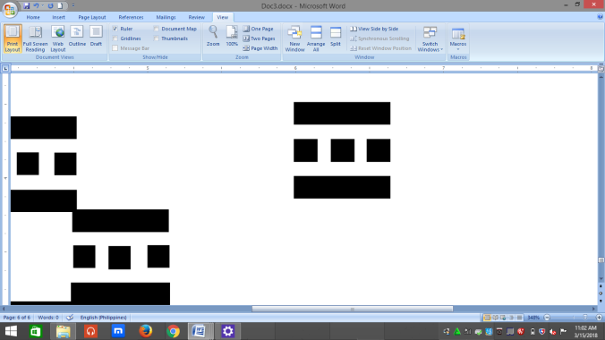

### Figure 1.b. Basic unit taken from Figure 2a

The figure 1.c shows that the basic unit has a rotation symmetry of 1800

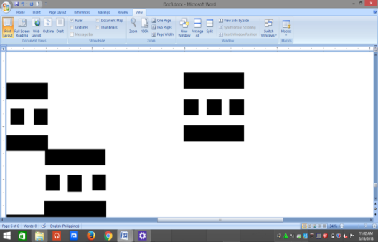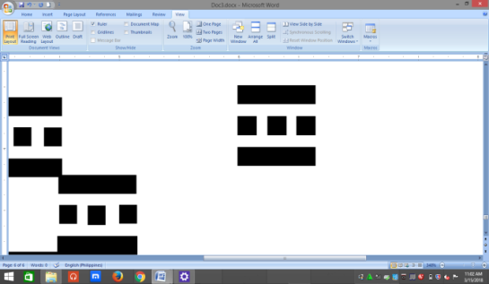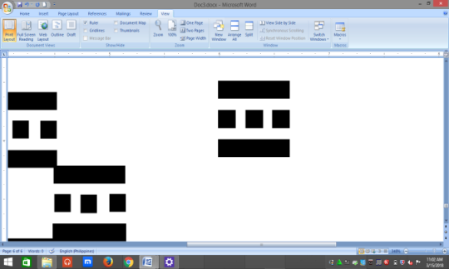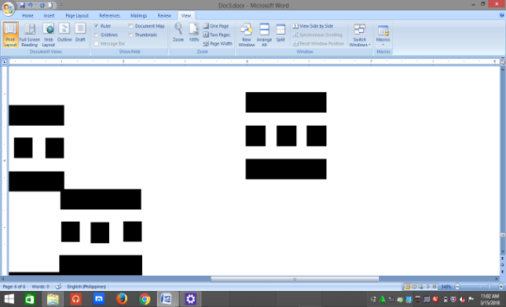

### Figure 1.c. Rotation of the basic unit

The figure below shows the translation symmetry of the basic unit.

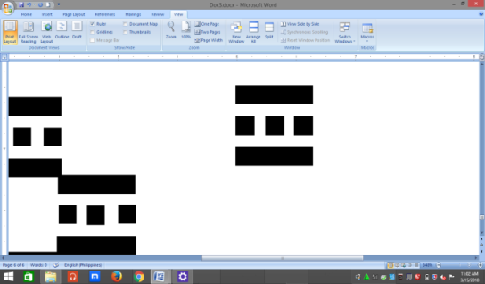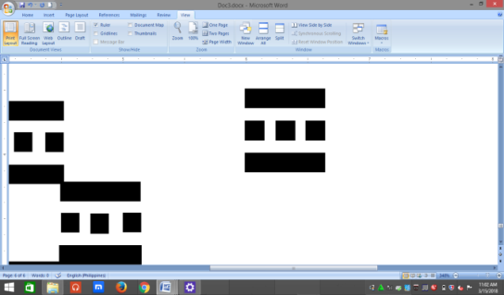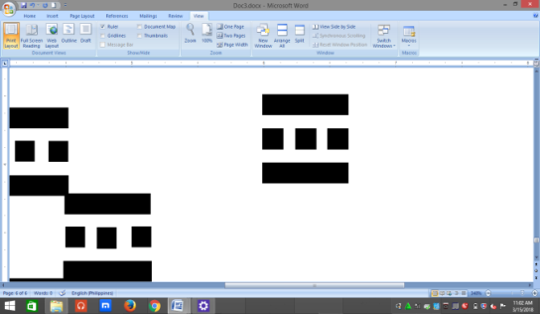

### Figure 1.d. Translation of the basic unit

Figure 1.c and 1.d shows that pattern from figure 1.a, has translation symmetry in the horizontal and vertical direction and a 1800 rotation. There is no reflection symmetry. So, we obtain the symmetry group type *p112.*

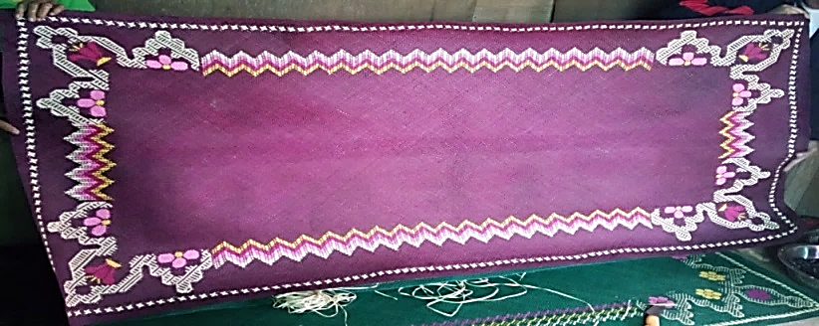

Figure 2. Picture of the whole banig with Frieze Pattern at the borders

The picture on the left (figure 2.a) is the enlarged view of border with frieze pattern from figure 1 and on the right is the illustration of the pattern.

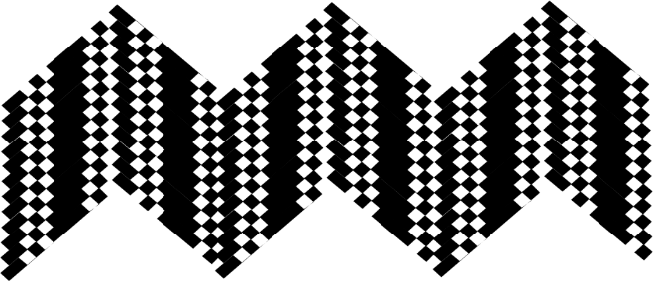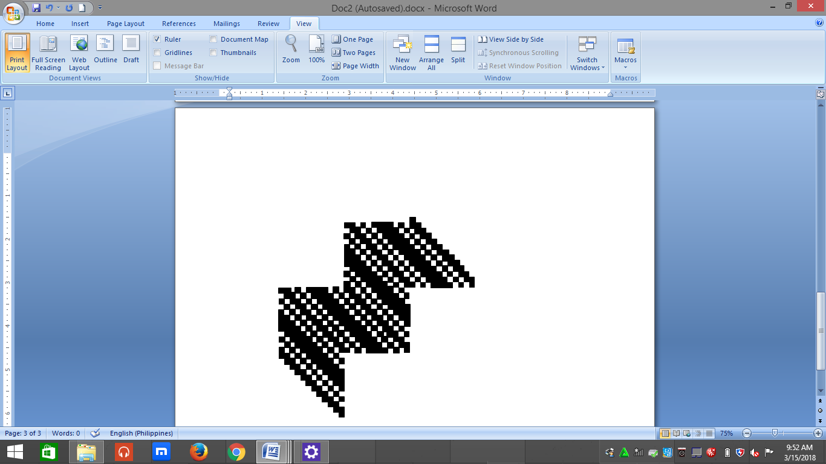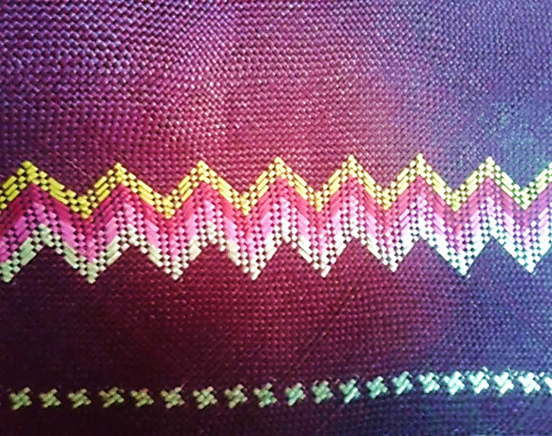

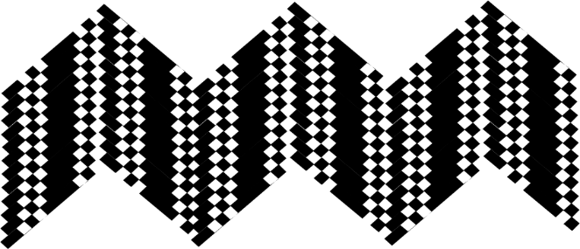

### (2) (2a) (2b) (2c)

Figure 2.a. Picture of the Frieze Pattern found in Figure 2.

Figure 2.b. Basic Unit

Figure 2.c Translation Pattern of the Basic Unit

Figure 2.c shows that the pattern from figure 2.a has only translational symmetry. There is no reflection symmetry neither rotational symmetry. Hence, it has a symmetry group type of *p111.*

**Area 2- Wallpaper Patterns**

The set of banig/mats that are from Brgy.Bantayan, San Roque N. Samar**.** Most of the banig weavers from Brgy. Bantayan opted for buri as their main material for making the banig. Unlike the banig from Las Navas, which has a border motif, the banig from San Roque has a wallpaper pattern. In this figure the researchers used the whole design of the banig and analyzed the wallpaper pattern using the basic unit and the symmetry group it belongs.

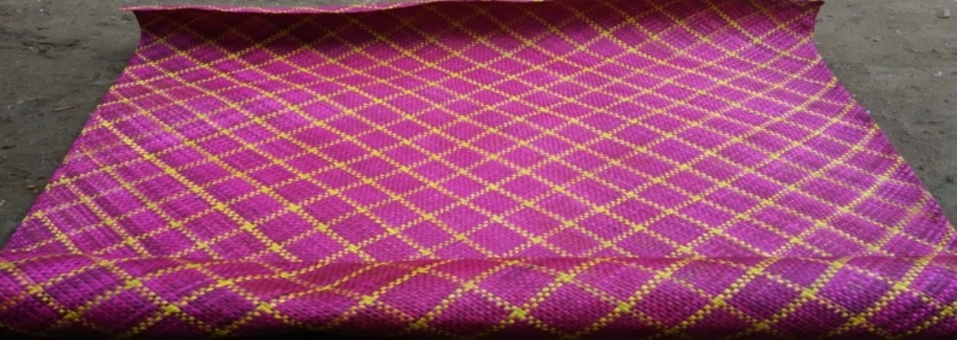

### Figure 3. Picture of the whole banig.

The picture on the left (figure 3.a) is the enlarged view of the banig with the wallpaper pattern from figure 3 and on the right is the illustration of the pattern.

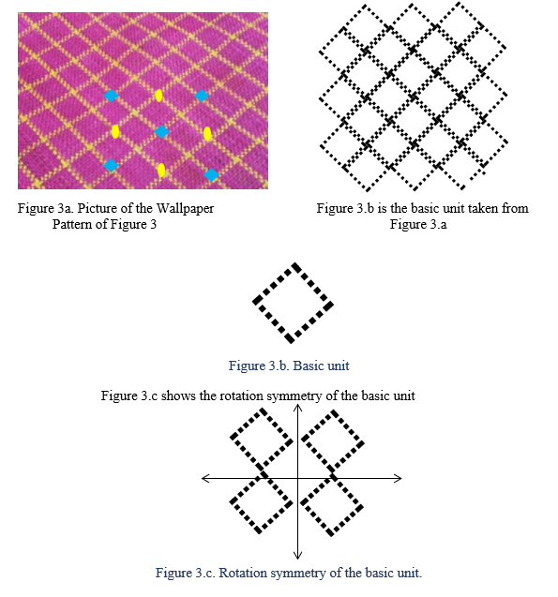

In summary, the research Ianalyzed the patterns in banig designs, focusing on identifying frieze and wallpaper patterns. The banig samples were divided into two areas: Area 1 (Brgy. Bukid) for frieze patterns in the borders, and Area 2 (Brgy. Bantayan) for wallpaper patterns.

For frieze patterns, the researchers used the international symbol "**pxyz"** (p for primitive cell, x for vertical reflection, y for horizontal reflection, z for rotation). For wallpaper patterns, they used "**qrst**" (q for primitive cell, r for highest rotation, s for a symmetry axis normal to the x-axis, t for an axis at ≤180º to the x-axis).

The researchers have come up with the result of the on-site research from two selected barangays in the province.

**Area 1 Brgy. Bukid Las Navas, Northern Samar**

**Frieze patterns (one dimensional)**

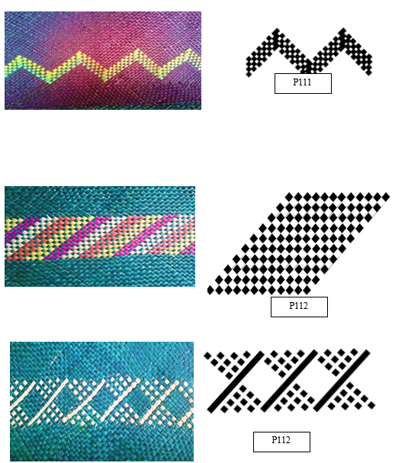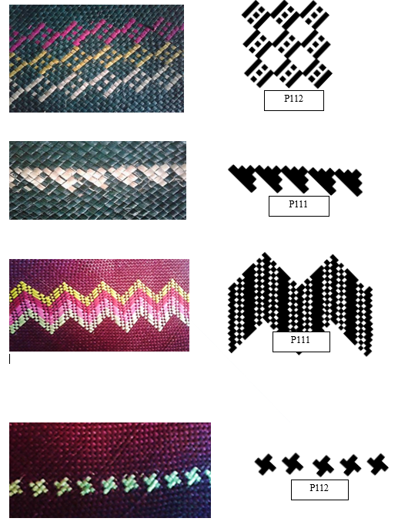

**Figure 4. Frieze Patterns in Brgy. Bukid And their corresponding Group Type.**

**Area 2- Brgy. Bantayan, San Roque, Northern Samar**

**Wallpaper patterns**

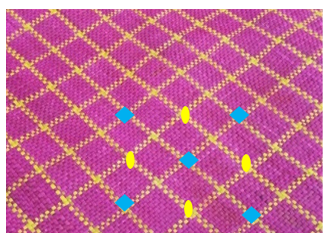

p4mm

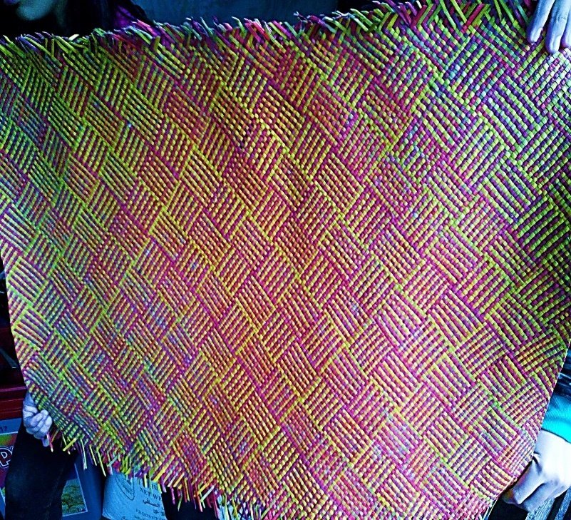

p4gm

**Figure 5. Wallpaper patterns in Brgy. Bantayan and their corresponding group type.**

The researchers analyzed the distribution of the seven types of frieze and crystallographic pattern. There were only five mats from Area 1, two of which have two patterns while the remaining three have only one frieze pattern each; thus, giving us the total of seven distinct patterns.

Figure 6. Distribution of Frieze Pattern on Banig from Brgy. Bukid

From the chart above, it is evident that only two types of frieze patterns, p111 and p112, were identified in the analyzed mats. Out of the seven possible frieze patterns, the researcher found these two in five mats.

In Area 2, there were only two banig analyzed. The chart below shows that the most common patterns observed were p4gm and p4mm, both characterized by four-fold rotation.

Figure 7. Distribution of Wallpaper Pattern on banig form Brgy. Bantayan

**V. Conclusion & Recommendations**

In conclusion, the researchers were unable to identify all seven frieze symmetry groups and the seventeen crystallographic symmetry groups in banig designs due to limited materials from the areas studied. In Area 1 (Brgy. Bukid, Las Navas), the researchers focused on border designs and found that the frieze patterns were mostly p111 (translation only) or p112 (translation and rotation). In Area 2 (Brgy. Bantayan, San Roque), they identified two-dimensional patterns with 90° and 180° rotations, classifying them as p4gm (four-fold rotation, glide reflection, and reflection) and p4mm (four-fold rotation and reflection).

Recommendations include:

1. Analyzing color symmetry in banig designs.
2. Studying other banig designs by the same weavers.

Outcome of the Study:

This study led to an extension program in Barangay Bantayan, San Roque, Northern Samar, where the community was assisted in creating banig designs similar to those in Brgy. Bukid, Las Navas. BS Mathematics students also suggested new patterns, helping expand design options and contributing to economic growth by promoting innovation and social entrepreneurship, ultimately aimed at reducing poverty.

**I. References**

De las Penas Mlan, Baylas N, Rapanut Ta. 2012. Weaving symmetry of the Philippine Northern Kankana-ey. In: Sarhangi R, Bosch R, McKenna D. eds. Bridges Towson 2012: Mathematics, Music, Art, Architecture and Culture. Hertfordshire:Tarquin Publications. p. 267-274. Retrieved from archived.bridgesmathart.org/2012/bridges2012-267.pdf

James F. Ulrich. et al. Geometry. Third Edition. Harcourt Brace Jovanovich. United States. 1978. pg. 515-529

Ma. Louise Antonette N. De Las Peñas and Analyn V. Salvador-Amores. . Retrieved from <http://philjournalsci.dost.govt.ph/pdf/pjs_pdf/vol145no1/pdf/mathematical_and_anthropological_analysis_of_funeral_textile_FINALCOPY.pdf>

Bennet. Jennie M.et.al. Glencoe Mathematics:(Application and Concepts)Oklahoma Edition. Course 3. Hort, Rinehart, and Winston. United States. 2004. pg 286-301

Poh Kim Muay. Frieze Patterns on Ming Porcelains. Retrieved from [www.math.nus.edu.sg/aslaksen/projects/rp-urops.pdf](http://www.math.nus.edu.sg/aslaksen/projects/rp-urops.pdf)

Washburn, Dorothy K. and Crowe, Donald W., Symmetries of Culture, University of Washington Press, 1988. Retrieved from archive.bridgesmathart.org/2001/bridges2001-1.pdf

https://www.cut-the-knot.org/Curriculum/Geometry/GlideReflection.shtml

Retrieved on January 23, 2018

www.math,uchicago.edu/~may/VIGRE/VIGRE2008/REUPapers/Levine.pdf

Retrieved on February 4, 2018

https://mathinphilippineart.wordpress.com/mathematical-connections/

Retrieved on December 10, 2017

<http://mathworld.wolfram.com/Isometry.html>

Retrieved on February 16, 2018

<http://www.clarku.edu/~djoyce/wallpaper/>

Retrieved on March 2, 2018

[www.mathematicsdicionary.com/english/vmd/full/t/translationalsymmetry.htm](http://www.mathematicsdicionary.com/english/vmd/full/t/translationalsymmetry.htm)

Retrieved on March 2, 2018

mathstat.slu.edu/Escher/index.php/Frieze_Pattern

Retrieved on December 5, 2018

<https://en.m.wikipedia.org/wiki/Banig>

Retrieved on November 8, 2018