***Case report***

**The Evolution of Installation Art in Contemporary Sculpture: A Case Study**

**ABSTRACT**

Installation art is a transformative practice that challenges traditional sculpture by integrating diverse media such as painting, video, sound, and performance. Unlike static, object-based sculptures, it creates immersive spatial experiences, redefining contemporary sculptural practice.

Its origins trace back to avant-garde movements that rejected conventional forms in Favor of experimental approaches. Early conceptual works expanded sculpture’s boundaries through site-specificity, audience engagement, and environmental awareness. The rise of conceptual and environmental art in the 1960s and 1970s reinforced the shift toward immersive environments that interact with space and viewer perception.

Contemporary installation art incorporates unconventional materials, digital technologies, and participatory elements. Large-scale installations engage the senses and provoke critical discourse, emphasizing bodily experience, social interaction, and spatial context. Theoretical perspectives highlight participatory and site-specific dimensions, showing how meaning is deeply connected to space and context.

A case study on eco-conscious installation art illustrates the use of natural resources in contemporary sculptural practice. It explores material selection and execution, reflecting sustainability and cultural heritage themes. The integration of storytelling and ecological awareness demonstrates installation art’s potential as a platform for socio-cultural discourse.

This study presents a case study on installation art and reviews literature exploring its evolution within contemporary sculpture.

*Keywords: Installation Art, Contemporary Sculpture, Immersive Environments*

**INTRODUCTION**

Installation art has emerged as a dynamic and immersive form of artistic expression that challenges traditional boundaries of fine art and sculpture. Unlike conventional sculptures that exist as standalone objects, installation art engages with space, environment, and audience perception, transforming the way viewers interact with art. The evolution of installation art within the field of contemporary sculpture reflects broader shifts in artistic practices, materials, and conceptual frameworks. This paper examines the historical development, theoretical underpinnings, and contemporary trends in installation art, highlighting its impact on sculptural practice.

1. Defining Installation Art

Installation art is a multidisciplinary approach that integrates various media, including sculpture, painting, video, sound, and performance, to create site-specific or immersive experiences. The term "installation" was popularized in the late 20th century, but the roots of this practice can be traced back to early avant-garde movements such as Dada, Surrealism, and Constructivism (Bishop, 2005). Unlike traditional sculpture, which is often static and object-based, installation art prioritizes spatial engagement and audience participation (Julie H. Reiss, 1999)

2. Historical Development

The origins of installation art can be linked to early experimental works by artists such as Marcel Duchamp, whose "Fountain" (1917) redefined artistic conventions by introducing found objects as art. The mid-20th century witnessed the rise of conceptual and environmental art, exemplified by Allan Kaprow’s Happenings and Yayoi Kusama’s immersive environments (Amelia Jones, 2012) By the 1960s and 1970s, artists such as Joseph Beuys and Robert Smithson expanded installation art’s scope by integrating political, ecological, and social themes (Miwon Kwon, 2002).d

3. Installation Art and Contemporary Sculpture

In contemporary practice, installation art intersects with sculpture through the use of unconventional materials, digital technologies, and interactive elements. Artists such as Olafur Eliasson, Anish Kapoor, and Ai Weiwei employ large-scale installations that engage the senses and provoke critical discourse (Bourriaud, 1998). The shift from object-based sculpture to immersive environments reflects a growing emphasis on relational aesthetics, where meaning is derived from audience interaction rather than static interpretation (Claire Bishopt, 2012)

4. Theoretical Perspectives

The evolution of installation art is underpinned by various theoretical frameworks, including phenomenology, postmodernism, and spatial theory (Maurice Merleau-Ponty, 1962). The phenomenological approach emphasizes bodily experience in perceiving art, which is central to installation-based works. Additionally, (Bourriaud, 1998)) concept of relational aesthetics highlights the participatory nature of contemporary installation art. Theorists such as Miwon Kwon, 2002) (Miwon Kwon, 2002) explore the site-specificity of installation art, arguing that its meaning is deeply tied to location and context.

The purpose of the current article is to elaborate on a case study of contemporary installation art and review its evolution.

**CASE PRESENTATION**

Creating an Eco-Conscious Installation Art Using Natural Resources

1. Introduction

Art has long been a medium for storytelling, cultural preservation, and environmental advocacy. As an artist working in a university rich in natural resources, I sought to create an installation that would not only be aesthetically compelling but also environmentally conscious. The central idea was to use locally available, sustainable materials to construct an artwork that reflects the evolving relationship between nature, culture, and time. Wood emerged as the ideal medium due to its availability, structural versatility, and intrinsic connection to nature. *This case study explores the conceptualization, material selection, and execution of an installation that embodies ecological awareness and cultural heritage.*

2. Conceptualization and Material Selection

The initial phase involved an extensive exploration of the forested areas surrounding the university to identify suitable natural materials. During this search, I discovered a variety of wooden logs and roots, some of which had been discarded after tree-cutting activities (figure 1 and 2). Many pieces were wet, making them unsuitable for sculpting due to the risk of cracks during drying. However, after careful selection, I found a 4-foot dry root with intricate, naturally occurring patterns that evoked the imagery of animals and birds. This organic structure became the foundation of my installation. Additionally, I 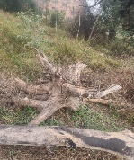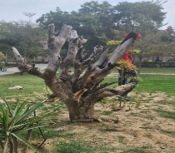selected another 2x2-foot root to complement the primary structure.

Figure 2. Inspection and preparation of the chosen wood log for installation

Figure 1. Wooden logs and roots in the vicinity of the forest

Considering the installation’s depth and stability, I chose a site near my department that offered an appropriate height for display. The stability of the structure was crucial, prompting the creation of a 2x2-foot cement and stone platform to support the roots securely. (Figure 3)

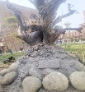

Figure 3. A pedestal made of stones and cement for the placement of the installation

3. Execution and Artistic Enhancements

With the help of workers, the primary root was fixed onto the platform and allowed to settle. Upon returning the next day, I observed that the natural form of the structure already conveyed a powerful aesthetic, but I envisioned further embellishments to amplify its artistic and symbolic meaning. To elevate the installation’s visual impact and conceptual depth, I integrated additional natural elements such as wooden blocks, jute cloth, iron, wire, and rope (figure 4A, 4B, 4C, and 4D).

Figure 4A,4B,4C, & 4D. The process of making a human figure using iron wire, bubble sheet, jute, and rope for the installation

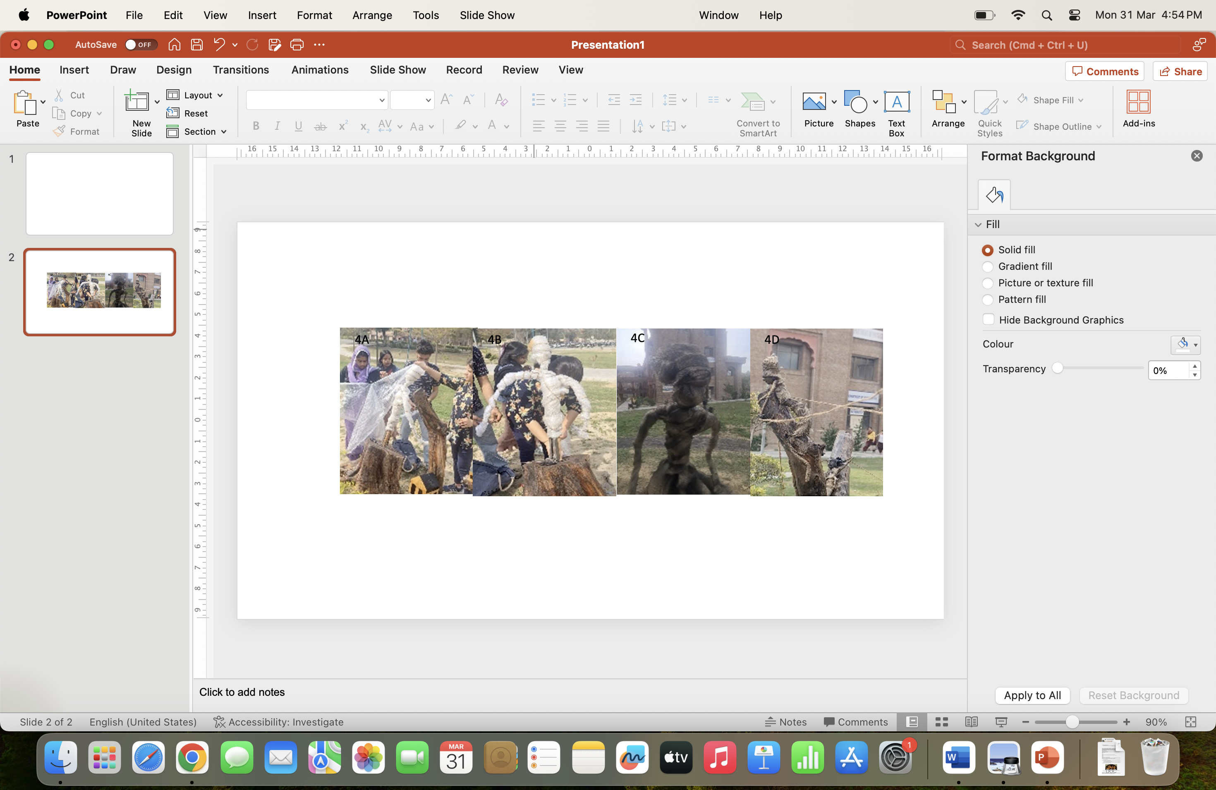

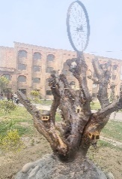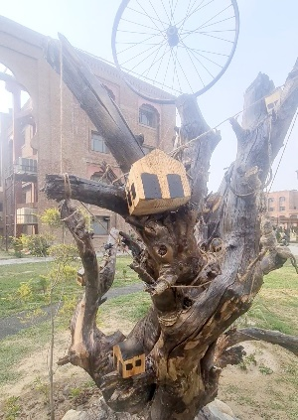Inspired by tribal art and indigenous storytelling, I sculpted human figures using iron wire and M-seal, draping them in jute cloth to represent traditional attire. These figures were arranged in dynamic poses, engaging in various cultural activities, symbolizing the continuity of tribal traditions. Small wooden huts were also incorporated to depict settlement and heritage. (Figure 5). A significant element of the installation was an iron wheel placed at the top, representing the relentless movement of time and progress. This addition emphasized the tension between tradition and modernization, urging viewers to reflect on the importance of cultural preservation amid rapid societal changes (Figure 6).

Figure 6. The iron wheel is placed at the top of the

Figure 5. Wooden huts on the main structure of the installation

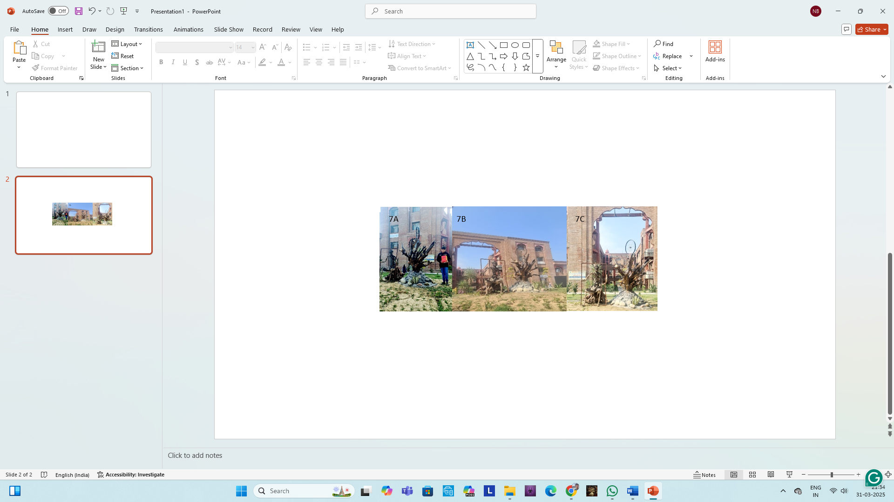Beside the primary root, I positioned the second selected root and sculpted *a 4-foot tribal figure* from wire, bubble wrap, jute cloth, and rope. The figure was designed to hold an iron photo frame (figure), symbolizing the act of framing one’s heritage over time. This artistic decision reinforced the installation’s core message: the necessity of preserving nature and cultural identity for future generations (Figure 7A, 7B, & 7C).

Figure 7A, 7B, & 7C. Final display of the installation with different views

4. Conclusion and Impact

The installation, completed over 15 days, presented a creative and technical challenge in achieving balance, stability, and narrative coherence. It serves as a visual dialogue between nature and culture, highlighting the timeless efforts of indigenous communities in environmental conservation. Through this installation, I aimed to emphasize the evolving relationship between humans and their natural surroundings while conveying a message of sustainability and cultural preservation. Universities serve as platforms for creation and intellectual exploration. By utilizing natural resources for this installation, a deeply meaningful artistic statement can be crafted that not only honours traditional wisdom but also inspires future generations to respect and protect the environment.

**DISCUSSION**

The evolution of installation art within contemporary sculpture represents a paradigm shift from traditional, object-based forms to immersive, experiential environments. This transformation has been influenced by advancements in artistic philosophy, material experimentation, and technological integration. The discussion examines key aspects of this evolution, including materiality, spatial dynamics, audience engagement, and the theoretical frameworks that underpin installation art’s role in contemporary sculpture.

1. Materiality and Medium in Installation Art

Traditional sculpture has historically relied on durable materials such as marble, bronze, and wood. However, installation art has expanded the range of sculptural media to include ephemeral, organic, and digital materials (Bishop, 2005). Contemporary artists such as Anish Kapoor and Olafur Eliasson utilize reflective surfaces, light, and water to create interactive and sensorial experiences. Similarly, Yayoi Kusama’s Infinity Mirror Rooms employ mirrors and LED lights to transcend material limitations and create immersive, infinite spaces (Munroe, 2012).

Incorporating unconventional materials challenges the permanence of traditional sculpture, aligning with postmodern critiques of artistic commodification. As Jean-François Lyotard (Lyotard, 1984) argued, contemporary art destabilizes established narratives, encouraging fluidity in form and interpretation. This is evident in Christo and Jeanne-Claude’s temporary environmental installations, which use fabric and natural landscapes to highlight the transient nature of art (Fineberg, 2000).

2. Spatial Dynamics and Site-Specificity

One of the defining characteristics of installation art is its engagement with space. Unlike traditional sculptures that exist as autonomous objects, installations interact with their environment, often altering the perception of the surrounding space (Kwon, 2002). Artists such as Richard Serra and Rachel Whiteread create large-scale installations that redefine architectural and urban spaces, making the environment an active participant in the artwork.

The concept of site-specificity is crucial in understanding installation art’s impact on sculpture. Miwon Kwon (2002) distinguishes between phenomenological site-specificity, which focuses on direct spatial experience, and discursive site-specificity, which embeds cultural and historical meaning into the location. This approach can be seen in Ai Weiwei’s Sunflower Seeds (2010), where millions of handcrafted porcelain seeds were placed in the Tate Modern’s Turbine Hall, engaging with themes of labor, mass production, and political critique (Bishop, 2012).

3. Audience Interaction and Relational Aesthetics

Another key transformation in contemporary sculpture through installation art is the shift from passive observation to active participation. Nicolas Bourriaud’s (2002) theory of relational aesthetics argues that art should foster social interaction and collective experiences rather than remain static and self-contained. Artists such as Carsten Höller create interactive installations like Test Site (2006), where viewers engage physically with slides installed at the Tate Modern.

This participatory nature challenges traditional distinctions between artist and audience. Claire Bishop (2012) critiques this trend, arguing that while interactivity enhances engagement, it can sometimes undermine critical discourse by prioritizing spectacle over substance. However, artists like Marina Abramović counter this critique by blending installation and performance, as seen in “The Artist is Present” (2010), where the viewer’s presence became the core of the artwork.

4. Theoretical Implications and Future Directions

The shift from object-based sculpture to immersive installation art aligns with broader theoretical perspectives. Maurice Merleau-Ponty’s (Merleau-Ponty, 1962) phenomenology of perception emphasizes bodily experience in art, which is fundamental to installation practices. Additionally, postmodern theorists such as Jacques Derrida (Derrida, 1978)) argue that contemporary art deconstructs fixed meanings, allowing for multiple interpretations based on viewer engagement.

Looking ahead, the integration of digital technology, augmented reality, and artificial intelligence is expanding the possibilities of installation art in sculpture. Artists like Refik Anadol use data-driven visualizations to create generative environments, blurring the line between physical and virtual spaces (Grau, 2003). As technology advances, installation art will likely continue redefining sculptural practice, emphasizing interactivity, temporality, and environmental consciousness.

**CONCLUSION**

The evolution of installation art within contemporary sculpture marks a shift towards spatial, interactive, and conceptual approaches. By incorporating diverse materials, engaging with site-specificity, and fostering audience participation, installation art challenges traditional sculptural boundaries. The theoretical frameworks of phenomenology, relational aesthetics, and postmodernism provide a deeper understanding of this transformation. As artists continue to experiment with new media and digital technologies, installation art is poised to redefine the future of sculptural practice.

References:

1. Bishop, C. (2005). *Installation art : a critical history*. London: London : Tate.
2. Julie H. Reiss. (1999). *From Margin to Center: The Spaces of Installation Art* (Julie H. Reiss, Ed.). Massachusetts London England: The MIT Press Cambridge.
3. Amelia Jones. (2012). *Seeing Differently: A History and Theory of Identification and the Visual Arts* (1st ed.; Amelia Jones, Ed.). London: Routledge.
4. Miwon Kwon. (2002). *One Place after Another: Site-Specific Art and Locational Identity* (Miwon Kwon, Ed.). London, England: The MIT Press, Massachusetts.
5. Bourriaud, N. (1998). *Esthétique relationnelle [Relational aesthetics].* (N. Bourriaud, Ed.). Les Presses du réel.
6. Claire Bishop. (2012). *Artificial Hells: Participatory Art and the Politics of Spectatorship* (Claire Bishop, Ed.). London, NewYork: Verso.
7. Maurice Merleau-Ponty. (1962). *Phenomenology of perception* (Maurice Merleau-Ponty, Ed.). Routledge.
8. Munroe, A. (2012). *Yayoi Kusama: Infinity mirrors* (A. Munroe, Ed.). Munich: Prestel Publishing, .
9. Lyotard, J.-F. (1984). *The postmodern condition: A report on knowledge (G. Bennington & B. Massumi, Trans.)*. University of Minnesota Press.
10. Fineberg, J. (2000). *Art since 1940: Strategies of being* (J. Fineberg, Ed.). London: Laurence King Publishing.
11. Derrida, J. (1978). *Writing and difference (A. Bass, Trans.)* (J. Derrida, Ed.). Chicago: University of Chicago Press.