Original Research Article
A palm fruit of Cocos from the sediments near the Cretaceous-Palaeogene (K/Pg) boundary in Central India

Abstract
The Deccan Traps from the Indian subcontinent represent one of the largest and most spectacular outpouring of continental flood basalts which is often linked with the Cretaceous-Palaeogene (K/Pg) boundary. In many of their exposed sections, the time gap between consecutive lava flows is reflected as thin bands of carbonate clay succession popularly termed as Intertrappean beds. These layers host a considerable quantum of fossils. From the same Intertrappean horizon, we report a permineralised coconut drupe for the first time from Dhangaon, central India demonstrating the typical traits of Arecaceae/Palmae defined by a fibrous mesocarp surrounding a smooth pyrene. Along with the other reports of the same genera elsewhere in the central India, it represents the world’s oldest fossil record of Cocos and also provides an evidence of tropical conditions and winters without frost in the geological record around K/Pg boundary whereas dry to moist deciduous forests is now dominated in the central India. The mentioned shift in the climate reflected by the ancient and modern flora can be attributed to the changing latitude driven by the northward movement of Indian plate, uplift of Western Ghats and a corresponding decrease in the sea level.
Key words: Basalt, Cocos, Deccan, Dhangaon, Intertrappean, Palm.
1. Introduction
The Deccan Traps form a conspicuous flat-topped plateau type topography typically seen in other parts of central India. These rocks are basaltic in composition and formed by low viscosity volcanic eruption (67.5 ±1 to 63 Ma) around Cretaceous-Palaeogene (K/Pg) boundary (Keller et al. 2009a, b, Chenet et al. 2009). This great volcanic eruption is considered as episodic in nature reflected in the field observation by a break in the slope of plateau topography, presence of palaeosols, distinct megascopic and microscopic characters of the individual flows and the intervening sedimentary beds which are medium to fine grained carbonate and fine clastics often known as Intertrappean beds. These beds indicate a pause in volcanism and are laid down by sedimentary processes in probably fluvio-lacustrine setting. They are particularly significant in the sense that they host rich fossil assemblages which are reported at various times (Sahni 1934, Prakash 1972, Lakhanpal 1973, Chitaley and Kate 1974, Lakhanpal et al. 1975, 1982, Bande et al. 1982, Bande 1992). Since Intertrappean beds represent episodic deposition around K/Pg boundary, they exhibit fossils indicative of both ages (Sahni 1983, Kar & Srinivasan 1988, Khosla 1999, Khosla & Sahni 2003, Bajpai 2009, Keller et al. 2009a, Samant & Mohabey 2009, Srivastava 2011, Sahni 1934, Bande 1992). Another interesting feature that makes these beds worth studying is the considerable reports of fossil palms (Bande and Prakash, 1982, Srivastava 2011, Srivastava and Srivastava, 2014). Some other significant contributions include Cocos (Kaul, 1951, Singh et al. 2016), Nypa (Sahni and Rode, 1937, Lakhanpal 1952), Hyphanocarpon indicum(Bande and Prakash, 1982). Such an extensive occurrence of Palm close to the K/Pg boundary suggest that they were not significantly affected by the end Cretaceous mass extinction and the diversification of palm genera until Neogene (Couvreur et al. 2011) confirm their survival after the extinction event.
In the present work, we present the morphological and microscopic study of Cocos found from the Intertrappean beds near Dhangaon, Central India which is situated in the northern hemisphere. At the time of the deposition of Intertrappean beds and fossilization however, the Indian subcontinent was located (Fig.1) towards southern palaeolatitude (ODSN).

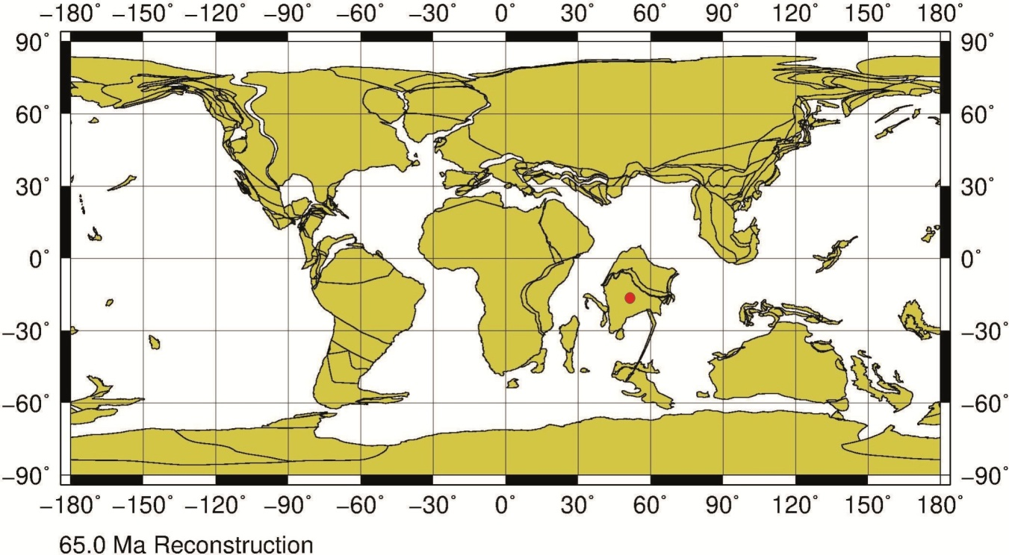
Fig. 1 Palaeogeographic map showing the area of the fossil locality (red dot) at 65 Ma (ODSN).
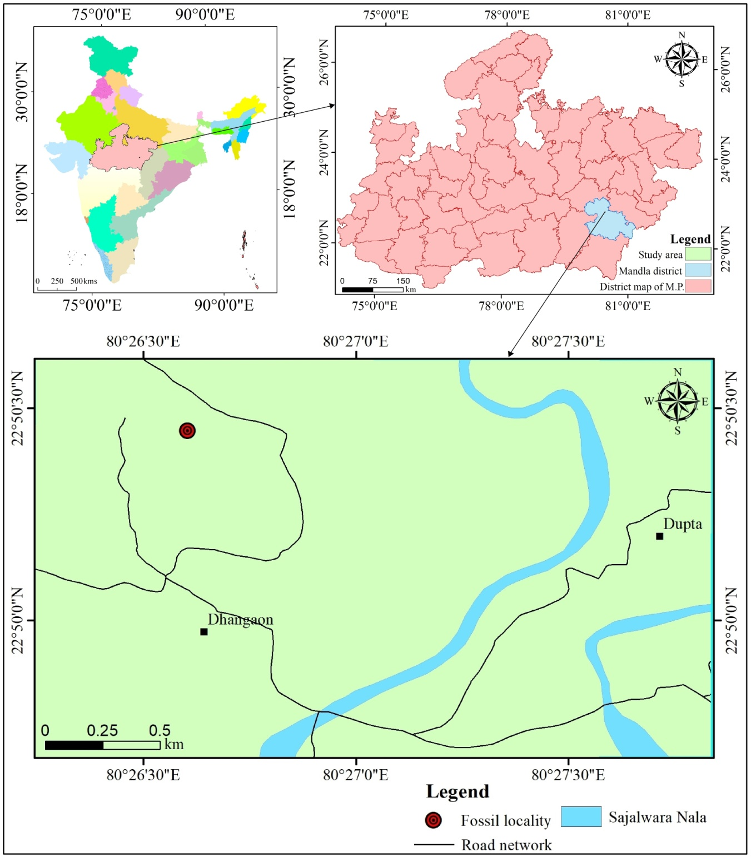
Fig.2 Geographic location of the Dhangaon Village, Madhya Pradesh.
2. Methods and Materials
The fossilized fruit is found embedded in the soft, highly weathered sediment of an intertrappean bed exposed near Dhangaon Village (Mandla District) of Madhya Pradesh, Central India (Fig.2). Low angle photography from the direction opposite to light is carried out with a Nikon digital camera at 15 mega pixels resolution. Slices from the pyrene and from the exposed endosperm are thin sectioned (30 μm) to examine the anatomical details under petrological microscope employing both bright-field transmitted and polarized light from the model no. 13524 of Censico high power microscope.
3. Geological Description
The general geological description of different basaltic lava flows around the area can be found in Solanki, (1991), Kashyap et al. (2010) and Srinivas et al., (2019). The individual basalts are almost flat and exhibit sub-horizontal to gently dipping flows. The area around Dhangaon is geologically characterized by three prominent units namely basaltic flows, Intertrappean beds and alluvium present mostly along river Narmada which serve as a cover material for traps and associated sediments. The volcanic flows are simple Aa and Pa-hoe-hoe type having thickness ranging from 10-50 m. with columnar joints well developed in many flows (Solanki, 1991). They are fine to medium grained hard compact rocks with ophitic to porphyritic texture having rounded to sub-rounded vesicles developed at the top and base whereas the middle part is massive. Some of the vesicles are empty while others are filled with secondary material like secondary quartz, zeolite, glass and calcite. Associated with these flows; are the Intertrappean beds which are found either persistently or as thin bands of impure to crystalline carbonates and claystones. The Cocos fossil described here is found in about 2-3 m thick whitish impure carbonate of Intertrappean bed around an elevation of 480m. A coarse litholog given in Fig.3 illustrates the general characters of lower and upper flow between which, the fossiliferous intertrappean bed is stratigraphically located. The lower flow is characterized by thin basal vesicular zone having empty vesicles followed by middle massive basalts with columnar joints grading to top vesicular zone. Similarly, upper flow also exhibits three zones viz. vesicular zone at the base followed by less hard and compact basalts with spheroidal weathering and uppermost vesicular zone. Most vesicles are filled with secondary materials including chert, glass, quartz and zeolites.
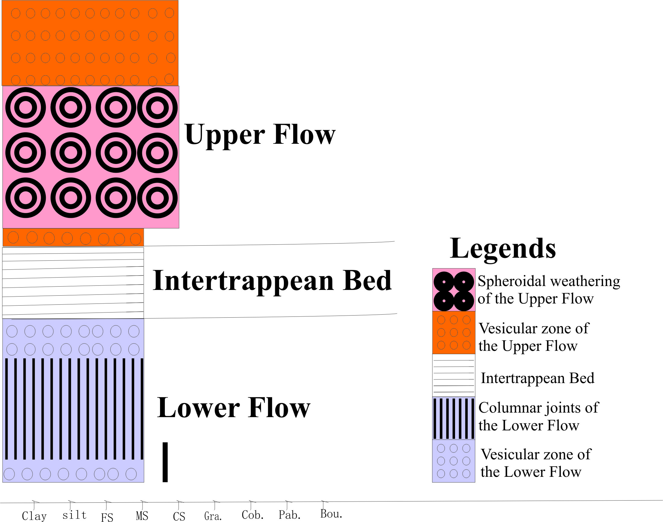
Fig. 3 General Litholog showing the fossiliferous intertrappean bed bounded by lower and upper flows respectively. Scale bar = 2.5m.
4. Systematic Palaeobotany
Class Monocotyledons (Liliopsida)
Family Arecaceae Schultz Schultzenst.
(nom. altern.)
Subfamily Arecoideae Griffith
Tribe Cocoseae Mart.
Subtribe Attaleineae Drude
Genus Cocos L.
Repository: Museum sample No. 39, Department of Geography, Government Higher Secondary School No.2, Mandla, Madhya Pradesh, India.
Locality: Dhangaon Village, Mandla District, Madhya Pradesh, Central India (Fig.2).
Age and Stratigraphy: Maastrichtian-Danian Intertrappean beds associated with flow basalts of Deccan Traps.
5. Results and Interpretation
Compressed fruit, ovoid, 103 mm long, 92 mm wide, apex acute, asymmetrically located (Fig. 4a-b); base and the whole surface covered by longitudinal fiber scars; inconspicuous ridge longitudinally oriented. The primary characters observed in the fossil fruit including the ovoid shape, the parallel, longitudinally oriented fibers, the inconspicuous longitudinal ridges, and the moderate size indicate a strong affinity to the family Arecaceae. Additionally, within Arecaceae, these characters can be related to the subtribe Attaleinae (Dransfield et al., 2005) of the Cocoseae. The palm fossil described in this work can only be compared to Cocos among the modern genera of the Attaleinae in being moderately large and having inconspicuous longitudinal ridges (Fig. 4a-b). Due to physical compaction and diagenesis related recrystallization (chemical compaction), the internal layers of the fruit pyrene are indistinguishable, and hence, it is not possible to confirm the presence of three pores in the pyrene, the specific characteristic of the tribe Cocoseae. Diagenetic modifications do not attest the complete preservation of the fruit and that there can be cases where the Cocos fruits can be found without germ pores.
Even though, there is no distinct differentiation among the internal layers, an attempt has been made to investigate the anatomy through thin sections obtained from the drupe. The histological elements observed under microscope include longitudinal thin walled (Fig.5 a-b) to brownish, thin walled cells (Fig.5c) and polygonal thick walled (Fig.5d) sclereid.

6. Affinities
The form and shape of the preserved fruit along with longitudinal ridges indicate the characters of the family Arecaceae and subtribe Attaleineae. The stratigraphic record of the related palm or Cocos is fairly maintained from many continents of Gondwanaland including Cocos nucifera from Pliocene of Australia (Rigby 1995), Mio-Pliocene of New Zealand (Berry 1926, Ballance et al. 1981), and Paleocene of South America (Gomez-Navaro et al. 2009). It is also well represented in the Indian subcontinent (Patil & Upadhye 1984, Tripathi et al. 1999, Mishra 2004, Kaul 1951, Shukla et al. 2012, Srivastava and Srivastava 2014, Singh et al. 2016). Additionally, the related morphotaxa other than Cocos including Palmocarpon cocoides (Mehrotra 1987), Palmoxylon (Cocos) sundaram (Sahni 1946, Bonde et al. 2004), are also reported from Cretaceous Intertrappean beds.

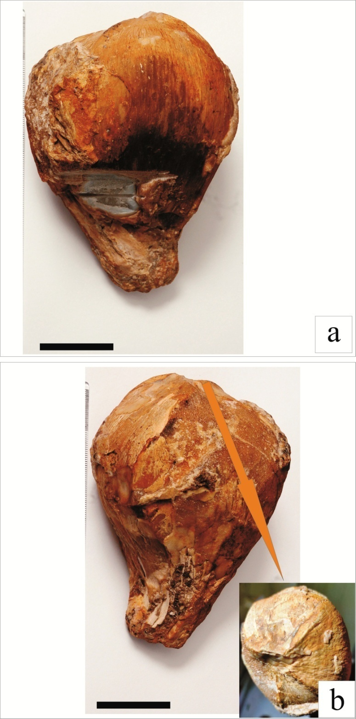
Fig.4 (a) Fossil fruit showing shape, size and part used for thin section given in Fig. 5 (a-b). (b) Fruit apex with prominent longitudinal ridges. Scale bar = 30 mm.
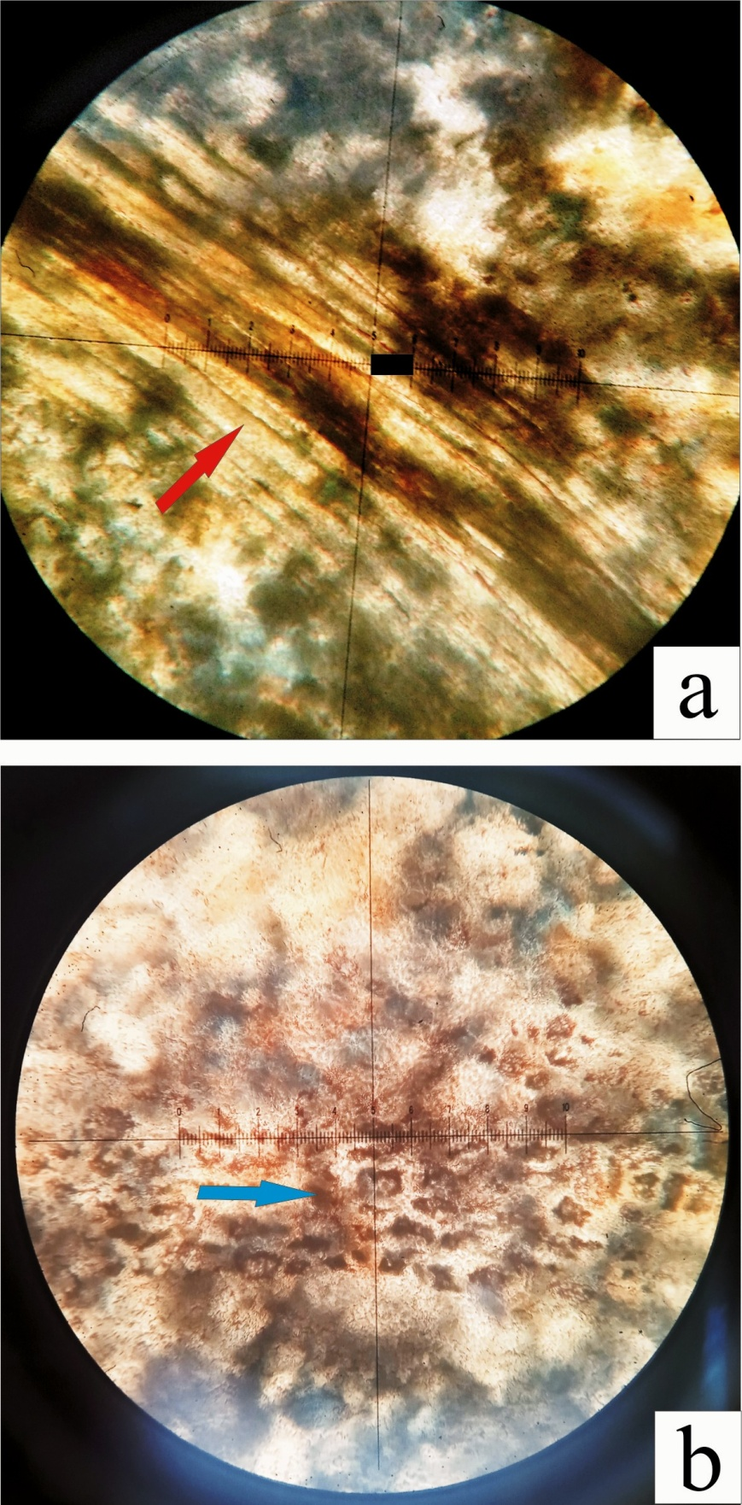
Fig.5 (a) Longitudinal sclereid cells of the pyrene, bar=25μ. (b) Brown cells of the endosperm, bar=25μ.

7. Discussion
The origin of Cocos is considered as monophyletic with commelinid affinity of the palm family with characters including the ovoid shape, the parallel, longitudinally oriented fibers, the inconspicuous longitudinal ridges (Chase et al. 2006, Davis et al. 2006). There are many views however, on its dispersal from Polynesian or Melanesian (Beccari 1963, Corner 1966, Moore 1973, Harries 1978), South American (Gomez-Navaro et al. 2009) and the Indo-Pacific region (Guppy 1906, Cook 1910, Gunn 2004). In the Indian subcontinent however, the earliest report of Cocos is from around K/Pg boundary (65.5–61.7 Ma; Gradstein et al. 2004) or Maastrictian-Danian intertrappean sedimentaries associated with Deccan volcanism. The occurrence of Cocos around K/Pg boundary also indicates a little early (earlier than 60 Ma) divergence of sub-tribes Bactridinae-Elaeidinae from Attaleinae (Dransfield et al. 2005, 2008, Govaerts & Dransfield 2005) than suggested by Gunn (2004). The tropical or pantropical distribution of Coconut Palm now and in the geological past (Reichgelt et al., 2018, Srivastava and Srivastava 2014, Couvreur et al., 2011) bears an important control on their preservation potential. The fossil palms are indicative of subtropical conditions with frost free winters (Reichgelt et al., 2018, Couvreur et al., 2011). A warm humid climate with a near coastal setting is perhaps one of the most ideal situations for the Palm family to flourish. Such a climate also favors the chemical weathering of the minerals in the host rock (Deccan basalts) like pyroxenes and feldspars. Such a condition is fairly suitable for the preservation of Palms as leaves, stems and fruits.
Fossils assigned to Cocos such as those reported by Gomez-Navaro et al. (2009), Srivastava and Srivastava (2014) and Singh et al. (2016) also lack the characteristic three germ pores.

The occurrence of Cocos along with marine algae Distichoplax and Peyssonellia (Bande et al. 1981) indicate a marine Cretaceous sea way in central India which is also supported by the mangrove and coastal fossils like Acrostichum (Bonde & Kumaran 2002), Barringtonia (Srivastava et al. 2009), Nypa (Chitaley & Nambudiri 1995), Sonneratia (Srivastava 2008). Marine incursion of Cretaceous age in central India is also documented by Lakhanpal (1970) later supported by the other works (Sahni 1983, Keller et al. 2009a, Bajpai 2009).

References
Bande M.B. and Prakash U. (1982). Palaeoclimate and palaeogeography of central India during Early Tertiary. Geophytology, 12(2), 152–165.
Bande M.B., Prakash U. and Bonde S.D. (1981). Occurrence of Peyssonnelia and Distichoplax in the Deccan Intertrappeans with remarks on the age of Chhindwara traps and palaeoecology of the region. Geophytology, 11(2): 182–188.
Bande M.B. (1992). The Palaeogene vegetation of Peninsular India (megafossil evidences). Palaeobotanist, 40, 275–284.
Bajpai S. (2009). Biotic perspective of the Deccan volcanism and India–Asia collision: Recent advances. In: Mukunda N. (ed.), Current Trends in Science – Platinum Jubilee Spec. Publ., Indian Acad. Sci., 505–516.
Ballance P.F., Gregory M.R. & Gibson G.W. (1981). Coconuts in Miocene turbidities in New Zealand: possible evidence for tsunami origin of same turbidity currents. Geology, 9, 592- 598.
Beccari O. (1963). The origin and dispersion of Cocos nucifera. Principes, 7, 57–69.
Berry E.W. (1926). Cocos and Phymatocaryon in the Pliocene of New Zealand. Am. Jour. Sci., 12, 181–184.
Bonde S.D. And Kumaran K.P.N. (2002). A permineralised species of mangrove fern Achrostichum from the Deccan Intertrappean beds of India. Rev. Palaeobot. Palynol., 120: 285–299.
Bonde S.D., Gamre P.G. & Mahabale T.S. (2004). Further contribution to Palmoxylon (Cocos) sundaram Sahni: Structure of the rooting base and its affinities: 229–235. In: Srivastava P.C. (ed.), Vistas in Palaeobotany and Plant Morphology: Evolutionary and Environmental Perspectives. Prof. D.D. Pant Commemoration Vol.
Chase M.W., Fay M.F., Devey D.S., Maurin O., Ronsted N., Davies J. & Pillon Y. (2006). Multigene analyses of monocot relationships: A summary. Aliso, 22, 63–75.
Chenet A., Courtillot V., Fluteau F., Gérard M., Quidelleur X., Khadri S.F.R., Subbarao K.V. & Thordarson T. (2009). Determination of rapid Deccan eruptions across the Cretaceous-Tertiary boundary using palaeomagnetic secular variation: 2. Constraints from analysis of eight new sections and synthesis for a 3500-m-thick composite section. J. Geophysical Res., 114, B06-103.
Chltaley, S.D. & Kate, U. R. (1974). Deccanathus savitrii, a new petrified flower from the Deccan Intertrappean beds of India. Palaeobotanist, 21 (3), 317-320.
Chitaley S. And Nambudiri E.M.V. (1995). Anatomy of Nypa fruits reviewed from new specimens from the Deccan Intertrappean flora of India. 83–94. In: Pant D.D. (ed.), Proc. Internatn. Conf. on Global Environment and Diversification of Plants through Geological Time. Allahabad.
Couvreur T.L.P., Forest F. & Baker W.J. (2011). Origin and global diversification patterns of tropical rain forests: Inferences from a complete genuslevel phylogeny of palms. BMC Biology, 9, 44.
Corner, E.J.H. (1966). The natural history of palms. London, UK: Weidenfeld and Nicholson.
Cook O.F. (1910). History of the coconut palm in America. Contributions from the U. S. National Herbarium, 14, 271–342.
Davis J.I., Petersen G., Seberg O., Stevenson D.W., Hardy C.R., Simmons M.P. Michelangeli F.A., Goldman D.H., Campbell L.M., Specht C.D. & Cohen J.I. (2006). Are mitochondrial genes useful for the analysis of monocot relationships? Taxon, 55(4), 857–870.
Dransfield J., Uhl N.W., Asmussen C.B., Baker W.J., Harley M.M. & Lewis C.E. (2005). A new phylogenetic classification of the palm family, Arecaceae. Kew Bull., 60, 559–569.
Dransfield J., Uhl N.W., Asmussen C.B., Baker W.J., Harley M.M. & Lewis C.E. (2008). Genera palmarum: The evolution and classification of palms. Royal Botanic Gardens, Kew, UK.
Gomez-Navarro C., Jaramillo C., Herrera F., Wing S.L. and Calljas R. (2009). Palms (Arecaceae) from a Palaeocene rainforest of northern Colombia. Am. J. Bot., 96, 1300–1312.
Govaerts R. & Dransfield J. (2005). World Checklist of Palms. Royal Botanic Garden, Kew, UK.
Gunell Y., Gallagher K., Carter A., Widdowson M. And Hurford A.J. (2003). Denudation history of the continental margin of western peninsular India since the early Mesozoic-reconciling apatite fission-track data with geomorphology. Earth Planet. Sci. Lett., 215: 187–201.
Guppy H.B. (1906). Observations of a Naturalist in the Pacific between 1896 and 1899. Plant dispersal, London, U.K.: Macmillan, 2.
Gunn B.F. (2004). The phylogeny of the Cocoseae (Arecaceae) with emphasis on Cocos nucifera. Ann. Missouri Bot. Gard., 91, 505–522.
Gradstein F.M., Ogg J.G. & Smith A. (2004). A Geologic Time Scale. Cambridge, UK: Cambridge University Press.
Harries H.C. (1978). The evolution, dissemination, and classification of Cocos nucifera L. Bot. Rev., 44, 265–319.
Kar R.K. & Srinivasan S. (1988). Late Cretaceous palynofossils from the Deccan Intertrappean beds of Mohgaon-Kalan, Chhindwara District, Madhya Pradesh. Geophytology, 27, 17–22.
Kashyap M, Shrivastava J P and Raju K. (2010). Occurrence of small scale inflated pahoehoe lava flows in the Mandla lobe of the Eastern Deccan Volcanic Province; Curr. Sci. 98, 72–76.
Kaul K.N. (1951). A palm fruit from Kapurdi (Jodhpur, Rajasthan Desert) Cocos sahnii sp. nov. Curr. Sci., 20, 138.
Keller G., Adatte T., Bajpai S., Mohabey D.M., Widdowson M., Khosla A., Sharma R., Khosla S.C., Getsch B., Fleitmann D. & Sahni A. (2009a). K-T transition in Deccan Traps of central India marks major marine seaway across India. Earth Planet. Sci. Lett., 282, 10–23.
Keller G., Sahni A. & Bajpai S. (2009b). Deccan Volcanism, the KT Mass Extinction and Dinosaurs. J. Biosci., 34 (5), 709–728.
Khosla A. & Sahni A. (2003). Biodiversity during the Deccan volcanic eruptive episode. J. Asian Earth Sci., 21, 895–908.
Khosla S.C. (1999). Costabuntonia, a new genus of Ostracoda from the Intertrappean beds (Paleocene) of east coast of India. Micropaleontology, 45, 319–323.
Lakhanpal R.N. (1970). Tertiary floras of India and their bearing on the historical geology of the region.
Taxon, 19(5): 675–694.
Lakhanpal, R. N. (1973). Tertiary floras of the Deccan Trap country. Proceedings of Symposium on Deccan Trap Country. Bull. Ind. nat. Sci. Acad., 45, 127-155.
Lakhanpal, R. N., Prakash, U. & Bande, M. B. (1975). An angiospermous inflorescence from the Deccan Intertrappean Series of India. Geophytology, 5(2), 229-230.
Lakhanpal, R. N., Prakash, U. & Bande, M. B. (1982). A monocotyledonous inflorescence from the Deccan Intertrappean beds of India. Palaeobotanist, 30(3), 316-324.
Lakhanpal, R. N. (1952). Nipa salmii, a palm fruit in the Tertiary of Assam. Palaeobotanist, 1, 289-294.
Mehrotra R.C. (1987). Some new palm fruits from the Deccan Intertrappean beds of Mandla District, Madhya Pradesh. Geophytology, 17, 204–208.
Mishra S.N. (2004). Cocos pantii sp. nov. The Tertiary counterpart of modern coconut fruit from Amarkantak, India. 237–239. In: Srivastava P.C. (ed.), Vistas in Palaeobotany and Plant Morphology: Evolutionary and Environmental Perspectives. U.P. Offset: India.
Moore H.E. (1973). The major groups of palms and their distribution. Gentry Herbarium, 11, 27–141.
Patil G.V. & Upadhye E.V. (1984). Cocos-like fruit from Mohgaonkalan and its significance towards the stratigraphy of Mohgaonkalan Intertrappean beds: 541–554. In: Sharma A.K., Mitra G.C., Banerjee M. (eds), Proc. Symp. Evolutionary Botany and Biostratigraphy, New Delhi: today and tomorrow’s Printers and Publishers.
Prakash, U. (1972). Palaeoenvironmental analysis of the Indian Tertiary floras. Geophytology, 2 (2), 178-205.
Reichgelt T., West C.K., & Greenwood D.R. (2018). The relation between global palm distribution and climate. Nature, 8, 11.
Rigby J.F. (1995). A fossil Cocos nucifera L. fruit from the latest Pliocene of Queensland, Australia. 379–381. In: Pant D.D., Nautiyal D.D., Bhatnagar A.N., Surange K.R., Bose M.N. and Khare P.K. (eds), Birbal Sahni Centenary Volume, South Asian Publisher: Allahabad, India.
Sahni B. (1934). The Deccan Traps: Are they Cretaceous or Tertiary? Curr. Sci., 3, 134–136.
Sahni B. (1946). A silicified Cocos-like palm stem, Palmoxylon (Cocos) sundaram, from the Deccan Intertrappean Beds. J. Indian Bot. Soc., 26, 361–374.
Sahni A. (1983). Upper Cretaceous palaeobiogeography of peninsular India and the Cretaceous-Paleocene transition: The vertebrate evidence: 128–140. In: Maheshwari H.K. (ed), Cretaceous of India. Indian Association of Palynostratigraphers. Lucknow.
Samant B. & Mohabey D.M. (2009) Palynoflora from Deccan volcano-sedimentary sequence (Cretaceous- Palaeogene transition) of central India: implications for spatio-temporal correlation. J. Biosci., 34(5), 811–823.
Solanki J.N. (1991). A report on systematic Geological Mapping of Deccan Traps and associated rocks in parts of Mandla District, Madhya Pradesh in part of toposheets no. 64b/09 and 64b/10. Geological Survey of India, CR-019853.
Srinivas K.N.S.S.S., Kishore, P.P., & Rao, D.V.S. (2019). The geological site characterisation of the Mandla region, Eastern Deccan Volcanic Province, Central India. J. Earth Syst. Sci.,128-139.
Srivastava R. (2008). Fossil woods resembling Sonneratia with fungal infection from Deccan Intertrappean sediments of Seoni District, Madhya Pradesh. Geophytology, 37: 87–92.
Srivastava R., Kapgate D.K. And Chaterjee S. (2009). Permineralised fungal remains in the fossil white horizontal longitudinal wood of Barringtonia from the Deccan Intertrappean sediments of Yavatmal District, Maharashtra, India. Palaeobotanist, 58: 11–19.
Srivastava R. (2011). Indian upper Cretaceous-Tertiary flora before collision of Indian Plate: A reappraisal of Central and Western Indian Flora. Mem. Geol. Soc. India, 77, 281–292.
Shukla A., Mehrotra R.C. & Guleria J. S. (2012). Cocos sahnii Kaul: A Cocos nucifera L.-like fruit from the Early Eocene rainforest of Rajasthan, western India. J. Biosci., 37(4), 769–776.
Srivastava R. & Srivastava G. (2014). Fossil fruit of Cocos L. (Arecaceae) from Maastrichtian-Danian sediments of central India and its phytogeographical significance. Acta Palaeobotanica, 54(1), 67–75.
Singh H., Shukla, A., & Mehrotra R. (2016). A Fossil Coconut Fruit from the Early Eocene of Gujarat. Journal of the Geological Society of India, 87, 68-70.
Sahni, B. & Rode, K. P. (1937). Fossil plants from the Intertrappean beds of Mohgaon Kalan in the Deccan with a sketch of the geology of the Chhindwara District. Proc. Natn. Acad. Sci. India, 7 (3), 165-174.
Tripathi R.P., Mishra S.N. & Sharma B.D. (1999). Cocos nucifera like petrified fruit from the Tertiary of Amarkantak, M.P., India. Palaeobotanist, 48, 251–255.

