Case report

**RECURRENT CAROTID BODY TUMOR TREATED WITH EXTERNAL BEAM RADIO THERAPY: A CASE REPORT AND LITERATURE REVIEW**

**ABSTRACT**

|  |
| --- |
| Aims Carotid body tumors (CBTs) are rare, non-chromaffin paragangliomas that typically require surgical resection. However, recurrent cases pose significant challenges. This report describes the successful management of a recurrent CBT with external beam radiotherapy (EBRT), highlighting treatment decisions and clinical outcomes. Presentation of Case A 39-year-old female presented with a recurrent swelling in the left neck three months after surgical excision of a carotid body tumor. Imaging confirmed tumor recurrence, with involvement of adjacent structures. Due to the high risk of cranial nerve injury, reoperation was deemed unsuitable, and the patient was referred for EBRT. She received 54 Gy in 27 fractions using Volumetric-Modulated Arc Therapy (VMAT). Follow-up imaging after one year showed tumor size reduction with no progressive symptoms. Discussion While surgery remains the primary treatment for CBTs, recurrent cases require alternative strategies. EBRT provides a non-invasive approach, offering local control while preserving critical neurovascular structures. Literature suggests that doses above 40 Gy significantly reduce recurrence rates. The successful application of EBRT in this case aligns with existing evidence, demonstrating its effectiveness in managing recurrent CBTs. Conclusion EBRT is a viable treatment option for recurrent CBTs, particularly in patients unsuitable for re-excision. This case underscores the importance of a multidisciplinary approach in optimizing patient outcomes. |

*Keywords: Carotid body tumor, Recurrence, External Beam Radiotherapy, Paraganglioma*

**1. INTRODUCTION**

The carotid body, which originates in the neural crest, is important in the body’s acute adaptation to fluctuating concentrations of oxygen, carbon dioxide, and pH. The carotid body protects the organs from hypoxic damage by releasing neurotransmitters that increase the ventilatory rate when stimulated(1). A family of tumors of sympathetic and parasympathetic paraganglia comprises paraganglioma(2). Carotid body tumors are uncommon neoplasms originating from neural crest-derived paraganglionic tissue at the carotid bifurcation. Though typically benign, local invasion and recurrence may occur, necessitating various treatment modalities. Surgical resection remains the primary approach; however, recurrent cases may require alternative strategies, such as External Beam Radiotherapy (EBRT).

**2. CASE PRESENTATION**

39-year-old female evaluated for swelling in the left side of neck. CECT shows a solid well defined brilliantly enhancing mass in left carotid space measuring 1.6 x 2.4 x 2.8cm, centered at left common carotid artery bifurcation causing splaying at External carotid artery – Internal carotid artery junction, partly encases proximal internal carotid artery with angle of contact approximately 270°; tumor margin smooth and all surrounding fat planes well maintained, features consistent with carotid body paraganglioma, with sub centimetric bilateral level Ib, II and V lymph nodes. Patient underwent carotid body tumor enucleation. Peroperatively, a 2 x 2 cm tumor in the bifurcation of carotid with feeding vessels from external carotid with multiple enlarged lymph nodes. Postoperative histopathology report shows a Zellballen pattern, with nests of chief cells surrounded by a rich capillary network and sustentacular cells at the periphery. No significant atypia or mitotic activity is observed, consistent with a benign paraganglioma(Figure 1).

Three months after surgery, she presented with a recurrent swelling in the left side of neck; CECT shows a well defined solid lobulated soft tissue density lesion showing vivid postcontrast peripheral enhancement with central non enhancing necrotic area in left carotid space epicentered on bifurcation of left common carotid artery and causing splaying of internal and external carotid artery with an angle of contact >270°, measuring 2.7 x 1.9 x 3.7 cm, anteriorly abutting left submandibular gland, posteriorly abutting left internal jugular vein, medially abutting left horn of hyoid bone and pharyngeal wall muscle – likely recurrent left carotid body paraganglioma. There was also medial deviation of posterior aspect of vocal cord on left side, thickening of left aryepiglottic fold with medialization and dilatation of left laryngeal ventricle and left vallecula, with features of left vocal cord paralysis. Redo surgery was deferred due to high risk of cranial nerve injury and she was referred to Radiation Oncology department. Patient was treated with External Beam Radiation Therapy. CT simulation done in supine position with immobilization using head and neck thermoplastic mask, head rest and shoulder retractor. CT taken with 2.5mm slice thickness.Gross tumor volume (GTV) delineated using CECT image fusion. Clinical Target Volume (CTV) contoured as GTV with 1cm margin. Planning Target Volume (PTV) contoured as CTV with 0.5cm margin. EBRT delivered using Volumetric-Modulated Radiotherapy (VMAT) technique with a doseof 54Gy in 27 Fractions (2Gy/ Fraction) (Figure 2). Patient was on follow up for the past two-year with no progressive symptoms. MRI done one year after EBRT shows 2.5 x 2.2 x 1.9 cm lesion in left carotid space with prominent vessel flow on T2WI, indicating reduction in size of tumor.

**3. discussion**

Carotid body tumors (CBTs) are rare, non-chromaffin paragangliomas deriving from the carotid bifurcation. While surgical resection remains the gold standard, the management of recurrent cases poses a significant challenge. This case report outlines the successful utilization of External Beam Radiotherapy (EBRT) for the treatment of a recurrent CBT. The discussion will delve into the rationale for choosing EBRT, its efficacy, and the relevant literature on the subject.

Recurrence of CBTs often demands alternative therapeutic strategies due to the complexities of reoperation and the potential for significant morbidity. EBRT emerges as a valuable non-invasive option for managing recurrent lesions while preserving critical structures in the intricate carotid region. Several factors influenced the decision to choose EBRT in this case. The recurrent nature of the tumor, the desire for an organ-preserving approach, and the need to avoid the risks associated with reoperation all favored the selection of EBRT(3). Additionally, the potential advantages of EBRT, including its ability to deliver precise doses to the target while sparing surrounding healthy tissues, were critical considerations.

The successful implementation of Volumetric-Modulated Radiotherapy (VMAT) in this case was pivotal in achieving optimal treatment outcomes. Several studies detected a recurrence rate of 22% with doses less than 40Gy, whereas recurrences occurred only in 1.4% with doses > 40 Gy(3). VMAT enables the delivery of highly conformal doses to the tumor while minimizing exposure to adjacent critical structures. Daily image guidance further ensures the accuracy of treatment delivery, reducing the risk of complications associated with irradiating nearby sensitive tissues. Radiation therapy is utilized for patients deemed unsuitable for surgical excision, either due to the extensive nature of the lesion, advanced age, or the presence of comorbid conditions.

The achievement of controlled disease following radiotherapy is defined by the stable tumor size or regression. Additionally, radiotherapy poses a challenge for subsequent head and neck surgeries due to the development of significant fibrosis(4). Although experience withradiotherapy for paragangliomas is limited, it appears beneficial for cases involving unresectable lesions, high-risk patients, and as a supplement to surgery for incompletely excised tumors or metastases(5).

Post-surgery or radiotherapy, periodic follow-up is essential for both sporadic and familial paragangliomas. The estimated malignancy rate for carotid paragangliomas falls within the range of 2 to 10%, with malignancy and multifocality being more prevalent in familial paragangliomas(6,7). The favorable outcome observed in this case, characterized by symptomatic relief and stable disease on imaging at the one-year follow-up, aligns with findings from the literature. While the long-term efficacy of EBRT for CBT recurrence warrants continued surveillance, the initial response is encouraging and supports the consideration of EBRT as a viable option in recurrent cases.

**4. Conclusion**

In conclusion, the successful management of recurrent CBT using EBRT underscores the importance of a multidisciplinary approach and the utilization of advanced radiotherapeutic techniques. The decision to employ EBRT, supported by the existing literature, showcases its potential as a valuable tool in the armamentarium for treating recurrent CBTs while minimizing morbidity and preserving critical structures.

**References**

1. Alshewered AS, Al-Rawaq KJ, Al-Naqqash MA, Al-Awadi AF. Tow Rare Cases of Carotid Body Tumour with Review of Literature in Baghdad Radiation Oncology Center, Medical City, Baghdad, Iraq. J Tumor. 2018 May 18;6(1):516–9.

2. Huan L, Jetly R, Kandil E. Paraganglioma of the Organ of Zuckerkandl. J La State Med Soc Off Organ La State Med Soc. 2012;164(1):26–30.

3. J. Al-Rawaq K, A. Al-Naqqash M, K. Al-Saad R, S. Al-Shewered A, A. Al-Saad A, Departmentof Surgery, College of Medicine, Baghdad University, Baghdad, Iraq. Carotid Body Tumor: A Review of the Literature and two CasesReports in Baghdad Radiation Oncology Center, Medical City,Baghdad, Iraq: Al-Rawaq KJ et al. Carotid body tumor: review and case report. J Tumor. 2018;6(1):516–9.

4. Dwivedi G, Bharadwaja S, Kovilapu UB, Swain P, Kumari A. Carotid Body Tumor: A Case Report and Review of Literature. Indian J Otolaryngol Head Neck Surg. 2022 Oct;74(Suppl 2):2409–16.

5. Hinerman RW, Mendenhall WM, Amdur RJ, Stringer SP, Antonelli PJ, Cassisi NJ. Definitive radiotherapy in the management of chemodectomas arising in the temporal bone, carotid body, and glomus vagale. Head Neck. 2001 May;23(5):363–71.

6. Papaspyrou K, Mann WJ, Amedee RG. Management of head and neck paragangliomas: review of 120 patients. Head Neck. 2009 Mar;31(3):381–7.

7. Farr HW. Carotid body tumors. A thirty year experience at Memorial Hospital. Am J Surg. 1967 Oct;114(4):614–9

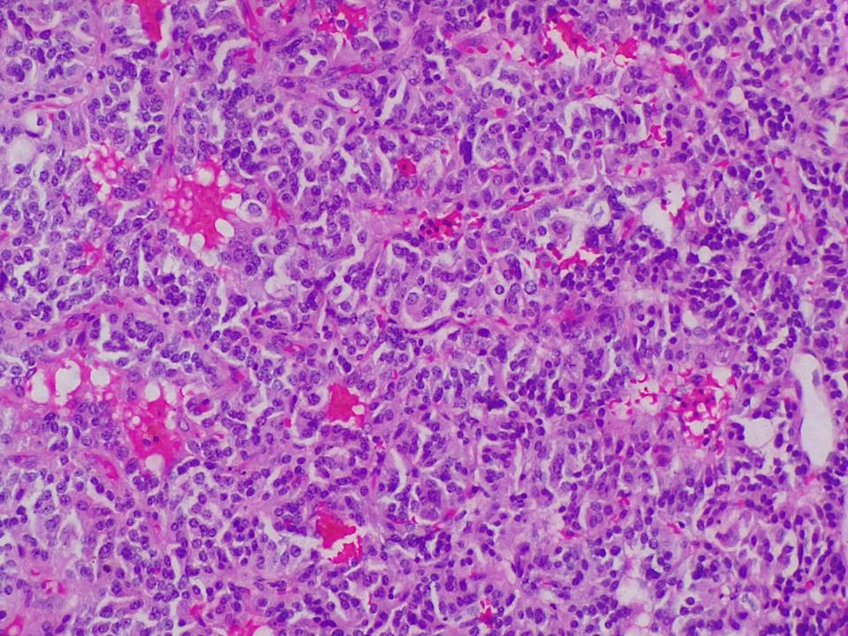

Figure 1: Histopathology of Carotid Body Tumor Showing Zellballen Pattern and Rich Vascular Stroma (H&E Stain, High Magnification)

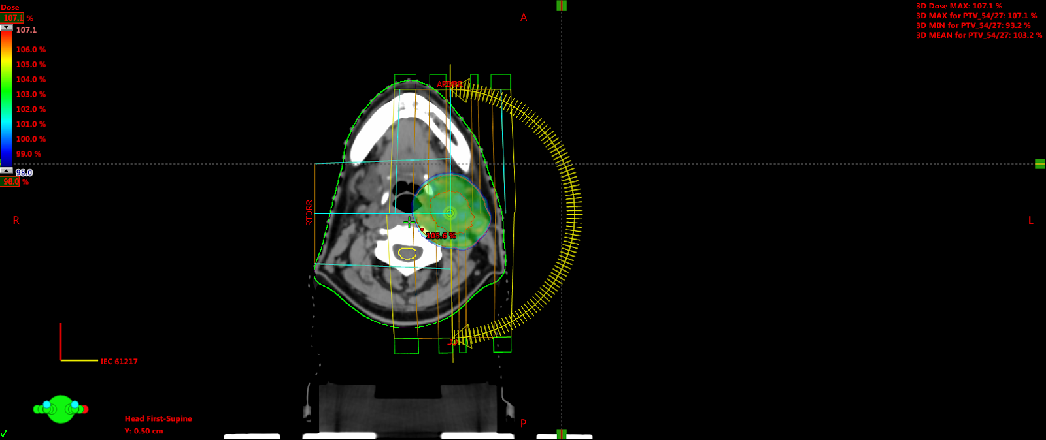

Figure 2: Volumetric Modulated Arc Therapy (VMAT) Plan for Recurrent Carotid Body Tumor: Dose Distribution and Target Coverage