**A COMPARATIVE STUDY BETWEEN CONVENTIONAL SKIN SUTURES, STAPLES AND ADHESIVE SKIN GLUE FOR SURGICAL SKIN CLOSURE**

**ABSTRACT**

Introduction:

The outcome of a surgical procedure is often defined by the resulting scar, making the choice of skin closure method crucial. It is important for the closure technique to be simple, efficient, quick, and cost-effective. Although sutures and staples remain the standard approaches, the use of surgical glue is increasingly being adopted in clinical practice. In this study, the authors assessed all three methods—sutures, staples, and glue—considering factors such as time efficiency, post-operative pain, wound-related complications, cosmetic outcomes, and overall cost-effectiveness.

Methods:

A 2-year prospective randomized controlled study was conducted on 90 healthy patients comparing tissue glue, staplers and sutures in primary wound closures following elective surgeries in the Department of General Surgery at M.K Shah Medical College and Research Centre (February 2023 To February 2025).

Result:

The patients in the three groups were analysed using chi-square, ANOVA, Fisher Exact test, and results were formulated. Staples consumed less time for application with a mean of 53.3 seconds when compared to glue (103.97 seconds) and sutures (294.97 seconds). Glue gave best results in terms of less post-operative pain. Mean VAS score calculated at 12,24,48,72 hrs was 63.13, 42.10, 16.94, and 7.27 and at 7 days was 4.73. The wound Asepsis score calculated on 3rd, 5th, and 7th day. Cosmesis score on 7th day, 1st month and 5th month was calculated using modified hollander and VAS cosmesis scale. Mean score with glue was 5.83, 88.90 and 96.13 respectively. Cost of material including length of hospital stay for glue was also effective with 3.47 days on an average. All the above proved statistical significance.

Conclusion:

Among the methods compared, staples allow for the quickest application, requiring significantly less time than both glue and sutures. However, skin glue outperforms the others in terms of reduced post-operative pain, improved wound cleanliness, superior cosmetic results, and better cost-efficiency. Overall, tissue glue emerges as a safe, appealing, and effective alternative to traditional wound closure techniques used in elective surgeries.

Keywords: Modified hollander scale, Octyl-2-cyanoacrylate, Staplers, Sutures, Tissue glue, VAS, Wound closure.

**INTRODUCTION**

The defining feature of a surgeon's work is often the scar left behind. As such, the technique chosen for skin closure must be straightforward, effective, rapid, and economical. Although sutures and staples remain the conventional methods, the use of surgical adhesives is becoming more widely adopted in clinical practice. This study compares these three techniques—sutures, staples, and adhesive glue—considering factors such as time efficiency, post-operative discomfort, wound complications, aesthetic results, and overall cost-effectiveness. The approach to wound closure has evolved alongside human progress, with numerous advancements and innovations in wound management and closure techniques over time. Closing of wounds to achieve an aesthetically pleasing scar has always been a challenge. The ideal surgical wound would be as strong as normal tissue, the moment it is closed. Douglas and Forester reported that, even with a one-year follow-up, the maximum tensile strength that can be regained in the tissue following closure is approximately 80% [1].

The primary objective of surgical wound closure is to align skin flaps in a manner that supports rapid healing, reduces complications, and ensures a satisfactory cosmetic appearance. Surgical site infection (SSI) is among the most prevalent complications following surgery, which occurs in approximately 1% to 3% of cases. Several factors contribute to an increased risk of infection, including older age, underlying health conditions such as diabetes, malnutrition, a high American Society of Anaesthesiologists (ASA) score (≥3), low serum albumin levels, prior radiotherapy, corticosteroid use, obesity, immune system compromise, smoking, and the wound’s location and contamination level [2].

Additional risk factors for surgical wound complications are associated with the nature and complexity of the procedure itself, the duration of surgery, and the surgical technique employed—whether open (laparotomic), minimally invasive (laparoscopic), or robotic-assisted [3,4]. Wound dehiscence represents another potential complication, which can result in prolonged hospitalizations, higher healthcare expenses, and an associated mortality rate of 9.6% [5]. Other postoperative issues include the development of hypertrophic or keloid scars. The cosmetic outcome of wound healing is an important consideration, as it significantly influences patient satisfaction. To achieve optimal results, careful surgical technique is essential to prevent local swelling, wound separation, and aesthetically poor scarring. The choice of wound closure method and material depends greatly on factors such as the type of surgery, the length of the incision, and its anatomical location.

Surgical wound closure is most commonly performed using sutures, which may be applied in either a continuous or interrupted fashion. The choice of suture material can differ based on the wound’s size and anatomical location, with options including natural or synthetic, absorbable or non-absorbable, and monofilament or braided sutures. Sutures are favoured for their strength, flexibility, biocompatibility, and ability to degrade within the body. Staples, primarily made of stainless steel (though absorbable options now exist), offer an effective alternative to suturing [6]. While sutures remain the most widely used method, they may elevate the risk of wound infection by compromising blood flow to the wound edges, potentially leading to ischemia and impaired healing. Staples, on the other hand, tend to provoke less tissue reaction, which may contribute to improved wound outcomes.

Staple use in contaminated wounds may offer greater resistance to infection, as it avoids the introduction of foreign material that could compromise the local immune response [7-11]. Additionally, staples are believed to reduce local inflammation, minimize wound width, shorten closure time, and lessen the appearance of cross-hatch marks [12,13]. While sutures remain the conventional choice for skin closure, staples appear to offer advantages in terms of fixation strength, improved cosmetic outcomes, and quicker application. However, existing literature does not clearly establish whether sutures or staples are superior overall. Some randomized controlled trials (RCTs) have shown no significant differences between the two methods regarding wound infection rates [14,15], while others have reported increased wound-related complications associated with staples [16,17]. Although evidence is beginning to accumulate across various surgical specialties, findings are often inconclusive due to limitations such as small sample sizes and low-quality data. Therefore, it is essential for clinicians to evaluate wound closure methods within the broader context of surgical disciplines. A systematic review of randomized controlled trials (RCTs) is needed to compare sutures and staples in relation to infection rates, length of hospital stay, readmissions, adverse effects, pain levels, and patient satisfaction with cosmetic outcomes. Such a review would assist surgeons in determining the most suitable closure technique for various procedures.

**Aim and Objectives:**

The purpose of this study is to evaluate and compare the efficacy of three dissimilar skin closure techniques—traditional suturing, staples, and adhesive glue—based on the following criteria:

* To assess and compare the time efficiency of each closure method.
* To evaluate the cost associated with each technique.
* To analyse the cosmetic outcome of the skin following closure using each method.
* To equate surgeon preferences and patients’ satisfaction across the three techniques.
* To examine post-operative pain levels and identify complications, if any, linked to each method of skin closure.

**MATERIAL AND METHODS**

This prospective comparative study was conducted on 90 patients, with 30 patients allocated to each of the three groups. All patients were admitted to the Department of General Surgery at Dr. M.K. Shah Medical College and Research Centre, located in Chandkheda, Ahmedabad, and the study was carried out from February 2023 to February 2025. Patients selected were in good overall health and undergoing one of the following elective procedures: open/laparoscopic inguinal hernioplasty, open/laparoscopic appendectomy, lipoma excision, laparoscopic cholecystectomy.

After performing subcutaneous approximation to eliminate dead space and align the wound edges, patients were randomly assigned to one of three groups. In Group A, the incisions were closed using skin adhesive (octyl-2-cyanoacrylate), which was applied with a ProPen device. A thin layer of adhesive was spread along the entire length of the wound, extending 5–10 mm beyond each edge. The adhesive was allowed to dry for 15–20 seconds before applying two additional layers. No further bandaging was applied.

In Group B, non-absorbable skin staples were used to close the incisions, applied in a single layer while the wound edges were held together using forceps.

In Group C, non-absorbable nylon sutures (Ethilon) were employed to close the incisions in a vertical mattress technique.

Before surgery, a detailed patient history and comprehensive physical examination were conducted. Routine blood tests were performed, including a complete hemogram, bleeding time (BT), clotting time (CT), HIV test, HBsAg test, blood sugar, blood urea, and serum creatinine levels, with additional tests done as necessary. A uniform antibiotic regimen was followed for all patients, with a 1 gm dose of intravenous ceftriaxone administered at the time of anaesthesia induction.

For all three groups, the time required to close the incised wound using the designated method was recorded with a stopwatch and compared across the groups. Post-operative pain was assessed at 12, 24, and 48 hours, 72 hours, and on the 7th day using the Visual Analog Scale (VAS), where 0 indicated no pain and 100 represented the worst possible pain, as reported by the patients. Wound outcomes were evaluated on the 3rd, 5th, and 7th post-operative days (POD) using a standardized wound asepsis scoring system ranging from 0 to 10 (Table 1).

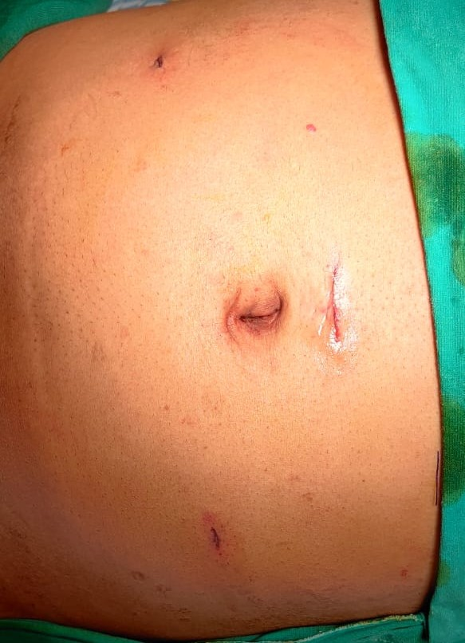

**Figure 1: Skin closure with glue in laparoscopic hernioplasty**

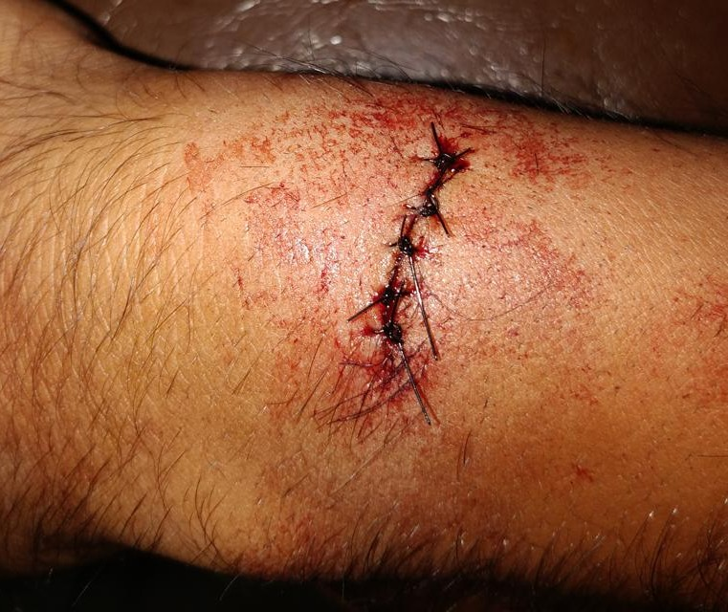

**Figure 2: Skin closure with sutures in lipoma excision**

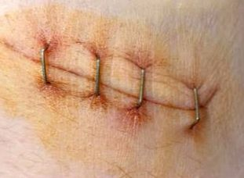

**Figure 3: Skin closure with stapler in laparoscopic cholecystectomy**

**Table 1: ASEPSIS score [18,19]**

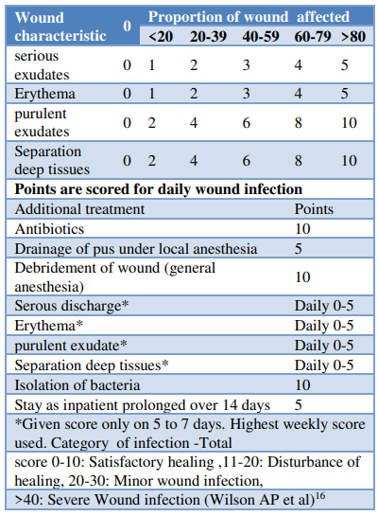

Wound cosmesis was assessed on the 7th post-operative day (POD) using the modified Hollander cosmesis scale, which ranges from 1 to 6. A score of 6 indicated optimal cosmesis, while a score of 5 or below was considered suboptimal. During follow-up visits at the 1st and 3rd months, wound cosmesis was re-evaluated by an independent, blinded observer using the Visual Analog Cosmesis Scale (VAS), where 0 represented the worst cosmetic outcome and 100 represented the best possible cosmesis. The following parameters were also assessed during evaluation:

* Step-off of the wound borders (0 for yes, 1 for no)
* Contour irregularities such as puckering (0 for yes, 1 for no)
* Wound margin separation (0 for yes, 1 for no)
* Wound edge inversion (0 for yes, 1 for no)
* Excessive wound distortion (0 for yes, 1 for no)
* Overall appearance (0 for poor, 1 for acceptable)

**Inclusion Criteria**

Patients undergoing clean, elective surgical procedures with skin closure performed using conventional suturing, staples, or adhesive skin glue, all following the same antibiotic protocol, between February 2023 and February 2025.

**Exclusion Criteria**

* Critical cases requiring damage control surgery.
* Cases where stomas are necessary.
* Patients unable to attend follow-up appointments on the 7th or 15th post-operative days.
* Wounds located on the face, bony prominences, or highly mobile areas that are unsuitable for stapler closure.
* Wounds located at mucocutaneous junctions (e.g., lips) or on friction-prone areas such as hands and feet, where adhesive glue would be inappropriate.
* Patients with a history of diabetes mellitus (DM), immunosuppression, malignancy, or a tendency for keloid or scar formation.

**Statistical Analysis**

Both descriptive and inferential statistical methods were employed for analysis in this study. Continuous data are presented as Mean ± SD (Min-Max), whereas categorical data are expressed as number (%). A significance level of 5% was used to determine statistical significance. The following assumptions were made regarding the data:

* The dependent variables should follow a normal distribution.
* The samples should be randomly drawn from the population, and the cases within the samples should be independent.

Analysis of Variance (ANOVA) was used to assess the significance of study parameters among three or more patient groups. To evaluate the significance of categorical data across two or more groups, the Chi-square or Fisher Exact test was applied. Non-parametric methods were employed for qualitative data analysis, with Fisher's exact test used when the sample size in cells was particularly small.

**P-Value Significance Levels:** +Suggestive significance (P value: 0.05 < P < 0.10); ++moderately significant (P value: 0.01 < P ≤ 0.05); +++strongly significant (P value: P ≤ 0.01)

The data analysis was conducted using SPSS version 18.0 and R version 3.2.2. Graphs, tables, and other visual representations were created using Microsoft Word and Excel.

**RESULTS**  
A total of 90 patients were enrolled in the study, with 30 patients randomly assigned to each group: suturing, stapling, and skin glue. The mean age of participants was 41.78 years, with 20% of patients falling within the 31–50-year age range. The mean age for the skin glue group was 41.10 years ± 19.85, for the skin staple group was 44.25 years ± 17.90, and for the suturing group was 39.00 years ± 18.30. The male population predominated, comprising 66 patients (73.3%) overall (Table 2).

The study included patients who underwent four types of surgeries: laparoscopic appendectomy, lipoma excision, laparoscopic cholecystectomy, and hernioplasty. The authors ensured an equal distribution of patients across the groups for each surgery, in order to obtain unbiased outcomes and to compare variables consistently. The following graph demonstrates the even distribution of patients across the different surgical procedures performed in each group.

In this study, the lengths of the incisions varied from 1 to 4 cm. The time taken to close the wounds was measured in seconds using a stopwatch. The results revealed that 73.3% (22 patients) in the staple group completed the wound closure in under 60 seconds. In contrast, 96.7% (29 patients) in the glue group required 60-200 seconds. The suturing group, however, had the longest closure times, with more than 200 seconds needed for most cases.

The Visual Analogue Scale (VAS), calibrated from 0 to 100 (Table 3), was used to assess pain scores at 12, 24, 48, 72 hours, and on the 7th day post-operatively. The results showed that at 12 hours post-operatively, the pain score was lowest in the glue group (mean = 64.50). Similarly, at 24 hours post-operatively, the glue group again reported the least pain (mean = 43.60), and at 48 hours, the glue group continued to have the lowest pain score (mean = 17.50). 72 hours post operatively again glue scored the least among the three population.

This finding is statistically significant, with a p-value of <0.001, strongly supporting that the use of glue results in the least amount of pain when compared to staples and sutures. Among the 90 patients, 12 experienced serous exudates at the wound site as a complication of the skin closure method. The incidence of erythema was lowest in the glue group, followed by the staples group, and then the sutures group. Purulent exudates were observed in all three groups.

The ASEPSIS score (Table 4), calculated using the parameters outlined in the methodology, indicated that a lower score represented better wound outcomes. The score was recorded on days 3, 5, and 7 post-operatively. The glue group demonstrated the lowest ASEPSIS scores on both days 3 and 5, with statistical significance observed on day 3 and suggestive significance on day 5. However, no statistical significance was found on day 7, although the glue group still had the best asepsis scores when compared across all groups.

Wounds in all three groups were evaluated for cosmesis on the 7th day using the Modified Hollander Cosmesis Scale (Table 5), and again at the 1st and 5th months using the Visual Analog Scale (VAS) for cosmesis. In terms of material costs, sutures were found to be the most cost-effective method among the three skin closure techniques. Cost-effectiveness was further assessed by comparing the total post-operative hospital stay. The results revealed that patients in the glue group had the shortest hospital stays, followed by those in the staples group, and finally the sutures group. The comparison between the groups showed a statistically significant difference with a p-value of 0.006, confirming strong significance.

**Table 2: Details of the surgeries performed**

|  |  |  |  |  |
| --- | --- | --- | --- | --- |
| **Variable** | **Glue** | **Staples** | **Sutures** | **Total** |
| Age (mean + SD) | 42.10 ± 19.85 | 44.25 ± 17.90 | 39.00 ± 18.30 | 41.78 ± 18.68 |
| Female | 9 (30%) | 7 (23.3%) | 8 (26.7%) | 24 (26.7%) |
| Male | 21 (70%) | 23 (76.7%) | 22 (73.3%) | 66 (73.3%) |
| Surgical procedure |  |  |  |  |
| Lap appendicectomy | 8 (26.7%) | 6 (20%) | 7 (23.3%) | 21 (23.3%) |
| Lap cholecystectomy | 4 (13.3%) | 4 (13.3%) | 4 (13.3%) | 12 (13.3%) |
| Lap hernioplasty | 14 (46.7%) | 16 (53.3%) | 15 (50%) | 45 (50%) |
| Lipoma excision | 4 (13.3%) | 4 (13.3%) | 4 (13.3%) | 12 (13.3%) |
| Incision length (cms) (mean +SD) | 6.60 ± 1.20 | 6.35 ± 1.40 | 6.50 ± 1.45 | 6.48 ± 1.35 |
| Time taken for wound closure (mean + SD) | 106.50 ± 16.00 | 55.10 ± 9.20 | 289.80 ± 45.00 | 150.47 ±107.20 |
| Complications |  |  |  |  |
| Serous exudate | 2 (6.7%) | 4 (13.3%) | 6 (20%) | 12 (13.3%) |
| Erythema | 1 (3.3%) | 3 (10%) | 11 (36.7%) | 15 (16.7%) |
| Purulent exudates | 0 (0%) | 1 (3.3%) | 2 (6.7%) | 3 (3.3%) |
| Wound gaping | 1 (3.3%) | 2 (6.7%) | 2 (6.7%) | 5 (5.6%) |
| Length of hospital stay | 3.40 ± 1.00 | 6.05 ± 4.30 | 6.75 ± 5.10 | 5.40 ± 4.13 |

**Table 3: Post-operative pain in three groups of patients**

|  |  |  |  |  |  |
| --- | --- | --- | --- | --- | --- |
| **Post-operative pain** | **Glue** | **Staples** | **Sutures** | **Total** | **P value** |
| 12 hrs | 64.50 ± 17.20 | 71.90 ± 13.70 | 80.40 ± 11.10 | 72.27 ± 15.33 | <0.001** |
| 24 hrs | 43.60 ± 11.90 | 47.30 ± 13.00 | 60.20 ± 11.50 | 50.37 ± 14.13 | <0.001* |
| 48 hrs | 17.50 ± 9.00 | 25.60 ± 8.40 | 34.70 ± 12.10 | 25.93 ± 12.34 | <0.001** |
| 72hrs | 7.90 ± 5.30 | 12.30 ± 7.80 | 17.60 ± 11.00 | 12.60 ± 9.37 | <0.001** |
| 7 days | 4.90 ± 5.20 | 9.10 ± 14.30 | 10.80 ± 14.50 | 8.27 ± 12.35 | 0.127 |

**Table 4: ASEPSIS score distribution in three groups of patients**

|  |  |  |  |  |  |
| --- | --- | --- | --- | --- | --- |
| **Asepsis score** | **Glue (n=30)** | **Staples (n=30)** | **Sutures (n=30)** | **Total (n=90)** | **P value** |
| Day 3 | | | | | |
| 0 | 25 (83.3%) | 22 (73.3%) | 17 (56.7%) | 64 (71.1%) | 0.021 |
| 1-10 | 5 (16.7%) | 8 (26.7%) | 13 (43.3%) | 26 (28.9%) |
| 11-20 | 0 (0%) | 0 (0%) | 0 (0%) | 0 (0%) |
| >20 | 0 (0%) | 0 (0%) | 0 (0%) | 0 (0%) |
| Mean ±SD | 0.63 ± 1.57 | 1.10 ± 2.15 | 1.60 ± 1.95 | 1.11 ± 1.93 |
| Day 5 | | | | | |
| 0 | 28 (93.3%) | 27 (90%) | 24 (80%) | 79 (87.8%) | 0.090 |
| 1-10 | 2 (6.7%) | 3 (10%) | 6 (20%) | 11 (12.2%) |
| 11-20 | 0 (0%) | 0 (0%) | 0 (0%) | 0 (0%) |
| >20 | 0 (0%) | 0 (0%) | 0 (0%) | 0 (0%) |
| Mean ±SD | 0.30 ± 1.50 | 0.67 ± 2.01 | 0.92 ± 1.65 | 0.63 ± 1.72 |
| Day 7 | | | | | |
| 0 | 29 (96.7%) | 28 (93.3%) | 27 (90%) | |  | | --- | | 84 (93.3%) | | 0.999 |
| 1-10 | 1 (3.3%) | 1 (3.3%) | 2 (6.7%) | 4 (4.4%) |
| 11-20 | 0 (0%) | 0 (0%) | 0 (0%) | 0 (0%) |
| >20 | 0 (0%) | 1 (3.3%) | 1 (3.3%) | 2 (2.2%) |
| Mean ±SD | 0.15 ± 0.75 | 0.95 ± 4.80 | 1.25 ± 5.70 | 0.78 ± 4.35 |
|  | | | | | |

**Table 5: Cosmesis Score distribution in three groups of patients**

|  |  |  |  |  |  |
| --- | --- | --- | --- | --- | --- |
| **Cosmesis** | **Glue (n=30)** | **Staples (n=30)** | **Sutures (n=30)** | **Total (n=90)** | **P value** |
| 7th day | | | | | |
| 0 | 0 (0%) | 1 (3.3%) | 2 (6.7%) | 3 (3.3%) | 0.762 |
| 1-3 | 0 (0%) | 0 (0%) | 0 (0%) | 0 (0%) |
| 4-6 | 30 (100%) | 29 (96.7%) | 28 (93.3%) | 87 (96.7%) |
| Mean ±SD | 5.80 ± 0.50 | 5.32 ± 1.12 | 5.10 ± 1.25 | 5.41 ± 1.04 |
| 1st month | | | | | |
| 0-20 | 0 (0%) | 0 (0%) | 0 (0%) | 0 (0%) | <0.001 |
| 21-40 | 0 (0%) | 1 (3.3%) | 0 (0%) | 1 (1.1%) |
| 41-60 | 0 (0%) | 2 (6.7%) | 4 (13.3%) | 6 (6.7%) |
| 61-80 | 2 (6.7%) | 13 (43.3%) | 17 (56.7%) | 32 (35.6%) |
| 81-100 | 28 (93.3%) | 14 (46.7%) | 9 (30%) | 51 (56.7%) |
| Mean ±SD | 88.67 ± 6.10 | 78.80 ± 13.50 | 71.30 ± 13.20 | 79.59 ± 13.20 |
| 5th month | | | | | |
| 0-20 | 0 (0%) | 0 (0%) | 0 (0%) | 0 (0%) | 0.061 |
| 1-40 | 0 (0%) | 0 (0%) | 0 (0%) | 0 (0%) |
| 41-60 | 0 (0%) | 1 (3.3%) | 3 (10%) | 4 (4.4%) |
| 61-80 | 0 (0%) | 2 (6.7%) | 4 (13.3%) | 6 (6.7%) |
| 81-100 | 30 (100%) | 27 (90%) | 23 (76.7%) | 80 (88.9%) |
| Mean ±SD | 96.03 ± 3.40 | 92.20 ± 8.85 | 88.67 ± 11.60 | |  | | --- | | 92.30 ± 9.00 | |

**DISCUSSION**

In the present study, three distinct methods of skin closure were evaluated: conventional suturing and two suture-less alternatives, namely skin staples and tissue adhesive (glue).

**Age**  
The majority of participants were in the 31–50 years age group. The mean age of patients in the glue group was 41.78 years, in the staples group was 44.25 years, and in the suturing group was 39.00 years. However, the influence of age in correlation with the type of surgical procedure and underlying disease was not analysed, which may pose a confounding factor in the assessment of wound healing outcomes.

**Gender**  
The study population had a predominance of male participants, accounting for 73.3%, while females made up 26.7% of the total sample.

**Incision Length**

The wounds closed in this study ranged from 0 to 4 cm in length, limiting the use of tissue adhesive to small sized incisions. This aligns with previously reported limitations of cyanoacrylate-based adhesives such as Dermabond, which are generally not suitable for closing long surgical wounds. Previous researchers have assessed these adhesives in specific contexts—for instance, Adoni et al. used tissue adhesives for episiotomy repair [20], while Samuel PR et al. and Maw JL et al. evaluated their effectiveness in head and neck surgical incisions [21,22]. Furthermore, Simon HK et al. demonstrated that cyanoacrylates are preferable for lacerations that run perpendicular to Langer’s lines [23]. Notably, none of these studies applied the adhesive to extensive skin wounds, emphasizing its limited utility in such scenarios.

**Time Taken for Skin Closure**

Ridgway et al. [24] reported that, in neck surgeries involving cervicotomy incisions, the meantime taken for closure with tissue adhesive was significantly greater than with skin staples, with a difference of approximately 67 seconds. Similarly, in a study on patients undergoing total hip or knee replacement, the average skin closure time using adhesive was 100 seconds, whereas staple closure took about 30 seconds [25]. However, Chibbaro et al. reported no statistically significant difference in closure time between adhesives and staples for neurosurgical scalp incisions [26].

In the present study, the duration of wound closure was significantly shorter in the staple group compared to the glue and sutures groups. This difference was statistically significant, underscoring the efficiency of staples in reducing operative time.

**Post-Operative Pain**

Post-operative pain levels were evaluated using the Visual Analogue Scale (VAS), as reported by the patients. Findings from the current study indicated that patients in the glue group experienced the least pain, followed by those in the staple group, and finally the suture group, across multiple postoperative intervals.

These findings are consistent with studies by Gaertner et al. and Singh et al., which showed that abdominal wounds closed with sutures were linked to higher post-operative pain levels [27,28]. Additionally, while Zempsky et al. and Arunachalam et al. reported reduced pain with adhesive use, their studies did not achieve statistical significance [29,30]. In contrast, the present study revealed a statistically significant reduction in pain with glue closures, further supporting its potential advantages in pain management.

**Complications / ASEPSIS Score**

This study observed several wound-related complications across all groups, including serous discharge, purulent discharge, erythema, and wound dehiscence. Of these, only erythema showed statistically significant differences among the groups, with the glue group presenting the lowest incidence compared to staples and sutures.

Khan et al. and Chibbaro et al. previously reported no significant difference in serous fluid accumulation between closure methods [25,26]. However, cases involving skin staples were more prone to wound gaping than those closed with glue. Meta-analyses from four notable trials indicated that suture closure was associated with a significantly lower rate of wound dehiscence when compared to other methods, without heterogeneity among studies. Conversely, Blondeel et al. [31], in a series of 209 patients closed using octyl-2-cyanoacrylate, concluded that this newer formulation offers closure results comparable to standard methods, with a tendency toward reduced wound infections.

In alignment with these findings, the present study demonstrated a significantly lower ASEPSIS score in the glue group, suggesting a lower rate of wound infection. A strong statistical significance was evident on post-operative day 3, while day 5 showed suggestive significance.

**Wound Cosmesis**

The cosmetic outcomes of wounds were assessed in all three study groups on postoperative day 7, at 1 month, and at 3 months using both the Modified Hollander and VAS Cosmesis scales. While the mean cosmesis scores on day 7 slightly favoured the glue group, the difference was not statistically significant. By the 1-month follow-up, the score differences between groups widened noticeably, with glue showing superior cosmetic results, which was statistically significant. At 3 months, the scores among the groups narrowed slightly, with glue scoring 96.03, staples 92.20, and sutures 88.67, demonstrating a trend toward statistical significance.

Keng et al.[32] reported similar findings in a randomized trial involving groin incisions, where cosmetic outcomes significantly favoured adhesive closures over subcuticular sutures (mean score 4.71 vs. 4.00 at 4 weeks, *p* < 0.05) (24). This aligns with the current study’s conclusion that glue yields better cosmetic outcomes than staples or sutures, supported by strong statistical evidence.

**Cost-Effectiveness**

Analysis of material costs revealed that conventional sutures were the most economical option for skin closure. However, when polyglactin sutures were used for subcuticular closure, the cost increased. In contrast, the glue group showed a significantly shorter hospital stay, contributing to better overall cost-efficiency, and this difference was statistically significant.

Jones et al. [33]evaluated cost-effectiveness and found that skin adhesives were significantly more economical (20.3 Euros) than sutures (29.3 Euros), with a *p* value < 0.001, despite similar clinical outcomes between methods. Additionally, a study conducted in Texas, USA, compared cyanoacrylate glue to Monocryl/Vicryl sutures for laparoscopic wound closure and reported an average cost saving of $303 per patient in the adhesive group, attributed to reduced surgical time [34]. These findings are consistent with our study, which demonstrated that skin glue offers greater cost-effectiveness compared to staples or sutures, with robust statistical significance.

**Conclusion**

This prospective comparative study evaluating adhesive skin glue, staples, and sutures for wound closure suggests that skin glue offers several advantages. Patients in the glue group experienced reduced postoperative pain, fewer wound-related complications, shorter hospital stays, and better cosmetic outcomes. Although the application time for glue was longer compared to staples and it incurred slightly higher costs than sutures, the overall benefits of skin glue are considerable.

Moreover, due to its bacteriostatic properties and the absence of a need for removal postoperatively, adhesive skin glue appears to be a favourable option for achieving optimal wound closure.

**Ethical Approval:** Approved by the Institutional Ethics Committee.

**REFERENCES**

1. Douglas DM, Forrester JC, Ogilvie RR. Physical characteristics of collagen in the later stages of wound healing. Br J Surg. 1969;56(3):219–22.
2. Mangram AJ, Horan TC, Pearson ML, Silver LC, Jarvis WR. Guideline for prevention of surgical site infection, 1999. Infect Control Hosp Epidemiol. 1999;20(4):250–78.
3. Korol E, Johnston K, Waser N, Sifakis F, Jafri HS, Lo M, et al. A systematic review of risk factors associated with surgical site infections among surgical patients. PLoS One. 2013;8(12):e83743.
4. de Lissovoy G, Fraeman K, Hutchins V, Murphy D, Song D, Vaughn BB. Surgical site infection: Incidence and impact on hospital utilization and treatment costs. Am J Infect Control. 2009;37(5):387–97.
5. van Ramshorst GH, Nieuwenhuizen J, Hop WC, Arends P, Twisk JW, Lange JF. Abdominal wound dehiscence in adults: Development and validation of a risk model. World J Surg. 2010;34(1):20–7.
6. Smith TO, Sexton D, Mann C, Donell ST. A systematic review of the use of skin adhesives in surgical incisions. Int J Surg. 2010;8(6):418–23.
7. Watson DP. Use of cyanoacrylate tissue adhesive for closing facial lacerations in children. BMJ. 1989;299(6706):1014.
8. Krishnan S, MacNeill AL, Wallace T, Chapman T. Wound closure techniques and surgical site infection: A systematic review. J Surg Res. 2017;210:212–20.
9. Sharma A, Sharp DM, Walker LG, Monson JR. Wound infection after abdominal surgery: The effect of clippers versus razors for pre-operative hair removal. Anaesthesia. 2000;55(9):923–8.
10. Smith TO, Sexton D, Mann C, Donell ST. A systematic review on the use of staples for skin closure in orthopaedic surgery. Bone Joint Res. 2010;8(6):418–23.
11. Wille-Jørgensen P, Guenaga KF, Matos D, Castro AA. Pre-operative mechanical bowel cleansing or not? An updated meta-analysis. Colorectal Dis. 2005;7(4):304–10.
12. Broome AM, Stringer MD. Skin closure techniques and wound healing in paediatric surgery: A randomized trial. J Pediatr Surg. 2012;47(5):857–62.
13. Kanegaye JT, Vance CW, Chan L. Comparison of skin stapling devices and standard suturing techniques in pediatric scalp lacerations. Am J Emerg Med. 1997;15(6):514–7.
14. Khan RJ, Fick D, Yao F, Rowe PJ, Love BR. A comparison of three methods of wound closure following arthroplasty: A prospective, randomised, controlled trial. J Bone Joint Surg Br. 2006;88(2):238–42.
15. Shetty AA, Kumar VS, Morgan-Hough C, Georgeu GA, Hegab H, McEachan JE. Comparative analysis of skin closure following hip surgery: Staples vs. sutures. Int Orthop. 2004;28(6):362–5.
16. Singh B, Murtaza B, Mahmood F, Khan B, Hayat U. Staples versus sutures for skin closure in orthopedic surgery: A meta-analysis of randomized controlled trials. World J Orthop. 2017;8(2):144–53.
17. Basha SI, Rochon M, Abdulla A, Lin Y, Chen M, Warman ML. Staples vs sutures for skin closure after orthopaedic surgery: A meta-analysis of randomized controlled trials. Am J Orthop (Belle Mead NJ). 2010;39(9):E93–7.
18. Khan RJ, Fick D, Yao F, Tang K, Hurworth M, Nivbrant B, et al. A comparison of three methods of wound closure following arthroplasty: a prospective, randomised, controlled trial. J Bone Joint Surg Br. 2006;88(2):238–42.
19. Chibbaro S, Tacconi L. Use of skin glue versus traditional wound closure methods in brain surgery: a prospective, randomized, controlled study. J Clin Neurosci. 2009;16(4):535–9.
20. Adoni A, Anteby EY. Randomized comparison of skin closure after episiotomy: sutures versus adhesive glue. Am J Obstet Gynecol. 1991;165(5 Pt 1):1314–6.
21. Samuel PR, Reddy VM, McGurk M. The use of tissue adhesive as an alternative to sutures in the closure of scalp wounds. Ann R Coll Surg Engl. 1997;79(6):418–20.
22. Maw JL, McClure AG, Dart JK, Leatherbarrow B. Use of tissue adhesive for closure of eyelid wounds. Br J Ophthalmol. 1997;81(3):256–8.
23. Simon HK, McLario DJ, Mullan PC. Laceration repair: A comparison of tissue adhesive and suturing. Pediatr Emerg Care. 1997;13(2):90–2.
24. Ridgway DM, Mahmood F, Moore L, Bramley D, Parker DC. A randomized prospective study of stapled versus tissue adhesive skin closure of cervical incisions. Otolaryngol Head Neck Surg. 2007;136(6):1014–7.
25. Khan RJ, Fick D, Yao F, Tang K, Hurworth M, Nivbrant B, et al. A comparison of three methods of wound closure following arthroplasty: a prospective, randomised, controlled trial. J Bone Joint Surg Br. 2006;88(2):238–42.
26. Chibbaro S, Tacconi L. Use of skin staples versus sutures in scalp closure after cranial surgery: a prospective, randomized, controlled trial. J Clin Neurosci. 2009;16(4):535–9.
27. Gaertner WB, Bonsack ME, Delaney JP. General surgical wound management: Suture versus tissue adhesive closure. Curr Surg. 2005;62(5):490–4.
28. Singh B, Kumar S, Gupta S, Rathee SP. A comparative study of the effect of different skin closure techniques on postoperative pain. Indian J Surg. 2012;74(5):330–3.
29. Zempsky WT, Parrotti D, Grem C, Nichols J. Randomized controlled comparison of cosmetic outcomes of simple facial lacerations closed with Steri-Strips or tissue adhesive. Pediatr Emerg Care. 2004;20(8):519–24.
30. Arunachalam P, Prasad C, Reddy S, Sumathi B. Cyanoacrylate tissue adhesives: a review of the literature and current applications in wound management. Indian J Plast Surg. 2009;42(1):13–8.
31. Blondeel PN, Murphy JW, Debrosse D, Nix JC, Puls LE, Sattler G, et al. Closure of long surgical incisions with a new formulation of 2-octylcyanoacrylate tissue adhesive versus commercially available methods. Am J Surg. 2004;188(3):307–13.
32. Keng TM, Loh A, Sng LH. A prospective randomised study comparing 2-octylcyanoacrylate tissue adhesive (Dermabond) and subcuticular sutures for skin closure after groin incision. Ann Acad Med Singap. 2003;32(6):787–90.
33. Jones CJ, Derbyshire S, Hannon RJ, Neville DW. A prospective blinded randomized trial comparing skin closure using tissue adhesive with conventional suturing in paediatric surgery. J Pediatr Surg. 2002;37(6):882–5.
34. Singer AJ, McClain SA, Taira BR, Lin F, Guerrera MF. Economic analysis of wound closure with cyanoacrylate glue in laparoscopic surgery. Am J Surg. 2002;183(4):381–5.