Surgery for aortic coarctation and hypoplastic aortic arch

.

Abstract:

|  |
| --- |
| **Objective:** Overview of perioperative management and outcome of aortic coarctation, interrupted aortic arch and hypoplastic aortic arch patients.  **Methods:** Retrospective observational analysis of data of patients presented for surgical repair of coarctation of aorta, interrupted aortic arch and hypolastic aortic arch at Queen Alia Heart Institute (QAHI) in the period of time between 2017 and 2022. Patients’ demographic, clinical, perioperative characteristics were recorded and analysed. Patients are also compared regarding their aortic arch diameter and (z-scores), the presence (or absence) of other associated congenital heart defects, left ventricular function, type of surgical repair, postoperative complications, recurrence of coarctation and mortality.  **Results:** Data of 81 patients presented for surgical repair of coarctation of aorta and hypolastic aortic arch was retrieved. Patients’ age ranged from 4 days to 21 years. Most of the patients were neonates (37%) and infants (51%). Toddlers were (6.2%), preschool (1.2%), school age (2.5%) and adult patients presented only (1.2%). The body weight of the patients ranged from 1.8 kg to 82 kg (mean weight 6.78 kg). Most of the patients were males (64.2%). Male to female ratio was 1.8:1.  The aortic arch diameter ranged from 1.8 to 16 mm with an average aortic arch diameter of 4.53 mm. The z-score of the arch diameter ranged from -9.57 to 0.12 with an average z-score of -5.123.  Discreet coarctation was the most common pathology and was evident in 68 patients (84%), hypoplastic arch in 6 patients (7.4%) and Interrupted arch in 7 patients (8.6%). Most common modes of repair were with left subclavian flap (53.1%) and resection with end-to-end anastomosis (33.4%). Other less common techniques of repair were Dacron patch reconstruction (4.9%), advanced flap (2.47%), patch aortoplasty (2.47%), interposition graft (1.23%), pericardial patch (1.23%), and arch reconstruction with end to end anastomosis (1.23%). Re-coarctation (recurrence) occurred in 8 patients (9.88%). This was managed in the catheterisation laboratory with balloon coarctation angioplasty (BCA) in 7 patients and one patient was surgically re-operated. Other less frequent complications were chylothorax, bilateral lower limbs weakness, global moderate left ventricular impairment, lung collapse, hypertension, left pleural collection, need for other surgery for aortic stenosis, pneumonia and seizures. Mortality occurred in 5 patients (6.17%).  **Conclusion**: Coarctation of aorta is twice as common in males as in females. Majority of patients presenting for surgery are below one year of age. Most common surgical techniques used are left subclavian flap and resection with end-to-end anastomosis. Late recurrence occurred in less than one tenth of patients. |

*Keywords: Anaesthesia, Aortic coarctation, Congenital, Cardiac, Paediatric, Repair, Surgery*

1. INTRODUCTION

Coarctation literally means “a drawing together”. Coarctation of the aorta is a congenital cardiovascular anomaly characterized by a narrowing of the aortic lumen, typically located just distal to the origin of the left subclavian artery at the site of the ductus arteriosus. [1]

The anatomist Morgagni described CoA of the aorta in 1760. Coarctation of the thoracic aorta was first resected successfully in 1944. [3] Although resection with end to end anastomosis has remained the most common method of repair; additional operations have been developed to encompass the anatomic variations of coarctation. The objective of all procedures is permanent relief of any gradient across the coarctation and establishment of normal, pulsatile flow to the lower body. [4] Coarctation of the aorta refers to the narrowing of aortic lumen, with severity ranging from mild posterior shelf wall thickening or infolding to complete aortic luminal atresia. This differs from interrupted aortic arch, which involves a true discontinuity of the aortic wall. [5] Aortic coarctation comprises 5–8% of congenital heart disease (CHD) cases; with an incidence of 4/10,000 live births. [6] It has a male preponderance and is frequently associated with other cardiac anomalies such as bicuspid aortic valve, the transposition of the great arteries, ventricular septal defects, patent ductus arteriosus, aortic stenosis, hypoplastic aortic arch and other. [7] Coarctation of the aorta (CoA) is a potentially life-threatening congenital and obstructive anomaly of the distal aortic arch. [8] Without treatment, the outcome for patients with coarctation of aorta is poor. Untreated aortic coarctation is associated with a mean age of death of 34 years and 75% mortality by age 43 years. Death was from congestive heart failure, aortic dissection or rupture, endocarditis, and intracranial bleeding. [9]

Major surgical complications of repair of aortic coarctation are recurrent or residual aortic coarctation, post-repair aneurysm formation, and persistent hypertension after repair, and spinal cord ischemia with lower limb weakness. [10] Patients with recurrent (re-coarctation) after surgical repair can be treated with catheter balloon aortoplasty with or without stent placement or with redo surgery. [11]

2. material and methods

This is a retrospective observational analysis of data of patients presented for surgical repair of coarctation of aorta, hypolastic aortic arch and interrupted aortic arch at Queen Alia Heart Institute (QAHI) in the period of time between 2017 and 2022. Patients’ demographic, clinical, perioperative characteristics were recorded and analysed. Patients are also compared regarding their aortic arch diameter and (z-scores), the presence (or absence) of other associated congenital heart defects, left ventricular function, type of surgical repair, postoperative complications, recurrence of coarctation and mortality. Patients were operated for isolated coarctation with left thoracotomy without cardiopulmonary bypass (CPB), while patients with interrupted aortic arch and hypoplasic aortic arch had mid-sternotomy with the use of CPB. All patients had general anaesthesia with advanced haemodynamic monitoring. Both femoral arterial and right radial arterial pressures were monitored and compared before and after aortic repair. [Images 1, 2 and 3]

**Image 1: Right Radial artery cannulation in neonate.**

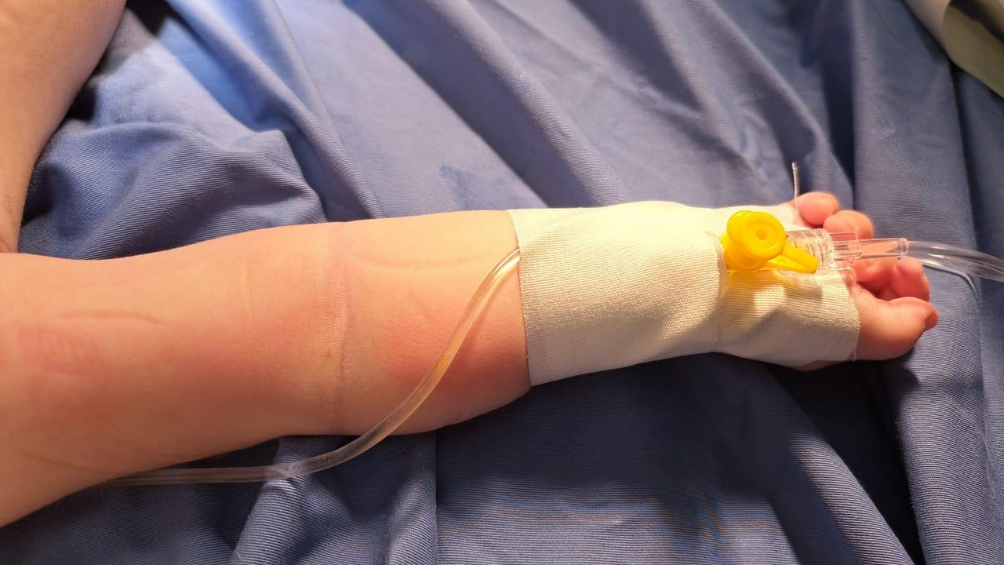

**Image 2: Simultaneous display of femoral and right radial artery (before repair of aortic coarctation)**

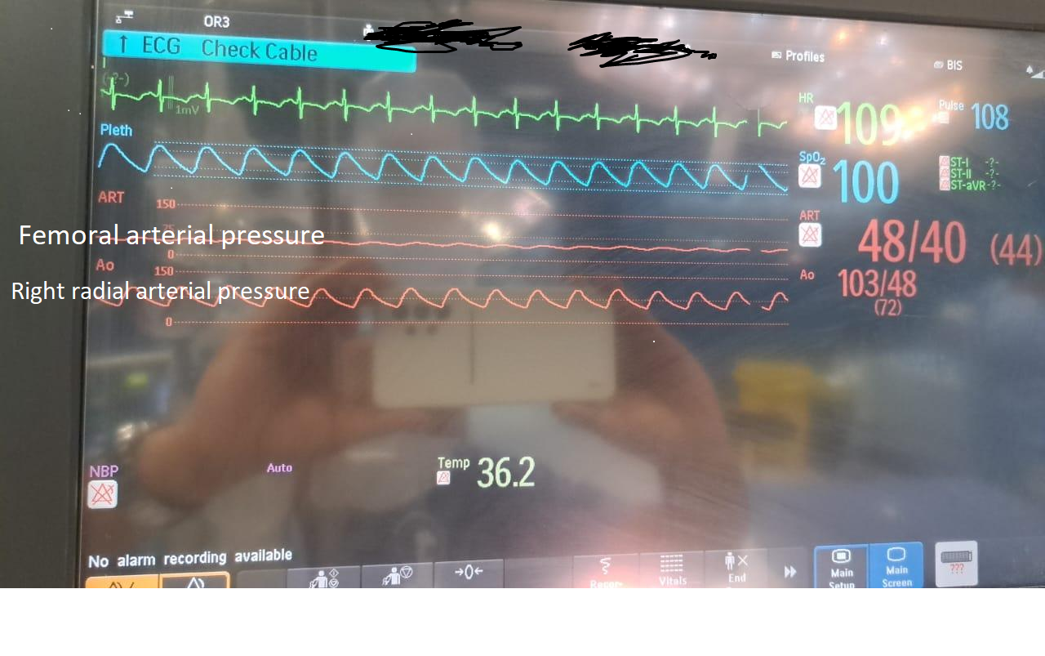

**Image 3: Simultaneous display of femoral and right radial artery (after repair of aortic coarctation)**

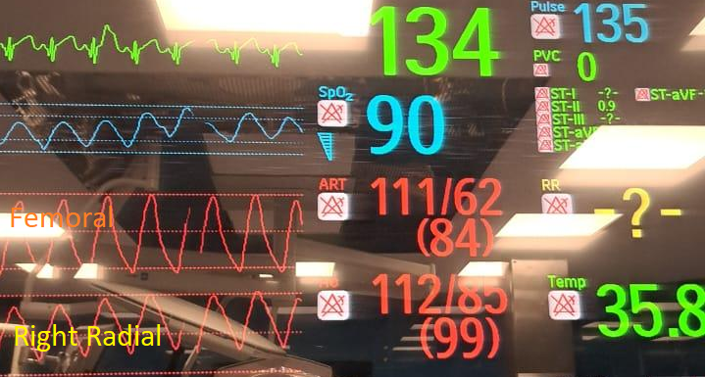

3. results and discussion

81 patients presented for surgical repair of coarctation of aorta, interrupted aortic arch and hypolastic aortic arch. (Table 1) Patients’ age ranged from 4 days to 21 years. Most of the patients were neonates (37%) and infants (51%). Toddlers were (6.2%), preschool (1.2%), school age (2.5%) and adult patients presented only (1.2%). (Figure 1) Male to female ratio was 1.8:1.

Discreet coarctation was the most common pathology and was evident in 68 patients (84%), hypoplastic arch in 6 patients (7.4%) and Interrupted arch in 7 patients (8.6%). (Table 1)

**Figure 1: Age at presentation for surgery:**

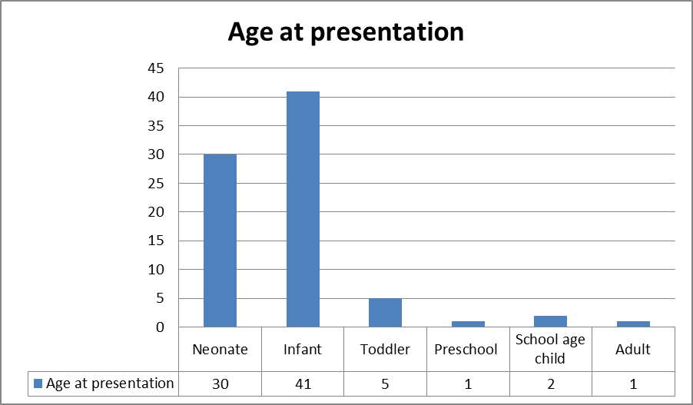

**Table 1: Demographic and clinical characteristics:**

|  |  |  |
| --- | --- | --- |
|  | Number of patients | Percentage |
| Neonates | 30 | 37.04% |
| Infants | 41 | 50.62% |
| Toddlers | 5 | 6.17% |
| Preschool age | 1 | 1.23% |
| School age | 2 | 2.47% |
| Adults | 1 | 1.23% |
| Males | 52 | 64.2% |
| Females | 29 | 35.8% |
| ***AORTIC PATHOLOGY:*** | | |
| Discreet coarctation | 68 | 83.95% |
| Hypoplastic aortic arch | 6 | 7.41% |
| Interrupted aortic arch | 7 | 8.64% |
| ***ASSOCIATED CARDIAC PATHOLOGY:*** | | |
| Normal left ventricular function | 69 | 85.2% |
| Left ventricular impairment | 12 | 14.8% |
| Patent ductus arteriosus | 33 | 40.7% |
| Ventricular septal defect | 24 | 29.6% |
| Bicuspid aortic valve | 7 | 8.6 % |
| ***OTHER PROCEDURES PERFORMED WITH THE REPAIR OF AORTIC COACTATION:*** | | |
| Ligation of patent ductus arteriosus | 58 | 71.6% |
| Pulmonary artery banding | 18 | 22.23% |
| Right ventricular outflow tract repair | 2 | 2.47% |

The body weight of the patients ranged from 1.8 kg to 82 kg (mean weight 6.78 kg). Most of the patients were males (64.2%). The aortic arch diameter ranged from 1.8 to 16 mm with an average aortic arch diameter of 4.53 mm. The z-score of the arch diameter ranged from -9.57 to 0.12 with an average z-score of -5.123. (Table 2)

**Table 2: Aortic arch diameter:**

|  |  |  |  |
| --- | --- | --- | --- |
|  | Minimum | Maximum | Mean |
| Body weight | 1.8 kg | 82 kg | 6.78 kg |
| Aortic arch diameter | 1.8 mm | 16 mm | 4.53 mm |
| z-score of arch diameter | -9.57 | 1.2 | -5.123 |

Most common modes of repair were with left subclavian flap (53.1%) and resection with end-to-end anastomosis (33.4%). Other less common techniques of repair were Dacron patch reconstruction (4.9%), advanced flap (2.47%), patch aortoplasty (2.47%), interposition graft (1.23%), and pericardial patch (1.23%), arch reconstruction with end to end anastomosis (1.23%). (Table 3)

**Table 3: Surgical technique of aortic repair:**

|  |  |  |
| --- | --- | --- |
|  | Number of patients | Percentage |
| Left subclavian flap | 43 | 53.1% |
| End to end anastomosis | 27 | 33.4% |
| Dacron patch reconstruction | 4 | 4.9% |
| Advanced flap | 2 | 2.47% |
| Patch aortoplasty | 2 | 2.47% |
| Interposition graft | 1 | 1.23% |
| Pericardial patch | 1 | 1.23% |
| Reconstruction and end to end anastomosis | 1 | 1.23% |
| ***Total*** | ***81*** | ***100%*** |

Re-coarctation (recurrence) occurred in 8 patients (9.88%). This was managed in the catheterisation laboratory with balloon coarctation angioplasty (BCA) in 7 patients and one patient was surgically re-operated. Other less frequent complications were chylothorax, bilateral lower limbs weakness, global moderate left ventricular ( L.V.) impairment, lung collapse, hypertension, left pleural collection, need for other surgery for aortic stenosis, pneumonia and seizures. Mortality occurred in 5 patients (6.17%). (Table 4)

**Table 4: Post-operative complications:**

|  |  |  |
| --- | --- | --- |
|  |  |  |
| Re-coarctation (Recurrence) | 8 | 9.88% |
| Chylothorax | 2 | 2.47% |
| Bilateral lower limbs weakness | 1 | 1.23% |
| Global moderate L.V. impairment | 1 | 1.23% |
| Lung collapse | 1 | 1.23% |
| Hypertension | 1 | 1.23% |
| Left pleural collection | 1 | 1.23% |
| Need for other surgery for aortic stenosis | 1 | 1.23% |
| Pneumonia | 1 | 1.23% |
| Seizures | 1 | 1.23% |
| Mortality | 5 | 6.17% |

Coarctation of the aorta (CoA) is a relatively common defect that accounts for 5-8% of all congenital heart defects. [12] The exact cause of coarctation of the aorta is unknown. [13) Several theories have been proposed for the explanation of the aetiology of coarctation of the aorta, including postnatal constriction of the ductus arteriosus, translocation of ductal tissue onto the aorta, and the haemodynamic theory. [14] The haemodynamic theory states that alterations in intrauterine blood flow cause altered flow through the aortic arch and reduced volume of blood flow through the foetal aortic arch and isthmus. [15] Aortic coarctation can occur in isolation or in combination with other cardiac anomalies. [17] In our survey aortic coarctation was associated with ventricular septal defect (VSD) in 29.6%, a patent ductus arteriosus (PDA) in 40.7% and bicuspid aortic valve (BAV) in 8.6 %.

This study is a comprehensive five year review of congenital aortic coarctation, hypoplastic and interrupted aortic arch in specialised cardiac centre. The majority of patients (87%) presented for surgery are less than one year old. Our results showed male to female predominance of 1.8:1. This is similar to many literature reports. [18, 19]This ratio varied from 1.7:1 in some reports to 4:1 in other published studies.[20, 21] All the patients in our study had a Computed Tomography Angiography (CTA) for confirmation of the diagnosis. Computed tomographic angiography (CTA) and echocardiography are used preoperatively in coarctation of the aorta to define arch hypoplasia and great vessel branching. [22]

All patients had general anaesthesia with endotracheal intubation (usually nasal) with standard monitoring according to AAGBI (Association of Anaesthetists of Great Britain and Ireland), in addition to central venous catheterisation (usually internal jugular) and arterial line. Our arterial haemodynamic monitoring technique involves cannulation of the femoral artery and the right radial artery with simultaneous display of both pressures. This has several benefits as it allows calculation of pressure gradient pre-operatively and serves to show the adequacy of the post-operative repair. [23] The right radial arterial cannulation and direct blood measurement also allows monitoring and management of blood pressure during the repair when the aorta is clamped and pressure trace disappears from the femoral artery. [24] Although the right radial artery cannulation might be challenging in low weight neonates due to the small size of the artery; its value cannot be overemphasized as all patients will have assessment of the adequacy of repair while still in the operative theatre. [25, 26]

After the first successful repair of aortic coarctation in 1944 by Crafoord and colleagues in Sweden, several operative techniques have been employed. [27] In infants with aortic coarctation; resection with direct end-to-end anastomosis or subclavian flap arterioplasty are the most commonly used techniques due to more favourable anatomic conditions. Subclavian flap arterioplasty and patch graft aortoplasty have been developed as an alternative to resection and direct end-to-end anastomosis in which more than one-half of patients experience recurrence. [28] Great attention should be paid to the aortic clamp time. [29] Murakami et al. reported mean aortic cross-clamping time of 18 ± 4 minutes in a study on 72 patients. [30] Bacha et al. reported median clamp time of 15.5 minutes in in infants weighing less than 2 kg. [31] In general; the maximum accepted aortic clamp time is around 20 minutes.

The most commonly used surgical techniques in our centre during the five years of this survey are subclavian flap (53.1%) and end-to-end anastomosis (33.4%). Other techniques of repair included Dacron patch reconstruction, advanced flap, patch aortoplasty, interposition graft, pericardial patch and aortic reconstruction with end to end anastomosis. Complications were mainly recurrence (re-coarctation) in 9.88% and less commonly chylothorax, lung collapse, hypertension, left pleural collection, need for other surgery for aortic stenosis, pneumonia, bilateral lower limbs weakness, global moderate L.V. impairment and seizures.

Recurrence of aortic coarctation (re-coarctation) occurred in eight patients in this survey (9.88%). This was managed with balloon aortic angioplasty with or without stenting of the coarctation segment in seven patients. Only one patient needed re-operation (1.23%).

4. Conclusion

Aortic coarctation was twice as common in males as in females. Majority of patients presenting for surgical repair of aortic coarctation are neonates and infants. Subclavian flap and resection with end-to-end anastomosis are the most used surgical techniques. Late recurrence occurred in less than one in ten patients and was managed by balloon angioplasty.

DISCLAIMER (ARTIFICIAL INTELLIGENCE)

AUTHOR(S) HEREBY DECLARE THAT NO GENERATIVE AI TECHNOLOGIES SUCH AS LARGE LANGUAGE MODELS (CHATGPT, COPILOT, ETC.) AND TEXT-TO-IMAGE GENERATORS HAVE BEEN USED DURING THE WRITING OR EDITING OF THIS MANUSCRIPT.

Ethical approval

THE STUDY WAS APPROVED BY THE INSTITUTIONAL ETHICS COMMITTEE

References

1. Law MA, Collier SA, Sharma S, et al. Coarctation of the Aorta. [Updated 2024 Dec 11]. In: StatPearls [Internet]. Treasure Island (FL): StatPearls Publishing; 2025 Jan-. Available from: <https://www.ncbi.nlm.nih.gov/books/NBK430913/>
2. Raza S, Aggarwal S, Jenkins P, Kharabish A, Anwer S, Cullington D, Jones J, Dua J, Papaioannou V, Ashrafi R, Moharem-Elgamal S. Coarctation of the Aorta: Diagnosis and Management. Diagnostics (Basel). 2023 Jun 27;13(13):2189. doi: 10.3390/diagnostics13132189. PMID: 37443581; PMCID: PMC10340190.
3. Torok RD, Campbell MJ, Fleming GA, Hill KD. Coarctation of the aorta: Management from infancy to adulthood. World J Cardiol. 2015 Nov 26;7(11):765-75. doi: 10.4330/wjc.v7.i11.765. PMID: 26635924; PMCID: PMC4660471.
4. Salciccioli KB, Zachariah JP. Coarctation of the Aorta: Modern Paradigms Across the Lifespan. Hypertension. 2023 Oct;80(10):1970-1979. doi: 10.1161/HYPERTENSIONAHA.123.19454. Epub 2023 Jul 21. PMID: 37476999; PMCID: PMC10530495.
5. Binti Mohamed Sharif, N. L., & M. Hijazi, Z. (2025). A Comprehensive Management of Coarctation of the Aorta; Modern Approaches and Updated Strategies for Adolescents and Adult. Jordan Medical Journal, 59(1). <https://doi.org/10.35516/jmj.v59i1.3615>
6. Teo LL, Cannell T, Babu-Narayan SV, Hughes M, Mohiaddin RH. Prevalence of associated cardiovascular abnormalities in 500 patients with aortic coarctation referred for cardiovascular magnetic resonance imaging to a tertiary center. Pediatr Cardiol. 2011 Dec;32(8):1120-7. doi: 10.1007/s00246-011-9981-0. Epub 2011 Apr 22. PMID: 21512788.
7. Margarint IM, Youssef T, Robu M, Rotaru I, Popescu A, Untaru O, Filip C, Stiru O, Iliescu VA, Vladareanu R. The Management of Aortic Coarctation Associated with Hypoplastic Arches and Particular Arch Anatomies: A Literature Review. J Pers Med. 2024 Jul 6;14(7):732. doi: 10.3390/jpm14070732. PMID: 39063986; PMCID: PMC11277657.
8. Klea Hysko, Harald Bertram, Dmitry Bobylev, Alexander Horke, Georg Hansmann; Advances in the Treatment of Neonatal Coarctation of the Aorta. Pediatrics February 2025; 155 (2): e2024067434. 10.1542/peds.2024-067434
9. Alkashkari W, Albugami S, Hijazi ZM. Management of Coarctation of The Aorta in Adult Patients: State of The Art. Korean Circ J. 2019 Apr;49(4):298-313. doi: 10.4070/kcj.2018.0433. PMID: 30895757; PMCID: PMC6428953.
10. Serfontein SJ, Kron IL. Complications of coarctation repair. Semin Thorac Cardiovasc Surg Pediatr Card Surg Annu. 2002;5:206-11. doi: 10.1053/pcsu.2002.31488. PMID: 11994880.
11. Saxena A. Recurrent Coarctation: Interventional Techniques and Results. World Journal for Pediatric and Congenital Heart Surgery. 2015;6(2):257-265. doi:10.1177/2150135114566099
12. Bhatt AB, Lantin-Hermoso MR, Daniels CJ, Jaquiss R, Landis BJ, Marino BS, Rathod RH, Vincent RN, Keller BB, Villafane J. Isolated Coarctation of the Aorta: Current Concepts and Perspectives. Front Cardiovasc Med. 2022 May 25;9:817866. doi: 10.3389/fcvm.2022.817866. PMID: 35694677; PMCID: PMC9174545.
13. Turaev, B.B., Abralov, K.K., Kobiljonov, B.K. et al. Assessment of anatomy of the aorta in patients with a coarctation of aorta. Cardiothorac Surg 31, 24 (2023). <https://doi.org/10.1186/s43057-023-00114-w>
14. Yokoyama U, Ichikawa Y, Minamisawa S, Ishikawa Y. Pathology and molecular mechanisms of coarctation of the aorta and its association with the ductus arteriosus. J Physiol Sci. 2017 Mar;67(2):259-270. doi: 10.1007/s12576-016-0512-x. Epub 2016 Dec 20. PMID: 28000176; PMCID: PMC10717425.
15. Hermida U, van Poppel MPM, Sabry M, Keramati H, Steinweg JK, Simpson JM, Vigneswaran TV, Razavi R, Pushparajah K, Lloyd DFA, Lamata P, De Vecchi A. The onset of coarctation of the aorta before birth: Mechanistic insights from fetal arch anatomy and haemodynamics. Comput Biol Med. 2024 Nov;182:109077. doi: 10.1016/j.compbiomed.2024.109077. Epub 2024 Sep 11. PMID: 39265477; PMCID: PMC11846778.
16. Tyczyński P, Kocańda S, Płaczkiewicz D, Gruczek J, Opolski MP, Czekajska E, Witkowski A, Różański J, Hoffman P, Michałowska I. Coarctation of the aorta associated with anomalous origins of the coronary arteries. Cardiol J. 2024;31(5):774-777. doi: 10.5603/cj.96025. Epub 2024 Sep 10. PMID: 39254575; PMCID: PMC11544406.
17. Türkmen H, Uysal F, Genç A, Bostan ÖM, Şenkaya Siğnak I. Evaluation of Children with Aortic Coarctation: A Single-Center Experience. Turk Arch Pediatr. 2024 Sep 2;59(5):480-487. doi: 10.5152/TurkArchPediatr.2024.24050. PMID: 39440413; PMCID: PMC11391242.
18. Zhou W, Gao S, Du R, Xiang H, Gao Y, Gao W. Congenital coarctation of the aorta: Role of peripheral vascular ultrasound in young hypertensive patients. Ultrasound Int Open. 2024 Oct 30;10:a24361007. doi: 10.1055/a-2436-1007. PMID: 39497896; PMCID: PMC11533725.
19. Chen W, Fan C, Tang S, Zhou W, Iroegbu CD, Li J, Wu X, Yang J. Application of Modified Sliding Anastomosis in the Repair of Aortic Coarctation. Biomed Res Int. 2020 May 14;2020:3805385. doi: 10.1155/2020/3805385. PMID: 32509857; PMCID: PMC7245663.
20. Teo LL, Cannell T, Babu-Narayan SV, Hughes M, Mohiaddin RH. Prevalence of associated cardiovascular abnormalities in 500 patients with aortic coarctation referred for cardiovascular magnetic resonance imaging to a tertiary center. Pediatr Cardiol. 2011 Dec;32(8):1120-7. doi: 10.1007/s00246-011-9981-0. Epub 2011 Apr 22. PMID: 21512788.
21. Rinnström D, Dellborg M, Thilén U, Sörensson P, Nielsen NE, Christersson C, Johansson B. High prevalence of ascending aortic dilation in adults with repaired coarctation of the aorta. Cardiol Young. 2021 Jun;31(6):992-997. doi: 10.1017/S1047951121000111. Epub 2021 Feb 18. PMID: 33597051.
22. Rose-Felker K, Robinson JD, Backer CL, Rigsby CK, Eltayeb OM, Mongé MC, Rychlik K, Sammet CL, Gossett JG. Preoperative Use of CT Angiography in Infants With Coarctation of the Aorta. World J Pediatr Congenit Heart Surg. 2017 Mar;8(2):196-202. doi: 10.1177/2150135116683929. PMID: 28329462.
23. Hamid T, Jamallulail SI, Clarke B, Mahadevan VS. Dual Arterial Access for Stenting of Aortic Coarctation in Patients with Near-Total Descending Aortic Interruption. Cardiol Ther. 2015 Dec;4(2):203-7. doi: 10.1007/s40119-015-0048-9. Epub 2015 Sep 19. PMID: 26387128; PMCID: PMC4675754.
24. Maddali MM, Valliattu J, al Delamie T, Zacharias S. Selection of monitoring site and outcome after neonatal coarctation repair. Asian Cardiovasc Thorac Ann. 2008 Jun;16(3):236-9. doi: 10.1177/021849230801600312. PMID: 18515675.
25. Schindler E, Kowald B, Suess H, Niehaus-Borquez B, Tausch B, Brecher A. Catheterization of the radial or brachial artery in neonates and infants. Paediatr Anaesth. 2005 Aug;15(8):677-82. doi: 10.1111/j.1460-9592.2004.01522.x. PMID: 16029403.
26. Selldén H, Nilsson K, Larsson LE, Ekström-Jodal B. Radial arterial catheters in children and neonates: a prospective study. Crit Care Med. 1987 Dec;15(12):1106-9. doi: 10.1097/00003246-198712000-00006. PMID: 3677763.
27. Kvitting JP, Olin CL. Clarence Crafoord: a giant in cardiothoracic surgery, the first to repair aortic coarctation. Ann Thorac Surg. 2009 Jan;87(1):342-6. doi: 10.1016/j.athoracsur.2008.08.072. PMID: 19101336.
28. Kaya U, Colak A, Becit N, Ceviz M, Kocak H. Surgical Management of Aortic Coarctation from Infant to Adult. Eurasian J Med. 2018 Feb;50(1):14-18. doi: 10.5152/eurasianjmed.2017.17273. Epub 2017 Dec 29. PMID: 29531485; PMCID: PMC5843446.
29. Moh’d, A.F., Al-Odwan, H.T., Altarabsheh, S. et al. Predictors of aortic clamp time duration and intensive care unit length of stay in elective adult cardiac surgery. Egypt Heart J 73, 92 (2021). <https://doi.org/10.1186/s43044-021-00195-0>
30. Murakami AN, Croti UA, Cajueiro FCM, Arteaga G, Pike RB, Moscardini AC, Marchi CH, Cardoso MRR, Santos FCGB, Borim BC. Isolated Coarctation Repair in Neonates and Infants Through Left Thoracotomy: Short-Term Outcomes. Braz J Cardiovasc Surg. 2021 Aug 6; 36(4):461-467. doi: 10.21470/1678-9741-2020-0554. PMID: 34617427; PMCID: PMC8522329.