Case report

Idiopathic Scrotal Calcinosis: A Case Report

ABSTRACT:
Idiopathic scrotal calcinosis is a rare benign condition with an unknown pathology and unclear etiology. They presented with multiple, irregular, hard, painless nodules. Treatment of this condition involves single-stage excision.
There are only 85 publications on this condition. Because of its rarity, we report the case of 42 years old male who presented with painless irregular swelling of the scrotum for 3 years. The diagnosis was based on a clinical examination. Single-stage excision of the nodules was performed with scrotoplasty and confirmed by histopathology.
Keywords: Idiopathic scrotal calcinosis; Calcinosis Cutis; Surgical excision
INTRODUCTION:
Idiopathic scrotal calcinosis is a rare benign condition characterized by the development of multiple, large, calcified nodules in the scrotum. These nodules are generally painless and vary in size. The exact cause of scrotal calcinosis is not known but may be related to underlying systemic metabolic conditions, such as scleroderma and dermatomyositis, or could be a result of dystrophic calcification of the epidermal cyst. Lewinsky first describe the condition in 1883. They are present at approximately 30 years of age and may present silently for several years before seeking treatment. Patients may come to the hospital for cosmetic reasons. Some cases may present with pruritus or soreness, white chalky exudate discharge, and may also affected by infection [1].
Differential diagnosis may include epidermal inclusion cysts, lipomas, angiokeratomas, solitary neurofibromas, genital leiomyomas, scleroderma, and steatocystoma. Particularly in patients with CREST syndrome (calcinosis cutis, Renaud’s phenomenon, esophageal dysfunction, sclerodactyly, Telangiectasia) [1].
The diagnosis of idiopathic scrotal calcinosis is always based on an excisional biopsy. The gold standard treatment for this condition is surgical excision of the nodules and primary wound closure. Sometimes, en-block excision and successful reconstruction of the scrotal skin (multiple flap transfers) are performed.
Histopathological examination revealed calcified deposits of varying sizes in the dermis, surrounded by histocytes and inflammatory giant cell reaction. The patient recovered uneventfully and was discharged home.

CASE REPORT:
A 42-year-old male, presented to OPD with multiple painless scrotal swellings, which gradually increase the number and size for last 3 years. Physical examination revealed multiple hard, painless subcutaneous nodules ranging from 2 mm to 10 mm in diameter. There was no itching or skin discoloration over the nodules but multiple whitish skin discoloration over the nodules were noted. There had no history of any scrotal infection and trauma or any metabolic disease. All other blood parameters, such as thyroid hormone, serum Na+, K+, Alkaline phosphate levels, were normal.
A diagnosis of idiopathic scrotal calcinosis was made, and a single-stage excision with scrotoplasty was planned. This procedure consists of thorough dissection between dermis and dartos muscle layer followed by scrotoplasty using single interrupted suture under spinal aesthesia.
Histological specimen tissue measuring 13x8x8 cm. The outer surface appeared nodular with white nodules. The cut section shows multiple spaces filled with chalky white material. The tissue appeared gritty during cutting. Microscopic examination revealed scrotal tissue lined with squamous epithelium. The underlying dermis appears fibrocollagenous and shows multiple large areas of granules and globules of basophilic calcified material. No evidence of atypia, malignancy or granuloma.
Histopathological examination confirmed the diagnosis of idiopathic scrotal calcinosis. Patient has uneventful recovery and discharged home. No recurrence was reported at the follow-up visits, and the patient was doing well after six months. 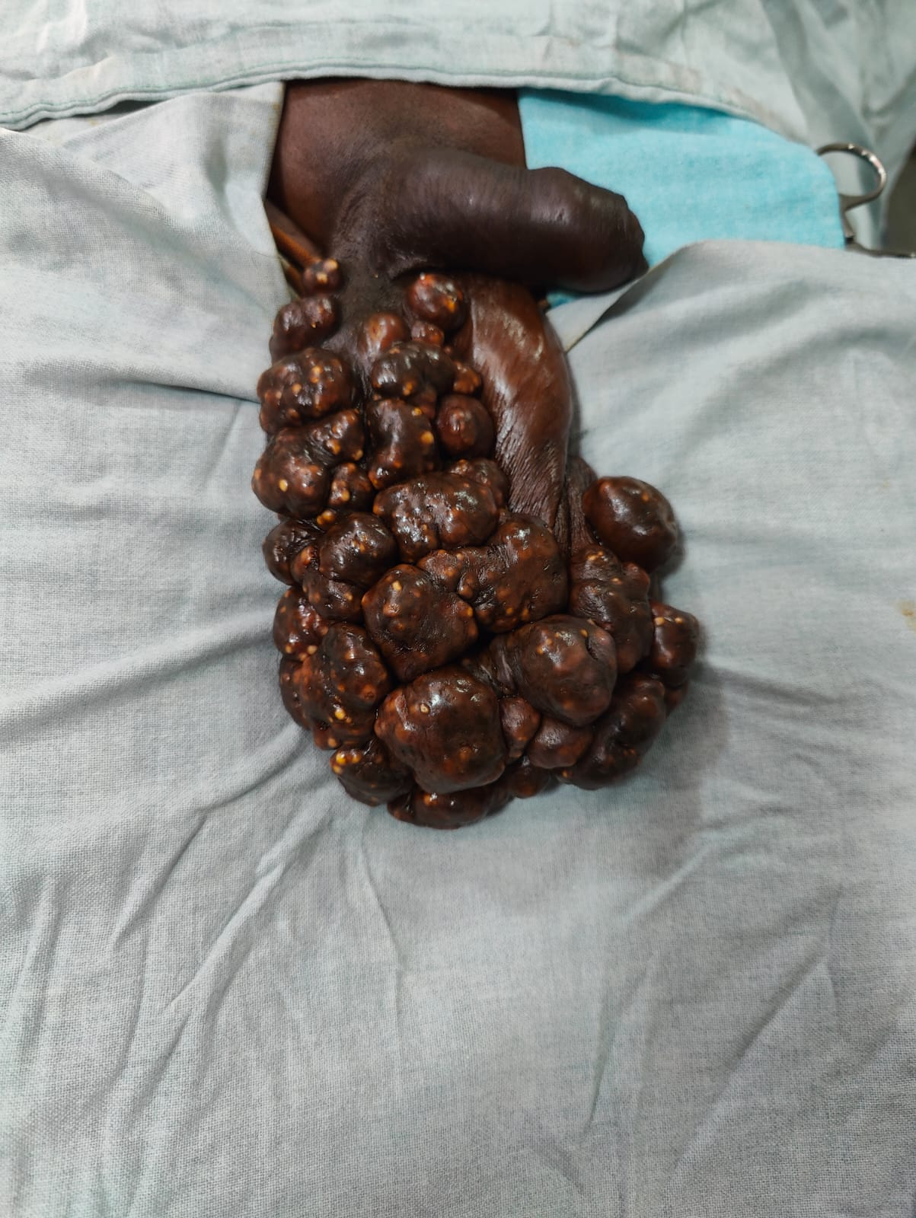
Fig.1. Patient before surgery
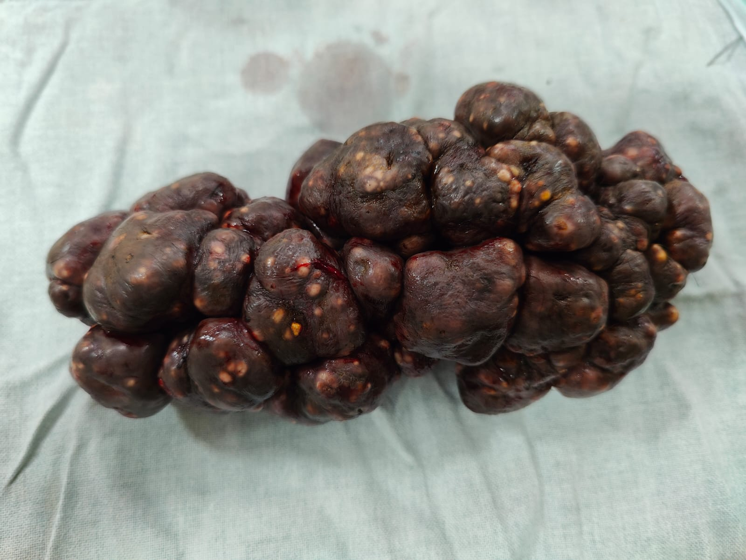
Fig. 2. Retrieved Specimen
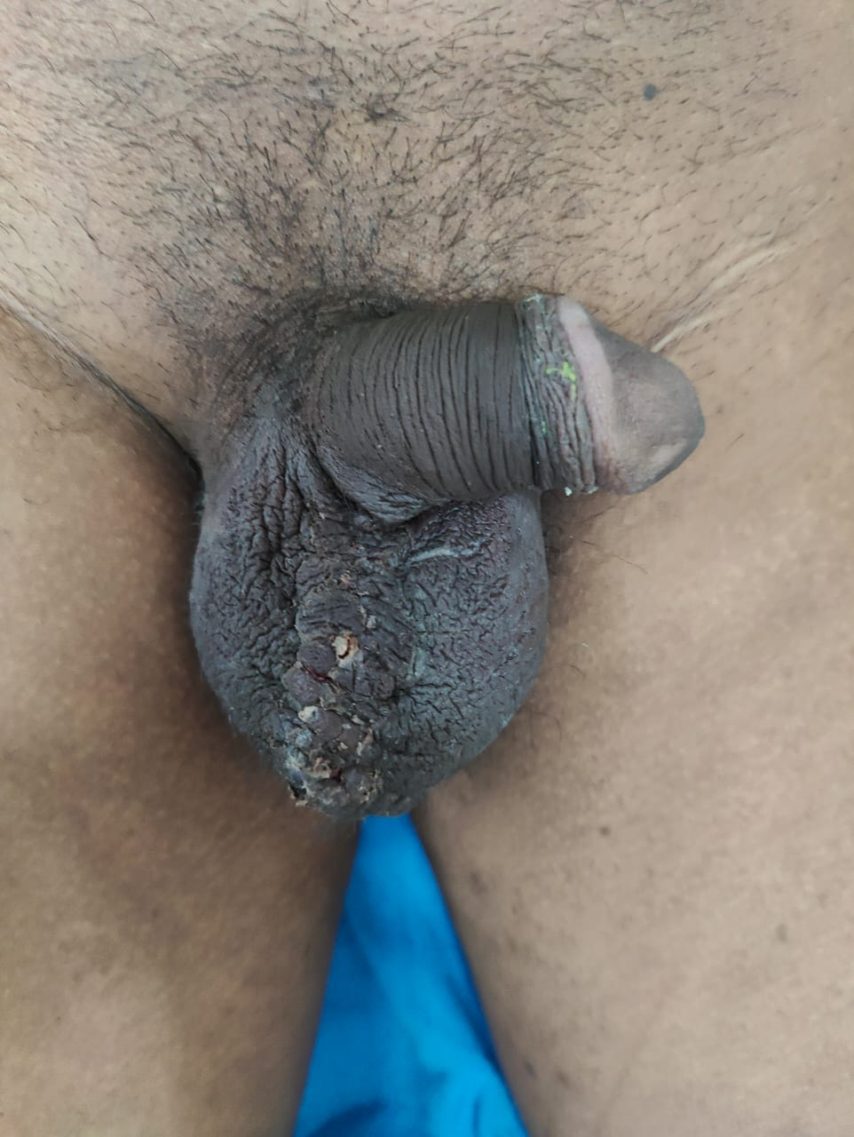
Fig.3 Results after scrotoplasty
DISCUSSION:
Idiopathic scrotal calcinosis is a benign condition characterized by multiple calcific nodules in the scrotal skin; its origin is controversial and may be due to dystrophic calcification of epidermal cysts. They mostly arise de novo, without any history of underlying metabolic disorders, possibly trauma. In our case, the lesions were idiopathic, as no other causative factors were present.
The patient presented with multiple subcutaneous painless nodules in the scrotum of varying sizes, along with calcified deposits in the dermis and subcutis. No extensive involvement of the scrotum was observed. This condition was first described by Lewinski in 1883 [3]and was established as a distinct entity by Shapiro et al. in 1970[4]. They proposed an idiopathic nature, as there were multiple cyst walls. This theory is supported by the majority of studies. Shah V et al [5] found cyst wall in 14 out of 20 cases. Song et al [6] found cyst wall structure in various stage of inflammation with calcification in 51 nodules from 1 case. Dubey et al [7] reported inflamed cyst with intact cyst wall in 53% cases, pseudocysts in 56% of cases out of total 100 cases. Cyst wall formation was not observed in the present case. Chalky discharge from the nodules, and some may present with secondary infections of the skin. In our case, there was no history of pruritus, soreness, exudation, or infection. The mean age of idiopathic scrotal calcinosis is 31.5 years, of which 70% presented with a third decade of life. Cosmetic appearance and decreased sexual quality of life were the main concerns in this case. Taren et al [1] in 2018 and Pompo et al 2013 [8] describe the condition mostly as symptomatic and some may present with pruritus, soreness and white chalky discharge. The pathogenesis of idiopathic scrotal calcinosis remains unknown and has been the subject of long-term controversy. In this case, there were no such findings and the patient was idiopathic in nature.
The gold standard treatment is surgical excision [9] followed by scrotoplasty. Various surgical methods are available, including enucleation, wide local excision with direct closure, and complex reconstruction in a single or multiple setting. Chang et al [10] in 2004 advocated pinch punch excision for scrotal calcinosis, it is a noble method for fewer and smaller lesions. Deng Cui et al [2] perform multiple en-bloc excisions with successful reconstruction of scrotal skin by multiple flap transfers. In this case, wide local excision with scrotoplasty was preferred. Our patient had desired cosmetic results and an improved sexual quality of life. There was no recurrence after six months of follow-up.
HPE shows deposits of calcium in the dermis, surrounded by histocytes and giant cell reactions. A parietal epithelial lining may be seen in some cases. In this case microscopic examination shows scrotal tissue by squamous epithelium. The underlying dermis was fibrocollagenous, with multiple large areas of granules and globules of calcified materials. There was no evidence of atypia or granulomas.
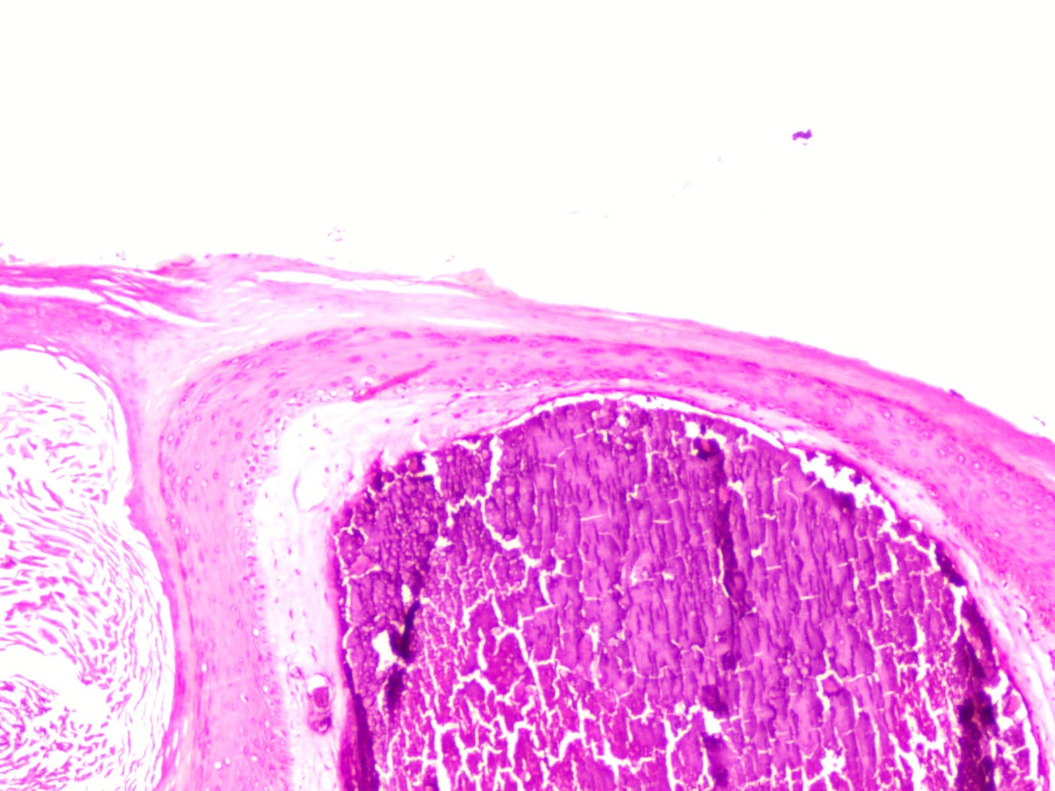
Fig. 4. Calcium deposits in dermis

CONCLUSION:
As it is benign and has a negative impact on cosmesis and sexual quality of life, the main steam of treatment is complete surgical excision, followed by scrotoplasty. The main etiology and pathogenesis are still controversial, but in this case, we believe that it was due to idiopathic calcification. Complete surgical excision is excellent with minimal or no recurrence.
CONFLICT OF INTEREST:
Authors don’t have any conflict of interest.

REFERENCES:
- Tareen A, Ibrahim RM. Idiopathic scrotal calcinosis – A case report. International Journal of Surgery Case Reports [Internet] 2018; 44:51–3 -PubMed
- Cui D, Chen G, Luo J, Liu C. Successful surgical treatment of extensive idiopathic scrotal calcinosis: A case report. Urology Case Reports [Internet] 2023; 51:102553 – PubMed
- Lewinski HM. Lymphangiome der Haut mitVerkalklemInhalt. Arch Pathol Anat. 1883;91:371–4 – Google Scholar
- Shapiro, L. (1970).
- Idiopathic Calcinosis of the Scrotum. Archives of Dermatology, 102(2), 199 – JAMA Dermatology
- Shah V, Shet T. Scrotal calcinosis results from calcification of cysts derived from hair follicles: a series of 20 cases evaluating the spectrum of changes resulting in scrotal calcinosis. American Journal of Dermatopathology [Internet] 2007;29(2):172–5 – PubMed
- Song DH, Lee KH, Kang WH. Idiopathic calcinosis of the scrotum: Histopathologic observations of fifty-one nodules. Journal of the American Academy of Dermatology [Internet] 1988;19(6):1095–101 – PubMed
- Dubey S, Sharma R, Maheshwari V. Scrotal calcinosis: Idiopathic or dystrophic? Dermatology Online Journal [Internet] 2010;16(2) – Dermatology online journal
- Pompeo A, Molina W, Pohlman G, Sehrt D, Kim F. Idiopathic scrotal calcinosis: A rare entity and a review of the literature. Canadian Urological Association Journal [Internet] 2013;7(5–6):439 – PubMed
- Jayarajah U, De Silva L, De Silva C, Seneviratne S. Idiopathic scrotal calcinosis: a case report of a rare entity. Case Reports in Urology [Internet] 2019; 2019:1–3 – PubMed
- Chang, C.-H., Yang, C.-H., & Hong, H.-S. (2004).
- Surgical pearl: pinch-punch excisions for scrotal calcinosis. Journal of the American Academy of Dermatology, 50(5), 780–781 – JAAD

