*Case report*

Cardiac Myxoma with atypical presentation : a case report

.

ABSTRACT

|  |
| --- |
| Although rare, cardiac Myxomas are the most common primary cardiac tumours, most frequently found in the left atrium. They are typically pedunculated and attached at the fossa ovalis on the left side of the atrial septum. Cardiac Myxomas are benign neoplasms developed from multipotent mesenchyme and usually present as an undifferentiated atrial mass. Although cardiac Myxomas are considered as biologically benign; they are often “functionally malignant” because of the potential for embolization, obstructive and constitutional symptoms. Potentially life-threatening, the presence of Cardiac Myxoma calls for prompt diagnosis and surgical resection. Common manifestations of cardiac Myxoma include dyspnea, orthopnea, fatigue, and constitutional symptoms.  In this case report we present a patient with versatile presentation of cardiac Myxoma presenting with recurrent miscarriages and cerebrovascular accidents. We also share intraoperative transoesophageal echocardiography (TOE) approaches to image the tumour pre- and post-excision while the patient is still in the operative room to ensure complete clearance of the tumour.  . |

*Keywords: Myxoma, Stroke, Miscarriage, Echocardiography, Cardiac.*

1. INTRODUCTION

Intracardiac Myxoma is the most common tumour of the heart with an estimated incidence of 0.5 per million per year .¹ It is estimated that more than 75% of myxomas originate in the left atrium either at the mitral annulus or the fossa ovalis border of the interatrial septum; 20% arise from the right atrium while 5% stem from both atria and the ventricle. ² The tumour has a female preponderance with a female-to-male ratio of approximately 3:1. ³The clinical presentation of cardiac myxoma depends on their location, size and mobility and is typified by the triad of intracardiac obstruction, embolization and constitutional symptoms. Although cardiac Myxomas are considered as biologically benign; they are often “functionally malignant” because of the potential for embolization. ⁴Other serious complications of cardiac Myxomas are related to mitral valve obstruction or constitutional effects. ⁵Morphologically, myxomas can be classified as gelatinous or solid. Gelatinous myxomas are soft, friable, and prone to fragmentation and embolization. Solid myxomas are firmer and less likely to embolize compared to their gelatinous counterparts. ⁶ Cardiac myxoma, whose name is derived from the predominantly myxoid stroma is composed of an extracellular matrix rich in glycoproteins and proteoglycans with polygonal cells scattered throughout. This tumour is thought to originate from the primitive mesenchymal cells that are capable of endothelial differentiation. ⁷

Transthoracic echocardiography (TTE) is the most practical investigation for diagnosis of cardiac myxomas as it often yields adequate information necessary for surgical resection. It determines the location, size and shape of the tumour. Transesophageal echocardiography (TOE) has a higher sensitivity and specificity and can detect small tumours, tumours with atypical locations and possible multi-chamber tumour infestation. ⁸

In this case report, we will present intra-operative TOE images before and after excision of left atrial myxoma.

2. PRESENTATION OF CASE

A 42 year old female patient presented to the cardiac surgery unit at Queen Alia Heart Institute (QAHI) for resection of huge left atrial Myxoma that is nearly obstructing the mitral valve. Our patient is a mother of four children (G17 P 4 + 12), had suffered 12 consecutive miscarriages and two episodes of cerebrovascular accidents (CVAs), from which she made partial recovery with residual one sided weakness. During medical workup and investigations for stroke, her echocardiography showed an unusual growth (tumour) inside the left atrium. Her transthoracic echocardiography (TTE) reported paradoxical septal wall motion abnormality with overall normal left ventricular systolic function, moderate to severe tricuspid valve regurgitation with RVSP (right ventricular systolic pressure) of 60 mm Hg and a soft tissue mass in the left atrium.

After admission to the operative room, anaesthesia was induced with full haemodynamic monitoring including pulse oximetry, electrocardiography (ECG), left radial artery cannulation, right internal jugular triple lumen central venous line, end-tidal capnography, nasopharyngeal temperature probe, cerebral oximetry and transoesophageal echocardiography (TOE) . The initial TOE images showed a left atrial myxoma that is located above the mitral valve. (Images 1 and 2)

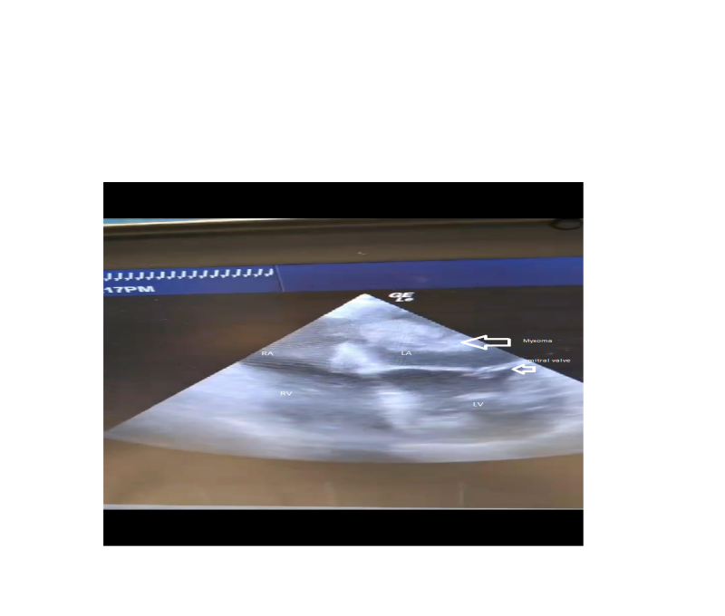

Image 1: Intra-operative Transoesophageal Echocardiodram (TOE) showing left atrial myxoma

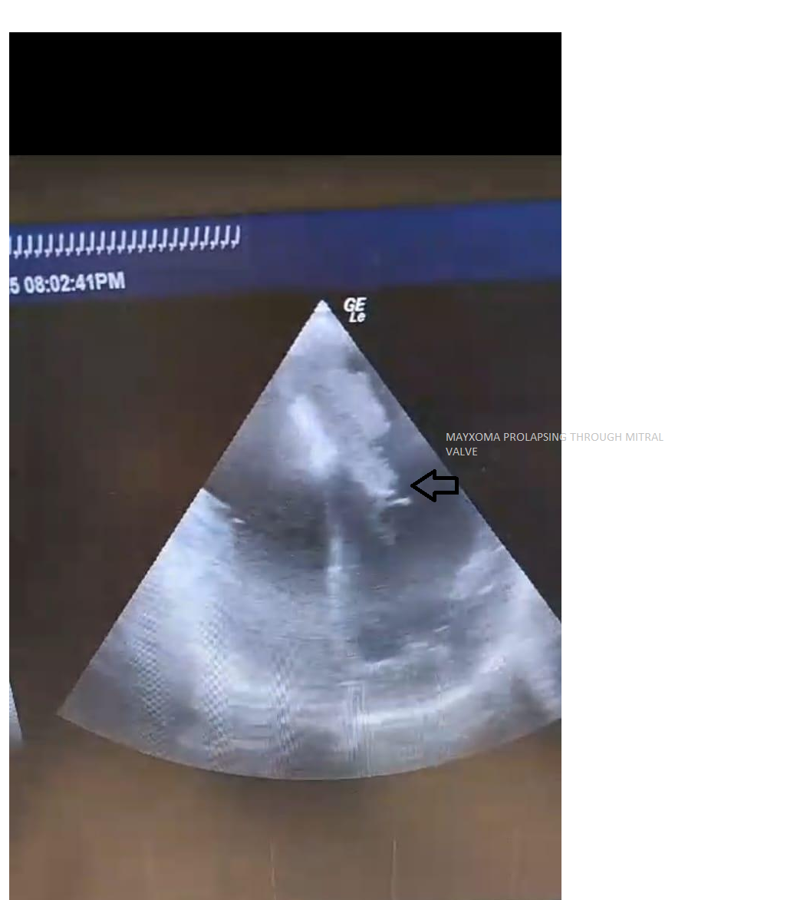

Image 2: Intra-operative Transoesophageal Echocardiodram (TOE) showing left atrial myxoma prolapsing through the mitral valve

The chest was opened through mid-sternotomy incision; heparinization of blood was confirmed by adequate activated clotting test (ACT) results, aortic and dual venous (bi-caval) cannulation followed by initiation of full cardiopulmonary bypass (CPB). After aortic cross clamping and adequate dose of cold crystalloid cardioplegia (St. Thomas) the heart was arrested and the right atrium was opened. (Image 3) The tumour was completely excised and was sent to the pathology laboratory for histological examination. (Image 4) The mass was measuring 2x3 cm, gelatinous in consistency. The septum was closed using pericardial patch. After closure of the atrium, the aortic clamp was removed and the patient was weaned from CPB. Another TOE was performed and showed no residual tumour in the left atrium. (Image 5) Post-operatively, the patient was extubated after three hours from arrival to the intensive care unit. She was discharged home from the hospital on the fifth post-operative day.

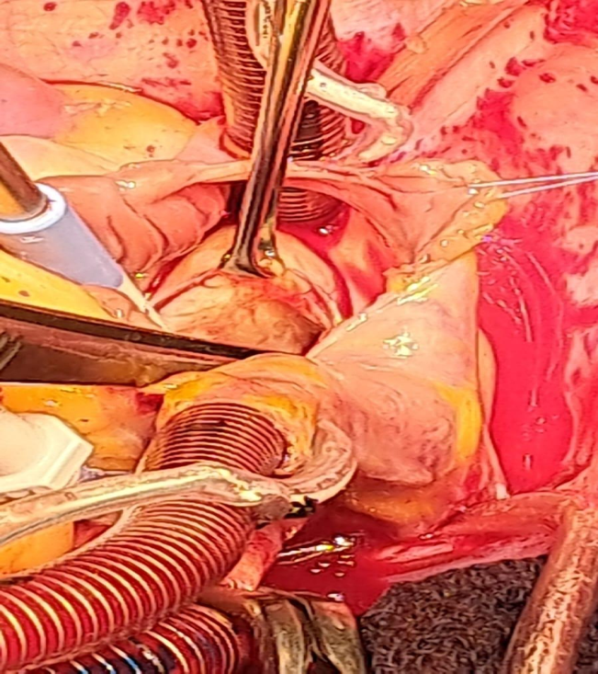

Image 3: Opening of the right atrium and the fossa ovalis excised

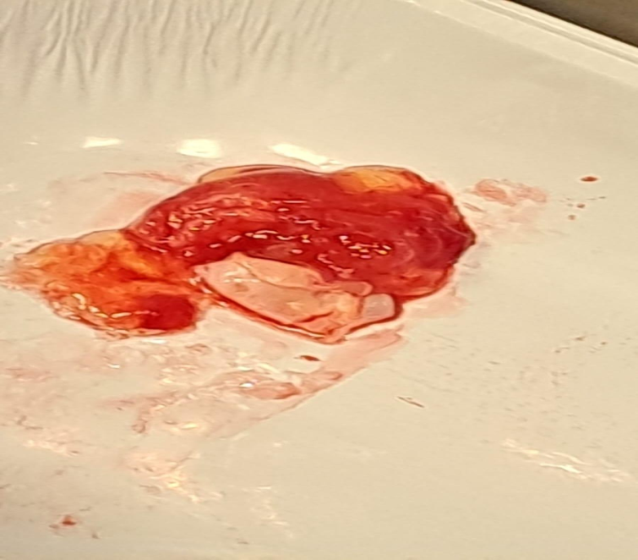

Image 4: Myxoma around 2x3 cm, gelatinous in consistency

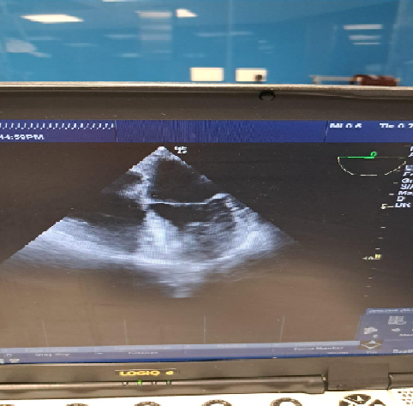

Image 5: Intraoperative T.O.E. showing complete excision of the tumour at the end of surgery.

3. discussion

Symptomatic cardiac myxomas are challenging to diagnose as they often cause signs and symptoms that suggest other more common conditions. Common manifestations of cardiac Myxoma include dyspnea, orthopnea, fatigue, and constitutional symptoms. Thus many patients present late for surgery after suffering from serious complications and a long journey of different investigations. Cardiac myxomas present a diagnostic challenge due to their ability to mimic various cardiovascular and systemic conditions. The triad of cardiac myxoma presentation includes obstructive symptom (with obstruction of the left ventricular outflow tract and mitral valve stenosis), embolization (commonly into the central nervous system, pulmonary arteries and coronaries) and constitutional symptoms such as fever, fatigue and weight loss. The diagnosis of myxoma may be missed and delayed as it poses various clinical manifestations. ¹¹ Our patient had an obstetric history of recurrent abortions and two cerebrovascular accidents (CVAs). She was transferred to the cardiology clinic to investigate a cardiac cause of her CVAs. Transthoracic echocardiography revealed an abnormal pedunculated mass in the left atrium. When the patient presented for surgery transoesophageal echocardiography assisted in precise localisation of tumour and confirmed complete excision. The patient is continuing a follow up in the cardiology clinic as an outpatient for six months now, with serials of TTE showing no recurrence of the tumour. The use of TOE has revolutionised cardiac surgery especially for valvular abnormalities and cardiac tumours.

Cardio-embolic stroke accounts for 14-30% of ischemic strokes. Atrial fibrillation, acute myocardial infarction, valvular heart disease, infective endocarditis and cardiac myxoma are all major sources of cerebral emboli. While atrial fibrillation is considered the most common etiology of cardio-embolic strokes resembling 45% of the causes; cardiac myxoma is responsible for only 0.5%.¹² An early diagnosis and surgery is recommended to prevent further sequelae and fatal complications. Two-dimensional echocardiography is the diagnostic procedure of choice. While screening can be done with TTE; intra-operative TOE is used for more accurate imaging; facilitating more precise localization and confirmation of complete excision.

4. Conclusion

Diagnosis of cardiac Myxoma is sometimes challenging as the sign and symptoms may suggest many common conditions. Strokes may occur due to embolisation of the tumour causing ischaemic brain infarctions and is related to the friable nature of the Myxoma. Intraoperative transoesophageal echocardiograpghy is a valuable tool for accurate localisition of the tumour and can help confirmation of complete tumour excision.

DISCLAIMER (ARTIFICIAL INTELLIGENCE)

Author(s) hereby declare that no generative AI technologies such as Large Language Models (ChatGPT, COPILOT, etc.) and text-to-image generators have been used during the writing or editing of this manuscript.

CONSENT

All authors declare that ‘written informed consent was obtained from the patient for publication of this case report and accompanying images.

ETHICAL APPROVAL

The study was approved by the Institutional Ethics Committee

COMPETING INTERESTS

Authors have declared that no competing interests exist

References:

1. I.M. Keeling, P. Oberwalder, M. Anelli-Monti, H. Schuchlenz, U. Demel, G.P. Tilz, P. Rehak, B. Rigler, Cardiac myxomas: 24 years of experience in 49 patients, European Journal of Cardio-Thoracic Surgery, Volume 22, Issue 6, December 2002, Pages 971–977, <https://doi.org/10.1016/S1010-7940(02)00592-4>
2. Nguyen T, Vaidya Y. Atrial Myxoma. [Updated 2023 Jul 3]. In: StatPearls [Internet]. Treasure Island (FL): StatPearls Publishing; 2025 Jan-. Available from: <https://www.ncbi.nlm.nih.gov/books/NBK556040/>
3. Yoon DH, Roberts W. Sex distribution in cardiac myxomas. Am J Cardiol. 2002 Sep 1;90(5):563-5. doi: 10.1016/s0002-9149(02)02540-7. PMID: 12208428.
4. Islam AKMM. Cardiac myxomas: A narrative review. World J Cardiol. 2022 Apr 26;14(4):206-219. doi: 10.4330/wjc.v14.i4.206. PMID: 35582466; PMCID: PMC9048271.
5. Lee VH, Connolly HM, Brown RD. Central Nervous System Manifestations of Cardiac Myxoma. Arch Neurol. 2007;64(8):1115–1120. doi:10.1001/archneur.64.8.1115
6. Ashinze, P., Banerjee, S., Egbunu, E. et al. Cardiac myxomas: a review of current treatment approaches and emerging molecular therapies. Cardiothorac Surg 32, 22 (2024). <https://doi.org/10.1186/s43057-024-00141-1>
7. Okongwu CC, Olaofe OO. Cardiac myxoma: a comprehensive review. J Cardiothorac Surg. 2025 Mar 13;20(1):151. doi: 10.1186/s13019-024-03333-2. PMID: 40082903; PMCID: PMC11905437.
8. Pérez de Isla L, de Castro R, Zamorano JL, Almería C, Moreno R, Moreno M, Lima P, García Fernández MA. Diagnosis and treatment of cardiac myxomas by transesophageal echocardiography. Am J Cardiol. 2002 Dec 15;90(12):1419-21. doi: 10.1016/s0002-9149(02)02891-6. PMID: 12480063.
9. Frizell AW, Higgins GL 3rd. Cardiac myxoma as a mimic: a diagnostic challenge. Am J Emerg Med. 2014 Nov;32(11):1399-404. doi: 10.1016/j.ajem.2014.08.044. Epub 2014 Aug 23. PMID: 25266769.
10. El-Mhadi, S., El Hajjaj, B., Benatmane, A. et al. Cardiac myxoma and cerebral vasculitis: Is there a link?. Egypt Heart J 76, 61 (2024). <https://doi.org/10.1186/s43044-024-00488-0>
11. Oktaviono YH, Saputra PBT, Arnindita JN, Afgriyuspita LS, Kurniawan RB, Pasahari D, Milla C, Wungu CDK, Susilo H, Multazam CECZ, Alkaff FF. Clinical characteristics and surgical outcomes of cardiac myxoma: A meta-analysis of worldwide experience. Eur J Surg Oncol. 2024 Feb;50(2):107940. doi: 10.1016/j.ejso.2023.107940. Epub 2023 Dec 30. PMID: 38219702.
12. Yuan SM, Humuruola G. Stroke of a cardiac myxoma origin. Rev Bras Cir Cardiovasc. 2015 Mar-Apr;30(2):225-34. doi: 10.5935/1678-9741.20150022. PMID: 26107455; PMCID: PMC4462969.
13. Manche N, Mercer MK, Baruah D. Diagnosis and Treatment of Cardiac Myxoma. Cureus. 2023 May 17;15(5):e39148. doi: 10.7759/cureus.39148. PMID: 37378149; PMCID: PMC10292048.