*Original Research Article*

**EFFECT OF AQUEOUS *allium sativum* BULB EXTRACT ON LEAD ACETATE** -**INDUCED TESTICULAR TOXICITY IN MALE WISTAR RATS**

**ABSTRACT**

**Introduction:** Infertility is one of the global public health concerns as it affects 15% of couples of reproductive ages. It was observed that lead exposure has been considered to adversely affect spermatogenesis and reduced fertility with the accumulation in the organ by inducing oxidative stress and inflammation in the testes.

**Aim:** This study aimed to determine the effect of aqueous *Allium savitum* bulb extract on lead induced testicular toxicity in male wistar rat.

**Methodology:** Male wistar rats were divided into 6 groups with six rats each**,** the normal control, the positive group received lead acetate alone 15 mg/kg/day via interperitoneally route daily for ten consecutive days while treatment groups were pretreated with lead-acetate as the positive control after which they received graded doses of the extract at 100, 200 and 400 mg/kg/day via oral route for 40 days.

**Results:** The results demonstrated that *Allium sativum* extract treatment induced a negative energy balance, as evidenced by significant reduction in body weight similar to the positive control group. Lead acetate administration induced significant deletions alterations in the serum Testosterone, body weight, testis weight and sperm characteristics (counts, motility and viability) of exposed rats (p<0.05). These were significantly reversed in the aqueous *Allium savitum* bulb extract-treated groups (p<0.05). Also, they were marked improvement in the observed lead acetate induced atrophy of the interstitial Leydig cells and reduction in intraluminal spermatids observed was significantly reversed in the representative photomicrographs, following administration of the extract.

**Conclusion:** The administrative of aqueous *Allium savitum* bulb extract exhibits beneficial effects on metabolic health and shows promise as a protective agent against lead-acetate induced toxicity.

**INTRODUCTION**

Human exposure to lead continues to be a serious public health problem (36). It has been proven that daily intake of lead above 0.3 mg for a long period is toxic to man (40). Reproduction dysfunction by lead has distinct morphological and biochemical features such as disorganized epithelia, decrease sperm quality, alteration of sperm morphology and low androgen level (3, 18).

Lead (Pb) is a heavy metal present in both organic (tetraethyl lead) and inorganic (lead acetate, lead chloride) forms in the environment (33). Its prolonged persistence in the environment results from its non-biodegradable nature (8,27), thus making it a potent environmental and occupational toxin. It is reputed for its wide range of toxic physiological, biochemical and histological effects on the brain (12), kidney (25), liver (26), blood (32), the endocrine system (3) and testis (6,13).

Lead -induced testicular toxicity is linked with its accumulation in the organ by inducing oxidative stress and inflammation in the testis. (11). It was observed that lead exposure has been considered to adversely affect spermatogenesis and reduced fertility (2). The mechanism of lead-induced oxidative stress involves an imbalance between generation and removal of ROS (reactive oxygen species) in tissues and cellular components causing damage to membranes, DNA and proteins (31).

Even in the light of recent advancement in the field of scientific research, there seem to be no “safe” level of exposure to Pb neither has there been any report of a level that is positively beneficial in biological systems. Ethnobotanical approaches in ameliorating its toxic effect should become an area of scientific interest since established therapy, such as the use of dimercaptosuccinic acid (DMSA), are often burdened with undesirable side effects (9).

The increased interest in developing phytotherapeutic agents like *Allium sativum* has gain popularity due to perception that they are safer, cost-effective and available offer a promising alternative (16).

*Allium sativum*, commonly called garlic belongs to the Amaryllidaceae family. It is a medicinal plant credited to have remarkable pharmacological properties; its active agent being allicin which imparts its characteristic odour (17,29). Its antibiotic, antioxidant, anti-inflammatory antimicrobial and antithrombotic potentials have been proven over different disease conditions such as prostate cancer and stroke (5) to mention a few. Despite these remarkable medicinal benefits, there is a dearth of literature on its effects on Pb-induced testicular injury.

However, investigation into *Allium sativum* potential may inform the development of novel, safer and more effective treatment strategies for male infertility.

**2. MATERIALS AND METHOD**

**2.1 Study Location**

The study was carried out in Chemical pathology laboratory, Microbiology laboratory, Pharmacognosy and Ethnopharmacy laboratory, Pharmacology and Toxicology laboratory, Usmanu Danfodiyo University, Sokoto.

**2.2 Plant: Source, Identification and Authentication**

The fresh *Allium sativum* bulb plants were purchased from the Central Market, Sokoto. The sample of *Allium sativum* bulb was identified and authenticated at the Herbarium unit, Department of Pharmacology and Ethnomedicine, Faculty of Pharmaceutical Sciences, Usmanu Danfodiyo University, Sokoto, Nigeria. The specimen voucher number was assigned as PCG/UDUS/AMARY/0002 and deposited in the Herbarium unit of the Department.

**2.3 Plant Extraction**

The extraction process was described as follows; Fresh bulbs of *Allium sativum* was peeled and washed with distilled water. It was then chopped into pieces with a mortar and pestle and shed dried. These were thereafter pulverized into powder form with an aid of a blender (Binatone BLG 450, London, United Kingdom) and sieved with mesh cloth (0.4mm). 500 g of the *Allium sativum* powder were weighed and dissolved into 3000 ml of distilled water, it was then allowed to macerated at room temperature for 24 hours. Afterward it was filtered with Whatman No 1 filter paper, (Whatman PLC, Middlesex, UK). The solution rich filtrate was then allowed to evaporate to dryness in water bath at 55ºC. Dried Brown paste extract was obtained and stored in refrigerator at 4ºC. The percentage (%) yield of aqueous *Allium sativum* bulb extract was calculated based on the formula;

% yield = Weight of crude extract × 100

Weight of powdered plant material

**2.4 Experimental Animals Procurement and Management**

A total of fifty-six (56) male wistar rats weighing 150-170 g was purchased from the Animal house, Faculty of Veterinary Medicine, Ahmadu Bello University (ABU) Zaria. The rats were housed in conventional well-ventilated wire cages under standard laboratory conditions in the animal house, Faculty of Pharmaceutical Sciences, Usmanu Danfodiyo University, Sokoto in an environment of ambient temperature (± 30.5ºC) and the lighting period of about 12 hours daily, then allowed to acclimatized for two weeks before commencing the experiment. They were fed standard commercial pelletized grower’s feed and drinking water *libitum*. All the experimental protocols followed institutional animal ethics committee guidelines.

**2.5 Phytochemical Screening**

Phytochemical analysis was carried out in department of Pharmacognosy and Ethnopharmacy, Faculty of Pharmaceutical Sciences, Usmanu Danfodiyo University, Sokoto. using standard procedures to identify the phytochemical constituents as described by Harbone (15), Trease and Evans (39), Sofowora (38).

**2.6 Acute Toxicity Study**

Acute toxicity testing was conducted using Lorke’s method, (24). In phase 1: nine (9) rats were used and randomly assigned into three (3) groups of rats each. The aqueous *Allium sativum* bulb extract was dissolved in distilled water and administered at doses of 10 mg/kg, 100 mg/kg and 1000 mg/kg respectively.In phase 11: three (3) groups of an animal each. The animals were administered high doses of 1600 mg/kg, 2900 mg/kg and 5000 mg/kg respectively. The rats were observed for 24hrs for clinicals signs of toxicity and mortality.

**2.7 Induction of Testicular Toxicity**

Testicular toxicity was induced via intraperitoneal route with Pb- acetate (15 mg/kg body weight), dissolved daily in distilled water for 10 consecutive days and 24 hours after the last administration, the rats were then sacrificed and blood sample taken through cardiac puncture. The rat’s testosterone levels were tested to see if testicular toxicity has been successfully induced (4). The grouping of the animal is presented in Table 1.

**Table 1: Experimental design**

**Group 1:**  Normal rats fed with vital feeds and water (Normal control).

**Group 2:** Rat induced with Pb (15 mg/kg) (Positive control).

**Group 3:** Rat induced with Pb + 500mg/kg Vitamin E.

**Group 4:** Rat induced with Pb + 100mg/kg plant extract.

**Group 5:** Rat induced with Pb + 200mg/kg plant extract.

**Group 6:** Rat induced with Pb + 400mg/kg plant extract.

All animals were fed with rat chow and allowed assess to water throughout the period of the experiment for 40 days. Plant extract = Aqueous *Allium sativum* bulb.

**2.8 Animals and sample collection**

At the end of the experiment blood sample was collected according to the method described by Ayoka (4). Each rat was anaesthetized with ketamine: xylazine (50: 10 mg/kg) in a desiccator and the blood samples of each animal collected through cardiac puncture method for biochemical assay. The blood samples are collected into appropriate plain sample bottles. Testes of the rats are harvested into universal bottles containing 10% formalin for histological test using hematoxylin and eosin stain.

The excised testis tissues of the rats were weighed to determine the relative testicular weight (21).

**2.9 Laboratory Analysis**

**2.9.1 Biochemical assays**

Serum Testosterone levels were determined by Odell and Parlow method (28), Monobind Inc., Lake Forest CA 92630, USA (Accu-Bind ELIZA Microwells).

**2.9.2 Sperm characterization**

Sperm fluid from the caudal epididymis was squeezed onto a microscope slide and epididymal sperm counts were made using haemocytometer and expressed as million/ml of suspension. Epididymal sperm motility was assessed by calculating motile spermatozoa per unit area and expressed as motility in percentage. Using Eosin-Nigrosin stain, the sperm viability was determined by preparing uniform smear spermatozoa on the slides by the method of Bloom and as described by WHO (43).

**2.9.3 Histopathological Examination**

Samples of the testis were dehydrated in graded alcohol and embedded in paraffin wax. Sections > 4 μm thick were stained with Hematoxylin-Eosin and viewed under a Leica DM750 Camera Microscope which was used to take the photomicrographs at a magnification of x 200.

**2.9.4 Data Analysis**

The data was statistically analyzed using one-way analysis of variance (ANOVA) with Tukey’s *post-hoc* to compare the levels of significant between the control and experimental rats. The values were expressed as mean ± SEM. All statistical analysis was evaluated using the computer software Statistical Package for Social Sciences (SPSS) version 25.0. Data was analyzed at a 95% confidence interval. Significance differences among means were considered significant at p < 0.05.

**3. RESULTS**

The result of phytochemical study is presented in Table 2. The results of phytochemical screening studied were carbohydrates, saponins, tannins, alkaloids, cardiac glycosides, steroids and flavonoids. The result of acute toxicity study is presented in Table 3. The acute toxicity after 24 hours ≥5000 mg/kg shows no adverse effect.

**Table 2: Phytochemical Constituents of aqueous *Allium sativum* bulb extract**

Compound Test Observation Result

Alkaloids Wagner’s Reddish-brown colour ++

Carbohydrates Molisch’s Purple colour ++

Cardiac Glycosides Keller-Kilanis Green-blue colour ++

Flavonoids Ferric chloride Dark green ++

Saponins Froth’s Persistent frothing ++

Steroids Salkwaskis Reddish-brown interface +

Tannins Lead acetate Blue-greenish colour ++

(++) Abundant; (+) trace

**Table 3**: Acute toxicity study of the bulb extract.

**S/N Dose (mg) Observation**

First Phase Second Phase

1 10 0/3 -

2 100 0/3 -

3 1000 0/3 -

4 1600 - 0/1

5 2900 - 0/1

6 5000 - 0/1

Acute toxicity test after 24 hours was ≥ 5000 mg/kg, 0: No death:

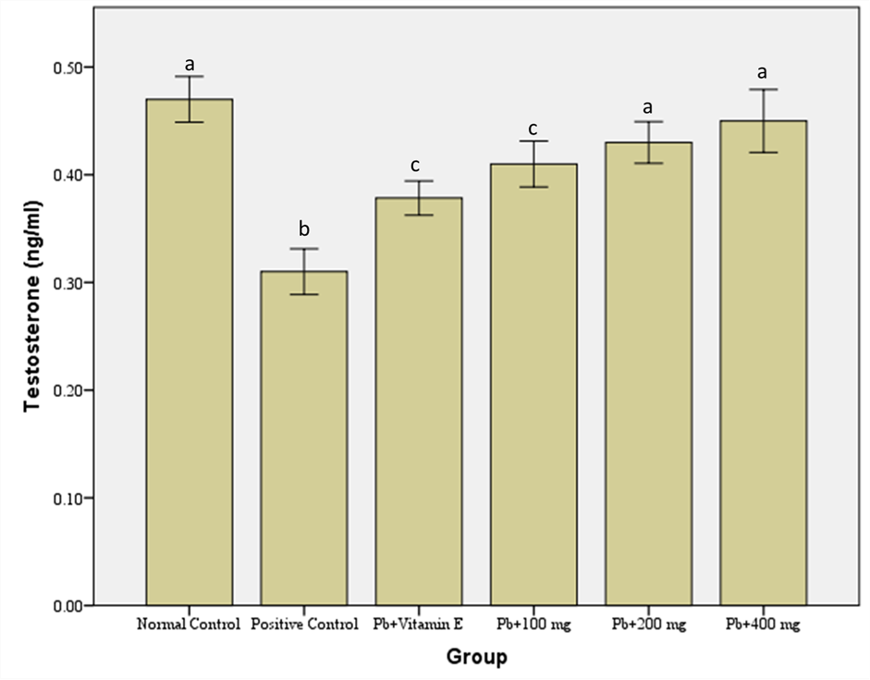

**Figure 1**: Effects of aqueous *Allium sativum* bulb extract on the testosterone levels in lead acetate induced testicular toxicity in male wistar rats. Values are expressed as mean ± SEM. Charts with different superscripts differ significantly (P<0.05).

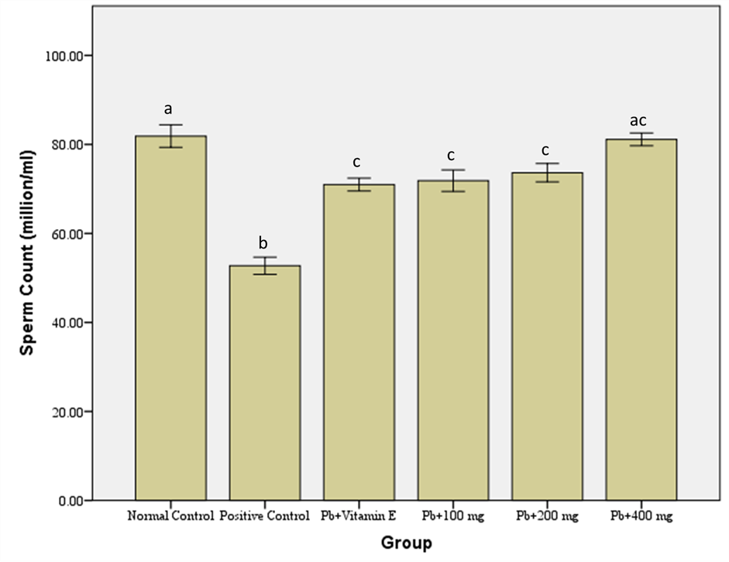

**Figure 2**: Effects of aqueous *Allium sativum* bulb extract on the sperm count in lead acetate induced testicular toxicity in male wistar rats. Values are expressed as mean ± SEM. Charts with different superscripts differ significantly (P<0.05).

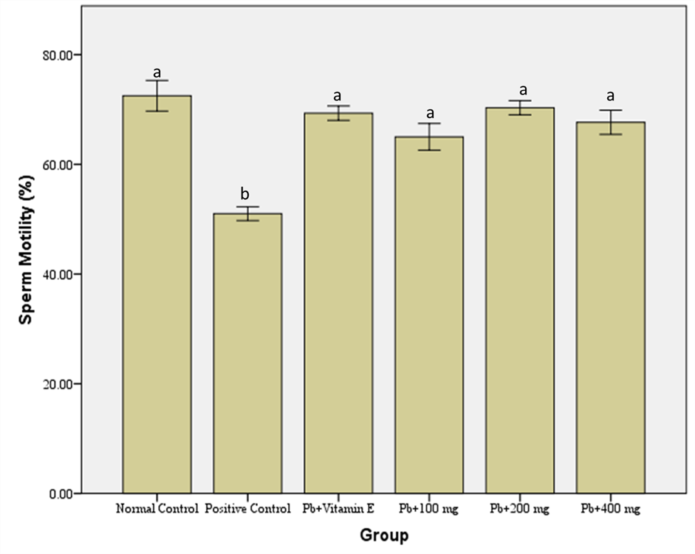

**Figure 3**: Effects of aqueous *Allium Sativum* bulb extract on sperm motility in lead acetate induced testicular toxicity in male wistar rats. Values are expressed as mean ± SEM. Charts with different superscripts differ significantly (P<0.05).

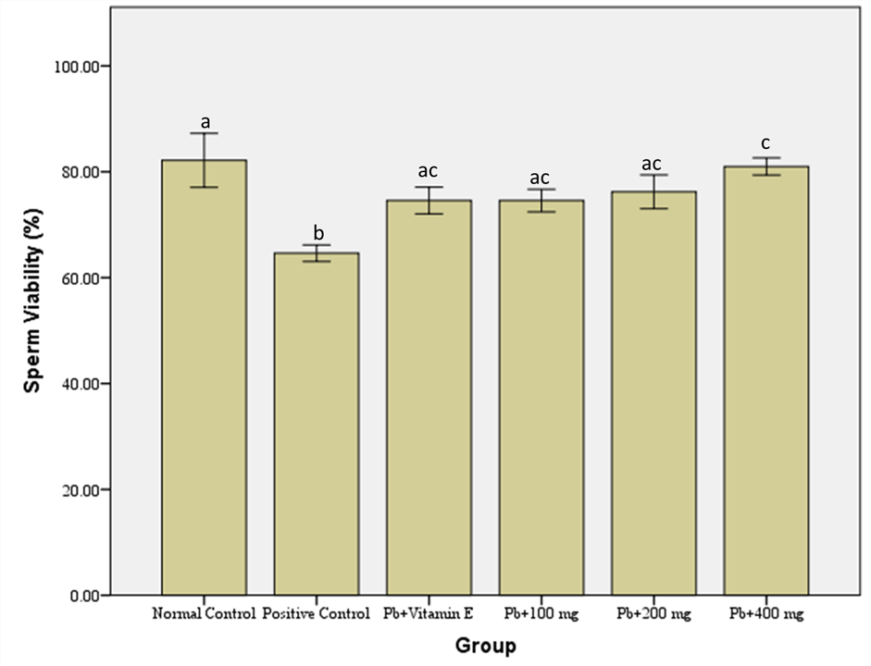

**Figure 4**: Effects of aqueous *Allium sativum* bulb extract on sperm viability in lead acetate induced testicular toxicity in male wistar rats. Values are expressed as mean ± SEM. Charts with different superscripts differ significantly (P<0.05).

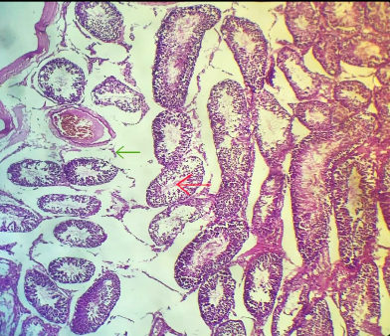

**G3**

**G4**

**G5**

**G6**

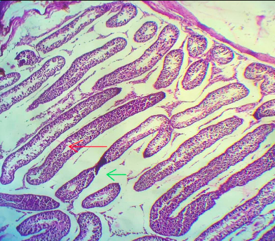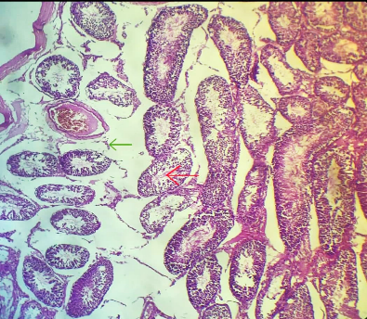

**G2**

**G1**

**Plate 1:** Photomicrograph of the testis showing effects of aqueous *Allium sativum* bulb extract on Lead acetate induced Testicular Toxicity in Male Wistar Rats. H&E × 200

**G1**: showing regular seminiferous tubules lined by spermatogenic series in varying degrees of differentiation up to spermatids (red arrow). The interstitium contains regular Leydig cells (green arrow). **G2**: showing atrophy of interstitial Leydig cells (green arrow) and reduction in intraluminal spermatids (red arrow). **G3, G4, G5 & G6:** showing restoration of spermatogenesis (red arrow) and Leydig cell atrophy has reversed (green arrow) compared to G2.

**4. DISCUSSION**

The study investigated the effects of administration of aqueous *Allium sativum* bulb extract on the testis of rats that was exposed to lead acetate toxicity.

Lead exposure has been reported to result in decreased body weight and testis weight (6,10,22,44) this could be attributed to appetite suppression, metabolic disruption and testicular atrophy.

Our findings are in line that of the aqueous *Allium sativum* extract treated groups partially mitigated weight loss which may not be sufficient to completely prevent weight loss associated with lead exposure. This was in agreement with Ola-Mudathir (30) who reported garlic extract improved reproductive health but it did not completely prevent weight loss associated with lead exposure.

The findings of this study also showed decrease in Relative Testicular Weight (RTW) of rats that were exposed to lead-toxicity, could be as a result of atrophy of the interstitial Leydig cells and reduction in intraluminal spermatids observed in the representative photomicrograph of (plate 1) which are indicative of testicular atrophy (22). This was corroborated by a significant declined in plasma testosterone levels; the hormone responsible for differentiation of male sexual characteristics (34). The administration of aqueous *Allium sativum* bulb extract to lead-acetate treated group significantly increases testicular weight in a dose-dependent manner which is in agreement with Singh (35) reported garlic extract reverses lead-induced testicular apoptosis and improvessperm quality in rats.

The highest dose of aqueous *Allium sativum* extract demonstrated (14,19,21 ) exhibited the most pronounced improvements in testicular histology, surpassing the protective effects of Vitamin E (41).

The significant decrease in plasma testosterone hormones observed agreed with findings as recorded in this of (1,45,47,). This might be as a result of disruption hypothalamic-pituitary gonadal axis, inhibition of steroidogenesis and damage to the Leydig cells. It is worthy of note to state that the aqueous *Allium sativum* bulb treated groups at higher doses produces a better attenuating testosterone level in the testis of rats when compared with the group that received vitamin E treatment.

The protective effect of aqueous *Allium sativum* extract has been reported by (20,23,46) that aqueous *Allium sativum* extract possess antioxidant and testosterone-boosting potentials in rat models exposed to lead-acetate testicular toxicity. This may have been enhanced by the presence of alkaloids and tannin in the extract. This important potentials of the aqueous *Allium sativum* extract phytochemicals are essential for reversing the deletions effect of lead on testicular functions.

The fact that sperm analysis correlated with fertility makes it one of the most sensitive tests for spermatogenesis. This makes it one of the most reliable tests for spermatogenesis (42). The lead acetate reduced induction in sperm count is indicative of testicular function was compromised. The lead acetate induced decrease sperm motility that was recorded might be functional or structural in origin.

The decline in Relative Testicular Weight and testosterone levels in the testes, as recorded in this study supports the fact. These indices show evidence of assault to the testicular tissue that was observed in the representative photomicrographs (plate 1). Also, a significant decrease in sperm motility and viability may occur if chemical agents permeate the blood-testis barrier.

This study revealed that administration of aqueous *Allium sativum* bulb extract in a dose-dependent manner successfully reversed the lead- induced alterations in sperm characteristic. This finding is consistent with the results reported by Ola-Mudathir (30) who demonstrated that the spermatogenic enhancing effects of garlic extract are dose-dependent. Thus, the results further showed that the beneficial effects were more pronounced in the group treated with aqueous *Allium sativum* extract, compared to the group received vitamin E treatment, indicating higher degree of efficacy.

Based on the result of this study, the suggested mechanism of action of aqueous *Allium sativum* extract in the reversal of lead induced alteration in sperm characteristic could be in its antioxidant and anti-inflammatory potentials enhance by the presence of phytochemicals such as alkaloids, tannins and flavonoids in its extract (23,47). The study demonstrated that the activities of these important phytochemicals have secondary beneficial effects for improving reproductive health.

The cumulative data from this study suggest that therapeutic administration of vitamin E alone may be insufficient to effectively mitigate lead-induced testicular toxicity in a rat model, indicating the need for adjunctive treatments.

**5. CONCLUSION**

The protective effects of aqueous *Allium sativum* bulb extract on testicular function may be attributed to its antioxidant and anti-inflammatory properties, which help restore homeostasis and promote overall health testicular health. Therefore, aqueous *Allium sativum* extract bulb represents a potential therapeutic strategy for mitigating lead-induced testicular toxicity and preserving testicular function in exposed subject.

**DISCLAIMER (ARTIFICIAL INTELLIGENCE)**

Author(s) hereby declare that NO generative AI technologies such as Large Language Models (ChatGPT, COPILOT, etc) and text-to-image generators have been used during writing or editing of manuscripts.

**ETHICAL APPROVAL**

Ethical approval and official permission number (PTAC/AS/(Be)/OT/73-24) were obtained from the Departments of Pharmacognosy and Ethnopharmacy, Pharmacology and Toxicology, Faculty of Pharmaceutical Sciences, Usmanu Danfodiyo University, Sokoto for the use and management of animals.

**COMPETING INTERESTS**

Authors have declared that no competing interests exist.

**REFERENCES**

1. Acharya, S., Mehta, K., Chaudhary, A. & Ralpuria, A. (2018). Toxic effects of lead on male reproductive system. *Andrology*, **63(3)**,439-446.
2. Alexander, B. H., Checkoway, H., Van Netten, C., Muller, C. H. & Kaufman, J. D. (1996). Semen quality of men employed at a lead smelter. *Annual of Occupational Environmental Medicine,* **53(6):** 411 – 416.
3. Amadi, C. N., Offor, S. J., Frazzoli, C. & Orisakwe, O. E. (2019). Natural antidotes and management of metal toxicity. *Environmental Science and Pollution* *Research*, **1:** 1–21.
4. Ashfaq, F., Ali, Q., Haider, M. A., Hafeez, M. M. & Malik, A. (2021). ‘Therapeutic activities of garlic constituent phytochemicals’, *Journal of Biological and Clinical Science Research,* 12-345.
5. Ayoka, A.O., Ademoye, A.K., Imafidon, E.C., Ojo, O. E. & Oladele, A.A. (2016). ‘Aqueous extract of *Allium sativum* (Linn.) bulbs ameliorated pituitary-testicular injury and dysfunction in wistar rats with Pb-induced reproductive disturbances’, *Journal of Medical Sciences,* **4**(**2**): 200-212.
6. Batra, N., Nehru, B. & Bansal, M. P. (2016). ‘Influence of lead exposure on testicular function in rats’, *Toxicology and Industrial Health,* **32**(**5**): 931-938.
7. Benoff, S., Centola, G. M., Millan, C., Napolitano, B., Marmar, J. L. & Hurley, I. R. (2003). ‘Increased seminal plasma lead levels adversely affect the fertility potential of sperm in IVF’, *Human Reproduction,* **18:** 374- 383.
8. Berrahal, A. A., Nehdi, A., Hajjaji, N., Gharbi, N. & El-Fazâa, S. (2007). ‘Antioxidant enzymes activities and bilirubin level in adult rat treated with lead’, *Competes Rendus Biologies,* **330:** 581-588.
9. Doaa El- Nager, M. & Badr, A. A. (2013). ‘Effect of corn oil, flax seed oil and black seed oil on testicular damage induced by lead acetate in Albino Mice: A histological study’, *Pakistan Journal of Zoology,* **45:** 1083– 1089.
10. El-Nekeety, A. A., El-Kady, A. A., Soliman, M. S., Hassan, N. S. & Abdel-Wahhab, M. A. (2015). ‘Protective effect of garlic oil against lead-induced hepatic and renal toxicity in rats’, *Environmental Science and Pollution Research,* **22**(**10**):7611-7621.
11. Elsheik, N. A. H., Omer, N. A., Li-lian, G. & Wang, G. L. (2022). ‘Lead induced oxidative stress and affected the expression of steroidgenesis-related genes in testis of male mice, Indian,’ *Journal of Forensic Medicine and Toxicology,* **16(3):** 248-254.
12. Galleano, M. & Puntarulo, S. (1997). ‘Dietary alpha-tocopherol supplementation on antioxidant defenses after in vivo iron overload in rats’, *Toxicology,* **124**:73-81.
13. Gorbel, F., Boujelbene, M., Makni, A. F., Guermazi, F., Croute, F., Soleilhavoup, J. P. & El-Feki, A. (2002). ‘Exploration des effets cytotoxiques du plomb sur la fonction sexuelle endocrine et exocrine chez le rat pubere male et femelle. Mise en evidence d'une action apoptotique. [Cytotoxic effects of lead on the endocrine and exocrine sexual function of pubescent male and female rats. Demonstration of apoptotic activity],’ *Comptes Rendus Biology*, **325:** 927-940.
14. Gupta, R. S., Yadav, R. S. & Singh, A. K. (2017). ‘Garlic protects against testicular damage in rats’, *Journal of Environmental Science and Health*. **35:** 137-144.
15. Harborne, J. B. (1980) *Phytochemical Methods*, Chapman and Hall, London. 2nd edition: 288-293.
16. Hayat, S. U., Ali, R., Khan, A. H., Din, I., Khan, S., Ullah, F., Hussain, W., Shahzadi, F. & Khan, R. A. (2022). ‘Effect of garlic (Allium Sativum) supplementation on growth performance and serum biochemistry of broiler chicks’, *American Academy of Science Research Journal of Engineering and Technology Science,* **85**(**1**): 287–300.
17. Hilderbrand, D. C., Der, R., Griffin, W. T. & Fahim, M. S. (1973). ‘Effect of lead acetate on reproduction’, *American Journal of Obstetrics Gynecology,* **115:** 1058- 1065.
18. Hsu, P. C., Liu, M. Y., Hsu, C. C., Chen, L. Y. & Leon, G. Y. (1997). Lead exposure causes generation of reactive oxygen species and functional impairment in rat sperm. *Journal of Toxicology,* **122(2):** 133 – 143.
19. Ige, O. F., Oyediran, O. O., Bakare, A. A. & Oyewole, O. E. (2017). ‘Protective effect of garlic extract on testicular damage in rats’, *Journal of Basic and Clinical Physiology and Pharmacology,* **28**(**3**): 257-264.
20. Kim, H. C., Jang, T. W., Chae, H. J., Choi, W. J., Ha, M. N., Ye, B. J., Kim, B. G., Jeon, M. J., Kim, S. Y. & Hong, Y. S. (2015). ‘Evaluation and management of lead exposure’, *Annals of Occupational Environmental Medicine,* **27**(**1**): 30.
21. Kumar, P., Kumar, N. & Thakur, S. (2011). ‘Protective effect of garlic extract against lead-induced testicular damage in rats’, *Journal Reproductive Toxicology,* **31(3):** 255-261.
22. Kumar, S., Kumar, V., Mahapatra, S. K. & Varalakshmi, C. (2014). ‘Lead-induced oxidative stress and apoptosis in testicular tissue of rats’, *Journal of Environmental Biology,* **35**(**3**): 537-544.
23. Lee, J., Lee, Y., Kim, J., Park, J. & Lee, S. (2018). ‘Allicin, a garlic compound, stimulates testosterone production in vitro’, *European Journal of Pharmacology,* **833:** 158-165.
24. Lorke, D. A. (1983). ‘New approach to practical Acute Toxicity testing’, *Archives of Toxicology,* **54:** 275-285.
25. Loumbourdis, N. S. (2003). ‘Nephrotoxic effects of lead nitrate in Rana ridibunda’, *Archives of Toxicology,* **77**: 527-532.
26. Mishra, K. P., Singh, V. K., Rani, R., Yadav, V. S., Chandran, V., Srivastava, S. P. & Seth, P. K. (2003). ‘Effect of lead exposure on the immune response of some occupationally exposed individuals’, *Toxicology,* **188:** 251-259.
27. Mudgal, V., Madaan, N., Mudgal, A., Singh, R. B., Mishra, S. (2010). Effects of toxic metals on human health. *Open Nutrition. Journal,* **3**(**2**)**:** 94–99.
28. Odell, W. D. & Parlow, A. F. (1981). Follicle stimulating and Leutinizing Hormone. *Journal of Clinical Investigation,* **47:** 2551.
29. Oladimeji, S. T., Omotade, I. O. & Olusola, B. A. (2014). ‘Dietary protection of Garlic extract against lead-induced oxidative stress and genetic birth defects’, *Oxidative Antioxidants Medical Science,* **3:** 79–82.
30. Ola-Mudathir, K. F., Akomolafe, R. O., Oladele, O. O. & Adebayo, A. O. (2018). ‘Ameliorative effects of garlic extract on reproductive toxicity induced by lead exposure in male rats’, *Journal of* *Reproductive Health*. **7**(**2**): 1-9.
31. Patra, R. C., Rautray, A. K. & Swarup, D. (2011). ‘Oxidative stress in lead and cadmium toxicity and its amelioration’, *Veterinary Medicine Inter*. 1–9.
32. Schwartz, B.S., Stewart, W. & Hu, H. (2002). ‘Neurobehavioral testing in workers occupationally exposed to lead’, *Occupational and Environmental Medicine,* **59:** 648 – 649.
33. Shalan, M. G., Mostafa, M. S., Hassouna, M. M., Nabi, S. E. & Rafie, A. (2005). ‘Amelioration of lead toxicity on rat liver with vitamin C and silymarin supplements’, *Toxicology,* **20:** 61 - 15.
34. Singh, A., Kumar, P. & Sharma, N. (2018). ‘Testosterone replacement therapy improves body composition in lead-exposed rats’, *Toxicology,* 12-21, 406-407.
35. Singh, R., Kumar, P., Kumar, V. & Mahapatra, S. K. (2019). ‘Lead-induced oxidative stress damages tissues, reducing body weight in rats’, *Toxicology Research,* **8**(**2**): 257-266.
36. Sinisa, F. (2023). ‘Infertility is one of the leading public health problems in the world’ *Journal of Gynecology Obstetrics Research,* **1(1):** 1-5.
37. Smith, John M., Emily, J. W., David, M. T., Lisa, N. N., Michael, T. G. & Jennifer, L. T. (2018). ‘Toxicity of Chemical X on Rat Testicular Weight’, *Journal of Toxicology,* **20**(**1**)**:** 12-20.
38. Sofowora, A. (1993). Medicinal plants and traditional medicine in African. Spectrum Books Ltd. (2nd ed) 26-100.
39. Trease, G. E. & Evans, W. C. (2002). Phytochemicals. In: Pharmacognosy. (15th ed). 246-249.
40. Udefa, A. L., Amama, E. A., Archibong, E. A, Nwangwa, J. N., Adama, S., Inyang, V. U., Inyaka, G. U., Aju, G. J., Okpa, S. & Inah, I. O. (2020). ‘Antioxidant, Anti-inflammatory and Anti-apoptotic effect of hydro-ethanolic extract of Cyperus esculentus L. (tigernut) on Lead Acetate-Induced Testicular Dysfunction in Wistar rats’, *Biomedicine and* *Pharmacotherapy,* **129:** 110491.
41. Ursini, M. V., Parrella, P., Festa, M., Rosso, E., D’Uva, M. & Pacchiano, F. (2016). ‘Vitamin E and reproductive health’, *Journal of Reproductive Medicine,* **62**(**2-2,2-8**).
42. World Health Organization. (2010). ‘WHO laboratory manual for the examination and processing of human semen’, 5th edition.
43. WHO Expanded Programme on Immunization. (2012). ‘Manual for the laboratory diagnosis of Measles and Rubella virus infection’, 2nd ed. Geneva.
44. Yadav, S. S., Singh, R. K., Singh, A. K., Singh, V. K. & Gupta, R. C. (2020). ‘Lead-induced reproductive toxicity in male rats’, *Journal of Toxicology,* 1–12
45. Yang, J., Wang, H., Zhang, Y. & Liu, X. (2011). ‘Garlic oil increases testosterone levels in rats’, *Journal of Ethnopharmacology,* **133**(**2**): 455-459.
46. Yang, Y., Zhang, Y., Chen, L., Wang, X. & Liu, J. (2019). ‘Garlic extract increases testosterone levels and improves spermatogenesis in rats’, *Journal of Ethnopharmacology,* **231:** 145-153.
47. Zhang, Y., Li, X., Zhao, Y., Zhang, L. & Chen, Z. (2019). ‘Effects of lead exposure on testicular damage and reproductive hormones in male rats’, *Biological Trace Element Research,* **188**(**2**): 287–297.