Toxicity Profile of Methanol Leaf Extract of Morinda Citrifolia on the Liver of Wistar Rats

ABSTRACT
Aim: The study is aimed to determine the toxicity effects of morinda citrofolia extracts on the liver of Wistar albino rat.
Study design: A total of twenty-four (24) Wistar rats were grouped into six (6), each comprises of eight rats and treated as follows: Group 1 received 1ml normal saline (control), Group2: received 100 mg/kg body weight of methanol extract of M. citrifolia leave, Group 3 received 200mg/kg body weight of methanol extract M. citrifolia leave and Group 4 received 400mg/kg of body weight of methanol extract of M. citrifolia leave
Methodology: Qualitative and quantitative phytochemical evaluation, acute toxicity assessments, biochemical liver function parameters (ALT, AST and ALP), and histology of the liver.
Results: The qualitative phytochemical analysis revealed the presence of various bioactive compounds, including alkaloids, flavonoids, saponins, and terpenoids. Quantitative analysis further revealed high concentrations of alkaloids (1540 ± 14.34 mg/100g), and flavonoids (734 ± 11.32 mg/100g of Gallic acid equivalent). Acute toxicity test revealed no mortality or signs up to an oral dose of 2000mg/kg. Liver function assays showed non-significant (p ≤ 0.05) changes in alanine aminotransferase (ALT), aspartate aminotransferase (AST), and alkaline phosphatase (ALP) levels across groups, although an increasing trend was noted. Liver histopathology exhibited mild congestion and inflammatory cell infiltration in some groups, suggesting potential mild hepato-toxic effects with prolonged exposure.
Conclusion: Morinda citrifolia methanol leaf extract demonstrated low acute toxicity, but prolonged exposure may lead to mild hepatotoxic effects. Further studies are recommended to explore the full toxicity profile of this plant extract.
Key words: Morinda citrifolia, Liver and phytochemicals
INTRODUCTION
The expression of toxicity can be considered the state of being poisonous, which is a sign of unfriendly impacts, coming about because of the association among toxicants and living cells (Wulandari et al., 2022). These interactions might vary relative to cell membrane and the biochemical properties of the toxicants, since it might take place either in the extracellular matrix and beneath tissues or on the surface of the cell, and within the cell body (Buechter and Gerken, 2022; Wulandari et al., 2024).
Medicinal plants are used in the whole world and have a growing economic importance (Jain et al., 2012). The use of plant parts to treat human or animal disease is as old as the disease itself and herbal medicine was the major form of medicine in West Africa especially in Benin. Besides, 80% of developing countries population depends on traditional medicines for their primary health care and 25% of the drugs are based on plants and their derivatives (Jain et al., 2012).
The use of plant materials for nutrient supply and therapeutic function has necessitated the exploration of the beneficial role of commonly consumed plant materials in multi-disease conditions. The absence or inaccessibility of modern healthcare services, affordability, cultural acceptance and, under certain circumstances, effectiveness than their modern counterparts have caused a large percentage of the population to rely mostly on plant based traditional medicines for their primary health care needs (Saminathan, et al., 2014). Moreover, before binding the toxicants to the vital organs, for instance, kidneys and liver or spleen, the toxic effects might have occurred.
Morinda Citrifolia Linn (Noni) is a plant belonging to the Rubiaceae family, native to Southeast Asia (Indonesia). It is also known as Ba Ji Tian, Nonu, Indian Mulberry, Canary wood, popularly known as Noni, is widely used for treatment of several diseases and gradually became prominent by its numerous medical benefits reported (TrieLy et al., 2020; Wulandari et al., 2022). The fruit is ovoid-shaped (figure 1) succulent and contains many triangular seeds of reddish coloration (Barbosa et al., 2017), and have 160 different phytochemicals. Ease of accessibility and possible therapeutic action made M. citrifolia to become popular (Matoso et al., 2013; Jambocus et al., 2016). Among its compounds, anthraquinones (damnacanthal, morindona, morindine) are notable because they have several cellular and molecular activities resulting in their various therapeutic uses (Campos et al., 2017).
In Nigeria, the use of different parts of the plant Morinda citrifolia is high. Toxicity studies is important in order to ascertain the safety and efficacy of the traditional and herbal products derived from the plant prior to consumption (Karamcheti et al., 2014; Lim et al., 2016). As at the time of carrying out this research work, there was paucity of report on the toxicity studies of leave extract of Morinda citrifolia on the Liver of wistar albino rats. The aim of this research work is to determine the toxicity effects of Morinda citrofolia extracts on the liver and of wistar albino rat.
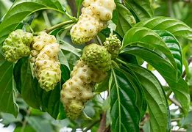
Figure 1: The Fruits and Leaves of Morinda Lucida (Chong, et al., 2019)

MATERIALS AND METHODS

Materials
Reagents/Chemicals
R1-Buffer (phosphate buffer 100mmol/L, pH 7.4, L-alanine, alpha-oxogluterate), R2- 2,4-dinitrophenyhydrazine, R1-Buffer (phospahate buffer 100mmol/L pH 7.4, L-aspartate 100mmol/L and alpha-oxogluterate 2mmol/L); R2- 2,4- dinitrophenylhydrazine,R1-Buffer (Diethanolamine buffer 1mol/L pH 9.8, MgCl2) and R2- Substrate (p-nitrophenylhydrazine), distilled water, Chloroform, Acetone, Ammonia, Acetic acid, Blood serum, Hydrogen peroxide, Formaldehyde, Randox test kits, Formal saline, Normal saline, Methanol, Filter paper, Glass bottles, Hydrochloric acid, Wagner’s reagent, 10% Sodium hydroxide, 10% Ferric chloride.

Equipment and Apparatus
Hand gloves, centrifuge, spectrophotometer, syringe and needle, micro pipette, test tubes (anticoagulant free), Sample bottles, Conical flask, Electronic weighing balance, Scale, Pipette, Measuring cylinder, Refrigerator and Olympus microscope, Rotatory evaporator, Cages, Drinkers, Canula, Beakers, Electrical blenders, Test tubes, Test tube rack, Micro pipette, Water bath, Spatula, Cotton wool, Surgical kit,

Methods

Collection and Authentication of Plant
The leaves of Morinda citrofolia were collected from Makurdi, Benue State Nigeria. The leaves were identified by a Taxonomist in the Department of plant science and biotechnology, Joseph Sarwuan Tarka University Makurdi, Benue State.

Preparation of Plant Extract
The leaves of Morinda citrofolia were air dried under room temperature. The dried leaves of the plant were pulverized using an electrical blender. The grounded sample (352 g) of Morinda citrofolia was macerated in 1500 mL of the solvent (Methanol) at room temperature for 48hours with occasional shaking. This was followed by filtration using Whatman No. 1 filter paper. The filterate was then concentrated under reduced pressure using rotatory vacuum evaporator at 40⁰C. It was then stored in an airtight container until required for the phytochemical analysis and administration to the animal model (Mauliku, et al., 2017).
The percentage yield of the extracts was calculated as follows:

Experimental animals
Twenty (30) adults female wistar rats, weighing 85–150g before the experiment were bought from the animal farm of the College of Veterinary Medicine, Joseph Sarwuan Tarka University Makurdi, Benue State Nigeria. On arrival, the rats were weighed and assigned randomly in polypropylene plastic cages with wood chips for bedding and housed in an animal room with controlled conditions. The animals were acclimatized in the animal house, College of Veterinary Medicine, Joseph Sarwuan Tarka University Makurdi, for one week. The rats were fed with standard commercial rat pellets (Pfizer feed plc, Lagos, Nigeria), and water was given ad-libitum. The animals were used in accordance with the guideline and recommendation of the ethic Committee on the use of animals for research of Joseph Sarwuan Tarka University.

Acute Toxicity study.
An acute toxicity test was performed according to the limit test recommended by the Organization for Economic Cooperation and Development (OECA) guideline 425 (OECD, 2022). Five female albino rats were weighed and used. On the first day, a single female rat that fasted for four (4) hours but with water ad libitum received 2000mg/kg of the plant extract orally. The rat was kept under strict observation for any behavioural or physical changes for twenty-four (24) hours. After 48 hours, the other four rats, one at a time were treated in the same manner. The rats were observed for gross behavioural changes such as loss of appetite, lacrimation, tremor, mortality and other sign of toxicity for 14 days (OECD, 2022).
Experimental design
Twenty-four (24) Wistar rats were grouped into six (6), each comprises of eight rats and treated as follows:
Group 1: Received 1ml normal saline (control)
Group2: Administered with 100mg/kg body weight of methanol extract of M. citrifolia leave
Group 3: Administered with 200mg/kg body weight of methanol extract M. citrifolia leave
Group 4: Administered with 400mg/kg of body weight of methanol extract of M. citrifolia leave
Two rats from each group were taken and sacrificed on the 5th, 12th and 19th of November, 2023. Also, the liver of the wistar rats were collected on the last day of the sacrifice for histopathological studies. The liver was fixed in 10% formalin for 10 days.
Qualitative Phytochemical Analysis
The phytochemical test (qualitative) was conducted using standard procedures as described by (Fitroh, et al., 2023)

Qualitative Test for Flavonoids
The extract (1 mL) was treated with few drops of sodium hydroxide solution separately in a test tube. Formation of an intense yellow colour, which becomes colourless on addition of drops of dilute acid, indicated the presence of flavonoids.

Qualitative Test for Saponin
The extract (1 mL) was diluted with distilled water in separate test tubes and they were shaken for one minute. The formation of layer of foam indicated the presence of saponins.

Qualitative Test for Tannins
The extract (1 mL) was dissolved in distilled water in the test tubes. To these solutions, 2 mL of 5% ferric chloride solution was added. The formation of blue, green or violet colour indicated the presence of tannins

Qualitative Test for Alkaloid
To the extracts, dilute hydrochloric acid was added, shaken well and filtered. To 3 mL of the filtrate, few drops of Meyer’s reagent was added along sides of test tube. Formation of creamy precipitate indicated the presence of alkaloids.

Qualitative Test for Cardiac Glycosides
Keller-Killiani test: 1 mL of glacial acetic acid was added to 2 mL of filtrate. 1 mL of ferric chloride was added followed by 1 mL of concentrated Sulphuric acid. Green-blue colouration indicates the presence of glycosides.

Qualitative Determination of Phlabotannins
The plant extract (2 mL) was boiled with 2 mL of 1% Hydrochloric acid, the formation of red precipitate indicates the presence of phlabotannins

Qualitative Test for reducing sugar
Diluted Sulphuric acid (2.5 mL) was added to 5 mL of the extract. The tube was boiled for 15minutes. The mixture was then allowed to cool and then neutralized with 10% sodium hydroxide. A brick -red precipitate indicated the presence of reducing sugar.

Qualitative Test for Terpenoids
Libermann- Burchardit test: To 1 mL of the plant extract, 1ml of Chlorofoam, 2 mL of acetate anhydride, 2 drops of concentrated Sulphuric acid was added. Pink or red colouration indicates the presence of terpenoid

Qualitative Test for Volatile oil
Diluted sodium hydroxide (0.1 mL) was added to 2 mL of the extract and small quantity of diluted HCl was added and the mixture was shook vigorously. Formation of white precipitates indicates the presence of volatile oil.

QUANTITATIVE ANALYSIS

Estimation of Total Phenolic Content
Folin Ciocalteau reagent (0.5 mL) was added to 0.5ml of the extracts in the test tubes. 0.5 mL of 15% sodium carbonate (NaCO₃) was added after few minutes, 2.5 mL of distilled water was added also to make up the solutions to 4 mL. The mixtures were allowed to stand for 20 minutes and the absorbance was read at 760 nm. The same experiment was carried out on tannic acid reference standard (Nnaoma et al., 2023) which is a known phytochemical. The concentration was calculated using this equation:
Concentration of sample (X) = x concentration of standard

Estimation of Total Flavonoid Content
To 1 mL of the plant extracts 75 µL of 5 % sodium nitrate (NaNO₃) was added. After five minutes 150 µL 10% of aluminum chloride hydrate (Al₂Cl₃) and 500 µL of 10% sodium hydroxide (NaOH) were added. 275 µL of distilled water was added after six minutes and the absorbance was read at 510nm. The same experiment was carried out on quercetin (reference standard) which is a known phytochemical (Nnaoma et al., 2023). The concentration was calculated using this equation:
Concentration of sample (X) = x concentration of standard

Estimation of Total Tannin Content
FeCl₃ (800 µL) and 800 µL Potassium ferrocyanide trihydrate (K₄Fe(CN)₆.3H₂O)were added to 1ml of the filtrate (filtered extracts) in the test tubes. The absorbance was taken within 10 minutes. The same experiment was carried out on tannic acid (reference standard) which is a known phytochemical. The concentration of was calculated using this equation:
Concentration of sample (X) = x concentration of standard

Estimation of Total Alkaloid Content
The extracts (2 mL) taken into conical flasks and they were titrated with concentrated ammonia until precipitation was completed. The samples were allowed to settle down for 5 minutes. Filter papers were weighed; after which they were used to filter the samples. The filtrates were washed using NH₃. The filter papers were labelled and allowed to dry. The dried filter papers were weighed and the differences in mass were recorded. The percentage of alkaloids present was calculated using the formula below;
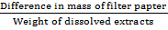 x 100

Collection of Blood Samples
At the end of the experiment, animals were anesthetized using chloroform and blood samples was collected via cardiac puncture and stored in plain tubes (without anticoagulant) for the liver function assay.

Termination and Collection of the organ liver
After the blood was collected, the rats were sacrificed. The liver was harvested and kept in 10% formaline for histological assays.

Determination of Liver Function Test
Blood samples were withdrawn from posterior vena cava from each rat and collected in serum vacuumed blood collection tubes. The blood samples were centrifuged (Hettichzent- EBA20, Germany) at 4,000 rpm for 5 minutes and then the serum were collected in microcentrifuge tubes and stored at 0°C. The serum samples were analysed using a Spectrophotometer. The levels of Alanine Transaminase, Aspartate Transaminase and Alkaline Phosphatase were determined.

Determination of Alanine Amino Transferases (ALT)
This was done based on the method by (Armstrong, 1964), Using Randox test kits.
Principle
Alpha ketoglutarate reacts with L- alanine in the presence of ALT to form L-glutamate plus pyruvate. The pyruvate is used in the indicator reaction for a kinetic determination of the reduced form of Nicotinamide Adenine Dinucleotide (NADH) consumption.

Determination of Aspartate Aminotransferase (AST)
This method was determined based on the method by (Armstrong, 1964), using Randox test kits.
Principle
Alpha ketoglutarate reacts with L- aspartate in the presence of AST to form L- glutamate plus oxaloacetate. The indicator reaction uses the oxaloacetate for a kinetic determination of NADH consumption. AST is measured by monitoring the concentration of oxaloacetate hydrazoneformed with 2, 4 dinitrophenylhydrazine. The brown colour formed is measured spectrophotometrically at 520 nm.

Determination of Alkaline Phosphatase (ALP)
Principle
ALP is an alkaline medium hydrolases phenylphosphate under defined condition of time, temperature and pH to release phenol, which reacts with 4- aminophenazone in the presence of potassium ferricyanide to give red pink colour measured spectrophotometrically at 520nm.
Histopathology of liver tissue
Principle
Alum acts as mordant and hematoxylin containing alum stains the nucleus light blue. This turns red in the presence of acid, as differentiation is achieved by treating the tissue with acid solution. Bluing step converts the initial soluble red colour within the nucleus to an insoluble blue colour.
Statistical Analysis
Results obtained were recorded as mean ± SD and subjected to one-way analysis of variance (ANOVA) and where significant differences exist, means were compared using Duncan multiple range test. It was performed using Statistical Analysis System at 0.05 significant level (p ≤ 0.05).The statistical analysis was carried out using Statistical Package for Social Sciences Software version 26 (SPSS Inc.,IL, USA).

RESULTS

Qualitative Phytochemical analysis of M citrifolia
The phytochemical analysis of Morinda citrifolia methanol leave extract shows the presences of Alkaloids, Saponins, Tannins, Phlobacternins, Reducing Sugars, Volatile oils and Steroids. However, Tannins were not detected as shown in Table 1.
Table 1: Result of qualitative phytochemical analysis of Morinda citrifolia leaves
Phytochemicals | Bioavailability
Alkaloids | +++
Saponins | ++
Tannins | +
Phlobacternin | ++
Flavanoids | +
Reducing Sugars | ++
Volatile oil | ++
Steroid | +
Terpenoids | -
Key: - not detected
+ Present in low quantity
++ Present in moderate quantity
+++ Present in high quantity

Table 2: Result of the quantitative phytochemical analysis of Morinda citrifolia leaves
Phytochemicals | Concentration (mg/100g)
Alkaloids | 1540±14.34
Flavonoids | 734±11.32
Total phenols | 1.54±0.11
Tannins | 36±4.21
Values represent triplicate analysis of n=3
Table 3: Result of the Acute Toxicity
S/NO | Dosage | No of Animals | Mortality status | Toxicity sign
1 | 2000mg/kg | 1 | 0 | No sign of toxicity shown after 14days
2 | 2000mg/kg | 1 | 0 | No sign of toxicity shown after 14 days
3 | 2000mg/kg | 1 | 0 | No sign of toxicity shown after 14days
4 | 2000mg/kg | 1 | 0 | No sign of toxicity shown after 14days
5 | 2000mg/kg | 1 | 0 | No sign of toxicity shown after 14days

Effect of Morinda citrifolia Methanol Leave extract on Alanine aminotransferase
Table 4 shows the mean values ± standard deviation (SD) of Alanine Aminotransferase (ALT) levels for different groups across three weeks. The groups are labelled as Group1, Group2, Group3, and Group4, and the measurements are taken at three different time points (Week1, Week2, Week3). The table reveals that there is no significant difference observed across the groups. At the same time, a drastic increase in ALT level is seen within the weeks in all the groups.
Table 4: Effect of Morinda citrifolia Methanol Leave Extracts on Alanine amino transferase
Groups | Week1(IU/L) | Week2(IU/L) | Week3(IU/L)
Group1 | 24.74±1.49ª | 50.09±6.82ª | 75.44±8.44ª
Group2 | 24.04±1.73ª | 52.99±7.45ª | 74.83±7.57ª
Grroup3 | 21.32±3.10ª | 59.56±11.54ª | 67.55±15.87ª
Group4 | 26.40±1.12ª | 57.99±9.06ª | 66.84±4.21ª
Values are expressed as mean ± SD; (n =6). Values with the same superscript down the column are considered not statistically significant at p ≤ 0.05
Goup1= Normal Control (1ml of Normal saline)
Group 2= 100mg/kg body weight of Plant Extract
Group3=200mg/kg body weight of Plant Extract
Group 4= 400mg/kg body weight of Plant Extracts
Week1: 2 animals were sacrificed from each group
Week2: 2 animals were sacrificed from each group
Week3: 2 animals were sacrifice from each group

Effect of Morinda citrifolia Methanol Leave Extracts on Aspartate aminotransferase
Table 5 describes the effect of the plant extracts on Aspartate amino transferase. The mean values ± standard deviation (SD) of Aspartate Aminotransferase (AST) levels for different groups across three weeks are shown on the table. A non-statistically significant difference was observed in both across the weeks and groups (P > 0). In week1, group 1 shows the highest concentration while group 2 of both week 2 and 3 has the highest concentration.
Table 5: Effect of Morinda citrifolia leave extract on Aspartate aminotransferase
Groups | Week1(IU/L) | Week2(IU/L) | Week3(IU/L)
Group1 | 65.63±1.57ª | 148.22±22.00ª | 171.19±15.79 ª
Group2 | 64.87±6.26ª | 149.33±22.00ª | 178.04±6.02ª
Grroup3 | 64.15±6.29ª | 126.74±22.53ª | 154.34±0.26ª
Group4 | 59.33±0.52ª | 135.44±7.07ª | 161.56±20.95ª
Values are expressed as mean ± SD; (n =6). Values with the same superscript down the column are considered not statistically significant at p ≤ 0.05
Goup1= Normal Control (1ml of Normal saline)
Group 2= 100mg/kg body weight of Plant Extract
Group3=200mg/kg body weight of Plant Extract
Group 4= 400mg/kg body weight of Plant Extracts
Week1: 2 animals were sacrificed from each group
Week2: 2 animals were sacrificed from each group
Week3:2 animals were sacrifice from each group
Effect of Morinda citrifolia Methanol Leave Extract on Alkaline Phosphatse
Table 6 shows the effect of M. citirifolia extracts on Alkaline phosphatase. The mean values (± standard deviation) of Alkaline Phosphatase (ALP) levels for different groups across three weeks. A variation in the mean alkaline phosphatase values for different groups appear to vary across the weeks. There was an increase in the level ALP down the group in week1 although its statistically non-significant. Week2 and 3 showed a decrease in the ALP level in group 1 (control) compared to group 4 of both groups.
Table 6: Effect of Morinda citrifolia extracts on Alkaline phosphatase
Groups | Week1(IU/L) | Week2(IU/L) | Week3(IU/L)
Group1 | 41.60±10.18ª | 44.40±2.26^{ab} | 56.00±1.13^{b}
Group2 | 40.20±0.85ª | 42.60±5.37^{ab} | 60.60±5.37^{bc}
Grroup3 | 44.20±12.16ª | 48.00±6.78 ^{b} | 66.40±0 .00^{c}
Group4 | 72.60±45.54ª | 34.20±1.98 ª | 45.60±3.96ª
Values are expressed as mean ± SD; (n =6). Values with the same superscript down the column are considered not statistically significant at p ≤ 0.05
Goup1= Normal Control (1 mL of Normal saline)
Group 2= 100mg/kg body weight of Plant Extract
Group3=200mg/kg body weight of Plant Extract
Group 4= 400mg/kg body weight of Plant Extracts
Week1: 2 animals were sacrificed from each group
Week2: 2 animals were sacrificed from each group
Week3:2 animals were sacrifice from each group

Effect of Morinda citrifolia Methanol Leave Extract on the Organ (liver) Weight.
Table 7 shows the effect of Morinda citirifolia methanol leaf extracts on the organ (liver) weight of the rats. It shows the mean values (± standard deviation) of liver weights for different groups across three weeks.
Table 7: Effect of Morinda citrifolia leave extract on the organ (liver) weight of
Groups | Week1(g) | Week2(g) | Week3 (g)
Group1 | 4.35±0.53ª | 3.71±0.59ª | 4.02±0.49ª
Group2 | 4.26±0.29ª | 5.92±0.30ª | 5.93±0.30^{b}
Grroup3 | 4.76±0.44ª | 5.05±0.00ª | 5.94±0.28^{b}
Group4 | 6.01±0.09^{b} | 5.17±1.54ª | 4.23±1.01ª
Values are expressed as mean ± SD; (n =6). Values with the same superscript down the column are considered not statistically significant at p ≤ 0.05
Goup1= Normal Control (1ml of Normal saline)
Group 2= 100mg/kg body weight of Plant Extract
Group3=200mg/kg body weight of Plant Extract
Group 4= 400mg/kg body weight of Plant Extracts
Week1: 2 animals were sacrificed from each group
Week2: 2 animals were sacrificed from each group
Week3:2 animals were sacrifice from each group

4.8 Histopathological analysis of the liver
Histopathological study shows insignificant damages on the liver cells in the various groups that were administered with M. citirifolia extracts. These damages include congestion of the central portal vein and sinusoidal dilation. The control group showed intact architectural layout with no congestion of the central portal vein. It also shows direction of sinusoidal towards the portal vein in an order with the hepatocyte sheets
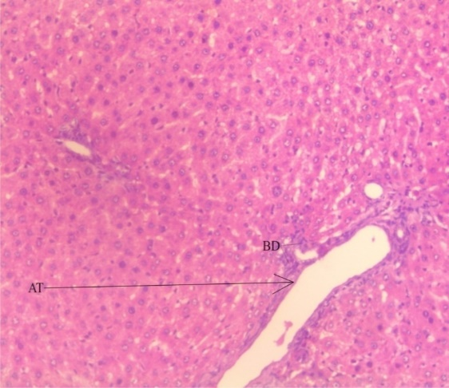
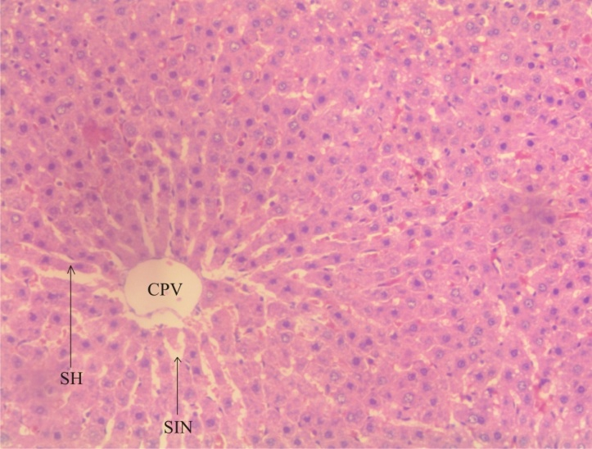
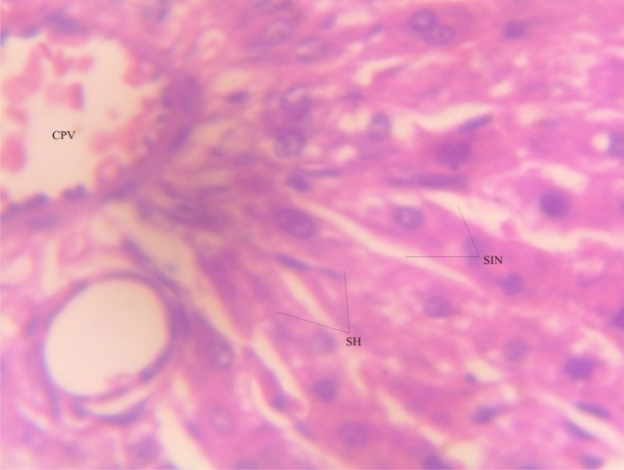
Plate1: Liver from group 1(100x) plate 2:Liver from group 2 (100x)
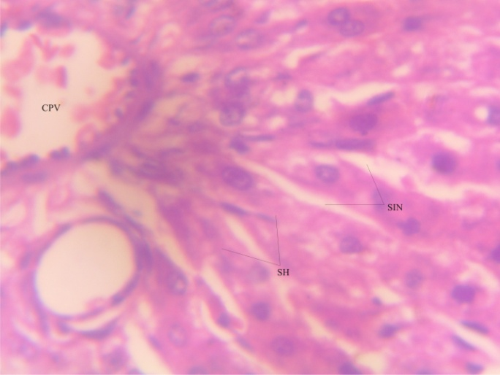
Plate3: Liver from group3 (150x) plate4:Liver from group4 (150x)
Keys: AT = Arteries; BD = Bile Duct; SH= Sheet of Hepatocytes; SIN = Sinusoids; CPV = Central Portal Vein

DISCUSSION
Toxicity studies on medicinal plants or extracts helps to determine the level of safety during drug development in particular (Jaijoy et al., 2010). Despite the benefits derived from medicinal plants, some may be a threat to the health of the users, due to the potential harmful effect or side effects which may be related to toxicity or overdose. This may lead to acute toxicity and death of the patients (Schultz, et al., 2020).
Organ toxicity is becoming an issue of concern because most herbal medicines are often used in their crude form which usually contains several other phytochemicals apart from their active compounds (Boukandou et al., 2015) The use of traditional herbal medicine is associated with dysfunction of the human organ such as liver. Several animal studies have shown some medicinal plants to be toxic to different organs (Inada et al.,2017) The preliminary qualitative phytochemical screening of the leaves of Morinda citrifolia revealed the presence of alkaloids, flavonoids, Tannins, Saponins, volatile oils, Reducing sugars and glycosides in the leaves (Table 1). The result of this study agreed with the report of Fitroh et al., (2023) who detected the presence of these phytochemicals in the leaves of these same plants. The existence of various kinds of active ingredients in Noni leaves results in many benefits of these leaves. Noni leaves have benefits as anti-inflammatories, antioxidants, natural antibiotics (Fitroh et al., 2023). However, saponins appeared to be higher in his studies which is contrary to this study which may be due to the difference in the solvent of extraction. The quantitative estimation of some phytochemicals was also carried out and the result showed that the leaves had a high content of alkaloids, saponins and reducing sugars. The presence of these phytochemicals have been reported to be associated with hepatoprotective property by preventing mitochondrial damage, increasing hepatic antioxidant enzymes and retaining the normal hepatic histology and ultrastructure of the liver (Chong et al., 2019)
The toxicological studies of the limit test investigation revealed that the methanol leave extract of Noni was relatively non-toxic to the rats at the oral dose of up to 2000mg/kg body weight as no any sign of toxicity was recorded.
The liver marker enzymes increase was non-significant within the groups (p > 0.05), although an increase in the liver enzymes secreted across the weeks was observed which suggests that there might be some toxic effect if consumed for a long time.
Serum Aspartate amino Transferase (AST), Alanine aminotransferase (ALT) and Alkaline Phosphatase (ALP) are the enzyme biomarkers to monitor the liver structural integrity and damage and aids in the clinical diagnosis of liver toxicity conditions (Beatriz et al., 2017)
The variation of ALT across the groups was not significant (P > 0.05), however, an increase in the activity of this biomarker was observed from week1 to week 3 of all the groups as shown in table 4. This indicates a continued rise in ALT levels over the three-week period. AST also had no significant increase (p > 0.05) across all the groups. On the other hand, a significant increase (p < 0.05) was observed over the three weeks period from 65.63 IU/L to 171.19 IU/L in group1, 64.87IU/L to 178.04IU/L in group 2, 64.15IU/L to 154.34IU/L in group3 and 59.33IU/L to 161.56IU/L in group 4. This indicates a continued rise in AST levels over the three-week period. In the case of ALP, a non-significant increase was observed both within the group and the weeks except in group 1-4 of week3. This is in contrast with (Wang et al., 2008). The organ weight in group 1-3 of week1 showed no significant difference, group 4 showed a significant difference compared to other groups in week1. All the groups in week 2 showed no significant difference (p > 0.05). The lack of significant differences in enzyme levels and organ weight suggests that the various concentrations of M. citrifolia extract may not have a substantial impact on these parameters within the tested ranges. On the other hand, significant increase in ALT and AST levels over the three weeks suggests a potential impact of M. citrifolia on liver function, possibly indicating liver stress or damage. ALP is an enzyme associated with liver and bone health, and its fluctuation may indicate a response to M. citrifolia. Organ weight increases over the three weeks, but the changes are not statistically significant. This might suggest a mild or gradual effect on organ weight that requires further investigation.
Injury to an organ such as liver and kidney may cause the elevation of ALT and AST with ALT been more specific for liver injury (Eric et al., 2017) Both ALT and AST can be used to identify liver damage arising from liver hepatocellular necrosis (Xuehui et al., 2021)
Histomorphological changes in the liver sections of the different groups of rats (Plates1– 4) were also noticed. From result of this study as shown in Plate 1 revealed a normal healthy state of the liver with the portal tract intact. Plate 2 shows normal vessels without congestion, Periportal hepatocytes arranged in plates and sinusoids appeared normal without infiltration, within the portal tract were the portal vein, hepatic artery and bile duct, no pathological lesion is seen.
From plate 3, the liver of the rats shows a partially disorganized cytoarchitecture with sinusoidal and central vein endothelial desquamation. It revealed mild congestion of the portal vein and focal area of mild haemorrhage, the sinusoids showed mild infiltration of inflammatory cells, mild perivascular infiltration, the sinusoids are mildly infiltrated by inflammatory cells even though the hepatocytes showed normal morphology. Plate 4 also revealed poor architecture of the liver. There was mild vascular congestion with the sinusoids showing mild infiltration by inflammatory cells. A focal area of granuloma within the liver parenchyma was seen. There was mild congestion of the portal vein which shows that some damages were done in the liver of the rat administered with highest dose of the M. citrifolia leave extracts. The present result agrees with studies of Ahmed et al. (2018) who reported a disarrangement of the hepatocytes. This suggests that prolonged consumption of this plant extracts could lead to damage of the liver cells. Algenstaedt et al., (2018) that showed that there is always an increase in cholesterol synthesis when there is a disturbance in bile release and utilization due to liver damage.

Conclusion
The Methanol extract of Morinda citrifolia had no toxic effect within the range used for this study. However, prolonged administration of the extract may lead to some toxic effect on the liver as seen in the histopathology of the rats administered for a longer duration.

Recommendation
More studies on the toxicity of Morinda citrifolia methanol extract should be carried out to know the chronic toxicity as there are no sufficient literatures with comprehensive information on the toxicity of Morinda citrifolia

COMPETING INTERESTS DISCLAIMER:
Authors have declared that they have no known competing financial interests OR non-financial interests OR personal relationships that could have appeared to influence the work reported in this paper.
Reference
- Ahmed, Z. Ahmed, U. Walayat, S. Ren, J. Martin, D.K Moole, H. Koppe, S Yong S. and Dhillon S. (2018) Liver function tests in identifying patients with liver disease, Clinical and Experimental Gastroenterology, 301-307.
- Algenstaedt, P., Stumpenhagen, A., and Westendorf, J. (2018). The effect of Morindacitrifolia L. fruit juice on the blood sugar level and other serum parameters in patients with diabetes type 2. Evidence-Based Complementary and Alternative Medicine,, 1–10.
- Alkaline Phosphatase 9001-78-9 wiki (guidechem.com)
- Barbosa, A.F., Costa, I., Langassner, S.Z. and Giordani, R.B. (2017). Morindacitrifolia: fatoseriscossobre o uso do noni. Revista Fitos, Rio de Janeiro.Vol. 11(2), 119-249,
- Beatriz, C.S., Camila B.M., Eellington, F.R., Juliana, R.M., Marco, V.S., Thiago, A.C., Javier, E.L., Thatiane, P.D., Helioswilton, S.C., Elizabeth, U.B and Carlo, J.O (2017) The effect of short term consumption of Morindacitrifolia (Noni) fruit juice on mice intestine, liver and Kidney immune modulation, Food and Agricultural Immunology, 28:3, 528-542.
- Boukandou M.M., Mewono L. and Aboughe A S. (2015). Toxicity studies of medicinal plants used in Sub-Saharan Africa. Journal of Ethnopharmacology. 174, 618-627
- Buechter M, and Gerken G. (2022). Liver Function- How to screen and to Diagnose: Insights from Personal Experiences, controlled clinical studies and future perspectives. Journal of personal Medicine. 12(10):1657
- Campos, S., Silva, C., Campana, P. and Almeida, V.J. (2017). Toxicity of plant species. Rev. bras. plantasmedine. 18, p.373-382
- Chong, C.LG., Hussan, F., Othman, F. (2019) Hepatoprotective effects of Morinda citrifolianLeaf Extract on Overiectomized Rats Fed with thermoxidized Palm oil Diet: Evidence at Histological and Ultrastructural Level. Oxidative Medicinal Cell Longevity
- Eric,s., Samuel, B; Brit, L., Alex, K. (2017) Elevated Liver Enzymes: Emmergency Department ‘Focused Management, The Journal of Emergency Medicine, 52,5
- Fitroh, A.M., Winda, Y., Teguh Setiawan, W., Akademi, F.Y., Husada, B., Mahardhika S. (2023) Phytochemical screening of Noni (Morinda citrifolia L) Leave Methanol Extracts in Pejagan Village, Bankalan Regency. Indonesian Journal of Interdisciplinary in Science and Technology. 1,7: 661-668
- Inada, A. C., Figueiredo, P. S., dos Santos-Eichler, R. A., Freitas, K., de, C., Hiane, P. A., . . . de, C. A. (2017). Morindacitrifolia Linn. (noni) and its potential in obesity-related metabolic dysfunction. Nutrients, 9(6), 1–29
- JaijoyDai, J. and Mumper, R. (2010). Plant phenolics: extraction, analysis and their antioxidant and anticancer properties. Molecules; 15: 7313-7352.
- Jain, K., Pankaj, L., Prashant, U., Neeraj, K. and Shivhare, Y. (2011). European Journal of Experimental Biology. 1(1):14-17.
- Jambocus, N. G. S., Saari, N., Ismail, A., Khatib, A., Mahomoodally, M. F., & Abdul Hamid, A. (2016). An investigation into the antiobesity effects of Morinda citrifolia L. leaf extract in high fat diet induced obese rats using a 1H NMR metabolomics approach. Journal of Diabetes Research, 1–14.
- Karamcheti, S.A., Satyavati, D., Subramanian, N.S., Pradeep, H.A., Pradeep, K.C. and Deepika, P.G. (2014). Chemoprotective effect of ethanolic extract of Morinda citrifolia against Cisplatin induced nephrotoxicity. The Pharma Innovation. 3(1): 84-91.
- Lim, S.L., Mustapha, N.M., Goh, Y.M., Bakar, N.A. and Mohamed, S. (2016). Metastasized lung cancer suppression by Morinda citrifolia (Noni) leaf compared to Erlotinib via anti-inflammatory, endogenous antioxidant responses and apoptotic gene activation. Molecular and Cell Biochemistry. 416(1-2):85-97.
- Matoso, L., de Melo, C., Menezes, L., de Oliveira, L.E. and de Oliveira, K.K.D. (2013). As Características e a Utilização do Noni (Morinda citrifolia).C&D-Revistaeletronica de Fainor, 2013. 42-50:6(1).
- Mauliku, N. E., Hendro, W., Saputo, S. H., & Kristina, T. N. (2017). Anti-tubercular activity of extract and Compounds of noni (Morinda citrifolia Linn). International Journal of Pharmacy and Pharmaceutica Sciences, 9(12), 105–109
- Nnaoma, I.N, Uchenna.F/O. Joseph R. Oguelbie N. (2023). Phytochemical Screening and invitro Antioxidant Properties of synthesized Noni Seed Nanoparticles. Academic Journal of Pharmacy 12.79-85
- OECD (2022), Test No. 425: Acute Oral Toxicity: Up and Down Procedure, OECD Guidelines for the Testing of Chemicals, Section 4, OECD Publishing, Paris.
- Saminathan, M., Ram, B.R., Kuldeep, D., Babu, L.J., Subramaniyam, S. and Gopikunte, J.R. (2014). Effects of Morinda citrifolia (noni) fruit juice on antioxidant, hematological and biochemical parameters in N-Methyl-N-Nitrosourea (NMU) induced mammary carcinogenesis in sprague-dawley rats. International Journal of Pharmacology.10(2):109-19.
- Schultz F., Anywar G., Wack B., Quave C.L., Garbe L.A (2020) Ethnobotanical study of selected medicinal plants traditionally used in the Rural Grester Mpigi regions of Uganda. Journal of Ethnopharmacology, 256, 112742.
- TrieLy, H., Nguyen, MTP Nguyen, TO., Bui, TPQ., Ke X., and Le, VM. (2020) Phytochemical Analysis and Wound-Healing Activity of Noni (Morinda citrifolia) Leaf Extract, Journal of Herbs and Medicinal Plants, 26:4, 379-393.
- Wang, M.Y. and Su, C. (2001). Cancer preventive effect of Morinda citrifolia (Noni). Ann N Y Acad Sci ;952 (1):161-8.
- Wang, M.Y., Diane, N., Gary, A., Jarakae, J. and West, B. (2008). Liver protective effects of Morinda citrifolia (noni). Plant Foods Human Nutrition. 63(2):59-63.
- Wulandari, D.D., Risthanti, R.R., Sari, E.A.P., Anisa, H., Filia, S. (2022). Phytochemical Screening and Toxicological Evaluation using Brime Shrimp Lethlity Test (BSLT) of ethanolic extract of Morinda citrifolia L. Bali Medical Journal.11(2):561-565
- Xuehui, Li., Guanjun, D., Huabao, X. and Hongyan, D. (2021). A Narrative review of the role of necrosis in liver disease: a double-edged sword. Annals of Translational Medicine 9:5-10

