**Protective Effects of *Ginkgo biloba* Against Methamphetamine-Induced Gastric Ulceration and Acid Hypersecretion in Wistar Rats**

**Abstract :**

Methamphetamine misuse is a growing global concern, contributing to significant harm to users' internal organs. This study investigated the potential protective effects of *Ginkgo biloba* extract against the ulcerogenic and gastric-stimulating effects of methamphetamine in Wistar rats. Forty-eight male albino Wistar rats were divided into four groups (n=12): one group received methamphetamine (2.0 mg/kg body weight), another received *Ginkgo biloba* (50 mg/kg body weight), and a third group received both *Ginkgo biloba* (2.0 mg/kg body weight) and methamphetamine (50 mg/kg body weight), and the control group received no treatment. After 28 days, treatment with *Ginkgo biloba* significantly alleviated the adverse effects induced by methamphetamine, including reductions in body and stomach weights, gastric acid and pepsin production, and ulcer scores, all of which reflect gastrointestinal mucosal damage. Methamphetamine intake was also found to disrupt intestinal transit time, likely due to its impact on the intestinal barrier. The treatment group showed significant increases in mucus secretion, pepsin secretion, gastric acid output, ulcer scores, and transit time compared to the other groups. Photomicrographs of the stomach revealed severe distortion of the mucosal cytoarchitecture, infiltration of the submucosal layer with eosinophils, hypertrophy of the muscular mucosa, and degeneration of glandular cells. These findings provide further insight into the physiological changes associated with methamphetamine use and point to potential therapeutic interventions targeting intestinal function. In conclusion, this study highlights the modulatory effects of *Ginkgo biloba* on METH-induced gastrointestinal alterations, suggesting its influence on intestinal transit and mucosal integrity. While these results advance our understanding of its biological interactions, further research is essential to elucidate the underlying mechanisms and evaluate its translational relevance.

**Introduction:**

Methamphetamine (METH) is a synthetic stimulant that is mostly used recreationally and has a significant potential for addiction [1]. Although it is occasionally recommended as a second-line treatment for disorders such as attention deficit hyperactivity disorder (ADHD) and obesity [2], it is nevertheless frequently abused recreationally. METH is referred to by street names like "speed," "ice," "crystal," "glass," "meth," and "chalk" in Southern East Nigeria [2]. When METH was first introduced in 1938 as Pervitin, it became well-liked by employees who needed to fight off fatigue. It was employed by the German military to cure troops' weariness during World War II. By 1943, it was prescribed for several conditions, including ADHD, narcolepsy, depression, obesity, and alcoholism [2]. METH usage and misuse are on the rise worldwide, especially in the US, Asia, and Oceania. According to [3], it is the second most commonly abused illegal substance in the world after cannabis, with over 10 million users in the United States alone and about 35 million worldwide. The prevalence of METH abuse is high among both young and old [4]. In Nigeria, METH abuse is very common, particularly among young people [5]. The ways of administering METH vary by location and can include injection, snorting, or smoking [6]. When the first euphoric effects wear off, users frequently take extra doses to extend the effects. In order to continue using METH for days, some people go on protracted "runs," skipping meals and sleep [7]. The most often used mode of administration is oral ingestion, allowing the drug to be absorbed and metabolized in the digestive system [7]. Effects of abuse include exhilaration, decreased hunger, hyperactivity, and increased talkativeness [8]. But illicit METH usage can have a serious negative effect on mental and physical health, leading to symptoms like anxiety, restlessness, stroke, disturbed sleep, lack of appetite, and excessive physical activity [9]. Flushed skin, dilated pupils, hyperactivity, and teeth grinding are some of the physical side effects of METH. According to [10], "meth mouth," a condition marked by significant teeth decay, can result from prolonged use.

In contrast to other stimulants, METH has long-lasting stimulating effects and is neurotoxic [11]. According to [12], it triggers the sympathetic nervous system, which results in acute adverse effects such diarrhea, raised body temperature, high blood pressure, fast heartbeat, and vasoconstriction. Furthermore, METH usage has been connected to serotonin system impairment, tremors, migraines, aggressive behavior, and paranoia [13]. Additionally, abusing METH can result in renal and liver failure and raise the risk of spreading infectious diseases like HIV and AIDS [14]. Glasner-Edwards & Mooney [15] have documented that METH is occasionally recommended by doctors for temporary weight loss.

For decades, *Ginkgo biloba* has been utilized in traditional medicine; in recent years, its medicinal qualities have drawn more attention. Studies conducted in the 1960s investigated its potential for treating cerebral atherosclerosis and blood flow abnormalities [16]. These days, EGb761, which comprises terpene lactones and flavonoids, is made with active components from *Ginkgo biloba* [17]. According to Almeida [18], EGb761 is used in traditional Chinese medicine to treat a number of ailments, such as bronchitis, stomach ache, asthma, and cognitive decline. The primary active ingredients of *Ginkgo biloba* are flavonoids, which are mainly taken as tablets or capsules [19]. Additionally, the plant has terpenoids, which add to its therapeutic qualities [20]. According to recent research, *Ginkgo biloba* extract offers preventive qualities, especially against toxicity. Clinical studies have demonstrated its capacity to boost mental and physical activity, improve memory, and help manage neurological and cardiovascular conditions, including Alzheimer's disease [21]. According to [22], its flavonoid and terpenoid content is essential for preventing oxidative stress and offering anti-ulcer properties.

METH was thought to harm the stomach tissues and mucosal epithelium, hence this study sought to assess its harmful effects on the stomachs of albino Wistar rats. In order to investigate potential safeguards, the researchers tested the potential of *Ginkgo biloba*, a medication high in terpenoids and flavonoids, to mitigate the harmful effects of METH on the stomach and visceral tissues in the experimental rat model.

**Materials and Methods**

**Chemicals**  
Methamphetamine (10 g) was obtained from the National Drug Law Enforcement Agency (NDLEA) and stored at temperatures below 25°C for the study.

**Experimental Animals**  
Forty-eight (48) male albino Wistar rats, initially weighing between 180-200 g, were sourced from the animal facility in the Department of Physiology, Faculty of Basic Medical Sciences, PAMO University of Medical Sciences, Port-Harcourt, Rivers State, Nigeria. The animals were housed under controlled environmental conditions (27±2ºC) with a 12-hour light/dark cycle in metabolic cages. They had unrestricted access to standard rodent chow and fresh drinking water for four weeks.

**Experimental Protocol**  
The 48 rats were randomly divided into four groups (n = 12 per group). Group 1 (control) received regular rat chow; Group 2 was given Ginkgo biloba (50 mg); Group 3 received methamphetamine (2.0 mg/kg body weight); and Group 4 was administered a combination of *Ginkgo biloba* (50 mg) and methamphetamine (2.0 mg/kg body weight). Prior to the experiment, animals were acclimatized for 7 days, and during the study, they had ad libitum access to food and water for 28 days.

**Determination of Bodyweight**  
The initial body weight of each rat was measured using an SCL-4000 animal scale (Kent Scientific Corporation). After the animals were randomly assigned to their respective groups, weekly weight measurements were recorded, and the differences in body weight were calculated. Additionally, the rats’ stomachs were excised, and their weight was recorded.

**Methamphetamine-induced Gastric Ulcer and Ulcer Score**  
Gastric ulceration in the methamphetamine-treated group was assessed according to the method outlined by [23] and modified by [24]. Following 18 hours of fasting, each rat was anesthetized with ketamine for stomach extraction. The stomach was dissected along the greater curvature, cleaned with saline, and pinned for clear visualization. The ulcer lesions were measured using calipers and magnifying glass, and ulcer scores were calculated using the method of [25].

**Estimation of Pepsin**  
Pepsin activity in gastric juice was measured using the method by Tan et al [26]. A small volume (0.1 mL) of gastric juice was centrifuged, and bovine albumin was added. The mixture was incubated, and further steps involved adding trichloroacetic acid, heating, and centrifuging the samples. The absorbance was read at 700 nm to estimate pepsin activity, expressed in μg/mL.

**Measurement of Mucus Concentration**  
The adherent mucus on the stomach lining was measured by first excising and opening the stomach. The mucus was scraped from the mucosal surface into a sample bottle, and the weight difference was measured using a digital scale, as per [26].

**Measurement of Gastric Acid Secretion by Continuous Perfusion Method**  
In a separate set of experiments, the continuous perfusion method described by [27] was used to assess gastric acid secretion. The rats were anesthetized, and the stomach was cannulated for continuous perfusion with saline at pH 7.0. After stabilization, histamine (100 mg/kg) and cimetidine (5 mg/kg) were administered subcutaneously. Gastric juice was collected every 10 minutes for analysis.

**Measurement of Intestinal Transit**  
Intestinal transit was determined based on the method by [28]. After fasting for 18 hours, activated charcoal was orally administered, and the rats were sacrificed after 9 minutes. The small intestine was carefully measured, and the distance traveled by the charcoal marker was noted to calculate intestinal transit as a percentage of the total length.

**Histological Analysis**  
Histological preparation followed the protocol of [27]. The stomach was harvested, fixed in 10% buffered formalin, and sectioned at 5 mm thickness. Hematoxylin and eosin staining was applied, and the sections were examined under a light microscope to capture photomicrographs.

**Statistical Analysis**  
Statistical analyses were conducted using GraphPad Prism software version 8.0. Data were expressed as mean ± SEM. Comparisons were made using ANOVA and an unpaired Student’s t-test. The Tukey test was used for post-hoc analysis when the F value was significant. Statistical significance was set at p<0.05.

**Results**

**Effect of Methamphetamine and *Ginkgo biloba* on Body Weight Change in Experimental Rat Groups**

Figure 1 shows the change in body weight following the administration of methamphetamine and *Ginkgo biloba* to the experimental animals. The methamphetamine-treated group displayed a significant decrease in average body weight (p<0.05) compared to the other groups. Meanwhile, the group treated with both methamphetamine and *Ginkgo biloba* showed a slight, non-significant reduction in body weight compared to the control and *Ginkgo biloba*-only groups.

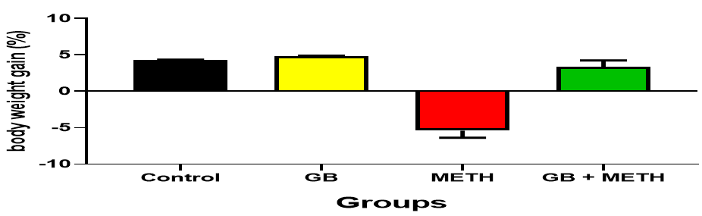

Figure 1: Body Weight Changes in Control, Methamphetamine, and *Ginkgo biloba* Treated Groups of Rats. Values are expressed as mean ± SEM, n = 12. *p* < 0.05 vs. control, GB, and (GB + METH), respectively.

**Effect of Methamphetamine and *Ginkgo biloba* on Stomach Weight Change in Experimental Rat Groups**

Figure 2 displays the changes in stomach weight following the administration of methamphetamine and *Ginkgo biloba* to the experimental animals. The methamphetamine-treated group showed a significant reduction in stomach weight (p<0.05) compared to both the control and other treatment groups. The *Ginkgo biloba*-only treatment group, on the other hand, exhibited a significant increase in stomach weight (p<0.001) relative to the control and other groups. The group treated with both methamphetamine and *Ginkgo biloba* showed a slight, but non-significant, increase in stomach weight compared to the methamphetamine-only group.

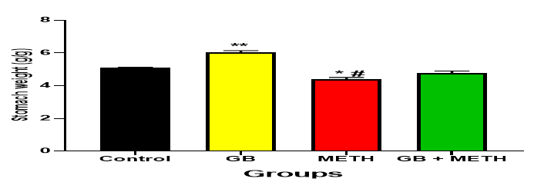

Figure 2: Stomach Weight in Control, Methamphetamine, and *Ginkgo biloba* Treated Groups of Rats. Values are expressed as mean ± SEM, n = 12. ** = p < 0.001 vs. control, METH, and GB + METH; \**# = p* < 0.05 vs. control, GB, and (GB + METH), respectively.

**Effect of Methamphetamine and *Ginkgo biloba* on Adherent Mucus in Experimental Rat Groups**

Figure 3 illustrates the effect of methamphetamine and *Ginkgo biloba* on adherent mucus in the experimental groups. The results show that the methamphetamine-treated group had a significantly higher adherent mucus weight (p<0.001) compared to both the control and other treatment groups. Additionally, the group treated with both methamphetamine and *Ginkgo biloba* exhibited a significant increase (p<0.05) in mucus weight compared to the control and the *Ginkgo biloba*-only treated groups.

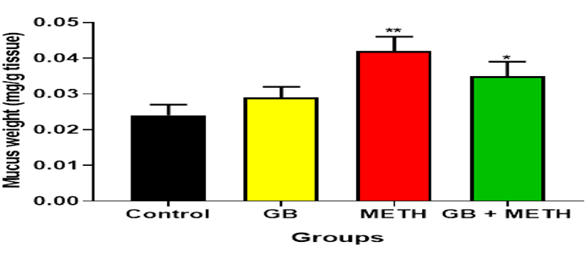

Figure 3: Effect of Methamphetamine and *Ginkgo biloba* on adherent mucus weight in the control and treated group of rats. Values are mean ± SEM, n = 12, ** = p<0.001 vs. control, GB and GB + METH, * = p<0.05 vs. control, GB and (GB +METH) respectively.

**Effect of Methamphetamine and *Ginkgo biloba* on Pepsin Secretion in Experimental Rat Groups**

Figure 4 shows the effect of methamphetamine and *Ginkgo biloba* on pepsin secretion across the treatment groups. The methamphetamine-only treated group exhibited a significant increase in pepsin secretion (p<0.001) compared to the control, *Ginkgo biloba*-only, and combined methamphetamine and *Ginkgo biloba* treatment groups. Additionally, the group treated with both methamphetamine and *Ginkgo biloba* also showed a significant increase in pepsin secretion (p<0.05).

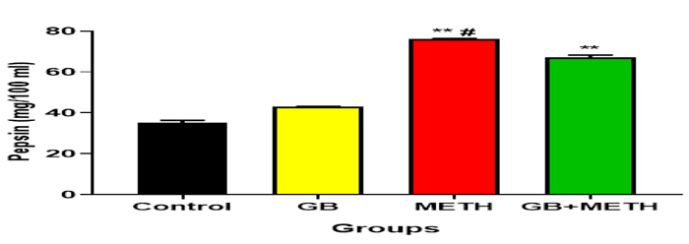

Figure 4: Effect of Methamphetamine and *Ginkgo biloba* on Gastric Pepsin Secretion in Control and Treated Groups of Rats. Values are expressed as mean ± SEM, n = 12. \*\***#** = p < 0.001 vs. control, GB, and (GB + METH); ** = p < 0.05 vs. control, GB, and METH, respectively.

**Effect of Methamphetamine and *Ginkgo biloba* on Stomach Acid Output after Histamine and Cimetidine Administration in Control and Treated Rat Groups**

The effect of methamphetamine and *Ginkgo biloba* on gastric acid output in control and experimental animals is presented in Table 1. The mean basal acid output values for the control, GB, METH, and GB+METH-treated groups were 4.3 ± 0.00, 3.98 ± 0.57, 11.7 ± 1.09, and 9.2 ± 0.18 µmol/hr, respectively. Basal acid secretion was significantly (p < 0.05) increased in the METH-only and METH+GB groups compared to the control and GB-only groups. Following histamine administration, peak acid output values for the control, GB, METH, and GB+METH-treated groups were 13.2 ± 0.07, 12.58 ± 0.19, 54.21 ± 0.03, and 43.64 ± 1.13 µmol/hr, respectively. A marked increase in gastric acid output was observed in the experimental groups. The METH-only group exhibited a significant (p < 0.001) increase in peak acid output compared to the control and other treatment groups. Similarly, the GB-only group also showed a significant (p < 0.001) increase in gastric output compared to the control. A comparable trend was observed in the METH+GB group. After cimetidine administration, the peak acid output values for the control, GB, METH, and GB+METH groups were 7.5 ± 0.01, 6.09 ± 0.38, 42.08 ± 0.06, and 30.18 ± 0.05 µmol/hr, respectively. A significant (p < 0.001) decrease in gastric output was noted in the treatment groups. The GB-only group showed a significant (p < 0.001) decrease in gastric output compared to the other treatment groups, and a similar trend was observed in both the METH and METH+GB groups.

Table 1: Effect of Methamphetamine and *Ginkgo biloba* on Stomach Acid Output Following Histamine and Cimetidine Administration in Control, and Treated Group of Rats.

|  |  |  |  |
| --- | --- | --- | --- |
| Group | Basal output (µmol/hr) | Peak acid output following histamine administration (µmol/hr) | Peak acid output following cimetidine administration (µmol/hr) |
| Control | 4.3±0.00 | 13.2±0.07 | 7.5±0.01 |
| *Ginkgo biloba* (GB) | 3.98±0.57 | 12.58±0.19* | 6.09±0.38* |
| METH | 11.7±1.09** | 54.21±0.03** | 42.08±0.06** |
| GB+METH | 9.2±0.18# | 43.64±1.13# | 30.18±0.05# |

Values are expressed as mean ± SEM, n = 12. * = p < 0.05 vs. control, GB, and (GB+METH); ** = **p** < 0.001 vs. control, GB, and (GB+METH); # = p < 0.001 vs. control, GB, and METH-only treated groups, respectively.

**Stomach Ulcer Scores in Rats among Experimental Groups**

As shown in Table 2, the mean ulcer scores for the control, GB, GB+METH, and METH-treated groups were 0.02 ± 0.23, 0.01 ± 0.33, 2.7 ± 0.23, and 1.8 ± 0.28, respectively. The METH-treated group exhibited a significant increase (p < 0.001) in ulcer scores compared to the control, GB, and GB+METH groups. However, the METH+GB group showed a significant reduction (p < 0.001) in ulcer scores compared to the METH-only treated group."

**Table 2: Effect of Methamphetamine and *Ginkgo biloba* on Stomach Ulcer Scores in Control and Treated Groups of Rats**

|  |  |
| --- | --- |
| Group | Ulcer score |
| Control | 0.02±0.23 |
| *Ginkgo biloba* (GB) | 0.01±0.13 |
| METH | 2.7±0.23** |
| GB+METH | 1.8±0.28**# |

Values are mean ± SEM, n = 12, ** = p<0.001 vs. control, GB, and GB+METH groups; **# = p<0.001 vs. control, GB, and GB+METH-treated animals respectively.

**Intestinal Transit in Rats across Experimental Groups**

The effects of methamphetamine and *Ginkgo biloba* on intestinal transit in the various experimental groups are summarized in Table 3. The mean intestinal transit values for the control, GB, GB+METH, and METH-treated groups were 75.23 ± 0.25%, 73.89 ± 0.14%, 81.53 ± 1.67%, and 77.12 ± 0.81%, respectively. A significant increase (p < 0.001) in intestinal transit was observed in the METH-treated group compared to the control and other treatment groups. Notably, the GB+METH group showed a significant reduction (p < 0.05) in intestinal transit compared to the METH-only group.

**Table 3: Effect of Methamphetamine and *Ginkgo biloba* on Intestinal Transit in Control and Treated Groups of Rats**

|  |  |
| --- | --- |
| Group | Intestinal transit (%) |
| Control | 75.23±0.25 |
| *Ginkgo biloba* (GB) | 73.89±0.14 |
| METH | 81.53±1.67** |
| GB + METH | 77.12±0.81# |

Values are mean ± SEM, n = 5, ** = p<0.001 vs. control, GB, and (GB + METH) groups respectively. # = p<0.05 vs. METH group.

**Effect of methamphetamine and *Ginkgo biloba* on the stomach mucosa of experimental animals**

Figure 5 (A–D) shows photomicrographs of the stomach mucosa from the control and experimental groups of animals. In the control group (A), the mucosa exhibited normal cytoarchitecture with well-preserved surface mucus epithelial cells (red arrow), and intact chief cells (yellow arrow) and parietal cells (black arrow). In the GB-only treated group (B), similar normal mucosal architecture was observed, with more prominently preserved surface mucus epithelial cells (red arrow), as well as intact chief (yellow arrow) and parietal cells (black arrow).  
In the METH-treated group (C), the surface epithelium showed signs of superficial erosion (red arrow) and marked vascular congestion (black arrow). The mucosa also revealed severe eosinophilic infiltration extending into the submucosa (green arrow), hypertrophy of the muscularis mucosae (yellow arrow), and degeneration of glandular cells (blue arrow).  
In contrast, the METH+GB-treated group (D) demonstrated recovery of the surface epithelium, with restoration of both superficial and deep glandular cells (black arrow).

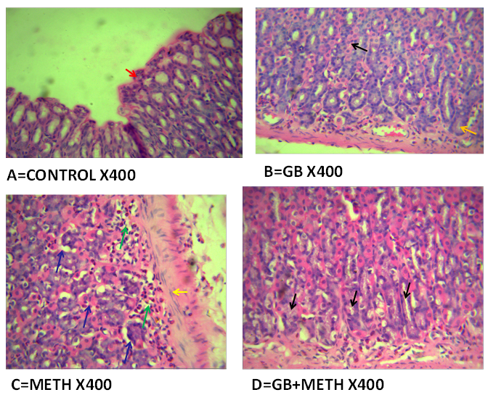

Figure 5: Photomicrographs illustrating methamphetamine-induced mucosal damage and the potential protective effect of *Ginkgo biloba*. (A = Control group; Red arrow = normal cytoarchitecture with well-preserved surface mucous epithelial cells; Yellow arrow = intact chief cells; Black arrow = intact parietal cells.) (B = *Ginkgo biloba* group; Red arrow = well-preserved surface mucous epithelial cells; Yellow arrow = intact chief cells; Black arrow = intact parietal cells.) (C = METH-treated group; Red arrow = superficial epithelial erosion; Black arrow = severe vascular congestion; Green arrow = extensive eosinophilic infiltration reaching the submucosa; Yellow arrow = hypertrophy of the muscular mucosa; Blue arrow = glandular cell degeneration.) (D = METH+GB group; Black arrow = recovery of surface epithelium with restoration of superficial and deep glandular cells.)

**Effect of Methamphetamine and *Ginkgo biloba* on the Gross Morphology of the Stomach in Control and Experimental Groups of Rats**

The gross morphological features of the stomach across the control and experimental groups are illustrated in Figure 6A–D. In both the control group (A) and the GB-treated group (B), the stomach mucosa exhibited normal cytoarchitecture. In contrast, the METH-treated group (C) showed a high number of ulcerative lesions (red arrow). Notably, the METH+GB-treated group (D) displayed a reduced number of ulcer lesions (blue arrow) compared to the METH-only group.

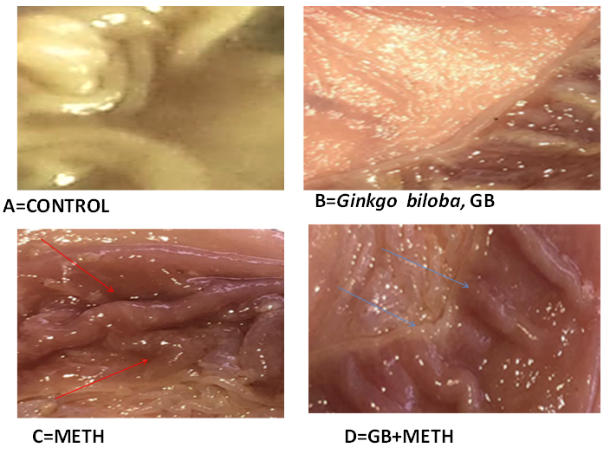

**Figure 6:** Gross morphology of the stomach illustrating methamphetamine-induced ulceration and the potential protective effect of *Ginkgo biloba* in the animal model.  
(A) Control group: normal mucosal cytoarchitecture.  
(B) GB-treated group: normal mucosal cytoarchitecture.  
(C) METH-treated group: increased number of ulcer lesions (red arrow).  
(D) METH+GB-treated group: reduced number of ulcer lesions (blue arrow).

**Discussion**

The gastrointestinal physiology of albino Wistar rats was reported to be negatively impacted by the injection of methamphetamine (METH). Rats given METH specifically displayed decreased body and stomach weight, mucus secretion, gastric acid production, ulcer scores, pepsin secretion, and intestinal transit time. Severe mucosal damage, including cytoarchitectural distortion, epithelial erosion, eosinophilic infiltration, muscular mucosa enlargement, and glandular cell degeneration, was confirmed by histological examination of stomach tissues. According to these findings, METH causes significant gastrointestinal disruption and inflammation.

By raising dopamine levels in the brain, which reduce hunger and change ghrelin and leptin signaling, METH seems to have an impact on the hypothalamic areas that regulate appetite. This is in line with the weight loss that was seen and confirms earlier research by [29] that connected METH usage to appetite suppression and weight loss. The loss in stomach weight is probably the result of ischemia, mucosal injury, and poor digestion due to inflammation and vasoconstriction brought on by METH.   
On the other hand, many of these negative effects were lessened by *Ginkgo biloba* extract, which is high in flavonoids and antioxidants. Rats that received *Ginkgo biloba* concurrently displayed decreased gastric acid and pepsin production, improved body and stomach weight, and decreased ulcer scores. According to earlier research Noor et al [30] *Ginkgo biloba* promotes insulin signaling, lowers inflammation (by down regulating NF-κB and TNF-α), and increases blood flow. These effects may help heal damaged tissue and facilitate the absorption of nutrients. These characteristics support its medicinal potential in reducing the METH-induced toxicity.   
Given that pepsin not only facilitates digestion but also aggravates mucosal damage, impeding ulcer repair, the increased pepsin secretion seen in the METH group is especially concerning [31]. This, together with increased acid production, makes the stomach lining unfavorable. For instance, in the METH group, gross observations showed widespread ulceration and micro-bleeding, confirming significant mucosal degradation. Inflammatory features such as eosinophilic infiltration, glandular degeneration, and muscle hypertrophy that all indicate METH-induced stomach disorders- were seen in photomicrographs. METH treatment also increased intestinal transit time, which may have been due to permeability-increasing intestinal mucosal injury and epithelial barrier breakdown. Li's [32] findings, which connected METH usage to impaired gut integrity, are consistent with this discovery.

The protective effects of *Ginkgo biloba* co-administered with METH were demonstrated by better stomach histology, which showed less ulcers and a partial restoration of mucosal integrity. These findings are consistent with past research showing that the anti-inflammatory and antioxidant properties of *Ginkgo biloba* provide gastroprotective benefits [33]. The precise mechanism by which *Ginkgo biloba* ameliorated this impact by shortening transit time is unclear. It could be adduced that the gut environment may be stabilized due to its antioxidant properties, although more research is required to fully understand this.

**Conclusion**

In conclusion, this study shows that long-term METH use negatively impacts gastrointestinal function by lowering stomach and body weight, raising pepsin and acid output, causing mucosal injury, and slowing intestinal transit. *Ginkgo biloba* extract considerably reduced these symptoms, most likely as a result of its antioxidant, anti-inflammatory, and mucosal-healing qualities. These findings highlight the modulatory effects of Ginkgo biloba on METH-induced gastrointestinal alterations, suggesting its influence on intestinal transit and mucosal integrity. While these results advance our understanding of its biological interactions, further research is essential to elucidate the underlying mechanisms and evaluate its translational relevance.

**References:**

1. Panenka WJ, Procyshyn RM, Lecomte T, et al (2013) Methamphetamine use: A comprehensive review of molecular, preclinical and clinical findings. Drug Alcohol Depend 129:167-79.
2. Prakash, M.D., Tangalakis, K., Antonipillai, J., Stojanovska, L., Nurgali, K. And Apostolopoulos, V. (2017). Methamphetamine: effects on the brain, gut, and immune system. Pharmacological research; 120: 60-67.
3. Salamanca SA, Sorrentino EE, Nosanchuk JD and Martinez LR (2015) Impact of methamphetamine on infection and immunity. Front Neurosci 8:445 doi: 10.3389/fnins.2014.00445.
4. SAMHSA. (2023). Substance Abuse Centre for Behavioural Health Statistics and Quality. Results from the 2021 National Survey on Drug Use and Health: Detailed Tables. Accessed April 2024
5. Chigbu E, Oguzie A, Augustine N, Ngwaka L, Onu E (2022) Effects of Cognitive Restructuring and Self Management Techniques on Methamphetamine Abuse among Youth in Enugu State, Nigeria. Human Nature Journal of Social Sciences 3(3):335-345
6. Blaker, A.L., & Yamamoto, B.K. (2018). Methamphetamine-Induced Brain Injury and Alcohol Drinking. Journal of Neuroimmune Pharmacology, 13(1), 53–63. doi:10.1007/s11481-017-9764-3.
7. Chomchai C, Chomchai S (2015) Global patterns of methamphetamine use. Curr Opin Psychiatry 28:269-74.
8. Bearn, J. and O'Brien, M. (2015). Chapter Ten - Addicted to Euphoria: The History, Clinical Presentation, and Management of Party Drug Misuse. International Review of Neurobiology. Vol 120 Academic Press pp; 205–33.
9. Okonkwo CO (2022) The Relevance of Rational Emotive Behavioural Therapy on The Reduction of Crystal Methamphetamine (Mkpuru Mmiri) Use Among the Youth in Nigeria. International Journal for Psychotherapy in Africa 7(1)
10. Hussain, F., Rw, F. and Kl, P.B. (2012). Drug abuse identification and pain management in dental patients: a case study and literature review. PubMed; 60 (4): 334–337.
11. Kim, B., Yun, J. and Park, B. (2020). Methamphetamine-induced neuronal damage: neurotoxicity and neuroinflammation. Biomolecules & therapeutics 28(5): 381.
12. Ahmadi, I. and Foruozandeh, H. (2020). Evaluation of the multi-organs’ toxicity of methamphetamine in rats. Toxicologie Analysis etiqueet Clinique; 32 (1): 4-11.
13. Koriem KMM, Abdelhamid AM, Younes HF (2013) Caffeic acid protects tissue antioxidants and DNA content in methamphetamine induced tissue toxicity in Sprague Dawley rats. Toxicology Mechanisms and Methods 23(2):134–143
14. Al‐Shammry AA, Yasser A, Refaat A (2024) Death from methamphetamine intoxication in a body stuffer. Journal of forensic sciences 69(1):365-370
15. Glasner-Edwards S, Mooney LJ (2014) Methamphetamine psychosis: epidemiology and management. CNS Drugs 28:1115-26
16. Talreja, S. and Tiwari, D.S. (2023). An In-Depth Exploration of Ginkgo Biloba: A Review. Int J in Pharm Sci 1(7): 326-334.
17. Müller, W.E., Eckert, A., Eckert, G.P., Fink, H., Friedland, K., Gauthier, S. and Möller, H.J. (2019). Therapeutic efficacy of the Ginkgo special extract EGb761® within the framework of the mitochondrial cascade hypothesis of Alzheimer’s disease. The World Journal of Biological Psychiatry 20(3): 173-189.
18. Almeida, E.R. (2009). Plantasadaptógenas e com ação no sistemanervoso central. São Paulo: Biblioteca, 24.
19. Chen, S., Wang, Z., Huang, Y., Ouyang, K., & Zhang, Y. (2021). Overview and Recent Progress on the Biosynthesis and Regulation of Flavonoids in Ginkgo biloba. Frontiers in Plant Science, 12, 750444.
20. Okhti ZA, Abdalah ME, Hanna DB (2021) Phytochemical structure and Biological Effect of Ginkgo biloba leaves: A review. International Journal of Pharmacological Research 13(2)
21. Yalçın E, Çavuşoğlu K, Acar A, Yapar K (2020) In vivo protective effects of Ginkgo biloba L. leaf extract against hydrogen peroxide toxicity: cytogenetic and biochemical evaluation. Environmental Science and Pollution Research 27:3156-3164
22. Liu H, Ye M, Guo H (2020) An Updated Review of Randomized Clinical Trials Testing the Improvement of Cognitive Function of Ginkgo biloba Extract in Healthy People and Alzheimer’s Patients. Frontiers in Pharmacology, 10
23. Hawthorne, A.B., Mahida, Y.R., Cole, A.T. and Hawkey, C.J. (1991). Aspirin‐induced gastric mucosal damage: prevention by enteric‐coating and relation to prostaglandin synthesis. British journal of clinical pharmacology; 32 (1): 77-83.
24. Umoren, E. B., Okon, I. A., Idabie, P. B., Owu, D. U., Bassey, A. L., & Efiom, E. O. (2023). Jatropha tanjorensis ameliorates effects of aspirin-induced stomach ulcer in Wistar rats. Journal of Gastrointestinal & Digestive System, 13(732).
25. MacAllister, C.G., Andrews, F.M., Deegan, E., Ruoff, W. and Olovson, S.G. (1997). A scoring system for gastric ulcers in the horse. Equine Vet J; 29 (6): 430-3.
26. Tan, M.S., Yu, J.T., Tan, C.C., Wang, H.F., Meng, X.F., Wang, C., Jiang, T., Zhu, X.C., and Tan, L. (2015). Efficacy and adverse effects of Ginkgo biloba for cognitive impairment and dementia: a systematic review and meta-analysis. J Alzheimers Dis.; 43, (2): 589-603.
27. Ismail OI, El-Meligy MMS (2022) Curcumin ameliorated low dose Bisphenol A induced gastric toxicity in adult albino rats. Sci Rep 12: 10201.
28. Umoren, E. B., Obembe, A. O., & Osim, E. E. (2013). Ulcerogenic and intestinal motility/transit stimulating actions of nevirapine in albino Wistar rats. Journal of Physiology and Biochemistry, 69(3), 547–557
29. National Institute on Drug Abuse (NIDA). (2022). Methamphetamine drug facts. Retrieved from <https://nida.nih.gov/publications/drugfacts/methamphetamine>
30. Noor-E-Tabassum, Das. R., Lami, M.S., Chakraborty, A.J., Mitra, S., Tallei, T.E., Idroes, R., Mohamed, A.A., Hossain, M.J., Dhama, K., Mostafa-Hedeab, G. and Emran, T.B. (2022). Ginkgo biloba: A Treasure of Functional Phytochemicals with Multimedicinal Applications. Evid Based Complement Alternat Med; 8288818.
31. Smith, J.A. (1995). Reflux esophagitis and its role in the pathogenesis of Barrett's metaplasia. J Clin Gastroenterol; 21 Suppl 1: S13-7.
32. Li, Y., Kong, D., Bi, K., and Luo, H. (2022). Related Effects of Methamphetamine on the Intestinal Barrier via Cytokines, and Potential Mechanisms by Which Methamphetamine May Occur on the Brain-Gut Axis. Front Med (Lausanne); 9: 783121
33. Abd-Eldayem AM, Alnasser SM, Abd-Elhafeez HH, Soliman SA, Abdel-Emam RA (2022) Therapeutic Versus Preventative Use of Ginkgo biloba Extract (EGb 761) against Indomethacin-Induced Gastric Ulcer in Mice. Molecules 27(17):5598