Case report

Transverse colon volvulus presenting as bowel obstruction: a rare case report and literature review

**Abstract**

Volvulus of transverse colon is a rare cause of large bowel obstruction, the total number of cases reported in the literature is 100. The usual sites affected being the sigmoid colon (75%), the caecum (22%) and the transverse colon (2%).

It is a surgical emergency that can lead to bowel infarction, peritonitis, and death.

It is important to highlight this case and those of the literature, as many gastro-enterologist and surgeons may have never seen a case of transverse colon volvulus.

So hrough the column of this article, we describe a 52 years old male to whom the clinical presentation and the radiological findings were that of large bowel obstructionA subtotal colectomy and colostomie were performed.

Keywords : Transverse colon, Volvulus, ogilvie syndrome

**Introduction**

Colonic volvulus is the axial twisting of the colon on its vascular pedicle. Rare sites of colonic volvulus include the transverse colon (about 2%) and the splenic flexure (1-2%) [1].

To our knowledge, few reports have been published to date less than 100 patients were described with such a diagnosis (2).

Such emergency can lead to infarction, peritonitis, and death [3].

Below we present a case of a 52 years old patient presented with acute transverse colon volvulus.

**Case Report**

We report a history that goes back to 27/07/23 of a 52 years old man, with one year history of constipation there was no other significant past medical history, particularly psychiatric disease, or abdominal surgery. starting by the appearance of a sub occlusive syndrome made of cessation of materials and gas his last bowel movement had been 3 days ago.

Followed by the appearance of abdominal pain the leading cause of nausea without vomiting of ​​progressive aggravation, which motivated a consultation.

Examination on admission shows a conscious patient, his blood pressure was at 120/80 mmHg and his heart rate was at HR 88 pulses per minute. His respiratory rate at 23c /min and arterial oxygen saturation at 96% at room air without fever (body temperature at 36°.9C),

The abdominal exam showed an important distention associated to tympanitic abdomen to percussion without signs of peritonitis.

The digital rectal exam showed an empty rectal ampulla without any intraluminal mass.

The abdomen without preparation (ASP) that finds out one of its good indication showed an aspect of bowel volvulus. The patient was admitted in our gastro enterology unit for further investigations.

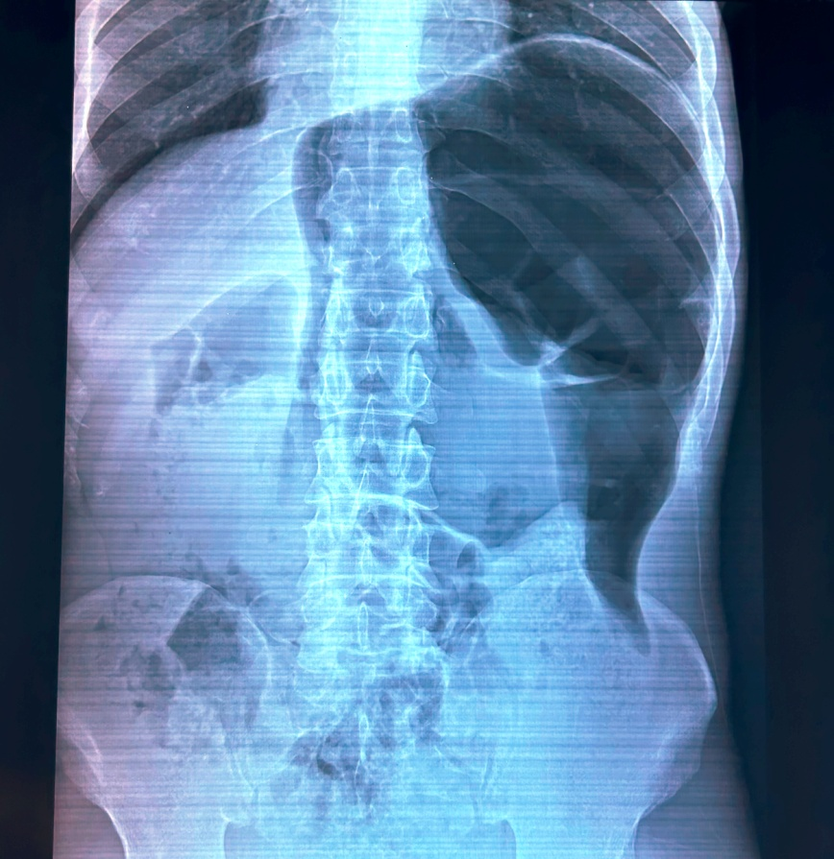

Figure 1: ASP revealing important bowel volvulus

ct scan showed colon distention without obstacle concluding to probable Ogilvie syndrome.

The patient's biological assessment revealed a white blood cell number of 4,820 cells / mm 3 (Neutrophils 3040, lymphocytes 1200), hemoglobin of 12.2 g /dl, thrombocytes at 190,000 cells /mm3. Prothrombin time and partial thromboplastin time were normal (TP at 70% and TCA at 26s for a witness of 23s).

Natremia:142 mmol / l, kalemia: 3.9mmol / l, correct liver and renal function (urea : 0.72 g /l and creatinine : 8.9 mg /l, ASAT : 20 IU / l and ALT: 24 IU / l), fasting blood sugar at 1.03 g / l, C-reactive protein at 1 mg /l, albumin 42 g/l

Therapeutic management included oxygen therapy, medical pain treatment.

Therapeutic exufltation colonoscopy was performed showing enlarged colonic lumen without obstructive cause concluding to an aspect of a dolichocolon.

On the second day, the symptomatology worsened by the aggravation of pain and abdominal distention leading to a surgical exploration.

The surgical exploration showed purulent peritoneal effusion and dolichocolon with necrotic transverse colon volvulus realising two spire towers

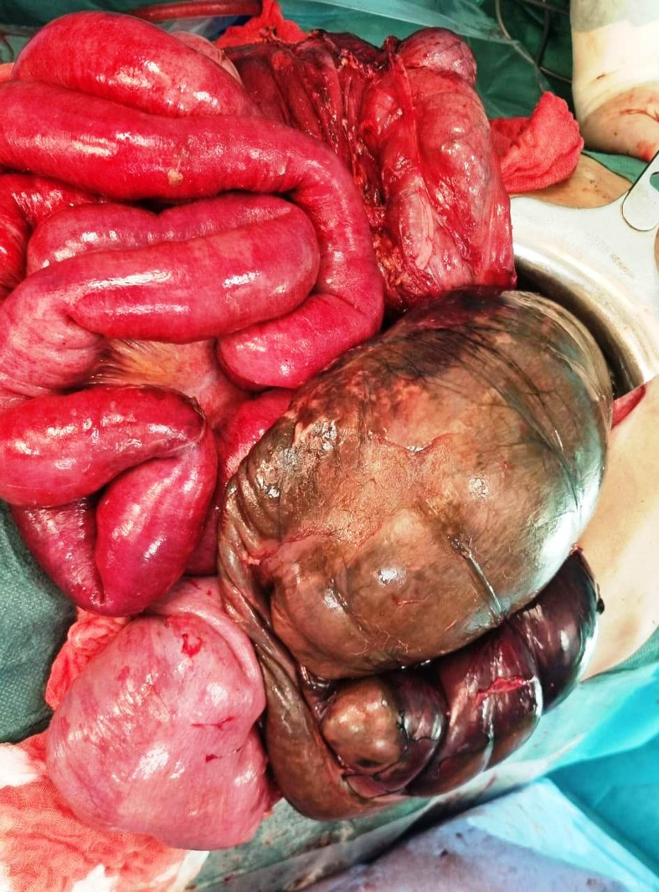

Figure 2 : peropertive image showing necrotic transverse colon volvulus

**Discussion:**

Volvulus of the transverse colon case first described in 1932 by the Finnish surgeon Kallio [4].

it is an abnormal twisting of bowel along its mesenteric axis leading to closed-loop obstruction. It stops venous return and compromises arterial supply leading to ischemia [5].

Volvulus itself is an unusual cause of intestinal obstruction accounting for 5% of cases of gastrointestinal obstruction and 10-15% of large bowel obstruction.

Moreover, chronic constipation seems to be associated with the occurrence of the transverse colon`s volvulus by causing its excessive elongation [6].

Given the clinical picture and morphological transformations, acute volvulus form is characterized by the sudden severe abdominal pain, peritoneal signs, nausea, vomiting, and severe clinical state.

Insufficiently rapid implementation of an effective treatment can lead to exacerbation and transition to a fulminating form [7/8].

The diagnosis of this condition is usually made at laparotomy despite a thorough history, examination and appropriate radio logical investigations [9].

In the absence of clinical and radiological signs of necrosis or perforation, the initial management of volvulus involves colonoscopic derotation and decompression followed by semi-elective resection and anastomosis after optimizing the patient [10/11].

According to the literature; in contrast to the volvulus of the sigmoid colon and caecum, an attempt of endoscopic decompression and drainage of the colon is not recommended mainly due to the high probability of necrosis In the case of volvulus of transverse colon [12], the mortality rate is 33%, which is much higher than the mortality rate recorded for the volvulus of the sigmoid colon or cecum, which is 21% and 10% respectively [13].

Our patient had an extensive right hemicolectomy with colonostomy; His postoperative

course was eventful; the symptomatology worsened by an hemodinamical intability, the patient was intubated and passed away within 24 hours after the surgery.

**Conclusion:**

Transverse colon volvulus is a rare cause of bowel obstruction syndrome. Its diagnosis is challenging.

Prompt recognition with emergency intervention constitutes the key to a successful outcome to prevent complications.

**References**

1. Lianos G, Ignatiadou E, Lianou E, Anastasiadi Z, Fatouros M. Simultaneous volvulus of the transverse and sigmoid colon: case report. G Chir. 2012;33(10): 324-326.

2. *Ciraldo A, Thomas D, Schmidt S*: Case report: transverse colon volvulus associated with Chilaiditis Syndrome. *Internet J Gastroenterol* 2000; 1: 1.

3. Sana L, Ali G, Kallel H, Amine B, Ahmed S, Ali M, *et al*. Spontaneous transverse

colon volvulus. Pan African Med J. 2013;14:1937–8688.

4. Kallio KB. Uber volvulus transversii. Act Chir Scand. 1932;70:39–58

5. Sparks DA, Dawood MY, Chase DM, Thomas DJ. Ischemic volvulus of the transverse colon: a case report and review of literature. Cases J. 2008;1(1): 174.

6. *Casamayor Franco MC, Gracia Solanas JA, Artigas Marco C* et al.: Intestinal occlusion secondaryto transverse colon volvulus. *Rev Esp Enferm Dig* 2005; 97: 914-15.

7. *Sparks D, Dawood M, Chase D* et al.: Ischemic volvulus of the transverse colon: A case report and review of literature. *Cases J* 2008; 1: 174.

8. *Eisenstat TE, Raneri AJ, Mason GR*: Volvulus of the transverse colon. *Am J Surg* 1977; 134: 396.

9. Islam S, Hosein D, Bheem V, Dan D. Synchronous volvulus of the sigmoid colon and caecum, a very rare cause of large bowel obstruction. Case Reports. 2016; 2016: bcr2016217116.

10.Motsumi MJ, Tlhomelang O. Synchronous volvulus of the sigmoid and transverse colon in a 26-year-old male. J Surg Case Rep. 2018;2018(11): rjy295.

11. Chung YFA, Eu KW, Nyam DCNK, Leong AFPK, Ho YH, Seow-Choen F. Minimizing recurrence after sigmoid volvulus. British Journal of Surgery. 1999;86(2): 231-233.

12.*Echenique M, Amondaraín JA*: Colonic volvulus. *Rev Esp Enferm Dig* 2002; 94: 201-05.

13. *Ciraldo A, Thomas D, Schmidt S*: Case report: transverse colon volvulus associated with Chilaiditis Syndrome. *Internet J Gastroenterol* 2000; 1: 1