***Original Research Article***

**Effect of Photobiomodulation Therapy in an *In Vitro* Model of Lung Adenocarcinoma**

**ABSTRACT**

|  |
| --- |
| **Aims:** To evaluate the dosimetric parameters and biological effects of photobiomodulation in an *in vitro* model of urethane-induced lung adenocarcinoma. Specifically, to quantify inflammatory mediators (IL-6, IL-8, IL-10, IL-1β, and IFN- γ) and assess the functional activity of BEAS-2B cells after irradiation with low-level laser therapy (LLLT) at two energy densities (3J and 7.5J).  **Study design:** An experimental *in vitro* study using BEAS-2B bronchial epithelial cells exposed to urethane and treated with LLLT at 660 nm.  **Place and Duration of Study:** Department of Medicine-Biophotonic, Universidade Nove de Julho, Campus Vergueiro, São Paulo, Brazil, between march 2020 and December 2022.  **Methodology:** BEAS-2B cells were cultured in RPMI 1640 medium supplemented with 10% fetal bovine serum, 1% glutamine, and 100 U/mL gentamicin. After 24 hours, cells were incubated with urethane (375 μg/mL) for 1 hour and then irradiated with LLLT (3J or 7.5J, 660 nm). Supernatants were collected after 24 hours for cytokine quantification. Four experimental groups were established: (1) Control (untreated cells), (2) LLLT (cells irradiated without urethane exposure), (3) Urethane (cells treated with urethane only), and (4) Urethane+LLLT (urethane-treated cells irradiated with LLLT).  **Results:** The urethane group showed a significant increase in IL-1β, IL-6, and IL-8 levels and a decrease in IL-10 compared to the control group. Conversely, the Urethane+LLLT group exhibited a reduction in IL-1β, IL-6, and IL-8 levels and an increase in IL-10 and IFN- γ compared to the urethane group.  **Conclusion:** Photobiomodulation demonstrated beneficial effects at both 3J and 7.5J, though the 3J energy density provided the most pronounced anti-inflammatory response in urethane-exposed BEAS-2B cells. Further in vivo studies are required to validate these findings and explore the therapeutic potential of LLLT in lung cancer models. |

*Keywords: lung cancer, adenocarcinoma, cytokines, chemokines, photobiomodulation.*

**1. INTRODUCTION**

Lung cancer is one of the most aggressive malignancies worldwide, strongly linked to tobacco consumption. Its increasing morbidity underscores the urgent need for improved treatment strategies, as it remains a leading cause of cancer-related mortality (Alberg et al., 2013). Due to its high lethality, global survival rates show little variation across regions. However, the lack of comprehensive cancer registries limits accurate epidemiological assessments, with only one-sixth of the global population having access to reliable cancer data (Bade et al., 2020). Lung cancer incidence and mortality trends reflect historical smoking patterns, with men exhibiting higher smoking rates and mortality compared to women (Barta et al., 2019).

Despite advancements in cancer research, lung cancer continues to be the leading cause of cancer-related deaths in both sexes (Fitzmaurice et al., 2015). In 2018, GLOBOCAN estimated 2.09 million new cases (11.6% of all cancers) and 1.76 million deaths (18.4% of all cancer-related deaths), surpassing previous statistics (Bray et al., 2018). By 2020, global cancer incidence reached 19 million cases, with 10 million deaths, and lung cancer ranking among the ten most frequent malignancies (Sung et al., 2020). In Brazil, the National Cancer Institute (INCA) estimated 30,000 new lung cancer cases and 29,000 deaths in 2020. Studies indicate that lung cancer mortality is higher in men, though an increasing trend has been observed in women due to historical changes in smoking habits (Souza et al., 2012). Tobacco remains the primary cause, promoting epithelial damage, oxidative stress, and genetic alterations that drive tumor development (Bhargava et al., 2020).

The immune system plays a crucial role in maintaining tissue homeostasis, protecting against pathogen invasion, and eliminating damaged cells. Both innate and adaptive immune responses are key determinants in epithelial carcinogenesis (Abrahamse & Crous, 2013). Lung cancer, however, is a potent suppressor of immune responses, promoting both local and systemic immunosuppression and impairing cytotoxic T lymphocyte (CD8) function (Basford, 1995). Tumor cells create an immunosuppressive microenvironment that inhibits effector T-cell activity, favoring neoplastic progression (Matic, 2003). Hypoxia within tumors further enhances this effect by stimulating macrophages to release pro-angiogenic factors, facilitating neoplastic growth through increased vascularization (Stadler et al., 2004).

Each tissue exhibits a unique inflammatory response to neoplasia, impacting the immune landscape differently. In lung adenocarcinoma, high T-cell infiltration, secondary lymphoid structures (CD4+ T cells and dendritic cells), and immune checkpoint blockade are commonly observed (Sommer et al., 2001). Dendritic cells (DCs) play a critical role in adaptive immunity by capturing and presenting foreign antigens to immune cells, contributing to tumor surveillance and being associated with better prognostic outcomes (Passarella et al., 1980; Wan-Ping et al., 2007).

During carcinogenesis, tumor cells develop mechanisms to evade immune-mediated destruction by downregulating antigen expression and inhibiting T-cell activation. This immune evasion process occurs in three phases: (1) Elimination, where mutant cells are detected and destroyed, initiating cancer immune surveillance; (2) Equilibrium, in which dormant tumor cells with reduced immunogenicity persist while maintaining a balance with antitumor immunity; and (3) Escape, where cancer cells establish an immunosuppressive network to evade immune attack, leading to tumor progression (Schindl et al., 1998; Masha et al., 2013).

The tumor microenvironment employs multiple mechanisms to suppress antigen presentation and resident DC function. Tumor-derived chemokines (e.g., CCL22) recruit regulatory T cells (nTregs), which, upon activation, suppress effector T-cell responses. Additionally, tumor-associated antigens (TAAs) are taken up by dysfunctional DCs, further impairing immune activation. The release of immunoregulatory cytokines IL-10 and TGF-β from tumor cells enhances immune suppression, while VEGF production promotes angiogenesis, collectively fostering tumor immune evasion (Bellanti, 2012).

To better understand lung cancer pathology, functional assessments of cancer cells were conducted, which may assist in early detection, treatment, and prognosis. Currently, lung cancer diagnosis primarily relies on clinical symptoms, often leading to detection only at advanced stages. Numerous potential biomarkers for early lung cancer detection have been explored (García-Río et al., 2022). However, no clinically applicable tools exist due to challenges in sensitivity, specificity, and the functional relevance of these mediators in lung carcinogenesis.

In terms of therapy, angiogenesis inhibitors have emerged as a promising approach for personalizing lung cancer treatment. Despite their potential, resistance to these therapies often leads to significant side effects. Thus, the challenge lies in identifying the most effective combination therapy for each patient, minimizing side effects while providing optimal treatment (Zhang et al., 2014).

Current treatments include radiotherapy, chemotherapy, and surgical resection, depending on the tumor's location and operability. However, with technological advancements, alternative therapies are being explored, including low-level laser therapy (LLLT), which has shown promise in several studies (Kiro et al., 2017; Zecha et al., 2016).

LLLT generates controlled electromagnetic radiation (ranging from 180 nm to 999 nm) (Tuner & Hode, 2004), with effects depending on wavelength and power. It induces biological changes at the cellular level without generating thermal effects. By stimulating mitochondrial activity, LLLT enhances ATP production, cAMP synthesis, and enzymatic activity, influencing DNA and RNA synthesis. Clinical applications include wound healing, neuropathy treatment, and improved microcirculation.

Photobiomodulation has shown promise in managing chemotherapy and radiation side effects, such as oral mucositis (Zecha et al., 2016). However, concerns remain regarding its effects on malignant cells due to cellular heterogeneity (Sonis, 2019; Silveira et al., 2019). While studies suggest benefits (Hamblin et al., 2018; Paglioni et al., 2019), others highlight risks of increased tumor cell proliferation (Kara et al., 2017).

Photodynamic therapy (PDT) is another promising approach, inducing oxidative stress in tumor cells to trigger cell death. PDT enhances immune responses by activating antigen-specific T cells (Trinh et al., 2015). However, discrepancies in study results highlight the need for standardized protocols (Bensadoun et al., 2020).

This study evaluates photobiomodulation therapy’s effects in an *in vitro* lung adenocarcinoma model induced by urethane. Two energy densities (3J and 7.5J) with a red wavelength (660 nm) were tested on bronchial epithelial cells (BEAS) stimulated with ethyl carbamate.

**2. MATERIAL AND METHODS**

**2.1 - Cell line – BEAS**

The human BEAS-2B cell line was cultured in RPMI 1640 medium (Gibco, Carlsbad, CA), supplemented with 10% fetal bovine serum, 100 U/ml gentamicin, and 1% glutamine. The cells were counted (1 x 10^5 cells/well) and plated in 6-well plates. After 24 hours of culture, the cells were incubated with urethane (375 µg/ml). After 1 hour of culture, the plates were irradiated or not with the 660 nm LBP. After 24 hours, the culture supernatant was collected for mediator dosage.

**2.2 - Low-Intensity Laser**

For laser application, a laser diode with an output area of 0.785 cm², output power of 30 mW, and a wavelength of 660 nm was used. The irradiation time was 60 s and 150 s, resulting in final energy doses of 3J and 7.5J, respectively.

**Table 1 - Characteristics of the light source and parameters**

|  |  |  |
| --- | --- | --- |
| Parameters | *Laser* | *Laser* |
| Beam area (cm²) | 0.785 | 0.785 |
| Output power (mW) | 30 | 30 |
| Wavelength (nm) | 660 | 660 |
| Irradiation time (s) | 60 | 150 |
| Energy density (J) | 3 | 7.5 |

**2.3 - URETHANE STIMULATION AND LIL IRRADIATION**

The cell cultures were divided into 4 experimental groups, arranged in 24-well plates, with 6 wells per group. The conditions applied to the groups were: Medium (cells only); LIL (cells irradiated with LIL); Urethane (cells stimulated with urethane); Urethane + LIL (cells stimulated with urethane and irradiated with LIL). For the laser application in the treated groups, a black irradiation filter paper was used to ensure that only the well where the application was made received the irradiation. Furthermore, the wells were arranged in such a way that there was at least one well between them, preventing overdose of laser exposure.  
The laser application in the Urethane + Laser group was performed one hour after the stimulus. Cytokine levels were measured 24 hours after laser application.

**2.4 - CYTOKINE AND CHEMOKINE QUANTIFICATION**

The levels of IL-1β, IL-6, IL-10, IFN- γ, and IL-8 were quantified in the supernatant of the cell cultures using eBioscience ELISA kits, following the manufacturer's instructions.

**2.5 - STATISTICAL ANALYSIS**

The data (parametric distribution) were subjected to One-way ANOVA, followed by the Student-Newman-Keuls test for comparisons between groups. The significance levels were adjusted to 5% (p<0.05). Graphs and statistical analysis were performed using GraphPad Prism 5.0 software.

**3 - RESULTS AND DISCUSSION**

**3.1 Results**

The following results refer to the quantification of cytokines after irradiation with low-intensity laser at a wavelength of 660 nm, at two energy densities (3J and 7.5J).

In Figure 1, a significant increase in IL-8 levels in the BEAS culture supernatant is observed in the Urethane group compared to the Control and Laser 3J groups (Figure 1A) and 7.5J groups (Figure 1B). A significant reduction in this chemokine is observed in the BEAS culture supernatant in the group incubated with Urethane and irradiated with Laser 3J (Figure 1A) and 7.5J (Figure 1B) compared to the experimental group (Urethane).

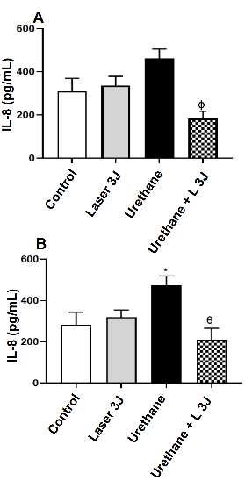

**Fig. 1. Effect of photobiomodulation therapy on IL-8 levels in the BEAS culture supernatant.**

*Cells (5x10⁴) were incubated with urethane (375 µg/ml) and irradiated or not with LIL (660 nm): * P < 0.05; θ P <0.01; Φ P< 0.00; The data are represented as mean ± SEM of the experiments*

In Figure 2, we observe a reduction in IL-10 levels in the BEAS culture supernatant in the Urethane group compared to the Control and Laser 3J groups (Figure 2A) and 7.5J groups (Figure 2B). On the other hand, an increase in the levels of this cytokine is observed in the BEAS culture only in the group incubated with Urethane and irradiated with Laser 3J (Figure 2A) compared to the Urethane group.

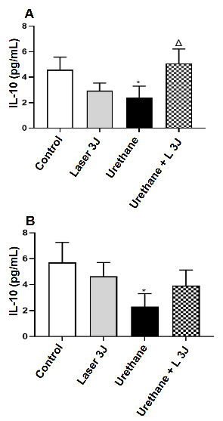

**Fig. 2. Effect of LIL therapy on IL-10 levels in the BEAS culture supernatant.**

*Cells (5x10⁴) were incubated with urethane (375 µg/ml) and irradiated or not with LIL (660 nm): * P < 0.05; Δ P < 0.05; The data are represented as mean ± SEM of the experiments.*

Regarding the IL-6 levels in the BEAS culture supernatant (Figure 3), we observe an increase in the Urethane group compared to the Control and Laser 3J groups (Figure 3A) and 7.5J groups (Figure 3B). Additionally, a reduction in IL-6 levels is observed in the BEAS culture only in the group incubated with Urethane and irradiated with Laser 3J (Figure 3A) compared to the Urethane group.

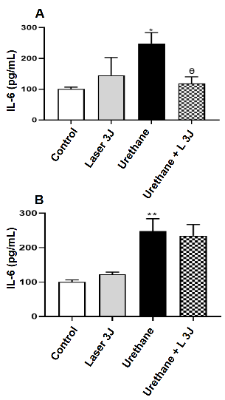

**Fig. 3. Effect of photobiomodulation therapy on IL-6 levels in the BEAS culture supernatant.**

*Cells (5x10⁴) were incubated with urethane (375 µg/ml) and irradiated or not with LIL (660 nm): **P < 0.01; θ P <0.01; The data are represented as mean ± SEM of the experiments.*

In Figure 4, a significant increase in IL-1β levels is observed in the BEAS culture supernatant in the Urethane group compared to the Control and Laser 3J groups (Figure 4A) and 7.5J groups (Figure 4B). On the other hand, a significant reduction of this cytokine is observed in the BEAS culture of the group incubated with Urethane and irradiated with Laser 3J (Figure 4A) and 7.5J (Figure 4B) compared to the experimental group (Urethane).

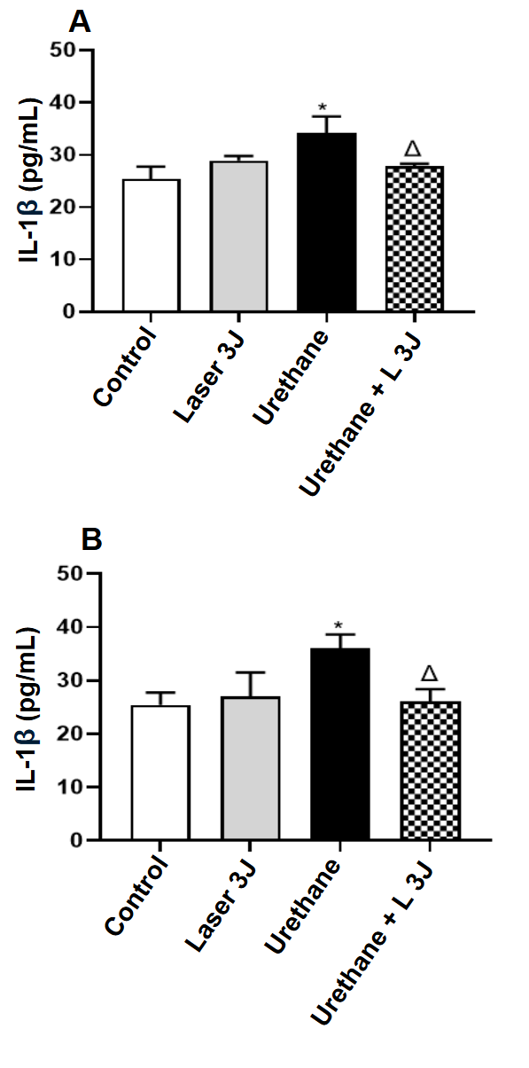

**Fig. 4. Effect of photobiomodulation therapy on IL-1β levels in the BEAS culture supernatant.**

*Cells (5x10⁴) were incubated with urethane (375 µg/ml) and irradiated or not with LIL (660 nm): * P < 0.05; Δ P < 0.05; The data are represented as mean ± SEM of the experiments.*

In Figure 5A, no significant difference in IFN-𝛄 levels in the BEAS culture supernatant was observed in any of the studied groups. Interestingly, an increase in this cytokine is observed in the group incubated with Urethane and irradiated with Laser 7.5J (Figure 5B) compared to the Urethane group.

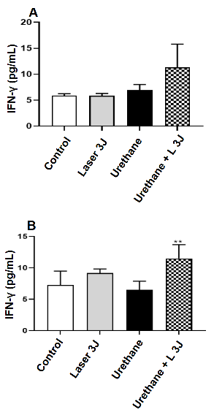

**Fig. 5. Effect of photobiomodulation therapy on IFN-𝛄 levels in the BEAS culture supernatant.**

*Cells (5x10⁴) were incubated with urethane (375 µg/ml) and irradiated or not with LIL (660 nm): **P < 0.01; The data are represented as mean ± SEM of the experiments.*

**3.2 Discussion**

Photobiomodulation is a form of phototherapy using red and infrared light to promote healing, reduce pain, and enhance overall well-being by stimulating physiological processes and restoring cellular balance. The appropriate dose and intensity of light for each tissue remain a topic of discussion in the literature. By inducing minor cellular stress, photobiomodulation helps the body adapt to a new equilibrium. Therefore, determining the optimal dose for each cell type is crucial to achieving homeostasis.

In a tumor environment, light stimulation can lead to unwanted effects such as cancer cell proliferation, recurrence, and secondary tumor development. Identifying the ideal light dose for each tissue is critical. Kara et al. (2017) investigated osteosarcoma and lung carcinoma cells (A549) irradiated with a Nd:YAG laser at different intensities (0.5, 1.2, and 3 W) and application frequencies (1, 2, or 3X). They observed increased tumor cell proliferation with higher application numbers compared to the control. Similarly, Stein et al. (2005) reported proliferation in human osteoblasts exposed to a He-Ne laser. However, Schartinger et al. (2012) found no proliferation in human oral carcinoma cells (SCC-25), highlighting discrepancies in the literature.

Numerous studies support photobiomodulation as a beneficial therapy in oncology, particularly for managing oral mucositis, lymphedema, radiodermatitis, and peripheral neuropathies. Paglioni et al. (2019) conducted a systematic review on its role in preventing and managing cancer treatment-related toxicity and found no evidence of tumor proliferation. Similarly, Bensadoun et al. (2020) reviewed phototherapy safety and efficacy in cancer patients, reporting conflicting *in vitro* findings due to parameter variability. Petrellis et al. (2017) analyzed Walker rat tumor cells (T 256) at different densities (1.3J and 6J) with three applications every two days. The 1J dose significantly increased IL-10 levels while reducing COX-2, leading to analgesia comparable to nimesulide administration.

Cancer research increasingly recognizes the immune system's role in tumor development, as tumor growth is often linked to immune suppression. Efforts to manipulate immune responses to target tumors are advancing, focusing on cytokine regulation and immune cell activation. Photobiostimulation can modulate inflammatory cytokines, influencing tumor microenvironments favorably.

This study analyzed the effects of low-power laser irradiation (660 nm) at 3J and 7.5J on cytokine and chemokine levels (IL-6, IL-8, IL-10, IL-1β, IFN-γ) in BEAS cell cultures. IL-8 was significantly elevated in the urethane group compared to the control and laser-treated groups. After laser irradiation, IL-8 levels decreased significantly, which is favorable as IL-8 promotes metastasis, angiogenesis, and inflammation (Kiss et al., 2020).

IL-6, produced by various cells including tumor cells and macrophages, is involved in immune defense and malignancy modulation. It promotes protein synthesis, neutrophil production, and B-cell differentiation but is also linked to tumor progression via apoptosis inhibition, angiogenesis, and drug resistance (Guo et al., 2012). Our study found that 3J laser irradiation reduced IL-6 levels in urethane-treated cells, suggesting a potential tumor-suppressive effect.

IL-1β, a pro-inflammatory cytokine associated with tumor progression, was significantly higher in the urethane group compared to control and laser-treated groups. Laser irradiation reduced IL-1β levels, indicating a beneficial effect of photobiomodulation in modulating the tumor microenvironment. Overexpression of IL-1β correlates with increased tumor activity, invasion, and angiogenesis, whereas its inhibition suppresses tumor progression and enhances immune surveillance (Karki & Kanneganti, 2019). IL-1β also activates M2 macrophages, which favor tumor growth (Garon et al., 2020).

IL-10, a cytokine with immunosuppressive and angiogenic properties, plays roles in wound healing, autoimmunity, and cancer. Our results showed significantly reduced IL-10 levels in the urethane group compared to others, indicating an acute Th1 inflammatory response. As tumors progress, IL-10 can facilitate immune evasion (Ni et al., 2020). While high IL-10 levels are often associated with poor prognosis (Sredni et al., 2004; Mannino et al., 2015), some studies suggest exogenous IL-10 stimulates CD8+ T cells, enhancing anti-tumor immunity (Wang et al., 2015; Naing et al., 2016). Our findings showed increased IL-10 in the 3J laser group, suggesting a potential anti-tumor benefit.

IFN-γ plays dual roles in tumor immunity, acting both pro- and anti-tumorigenically. It induces apoptosis in tumor cells via the JAK-STAT1-caspase pathway but also stimulates immunosuppressive mechanisms. Some studies show high IFN-γ levels can trigger apoptosis in NSCLC cell lines (A549, H460), though its non-specific interactions can cause side effects. In our study, 7.5J laser irradiation increased IFN-γ levels in urethane-treated cells, suggesting an anti-tumor immune activation through CD8+ T cells and Natural Killer (NK) cells. These findings align with the role of IFN-γ in enhancing tumor antigen presentation, inhibiting angiogenesis, and promoting tumor cell lysis.

Our study suggests photobiomodulation therapy may have beneficial effects on lung adenocarcinoma by modulating cytokine and chemokine levels. The 3J dose appears to favorably influence IL-10 expression in the tumor environment, while the 7.5J dose enhances IFN-γ production. Additionally, 3J irradiation reduced IL-6 levels, which are associated with tumor development. These promising *in vitro* findings warrant further investigation in animal models before clinical applications in lung adenocarcinoma treatment can be considered.

**4. Conclusion**

After quantifying several cytokines in urethane-induced BEAS cell environments, we found that the cytokines showed favorable results for photobiomodulation of the immune system, reducing the chances of immune escape.

Regarding dosimetry and IL-10, we observed favorable results with 3J in the tumor environment, while 7.5J stimulates IFN-γ in the lung. However, when comparing the two energy intensities, 3J reduces the release of IL-6, which favors tumor growth.

Therefore, photobiomodulation presents a promising treatment for lung adenocarcinoma, with better results observed at the 3J energy intensity. Further studies are needed to complement the laser's action, which directly affects tumor cells or the tumor microenvironment, with the aim of eliminating the tumor itself.

**Competing interests**

All authors disclose any financial and personal relationships with other people or organizations that could inappropriately influence (bias) this study.

**DISCLAIMER (ARTIFICIAL INTELLIGENCE)**

The authors declare that generative artificial intelligence (AI) technologies, specifically Large Language Models, were employed in the writing and editing of this manuscript. The details of AI utilization are as follows:

AI Technology: ChatGPT

Version: GPT-4

Model: Large Language Model (LLM)

Source: OpenAI

Types of AI Assistance Provided:

* Translation of text.
* Reduction of word count while preserving meaning and scientific accuracy.

These AI-generated contributions were incorporated throughout the manuscript revision and editing process.

**Consent**

All authors declare that ‘written informed consent was obtained from the patient (or other approved parties) for publication of this case report and accompanying images. A copy of the written consent is available for review by the Editorial office/Chief Editor/Editorial Board members of this journal.

**References**

ALBERG, AJ, BROCK, MV, FORD, JG, et al. Epidemiology of lung cancer: diagnosis and management of lung cancer, 3rd ed: American College of Chest Physicians evidence-based clinical practice guidelines. Chest2013;143:e1S-29S.

BADE, B. C.; DELA CRUZ, C. S. Lung Cancer 2020: Epidemiology, Etiology, and Prevention. Clinics in Chest Medicine, 2020, v. 41, n. 1, p. 1–24.

BARTA, J. A.; POWELL, C. A.; WISNIVESKY, J. P. Global epidemiology of lung cancer. Annals of Global Health, 2019, v. 85, n. 1, p. 1–16.

BASFORD, JR. Low intensity laser therapy: still not an established clinical tool. Lasers Surg Med. 1995;16: 331–342.

BELLANTI, JA (Ed). Imunologia IV: Clínica Aplicações em Saúde e Doença. I Care Press, Bethesda, MD, 2012

BENSADOUN RJ, EPSTEIN JB, NAIR RG, et al. Safety and efficacy of photobiomodulation therapy in oncology: A systematic review. *Cancer Med*. 2020;9(22):8279-8300. doi:10.1002/cam4.3582

BHARGAVA, A. et al. Immune cell engineering: opportunities in lung cancer therapeutics. Drug Delivery and Translational Research, 2020, v. 10, n. 5, p. 1203–1227.

BRAY, F, FERLAY, J, SOERJOMATARAM, I et al. Global cancer statistics 2018: GLOBOCAN estimates of incidence and mortality worldwide for 36 cancers in 185 countries. CA Cancer J Clin 2018; 68(6): 394–424.

CROUS, Anine M. & ABRAHAMSE, Heidi. Lung cancer stem cells and low-intensity laser irradiation: a potential future therapy? Stem Cell Res Ther. 2013; 4(5): 129.

DE PAULI PAGLIONI, M. et al. Tumor safety and side effects of photobiomodulation therapy used for prevention and management of cancer treatment toxicities. A systematic review. Oral Oncology, 2019, v. 93, n. April, p. 21–28.

FITZMAURICE, C, DICKER, D, PAIN, A, et al. The Global Burden of Cancer 2013. JAMA Oncology. 2015; 1(4): 505–527.

GARCÍA-RÍO F, ALCÁZAR-NAVARRETE B, CASTILLO-VILLEGAS D, et al. Biological Biomarkers in Respiratory Diseases. Biomarcadores biológicos en las enfermedades respiratorias. *Arch Bronconeumol*. 2022;58(4):323-333.

GARON, E. B.; CHIH-HSIN YANG, J.; DUBINETT, S. M. The Role of Interleukin 1β in the Pathogenesis of Lung Cancer. JTO Clinical and Research Reports, 2020, v. 1, n. 1, p. 100001.

GUO, Y. et al. Interleukin-6 signaling pathway in targeted therapy for cancer. Cancer Treatment Reviews, 2012, v. 38, n. 7, p. 904–910.

HAMBLIN, M. R.; NELSON, S. T.; STRAHAN, J. R. Photobiomodulation and Cancer: What Is the Truth? Photomedicine and laser surgery, 2018, v. 36, n. 5, p. 241–245.

KARA, C. et al. Low level laser therapy induces increased viability and proliferation in isolated cancer cells. Cell Proliferation, 2018, v. 51, n. 2, p. 1–6.

KARKI R, KANNEGANTI TD. Diverging inflammasome signals in tumorigenesis and potential targeting. Nat Rev Cancer. 2019 Apr;19(4):197-214.

KIRO NE, HAMBLIN MR, ABRAHAMSE H. Photobiomodulation of breast and cervical cancer stem cells using low-intensity laser irradiation. *Tumour Biol*. 2017;39(6):1010428317706913.

KISS, E. et al. Cisplatin treatment induced interleukin 6 and 8 production alters lung adenocarcinoma cell migration in an oncogenic mutation dependente manner. Respiratory Research, 2020, v. 21, n. 1, p. 1–10.

MANNINO, M. H. et al. The paradoxical role of IL-10 in immunity and cancer. Cancer Letters, 2015, v. 367, n. 2, p. 103–107.

MATIC, M, LAZETIC, B, POLLJACKI, M, DURAN, V, IVKOV-SIMIC, M. Low level laser irradiation and its effects on repair processes in the skin. Med Pregl. 2003; 56:137–141.

NI, G. et al. Targeting interleukin-10 signalling for cancer immunotherapy, a promising and complicated task. Human Vaccines and Immunotherapeutics, 2020, v. 16, n. 10, p. 2328–2332.

PASSARELLA, S; CASAMASSIMA, E; MOLINARI, S; PASTORE, D; QUAGLIARIELLO, E; CATALANO, IM. Increase of proton electrochemical potential and ATP synthesis in rat liver mitochondria irradiated *in vitro* by helium-neon laser. FEBS Lett. 1984; 175:95–99.

PETRELLIS, M. C. *et al*. Laser-photobiomodulation on experimental cancer pain model in Walker Tumor-256. Journal of Photochemistry and Photobiology B: Biology, 2020, v. 210, n. July.

SCHARTINGER, V. H. *et al*. Differential responses of fibroblasts, non-neoplastic epithelial cells, and oral carcinoma cells to low-level laser therapy. Supportive Care in Cancer, 2012, v. 20, n. 3, p. 523–529.

SCHINDL, A, SCHINDL, M, SCHON, H, KNOBLER, R, HAVELEC, L, SCHINDL, L. Low intensity laser irradiation improves skin circulation in patients with diabetic microangiopathy. Diabetes Care. 1998; 21:580–584.

SILVEIRA, F. M. et al. Examining tumor modulating effects of photobiomodulation therapy on head and neck squamous cell carcinomas. Photochemical and Photobiological Sciences, 2019, v. 18, n. 7, p. 1621–1637.

SOMMER, AP; PINHEIRO, AL; MESTER, AR; FRANKE, RP; WHELAN, HT. Biostimulatory windows in low intensity laser activation: lasers, scanners and NASA light-emitting diode array system. J Clin Laser Med Surg., 2001; 19:29–34.

SONIS, S. Correction to: Could the impact of photobiomodulation on tumor response to radiation be effected by tumor heterogeneity? Supportive Care in Cancer, 2020, 28, 2, (423-424), 10.1007/s00520-019-05146-9. Supportive Care in Cancer, 2020, v. 28, n. 4, p. 2033.

SOUZA MC, VASCONCELOS AG, CRUZ OG. Trends in lung cancer mortality in Brazil from the 1980s into the early 21st century: age-period-cohort analysis. Cad Saude Publica. 2012 Jan;28(1):21-30.

SREDNI, B. et al. Ammonium Trichloro(dioxoethylene-o,o′)tellurate (AS101) Sensitizes Tumors to Chemotherapy by Inhibiting the Tumor Interleukin 10 Autocrine Loop. Cancer Research, 2004, v. 64, n. 5, p. 1843–1852.

STADLER, L, LANZAFAME, R, OSKOUI, P, ZHANG, R, COLEMAN, J, WHITTAKER, M. Alteration of skin temperature during low level laser irradiation at 830 nm in a mouse model. Photomed Laser Surg. 2004; 22:227–231.

STEIN, A. et al. Low-level laser irradiation promotes proliferation and differentiation of human osteoblasts *in vitro*. Photomedicine and Laser Surgery, 2005, v. 23, n. 2, p. 161–166.

Sung H, Ferlay J, Siegel RL, Laversanne M, Soerjomataram I, Jemal A, Bray F. Global Cancer Statistics 2020: GLOBOCAN Estimates of Incidence and Mortality Worldwide for 36 Cancers in 185 Countries. CA Cancer J Clin. 2021 May;71(3):209-249.

TRINH, QD, NGUYEN, PL, LEOW, JJ, et al. Cancer specific mortality of Asian Americans diagnosed with cancer: A nationwide population-based assessment. J Natl Cancer Inst. 2015; 107(6).

TUNER, J, HODE, L. Some Basic Laser Physics. AB Grangesberg, Sweden: Prima Books; 2004. Laser therapy-clinical practice and scientific background.

WANG, L. et al. IL-10 enhances CTL-mediated tumor rejection by inhibiting highly suppressive CD4+ T cells and promoting CTL persistence in a murine model of plasmacytoma. OncoImmunology, 2015, v. 4, n. 7, p. 1–9.

WAN-PING, H, JEH-JENG, W, CHIA-LI, Y, CHENG-CHE, EL, GOW-SHING, C, HSIN-SU, Y. Helium-neon laser irradiation stimulates cell proliferation through photostimulatory effects in mitochondria. J Invest Dermatol. 2007; 127:2048–2057.

ZECHA, J. A. E. M. et al. Low-level laser therapy/photobiomodulation in the management of side effects of chemoradiation therapy in head and neck cancer: part 2: proposed applications and treatment protocols. Supportive Care in Cancer, 2016, v. 24, n. 6, p. 2793–2805.

ZHANG, Y; LI, X; CHEN, Z; BEPLER, G: Ubiquitination and degradation of ribonucleotide reductase m1by the polycomb group proteins rnf2 and bmi1 and cellular response to gemcitabine. PLoS One (2014) 9(3): e91186.

**Definitions, Acronyms, Abbreviations**

**PDT -** Photodynamic Therapy

**FS -** Photosensitizer

**J -** Joules

**W -** Watts

**Nm -** Nanometers

**LIL -** Low-Intensity Laser

**cm² -** Square Centimeter

**λ -** Wavelength

**TGF-β -** Transforming Growth Factor Beta

**TNF-α -** Tumor Necrosis Factor Alpha

**IL-6 -** Interleukin 6

**IL-8 -** Interleukin 8

**IL-10 -** Interleukin 10

**INCA –** National Cancer Institute

**NSCLC -** Non-Small Cell Lung Carcinoma

**SCLC -** Small Cell Lung Carcinoma

**DC –** Dendritic Cells

**CD4+ T Cells –** CD4 Lineage T Lymphocytes

**CD8+ T Cells –** CD8 Lineage T Lymphocytes

**ATP –** Adenosine Triphosphate

**cAMP -** Cyclic Adenosine Monophosphate

**BEAS -** Bronchial Epithelial Cells

**TME -** Tumor Microenvironment

**EC -** Ethyl Carbamate

**DNA -** Deoxyribonucleic Acid