*Case report*

The Perils of Drug Reintroduction: A Case of Generalized Bullous Fixed Drug Eruption

.

ABSTRACT

|  |
| --- |
| Generalized Bullous Fixed Drug Eruption (GBFDE) is a severe cutaneous adverse drug reaction that can mimic toxic epidermal necrolysis (TEN).  We report the case of a female patient in her fifth decade who developed widespread bullous lesions with significant epidermal detachment within 24 hours of taking Piroxicam. A previous, less severe reaction to Diclofenac was noted, suggesting cross-reactivity among NSAIDs. Given the potential severity of GBFDE and its risk of recurrence, accurate diagnosis and strict drug avoidance strategies are essential.  This case underscores the importance of thoroughly reviewing patients’ allergy history and considering a complete switch to a different pharmacological class, especially in cases of life-threatening reactions. |

*Keywords: fixed drug eruption, generalized bullous fixed drug eruption, adverse drug reaction, toxidermia.*

1. INTRODUCTION

Fixed drug eruption (FDE) is a generally benign dermatological condition. However, its generalized bullous form, known as generalized bullous fixed drug eruption (GBFDE), remains uncommon and severe drug-induced toxidermia. The condition can be localized or generalized and is often misdiagnosed as other blistering dermatoses (Balta et al., 2014).

A hallmark of FDE is the recurrence of lesions at the same anatomical sites upon reintroduction of the causative drug, often leaving behind residual pigmentation. This condition requires specialized care, as it can threaten vital prognosis if not properly managed (Valeyrie-Allanore et al., 2015).

This report highlights the importance of early recognition and prompt management of GBFDE, as well as the need to carefully evaluate drug reintroduction to avoid potentially severe, generalized reactions.

2. PRESENTATION OF CASE

We report the case of a female patient in her fifth decade who presented to our department with multiple pruritic erythematous patches that rapidly generalized 24 hours after taking a Piroxicam tablet for a headache. The condition progressed to the development of flaccid bullae with a positive Nikolsky’s sign and significant epidermal detachment (Fig. 1,2), exposing the dermis and giving it a "wet linen" appearance (Fig. 3).

Despite the severity of the cutaneous involvement, the patient remained hemodynamically and respiratorily stable, with no mucosal involvement. Lymph node examination, as well as the rest of the clinical assessment, was unremarkable. Anamnesis revealed a similar but less extensive maculopapular rash five years earlier, occurring within a day of taking a diclofenac tablet.

An initial biological workup was conducted to assess hydration status, major organ functions, and potential infection markers. A skin biopsy revealed keratinocyte necrosis associated with vacuolar interface dermatitis, along with superficial and deep perivascular infiltration of eosinophils and lymphocytes (Fig. 4). Based on the characteristic clinical presentation, the compatible time of onset, the recurrence of lesions at the same anatomical sites, and the presence of residual pigmentation, a diagnosis of generalized bullous fixed drug eruption (GBFDE) was established.

Management involved discontinuation of the suspected drug, close clinical and biological monitoring, and daily application of a topical corticosteroid preparation, leading to a favorable evolution within approximately 10 days. A pharmacovigilance investigation confirmed the causative role of Piroxicam, assigning it an imputability score of I3B4.

Given the severity of the reaction and the fact that two different nonsteroidal anti-inflammatory drugs (NSAIDs) from distinct chemical families had triggered similar adverse effects in the same patient, a complete contraindication of all NSAIDs was recommended in her medication plan.

3. discussion

Fixed drug eruption (FDE) is a common adverse drug reaction that typically recurs in the same sites with repeated administration of the triggering drug. Its clinical presentation can range from solitary pigmented lesions to extensive bullous lesions or even pseudo-Lyell syndromes, as seen in our patient (Valeyrie-Allanore et al., 2012).

Generalized bullous forms of FDE, involving over 10% of the body surface area and at least three anatomical sites, are particularly severe and require careful attention (Cho et al., 2014).

The condition can affect patients of all ages (Morelli et al., 1999). The sex ratio is generally balanced, though some studies report a predominance of females (Valeyrie-Allanore et al., 2015; Brahimi et al., 2010).

FDE, including generalized bullous form, is a delayed hypersensitivity reaction mediated by CD8 T lymphocytes, which reside in the epidermis and reactivate when the causative drug is reintroduced. This process results in keratinocyte destruction through cytotoxic mechanisms, exacerbated by insufficient regulation of T regulatory cells, explaining the recurrences and severity of generalized forms (Valeyrie-Allanore et al., 2015).

GBFDE can be misdiagnosed as other bullous dermatoses, such as severe adverse drug reactions like toxic epidermal necrolysis (TEN) or Stevens-Johnson syndrome (SJS) making accurate diagnosis reliant on a thorough medical history, clinical examination, and histopathological analysis (Patel et al., 2020; Zaouak et al., 2019).

The onset of this toxidermia is relatively rapid, usually occurring within a few days, but can be accelerated to a few hours upon re-exposure to the causative drug. The eruption is marked by large erythematous patches, frequently asymmetric, with large intervals of healthy skin and extensive areas of epidermal detachment, exposing the dermis and creating a "wet linen" appearance. No target-like or pseudo-target lesions are noted (Valeyrie-Allanore et al., 2015).

Mucosal involvement is common with studies showing that 66.7% of patients with GBFDE experience it, compared to only 30% in non-generalized bullous FDE (Anderson & Lee, 2021).

Despite the significant cutaneous manifestations, patients generally remain stable, with no significant asthenia, fever, or appetite loss (Valeyrie-Allanore et al., 2015).

Diagnosis of GBFDE is typically suspected based on clinical findings and confirmed histopathologically. Histological examination of acute generalized bullous fixed drug eruption (GBFDE) typically reveals keratinocyte necrosis, often eosinophilic, associated with basal vacuolization and subepidermal blister formation. Dermal edema and a mild perivascular mononuclear cell infiltrate are also commonly observed (Zaouak et al., 2019; Grimaux et al., 2016). Direct and indirect immunofluorescence studies are usually negative in GBFDE (Valeyrie-Allanore et al., 2015).

The clinical-pathologic correlation remains the gold standard for diagnosis (Weyers & Metze, 2001).

Various drugs have been implicated in the development of fixed drug eruptions (Butler, 2009). Certain medications more common in specific regions, such as sulfonamides in Asia and Africa, are the most frequent culprits, followed by nonsteroidal anti-inflammatory drugs (NSAIDs) such as phenazone derivatives and oxicams, synthetic antimalarial drugs, non-sulfonamide antibiotics, and paracetamol (Valeyrie-Allanore et al., 2015).

Within NSAIDs, oxicam derivatives, such as piroxicam, are particularly notorious for their high potential to trigger severe cutaneous adverse drug reactions, including GBFDE and even Stevens-Johnson syndrome/toxic epidermal necrolysis (SJS/TEN) spectrum (Valeyrie-Allanore et al., 2015; Butler, 2009). Other NSAIDs, such as diclofenac, mefenamic acid, and ibuprofen, have also been reported as causative agents, although with a lower frequency (Anderson & Lee, 2021). Given the recurrent nature of FDE upon re-exposure, it is crucial to establish a precise drug history and recommend the avoidance of not only the identified culprit drug but potentially all NSAIDs, particularly in patients who have reacted to multiple agents from different chemical families, as seen in our case (Zaouak et al., 2019).

Management of GBFDE includes discontinuation of the causative drug, supportive care, and the use of topical or systemic corticosteroids, with cyclosporine showing promise in recent treatments (Anderson & Lee, 2021).

Hydroquinone bleaching creams can be used to try and reduce any persistent PIH (Gendernalik & Galeckas, 2009).

In severe cases, hospitalization and intensive care may be required, similar to the management of TEN (Valeyrie-Allanore et al., 2007).

Pharmacovigilance using drug imputability scores is crucial in identifying the offending drug, particularly in patients with polypharmacy.

The definitive diagnosis of drug imputability is the drug patch test. The oral provocation test, used in case of negativity of drug patch test, is contraindicated in patients who have had generalized bullous forms (Zaouak et al., 2019).

The prognosis of GBFDE is typically better than SJS/TEN; however, mortality rates in severe cases can reach 22%, underscoring the importance of prompt timely management (Lipowicz et al., 2013).

4. Conclusion

Generalized Bullous Fixed Drug Eruption (GBFDE) remains uncommon but severe manifestation of fixed drug eruption, necessitating early recognition and prompt management to prevent life-threatening complications. The recurrence of lesions at the same anatomical sites upon drug re-exposure is a key diagnostic feature, highlighting the crucial role of pharmacovigilance in preventing future episodes. Our case reinforces the importance of drug avoidance strategies, particularly in patients with prior hypersensitivity to multiple NSAIDs.

Consent (where ever applicable)

All authors declare that written informed consent was obtained from the patient for the publication of this case report and accompanying images.

Ethical approval (where ever applicable)

All authors have obtained all necessary ethical approval and have therefore been performed in accordance with the ethical standards laid down in the 1964 Declaration of Helsinki.

References

Balta, I., Simsek, H., & Simsek, G. G. (2014). Flurbiprofen-induced generalized bullous fixed drug eruption. Human & Experimental Toxicology, 33(1), 106-108.

Valeyrie-Allanore, L., Lebrun-Vignes, B., Bensaid, B., Sassolas, B., & Barbaub, A. (2015). Fixed pigmented erythema: Epidemiology, physiopathology, clinical features, differential diagnosis, and therapeutic management. Annales de Dermatologie et de Vénéréologie, 142(11), 701-706. [French]

Valeyrie-Allanore, L., & Revuz, J. (2012). Drug reactions. In Bolognia, J. L., Jorizzo, J. L., & Rapini, R. P. (Eds.), Dermatology (3rd ed., pp. 335–356). Elsevier.

Cho, Y.-T., Lin, J.-W., Chen, Y.-C., Chang, C.-Y., Hsiao, C.-H., Chung, W.-H., & Chu, C.-Y. (2014). Generalized bullous fixed drug eruption is distinct from Stevens-Johnson syndrome/toxic epidermal necrolysis by immunohistopathological features. Journal of the American Academy of Dermatology, 70(4), 539–548.

Morelli, J. G., Tay, Y. K., Rogers, M., Halbert, A., Krafchik, B., & Weston, W. L. (1999). Fixed drug eruptions in children. Journal of Pediatrics, 134(3), 365-367.

Brahimi, N., Routier, E., Raison-Peyron, N., Tronquoy, A. F., Pouget-Jasson, C., Amarger, S., et al. (2010). A three-year analysis of fixed drug eruptions in hospital settings in France. European Journal of Dermatology, 20(4), 461-464.

Patel, S., John, A. M., Handler, M. Z., et al. (2020). Fixed Drug Eruptions: An Update, Emphasizing the Potentially Lethal Generalized Bullous Fixed Drug Eruption. American Journal of Clinical Dermatology, 21(3), 393–399.

Zaouak, A., Ben Salem, F., Ben Jannet, S., Hammami, H., & Fenniche, S. (2019). Bullous fixed drug eruption: A potential diagnostic pitfall: A study of 18 cases. Therapie, 74(5), 527-530.

Anderson, H. J., & Lee, J. B. (2021). A Review of Fixed Drug Eruption with a Special Focus on Generalized Bullous Fixed Drug Eruption. Medicina, 57(9), 925.

Grimaux, X., Bigot, P., & Leclec'h, C. (2016). Bullous fixed drug eruption of the glands due to tadalafil: A case report. Progress in Urology, 26(8), 435-436. [French]

Weyers, W., & Metze, D. (2001). Histopathology of drug eruptions–general criteria, common patterns, and differential diagnosis. Dermatology Practical & Conceptual, 1, 33–47.

Butler, D. F. (2009). Drug-induced bullous disorders. Emedicine. Retrieved from http://emedicine.medscape.com/article/1062790-overview.

Gendernalik, S. B., & Galeckas, K. J. (2009). Fixed drug eruptions: A case report and review of the literature. Cutis, 84(4), 215-219.

Valeyrie-Allanore, L., Sassolas, B., & Roujeau, J. C. (2007). Drug-induced skin, nail, and hair disorders. Drug Safety, 30(12), 1011–1030.

Lipowicz, S., Sekula, P., Ingen-Housz-Oro, S., Liss, Y., Sassolas, B., Dunant, A., Roujeau, J.-C., & Mockenhaupt, M. (2013). Prognosis of generalized bullous fixed drug eruption: Comparison with Stevens-Johnson syndrome and toxic epidermal necrolysis. British Journal of Dermatology, 168(4), 726–732.

APPENDIX

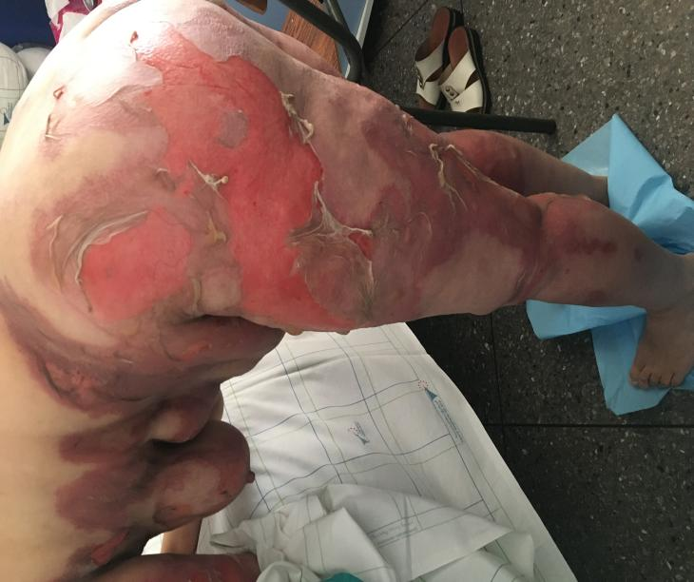

Fig 1: Clinical images showing an estimated of 55% detached skin surface.

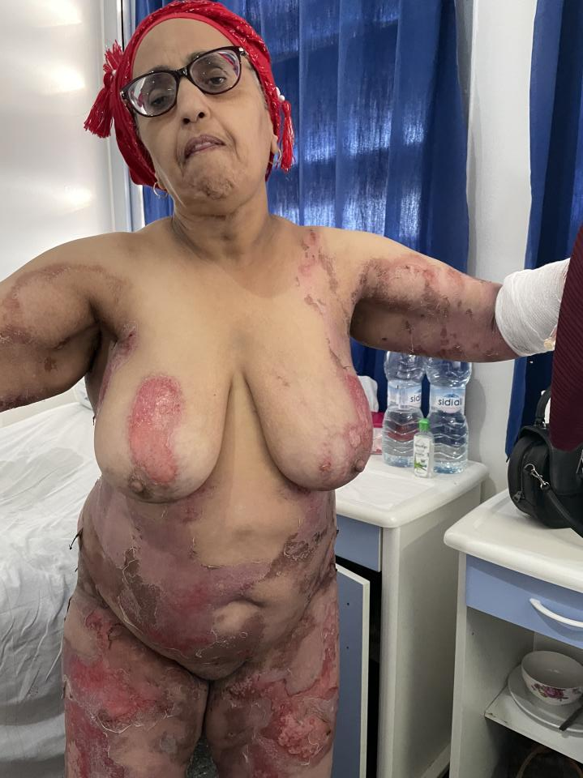

Fig 2: Clinical images showing significant epidermal detachment with exposure of the dermis.

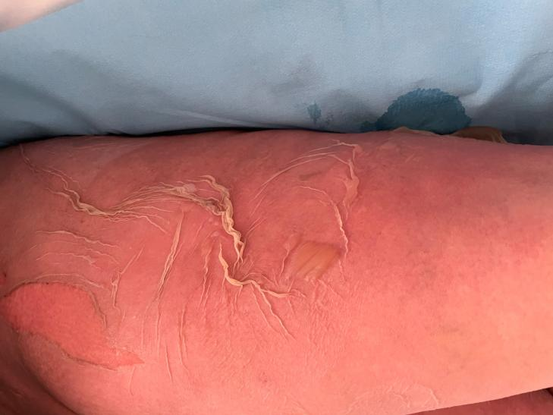

Fig 3: Clinical images showing a "wet linen" appearance.

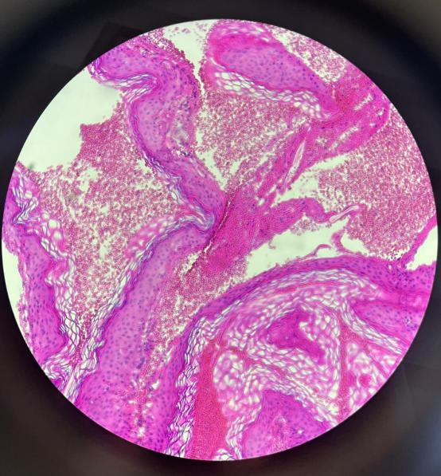

Fig 4: histological image revealing keratinocyte necrosis associated with vacuolar interface dermatitis, along with superficial and deep perivascular infiltration of eosinophils and lymphocytes.