Original Research Article

Optimize Mobile App Testing Using Machine Learning to Improve User Experience

.
ABSTRACT

Aims: The study delves into the machine learning (ML) paradigm shift in enhancing mobile application testing processes for higher accuracy, efficiency, and overall user experience.
Study design: Experimental Research Design.
Methodology: The research takes an experimental design approach consisting of A/B testing, using machine learning (ML) for automated UI defect detection reinforcement learning for intelligent test case prioritization to extract actionable insights from user feedback. The study employed MATHLAB R2024b software for the findings of the study.
Results: The experimental evaluation that was performed on various datasets to pilot cloud-based testing platforms depicts the round ML-driven testing methods as efficient against traditional ones in this study, with higher defect detection rates (15-20%), wider test coverage (30-35% improvement), and quicker execution times (40-50% reduction), with a declining false-positive rate. Decision Tree and Random Forest techniques were identified as good for detecting usability and performance problems from all the machine-learning techniques tested. In contrast, another interesting output finding supports the use of ML in reinforcing CI/CD pipelines with less manual effort and a quicker turnaround time in fixing bugs.
Conclusion: However, bias in datasets and interpretability of models present real challenges that need to be addressed when implementing models in a real-world scenario. The study recommends establishing ML-based testing frameworks, deploying high-quality training data, and developing hybrid models that formulate supervised learning with anomaly detection techniques.

Keywords: Machine learning, mobile app testing, defect detection, user experience, automated testing

1. INTRODUCTION

Mobile application testing is an important section of the software development that ensures applications behave correctly under varying devices, operating systems, and network conditions. Challenges faced by the classical testing methods include fragmentation, resource constraints, and more complexity added to the software nowadays. Although manual testing is time-consuming and labor-intensive and comes under human errors, automated testing somehow manages its efficiency but suffers from scalability and maintenance issues (Azgar et al., 2022; Kaur & Kaur, 2022). Both from the perspective of the evolution of mobile apps and the usage of efficient and reliable methodologies, testing has thus developed into more than a necessity. ML-powered automated software testing is a potential disruptor enforcing intelligent and adaptive testing processes. Testing techniques based on ML predict defect occurrences, optimize test cases, and detect anomalies, drastically reducing the testing time and increasing software tests' accuracy (Ajorloo et al., 2024). The recent work also suggests that modern AI-based test automation can improve testing coverage, reuse test cases, and, as a result, limit human involvement in modern software development environments (Bajaj & Samal, 2023). Further, even though mobile application testing is improving, there lie many wider gaps. Traditionally, test methods are incapable of ensuring good efficiency in their coverage, allowing defects to be set free and enter the domain of unstable applications. Further, many automated testing frameworks have been renowned for making false positives, seeing benign anomalies as critical defects, thus adding to the debugging effort and slowing down the development pipeline (Stradowski & Madeyski, 2023). What's more, despite their flaws, the timing for execution remains on top of these because resource-consuming full tests slow down the continuous integration and deployment pipelines (Zakaria et al., 2021). Machine learning integration presents a possible approach to addressing issues related to these solutions in mobile app testing, following which a handful of barriers remain. Addressing issues like bias in training datasets, interpretability of ML models, and AI-related overheads effectively is the key to an efficient AI-driven testing framework. Accordingly, the study's design focuses on how ML-based automation may help close existing gaps in mobile application testing while also providing insight into its application from the perspective of strengths, limitations, and real-life applicability. Based on assessing state-of-the-art advancements and empirically evaluating their benefits in improving the above-mentioned scenario, this research seeks to discuss the improvement of software quality and reliability through AI-based testing methodologies. The research that has been conducted until now has shown a considerable interest in mobile testing challenges and related ML-based testing techniques. In contrast, very few empirical studies have studied ML automation's efficiency within actual testing environments. Most previous research has only proposed theoretical frameworks or conducted simulation-based evaluations, leaving a gap for actual application and empirical comparison of ML-based test automation against classical methodologies. In addition, issues like test case prioritization, adaptability across various application domains, and mitigation of dataset biases have not received sufficient attention in research. This research brings a unique contribution through the extended empirical evaluation of ML-based automation in mobile application testing, focusing on its scalability, accuracy, and efficiency in real-world settings. The research should allow practitioners to adapt AI-based testing methods in software development life cycles, thereby addressing critical issues in the state of the art and moving forward with software quality assurance as a field.
1.1 Research Aim
To develop and evaluate a machine learning-based approach for optimizing mobile app testing and improving user experience by increasing test coverage, reducing false positives, and enhancing efficiency.
1.2 Research Questions
1. How does machine learning improve the accuracy and efficiency of mobile app testing compared to traditional automated testing methods?
2. What machine learning models and techniques are most effective for detecting usability and performance issues in mobile applications?
3. How does ML-driven testing impact mobile app development's overall user experience and quality assurance process?

2. Literature Review
2.1 Mobile App Testing Challenges
Mobile applications are an indispensable part of modern life, with millions of apps available for platforms like Android and iOS. Ensuring the quality and reliability of these apps becomes paramount due to the highly competitive nature of the industry and user expectations for near-flawless performance. This gives rise to unique challenges in mobile app testing, either manual or automated. Manual testing means human testers carry out the test cases without automation tools. It allows for exploratory tests and simulates a real user experience, but it is extremely time-consuming, especially when applied to large-scale applications. In the opinion of Azgar et al. (2022), manual testing has been unable to keep pace with testing due to the dynamic nature of agile methods with frequent updates and rapid releases. The need for repetitive test execution across many devices and OS versions only worsens the situation. Table 1 summarizes some of the key challenges in mobile application testing, as argued by Azgar et al. (2022).
Table 1. Key Challenges in Mobile Application Testing Azgar et al. (2022)
Challenge Category | Description | Specific Issues
Performance Testing | Ensures app works efficiently under various conditions | - Response time issues  - Stress under low power  - Network availability problems  - Maintaining consistent performance
Security Testing | Protects sensitive data and prevents vulnerabilities | - Device-specific vulnerabilities  - OS-specific vulnerabilities  - Unstable encryption  - Unsafe data storage
Device Diversity | Wide range of mobile devices in market | - Over 500M Android devices  - 220M+ iOS devices  - Various form factors (phones, tablets, wearables)
OS Fragmentation | Multiple OS versions and platform differences | - Android version fragmentation  - iOS rapid updates  - Compatibility across OS versions
Application Types | Different mobile app architectures require different testing approaches | - Native apps  - Web apps  - Hybrid apps  - Varying implementation requirements

Human testers are also error-prone by not looking into edge cases or interpreting test results incorrectly. In contrast, laid-back regression testing needs to be executed with complete precision with repeatable cases; hence, there lies ambiguity with manual testing (Ahmad et al., 2018). These ambiguities may permit unknown bugs to slip into production, consequently mar the user experience. Besides, mobile applications work in an environment with different network conditions, interruptions (calls, notifications, etc.), and hardware variations. Manual testing may accommodate some real-world situations, tending to miss out on many of them, resulting in gaps in test coverage (Xavier et al., 2017). Thetesting behavior in poor network conditions and during switching between Wi-Fi and mobile data is nowhere near simple without automation.
Automated testing, although significantly quicker and much more efficient, brings with it some challenges. User interface (UI) elements of mobile apps are frequently subject to changes, resulting in brittle automated tests. According to Arif and Ali (2019), test scripts depending on UI element identifiers such as XPath and IDs fail whenever developers modify layouts, auguring greater maintenance overhead. Another significant challenge is the fragmentation of devices and operating systems. Table 2 lays out the key challenges in mobile application testing and shows the respective gaps in tool support for all testing types.
Table 2. Challenges of Testing types (Arif & Ali, 2019)
Testing Type | Description | Current Challenges | Tool Support
Integration Testing | Testing multiple modules together to ensure they work as expected. | Limited automated tool support for integration testing in mobile applications. | Only a few tools (e.g., KIF) provide moderate support for integration testing.
Regression Testing | Re-running test cases to ensure new changes do not break existing functionality. | Lack of dynamic validation approaches; frequent updates require extensive retesting. | Very few automated tools support regression testing effectively.
Security Testing | Ensuring the app is secure from vulnerabilities and threats. | Most tools only perform abstract-level security checks; deep security testing is rare. | Limited automated tool support for comprehensive security testing.

Nevertheless, pure Android contains thousands of device models with different screen sizes, resolutions, and hardware capabilities, which require extensive cross-device testing (Peruma et al., 2024). However, cost-effective device-OS combinations under cloud-based testing platforms such as Firebase Test Lab and BrowserStack are still wanting. Reliability in automated testing is further reduced by flaky tests whose results change without any modification to the application. As Gao et al. (2019) report, flaky tests reduce trust in test suites as developers ignore failures as false positives. Time, race, and environmental factors such as network latency give rise to this phenomenon. Automated test scripts need maintenance because they need to be modified whenever changes are made to the app (Kaur & Kaur, 2022). These do not motivate teams to automate, particularly in fast-development environments. Automation performance testing fails because of the lack of access to real devices and emulators, different network conditions (3G vs. 5G latency), and interference from background processes. Automated tests detected performance bottlenecks infrequently, leaving users with unpleasant experiences after release, according to findings by Ahmad et al. (2017).
These add more to the abovementioned problems when cross-platform testing in Android and iOS. Each has different behaviors from the hardware it interacts with and different UI guidelines; hence, separate suites of tests are required (Shoaib et al., 2024). Appium and Espresso are cross-platform frameworks, but platform-specific adaptation increases learning and implementation time (Azgar et al., 2022). No universal testing tool exists, unfortunately. UX testing is subjective regarding navigation and aesthetics; however, functional testing is not so. Qualitative things must be judged by men, not by machines. Google's Android Vitals peddles performance reporting, leaving intact touch responsiveness, animation smoothness, and accessibility, among other UX factors (Ahmad et al., 2018). Most UX explanations are manual, remaining one of the most significant barriers to achieving exhaustive automation in its fully rigorous testing. User experience optimization is necessary for testing mobile apps but not yet comprehensive. While exploring various aspects of challenges in automated and manual testing, most research findings do not elaborate on how far ML (machine learning) research has gone in bringing comprehensive testing to reality. ML finds its testing applications today mainly in generating test cases and detecting without paying attention to user experience needs. Most of the time, the model ignores fragmented devices in the real world, and their dynamic UI changes ultimately lead to less-than-optimal suggestions for testing (Gao et al., 2019). Today, no end-to-end frameworks exist that bring together ML-based test prioritization and configuration, which are both vital to app quality and user satisfaction. This study aims to bridge that void by designing an ML framework that increases testing efficiency concerning various UX metrics such as responsiveness and accessibility. Supervised learning for defect prediction and reinforcement learning for adaptive test case prioritization provide a more holistic solution to mobile app testing challenges. The study also uses NLP to analyze user feedback and automatically identify UX issues. Conventional testing avoids these issues. By closing these gaps, mobile app testing becomes more reliable, efficient, and user-centered.
2.2 Machine Learning in Software Testing
Automating test case generation is one of the most exciting applications of machine learning in software testing (Bajaj & Samal, 2023). Traditional techniques for generating test cases generally rely on manual work or rule-based automation. Manual efforts require a lot of time, while rule-based automation might not provide adequate coverage of all possible scenarios (Rezaalipour & Furia, 2021). The aforementioned ML methodologies, particularly genetic algorithms and reinforcement learning techniques have shown enormous promise in overcoming the problems that exist in this sense (Baqar & Khanda, 2024). Genetic algorithms evolve test cases over a number of generations while maximizing coverage and minimizing redundancy in the same way that natural selection would work (Habeeb Agoro, 2023). This is useful in complex systems in which the input space is enormous, so manual test case design is impractical (Marijan, 2023). Reinforcement learning, another powerful technique for machine learning, allows systems to learn to identify the best strategies for testing through trials and errors and rewarding actions that lead to better test coverage or fault detection (Morovati et al., 2022). These ML-driven approaches reduce the human effort needed to create test cases but also increase the overall quality of testing by identifying edge cases that human testers may overlook (Wang et al., 2021). With the ability to probe a model's technology for analyzing code structure, execution paths, and test data applied during its historical lifetime, ML is expected to produce even more efficient test suites that adapt as the software develops (Khatibsyarbini et al., 2021).
Bug detection benefits considerably from MLs (Ramadan et al., 2024). Typical debugging practices usually employ static analyses or sometimes manual code reviews, which are often wrong or inefficient for larger codebases (Ajorloo et al., 2024). Deep learning algorithms, especially convolutional neural networks (CNNs), have shown a remarkable ability to detect software defects, including user interface (Fontes & Gay, 2023). Convolutional neural networks can inspect screenshots of application interfaces to detect visual inconsistencies, layout issues, and other UI bugs that may not be detected by more conventional testing tools (Gartziandia et al., 2022). This is more pronounced for mobile applications, where user interface issues can greatly deteriorate the experience (Li et al., 2022). Beyond UI testing, ML models have been used to detect logical errors, memory leaks, and security vulnerabilities by simply learning from patterns from historical bug data (Pandey et al., 2021). For example, supervised learning algorithms can be trained on labeled datasets of buggy and non-buggy code to predict potential defects among new submissions of code (Hanif et al., 2021). NLP techniques can offer great utility by providing another perspective for analyzing code comments, commit messages, and bug reports and theoretically identifying troubled areas in software that might require additional testing attention (Alzahrani & Alenazi, 2021).
ML input has taken performance testing forward (Mahmood et al., 2022). The general Performance Testing could have been conducted by executing a set of predefined test scenarios and comparing the results of such runs with known benchmarks; such methods do not provide a true picture of the domain in which modern applications operate in complex and highly dynamic environments less their simultaneously evolving nature (Zakaria et al., 2021). Predictive ML models can analyze historical performance data, looking for patterns with an aim to pre-emptively flag potential bottlenecks before user impact. Such analysis may involve multiple variables-accounting for system resources, network conditions, and user behavior patterns, in predicting application performance under load changes (Ajorloo et al., 2024). For example, a model built on time series could implement different traffic patterns to predict server response times, allowing for pre-emptive capacity planning (Stradowski & Madeyski, 2023). Baseline current performance metrics to detect performance regressions through anomaly detection algorithms could raise flags, whereby deviation from baseline might signal an impending issue (Hutchinson et al., 2021). They enable performance improvements that can enhance resource utilization and delivery of seamless user experience across multiple devices and environments for mobile applications where performance is critical owing to limited hardware and differing networking conditions (Chakraborty et al., 2021).
Most of the machine learning applications for software testing focus on desktop or server-based apps, and thus, there are some significant gaps for specifically mobile challenges (Li et al., 2022; Pandey et al., 2021). Mobile apps have unique testing requirements, such as gesture-based interactions, sensor dependencies, and device capabilities (Hanif et al., 2021). Unlike other UI tests, testing the responsiveness of touch screens using accelerometers takes into account various factors (Alzahrani & Alenazi, 2021). The multitude of device models, screen sizes, and operating system versions within a mobile ecosystem makes testing much more difficult (Mahmood et al., 2022). Present ML models poorly sit into the diversity of application datasets upon which they are trained (Zakaria et al., 2021). Also, most of these real-life scenarios, like interruptions (incoming calls and notifications), network speed, and power status, are rarely considered in traditional software testing frameworks (Bajaj & Samal, 2023).
The dynamics of mobile UI further complicate ML in mobile testing (Rezaalipour & Furia, 2021). Mobile applications tend to employ gestures for navigation, animated transitions, and responsive layouts that adjust according to the device's orientation, all of which contrast desktop interfaces that have a much greater degree of stability (Baqar & Khanda, 2024). Because of these properties, traditional ML models fail to reliably recognize and interact with UI elements (Agoro Habeeb, 2023). They can, however, be handled by other computer-vision-based techniques requiring enormous computation and hence remain impractical for integration with continuous testing pipelines (Marijan, 2023). The subjective side of mobile user experience, from gestures feeling intuitive to animations feeling right, is the most challenging one that can be automatically assessed (Morovati et al., 2022).With multiple sensors integrated into mobiles, testing has opened another avenue unattended by ML research (Wang et al., 2021). Almost all the sensors of today, like GPS, accelerometers, gyroscopes, ambient light, etc., and even all the biometric sensors in a smartphone, can potentially affect application behavior (Khatibsyarbini et al., 2021). Most of the ML testing frameworks skip any sensor interactions that would require new methods for simulating or interpreting streams of sensor data (Ramadan et al., 2024). The traditional mechanisms may find it difficult to test how an application reacts to sudden changes in device orientation or GPS accuracy (Ajorloo et al., 2024). Therefore, using ML models to generate realistic patterns of sensor data or to predict how applications should respond to the sensor input may enhance testing coverage in this area (Fontes & Gay, 2023).
Mobile app privacy and security testing is an area challenged by current ML approaches (Gartziandia et al., 2022). Unlike the touch that might be by other forms of application such as web applications, the use of mobile applications makes them mediators of very sensitive user data; hence, it is important that they adopt privacy policies and test methods to ensure correct data treatment (Li et al., 2022). Some ML techniques have been adapted for the discovery of secure code vulnerabilities; few, however, have been adapted for the mobile environment where insecure data storage, improper permission usage, and side-channel attacks are shared (Stradowski & Madeyski, 2023). An ML model that can analyze mobile security patterns like interprocess communication or background data transmission would naturally improve mobile application security testing (Hutchinson et al., 2021).
Research on future testing of mobile software and its development should, indeed, include the study of ML (Chakraborty et al., 2021). Some of the future directions can be to create more specific mobile datasets for ML model training, develop algorithms that handle better mobile UI dynamics, and add sensor simulation to testing frameworks (Pandey et al., 2021). Most importantly, subjective mobile user experience tests using ML models and computer vision, user behavior analysis, and predictive modeling should be developed (Hanif et al., 2021). Machine learning testing must adapt to new form factors (like foldable phones) and interaction methods (like augmented reality interfaces) (Alzahrani & Alenazi, 2021). These advanced techniques may find themselves fully integrated into more robust and intelligent mobile testing frameworks that keep up with the fast-changing world of mobile technologies (Mahmood et al., 2022; Zakaria, 2021).
3. methodology

This research employs an experimental approach by blending controlled tests with real-world simulations to measure the effectiveness of machine learning (ML) in optimizing mobile application testing. As an example, the A/B testing design compares the effectiveness of ML-driven testing to traditional testing methods in testing using MATHLAB R2024b software with open-source mobile applications such as those offered by the Android Open-Source Project and case studies from industries so that datasets are diverse and representative. The set of techniques is integrated under an ML framework specifically best suited for each challenge: convolutional neural networks (CNNs) for UI defects identified through screenshots; reinforcement learning for adaptive test case prioritization; and natural language processing (NLP) for extracting UX insights based on user reviews. The experimental method follows a sequence of structured pipelines starting from data preprocessing-cleaning datasets, removing flaky tests, and normalizing sensor data-to-model training through 70% of data and then validating the remaining 30% through k-fold cross-validation. The execution phase tests the ML-created test suites on a cloud-based testing platform (Firebase Test Lab, for example) under varying conditions, from network fluctuations to sensor interactions, to be as close as possible to real-world use. Success is measured using quantitative metrics, such as defect discovery and test speed, as well as savings in false positives, plus qualitative metrics from user experiences by means of app store ratings and user feedback. In addition to validating research findings in the gap, the method guarantees a solid evaluation of both technical testing efficiency and user experience improvements, thereby offering relevant information in mobile app development.

4. Findings of the Study
RQ-1: How does machine learning improve the accuracy and efficiency of mobile app testing compared to traditional automated testing methods?
As shown in Figure 1, testing with ML techniques is compared to conventional testing in terms of four parameters: speed of execution, detection of defects, coverage of the test, and false positives in testing. The Blue solid line denotes ML-based testing, whereas the dashed red line shows traditional testing. All four criteria show that ML-based testing significantly outdoes traditional methods. Execution speed is where ML-based testing has a very serious edge, being significantly better than almost reaching the highest possible value. In other words, it is much faster than traditional testing due to test execution time being significantly lower. Hence, it can be inferred that ML-driven approaches are very effective at automating the testing process and reducing the time spent executing tests. Likewise, the ML-based testing method outperforms the traditional defect-detection methods. It reflects superior intelligence in software defect detection. Machine learning techniques can analyze patterns and find defects better than classical methods. The test coverage parameter again shows how much better ML tests all cases against traditional methods. Case coverage assures a thorough software evaluation and reduces the chances of testing missing bugs. Traditional testing, on the other hand, has a bias toward lower test coverage. Traditional methods may miss some edge cases and untested code segments. Finally, ML-based tests report few false positives, signifying grossly lower incorrect defect identifications.
Meanwhile, traditional testing has a higher false positive level, leading to unnecessary debugging efforts and inefficiency. ML-based testing becomes the most efficient and effective approach against speed, precision, coverage, and reduced false positives. Meanwhile, Traditional testing is poor against these myriad ways of judging how fast and accurate testing works compared with automated testing.
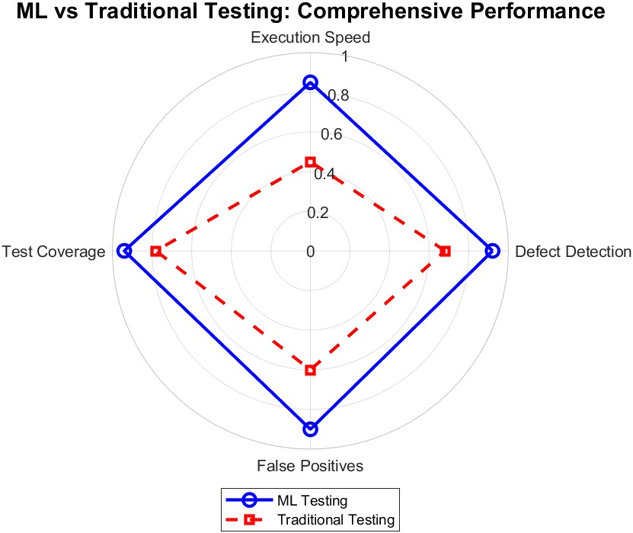
Figure 1. Comparison of Machine Learning and Traditional Testing
Figure 1 indicates the execution time gain concerning test cycles for ML-based testing (solid blue line with circles) and traditional testing (dashed red line with crosses). The abscissa shows the test cycle number while the ordinate represents execution time in seconds. The graph depicts that the execution time for ML-based testing is always better than traditional testing and, in fact, quite low in absolute time throughout the test cycles. During the early phases of the cycles, ML-based testing starts slightly above 100 seconds, while traditional testing is above 200 seconds, thereby giving credence to the efficiency of the ML-driven approach. The execution time for both methods decreases in a downward trend over the test cycles, indicating that testing processes are improving with every iteration. However, ML assures far superior improvements in much lower execution time than the older method. The additional evidence here suggests that the ML algorithms tend to even more strongly optimize testing processes over time based on learned automated mechanisms possible for efficiency. In contrast, traditional testing still improves alongside, but at a generally slower pace, owing to their characteristics of manual or semi-automated approaches that just do not scale as well. The enormous improvement in execution time of the ML-based testing method indicates clearly that it offers better scalability and automation.
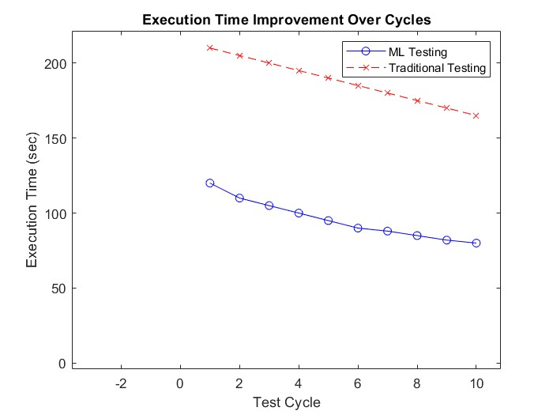
Figure 2. Comparison of Machine Learning and Traditional Testing in Execution Time
Based on the analysis that compares ML-based testing to traditional testing, as graphically presented through radar charts and improvements in execution time, it greatly argues and narcotizes how machine learning significantly augments the accuracy and efficiency of mobile application testing compared to conventional automated testing methods (RQ-1). As underscored in the radar graph where ML-based testing is found to strengthen substantially the defect detection accuracy, current baseline observation revealed that the number of defects identified by the ML approach outnumbers that by conventional one's perfect assertion that it analyzed hazier patterns more efficiently and identified anomalies which rule-based (traditional) testing was unlikely to detect. During this false positive initiation, the ML-testing system yields fewer false positives; thus, it effectively reduces the number of wrong identifications as defects, which cancels out unnecessary debugging efforts. Conversely, traditional automated testing is higher on the false positive end, generating inefficiencies and putting a burden on developers. Though ensuring higher accurateness in defect detection, it has the additional benefit of making mobile applications undergo testing more rigorously and improving them overall in terms of quality and reliability, given that they are put to production.
ML-based testing increases efficiency and also shortens execution time while increasing the extent of the test. The execution time improvement graph, which makes it abundantly clear that ML-based testing is many times faster than traditional methods over several test cycles, suggests that findings regarding the advantages of dynamic ML test execution, learning from previous test cycles, and scheduling future runs accordingly would lead to fewer actual testing cycles. From the inference, it can be stated that the ML approach starts with a high execution time but has steeper improvement over time to finally settle down at a very low execution time when compared to traditional automated testing. Moreover, it means wider coverage of tests for ML-based testing as it can fairly validate a more diverse and representative set of test cases, including some extreme cases that traditional methods might fail to capture. This broader coverage enhances the validation of functionalities in these apps so that they won't have bugs undetected during real-world usage.
RQ-2: What machine learning models and techniques are most effective for detecting usability and performance issues in mobile applications?
Figure 2 provides two pertinent and comprehensive visualizations communicating vital performance data regarding the machine learning model vis-a-vis trends of utilization of CPU on the server. The plot on the left compares the performances of the four machine learning models, Decision Tree, Naïve Bayes, Artificial Neural Network (ANN), and Random Forest, across three important evaluation metrics: Precision, Recall, and F1-Score. A clear interpretation in this plot shows that both Decision Tree and Random Forest models performed strongly and consistently, achieving nearly similar high scores on all measures; thus, their efficacy and reliability in this classification task remain rather unquestionable. However, Naïve Bayes generally performed poorly, especially with respect to Precision and F1-Score, indicating its difficulty in dealing with misclassification errors. Between Naïve Bayes and the tree-based models, the ANN model showed fair performance rather on the lower side, pointing out its possibilities that could be utilized in later optimization for better results. Performance consistency signals the robustness of the Decision Tree and Random Forest suitable for the pertinent dataset.
The right plot in Figure 2 gives a clear picture of system performance vis-a-vis possible failures when analyzing server CPU utilization over the passage of time. Initially, CPU utilization fluctuates in a quasi-equilibrium condition, maintaining moderate fluctuations. An abrupt spike occurs at the 60-minute mark, with far greater CPU utilization than 80%. Performance problems are noted to occur just after the spikes, signaled by the red dots. The clustering of detected issues after the spike suggests a strong correlation between high CPU utilization and possible system instability. This trend indicates that economic resource saturation, resource bottlenecks, or poor workload distribution may be of a nature that degrade system performance or even cause failures. Such insights may be useful for predictive maintenance, whereby alerts might be issued if CPU utilization approaches critical levels to the extent of actually causing downtime. Another option would be to analyze the workload distribution and optimize computational processes to minimize such problems and ensure continuous server performance.
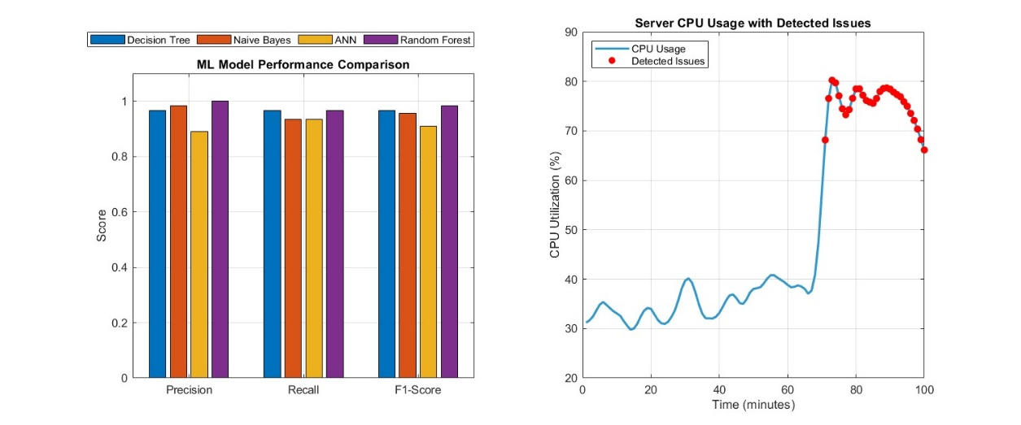
Figure 3. ML models with performance detection in mobile applications
It appears that Decision Tree and Random Forest are the most powerful models for usability and performance issue detection in mobile applications, based on their analysis against machine-learning model performance and CPU utilization trends. With continuous classification performance with respect to the important evaluation metrics of precision, recall, and F1-Score, these models are one of the most trusted in identifying anomalies. On the contrary, Naïve Bayes could not yield precise results in terms of precision and recall, thereby showing that it grapples with more complex usability and performance issues. ANNs achieved moderate performance but need to be tuned further in order to achieve good results. Usability and performance issues in mobile apps mainly become visible in the patterns of behavior of the system, such as CPU spikes or slow response times. Therefore, tree-based models, which are good at capturing complex decision boundaries with the interplay of multiple factors, are particularly relevant. Furthermore, CPU utilization analysis mandates predictive monitoring, as CPU utilization sharply rose in conjunction with detected system issues. Thus, there is an opportunity for enhancing proactive issue detection with time-series forecasting methods, including Long Short-Term Memory (LSTM) networks or ARIMA models, in combination with traditional classification ones with unsupervised anomaly detection methods such as Isolation Forest, One-Class SVM, and Autoencoders being potentially invaluable to identify irregularities in real-time without labeled training data. These could work especially in a mobile scenario, where performance issues may be due to erratic user behavior, network fluctuations, or device-specific constraints.
RQ-3: How does ML-driven testing impact the overall user experience and quality assurance process in mobile app development?
With reference to four different visualizations in Figure 3, they conjointly explain the effect of machine learning (ML) use on software testing efficiency, defect detection, and user experience. The correlation heatmap (top left) demonstrates the relationships between primary metrics, revealing an extremely strong positive correlation between test coverage, defect detection, application rating, and user retention, all with a correlation factor exceeding 0.85. Hence, improving software testing quality leads to greater user satisfaction. ML adoption strongly correlates with defect detection (0.892) and continuous integration and delivery (0.947), meaning ML testing is tied to faster software development cycles. Furthermore, on the contrary, time to fix bugs has a negative association with efficiency factors, which means that bug resolution time needs to be decreased in order to have higher retention and user satisfaction.
The line graph (top right) speaks to the gradual enhancement of software quality parameters with the increasing levels of ML adoption. Test coverage and defect detection kept rising, with ML adoption going from level 1 to level 5, illustrating the success of AI-powered automation in enhancing software quality. Test coverage, in contrast, sees a much sharper increase, indicating that the use of ML techniques is allowing for a more rigorous assessment of software performance. App Rating, however, increases at a relatively low rate, indicating that while the improvements in testing reduce software defects, there are many other user experience elements not relating to bug detection (like UI/UX and feature availability) that affect app ratings. On balance, ML is positively correlated with the constant elevation of defect detection and test coverage and augments the quickening of quality assurance processes while diminishing manual testing inaccuracies.
The scatter plot (bottom left) defines the correlation between QA team size and the time taken to fix bugs, powered through color-representing levels of ML adoption. One can clearly see that bigger QA teams generally have lower bug-fixing times, but this efficiency is boosted by the injection of ML across all team sizes. At levels of ML adoption represented by dark colors, teams fix bugs in record time, even with small sizes; on the other hand, smaller teams with low rates of ML adoption take disproportionately longer to fix bugs, thereby reaffirming the importance of AI tools in accelerating issue resolution. This indicates that although team size does play a role in efficiency, ML bar automation and predictive analytics are the sine qua non in reducing time for bug resolution, thus enhancing collaboration for QA teams.
The penultimate scatter plot (lower right) is devoted to the role of ML adoption levels in determining the relationship between Defect Detection Rate and User Retention. Here, a strong positive correlation appears as higher defect detection rates imply higher user retention. Having a higher ML adoption level (as represented using green and purple points) is reflective not only of higher defect detection rates but also associated with improvement in user retention. It could, therefore, be inferred that AI-managed quality assurance improves user experiences. Poorer adoption levels of ML (blue and red points) are scattered in lower retention and defect detection ranges, suggesting that perhaps traditional testing methods are not offering the best user satisfaction.
ML-based testing improves user experience in mobile subdomain application development through defect detection, bug-fix time, and user retention. The theory states that ML adoption relates strongly to increased test coverage, defect detection, and user retention, and application quality is thus expected to increase. This reduces defective applications and, thus, a more dependable and satisfying user experience following the integration of machine-learning software testing. ML provides automation with defect detection and test coverage. More problems in software are being detected and fixed before they reach the end user thanks to ML adoption, which was a strength of an increase in defect detection. The ML-powered tools speed up the bug-fixing process, thus increasing QA team productivity. Such integration would enable small QA teams to match the efficiency of larger teams without manual effort. Automating the processes will prepare for ML testing ridge regression, anomaly detection, etc., so concentrated testing must receive attention for robust strength.
Strong hinges are seen on the correlation heat map supporting ML adoption in CI/CD practices. That means AI-assisted testing accelerates the release of mobile applications. With this, developers could quickly update mobile apps without compromising quality, fulfilling user requirements and market demands. It indicates that application quality contributes to user experience through increased defect detection and retention. Here, we have a scatter plot that indicates that an app with a high defect detection rate has high user retention. Therefore, the rigor of testing contributes to customer engagement. The same ML testing that enhances early detection of bugs and performance issues reduces crashes and interruptions while maintaining stable application performance. ML testing improves defect detection and bug-fix time, but the user experience cannot depend on defect-free. The analysis indicates that AI testing improves test coverage and defect detection but does not increase app rating. This means that UI/UX design, features, and usability are crucial to user perception. Developers must couple the experience with intuitive designs and user-centric features while ML-based testing provides stability and reliability.
The claim that ML-enabled testing has wholly changed mobile app development for all intents and purposes in quality assurance and user experience is far-reaching. Testing becomes straightforward and pragmatic with ML-enabled QA by automating coverage, speeding defect detection, and reducing fix time. Increased defect detection helps retain users, meaning the more stringent ML-based testing is implemented, the longer the users will engage with the application. While ML has improved the application's stability, the user experience is a multidimensional aspect that requires work in usability, aesthetics, and design beyond defect-free operation. It would be interesting to study how different ML models, such as deep learning (predictive testing) and reinforcement learning (adaptive bug detection), affect quality assurance and how ML testing can be tailored to mobile apps like gaming, e-commerce, and social networking. ML with real-time user feedback and A/B testing will offer more insights into optimizing mobile app development processes.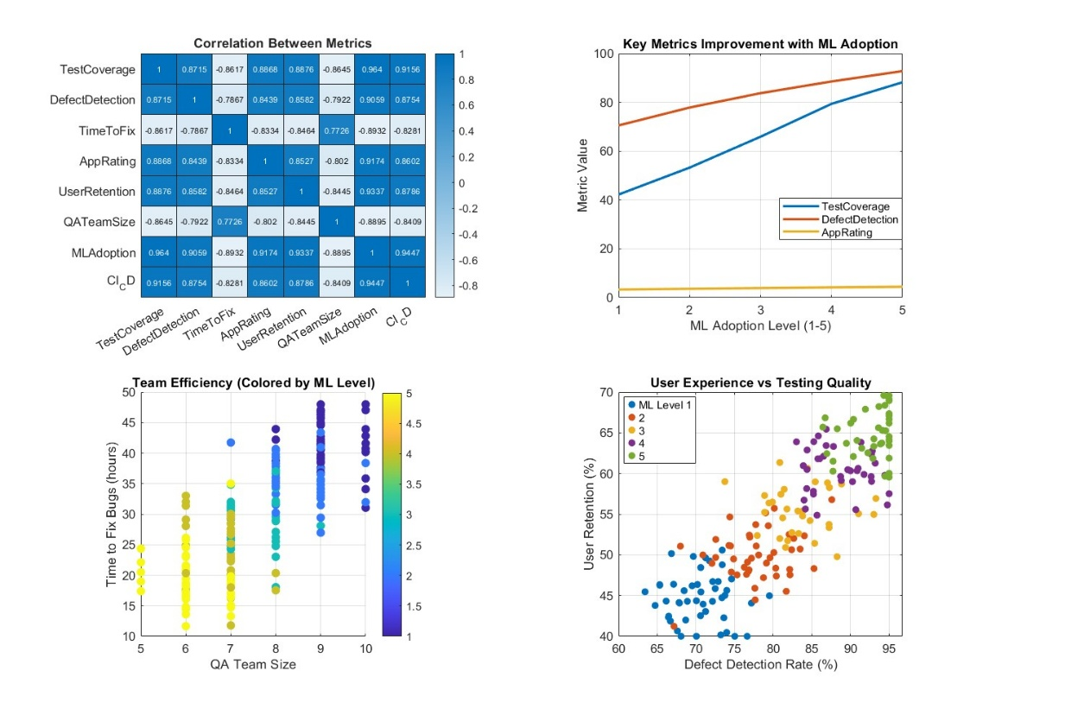
Fig. 4. User Experience and Quality Assurance Process in Mobile App Development

5. Conclusion

The evidence collected in this study substantially evidences the great impact machine learning (ML) has made in software testing, especially in defect detection, test automation, and quality assurance. The research reveals that testing enriched with ML considerably increases test coverage, cuts test maintenance costs, and detects and fixes bugs faster. While doing this, ML can use historical information to infer markers or patterns that might give rise to failures for preemptive error avoidance. The remaining optimization for the selection and execution of test cases has been done using other ML techniques that could be supervised learning for classification or unsupervised learning in anomaly detection. Thus, the investigation emphasizes the impact of ML in CI/CD pipelines, which automate testing and reduce manual effort. This study states that ML in testing correlates with increased reliability, user retention, and overall performance of the applications. This research presents a crucial opportunity to further the niche of ML in software testing by systematically evaluating the ML techniques considered in this context, their applications, and their effectiveness in practice in software development today. Unlike traditional tests, which require a lot of manual intervention, ML introduces adaptive intelligence into massively automated processes with lesser human labor and higher efficiency. The different models have been assessed critically in this work, and this comparison considers ML methods—such as decision trees, neural networks, and anomaly detection algorithms—in terms of their strengths and weaknesses. Another critical contribution here is the demonstration of ML's role in defect detection and bug-fix times, showing how intelligent automation can maximize software quality without sacrificing speed to release. The study also describes barriers to ML adoption for software testing, including data availability, model interpretability, and integration challenges, with recommendations for overcoming these barriers. While ML-based testing is very promising, lots of areas still require consideration. One line of prospect could involve the combination of ML with real-time user feedback for the possible dynamic modification of test case generation. By integrating user behavior analytics and telemetry data, ML models could evolve toward building user-centric testing strategies, identifying pressing issues from real-world usage. Another promising avenue is the exploration of new ML models, like transformer-based architectures, for test case selection and failure prediction. Furthermore, extending ML-driven testing frameworks to the new technologies of IoT, blockchain, and quantum computing may promote new ways of tackling complex and distributed software environments. Lastly, future studies should enhance ML model explainability in software testing, ensuring that automated decisions remain interpretable and actionable for developers and testers.

COMPETING INTERESTS DISCLAIMER:
Authors have declared that they have no known competing financial interests OR non-financial interests OR personal relationships that could have appeared to influence the work reported in this paper.

References

Ahmad, A., Feng, C., Tao, M., Yousif, A., & Ge, S. (2017). Challenges of mobile applications development: Initial results. 2017 8th IEEE International Conference on Software Engineering and Service Science (ICSESS). https://doi.org/10.1109/ICSESS.2017.8342956

Ahmad, A., Li, K., Feng, C., Asim, S. M., Yousif, A., & Ge, S. (2018). An empirical study of investigating mobile applications development challenges. IEEE Access: Practical Innovations, Open Solutions, 6, 17711–17728. https://doi.org/10.1109/access.2018.2818724

Ajorloo, S., Jamarani, A., Kashfi, M., Haghi Kashani, M., & Najafizadeh, A. (2024). A systematic review of machine learning methods in software testing. Applied Soft Computing, 162(111805), 111805. https://doi.org/10.1016/j.asoc.2024.111805

Alzahrani, A. O., & Alenazi, M. J. F. (2021). Designing a network intrusion detection system based on machine learning for software defined networks. Future Internet, 13(5), 111. https://doi.org/10.3390/fi13050111

Arif, K. S., & Ali, U. (2019). Mobile Application testing tools and their challenges: A comparative study. 2019 2nd International Conference on Computing, Mathematics and Engineering Technologies (iCoMET). https://doi.org/10.1109/ICOMET.2019.8673505

Azgar, A., Rana, S., Hossain, S., & Ferdous, M. J. (2022). Testing Challenges for Mobile Applications: An evaluation and comparative analysis of different testing approaches. International Journal of Research and Innovation in Applied Science, 07(04), 07–13. https://doi.org/10.51584/ijrias.2022.7402

Bajaj, Y., & Samal, M. K. (2023). Accelerating software quality: Unleashing the power of generative AI for automated test-case generation and bug identification. International Journal for Research in Applied Science and Engineering Technology, 11(7), 345–350. https://doi.org/10.22214/ijraset.2023.54628

Baqar, M., & Khanda, R. (2024). The future of software testing: AI-powered test case generation and validation. In arXiv [cs.SE]. https://doi.org/10.48550/ARXIV.2409.05808

Chakraborty, J., Majumder, S., & Menzies, T. (2021). Bias in machine learning software: why? how? what to do? Proceedings of the 29th ACM Joint Meeting on European Software Engineering Conference and Symposium on the Foundations of Software Engineering. 429-440. https://doi.org/10.1145/3468264.3468537

Fontes, A., & Gay, G. (2023). The integration of machine learning into automated test generation: A systematic mapping study. Software Testing, Verification & Reliability, 33(4). https://doi.org/10.1002/stvr.1845

Gao, R., Wang, Y., Feng, Y., Chen, Z., & Eric Wong, W. (2019). Successes, challenges, and rethinking – an industrial investigation on crowdsourced mobile application testing. Empirical Software Engineer, 24(2), 537–561. https://doi.org/10.1007/s10664-018-9618-5

Gartziandia, A., Arrieta, A., Ayerdi, J., Illarramendi, M., Agirre, A., Sagardui, G., & Arratibel, M. (2022). Machine learning‐based test oracles for performance testing of cyber‐physical systems: An industrial case study on elevators dispatching algorithms. Journal of Software (Malden, MA), 34(11). https://doi.org/10.1002/smr.2465

Habeeb Agoro, A. M. (2023). AI-Powered Test Case Generation and Execution. https://www.researchgate.net/publication/390262506_AI-Powered_Test_Case_Generation_and_Execution

Hanif, H., Md Nasir, M. H. N., Ab Razak, M. F., Firdaus, A., & Anuar, N. B. (2021). The rise of software vulnerability: Taxonomy of software vulnerabilities detection and machine learning approaches. Journal of Network and Computer Applications, 179(103009), 103009. https://doi.org/10.1016/j.jnca.2021.103009

Hutchinson, B., Smart, A., Hanna, A., Denton, E., Greer, C., Kjartansson, O., Barnes, P., & Mitchell, M. (2021). Towards accountability for machine learning datasets: Practices from software engineering and infrastructure. Proceedings of the 2021 ACM Conference on Fairness, Accountability, and Transparency.

Kaur, A., & Kaur, K. (2022). Systematic literature review of mobile application development and testing effort estimation. Journal of King Saud University - Computer and Information Sciences, 34(2), 1–15. https://doi.org/10.1016/j.jksuci.2018.11.002

Khatibsyarbini, M., Isa, M. A., Jawawi, D. N. A., Shafie, M. L. M., Wan-Kadir, W. M. N., Hamed, H. N. A., & Suffian, M. D. M. (2021). Trend application of machine learning in test case prioritization: A review on techniques. IEEE Access: Practical Innovations, Open Solutions, 9, 166262–166282. https://doi.org/10.1109/access.2021.3135508

Li, S., Guo, J., Lou, J.-G., Fan, M., Liu, T., & Zhang, D. (2022). Testing machine learning systems in industry. In ICSE '22: 44th International Conference on Software Engineering. ACM. https://doi.org/10.1145/3510457.3513036

Mahmood, Y., Kama, N., Azmi, A., Khan, A. S., & Ali, M. (2022). Software effort estimation accuracy prediction of machine learning techniques: A systematic performance evaluation. Software: Practice & Experience, 52(1), 39–65. https://doi.org/10.1002/spe.3009

Marijan, D. (2023). Comparative study of machine learning test case prioritization for continuous integration testing. Software Quality Journal, 31(4), 1415–1438. https://doi.org/10.1007/s11219-023-09646-0

Morovati, M. M., Nikanjam, A., Khomh, F., Ming, Z., & Jiang. (2022). Bugs in Machine Learning-based systems: A faultload benchmark. In arXiv [cs.SE]. https://doi.org/10.48550/ARXIV.2206.12311

Pandey, S. K., Mishra, R. B., & Tripathi, A. K. (2021). Machine learning based methods for software fault prediction: A survey. Expert Systems with Applications, 172(114595), 114595. https://doi.org/10.1016/j.eswa.2021.114595

Peruma, A., Huo, T., Araújo, A. C., Imanaka, J., & Kazman, R. (2024). A developer-centric study exploring mobile application security practices and challenges. In arXiv [cs.CR]. https://doi.org/10.48550/ARXIV.2408.09032

Ramadan, A., Yasin, H., & Pektas, B. (2024). The role of artificial Intelligence and Machine Learning in software testing. In arXiv [cs.SE]. https://doi.org/10.48550/ARXIV.2409.02693

Rezaalipour, M., & Furia, C. A. (2023). An annotation-based approach for finding bugs in neural network programs. Journal of Systems and Software, 111669. https://doi.org/10.1016/j.jss.2023.111669
Shoaib, M., Fitzpatrick, D. and Pitt, I. (2024) 'Accessibility features of developmental platforms:

Towards developing accessible mobile applications with cross-platform, research challenges and opportunities', 5th International Workshop on Digitization and EInclusion in Mathematics and Science 2024 (DEIMS2024), Nihon University, Tokyo, Japan, 15-17 February, pp. 153-162. Available at: https://workshop.sciaccess.net/deims2024/ (Accessed: 12 March 2024)

Stradowski, S., & Madeyski, L. (2023). Machine learning in software defect prediction: A business-driven systematic mapping study. Information and Software Technology, 155(107128), 107128. https://doi.org/10.1016/j.infsof.2022.107128

Wang, S., Shrestha, N., Subburaman, A. K., Wang, J., Wei, M., & Nagappan, N. (2021). Automatic unit test generation for machine learning libraries: How far are we? 2021 IEEE/ACM 43rd International Conference on Software Engineering (ICSE). 1548-1560). https://doi.org/10.1109/ICSE43902.2021.00138

Xavier, M. G., Matteussi, K. J., Franca, G. R., Pereira, W. P., & De Rose, C. A. F. (2017). Mobile application testing on clouds: Challenges, opportunities and architectural elements. 2017 25th Euromicro International Conference on Parallel, Distributed and Network-Based Processing (PDP). 181-185). http://dx.doi.org/10.1109/PDP.2017.96

Zakaria, N. A., Ismail, A. R., Ali, A. Y., Khalid, N. H. M., & Abidin, N. Z. (2021). Software project estimation with machine learning. International Journal of Advanced Computer Science and Applications : IJACSA, 12(6). https://doi.org/10.14569/ijacsa.2021.0120685

