**ENSEMBLE MACHINE LEARNING-BASED HEART DISEASE PREDICTION WITH HYPER-TUNING PARAMETERS**

**Abstract**

Heart disease is the most dangerous issue in the world. Health sector people also face problems with this disease in the world. Serious investigation avoids the issue in a short time. Optimal prediction generates accurate results for this disease. This type of investigation helps to doctors for identification of diseases and cures for health. Machine learning techniques play a crucial role in this scenario. In health industry utilized such type of engineering techniques for speedy identification and recovery. My goal is to avoid such types of illnesses in people's lives. Here we use ensemble learning with hyper-tuning parameters of the dataset. Our research observes that, if I use the different machine learning models individually then the accuracy for the decision tree predicts 70.37%, the Random Forest tree is 79.63%, the Support Vector Machine is 75.93% and the Logistic Regression predicts 81.48%. But ensemble models of decision tree and Random Forest tree generate an accuracy rate is 71. 29% and SVM and LR accuracy rate is 76.85%.

1. **INTRODUCTION**

Our heart is the most crucial organ in our body parts. The heart consists of entire coronary arteries. If any one thing is damaged, the entire system of the body is affected immediately. Enduring situations encompass cardiovascular diseases [1]. World Health Organization forms certain rules regarding this disease for prevention and treatment. Health sector people also face problems with this disease in the world. Serious investigation avoids the issue in a short time [2]. Optimal prediction generates accurate results for this disease. This type of investigation helps to doctors for identification of diseases and cures for health. Machine learning techniques play a crucial role in this scenario. In health industry utilized such type of engineering techniques for speedy identification and recovery [3].

So many emerging technology techniques are used for critical evaluation of healthcare records and data extraction for easy understanding. Using these techniques finding the intense of severity of the disease and maintaining of connection between organs with the heart [4]. Clinical decision-making plays a key role in this context for generating the best disease prevention procedures. In modern lifestyles, due to the public eating habits that cause cardiac problems [5]. Some other medical conditions are affecting this cardiac disease. In this context, patient health information is most important for handling heart disease patients. Information extraction is the most important and challenging task for medical science [6].

Heart disease is the most life-threatening health issue in the real-world scenario. That means the cardiovascular not pumping the proper amount of blood to the body [13]. It is essential to produce the insusceptible arrangement of the human body. A lot of symptoms include cardiovascular like breathing problems, balance exhaustion, increased moist pulse rate, and swollen feet [7].

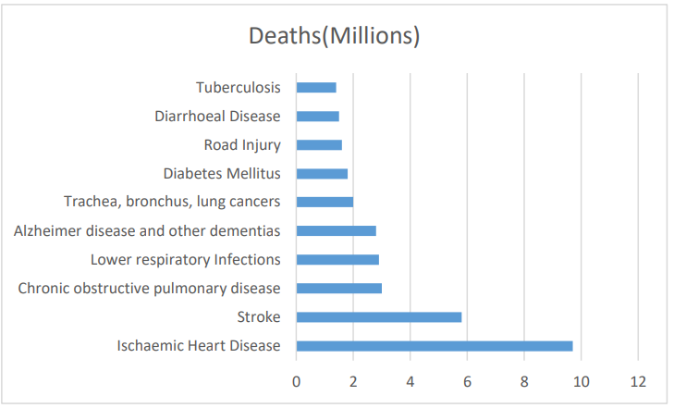

**Figure 1:** 10 Global issues of deaths 2023

1. **PROPOSED WORK AND ARCHITECTURE**

We used classification methods, virtuously for construction relations amongst massive databases by simply expecting the results by bearing in mind the type of connotation [14]. This kind of method plays an important role in each facet of science and engineering [8]. Health sector people also face problems with this disease in the world [9]. Serious investigation avoids the issue in a short time. Optimal prediction generates accurate results for this disease [11]. This type of investigation helps to doctors for the identification of diseases and cure of health also. Machine learning techniques play a crucial role in this scenario. In health industry utilized such type of engineering techniques for speedy identification and recovery [12].

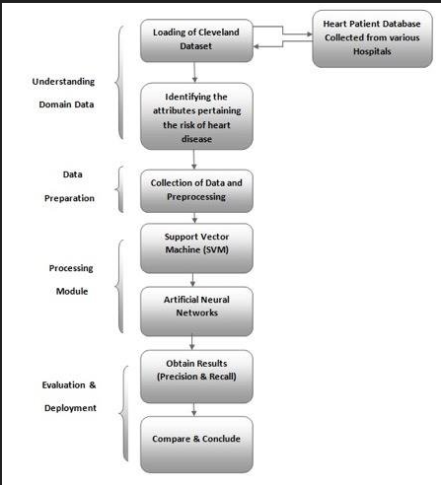

**Figure 2:** Architecture of Proposed Work[16]

The following figure 2 displays the building of our projected work. It starts from loading data to predicting results, in between multiple phases available for data flowing. Finally, get the accuracy result.

**III. RESULTS AND ANALYSIS**

**3.1 Data and Libraries of Python**

After installing the numpy and pandas packages, we are ready to fetch data using the pandas package, before we use it, we need to know where's our dataset located. This means what is the path of our dataset.

# 3.1 Data Collection

# Data is a collection of attributes. Different types of attributes provide information regarding disease. Load the dataset into the system.

**Table 1:** Dataset [10]

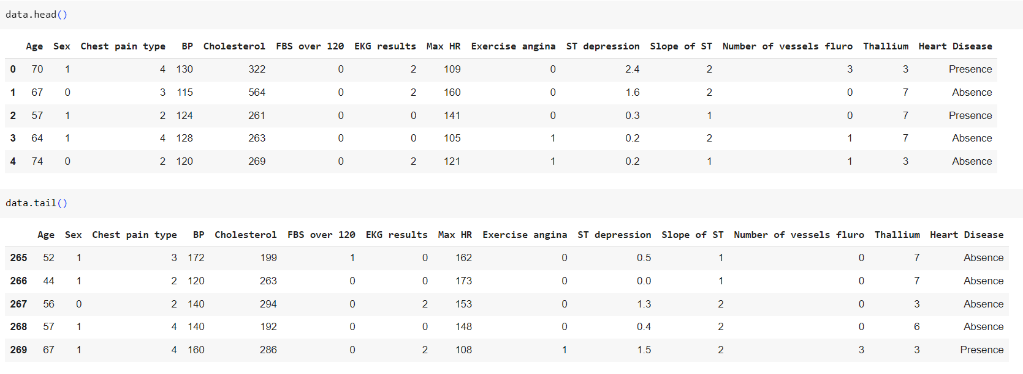

# Data Analysis

# Table 2: Attribute information

# 

# Data Visualization

# In our research multiple attributes are used finding result, the following figure 3 shows the data visualization of attributes.

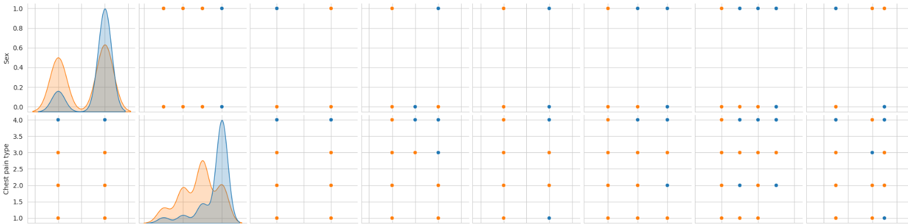

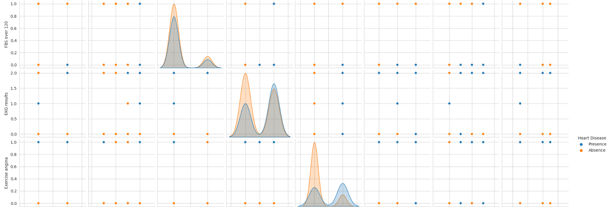

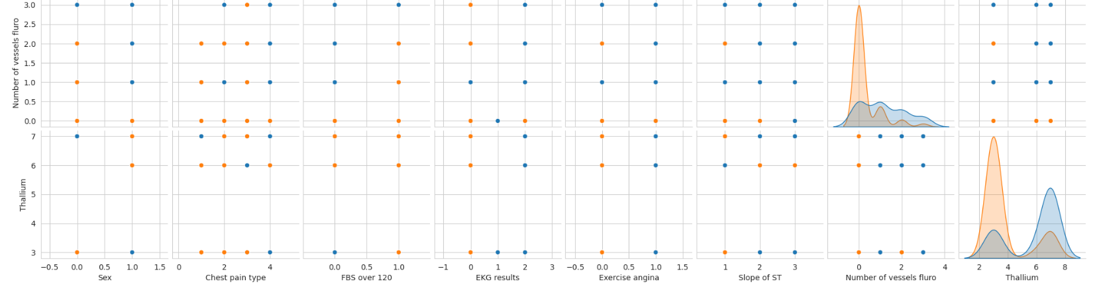

**Figure 3:** Visualization of Given input dataset

Heat Maps are graphical depictions of data. The prime determination of Heat Maps is to improve the envision the capacity of locations within a dataset and support directional addressees to areas on data visualizations. The following picture 4 for multiple attributes representation of heat map.

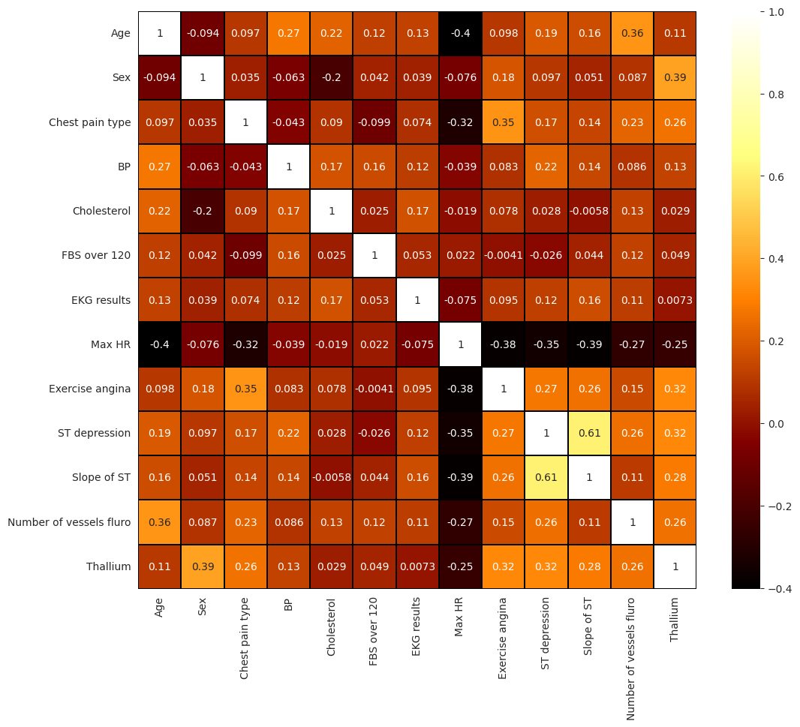

**Figure 4:** Heatmap of Given input dataset

# 3.4 Model Implementation

# Model implementation with multiple libraries for starting our research with python.

### **3.5 Features Selection**

# Select a feature for accurate predictions from given input data.

# Table 3: selection of features

# 

### **3.6 Data split and scaling**

After selection of features data can be split and scaling of data(preprocessing).

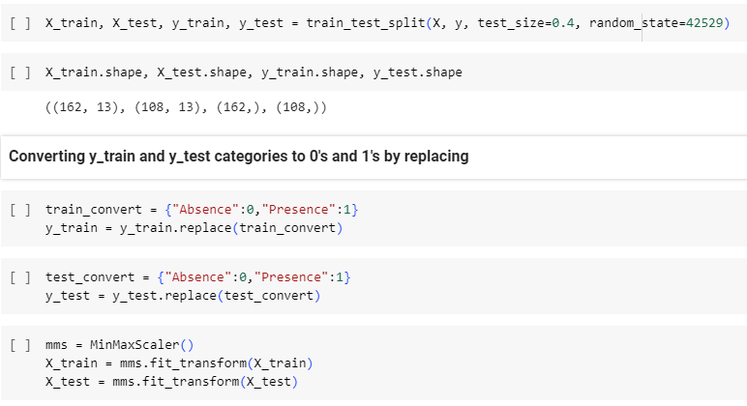

# 3.7 ML Model Selecting and Model Prediction

Model selection and prediction are most important for the accuracy of research. It affects the performance also.

### **3.8 Model Implementing**

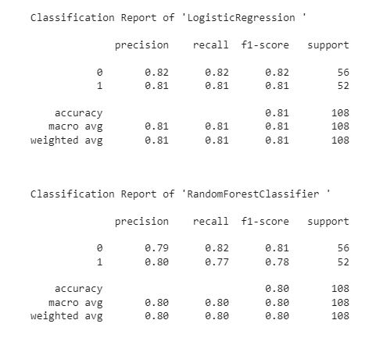

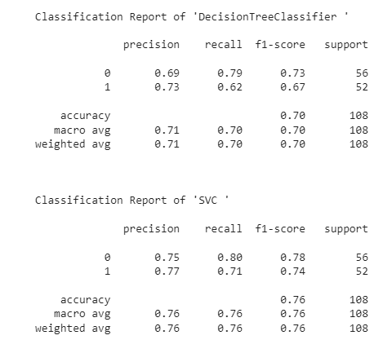

A confusion matrix is a performance assessment tool in the artificial domain. 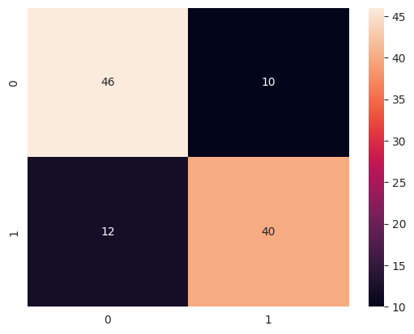

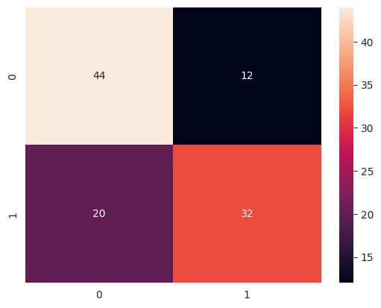

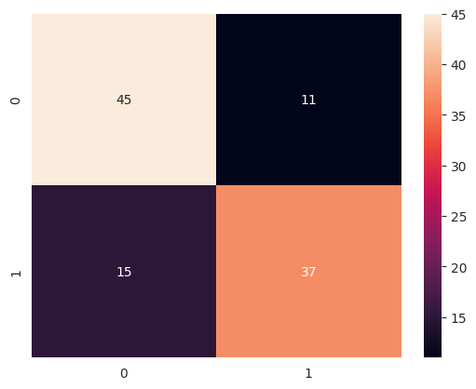

**Figure 5:** Confusion matrix of our models

While predicting we can store the model’s score and prediction values to a newly generated data frame. The following Table 4 shows the different machine learning models' accuracy as the decision tree predicts 70.37%, the Random Forest tree is 79.63%, the Support Vector Machine is 75.93& and the Logistic Regression predicts 81.48%. If you observe this table Logistic regression performs more accurately compared to other models.

**Table 4:** Accuracy table

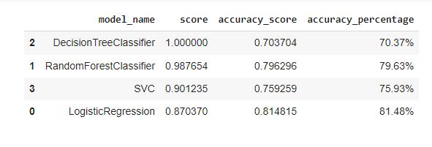

### **3.9 Hyper tuning the ML Model**

For Hyper Tunning we can use Grid Search CV to know the finest performing parameters.

## **3.10 Ensemble model (Decision Tree + Random Forest)**

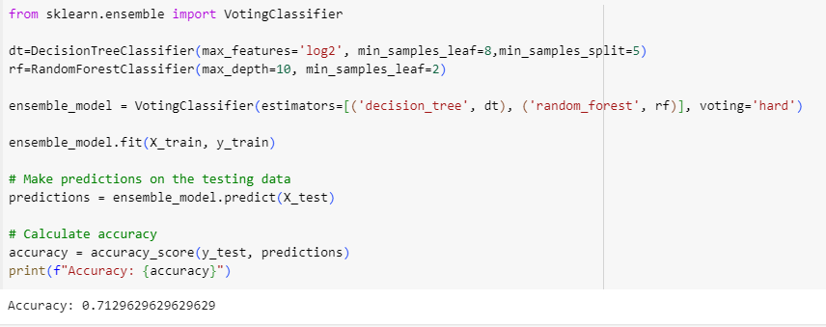

## **3.11 Ensemble model (SVC + Logistic Regression)**

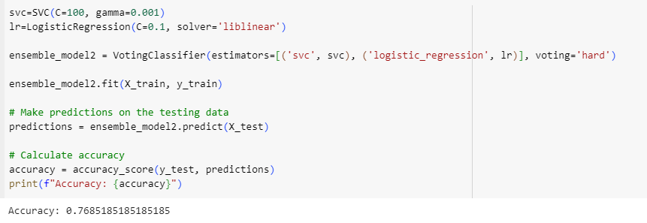

Our proposed ensemble model decision tree and Random Forest generate an accuracy rate is 71. 29% and Support Vector Machine and Logistic Regression accuracy rate is 76.85%. Finally, our research observes that, if I use the different machine learning models individually then the accuracy for the decision tree predicts 70.37%, the Random Forest tree is 79.63%, the Support Vector Machine is 75.93% and Logistic Regression predicts 81.48%. But ensemble models of decision tree and Random Forest tree generate an accuracy rate is 71. 29% and Support Vector Machine and Logistic Regression accuracy rate is 76.85%.

In this research except the decision tree model remaining three models perform the same or high performance compared to ensemble learning.

1. **CONCLUSION**

Health sector people also face problems with this disease in the world. Serious investigation avoids the issue in a short time. Optimal prediction generates accurate results for this disease. This type of investigation helps to doctors for the identification of diseases and cure of health also. Machine learning techniques play a crucial role in this scenario. In health industry utilized such type of engineering techniques for speedy identification and recovery. Our goal is to avoid such types of illness in people's lives. The major goal of this job effort extremely to forestall the incidence of coronary disease. Our research observes that, if I use the different machine learning models individually then the accuracy for the decision tree predicts 70.37%, the Random Forest tree is 79.63%, the Support Vector Machine is 75.93% and the Logistic Regression predicts 81.48%. But ensemble models of decision tree and Random Forest tree generate an accuracy rate is 71. 29% and SVM and LR accuracy rate is 76.85%.

**REFERENCES**

1. Arthy, S. (2018): A survey on heart disease prediction using data mining techniques. IJERCSE, 5(4), 280-287.
2. Australian Institute of Health and Welfare (AIHW). (2011). Cardiovascular Disease Series. AIHW, Canberra, Australia.
3. Ayon, S. I., Islam, M. M., & Hossain, M. R. (2020). Coronary artery heart disease prediction: A comparative study of computational intelligence techniques. Journal of the Institution of Electronics and Telecommunication Engineers, 1–20.
4. Bui, L., Horwich, T. B., & Fonarow, G. C. (2011). Epidemiology and risk profile of heart failure. Nature Reviews. Cardiology, 8(1), 30–41. doi:10.1038/nrcardio.2010.165 PMID:21060326.
5. Burse, K., Kirar, V. P. S., Burse, A., & Burse, R. (2019). Various preprocessing methods for neural network-based heart disease prediction. In Smart innovations in communication and computational sciences, (pp. 55–65). Springer. doi:10.1007/978-981-13-2414-7_6
6. Dahiwade, D. (2019) Designing disease prediction model using machine learning approach. In Third IEEE International Conference on Computing Methodologies and Communication (ICCMC). 10.1109/ ICCMC.2019.8819782
7. Dey, D., Slomka, P. J., Leeson, P., Comaniciu, D., Shrestha, S., Sengupta, P. P., & Marwick, T. H. (2019). Artificial intelligence in cardiovascular imaging: JACC state-of-the-art review. Journal of the American College of Cardiology, 73(11), 1317–1335.
8. Gavhane, A. (2018). Prediction of Heart Disease Using Machine Learning. Second International Conference on Electronics, Communication, and Aerospace Technology (ICECA), p. 1275–8.
9. B. Venkata Lakshmi, M.V Shivsankar:” Heart Disease Diagnosis Using Predictive Data mining”, TIFAC-CORE, Pervasive Computing Technologies, Velammal Engineering College, Chennai, India.
10. UCI Machine learning Repository <https://archive.ics.uci.edu/ml/datasets/Heart+Disease>.
11. SantoshandSubhani Shaik,” Heart disease prediction with PCA and SRP”, International Journal of Engineering and Advanced Technology,” Volume-8, Issue-4, 2019.
12. Subhani shaik, Dr. Vijayalakshmi Kakulapati,” Prediction and Diagnosing of Heart Diseases using Data Mining and Artificial Intelligence based Algorithms”, ISBN13: 9781668457412, IGI Global Publication, Oct-2022.
13. KP Surya Teja, Vigneswara Reddy, and Subhani Shaik,” Flight Delay Prediction Using Machine Learning Algorithm XGBoost”, Jour of Adv Research in Dynamical & Control Systems, Vol. 11, No. 5, 2019.
14. Dr. R. Vijaya Kumar Reddy, Dr. Shaik Subhani, Dr. G. Rajesh Chandra, Dr. B. Srinivasa Rao,” Breast Cancer Prediction using Classification Techniques”, International Journal of Emerging Trends in Engineering Research, Vol. 8, No.9,2020.
15. Mr. Sujan Reddy, Ms. Renu Sri, andSubhani Shaik,” Sentimental Analysis using Logistic Regression”, International Journal of Engineering Research and Applications (IJERA), Vol.11, Series-2, July-2021.
16. Ms. Mamatha, Srinivasa Datta and Subhani Shaik,” Fake Profile Identification using Machine Learning Algorithms”, International Journal of Engineering Research and Applications (IJERA), Vol.11, Series-2, July-2021.