Massive Right Atrial Myxoma Mimicking Right Heart Failure: A Rare Case

.

ABSTRACT

|  |
| --- |
| **Aims**: Myxomas are rare, which in common pupolation has an incidence of 0.0017%. The majority (75–80% of cases) of myxomas are located in the left atrium, and 18% of cases are located in the right atrium with diverse clinical manifestations.  **Presentation of Case**: A 30-year-old woman came with a chief complaint of dyspnea and near syncope on effort, and a history of ascites and edema of the lower extremities. Transthoracic echocardiography (TTE) disclosed a substantial mass in the RA, indicative of myxoma, causing right ventricular (RV) inflow obstruction with a mean gradient of 18 mmHg. Our patient was undergoing cito open heart surgery with resection of an 8.5 x 6.5 cm multilobulated mass. The residual septal defect was rectified with direct closure. Tricuspid valve coaptation testing was good. The diagnosis of myxoma was validated through a histological examination. The post operative recovery was unremarkable, and the patient was discharged on the sixth day following surgery.  **Discussion and Conclusion:** RA myxoma often goes undetected due to its low incidence rate and mimicking right heart failure presentation. Postponement of surgical operation may result in irreversible consequences. Surgical resection is the optimal therapy and should be executed promptly following diagnosis. |

*Keywords intracardiac neoplasms, RA myxoma, right heart failure*

1. INTRODUCTION

Intracardiac neoplasms represent 0.2% of all human malignancies.(Arruda, Braile, Joaquim, Soares, & Alves, 2008) These masses are classified as primary (benign or malignant) and metastatic (malignant). Metastatic neoplasms occur 20-40 times more frequently than initial neoplasms. Primary cardiac neoplasms are uncommon. About 75% of primary neoplasms are benign, while around 50% are benign, including myxoma, which in common population has an occurrence of 0.0017%. Myxoma is an authentic neoplasm originating from multipotent mesenchymal cells of the sub-endocardium histologically.(Arruda et al., 2008; De et al., 2008; Hermans, Jaarsma, Plokker, Cramer, & Morshuis, 2003; Jang et al., 2010)

Myxoma is located in the left atrium in 75-80% of cases and typically manifests with indications of mitral valve pathology or thrombo-embolic occurrences. They may occur in atypical locations within the right atrium (RA) in 18% of cases.(Diaz, Di Salvo, Lawrence, & Hayward, 2011) The other assessment primarily distinguishes between thrombus and vegetation.(Jang et al., 2010)

Although its benign nature, myxoma has varied signs and symptoms that make it difficult to establish an initial intracardiac neoplasm diagnosis.(De et al., 2008) The symptoms of myxoma may remain asymptomatic or advance to thromboembolic events, potentially resulting in sudden death.(De et al., 2008; Hermans et al., 2003; Murayama et al., 2001) The symptoms are contingent upon the size, location, and mobility of the myxoma.

The conventional triad in patients with myxoma consists of flow obstruction, thromboembolic manifestation, and constitutional symptoms.(De et al., 2008; Hermans et al., 2003; Oliveira et al., 2010) RA myxoma can obstruct the tricuspid valve, which results in right heart failure signs and symptoms such as elevated jugular venous pressure, peripheral edema especially in lower legs, ascites, hepatic congestion, hypotension, shock condition, and syncope.(Oliveira et al., 2010)

If the diagnosis of myxoma is confirmed, surgical resection of the myxoma should be performed immediately due to the risk of flow obstruction and thromboembolism.(Arruda Et Al., 2008; Guhathakurta & Riordan, 2000) Surgical treatment generally results in good outcomes for patients and recurrence rates in cases of myxoma resection are very rare. This report details an uncommon case of RA myxoma, emphasizing the challenges in the awareness of this neoplasm due to its atypical location and size.

2. PRESENTATION OF CASE (Arial, Bold, 11 font, left aligned, caps)

A 30-year-old woman came to the referring hospital with a primary complaint of ascites and bilateral lower leg edema. The patient had a history of dyspnea and near syncope during moderate-heavy activity for the past 6 months, which had worsened two months ago. There was no history of hypertension, diabetes, chronic disease, or malignancy. The patient also had no family history of malignancy. Physical examination was consistent with signs of right heart failure such as increased jugular venous pressure (JVP), ascites, and bilateral leg edema.

The patient was then treated with right heart failure management. During treatment, the patient underwent transthoracic echocardiography (tte), and a suspected ra myxoma was found accidentally. The patient’s clinical condition then improved and was discharged on the 6th day of treatment with a plan to be referred to our hospital per polyclinic.

The patient came to our hospital polyclinic in a stable hemodynamic state with gcs e4m6v5, blood pressure 96/55 (map 68) mmhg, heart rate 88 bpm, and a respiratory rate of 18-20 tpm. The patient underwent a blood test, chest x-ray, and tte. No abnormalities were found in the blood laboratory examination. A chest x-ray revealed a clear lung with ra dilatation. Tte showed a mass was found in the ra (suspected ra myxoma), which was fixed to the fossa ovalis of the interatrial septum (ias) measuring 7.7 cm x 5.3 cm, which caused rv inflow obstruction with a mean gradient of 18 mmhg.

The urgent heart team discussion was held on the same day with the conclusion of the discussion: the patient was undergoing emergency surgery for the ra myxoma on the same day. Following the acquisition of written information and consent, our patient was performed open heart surgery beneath general anaesthesia. The atriotomy procedure was performed to access the ra. The large neoplasm was seen affixed to the margin of the fossa ovalis and then was excised together with the ias to which the neoplasm was connected. The residual septal defect has been repaired with a direct closure approach. The tricuspid valve leaflet coaptation was good and remained without surgical intervention. Transesophageal echocardiography (tee) revealed modest tricuspid valve regurgitation during the weaning process from cardiopulmonary bypass. The length of the cardiopulmonary bypass was 64 minutes.

Macroscopically, the neoplasm presented as an 8.5 x 6.5 cm lobulated mass with an irregular surface, featuring polypoid regions of elastic consistency and vulnerable tissue. Microscopy revealed a profusion of myxoid stroma accompanied by stellate cells. Necrosis, mitotic activity, atypia, and pleomorphism were absent. The histological analysis indicated a benign myxoma. The postoperative recovery went well, and the patient was discharged on the 6th postoperative day.

3. discussion

Primary cardiac neoplasms are infrequent, with an estimated frequency ranging from 0.0017-0.19%, constituting less than 5% of all cardiac malignancies.(azevedo et al., 2010) myxoma is the most common primary cardiac neoplasm. The ra is an atypical site, accounting for 15% to 20% of myxoma occurrences.(diaz et al., 2011) a low prevalence of ra myxoma has been documented for decades. About 70% of the individuals afflicted are women(jang et al., 2010; manfroi, vieira, saadi, saadi, & alboim, 2001) primarily between the ages of 30 and 60,(guhathakurta & riordan, 2000; ojji, ajiduku, omonua, abdulkareem, & parsonage, 2008) in accordance with our patient, of the 30-year-old woman presented in this report.

The clinical manifestations of myxomas depend on the size, mobility, and location of the neoplasm, the clinical presentation of ra myxoma differs from la myxoma.(oliveira et al., 2010) the ra myxoma can be asymptomatic(yuce, dagdelen, ergelen, eren, & caglar, 2007), or manifest also through three symptom categories: (1) hemodynamic impairments due to obstruction of blood flow (2) neoplasm embolization or pulmonary embolism, and (3) constitutional symptoms.(kirklin & blackstone, 2012; klaus, 2024) if the neoplasm is large, it can entirely block the valve orifice, resulting right heart failure sign and symptoms. The severe blockage of tricuspid valve potentially resulting in cardiogenic shock and even sudden death.(modi, venkatesh, agnani, rowland, & reddy, 2010)

Dyspnea is the most prevalent sign, occurring in 80% of patients, with instances of right heart failure also documented. Dyspnea on exertion was established in this case. Physical examination findings consistent with right heart failure, including elevated jugular venous pressure (jvp), ascites, and bilateral lower extremity edema. Echocardiographic evaluation revealed a mean gradient of 18 mmhg across the tricuspid valve, indicative of right ventricular (rv) inflow obstruction.

The ra myxoma typically originates in the fossa ovalis or the base of the ias,(stolf, benício, moreira, & rossi, 2000) which aligns with our case. A recent study documented 19 years of surgical management for primary myxoma and reported that seven (17%) of the 41 patients originated from the ra. The average maximal size of the ra myxoma was 5.1 ± 1.8 cm.(samanidis et al., 2011) our case represents one of the largest ra myxomas documented in the literature (7.7 cm x 5.3 cm).

Echocardiography is the most effective diagnostic technique for identifying and evaluating the amount of myxoma and finding reoccurrence, with a sensitivity of up to 100%. Despite that, tte may not be enough to find cancers less than 5 mm wide, indicating a tee is needed when an impression of a minuscule neoplasm exists.(manfroi et al., 2001) transthoracic echocardiography suggested the presence of an ra myxoma, which was later confirmed through histological analysis. Echocardiography is the preferred method to evaluate cardiac masses; however, mri and ct scans offer insights into tissue features and provide a comprehensive view of cardiac and paracardiac morphology.(oliveira et al., 2010) ct scan was not performed on this case considering that an immediate cardiac ct scan could not be performed, and tte showed that the myxoma had caused rv inflow obstruction with a mean gradient of 18 mm, which could at any time cause shock condition, total obstruction, or even mortality.

The recommended treatment for myxomas is surgical excision.(arruda et al., 2008; guhathakurta & riordan, 2000) thorough excision of the neoplasm and its implantation base, ensuring an adequate margin, is crucial for curing the symptoms, averting reoccurrence, and further surgical interventions, which may subject the patient to additional difficulties like hemorrhage and requirements for blood products. Myxoma is also often excised through extensive excision of the pedicle or attachment to avert recurrence. The myxoma was attached to the ias, doing an excision with an extensive margin potentially causing residual atrial septal defect. The surgical procedure involved myxoma excision and direct closure for ias repair.

The reoccurrence of sporadic neoplasms is minimal, ranging from 1% to 3%. Seven mortality from operation varies from 0% to 3% across several studies.(murayama et al., 2001; oliveira et al., 2010) the postoperative survival rate is increased.(guhathakurta & riordan, 2000) in this case, our patient improved, and no events occurred during treatment.

4. Conclusion

Although an uncommon site for a substantial myxoma, the RA myxoma must consistently be included in the diagnosis of a right-sided cardiac neoplasm, particularly when it also exhibits manifestations of right heart failure with an indeterminate cause. The cardiologists and surgeons must promptly diagnose and give further treatments to patients with these malignancies to enhance prognosis.

Consent

All authors declare that ‘written informed consent was obtained from the patient (or other approved parties) for publication of this case report and accompanying images. A copy of the written consent is available for review by the Editorial office/Chief Editor/Editorial Board members of this journal.

References

Arruda, M. V. F. de, Braile, D. M., Joaquim, M. R., Soares, M. J. F., & Alves, R. H. (2008). Resection of left ventricular myxoma after embolic stroke. *Brazilian Journal of Cardiovascular Surgery*, *23*, 578–580.

Azevedo, O., Almeida, J., Nolasco, T., Medeiros, R., Casanova, J., Bartosch, C., … Pinho, P. (2010). Massive right atrial myxoma presenting as syncope and exertional dyspnea: case report. *Cardiovascular Ultrasound*, *8*, 1–3.

De, M., Vale, P., Freire Sobrinho, A., Sales, M. V., Teixeira, M. M., & Cabral, K. C. (2008). *Mixoma gigante em átrio esquerdo-Relato de caso Giant myxoma in the left atrium-Case report*. *Rev Bras Cir Cardiovasc* (Vol. 23).

Diaz, A., Di Salvo, C., Lawrence, D., & Hayward, M. (2011). Left atrial and right ventricular myxoma: an uncommon presentation of a rare tumour. *Interactive CardioVascular and Thoracic Surgery*, *12*(4), 622–625. doi:10.1510/icvts.2010.255661

Guhathakurta, S., & Riordan, J. P. (2000). *Surgical Treatment of Right Atrial Myxoma*.

Hermans, K., Jaarsma, W., Plokker, H. W. M., Cramer, M. J. M., & Morshuis, W. J. (2003). Four Cardiac Myxomas Diagnosed Three Times in One Patient. *European Journal of Echocardiography*, *4*(4), 336–338. doi:10.1016/S1525-2167(03)00018-0

Jang, K.-H., Shin, D.-H., Lee, C., Jang, J.-K., Cheong, S., & Yoo, S.-Y. (2010). Left Atrial Mass with Stalk: Thrombus or Myxoma? *Jcu*, *18*(4), 154–156. doi:10.4250/jcu.2010.18.4.154

Kirklin, J. K., & Blackstone, E. H. (2012). *Kirklin/Barratt-Boyes Cardiac Surgery: Expert Consult-Online and Print (2-Volume Set)*. Elsevier Health Sciences.

Klaus, R. (2024). Cardiac Myxomas. *New England Journal of Medicine*, *333*(24), 1610–1617. doi:10.1056/NEJM199512143332407

Manfroi, W., Vieira, S. R. R., Saadi, E. K., Saadi, J., & Alboim, C. (2001). Multiple recurrences of cardiac myxomas with acute tumoral pulmonary embolism. *Arquivos Brasileiros de Cardiologia*, *77*, 164–166.

Modi, K., Venkatesh, P., Agnani, S., Rowland, T., & Reddy, P. (2010). *Sudden Death in a Patient with Left Atrial Myxoma: Report of two cases and review of literature*. *British Journal of Medical Practitioners* (Vol. 3).

Murayama, H., Tamaki, S., Kato, N., Yuji, N., Yokote, J., Mutsuga, M., & Okada, M. (2001). Right atrial myxoma associated with atrial septal defect: a case report and review of the literature. *Annals of Thoracic and Cardiovascular Surgery*, *7*(3), 166–169.

Ojji, D. B., Ajiduku, S. S., Omonua, O. O., Abdulkareem, L. L., & Parsonage, W. (2008). A probable right atrial myxoma prolapsing through the tricuspid valve into the right ventricle: a case report. *Cases Journal*, *1*(1). doi:10.1186/1757-1626-1-386

Oliveira, R., Branco, L., Galrinho, A., Abreu, A., Abreu, J., Fiarresga, A., … Ferreira, R. (2010). Cardiac myxoma: a 13-year experience in echocardiographic diagnosis. *Revista Portuguesa de Cardiologia : Orgao Oficial Da Sociedade Portuguesa de Cardiologia = Portuguese Journal of Cardiology : An Official Journal of the Portuguese Society of Cardiology*, *29*(7–8), 1087–1100. Retrieved from http://europepmc.org/abstract/MED/21066964

Samanidis, G., Perreas, K., Kalogris, P., Dimitriou, S., Balanika, M., Amanatidis, G., … Michalis, A. (2011). Surgical treatment of primary intracardiac myxoma: 19 years of experience☆. *Interactive CardioVascular and Thoracic Surgery*, *13*(6), 597–600. doi:10.1510/icvts.2011.278705

Stolf, N. A. G., Benício, A., Moreira, L. F. P., & Rossi, E. (2000). Right atrium myxoma originating from the inferior vena cava: an unusual location with therapeutic and diagnostic implications. *Brazilian Journal of Cardiovascular Surgery*, *15*, 255–258.

Yuce, M., Dagdelen, S., Ergelen, M., Eren, N., & Caglar, N. (2007). A huge obstructive myxoma located in the right heart without causing any symptom. *International Journal of Cardiology*, *114*(3), 405–406. doi:10.1016/j.ijcard.2005.11.086

Abbreviations

TTE : Transthoracic Echocardiography

TEE : Transesophageal Echocardiography

RV : Right Ventricular

RA : Right Atrium

LA : Left Atrium

JVP : Jugular Venous Pressure

IAS : Interatrial Septum

MRI : Magnetic Resonance Imaging

CT Scan`: Computed Tomography Scan

**Figure 1**. TTE showed a large RA myxoma on both PLAX view (A) and apical 4-chamber view (B) with RV inflow obstruction with a mean gradient of 18 mmHg. TTE: transthoracic echocardiography; RA: right atrium; PLAX: parasternal long axis; RV: right ventricular.

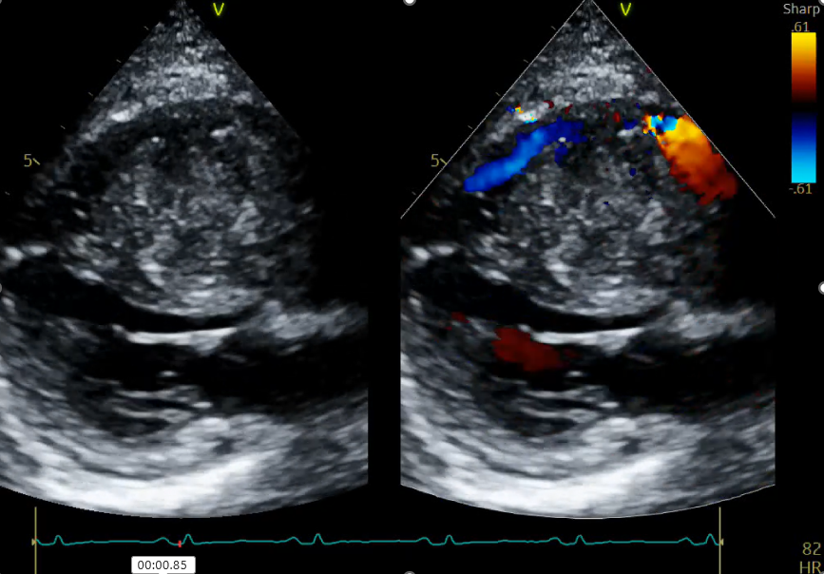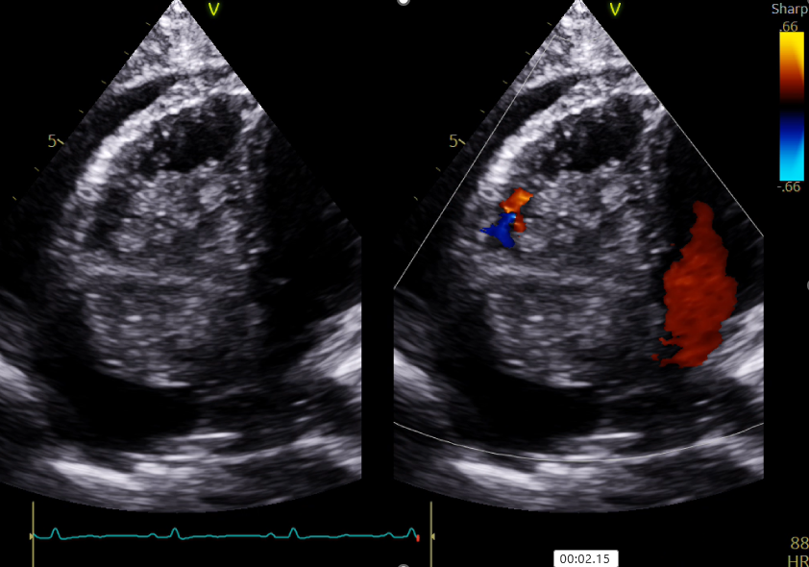

**A**

**B**

**Figure 2**. (A) TEE pre-surgery showed a large RA myxoma with RV inflow obstruction, (B) TEE post-surgery showed complete myxoma resection, complete IAS repair, and tricuspid regurgitation. TEE: transesophageal echocardiography; RA: right atrium; RV: right ventricular; IAS: interatrial septum.

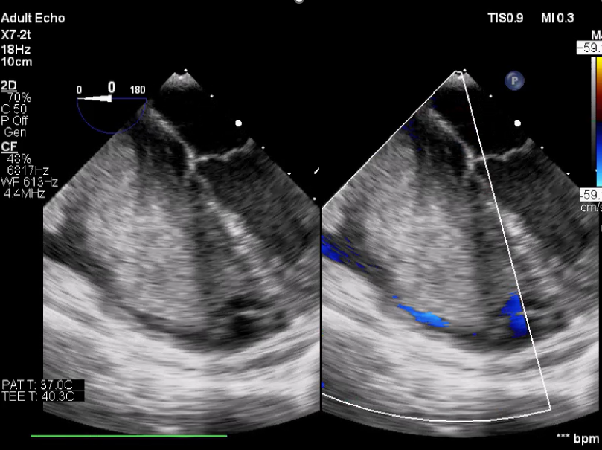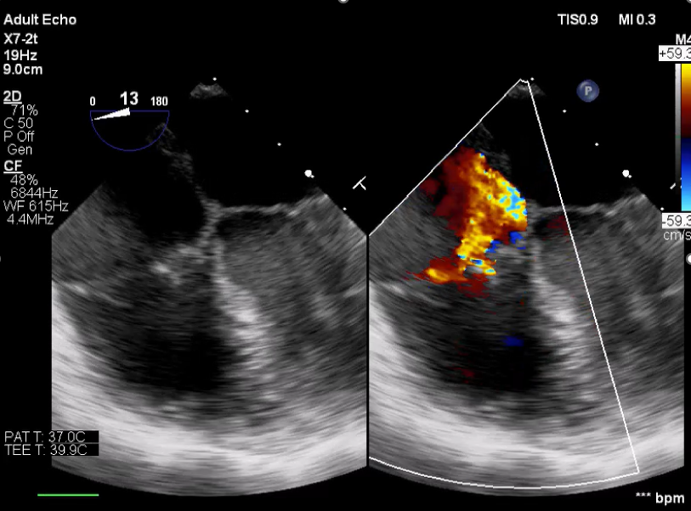

**A**

**B**

**Figure 3**. Large RA myxoma after complete resection surgery. RA: right atrium.

