**Co-administration of Vitamin E and Quercetin**

**Ameliorates Sodium fluoride-induced Toxicities in Wistar rats**

**ABSTRACT**

High dosages of fluoride have damaging effects in humans and animals. This study examined the beneficial role of co-administration of quercetin and vitamin E on sodium fluoride (NaF)-induced toxicities in Wistar rats because there are few documented reports on the synergistic effect of these two compounds' ameliorative properties against NaF-induced toxicity in Wistar rats. For this investigation, thirty adult Wistar rats were randomized into five groups with six rats in each group, and they were allowed to acclimate for fourteen days. While groups three, four, and five received 18 mg/kg b.w. of sodium flouride and after 14 days were given quercetin, vitamin E, and quercetin-vitamin combination for 21 days. Group 1 received sodium flouride for 14 days at dosage of 18 mg/kg b.w., while group 2 received feed and water for 35 days. Liver function, Creatinine, urea, lipid profile, and oxidative stress indicators were also assessed. According to the findings, giving soduim flouride (18 mg/kg b.w.) for two weeks caused reactive oxygen species to be produced and the oxidant and antioxidant balance system to be upset, which in turn caused hepatic and renal damage. The findings also showed that vitamin E, quercetin, and quercetin-vitamin E combination amplified serum levels of albumin, conjugated bilirubin, triglycerides, low density lipoprotein, hepatic tissue levels of reduced glutathione, and catalase and superoxide dismutase activities while decreasing serum activities of aspartate amino transferase, alkaline phosphatase, hepatic tissue levels of malondialdehyde, and serum levels of total bilirubin, high density lipoproteins, total cholesterol, urea, and creatinine. Overall, the results show that quercetin and vitamin E can reduce toxicity caused by sodium flouride, but that the combined effects of co-administration are more potent.

**KEYWORDS:** Quercetin; Vitamin E; Sodium Fluoride; Oxidative Stress; Lipid Profile

**Background**

Due to human and geogenic activity, fluorine, a pollutant, is extremely prevalent in the water, air, and soil. Consuming fluorine causes fluorosis, a debilitating illness that affects people all over the world. Fluorosis is primarily occasioned by the ingestion of too much fluoride through processed foods that contain fluoride, toothpaste, tainted drinking water and mouthwash, (Bharti et al., 2017). The growing prevalence of fluoride-induced harm to human health is largely due to natural geological sources and growing industrialization. According to recent research, the majority of fluorine comes from agrochemicals (30–40%) and prescription medications (20%) (Bharti et al., 2017).

Numerous health hazards, including skeletal and dental fluorosis and bone deformation, arise from excessive exposure to NaF (Dehghani et al., 2019). The liver, kidney, heart, and brain are among the non-skeletal organs that are impacted by fluoride (Nabavi et al., 2012). Long-term fluoride exposure may cause the brain, spinal cord, and skeletal muscles to lose their structure and function (Olusegum et al., 2013). Fluorine in drinking water is quickly absorbed via the intestinal epithelium and builds up in the various organs of the biological systems, interfering with metabolic activities (Basha et al., 2011). Low birth weights can result from fluoride's ability to cross the blood-brain and placental barriers, neurodegeneration can cause memory problems and learning disabilities, and fluoride buildup during the fetal stage can change growth (Adimalla, 2018),

Because of its negative charge, fluoride can generate fluoride ions, which can flow via ion channels in cell membranes where it damages tissues by causing oxidative stress (Sharma et al., 2023). The primary ways that fluoride causes harm are via chelating enzyme cofactors and weakening the antioxidant defense system (Khan et al., 2018; Bharti et al., 2017). Research has shown that fluoride-induced ROS generation lowers glutathione (GSH) levels and inhibits antioxidant enzymes such as superoxide dismutase (SOD), catalase (CAT) and glutathione peroxidase (GPx) (Khan et al., 2018). According to Waugh et al. (2019), hypocalcemia, which results from the binding of fluorine with calcium ions, disrupts a number of physiological processes, that can result in chronic renal illnesses, developmental and neurobehavioral abnormalities, and cardiovascular impairment. Prior research has demonstrated a correlation between modest levels of F-exposure and notable changes in both human and animal hepatorenal health indicators (Malin et al., 2019).

Melatonin, curcumin, ginkgo biloba, dehydrozingerone, ascorbic acid, lipoic acid, and the combined ingestion of vitamin E and homtamin ginseng are some of the preventive and control methods that have been reported to lessen the toxicity of fluoride (Ahuja et al., 2025; Tesi et al., 2023; Rajuet al., 2020; Nabavi et al., 2012; Giri et al., 2016). As a powerful antioxidant, vitamin E (vitamin E) aids in shielding the body from oxidative stress. It is particularly advantageous since it can reach unsaturated fatty acids existing in the phospholipid of cells, adding an extra line of protection against oxidative damage. Because it donates a hydrogen atom (H), vitamin E can decrease the presence of free radicals (Lablack et al., 2020). The catechol group attached to B ring and the hydroxyl group present on the third position of the molecule, are free radical scavengers and are the two pharmacophores that make quercetin. Quercetin occurs naturally in some plants (Mesram et al., 2019). Due to its strong antioxidant properties, quercetin has garnered significant attention for its potential to prevent heart, liver, and kidney disorders. According to earlier research, quercetin inhibits free radicals directly and indirectly increases the production of non-enzymatic antioxidants like GSH and enzymatic antioxidants like SOD, CAT and GPx (Nabavi et al., 2015).

According to certain research, quercetin and vitamin E can be administered independently to treat toxicities caused by fluoride (Nabavi et al., 2012; Mesram et al., 2016). Although Ebokaiwe & Farombi (2015) and Oyeyemi et al. (2022) had demonstrated that the co-administration of vitamin E and quercetin is powerful against oxidative strain, there are currently no published reports on the synergistic prowess of quercetin's and vitamin E's ameliorative property against NaF-induced toxicity in Wistar rats. Therefore, the current study was carried out to exploit the beneficial role of the co-administration of quercetin and vitamin E on sodium fluoride induced injuries in Wistar rats.

**METHODS**

**Experimental Design**

For this study, healthy male Wistar albino rats weighing 160–180g were purchased from the Animal House at Delta State University in Abraka. Two weeks were given to the Wistar albino rats to acclimate. Throughout the trial, they were housed in standard cage in a well ventilated room. Water and regular animal feed given to the rats without limit. The animal handling was done in line with international animal care conventions and procedures and as specified by the Ethics Committee of the University. Thirty rats in all were employed, randomly split up into five groups of six rats each, and treated as presented in Figure 1.

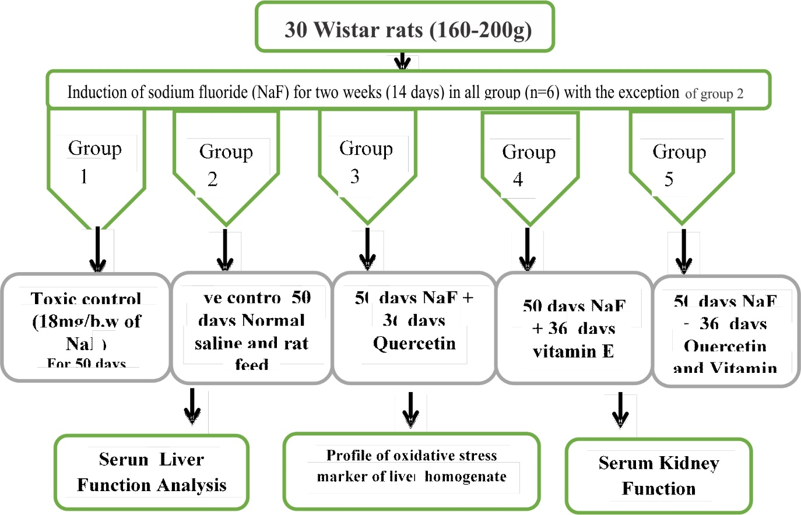

**Figure 1:** Experimental Design

**Quercetin Preparation and Administration**

For 21 days, quercetin was administered orally once daily after being dissolved in 0.9% physiological saline due to its weak water solubility(Mesram *et al*., 2019).

**Sodium Fluoride Treatments and Quercetin Pretreatment.**

For just 14 days, the first group, which acted as a negative control, was given oral sodium fluorine (18 mg/kg bw). Only water and food were given to the second group, known as the positive control, during the course of the study. After receiving NaF for 14 days, group three (3) received 10 mg/kg b.w. of quercetin orally for 21 days. After receiving NaF (18 mg/kg b.w) for 14 days, groups four (4) received vitamin E for 21 days at a dosage of 14.3 mg/kg b.w. Following a 14-day pretreatment with 18 mg/body weight of sodium fluoride, groups five (5) received a 21-day synergistic dose of vitamin E (14.3 mg/kg b.w.) and quercetin (10 mg/kg b.w.).

**Collection and preparation of samples**

Chloroform was used to anesthetize the animals, and their jugular veins were sliced to sacrifice them. Each rat's blood pool was gathered and placed in plain, labeled flasks for biochemical examination. The serum was separated into sterile, simple vials after centrifugation of the blood samples for five minutes (1200 rpm). The internal organ was opened by laparotomy, and tissue samples were taken and processed for biochemical investigation and Histology (Orororo et al., 2023).

**Biochemical Analysis**

**Determination of Oxidative Stress Parameters**

Oxidative stress parameters (MDA GSH, CAT, and SOD) were measured using the protocols and procedures described by Busari et al. (2023).

**Determination of Liver Function Parameters**

As previously reported by Orororo et al. (2024), liver function parameters, including serum levels of albumin, total protein (TP), direct bilirubin and total bilirubin, and as well as alkaline phosphatase (ALP); alanine aminotransferase (ALT) and serum aspartate aminotransferase (AST) activities were measured in compliance with the instructions in the various Randox assay kits.

**Determination of Kidney Function Parameters**

According to the directions in the Randox assay kits, serum creatinine and urea concentrations were determined using the methods outlined by Orororo et al. (2024).

**Assessment of Lipid Profile**

The concentrations of serum triglycerides (TAGs), HDL, LDL, and total cholesterol were measured in accordance with the guidelines provided by Orororo and Asagba (2024) on the Randox test kits.

**Histological Examination**

Following the application of Bouin's fixative, the extracted tissues (liver and kidney) were dehydrated using 50–100% ethanol. The tissues were rinsed with xylene to remove dehydrant. Thereafter, they were embedded in paraffin. The tissues were then cut into slices that were 6 μm thick, and the hematoxylin-eosin (H-E) stain was applied to the sections. Following staining, the slices were examined at 400x magnification using an Olympus light microscope (Tesi et al., 2023).

**Statistical Analysis:**

The results were subjected to analysis of variance and LSD multiple comparison test at the P < 0.05 level of significance. The data were displayed as means ± standard deviation. Data analysis was conducted using Graph Pad Prism.

**RESULTS**

**Ameliorative Effects of Co-Administration of Quercetin and Vitamin E on Oxidative Stress Parameters in NaF-induced Wistar Rats**

Table 1 shows how co-administration of quercetin and vitamin E affected oxidative stress markers in Wistar rats given sodium fluoride. When equated to the toxic control group, the quercetin and quercetin-vitamin E treatment groups displayed a significant (p<0.05) surge in hepatic CAT activity. Compared to the toxic control group, the vitamin E-treated group's hepatic CAT activity decreased in a non-significant (p<0.05) way.

SOD activities were higher in the vitamin E (29.79 ± 2.38) and quercetin-vitamin E (27.56 ± 04.60) treated groups than in the toxic control group (27.22 ± 01.09), whereas SOD activity was lower in the quercetin-treated group (21.74 ± 05.86). Superoxide dismutase activity variations were not statistically noteworthy (p<0.05). The concentration of reduced glutathione (µg/min/mg protein) was considerably (p<0.05) higher in the quercetin, vitamin E, and quercetin-vitamin E treated animals than in the toxic control.

Hepatic malondialdehyde (MDA) levels were considerably (p<0.05) lower in the quercetin and quercetin-vitamin E treated groups than in the toxic control group, but not significantly (p<0.05) reduced in the vitamin E treated group.

**Table 1: Ameliorative Effects of Co-Administration of Quercetin and Vitamin E on Oxidative Stress Parameters in Sodium Fluoride-induced Wistar Rats**

|  |  |  |  |  |
| --- | --- | --- | --- | --- |
| **Groups** | **CAT**  **(units/mg protein)** | **SOD**  **(units/mg protein)** | **GSH**  **(µg/min/mg protein)** | **MDA**  **(µmol/mg protein)** |
| Toxic control | 06.02 ± 01.19a | 27.22 ± 01.09a | 14.33 ± 2.47a | 4.34±1.18a |
| Normal control | 12.49 ± 02.06bc | 50.92 ± 07.97b | 18.16 ± 1.62ab | 1.24 ± 0.86ab |
| NaF + Quercetin | 08.29 ± 01.13bc | 21.74 ± 05.86a | 24.21 ± 1.59b | 2.30 ± 1.46c |
| NaF + Vitamin E | 03.76 ± 00.28a | 29.79 ± 02.38a | 23.13 ± 3.05b | 3.48 ± 1.58ac |
| NaF + Quercetin -Vit. E | 14.13 ± 02.61c | 27.56 ± 04.60a | 32.36 ± 3.95c | 1.24 ± 0.65bc |

n = 6. Values within the same column with dissimilar superscript letters are pointedly different.

**Ameliorative Effects of Co-Administration of Quercetin and Vitamin E on Selected Hepatic Function Parameters in Sodium Fluoride-induced Wistar Rats**

The effects of combined ingestion of vitamin E and quercetin on hepatic function measures in Wistar rats induced by sodium fluoride are displayed in Tables 2 and 3. AST activity was significantly (p<0.05) redeced in the quercetin, vitamin E, and quercetin-vitamin E treatment groups than in the toxic control group. When paralleled with the toxic control group, the vitamin E and quercetin-vitamin E treated groups had lower serum ALT levels; however, this difference was not statistically important (p<0.05). Serum ALT levels increased in the quercetin-treated group, although the rise was not statistically significant (p<0.05). Serum levels of ALP were significantly (p<0.05) lower in the quercetin, vitamin E, and quercetin-vitamin E treatment groups than in the toxic control group.

**Table 2: Ameliorative Effects of Co-Administration of Quercetin and Vitamin E on ALP AST, and ALT activities in Sodium Fluoride-induced Wistar Rats**

|  |  |  |  |
| --- | --- | --- | --- |
| **GROUPS** | **AST**  **(U/L)** | **ALT**  **(U/L)** | **ALP**  **(U/L)** |
| **Toxic control** | 77.98 ±11.47a | 31.37 ± 04.12a | 107.57 ± 11.36a |
| **Normal control** | 46.11 ± 06.06b | 31.25 ± 04.12b | 63.17 ± 10.79b |
| **NA + Quercetin** | 41.10 ± 03.83b | 31.96 ± 10.65a | 84.33 ± 05.43b |
| **NAF + Vitamin E** | 43.76 ± 03.53b | 24.45 ± 03.93a | 90.36 ± 08.31b |
| **NAF + Quercetin-Vitamin E** | 34.95 ± 07.39b | 23.24 ± 03.80a | 80.08 ± 04.90b |

Data are shown in the form of mean ± SD of six determinations with dissimilar superscript letters indicating statistical difference.

Comparing the quercetin-vitamin E treated group to the toxic control group, Table 3 demonstrates a significant (p<0.05) rise in serum levels of TP. Comparing the vitamin E-treated groups to the toxic control group revealed a significant (p<0.05) drop in serum levels of total protein (TP), whereas the quercetin-treated groups showed a non-significant (p<0.05) drop in serum levels of TP. Serum albumin levels were significantly (p<0.05) higher in the quercetin-vitamin E treated group than in the toxic control group, but not meaningfully (p<0.05) greater in the vitamin E and quercetin treated groups than in the toxic control group.

Serum globulin levels were significantly (p<0.05) lower in the quercetin and vitamin E-treated groups than in the toxic control group. Serum globulin levels in the quercetin-vitamin E treatment group did not differ substantially (p<0.05) from those in the toxic control group.

Serum total bilirubin (TB) levels were significantly (p<0.05) lower in quercetin-vitamin E-treated groups than in the toxic control group. When compared to the toxic control group, the vitamin E and quercetin-treated groups' serum total bilirubin levels decreased and increased, respectively; however, these changes were not statistically different (p<0.05).

When compared to the toxic control group, the quercetin-vitamin E treated group exhibited a significant (p<0.05) increase in serum conjugated bilirubin (D.BIL) levels, while the quercetin and vitamin E treated groups exhibited a non-significant (p<0.05) increase in serum direct bilirubin (D.BIL) levels.

**Table 3: Ameliorative Effects of Co-Administration of Quercetin and Vitamin E on serum levels of some Liver function indices Sodium Fluoride-induced Wistar Rats**

|  |  |  |  |  |  |
| --- | --- | --- | --- | --- | --- |
| **Treatment groups** | **Total protein (g/dL)** | **Albumin**  **(g/dL)** | **Globulin**  **(g/dL)** | **Total bilirubin**  **(mg/dL)** | **Conjugated bilirubin**  **(mg/dL)** |
| Toxic control | 7.58±0.75a | 3.14±0.19a | 4.43±0.64a | 3.15±0.29a | 1.58±0.38a |
| Normal control | 10.35±0.42ab | 3.70±0.09ab | 6.65±0.44ab | 1.71±0.22b | 1.27±0.14ab |
| NaF + Quercetin | 6.59±1.21ab | 3.43±0.14ab | 3.16±1.17a | 3.27±0.40a | 1.62±0.40ac |
| NaF + Vit. E | 5.03±0.86c | 3.69±0.16ab | 1.84±0.52a | 2.70±0.41ab | 1.59±0.48ac |
| NaF + Q-Vit. E | 8.45±1.04c | 4.02±0.28b | 4.43±1.15a | 2.04±0.22bc | 1.72±0.27c |

Data are shown in the form of mean ± SD of six determinations with dissimilar superscript letters indicating statistical difference.

**Ameliorative Effects of Co-Administration of Quercetin and Vitamin E on Renal Function Parameters in Sodium Fluoride-induced Wistar Rats**

Figures 2 and 3 display the effects of co-administration of vitamin E and quercetin on renal function measures in Wistar rats that were given sodium fluoride.

When compared to the toxic control group, the quercetin-vitamin E combination treated group exhibited a significant (p<0.05) decrease in plasma creatinine concentration, whereas the quercetin and vitamin E treated groups displayed a significant (p<0.05) rise in plasma creatinine concentration.

When matched with group 1, the quercetin-vitamin E combination treated group's plasma concentration of urea (mmol/L) was considerably (p<0.05) lower. When compared to group 1, the quercetin and vitamin E-treated groups' plasma levels of urea decreased; nevertheless, these changes were not statistically different (p<0.05).

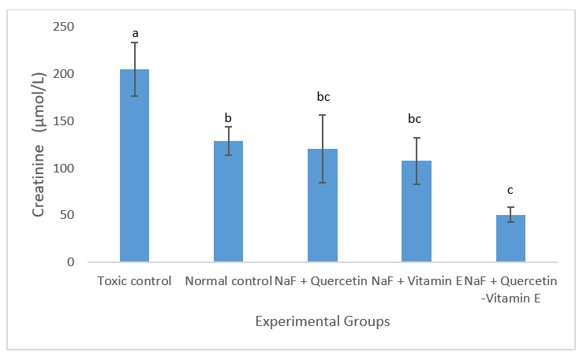

**Figure 2:** Ameliorative Effects of Co-Administration of Quercetin and Vitamin E on Serum Creatinine levels in Sodium Fluoride-induced Wistar Rats. The mean ± SD (n = 6) was used to represent the data. Significant variances (p<0.05) are indicated by values with dissimilar superscript letters.

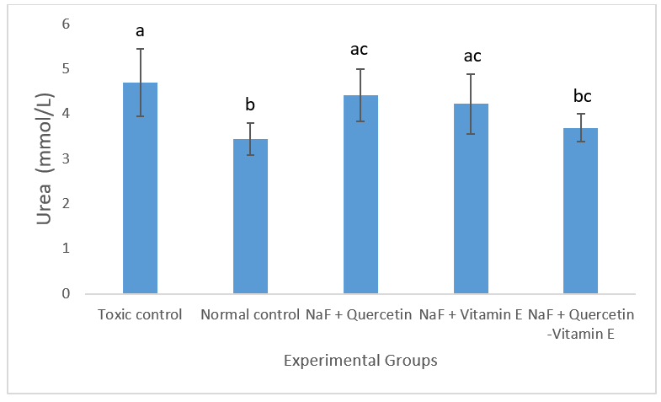

**Figure 3:** Ameliorative Effects of Co-Administration of Quercetin and Vitamin E on Serum Urea levels in Sodium Fluoride-induced Wistar Rats. The mean ± SD was used to represent the data (n = 6). Significant changes (p<0.05) are indicated by values with dissimilar superscript letters.

**Ameliorative Effects of Co-Administration of Quercetin and Vitamin E on Lipid Profile of Sodium Fluoride-induced Wistar Rats**

Table 4 displays the ameliorative effects of co-administration of quercetin and vitamin E on the lipid profile of Wistar rats that have been exposed to NaF.

When compared to the normal control group, the hazardous group's plasma lipid profile revealed a significant rise in plasma total cholesterol levels. The plasma total cholesterol levels of the quercetin, vitamin E, and quercetin-vitamin E combination treatment groups were non-significantly lower than those of the toxic control group.

When compared to the toxic control group, the plasma triglyceride levels in the quercetin and vitamin E treatment groups were significantly higher, however the plasma triglyceride levels in the quercetin-vitamin E combination treated group were not significantly higher. When matched with the toxic control group, vitamin E and the quercetin-vitamin E combination significantly raised HDL plasma levels. Compared to the toxic control group, the quercetin-treated group's plasma HDL level increased non-significantly. in comparison with the toxic control group, plasma LDL levels were significantly lower in the quercetin, quercetin-vitamin E combination, and vitamin E treatment groups.

**Table 4: Ameliorative Effects of Co-Administration of Quercetin and Vitamin E on Lipid Profile of Sodium Fluoride-induced Wistar Rats**

|  |  |  |  |  |
| --- | --- | --- | --- | --- |
| **Treatment**  **Groups** | **Total**  **Cholesterol**  **(mg/dL)** | **Triglycerides**  **(mg/dL)** | **HDL**  **Cholesterol**  **(mg/dL)** | **LDL**  **Cholesterol**  **(mg/dL)** |
| **Toxic control** | 97.22±06.00b | 45.60±04.88a | 29.92±03.92b | 58.17±05.89b |
| **Normal control** | 80.78±01.17a | 42.08±04.00a | 52.99±02.75a | 19.38±03.01a |
| **NaF + Quercetin** | 81.75±02.13a | 91.91±03.75b | 29.49±02.14b | 34.12±02.80c |
| **NaF + vitamin E** | 84.18±02.96a | 85.78±12.04b | 42.52±05.92a | 27.50±05.82 a c |
| **NaF + Quercetin + vitamin E** | 82.24±03.65a | 52.84±03.34a | 50.66±01.96a | 21.01±04.05 a c |

Data are shown in the form of mean ± SD of six determinations with dissimilar superscript letters indicating statistical difference.

**Ameliorative Effects of Co-Administration of Quercetin and Vitamin E on histology of the liver and kidney of Sodium Fluoride-induced Wistar Rats**

The ameliorative effects of co-administration of Quercetin and Vitamin E on histology of the kidney and liver of Sodium Fluoride-induced Wistar Rats is displayed in Figures 4 and 5 respectively.

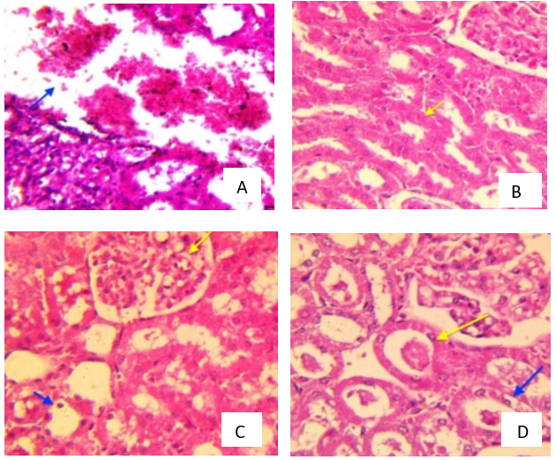

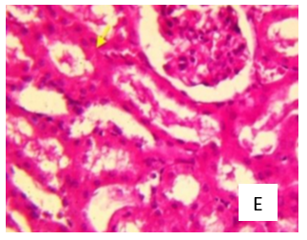

**Figure 4:** Combined ingestion of quercetin and vitamin E improves the kidney histology in Wistar rats that have been exposed to NaF. (a) Toxic control displaying interstitial hemorrhage and severe necrosis (blue arrow). (b) Normal Control: Bowmen's capsule (yellow arrow) bordered with cuboidal epithelium, regular glomerulus. (c) NaF + quercetin caused modest congestion of glomerular and deterioration (yellow arrow) and tubular epithelial degenerative alterations (blue arrows). (d) NaF + Vit. Mild vacuolar deterioration (blue arrow) and tubular casts (yellow arrow) are visible. (e) NaF + Q-Vit E. kidney architecture with functional tubules and glomerulus (yellow arrow).

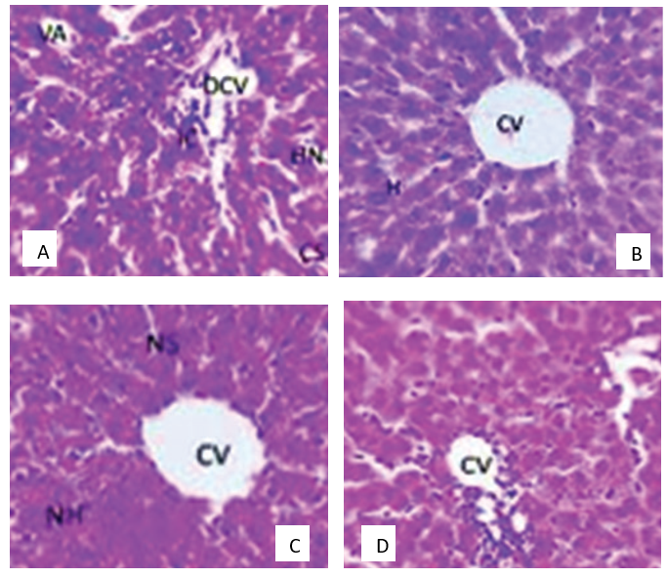

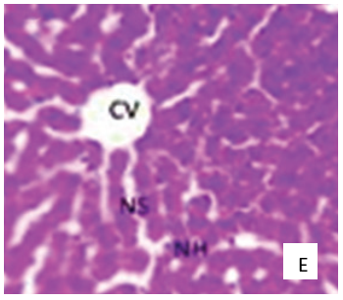

**Figure 5:** Ameliorative effects of co-administration of Quercetin and Vitamin E on histology of the liver of Sodium Fluoride-induced Wistar Rats. (a) Toxic Control showing Vacuolization (VA), Dilated central vein (DCV), Congested Sinusoids (CS) and Hepatocyte necrosis (HN). (b) Normal Control showing Central vein (CV) and Hepatocyte (H). (c) NaF + Quercetin showing Central vein (CV), Normal hepatocyte (NH) and Normal sinusoids (NS). (d) NaF + Vit. E showing Central vein (CV). (e) NaF + Q-Vit. E showing Central vein (CV), Normal hepatocyte (NH) and Normal sinusoids (NS).

E

D

C

**DISCUSSION**

Through the generation of reactive oxygen species and disruption of the oxidant and antioxidant balance system, sodium fluoride (18 mg/kg bw) administered for fourteen days in this study caused damage to the liver and kidneys. Activities/levels of CAT, SOD and GSH significantly decreased due to the oxidative stress caused by NaF, and lipid peroxidation levels subsequently increased. These findings align with earlier research that found oxidative stress caused by NaF (Tesi et al., 2023; Sharma et al., 2023a; Mesram et al., 2016). Numerous studies have shown that increased ROS production, a decline in antioxidant defenses such as decreased catalase and SOD activity, and a decreased amount of reduced GSH are all linked to the toxicity of fluoride poisoning. Additionally, fluoride poisoning has been shown to produce excessive amounts of reactive nitrogenous species, including nitric oxide (NO). Lipid peroxidation and damage to macromolecular components including proteins, DNA, and cell membranes will unavoidably result from all of these changes in the oxidant-antioxidant equilibrium (Ahuja et al. 2025). In response to pesticide and metal toxicity, several other investigations have documented a reduction in CAT, SOD, and GSH (Orororo et al., 2024; Efekemo and Orororo 2022; Ekakitie et al; 2021).

This result is indicative of oxidative stress and a weakened endogenous antioxidant arrangement. The antioxidant activity of the cellular molecules is significantly reduced by the oxidation process of the produced ROS (Esiekpe et al., 2020; Orororo et al. 2018; Onobrudu et al., 2016a). Catalase and glutathione are powerful free radical scavengers. CAT breaks down hydrogen peroxide (lipid peroxidation’s primary cause) and keeps the cellular oxidation-reduction rate in check. This antioxidant molecule's diminished activity allows free radicals to cause more severe lipid peroxidation (Busari et al. 2024; Busari et al. 2023; Calabrese & Kozumbo 2021).

Vitamin E-quercetin treatment markedly amplified the GSH levels, catalase, and SOD activities of the treated animals in comparison to the toxic control. This outcome is consistent with research by Oyeyemi et al. (2022), which found that administering vitamin E and quercetin together reduced oxidative stress by raising GSH concentrations and CAT/SOD activity. Vitamin E and quercetin's anti-oxidative properties may have contributed to the regeneration of the hepatic tissue, as seen by the rise in catalase, superoxide dismutase, and reduced glutathione concentrations. The rise in reduced glutathione levels seen in this study suggests that vitamin E and quercetin treatment has caused the redox potential in the epithelial cells to reverse from an oxidizing state to a strong reducing state (Al-zharani et al. 2024; Lablack et al. 2020; Mesram et al. 2019). GSH serves a number of purposes in living things. It functions as a co-factor for GST and GPx in addition to carrying the active thiols group because of the cysteine residues it contains (Onobrudu and Nwiloh, 2020). Glutathione keeps protein thio groups in their reduced state and can prevent the production of reactions brought on by free radicals, which blocks the autocatalytic processes of lipid peroxidation. This outcome also supports previous research showing quercetin to be a strong antioxidant against oxidative stress caused by a variety of toxins in rats (Costa et al., 2016). Research has demonstrated quercetin's effectiveness as an anti-inflammatory and antioxidant (Sharma et al., 2023). However, because it inhibits the harmful effects of lipid peroxidation, vitamin E, is necessary to maintain several metabolic functions. Vitamin E (α-tocopherol) prevents cell membrane lipoproteins (polyunsaturated lipids) from being peroxidized by free radicals. In order to create non-toxic lipids, vitamin E directly counters free radicals that target cell lipids (Coline et al. 2020). By scavenging radicals of lipid peroxyls and converting them into α-tocopherol radicals, vitamin E significantly reduces the lipid peroxidation of cell membranes. Vitamin E prevents the production of peroxyl radicals at the earliest stage of ROS synthesis by breaking the alkyl radical's reaction chain with molecular oxygen (Calabrese & Kozumbo 2021). Additionally, vitamin E increases the activity of GPx, which is directly involved in breaking down lipid peroxides.

The administration of quercetin/vitamin E and the quercetin-vitamin E combination dramatically decreased the activity of ALP, ALT and AST in the induced animals in comparison to the negative control. Increases in aminotransferase enzyme activity are frequently indicative of hepatocellular damage involving the cytoplasmic or mitochondrial membranes (Ekakitie et al., 2019; Onobrudu et al., 2016). Damage to hepatocyte cell membranes results in increased plasma enzyme activity of aminotransferases (Ekakitie et al. 2019; Orororo et al., 2022). Consequently, lower levels of plasma transaminase found in this investigation are suggestive of quercetin and vitamin E's potential for improvement. Any kind of hepatobiliary blockage causes the liver to produce more ALP, which enters the bloodstream and raises the serum level of the protein (Emejulu et al. 2016; Burtis and Ashwood, 2001). Consequently, the decrease in ALP plasma activity seen in all treated groups is suggestive of the beneficial effects of both vitamin E and quercetin (Orororo and Udi, 2023).

The vitamin E-quercetin treatment meaningfully (p<0.05) raised serum levels of albumin, TP, and conjugated bilirubin while lowering serum levels of total bilirubin in the treated animals when compared to animals maintained on the toxicant alone. This indicates that the combined administration of vitamin E and quercetin improved the hepatobiliary system's decline, which in turn improved the liver's capacity to synthesize albumin and other proteins and restored the liver's capacity to absorb, conjugate, and secrete bilirubin into the bile. These outcomes are consistent with the earlier study by Olisah et al. (2017), which found that vitamin C reduces the activities of AST, ALT, and ALP to mitigate calcium carbide-induced hepatotoxicity in a rat prototypical. The findings also showed that, in comparison to the vitamin E and quercetin treatment groups, the quercetin-vitamin E combination treatment significantly decreased ALP, AST and ALT in rats intoxicated with sodium fluoride.

Elevated creatinine and urea levels typically indicate impaired kidney function or kidney disease (Orororo et al., 2024) and are trustworthy markers of kidney function (Orororo and Asagba 2023). Both are eliminated by the kidneys, and elevated levels of both suggest impaired renal functioning. Urea comes from protein metabolism in the liver, while CR comes from creatine when muscle proteins breakdown (Orororo et al., 2024b). Consistent with previous findings (Sharma et al. 2023b; Kasim and Alkalby, 2019), the toxicant-administered rats in the current investigation had higher levels of the plasma renal indicators analyzed as paralleled with the control and treatment groups. Previous investigations have documented changes in biochemical markers with exposure to heavy metals and F (Verma et al., 2021).

In contrast to the untreated sodium fluoride group, this study demonstrated that vitamin E, quercetin, and the vitamin-quercetin combination dramatically reduced serum levels of creatinine and urea. According to the findings, vitamin E, quercetin, and the vitamin E-quercetin combination heal renal membrane damage, redox potential, and renal functioning. This conclusion agrees with the findings of Prabu et al. (2010), who showed that the synergistic antioxidant effects of vitamin E, vitamin C, and quercetin help restore kidney functioning from cadmium-induced renal damage by lowering urea and creatinine levels.

The development of several cardiac conditions, including atherosclerosis and heart failure, is significantly influenced by fluoride-induced oxidative stress. When matched with the normal control group, the toxicant's administration alone occasioned a significant rise in the toxic group's plasma lipid profile, indicating toxic effects (Orororo and Asagba 2024). When paralleled with the hazardous group, the administration of quercetin, vitamin E, and the quercetin-vitamin E combination dramatically reduced total cholesterol levels. This is related to the ability of vitamin E and quercetin to reduce artherosclerosis in albino Wistar rats. Because it inhibits the formation of prostaglandins, the expression of cyclooxygenase-2 (COX-2), and the activation of nuclear factors, quercetin is a good antioxidant and anti-inflammatory drug (Pany et al., 2014). The findings of this study are consistent with Vandi et al. (2013)'s published publications, which state that vitamin E prevents LDL from oxidizing in arterial walls and that there is a link between vitamin E intake or serum levels and coronary artery disease.

Because the co-administration of quercetin and vitamin E resulted in the lowest decrease in LDL concentration when compared to the separate treatments of quercetin/ vitamin E, the ameliorative effects of these antioxidants on the serum lipid profiles were found to be more effective.

Degeneration, necrosis, and bleeding were among the several histological changes observed in the renal parenchyma and hepatocytes following the injection of toxicants. These alterations are caused by oxidative damage brought on by toxicants. According to Sharma et al. (2023), Wistar rats' oxidative stress indices and the histomorphology of their liver, kidney, and heart tissues changed as a result of long-term exposure to F. The toxicant group showed the most severe histopathological alterations, which is consistent with other findings (Sharma et al. 2023; Meltem et al. 2023).

Quercetin and vitamin E, both separately and in combination, decreased the histological alterations in the liver and kidney caused by NaF, which is consistent with the biochemical indicators that were assessed. However, the combined treatment (Q+Vit E) showed amelioration close to normal as depicted by functional glomerular epithelial cells and the renal (Kasim et al., 2019).

**CONCLUSION**

Together, quercetin and vitamin E can reduce sodium fluoride-induced hepatic and renal toxicity by boosting the levels and activities of antioxidant molecules and enzymes, which in turn reduces lipid peroxidation, according to the overall experimental data. The lipid profile's degradation caused by NaF was likewise restored by the combined treatment. Co-administration of quercetin with vitamin E has a more potent synergistic impact than either substance alone.

**LIST OF ABBREVIATIONS**

Vit E Vitamin E on

NaF Sodium fluoride

RNS Reactive nitrogen species

ROS Reactive oxygen species

GSH Reduced Glutathione

SOD Superoxide dismutase

CAT Catalase

MDA Malondialdehyde

TP Total Protein

DBIL Direct Bilirubin

TBIL Total Bilirubin

ALP Alkaline Phosphatase

AST Aspartate Aminotransferase

ALT Alanine Aminotransferase

TAG Triglycerides

HDL High Density Lipoprotein

LDL Low Density Lipoprotein

**DECLARATIONS**

**Ethics approval and consent to participate**

Institutional Animals Ethics (IAEC), as adopted by the ethical committee of the School of Biomedical Sciences, Novena University, Ogume, Delta State, Nigeria with ethical clearance code of NU/SBS/4/24 was followed. This manuscript adheres to ARRIVE guidelines.

**Animal Ethics Declaration**:

Ethical approval for this research was obtained from the School of Biomedical Sciences, Novena University, Ogume, Delta State, Nigeria (NU/SBS/4/24). Animals were handled in compliance the Institutional Animals Ethics (IAEC) guidelines.

**Clinical Trial Number:**

Not Applicable

**Consent for publication**

Not Applicable

**Availability of data and material**

Experimental data and materials employed in the development of this research report would be made available upon a reasonable request, but for the meantime, they are kept in the correspondent’s repository.

**REFERENCES**

Adimalla, N. & Li, P. (2018). Occurrence, health risks, and geochemical mechanisms of fluoride and nitrate in groundwater of the rock-dominant semi-arid region, Telangana State, India. *Human and Ecological Risk Assessment: An Internal Journal*, 25(1–2):81–103.

Ahuja, T., Farmiza, B., Gautam, K., Smita, S., Nitesh, K. & Rekha, R. S. (2025). Exploring the protective role of metformin and dehydrozingerone in sodium fluoride‑induced neurotoxicity: evidence from prenatal rat models. *Biotechnology*, 15:36:1-15.

Al-zharani, M., Eman, A., Mohammed, M., Hassan, R., Nada, A., Khadijah, Y., Saad, A., Fahd, A., Al-doaiss, A. & Mohammed, S. (2024). Comparison between the Antioxidant Properties of Quercetin and Combined Vitamin E and Selenium to Ameliorate the Oxidative Stress Induced by Cadmium Toxicity. *Current Research in Nutrition and Food Science*, 12 (3):1093-1105.

Amal, C. (2017). Toxicity of sodium fluoride in liver of Albino Rat and the Beneficial Effect of calcium in Reversing Fluoride Toxicity: Histological, Ultrastructural and immunochemical studies. *The Egyptian Journal of Hospital Medicine,* 69 (6):2562-2582.

Basha, P.M., Rai, P. & Begum, S. (2011). Evaluation of fluoride-induced oxidative stress rat brain: a multigeneration study. *Biological Trace Element Research*, 142:623-637.

Bharti, V.K., Giri, A. & Kumar, K. (2017) Fluoride Sources, Toxicity and Its Amelioration: A Review. *Peertechz Journal of Environmental Science and Toxicology,* 2(1): 021-032.

Busari, A. A., Obadiah, C. C., Orororo, O. C., Efejene, I. O., Aisuodionoe, M. E., Osirim, E., DeLoache, S., Ebu, C. I., Adejare, A. A. & Badmos K. (2024). Assessment of Cardiovascular Function in Periodontitis and Diabetes Mellitus Induced Rats Treated with Black Seed (*Nigella sativa*) Oil. *Asian Journal of Cardiology Research*; 7(1):230-244.

Busari, A. A., Orororo, O. C., Opute, U. A., Efejene, I. O., Badmos, K., Obadiah, C. C., Akinshipo, W. A. & Egbune, E. O. (2023). Effects of Black Seed Oil on Oxidative Stress Parameters and Gingival Expression of Inducible Nitric Oxide Synthase in Diabetes and Periodontitis-Induced Rats. *African Scientist*, 24(3): 376-386.

Dehghani, M. H., Zarei, A., Yousefi, M., Baghal Asghari, F., & Haghighat, G. A. (2019). Fluoride contamination in groundwater resources in the southern Iran and its related human health risks. *Desalination and Water treatment*, 153, 95–104.

Ebokaiwe, A. P. & Farombi, E. O. (2015). Influence of vitamin E and quercetin on Nigerian Bonny Light crude oil-induced neuronal and testicular toxicity in Wistar rats. *Journal of Basic and Clinical Physiology and Pharmacology*, 26(3): 223-231.

Efekemo, O. & Orororo O. C. (2022). Effect of mixture of leaf extract of *Ocimum gratissimum* and *Vernonia amygdalina* on cadmium induced hepatotoxicity in wistar rats. *Journal of Biochemistry International*, 9(4):73-81.

Ekakitie, L. I., Orororo O. C. & Okpoghono, J., (2021). Changes in haematological parameters of aluminium-exposed rats treated with natural bee honey. *IOSR Journal of Environmental Science, Toxicology and Food Technology*; 15(5):22-25.

Ekakitie, L., Asagba, S. O. & Orororo, O. C. (2019). Changes in Tissue Oxidative Enzymes in Rats exposed to Red Bull Energy Drink and Alcohol. *Journal of Applied Science and Environmental Management*, 23(6): 1175 – 1179.

Esiekpe, G. T., George, B. O., Orororo, O. C., Akpede, A. A., Okevwe, G. E., Onotugoma, E. & Oguntola, J. (2020) Monodora myristica seed extracts ameliorate crude oil contaminated diet-induced cardiotoxicity in rats. *Thai Journal of Pharmaceutical Sciences;* 44 (3): 145-151

Giri, A., Bharti, V. K., Angmo, K., Kalia, S. & Kumar, B. (2016). Fluoride versus Oxidative stress, Immune System and Apoptosis in Animals: A Review. *International Journal of Bioassays*, 5:5163-5173. Link: <https://goo.gl/1QiNES>

Kasim, S. F. & Alkalby, J. M.A. (2019). Impact of Co-Administration of Vitamin C and Calcium Chloride on Kidneys Function of Adult Male Rats Treated with Sodium Fluoride. *Al-Nisour Journal for Medical Sciences,* 1 (1), Article 4. DOI: https://doi.org/10.70492/2664-0554.1014

Khan, A.M., Raina, R., Dubey, N. & Verma, P.K. (2018). Effect of Deltamethrin and Fluoride Co-Exposure on the Brain Antioxidant Status and Cholinesterase Activity in Wistar Rats. *Drug Chemistry and Toxicology*, 41: 123–127.

Lablack, M., Nadia, A.H., Fatima, Z. T., Samia, S., Ibtisam, H. & Omar, K. (2020). Protective effects of vitamin E on aluminium chloride-induced liver and kidney damage in rats. *South Asian Journal of Experimental Biology,* 10 (5): 301-312.

Malin, A.J., Lesseur, C., Busgang, S.A., Curtin, P., Wright, R.O. & Sanders, A.P. (2019). Fluoride Exposure and Kidney and Liver Function among Adolescents in the United States: NHANES, 2013–2016. *Environment International*, 132:105-119.

Mesram, N., Pyata, U. & Karnati, P. R. (2019). Quercetin reverses sodium arsenate induced oxidative stress, behavioural and histological alterations in brain of rat. *Journal of Pharmaceutical Science and Research,* 11(6), 2019, 2267-2274

Nabavi, S.F., Gian, L.R.B., Maria, D.C. & Nabavi, S.M. (2015). Role of quercetin as an alternative for obesity treatment: you are what you eat! *Food Chemistry*, 179:305–310.

Nabavi, S.F., Nabavi, S.M., Abolhasani, F., Moghaddam, A.H. & Eslami, S. (2012). In vivo protective effects of quercetin against sodium fluoride-induced oxidative stress in the hepatic tissue. *Food Chemstry*, 132:931-935

Nageshwar, K. N., Rajkiran, R. B., Chandrashakar, R. M., Nalagoni, P. R. K. (2016). Quercetin treatment against NaF induced oxidative stress related neuronal and learning changes in developing rats. *Journal of King Saud University – Science*, 29:221–229.

Olusegum, A., Shallie, P.D., Bamidela, S., Emmanual,  O. I. & Gbenga,  A.A. (2013). Comparative study on the influence of fluoride on lipid peroxidation and antioxidant levels in the different brain regions of well fed and protein undernourished rats. *Journal of Trace Element Med Biology*, 27 (2013):370-374

Onobrudu, D.A. & Nwiloh, B.I. (2020). Monosodium glutamate alter hepatic functions, redox potential and lipid metabolism: Omega 3 fatty acids ameliorative intervention. *GSC Biological and Pharmaceutical Sciences,* 13(01), 101-110

Onobrudu, D.A., Ikewuchi, J.C. & Onyeike, E.N. (2016a). Moderation of ocular markers of oxidative stress of selenite-induced cataractous Pups by *Boswellia dalzielii* Hutch Extract. *Global Advanced Research Journal of Medicinal Plant*, 4(2): 007 - 011.

Onobrudu, D.A., Onyeike E.N. & Ikewuchi, J.C. (2016b). Effect of the methanolic leaf extract of *Boswellia dalzielii* hutch on the liver integrity of selenite-induced cataract pups*. International Journal of Advanced Research*, 5(1):2600-2604

Orororo, O. C. & Udi, O. A. (2023). Assessment of the hepato-protective effects of combined ethanolic extract of *Psidium guajava* and *Carica papaya* leafs in rats challenged with Cadmium. *Nigerian Journal of Pure and Applied Sciences,* 36:4521-4530.

Orororo, O. C., Asagba, S. O, Tonukari, N. J., Okandeji, O. J. & Mbanugo J. J. (2018). Comparative Assessment of the Antioxidant Properties of *Hibiscus sabdarrifa* L Anthocyanins and its Aqueous Extract in Cadmium-exposed Rats. *Research Journal of Pharmaceutical, Biological and Chemical Sciences;* 9(3): 836-843.

Orororo, O. C., Efekemo, O., Egbune, E. O., Awhin, E. P., Odeghe, O. B. & Okoro, E. O. (2024). Amelioration of Cadmium toxicity in the liver and kidney of Wistar rats by combined *Citrus sinensis* and *Manihot esculenta* Leaf extract. *International Journal of Biochemistry Research and Review*; 23 (6): 71-79.

Orororo, O. C., Efekemo, O., Odeghe, O. B., Clark, P. D., Awhin, E. P., Egbune, E. O. & Efejene, I. O. (2024b). Phytochemical Screening, in vitro antoxidant capacity and Nephro-protective effects of combined extract of *Psidium guajava* and *Carica papaya* leaves in rats intoxicated with cadmium. *Asian Journal of Medicine and Health*, 22 (8): 86-97.

Orororo, O.C. & Asagba, S. O. (2024). Effects of *Hibiscus sabdariffa* L. Anthocyanins on Body Weight, Lipid Peroxidation, and Lipid Profile of Cadmium-exposed Rats. *Saudi Journal of Forensic Medical Sciences*; 4:21-25.

Oyeyemi, W. A., Akinola, A., Oluwadamilare, O., Ololade, D., Ikponmwosa, A., Opeyemi, T. D. Precious‑Gift, O. A., Iyesogie, O. O. & Tseye, D. O. (2022). Vitamin E and quercetin attenuated the reproductive toxicity mediated by lead acetate in male Wistar. *Bulletin of the National Research Centre*, 46 (22):2-10.

Prebu, S., Shaggirthak, M. & Rengadevi, J. (2010). Quercetin in combination with vitamins (C & E) improve oxidative stress and renal injury in cadmium intoxicated rats. *European Review of Medical and Pharmacological Science*, 14:1-12.

Raju, S., Sivanesan, S. & Gudemalla, K. (2020). *Ginkgo biloba* ameliorates fluoride toxicity in rats by altering histopathology, serum enzymes of heme metabolism and oxidative stress without affecting brain mGluR5 gene. *Phcog Mag*;16:S320-336.

Sharma, P., Verma, P.K., Sood, S., Yousuf, R., Kumar, A., Raina, R., Shabbir, M.A. & Bhat, Z.F. (2023). Protective Effect of Quercetin and Ginger (*Zingiber officinale*) Extract against Dimethoate Potentiated Fluoride-Induced Nephrotoxicity in Rats. *Foods*, 12:88-99.

Tesi, P.E., Oyovwi, M.O., Naiho, O.A., Ben-azu, B., Emojevwe, V., Ohwin, P.E., Rotu, A. R., Oghenetega, B.O., Eze, K. N. & Aloamaka, C. P. (2023). Co-Administration of Vitamin E and Homtamin Ginseng Prevented and Reversed Sodium Fluoride-Induced Testicular Dysfunction Through Inhibition of Oxidative Influx and Hormonal Modulation Mechanism in Wistar Rats. *Asia Pacific Journal of Medical Toxicology*, 12;4:123-136.

Waugh, D.T. (2019). Fluoride Exposure Induces Inhibition of Sodium-and Potassium-Activated Adenosine Triphosphatase (Na+, K+-ATPase) Enzyme Activity: Molecular Mechanisms and Implications for Public Health. *International Journal of Environmental Research and Public Health,* 16:14-27.