**Low Rainfall and Extreme Weather Regions Rainwater Physicochemical Investigated on Tropic of Cancer in Bangladesh: Insights Microbiological Analysis**

ABSTRACT

|  |
| --- |
| The recent drop in groundwater levels and decreased rainfall alarm the water scarcity and its potential impacts on agriculture, drinking water, and ecological balance, which is growing particularly in Bangladesh's northwest and southwest regions. Rainwater is the most crucial source of water in drought-prone areas like the Northwest region and the Southwestern region. Under the Tropic of Cancer, three extreme weather regions' rainwater samples were investigated. The microbial load obtained as in Faridpur 3.17×106 CFU/mL, Kushtia 3.31×106 CFU/mL, and Chuadanga 1.51×106 CFU/mL. Kushtia obtained the highest bacterial growth and fungus big colony formation obtained in Chuadanga and Faridpur. On the other hand, the physicochemical condition of Faridpur region rainwater obtained most contaminated. The rainwater of Faridpur was found acidic with pH 4.87 and the trace metal Arsenic (As) 0.22 mg/l was recorded as higher than the standard value of both ECR 2023 and WHO. The PCA analysis revealed that TDS, EC, As, and Ca significantly influenced water quality variations across the study sites, with Faridpur exhibiting elevated levels of TDS, EC and As, Kushtia showing the highest Ca concentration, and Chuadanga displaying lower iron concentration with a notable Association with resistivity and Zn; while other trace elements like Mg, Ni, Cr, Hg, Mn, Cu, Pb, Cd forms similar pattern and cluster for three sampling sites. The PCA analysis captures 73.49 % of the variance in PC1 and 26.51 % in PC2. This study highlighted the physicochemical and microbiological pollution of rainwater under the Tropics of Cancer regions, namely Kushtia, Chuadanga, and Faridpur. |

***Keywords:*** *Bacteria, Fungus,**Principle component analysis,**Pearson correlation****,*** *Tropic of cancer.*

**1.0 Introduction**

Water is an essential resource that all living things require to develop and procreate [1, 2]. One of the most significant sources of particulates and water resources is rainwater [3]. The most important natural water source employed by many nations as a substitute supply of water for human survival is rainwater. Rainwater is extensively used for both household and human consumption and it is recognized as a trustworthy source of both potable and non-potable water [4]. Rainwater is generally safe but during collection, the local environment and atmospheric conditions may impact the chemical composition [4]. Rainwater plays a vital role in eliminating air pollution as airborne contaminants react with raindrops when they fall [3]. The local air quality has a significant impact on the chemical composition of rainwater [5]. Chemical components and compounds found in the atmosphere, such as gases or solid particle substances, can travel great distances before being deposited by rain and be carried by the wind as aerosols or airborne particles, which can then affect the chemical composition of the soil, surface water, and vegetation [6-7]. Natural and man-made degradation processes assist in the chemical composition of rainwater [8] and provide an important depiction of the origins of surrounding air pollution [9-10]. Naturally occurring heavy metals of different concentrations can be found in the environment. Hence, anthropogenic sources like the dumping of waste from the burning of fossil fuels and various sectors of the mining, chemical, metallurgical and other industries have affected and contaminated the ecosystem by air pollution [11]. Contribution of local sources, the composition of rainwater varies from region to region in metropolitan areas [12-14, 54]. The chemical structure of rainwater collected at the soil's surface can identify significant changes in air pollution. For illustration, the anthropogenic local sources of trace elements in rainwater are industries and vehicular traffic [15-17, 54]. Several countries have expanded their study of trace elements in rainwater owing to these elements can have negative impacts on human health and the environment [18-19] when they accumulate in the ecosystem from raindrops [20-21]. After the rainwater sample was evaluated, the principal ions (Na+, K+, Ca2+, H+, Mg2+, NH4+, Cl−, NO3− and SO42−) [18] and trace metals (Pb, Cd, Zn, Cu, Al, Fe, Mn, Mo, Ni, Sb and V) [21, 54] were identified. The average pH of the rain samples collected was 6.4 ± 0.9 [20].

Heavy metal contamination is spread by water, fish, and foods in human bodies and causes many serious ailments [22]. Long-term exposure to heavy metals and metalloids can harm the kidneys, liver, lungs, brain, and bones, among other organs [23-24]. On the other hand, the microbial activity observed in previous studies is also concerning. Microbial parasites like viruses, bacteria, fungi, or protozoa are the most significant contaminants in rainwater, as explained by different researchers [25-27]. They also describe organisms such as *E. coli, salmonella*, thermotolerant strains of coliform, *Giardia*, *Campylobacter, Pseudomonas, Cryptosporidium*, and *Shigella* are the responsible organisms that serve as rainwater contamination [25-27]. The rainwater collection process is also crucial for microbial contamination. Compared with rainwater samples collected from rooftops and collected from the direct place of rainfall, a low concentration of physicochemical constituents and microbial counts were observed [28-30]. Also, after collecting rainwater, the storage condition is also vital for the growth of microorganisms and both open and closed tanks affected by different contaminants [31]. This investigation will highlight the physicochemical and microbial contamination of rainwater samples under the Tropics of cancer regions in Bangladesh for better scientific exploration and awareness of mass people.

**2.0 Material and Methods**

**2.1 Study Area**

This study selected three (3) areas or locations with low rainfall in Bangladesh's extreme weather regions: Kushtia-7000, Chuadanga-7200, and Faridpur-7800, located in the Tropic of cancer [59].

**Table 1.** Climatic conditions of the study area (Based on weather and climate reports from 2010-2024) [32-33].

|  |  |  |  |  |  |  |  |  |  |  |  |  |  |
| --- | --- | --- | --- | --- | --- | --- | --- | --- | --- | --- | --- | --- | --- |
| Location | Temperature (0C) | | | | | | | | | | | | |
| **Parameters** | **Jan** | **Feb** | **March** | **April** | **May** | **June** | **July** | **Aug** | **Sept** | **Oct** | **Nov** | **Dec** |
| A (Chuadanga) | Record High Tem. (0C) | 33.8 | 37.7 | 41.71 | 43.7 | 44.7 | 42.7 | 36.7 | 37.7 | 36.7 | 34.8 | 33.8 | 32.8 |
| Average High Tem. (0C) | 26.7 | 30.6 | 35.05 | 37.7 | 37.4 | 35.3 | 32.7 | 32.4 | 31.9 | 30.8 | 29.3 | 26.9 |
| Average Precipitation (mm) | 1.61 | 8.18 | 13.14 | 44.5 | 45.9 | 88.1 | 143.0 | 155.0 | 110.0 | 75.8 | 38.7 | 3.25 |
| B  (Kushtia) | Record High Tem. (0C) | 33.9 | 37.8 | 41.82 | 43.8 | 44.8 | 42.8 | 36.8 | 37.8 | 36.8 | 34.9 | 33.9 | 32.9 |
| Average High Tem. (0C) | 26.7 | 30.7 | 35.14 | 37.8 | 37.5 | 35.4 | 32.8 | 32.5 | 32.0 | 30.9 | 29.4 | 27.0 |
| Average Precipitation (mm) | 1.61 | 8.2 | 13.17 | 44.6 | 46.0 | 88.4 | 144.0 | 156.0 | 110.0 | 76.0 | 38.8 | 3.26 |
| C  (Faridpur) | Record High Tem. (0C) | 33.8 | 36.8 | 39.77 | 43.7 | 44.7 | 39.8 | 37.8 | 37.8 | 37.8 | 35.8 | 35.8 | 33.8 |
| Average High Tem. (0C) | 25.8 | 29.6 | 33.84 | 36.1 | 35.3 | 33.7 | 32.4 | 32.6 | 32.3 | 31.2 | 29.1 | 26.3 |
| Average Precipitation (mm) | 1.29 | 11.2 | 22.75 | 104.0 | 130.0 | 129.0 | 125.0 | 95.0 | 111.0 | 71.8 | 16.8 | 5.09 |

From Table 1, it was observed that in summer the highest temperature recorded among Bangladesh [32-33] in this study area was almost the same in all three regions which was 44.7 0C- 44.80C.

**2.2 Sample Collection**

The extreme weather regions where recorded the highest temperature and low rainfall in Bangladesh like Kushtia, Chuadanga, and Faridpur. So, we selected this region and collected our research rainwater samples from three points such as Raju Ahmed Road, Court para, Kushtia; Baragangni, Alamdanga, Chuadanga; and Jhiltuli, Faridpur Sadar, Faridpur. In June 2024, three (3) samples were collected from the stated three (3) locations. On rainy days, rainwater is collected in the open air by a plastic bowl; after 30.0 minutes of rain, rainwater samples are collected from the bowl of about 500.0 ml of each sample in a plastic bottle. Then the rainwater sample is preserved in the refrigerator Brand WALTON, Model WNM-2F1-GEHE-XX and in normal condition.

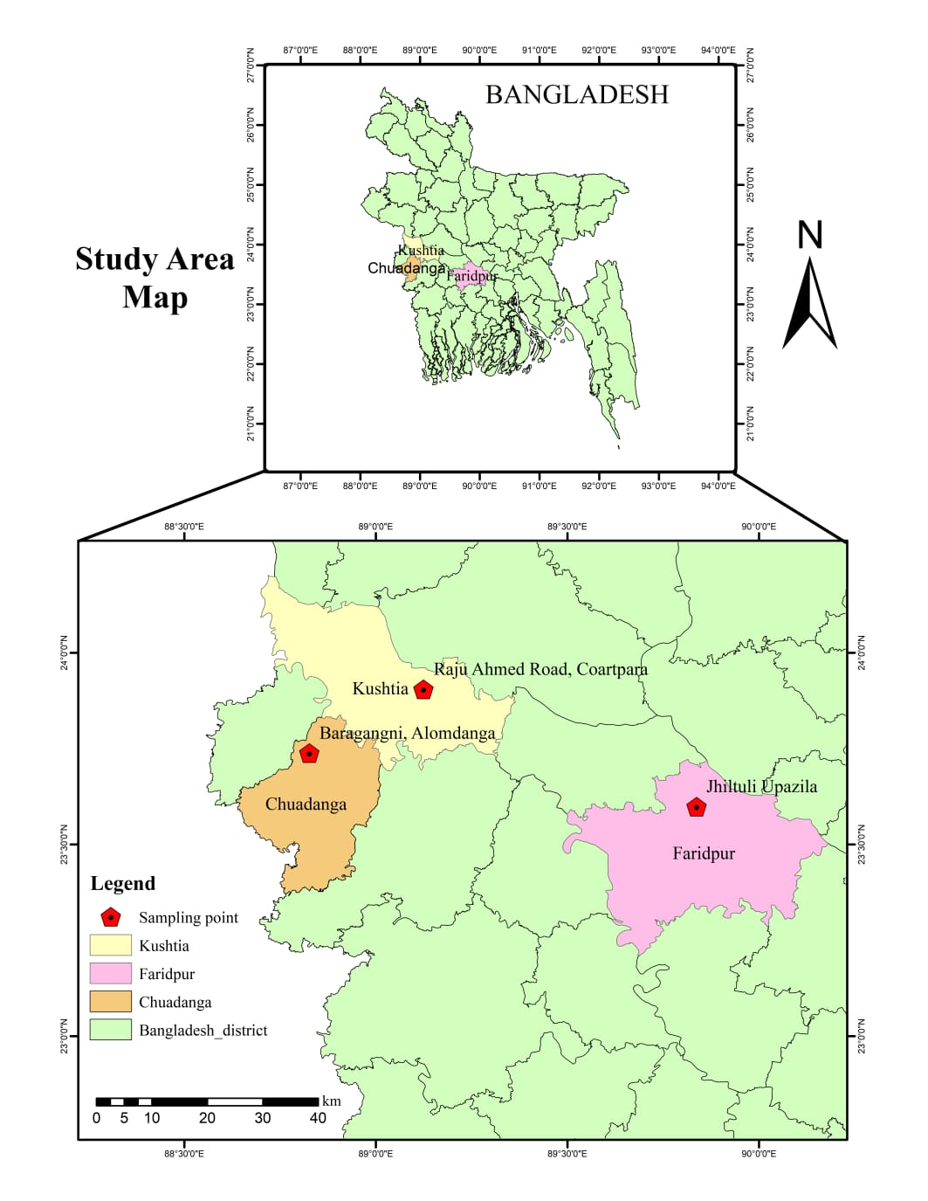

**Fig. 1.** Sampling point of the extreme weather region in Bangladesh.

**2.3 Rainwater Quality Parameters**

Rainwater quality such as pH measured by pH meter OHAUS [ST3100, serial number C034921870, China], Conductivity and other quality parameters like TDS, Resistivity and salinity are determined by a multiparameter [S-611L, Serial number PK61128202406103, USA]. Trace elements or heavy metals (Pb, Cd, Cr, Mn, Fe, Mg, Ca, Hg, As, Cu, Ni, Zn) are identified by atomic absorption spectroscopy (AAS) [AA240FS, Agilent, Australia].

**2.4 Statistical Analysis**

To evaluate the rainwater sample quality of extreme weather regions a thorough statistical analysis was carried out. A renowned univariate statistical technique for analyzing the consequences of the suspected pollutant source in rainwater samples is principal component analysis (PCA) [34-35]. To determine the possible source of the potential species obtained in rainwater by utilizing PCA in the study. PCA was also employed to perform and validate the result of the correlation matrix that was also done in this study [36-37]. IBM SPSS statistics (version 25) and Origin Pro 2024 were used for the statistical analysis and graphical displays. We also used the origin pro for the verification of the data homogeneity.

**2.5 Microbiological Analysis**

**2.5.1 Extraction of Bacteria from Rain Water**

The spread plate technique determined the number of viable bacteria species in all collected samples. The results obtained from the tests were statistically calculated to obtain the most probable number (MPN). The MPN gives the quantity of living organisms that are likely to yield results in future tests carried out on the samples. Three (3.0) rainwater samples were placed in three sterilized autoclaved falcon tubes. Serial dilution was performed to determine the precise number of organisms that had grown in the rainwater. A dilution factor of 3 was used for all samples during the experiment. Next in the process of bacterial analysis was the determination of bacteria colonies present in the sample that had gone through dilution. Thirty-five (35.0) ul of inoculum was used to form a streak on the Nutrient agar (NA) [31] using the pour plate method, which was employed in counting the number of bacteria colonies present in a given sample. The inoculated Petri dishes were incubated for 48.0 h at 37.0 0C. The number of colonies counted per Petri dish was used to determine the original number of colonies per sample. The formula below was used to determine the number of colony-forming units (CFU/mL) [31].

$Original number of colonies in samples= \frac{(Number of colonies counted×Dilution factor)}{Volume of sample plated}$

**2.5.2 Fungal Culture**

For fungus culture, Potato Dextrose Agar (PDA) [28] media is used. Autoclaved sterile media was poured into Petri dishes in a biosafety cabinet and waited until it became solid. Then, 100.0 ul rainwater was spread onto the agar plate. It was incubated for four (4) days at 32.0 0C.

**3. Characterization**

**3.1 Atomic Absorption Spectrometer**

Atomic absorption spectroscopy (AAS) is a technique used in spectra analysis that stabilizes the absorption of optical radiation, specifically light through gaseous free atoms, to determine chemical elements precisely [38]. The key concept of AAS is that atoms' electrons move to higher energy levels when stimulated by light, and when that excitation is followed by de-excitation, the atoms release light at frequencies distinct from that atom [39]. Fig. 2 shows a schematic diagram of an atomic absorption spectrometer. A sample must be atomized first using one of the two widely utilized types of atomizers available today: flame or electro-thermal atomizers, in order to perform an analysis of its atomic components [38]. After that, the resultant atoms are subjected to optical radiation, which could be from a source of line or continuum radiation peculiar to that element. After being separated from any additional radiation generated by a monochromatic source that radiation is subsequently measured by a detector [38].

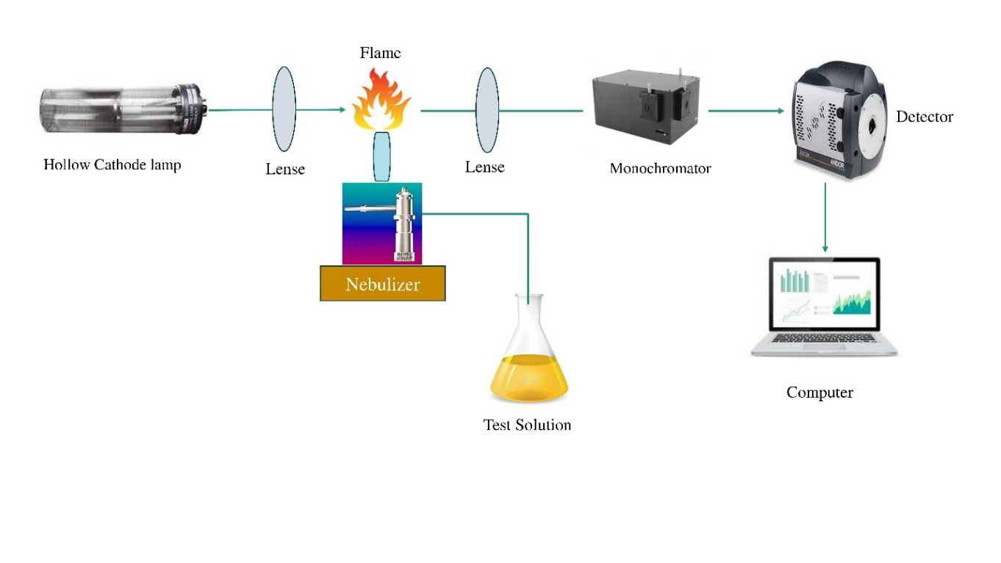

**Fig. 2.** Operating principals and schematic diagram of AAS.

Use the GFAA method with Electrothermal AAS (ET AAS) to detect Pb, Cr and Cd concentrations in samples for fish and water [38, 40]. The cold vapor hydride generation approach in AAS is used to assess the Hg concentration in the samples [40]. In a similar vein, the concentration of as in the samples is determined using the electric hydride vapor production approach in AAS [40]. The most popular three algorithms such as MLP (Multilayer Perceptron) for Ni, RBN (Radial Basis Function Network) for Cu and Zn, and ANFIS (Adaptive Neuro-Ffuzzy Inference System) for Pb are used in Atomic Absorption Spectroscopy (AAS) for the detection of heavy metals (Cr, Ni, Pb, Cu, and Zn) in water sample [41].

**3.2 Multi-parameter**

Multi-parameters are used for different parameter testing of water samples such as pH, TSS, TDS, DO, EC, and temperature. The principle of multi-parameter consolidated the water quality by the sensor system shown in Fig. 3. The entire system is divided into three levels/layers: the perception layer, the application layer and the process layer [42]. The monitoring objects interact with the perception layer. The app layer interfaces with users. Additionally, a process layer connects them. Six channels of water quality sensors, each capable of gathering six water quality indicators, constitute the perception layer [42]. Signals are transmitted to the process layer by the layer after it obtains these parameters and uses a transducer for transforming them into an electric signal. Through the MCU msp430, the process layer can receive and interpret both digital and analogue signals [42]. The signals of pH, dissolved oxygen (DO), conductivity, and NH3+ are then converted by MCU using AD, and the signals of temperature and water level are gathered using RS-485. Lastly, the CPU sends these facts to the application layer after updating them via software. Data is sent from the process layer to the application layer [42]. After that, the data will be transferred to a PC and stored in the flash. Through the Unilog program, users can read and configure sensor parameters at the application layer and view real-time data for each channel [42].

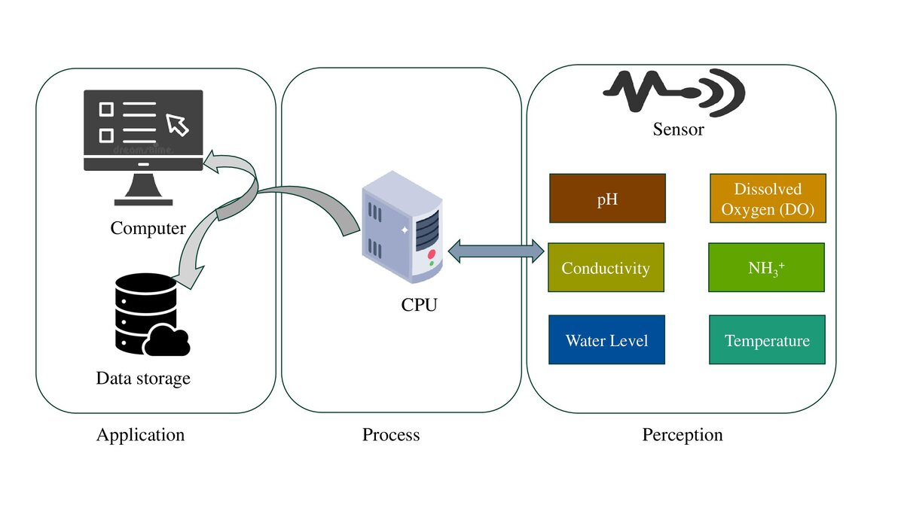

**Fig. 3.** Principal of multi-parameter System [42].

**4. Result & Discussion**

**4.1 Physicochemical Assessment**

The physicochemical parameters were investigated and the result found not good that followed the Bangladesh Environmental Conservation Role 2023[43] and WHO standard guidelines [44]. The naturally occurring rainfall is generally regarded as slightly acidic with a pH value of 5.6 in an unpolluted atmosphere [45-46]. Here in Table 2 displays a statistical fluctuation in pH at different regions like Kushtia, Chuadanga and Faridpur. In contrast, the maximum pH (7.11) was identified at Kushtia whereas the minimum pH was recorded in Faridpur (4.87).

**Table 2.** Physicochemical Parameters of rainwater samples compare to the different standard.

|  |  |  |  |  |  |
| --- | --- | --- | --- | --- | --- |
| Sample | pH | Conductivity (µS/cm) | Resistivity (MΩ-cm) | TDS (mg/L) | Salinity(ppt) |
| A (Chuadanga) | 6.73 | 25.3 | 0.040 | 12.56 | 0.0 |
| B (Kushtia) | 7.11 | 70.7 | 0.014 | 35.5 | 0.0 |
| C (Faridpur) | 4.87 | 98.0 | 0.01 | 48.9 | 0.0 |
| Bangladesh Standard, ECR 2023 | 6.5-8.5 | - | - | 1000 | - |
| WHO | 6.5-8.5 | - | - | 1000 | - |

The ability of water to conduct electrical current is measured by conductivity which is directly interrelated to the concentration of dissolved ions. According to Table 2, Lower conductivity in Chuadanga indicates fewer dissolved ions compared to Kushtia and Faridpur. This suggests that Chuadanga's rainwater might be less impacted by pollution or dissolved solids. Low rainwater conductivity is an indicator of good atmospheric environmental quality [47] also stated that electrical conductivity of rainwater reflects the impact of atmospheric particulate matter on the precipitation chemistry. In contrast, Kushtia and Faridpur show higher conductivity, especially Faridpur, which could indicate higher levels of atmospheric pollution or greater deposition of airborne particles and industrial emissions. This might be due to local sources of pollution, such as agricultural activities or vehicular emissions. The Electrical conductivity of rain and cloud water is sometimes used as a general indicator of water pollution because it increases the concentration of ions, which the droplets acquire from their environment [48].

Resistivity and conductivity are inversely correlated. Higher resistivity denotes purer water with less dissolved ions. Chuadanga rainwater has the highest resistivity, which supports the observation of lower ion content compared to Kushtia and Faridpur. The lower resistivity values in Kushtia and Faridpur indicate larger quantities of dissolved ions, which is compatible with the higher conductivity values. Faridpur, with the lowest resistivity, indicates the highest level of contaminants among the three samples.

TDS indicates the concentration of dissolved substances in the water. According to Table 2, Chuadanga's rainwater has the lowest TDS, suggesting it is the least contaminated by dissolved solids. Inversely, the higher TDS values in Kushtia and Faridpur, particularly in Faridpur, suggest higher levels of dissolved minerals and possibly pollutants. The total dissolved solids (TDS) in rainwater, originating from particulate matter suspended in the atmosphere usually range from 2.0 mg/l to 20.0 mg/l [49] recorded TDS values during the study exceeded the standard limit in Kushtia and Faridpur and it has gone beyond the limit probably due to the high concentration of particulate matter in the atmospheric air within the metropolis [47].

According to Table 2, salinity values show the measurable salinity is absent in the rainwater recorded during the study in every region. The lack of quantifiable salinity in every sample suggests that the rainwater does not contain significant amounts of salt. So, it suggests that the primary concern in these regions is not salt contamination but rather other dissolved ions and pollutants.

**4.2 Trace Elements in Rainwater**

Among the three locations, trace metals were identified as very low and the majority were observed under the detection limit. From this study Arsenic (As) contamination was obtained at a concerning level at Faridpur 0.22 mg/l that exceeded the national like as ECR 2023 0.05 mg/l [43] and International standard (WHO) 0.01 mg/l [44] values. In contrast, no As (Arsenic) contamination was observed in Chuadanga and a tolerable contamination of As (Arsenic) in Kushtia [54] was studied. Furthermore, Ca and Zn were also detected within tolerable limits observed in Table 3. Other trace metals like Pb, Cd, Cr, Mn, Fe, Mg, Hg, Cu, and Ni concentrations were below the detection limit.

**Table 3.** Trace Elements study from rainwater.

|  |  |  |  |  |  |  |  |  |  |  |  |  |
| --- | --- | --- | --- | --- | --- | --- | --- | --- | --- | --- | --- | --- |
| Sample | Trace Elements (mg/l) | | | | | | | | | | | |
| **Pb** | **Cd** | **Cr** | **Mn** | **Fe** | **Mg** | **Ca** | **Hg** | **As** | **Cu** | **Ni** | **Zn** |
| A (Chuadanga) | ND | ND | ND | ND | ND | ND | 0.2 | ND | ND | ND | ND | 0.05 |
| B (Kushtia) | ND | ND | ND | ND | ND | ND | 4.0 | ND | 0.04 | ND | ND | ND |
| C (Faridpur) | ND | ND | ND | ND | ND | ND | 1.23 | ND | 0.22 | ND | ND | 0.01 |
| Bangladesh Standard, ECR 2023 | 0.01 | 0.003 | 0.05 | 0.4 | 0.3-1.0 | 30-35 | 75 | 0.001 | 0.05 | 1.5 | 0.05 | 5.0 |
| WHO | 0.01 | 0.003 | 0.05 | - | 0.3 | - | - | 0.006 | 0.01 | 0.2 | 0.02 | - |

Here, ND= Not detected

These findings highlight the varying quality of rainwater across these regions, with Chuadanga having the best quality and Faridpur the most contaminated. Monitoring and addressing local pollution sources could help improve rainwater quality, especially in Kushtia and Faridpur.

**4.2.1 Health Concern Due to Trace Metals Contamination**

**Arsenic (As)**

In the rainwater sample of Faridpur, trace metal Arsenic (As) obtained at 0.22 mg/l exceeded the standard value that is As 0.05 mg/l (as per ECR’23) [43] and 0.01 mg/l (WHO)[44] and this high value of As may cause cancer if public take as drinking water. Arsenic (As) causes skin infection and elevates cancer risk [22, 56-58]. This toxin may be linked with diabetes and heart conditions. Implications on the skin, genitourinary system, fetus, gastrointestinal tract, hemopoietic system, and in addition to teratogenic consequences [22, 56-58].



**Fig. 4.** Arsenic’s effect on the human body [55].

From this study, the detection limit for Zn and Ca was obtained that was not at a concerning level; for that reason, health hazards were not studied here. The standard limit for Zn is 5.0 mg/l [43] and Ca is 75.0 mg/l [43].

**4.3 Correlation Analysis**

**4.3.1 Pearson Correlation Matrix**

Pearson Correlation among various physicochemical parameters and trace elements of the collected rainwater samples is shown in Fig. 5 from three different regions, namely Kushtia, Chuadanga, and Faridpur. The results revealed that a strong positive correlation (r=0.97) was found between electrical conductivity (EC) and total dissolved solids (TDS) which suggests that higher EC compounds to an increase in TDS levels [36] was found a strong positive correlation between TDS and electrical conductivity in the surface water and a similar trend followed in a study conducted by Kabir [52] Gajendran & Thramarai [50] reported a robust correlation between electrical conductivity (EC) and total dissolved solids (TDS) from the Namibiyar River Basin’s groundwater samples in India; and Priya and Arulraj [51] showed a similar trend in Coimbatore City’s groundwater, India.

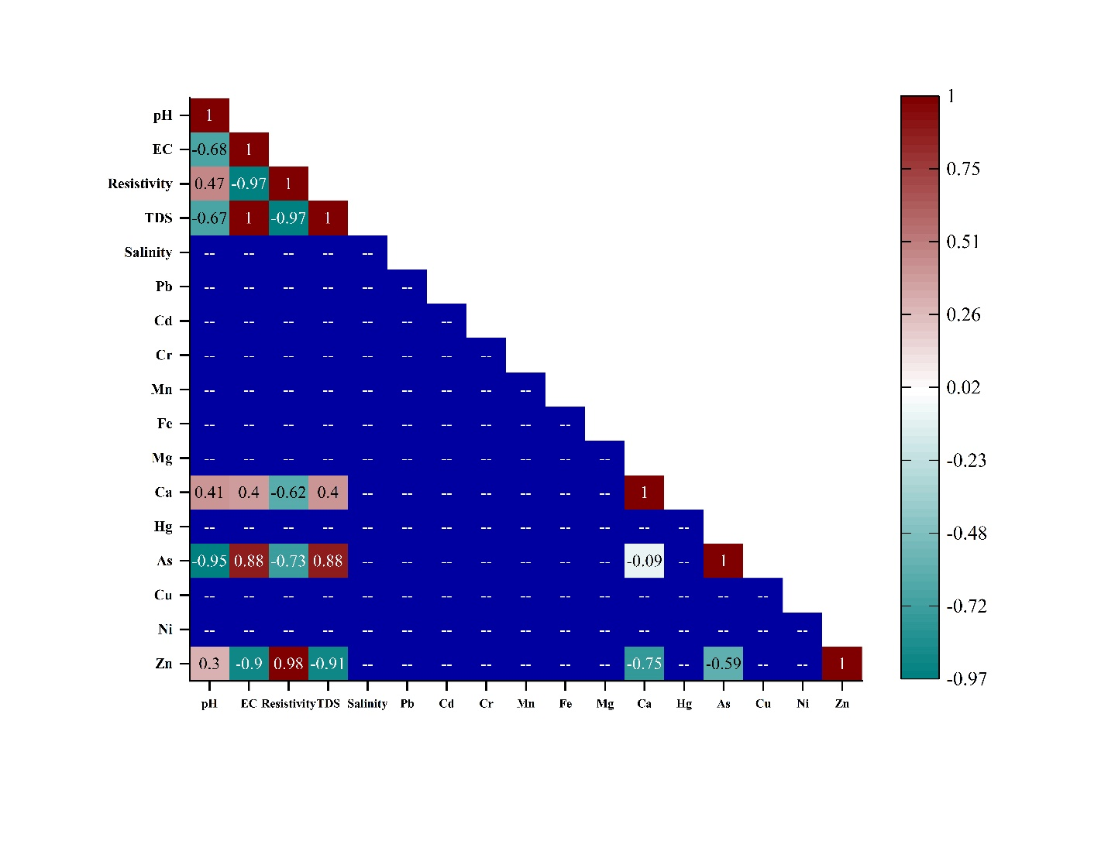

**Fig. 5.** Pearson correlation among water quality parameters for the three regions under the Tropic of Cancer.

Similarly, resistivity is inversely correlated with EC and TDS with correlations of -0.97 and -0.91, respectively. This indicates that as the dissolved ion concentrations increase, the water resistivity decreases. Furthermore, Trace elements show varying degrees of correlation; particularly, arsenic (As) has a strong negative correlation with pH (r=-0.95), suggesting that lower pH may associated with higher levels of arsenic concentrations while arsenic has a weak negative correlation with Calcium (Ca).

**4.3.2 Principle Component Analysis (PCA)**

We employed PCA to reduce the dimensionality of complex physicochemical and trace element data followed by Muniz & Filho [53] identifying key variables that explain spatial variations in water quality across the sampling site. Fig. 6 depicts the principal component analysis (PCA) biplot and provides a comprehensive assessment of physicochemical parameters and trace elements across three sampling sites like Chuadanga, Faridpur, and Kushtia zone that’s located in TC.

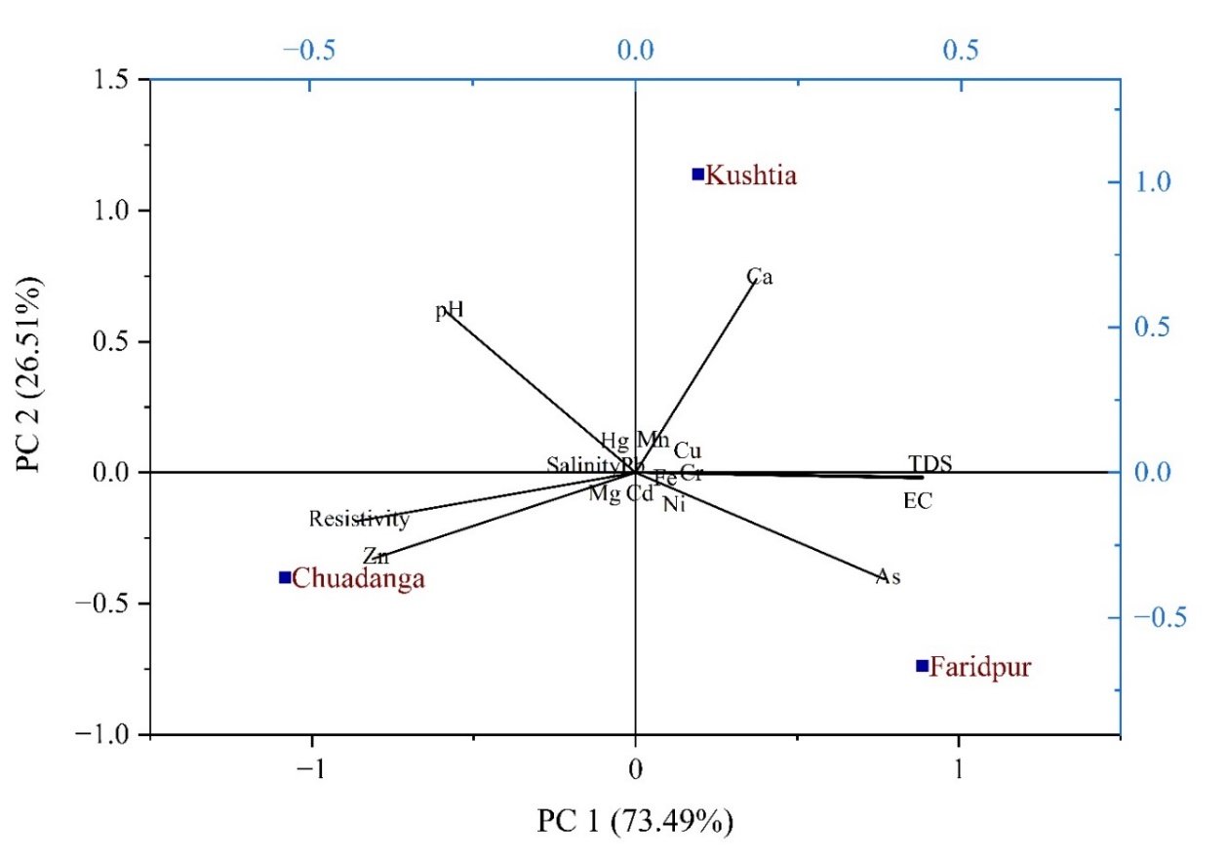

**Fig. 6.** PCA analysis among water quality parameters for the three regions under the Tropic of Cancer.

The PCA analysis captures 73.49 % of the variance in PC1 and 26.51 % in PC2. PC1 is dominated by parameters such as TDS, EC, As, and Ca, indicating these variables have significant contributions to the water quality variations. In contrast, PC2 is more influenced by pH, resistivity, and Zinc (Zn) reflecting their secondary roles in characterizing the differences among sites. The biplot shows distinct clustering of three locations, with Faridpur aligned closely with TDS and EC, indicating elevated levels of these parameters in this area. Kushtia is associated with higher Ca concentrations, reflecting potential geological and anthropogenic influences. Chuadanga, on the other hand, shows a closer association with resistivity and Zinc, suggesting lower ion concentrations and possibly less contamination. The dataset supports these findings, as Faridpur exhibits the highest EC (98 µS/cm) and TDS (48.9 mg/L) alongside significant arsenic levels (0.22 mg/l). Kushtia is characterized by the highest calcium content (4 mg/l), while Chuadanga displaces comparatively lower values for most parameters, except for resistivity and zinc.

**4.4 Microbial Assessment**

**4.4.1 Bacterial Abundance and Activity**

The research findings demonstrate the notable microbial heterogeneity and diversity seen in rainwater samples taken from Chuadanga, Kushtia, and Faridpur. This highlights the variations in bacterial and fungal loads among various areas that local air conditions, pollution levels, or environmental factors may cause [60]. The mean microbial load [25-27] in all the rainwater samples tested [31] is represented by Faridpur having 6 CFU/mL, Kushtia having 6 CFU/mL, and Chuadanga having 6 CFU/mL is shown in Table 4. All the CFU counting data were triplicated for better confirmation. Kushtia exhibited the highest bacterial growth Fig.7A, followed by Faridpur with the second-highest bacterial load. Chuadanga displayed the lowest bacterial growth. This indicates a significant difference in bacterial density among the rainwater of those zones.

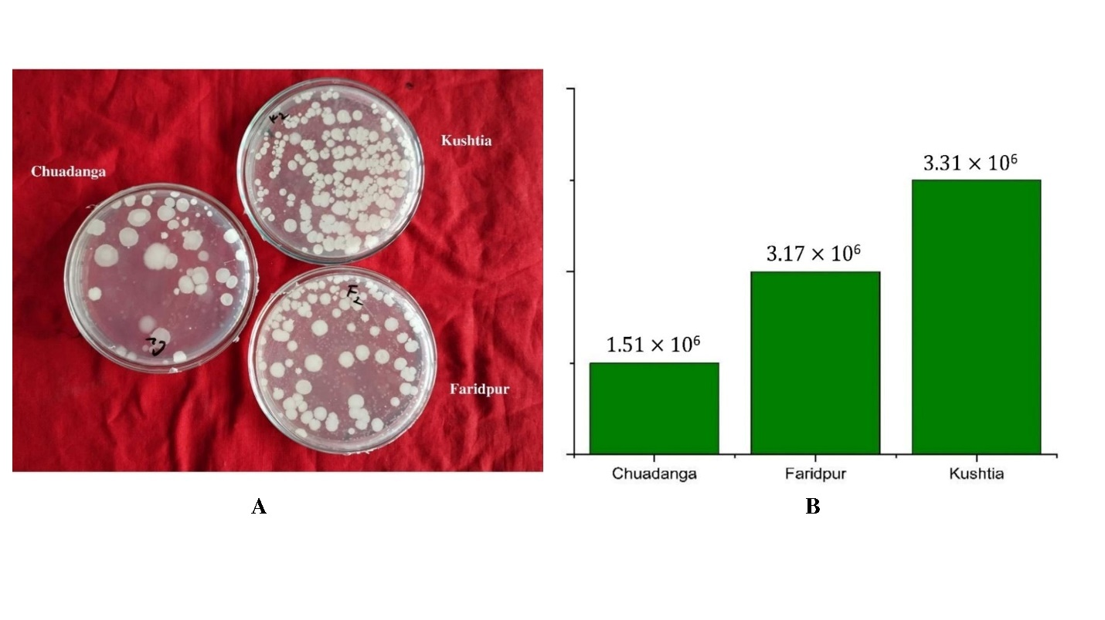

**Fig. 7.** A) Spread the bacterial culture of rainwater bacteria on nutrient agar B) Colony-forming unit of rainwater bacteria in three different zones.

According to the bacterial analysis, Chuadanga had the lowest bacterial growth (1.51 × 10⁶ CFU/mL), whereas Kushtia had the greatest bacterial load (3.31 × 10⁶ CFU/mL), followed by Faridpur (3.17 × 10⁶ CFU/mL). This pattern implies that Kushtia rainwater might have a more conducive bacterial growth environment, perhaps due to increased nutrient or pollutant concentrations or variations in atmospheric microbial seeding [60]. The increased bacterial load in Kushtia might result from industrial pollution, human activity, or agricultural methods that affect the microbial density of rainfall [61]. On the other hand, Chuadanga's relatively lower bacterial load suggests that the air or the surface contaminates the area less [62].The methodology used, which included serial dilution and the spread plate technique, produced accurate quantitative estimations of the number of live bacteria in rainwater [63]. To ensure that the reported microbial loads truly reflect the microbial composition of the sampled rainfall, the computed Most Probable Number (MPN) provides additional support for the data's accuracy [64]. The CFU/mL computations provide information on the extent of microbial contamination, and applying a 1 × 10³ dilution factor proved successful in locating colonies within a controllable range for analysis. These results are consistent with other research showing that rainwater is a source of microbes that are impacted by human activity and the environment [65].

**Table 4.** CFU value of rainwater in different regions.

|  |  |
| --- | --- |
| Location | Value of microbial load (CFU/ml) |
| Chuadanga | 1.51×106 |
| Faridpur | 3.17×106 |
| Kushtia | 3.31×106 |

This is the result of high microbial activity in air and the studied three (3) regions' air quality was not good. When raining the active micro-organisms easily contaminate the rainwater even the surface water. As a result, humans in these 3 regions are affected by different skin diseases by this microbial activity in air and water. The colony-forming graph is shown in Fig. 7B.

**4.4.2 Fungus Culture**

After observing the PDA media [28-30] obtained Fungi are grown in the rainwater sample of the three regions. White fungi are grown on all the plates. In the Faridpur region, an orange-colored fungus colony is observed in Fig.8. In PDA media big white-colony of fungus was obtained in the Chuadanga sample but in Kushtia small droplets of white-colony fungus were observed.

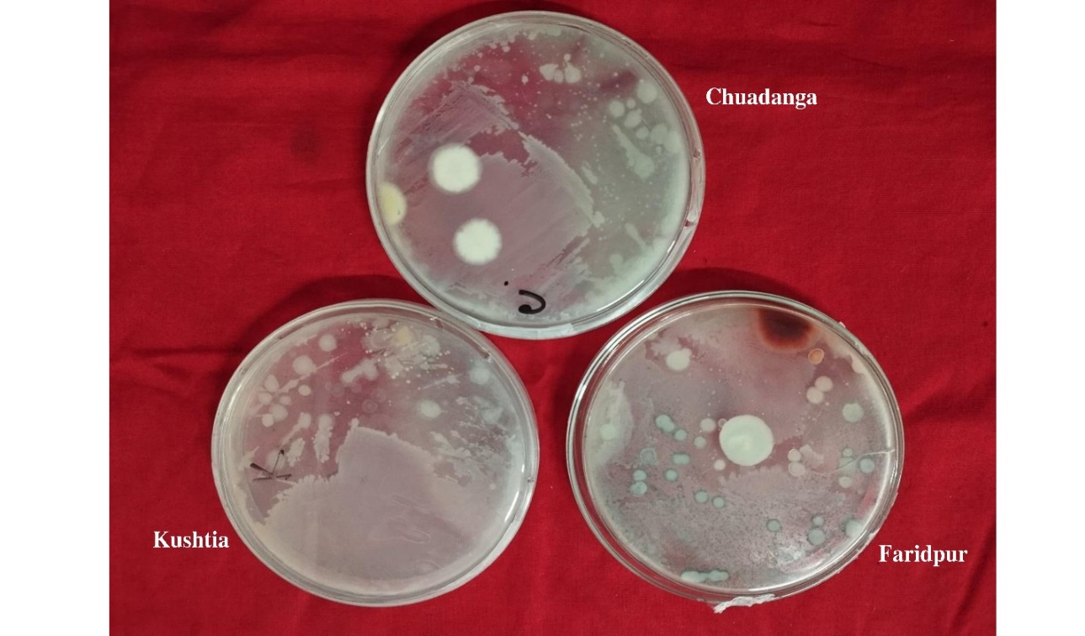

**Fig. 8.** Fungal growth is observed on PDA media.

Examining fungal cultures gave us a new perspective on the diversity of microorganisms in rainwater [66]. In all three regions, fungal colonies with enormous white morphologies were regularly found; the Faridpur samples were the only ones to contain an extra orange-colored fungal colony. This unusual fungus bloom in Faridpur can signify local fungal spores or atmospheric conditions unique to the locality. The fact that fungal development is uniform throughout all locations highlights the existence of fungal spores in atmospheric precipitation, which may have consequences for environmental monitoring, agriculture, and public health [67]. Comparatively, fungal colonies were successfully isolated and identified using Potato Dextrose Agar (PDA) media [68]. The incubation conditions were favorable for encouraging the development of various fungal morphologies, and the 100 µL spread technique guaranteed sufficient fungal growth for examination. These results support claims that rainwater can carry fungal spores, which could introduce harmful or allergic fungi into terrestrial environments [69].

**Conclusion**

Under the Tropic of Cancer, three extreme weather regions' rainwater samples showed a concerning contamination of bacteria and fungus. Kushtia has the highest bacterial growth and fungus big colony formation obtained in Chuadanga and Faridpur. On the other hand, the physicochemical condition of the Faridpur region rainwater obtained not so good and most contaminated. The rainwater of Faridpur was found acidic with pH 4.87 and the trace metal Arsenic (As) 0.22 mg/l was recorded as higher than the standard value that was for pH 6.5-8.5 (as per ECR’23 and WHO) also 0.05 mg/l (as per ECR’23) and 0.01 mg/l (WHO) for As (Arsenic) this high value of may cause cancer if public take as drinking water. The PCA analysis captures 73.49% of the variance in PC1 and 26.51% in PC2. Another study will take into consideration to identification of the specific bacteria and fungus that will help to make decisions to protect human health from any contamination. This study opens the scope of deep analysis on the consideration of microbial activity. This also helps for public awareness regarding use of rainwater.

**Data availability**

The data is available on request.

**Conflict of Interest**

The authors declared that there is no known conflict of interest that could be influence in this manuscript.

**COMPETING INTERESTS DISCLAIMER:**

Authors have declared that they have no known competing financial interests OR non-financial interests OR personal relationships that could have appeared to influence the work reported in this paper.

**Reference**

[1] Ahmed, R. (2010). Drinking-water contamination and its effects on human health. Water Research Foundation, Denver, 1-9.

[2] Al-Khabit, I. A., Daoud, F., Rasmawi, F., Wa'rra, S., & Kassabry, M. (2005). Peer reviewed papers-seasonal variation of bacteriological and chemical quality of drinking water: a case study in a palestinian district. Water and Environment Journal, 19(3), 154-158.

[3] Chen, D., & Guo, Z. (2022). The source, transport, and removal of chemical elements in rainwater in China. Sustainability, 14(19), 12439.

[4] Hossen, M. A., Hoque, A., Salauddin, M., Pal, S. K., Muktadir, M. G., & Jahan, H. (2021). Evaluation of physicochemical and trace metal qualities of rainwater in the south-eastern region of Bangladesh. AQUA—Water Infrastructure, Ecosystems and Society, 70(5), 757-772.

[5] Ullah, M., Islam, M. S., Akter, F., Shohel, M., Rokonujjaman, M., & Salam, A. (2023). Chemical composition and source apportionment of rainwater over Bangladesh during the monsoon. International Journal of Environmental Science and Technology, 20(8), 8445-8456.

[6] Honório, B. A. D., Horbe, A. M. C., & Seyler, P. (2010). Chemical composition of rainwater in western Amazonia—Brazil. Atmospheric Research, 98(2-4), 416-425.

[7] Niu, H., He, Y., Lu, X. X., Shen, J., Du, J., Zhang, T., ... & Chang, L. (2014). Chemical composition of rainwater in the Yulong Snow Mountain region, Southwestern China. Atmospheric Research, 144, 195-206.

[8] Berner, E. K., & Berner, R. A. (2012). Global environment: water, air, and geochemical cycles. Princeton University Press.

[9] Montoya-Mayor, R., Fernández-Espinosa, A. J., Seijo-Delgado, I., & Ternero-Rodríguez, M. (2013). Determination of soluble ultra-trace metals and metalloids in rainwater and atmospheric deposition fluxes: A 2-year survey and assessment. Chemosphere, 92(8), 882-891.

[10] Vázquez, A., Costoya, M., Pena, R. M., Garcı́a, S., & Herrero, C. (2003). A rainwater quality monitoring network: a preliminary study of the composition of rainwater in Galicia (NW Spain). Chemosphere, 51(5), 375-386.

[11] Alloway, B. J. (2013). Molybdenum. Heavy metals in soils: trace metals and metalloids in soils and their bioavailability, 527-534.

[12] Migliavacca, D., Teixeira, E. C., Wiegand, F., Machado, A. C. M., & Sanchez, J. (2005). Atmospheric precipitation and chemical composition of an urban site, Guaiba hydrographic basin, Brazil. Atmospheric Environment, 39(10), 1829-1844.

[13] Kulshrestha, U. C., Kulshrestha, M. J., Sekar, R., Sastry, G. S. R., & Vairamani, M. (2003). Chemical characteristics of rainwater at an urban site of south-central India. Atmospheric Environment, 37(21), 3019-3026.

[14] Flues, M., Hama, P., Lemes, M. J. L., Dantas, E. S. K., & Fornaro, A. (2002). Evaluation of the rainwater acidity of a rural region due to a coal-fired power plant in Brazil. Atmospheric Environment, 36(14), 2397-2404.

[15] Cheng, M. C., You, C. F., Lin, F. J., Huang, K. F., & Chung, C. H. (2011). Sources of Cu, Zn, Cd and Pb in rainwater at a subtropical islet offshore northern Taiwan. Atmospheric Environment, 45(11), 1919-1928.

[16] Hu, G. P., & Balasubramanian, R. (2003). Wet deposition of trace metals in Singapore. Water, air, and soil pollution, 144, 285-300.

[17] Kaya, G., & Tuncel, G. (1997). Trace element and major ion composition of wet and dry depositon in Ankara, Turkey. Atmospheric Environment, 31(23), 3985-3998.

[18] Báez, A., Belmont, R., García, R., Padilla, H., & Torres, M. D. C. (2007). Chemical composition of rainwater collected at a southwest site of Mexico City, Mexico. Atmospheric Research, 86(1), 61-75.

[19] Barrie, L. A., Lindberg, S. E., Chan, W. H., Ross, H. B., Arimoto, R., & Church, T. M. (1987). On the concentration of trace metals in precipitation. Atmospheric Environment (1967), 21(5), 1133-1135.

[20] Al-Momani, I. F. (2003). Trace elements in atmospheric precipitation at Northern Jordan measured by ICP-MS: acidity and possible sources. Atmospheric Environment, 37(32), 4507-4515.

[21] Pike, S. M., & Moran, S. B. (2001). Trace elements in aerosol and precipitation at New Castle, NH, USA. Atmospheric Environment, 35(19), 3361-3366.

[22] Sachchu, M. M. H., Hossain, A., Kobir, M. M., Hoda, M. D., Ahamed, M. R., Lima, M. N. J., ... & Alam, M. A. (2024). Heavy Metal Intake by Fishes of Different River Locations in Bangladesh: A Comparative Statistical Review. Asian Journal of Fisheries and Aquatic Research, 26(6), 43-67.

[23] Tchounwou, P. B., Yedjou, C. G., Patlolla, A. K., & Sutton, D. J. (2012). Heavy metal toxicity and the environment. Molecular, clinical and environmental toxicology: volume 3: environmental toxicology, 133-164.

[24] National Research Council, Division on Earth, Life Studies, Board on Environmental Studies, Water Science, Technology Board, & Committee on Drinking Water Contaminants. (2001). Classifying drinking water contaminants for regulatory consideration.

[25] Helmreich, B., & Horn, H. (2009). Opportunities in rainwater harvesting. Desalination, 248(1-3), 118-124.

[26] Kaushik, R., & Balasubramanian, R. (2012). Assessment of bacterial pathogens in fresh rainwater and airborne particulate matter using Real-Time PCR. Atmospheric Environment, 46, 131-139.

[27] Zdeb, M., Zamorska, J., Papciak, D., & Słyś, D. (2020). The quality of rainwater collected from roofs and the possibility of its economic use. Resources, 9(2), 12.

[28] Michael, N., Majesty, D., Innocentia, N., Chidera, O., & Francis, I. Assessment of Physicochemical and Microbiological Characteristics of Rainwater Harvested from Different Rooftops in Owerri, Imo State, Nigeria.

[29] Guillemette, R., Harwell, M. C., & Brown, C. A. (2023). Metabolically active bacteria detected with click chemistry in low organic matter rainwater. Plos one, 18(5), e0285816.

[30] Perera, W. A. K., & Magana-Arachchi, D. N. (2022). Microbial Diversity in Rainwater with Correspondence to Particulate Matter and Environmental Factors. Journal of Sustainability and Environmental Management, 1(4), 410-418.

[31] Tenebe, I. T., Emenike, P. C., Nnaji, C. C., Babatunde, E. O., Ogarekpe, N. M., Dede-Bamfo, N., & Omole, D. O. (2020). Bacterial characterization and quantification of rainwater harvested in a rural community in Nigeria. Environmental Nanotechnology, Monitoring & Management, 14, 100370.

[32] <https://weatherandclimate.com/bangladesh>

[33] Hazra, V., Ashrit, R., & Thota, M. S. (2024). Weather and Climate of Bangladesh.

[34] Palma, P., Alvarenga, P., Palma, V. L., Fernandes, R. M., Soares, A. M., & Barbosa, I. R. (2010). Assessment of anthropogenic sources of water pollution using multivariate statistical techniques: A case study of the Alqueva’s reservoir, Portugal. Environmental monitoring and assessment, 165, 539-552.

[35] Machiwal, D., & Jha, M. K. (2015). Identifying sources of groundwater contamination in a hard-rock aquifer system using multivariate statistical analyses and GIS-based geostatistical modeling techniques. Journal of Hydrology: Regional Studies, 4, 80-110.

[36] Lima, M. N. J., Hossain, M. K., Khatun, M. S., Molla, M. O. F., & Kabir, M. A. Evaluating Seasonal Dynamics of Water Quality and Embankment Soil along the Gorai River in Kushtia, Bangladesh.

[37] Hossen, M. A., Hoque, A., Salauddin, M., Pal, S. K., Muktadir, M. G., & Jahan, H. (2021). Evaluation of physicochemical and trace metal qualities of rainwater in the south-eastern region of Bangladesh. AQUA—Water Infrastructure, Ecosystems and Society, 70(5), 757-772.

[38] Paudel, S., Kumar, S., & Mallik, A. (2021). Atomic absorption spectroscopy: a short review. EPRA Int. J. Res. Dev.(IJRD), 6, 322-327.

[39] Malik, L. A., Bashir, A., Qureashi, A., & Pandith, A. H. (2019). Detection and removal of heavy metal ions: a review. Environmental Chemistry Letters, 17, 1495-1521.

[40] Ahsan, M. A., Siddique, M. A. B., Munni, M. A., Akbor, M. A., Bithi, U. H., & Mia, M. Y. (2018). Analysis of major heavy metals in the available fish species of the Dhaleshwari River, Tangail, Bangladesh. Int J Fish Aquat Stud, 6(4), 349-354.

[41] Ucun Ozel, H., Gemici, B. T., Gemici, E., Ozel, H. B., Cetin, M., & Sevik, H. (2020). Application of artificial neural networks to predict the heavy metal contamination in the Bartin River. Environmental Science and Pollution Research, 27, 42495-42512.

[42] Li, M., Li, D., Ding, Q., Chen, Y., & Ge, C. (2013). A multi-parameter integrated water quality sensors system. In Computer and Computing Technologies in Agriculture VI: 6th IFIP WG 5.14 International Conference, CCTA 2012, Zhangjiajie, China, October 19-21, 2012, Revised Selected Papers, Part I 6 (pp. 260-270). Springer Berlin Heidelberg.

[43] <https://doe.portal.gov.bd/site/page/34032b57-86f1-4740-8316-269b004743ae>

[44]<https://www.who.int/teams/environment-climate-change-and-health/water-sanitation-and-health/water-safety-and-quality/drinking-water-quality-guidelines>

[45] Xiao, J. (2016). Chemical composition and source identification of rainwater constituents at an urban site in Xi’an. Environmental earth sciences, 75, 1-12.

[46] Zhao, M., Li, L., Liu, Z., Chen, B., Huang, J., Cai, J., & Deng, S. (2013). Chemical composition and sources of rainwater collected at a semi-rural site in Ya’an, Southwestern China. Atmospheric and Climate Sciences, 2013.

[47] Cobbina, S. J., Michael, K., Salifu, L., & Duwiejua, A. B. (2013). Rainwater quality assessment in the Tamale municipality. International Journal of Scientific & Technology Research, 2(5), 1-5.

[48] Jonsson, H. H., & Vonnegut, B. (1991). Apparatus for measurements of the electrical conductivity of rainwater with high resolution in space and time. Journal of Applied Meteorology and Climatology, 30(8), 1220-1227.

[49] Krishna, H. J., Brown, C., Gerston, J., & Colley, S. (2005). The Texas manual on rainwater harvesting. Texas Water Development Board, 3, 1-88.

[50] Gajendran, C., & Thamarai, P. (2008). Study on statistical relationship between ground water quality parameters in Nambiyar River basin, Tamil Nadu, India. Pollution Research, 27(4), 679-683.

[51] Priya, K. L., & Arulraj, G. P. (2011). A correlation–regression model for the physicochemical parameters of the groundwater in Coimbatore city, India. Environmental technology, 32(7), 731-738.

[52] Kabir, M. A., Hossain, M. K., Hossain, M. A., Molla, M. O., Khatun, M. S., & Jamal, M. A. (2024). Impact of Water and Soil Salinity on Coastal Agriculture in Bangladesh: Insights and Mitigation Strategies. American Journal of Multidisciplinary Research and Innovation, 3(4), 36-48.

[53] Muniz, D. H., & Oliveira-Filho, E. C. (2023). Multivariate statistical analysis for water quality assessment: A review of research published between 2001 and 2020. Hydrology, 10(10), 196.

[54] Eva, T. N., Nahar, K., Hoda, M. D., Sachchu, M. M. H., Afrin, S., Lima, M. N. J., ... & Alam, M. A. Monitoring of Trace Elements in Groundwater of Municipal Area at Kushtia and Jhenaidah District of Bangladesh.

[55] https://www.hrw.org/news/2016/04/06/bangladesh-20-million-drink-arsenic-laced-water

[56] Zhang, P., Yang, M., Lan, J., Huang, Y., Zhang, J., Huang, S., ... & Ru, J. (2023). Water quality degradation due to heavy metal contamination: health impacts and eco-friendly approaches for heavy metal remediation. Toxics, 11(10), 828.

[57] Okpara, E. C., Fayemi, O. E., Wojuola, O. B., Onwudiwe, D. C., & Ebenso, E. E. (2022). Electrochemical detection of selected heavy metals in water: a case study of African experiences. RSC advances, 12(40), 26319-26361.

[58] Valko, M. M. H. C. M., Morris, H., & Cronin, M. T. D. (2005). Metals, toxicity and oxidative stress. Current medicinal chemistry, 12(10), 1161-1208.

[59] <https://en.wikipedia.org/wiki/Tropic_of_Cancer>

[60] Hu, W., Murata, K., Horikawa, Y., Naganuma, A., & Zhang, D. (2017). Bacterial community composition in rainwater associated with synoptic weather in an area downwind of the Asian continent. Science of the Total Environment, 601, 1775-1784.

[61] Karim, M. R. (2010). Microbial contamination and associated health burden of rainwater harvesting in Bangladesh. Water Science and Technology, 61(8), 2129-2135.

[62] Mazurkiewicz, K., Jeż-Walkowiak, J., & Michałkiewicz, M. (2022). Physicochemical and microbiological quality of rainwater harvested in underground retention tanks. Science of the Total Environment, 814, 152701.

[63] Ben-David, A., & Davidson, C. E. (2014). Estimation method for serial dilution experiments. Journal of microbiological methods, 107, 214-221.

[64] Schang, C., Henry, R., Kolotelo, P. A., Prosser, T., Crosbie, N., Grant, T., ... & McCarthy, D. T. (2016). Evaluation of techniques for measuring microbial hazards in bathing waters: A comparative study. PloS one, 11(5), e0155848.

[65] Denissen, J. K., Reyneke, B., Waso, M., Khan, S., & Khan, W. Human pathogenic bacteria detected in rainwater: risk assessment and correlation to microbial source tracking mark and traditional indicators.

[66] Hamilton, K., Reyneke, B., Waso, M., Clements, T., Ndlovu, T., Khan, W., ... & Ahmed, W. (2019). A global review of the microbiological quality and potential health risks associated with roof-harvested rainwater tanks. NPJ Clean Water, 2(1), 7.

[67] Deng, Y. (2021). Pollution in rainwater harvesting: A challenge for sustainability and resilience of urban agriculture. Journal of hazardous materials letters, 2, 100037.

[68] A. Raj, P. Maji, A. Ghosh, and A. Banik, “Comparison between Sabouraud Dextrose Agar (SDA) and Potato Dextrose Agar (PDA) with Banana Peel (BP) for studying fungi in the air by settle-plate method.,” www.ijsdr.org Int. J. Sci. Dev. Res., vol. 8, p. 782, 2023, [Online]. Available: [www.ijsdr.org](http://www.ijsdr.org).

[69] Niu, M., Hu, W., Cheng, B., Wu, L., Ren, L., Deng, J., ... & Fu, P. (2021). Influence of rainfall on fungal aerobiota in the urban atmosphere over Tianjin, China: A case study. Atmospheric Environment: X, 12, 100137.