Short Research Article

CONTINUOUS AMBULATORY PERITONEAL DIALYSIS FOR RENAL FAILURE IN CHILDREN- AN EMERGENCY LIFE-SAVING PROCEDURE

.

ABSTRACT

|  |
| --- |
| Background: Pediatric renal failure presents a critical healthcare challenge, necessitating effective renal replacement therapies. Continuous Ambulatory Peritoneal Dialysis (CAPD) has emerged as a preferred modality, particularly in children, due to its feasibility for home-based care1. This study explores continuous ambulatory peritoneal dialysis effectiveness, associated complications, and clinical outcomes in pediatric patients.  Objective: To study the role of continuous ambulatory peritoneal dialysis in children with acute kidney injury and chronic kidney disease  Methods: A prospective study was conducted at J.N. Medical College, KLES Dr. P.K. Hospital & MRC, Belagavi over a period of 2 years 8 months. Seven children, aged 1 month to 18 years, requiring continuous ambulatory peritoneal dialysis due to declining renal function unresponsive to other treatments, were enrolled. CAPD catheters were surgically inserted, and caregivers received comprehensive training for home-based dialysis. Patients were monitored for renal function recovery, complications, and treatment outcomes.  Results: Out of the seven cases, three patients recovered renal function and successfully discontinued CAPD, two continued CAPD while awaiting transplantation, one developed peritonitis requiring catheter removal, and one succumbed to septicemia.  Conclusion: CAPD is an effective alternative for pediatric renal failure, providing long-term management and bridging patients to kidney transplantation2. Increasing awareness and caregiver training can further enhance CAPD outcomes in children. |

*Keywords: Continuous Ambulatory Peritoneal Dialysis, Pediatric Renal Failure, Acute Kidney Injury, Chronic Kidney Disease, Peritoneal Dialysis, Hemolytic Uremic Syndrome*

**INTRODUCTION:** Renal failure in pediatric patients is a life-threatening condition requiring immediate medical intervention. While hemodialysis is a commonly used renal replacement therapy (RRT), it presents significant challenges in children due to vascular access difficulties and hemodynamic instability3. Continuous Ambulatory Peritoneal Dialysis (CAPD) provides a viable alternative, allowing dialysis to be performed at home with fewer complications related to vascular access4.

Continuous ambulatory peritoneal dialysis is particularly beneficial for infants and young children who require prolonged dialysis. It offers improved metabolic control, better fluid balance, and a higher degree of independence compared to hemodialysis5. Despite these advantages, CAPD remains underutilized due to limited awareness, insufficient training, and concerns about complications such as peritonitis6. This study evaluates the effectiveness of continuous ambulatory peritoneal dialysis in pediatric patients, highlighting its advantages, clinical outcomes, and challenges.

**REVIEW OF LITERATURE:**

**Pediatric Renal Failure and the Need for Dialysis**

Renal failure in children can be attributed to various conditions, including congenital anomalies, glomerulopathies, infections, and systemic diseases such as diabetes and hypertension7. Acute Kidney Injury (AKI) often results from dehydration, sepsis, or nephrotoxic drug exposure, while Chronic Kidney Disease (CKD) progresses over time due to genetic and structural abnormalities8. Dialysis becomes essential when renal function declines to the extent that conservative management is no longer effective.

**CAPD vs. Hemodialysis in Pediatrics**

Hemodialysis remains the most commonly utilized dialysis method but presents considerable challenges in pediatric patients, particularly in terms of vascular access and hemodynamic fluctuations9. CAPD, on the other hand, offers a gentler and more continuous mode of dialysis, preserving residual kidney function and reducing the risk of cardiovascular complications. Moreover, CAPD can be performed at home, reducing the burden on healthcare facilities and improving the quality of life for patients and their families2.

**Clinical Outcomes of CAPD in Children**

Several studies have highlighted the benefits of CAPD in pediatric nephrology, demonstrating comparable survival rates to hemodialysis while allowing for greater patient autonomy. However, complications such as peritonitis, catheter dysfunction, and metabolic imbalances must be carefully managed to optimize outcomes.

**MATERIALS AND METHODS:**

Study Design and Setting- This prospective study was conducted at J.N. Medical College, KLES Dr. P.K. Hospital & MRC, Belagavi over a period of 2 years 8 months, focusing on pediatric patients requiring continuous ambulatory peritoneal dialysis due to worsening renal function.

**Inclusion Criteria:** Pediatric patients (aged 1 month to 18 years) diagnosed with acute kidney injury or chronic kidney disease.

**Exclusion Criteria:**

Severe peritoneal adhesions preventing effective dialysis

Active, uncontrolled infections at the time of catheter placement

**CAPD Procedure:** Patients underwent CAPD catheter insertion under general anesthesia using a Tenckhoff catheter. Caregivers were extensively trained in dialysis procedures, infection prevention, and emergency management. Dialysis exchanges were initially conducted under medical supervision before transitioning to home-based treatment.

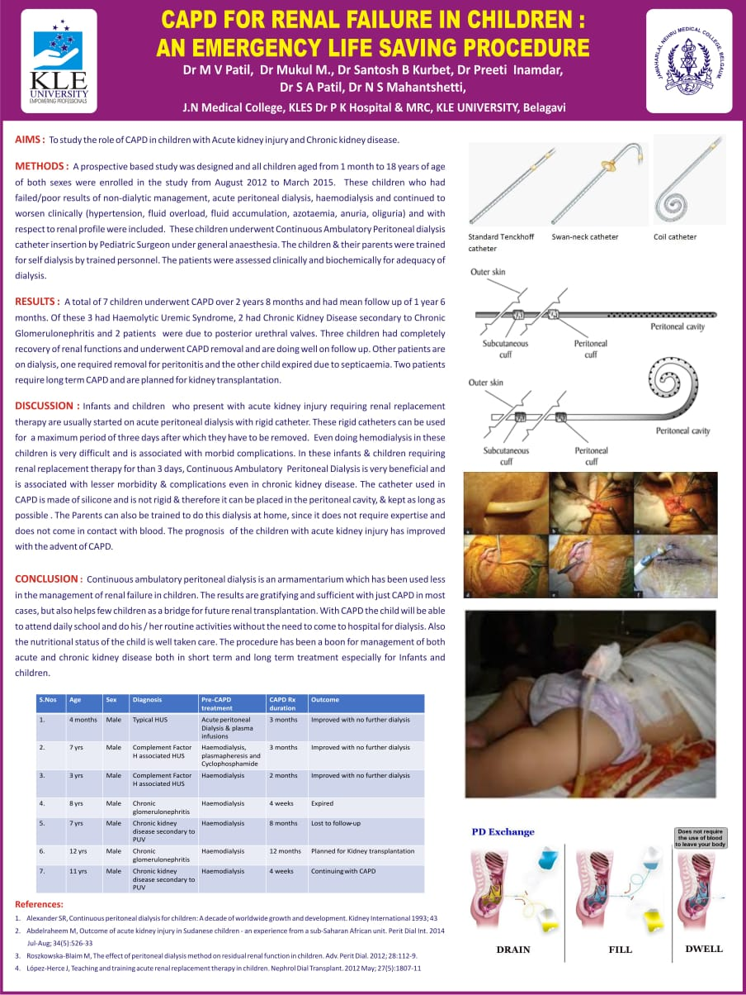

Fig 1- Standard Tenckhoff catheter and coil catheter



Fig 2- **CAPD Procedure and PD exchange**

**Data Collection and Outcome Measures:**

Key parameters monitored included:

1. Renal function recovery (serum creatinine, blood urea nitrogen
2. Incidence of infections (peritonitis)
3. Catheter-related complications
4. Long-term patient outcomes and survival rates

**RESULTS:** A total of 7 children underwent CAPD over 2 years 8 months and had mean follow up of 1 year 6 months. Of these 3 had Haemolytic Uraemic Syndrome,2 had Chronic kidney disease secondary to chronic glomerulonephritis and 2 patients were due to posterior urethral valves. Three children had complete recovery of renal functions and underwent CAPD removal and are doing well on follow up. Other patients are on dialysis, on required removal for peritonitis and the other child expired due to septicemia. Two patients required long term CAPD and are planned for renal transplantation.



Table 1- Outcome of CAPD in pediatric patients

**DISCUSSION:** Infants and children who present with acute kidney injury requiring renal replacement therapy are usually started on acute peritoneal dialysis with rigid catheter. These rigid catheter can be used for a maximum period of three days after which they have to be removed. Even doing hemodialysis in these children is very difficult and is associated with morbid conditions. In these infants and children requiring renal replacement therapy for more than 3 days, continuous ambulatory peritoneal dialysis is very beneficial and is associated with lesser morbidity and complications even in chronic kidney disease. The catheter used in CAPD is made of silicon and is not rigid and therefore it can be placed in the peritoneal cavity and kept as long as possible. The Parents can also be trained to do this dialysis at home, since it does not require expertise and does not come in contact with blood. The prognosis of this children with acute kidney injury has improved the advent of CAPD

Advantages of CAPD in Pediatric Patients:

1. Feasibility for Home Care – Reduces hospital dependency and improves family involvement in patient care.

2. Preservation of Residual Renal Function – Unlike hemodialysis, CAPD maintains residual kidney function for a longer duration.

3. Improved Growth and Development – Continuous dialysis facilitates better nutritional management.

**CONCLUSION:**

Continuous ambulatory peritoneal dialysis is a viable and effective renal replacement therapy for pediatric patients with renal failure, offering advantages such as home-based care and preservation of residual kidney function. The study highlights CAPD’s role in improving survival and quality of life in children with end-stage renal disease. Increased awareness, training programs, and better accessibility can further optimize CAPD’s benefits in pediatric nephrology.

**Challenges and Limitations:**

1. Peritonitis Risk – Requires stringent infection control measures.

2. Training Requirements – Caregivers need proper education to perform CAPD safely.

3. Long-Term Viability – Some patients eventually require kidney transplantation.

**Future Recommendations:**

1.Enhanced training programs for caregivers to reduce infection risks.

2.Improved catheter designs with antimicrobial properties.

3.Increased accessibility of CAPD in resource-limited settings.

DISCLAIMER (ARTIFICIAL INTELLIGENCE)

Authors hereby declare that NO generative AI technologies such as Large Language Models (ChatGPT, COPILOT, etc) and text-to-image generators have been used during writing or editing of this manuscript.

Consent

All authors declare that ‘written informed consent was obtained from parents for publication of this case report and accompanying images. A copy of the written consent is available for review by the Editorial office/Chief Editor/Editorial Board members of this journal

Ethical approval

It is not applicable.

ABBREVIATIONS

CAPD: continuous ambulatory peritoneal dialysis, AKI: acute kidney injury, CKD: chronic kidney diease, HUS: haemolytic uraemic syndrome

References

1. Warady BA, Bakkaloglu S, Newland J, Cantwell M, Verrina E, Neu A, et al. Consensus guidelines for the treatment of peritonitis in pediatric patients receiving peritoneal dialysis. Kidney Int Suppl. 2020;98(1):S51–S66..

2. Warady BA, Neu AM, Schaefer F. Optimal care of the infant on chronic peritoneal dialysis. Pediatr Nephrol. 2013;28(7):1127–1136.

3. Honda M, Ohtomo Y, Kawahara T, Ohashi H, Yoneyama T. Peritoneal dialysis in neonates and infants: Experience and outcomes in a single center. Clin Exp Nephrol. 2022;26(3):345–52.

4. Ronco C, Clark WR. Haemodialysis membranes: Comparative performance and impact on patient outcomes. Nat Rev Nephrol. 2018;14(6):394–410.

5. Schaefer F, Borzych-Duzalka D, Azocar M, Munarriz RL, Warady BA. Global epidemiology of pediatric peritoneal dialysis. Kidney Int. 2019;95(4):893–902.

6. Fischbach M, Terzic J, Menouer S, Chassaing N. Dialysis strategies in infants: peritoneal dialysis or hemodialysis? J Nephrol. 2015;28(1):63–71.

7. Harambat J, van Stralen KJ, Kim JJ, Tizard EJ. Epidemiology of chronic kidney disease in children. Pediatr Nephrol. 2012;27(3):363–73.

8. Coulthard MG, Crosier J, Griffiths C. Outcomes of severe acute kidney injury in children receiving renal replacement therapy: A 20-year single-center experience. Pediatr Nephrol. 2019;34(2):315–22.

9. Loirat C, Fila M. Hemolytic uremic syndrome in children. Clin Nephrol. 2019;91(1):19–27.