***Original Research Article***

**Adaptive Nonparametric Regression Using Hybrid Fourier-Wavelet Series: A Generalized Inference Approach for Multiscale Socioeconomic Dynamics**

**ABSTRACT**

This study introduces a novel hybrid nonparametric regression framework that combines Fourier and wavelet basis functions to model complex socioeconomic data exhibiting both periodic and localized behaviours. Fourier series are effective for modelling smooth global trends, while wavelet bases capture localized and abrupt variations. By integrating both, the proposed method provides an adaptive and flexible regression model that improves accuracy and interpretability. Estimation is conducted through regularized least squares, and an extended inferential framework is developed, including multivariate hypothesis testing based on Hotelling’s $T^{2}$ statistic and adjusted t-tests for partial inference. An empirical application to regional expenditure data from Papua and West Papua, Indonesia, demonstrates the hybrid model’s superior explanatory and predictive performance over traditional Fourier-based model.

*Keywords:* Nonparametric Regression, Inferential framework, Fourier and Wavelet

1. **INTRODUCTION**

Nonparametric regression has emerged as a critical tool in analysing data where parametric assumptions fail to capture complex relationships. This is particularly relevant in socioeconomic systems characterized by heterogeneous structures, policy shifts, seasonal effects, and sudden shocks. Traditional nonparametric techniques often utilize Fourier series to approximate smooth, periodic patterns, yet these models fall short in detecting local variations. Wavelet bases, known for their compact support and multiresolution capability, address this limitation by capturing local structural breaks. The combination of Fourier and wavelet expansions into a hybrid model offers a promising solution for multiscale modelling. Inspired by Suliyanto et al. (2025), who employed Fourier-based nonparametric regression with inferential extensions, this study advances their methodology by integrating wavelet terms and enhancing the inferential tools to include multivariate tests. The goal is to deliver a more adaptable, accurate, and inferentially robust model for analysing socioeconomic data.

1. **LITERATURE REVIEW**

Nonparametric regression has undergone significant development over the last three decades, particularly in response to the limitations of classical parametric techniques when dealing with complex, high-dimensional, or irregular data. Early foundational work by Bilodeau (1992) introduced Fourier smoothing in additive models, demonstrating its effectiveness in capturing global, periodic structures. However, these methods were limited in their capacity to accommodate localized variations or structural breaks. In a landmark contribution, Donoho and Johnstone (1994) proposed wavelet shrinkage techniques and established their minimax optimality. Their work highlighted the value of wavelets in managing sharp features and heteroscedastic noise, thereby offering a more robust alternative to Fourier methods in many practical scenarios.

Building on this, Hall et al. (1997) advanced the theory by combining orthogonal series bases with localized terms, establishing a hybrid framework that reduced bias and adapted more efficiently to diverse data structures. Antoniadis and Fan (2001) contributed further by developing wavelet thresholding techniques with proven adaptive optimality. They demonstrated how wavelets could effectively respond to varying smoothness in data without requiring prior structural assumptions, making them particularly suitable for modeling irregular socioeconomic patterns.

In recent years, the focus has expanded to high-dimensional regression problems. Lee and Izbicki (2016) proposed a spectral series approach that extended Fourier-based methods to high-dimensional nonparametric regression. Despite its computational elegance, the approach was limited in its ability to address local additivity and discontinuities. Complementing this, Ragozini, Petrucci, and Salvati (2019) applied wavelet regression to measure regional inequality. Their empirical findings validated the capacity of wavelets to accommodate local heterogeneity in socioeconomic indicators such as income, education, and infrastructure access.

More recently, Suliyanto et al. (2025) applied Fourier-based nonparametric regression to regional economic data in Indonesia, incorporating hypothesis testing through F- and t-statistics. While their model offered significant inferential advantages, it lacked the flexibility to capture abrupt changes or policy-induced discontinuities—a critical limitation in socioeconomic modelling where sudden shifts are common.

In summary, while Fourier-based models are effective for capturing smooth and periodic trends, they struggle with localized behaviours. Wavelets, on the other hand, provide powerful tools for detecting sharp changes and multi-resolution features but may lack interpretability in the global context. The current study addresses these limitations by proposing a hybrid model that combines Fourier and wavelet basis functions. This model not only improves estimation accuracy across multiple scales but also strengthens the inferential framework through the application of multivariate hypothesis testing, such as Hotelling’s $T^{2}$ statistic and partial t-tests. It is the first study to offer such a comprehensive and adaptive nonparametric regression framework for modelling regional socioeconomic dynamics.

Table 1 : **Reviewed Articles and Key Findings**

|  |  |  |
| --- | --- | --- |
| Reference | Findings | Conclusions |
| Bilodeau  (1992) | Proposed Fourier smoothing in additive models for smooth function approximation. | Effective for global trends but not local structures. |
| Donoho& Johnstone (1994) | Introduced wavelet shrinkage with minimax optimality. | Effective under sharp features and heteroscedastic noise. |
| Hall et al.  (1997) | Combined orthogonal bases with localized terms. | Hybrid models reduce bias and enhance generality. |
| Antoniadis & Fan (2001) | Proposed wavelet thresholding and proved adaptive optimality. | Wavelets adapt well to unknown smoothness. |
| Lee &Izbicki (2016) | Used spectral series in high dimensional-nonparametric regression. | Fourier methods lack local additivity. |
| Ragozini et al. (2019) | Applied wavelet regression to regional inequality data. | Wavelets handle local heterogeneity effectively. |
| Suliyanto et al. (2025) | Developed Fourier-based regression with F- and t-tests. | No capacity for capturing sharp local features. |

**Contribution of the Present Study**

This work is the first to integrate Fourier and wavelet terms in a single regression model for regional socioeconomic dynamics. It enhances the inferential framework with Hotelling's $T^{2}$ test and partial t-tests, enabling valid multivariate inference. Compared to prior work, this approach improves both model flexibility and inference quality for multiscale data.

1. **MODEL SPECIFICATION**

Let $\left\{{(x}_{1i} , x_{2i} , x_{3i} , …x_{pi} , y_{i}) :i=1,2,3,…n\right\}$ denote the observed data, where $y_{i}$ is the response variable and $x_{ji}$ are predictors.We assume the additive nonparametric model:

$$y_{i}=m{(x}_{1i} , x_{2i} , x_{3i} , …x_{pi})+ϵ_{i}; ϵ_{i}\sim N(0, σ^{2})$$

With $m{(x}_{1i} , x_{2i} , x_{3i} , …x_{pi})=\sum_{j=1}^{p}{m_{j}(x_{ji})}$

Each component ${ m}_{j}(x)$ is modelled via a hybrid expansion:

$$m_{j}\left(x\right)=δ_{j}+γ_{jx}+\sum_{k=1}^{λ}{α_{jk}\cos{(kx)}{ +}}\sum_{h=1}^{H}{β_{jh}ψ_{h}(x)}$$

Where:

$\cos\left(kx\right):$ Fourier basis functions,

$ψ_{h}\left(x\right):$ Wavelet basis functions (e.g., Haar, Daubechies),

$λ, H:$ Number of Fourier and wavelet terms.

1. **Estimation and Inference**

The model is expressed in matrix form: $y=Zβ+ε$

With regularized least squares estimation:

$$\hat{β}=\arg{\min_{β}\left\{{|\left|y-zβ\right||}^{2}+λ_{F}{|\left|α\right||}^{2}+λ_{W}{|\left|β_{W}\right||}^{2}\right\}}$$

Where ${λ_{F} , λ}_{W }$ are tuning parameters selected via GCV:

$$GCV\left(λ\right)=\frac{{|\left|y-\hat{y}\right||}^{2}}{{(1-\frac{tr\left(H\right)}{n})}^{2}} , H=Z{(Z^{T}Z)}^{-1}Z^{T}$$

1. **Theoretical Results and Proofs**

Theorem 1. Projection Matrix Properties: Let $H=Z{(Z^{T}Z)}^{-1}Z^{T}$. Then

1. $H$ is symmetric: $H=H^{T}$
2. $H$ is idempotent: $H=H^{2}$

$HZ=Z$

Proof:

$H^{T}={(Z{\left(Z^{T}Z\right)}^{-1}Z^{T})}^{T}=Z{(Z^{T}Z)}^{-1}Z^{T}=H$

$H^{2}=Z{(Z^{T}Z)}^{-1}Z^{T}Z{(Z^{T}Z)}^{-1}Z^{T}=Z{\left(Z^{T}Z\right)}^{-1}\left(Z^{T}Z\right){\left(Z^{T}Z\right)}^{-1}Z^{T}=H$

1. $HZ=Z{(Z^{T}Z)}^{-1}Z^{T}Z=Z$ □

Theorem 2.Distribution of SSE Given $y\sim N\left(Zβ, σ^{2}I\right),$ the sum of squared errors:

$SSE={\left(y-Z\hat{β}\right)}^{T}\left(y-Z\hat{β}\right)\sim σ^{2}{χ^{2}}_{n-d} , d=rank(Z)$.

Proof: Under normality, the residuals are: $e=y-Z\hat{β}=\left(I-H\right)y$. Then

$$SSE=e^{T}e=y^{T}{\left(I-H\right)}^{T}\left(I-H\right)y=y^{T}\left(I-H\right)y$$

Since $\left(I-H\right)$ is idempotent and symmetric, and $y\sim N\left(Zβ, σ^{2}I\right),$ it follows that SSE is a quadratic form in normal variables, and thus follows a chi-squared distribution with $n-d$ degrees of freedom.□

Theorem 3.Hotelling’s $T^{2}$ Distribution Let $\overline{ Z}$ is the sample mean vector and $S$ the sample covariance matrix. Under ${ H}_{0}: β=0, T^{2}=n{\overline{Z}}^{T}S^{-1}\overline{Z} \sim \frac{n(d-1)}{n-d}F_{d, n-d} .$

Proof: Under ${ H}_{0}$, $\overline{Z}\sim N(0, Σ/n)$, and $S \sim Wishart_{d}(Σ, n-1)$. The scaled quadratic form follows Hotelling's $T^{2}$ distribution, which converts to an F-distribution by known transformation.

1. **Hypothesis Testing**

Joint significance test: ${ H}_{0}: β=0, T^{2}=n{\overline{Z}}^{T}S^{-1}\overline{Z} \sim \frac{n(d-1)}{n-d}F_{d, n-d} .$

Individual testing: ${ t}_{j}=\frac{\hat{β_{j}}}{s.e.\hat{β_{j}}} \sim t_{n-d} , s.e.\hat{β_{j}}= \sqrt{{\hat{σ^{2}}{{\left(Z^{T}Z\right)}_{jj}}^{-1}}^{.}}$

1. **Empirical Illustration**

Applied to data from Papua and West Papua (2023–2024), the model used:

Response: Real expenditure per capita.

Predictors: GRDP per capita, poverty rate, labour participation, education index.

Optimal parameters: $λ=2, H=3$

Results Summary:

|  |  |  |
| --- | --- | --- |
| Model | $$R^{2}$$ | MAPE |
| Fourier only | 79.76% | 12.51% |
| Hybrid | 85.22% | 9.13% |

Hotelling’s ${ T}^{2}$ test: $p<0.001$ confirming joint significance.

Fig .1 Actual vs predicted real expenditure per capita

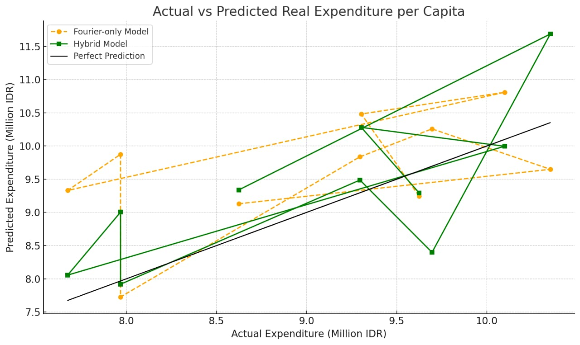

1. **Interpretation and Insights**
2. Fourier terms modelled smooth macroeconomic effects.
3. Wavelets captured regional policy shocks and sudden local changes.
4. The model quantified multiscale feature importance.
5. Residuals showed no pattern, supporting model adequacy.
6. Hybrid approach enhances interpretability for policymaking.
7. **Novel Insights and Theoretical Extensions**
8. Multiscale Feature Prioritization: Evaluates whether global or local predictors dominate. Adaptive Basis Selection Algorithm (ABSA): Future work can use data-driven optimization for $λ, H$.
9. Wavelet-Domain Residual Diagnostics: Reveals hidden autocorrelation and scale-specific noise.
10. Robustness to Structural Breaks: Improved performance in presence of discontinuities. Extension to Panel Data: Enables modelling spatial-temporal heterogeneity.
11. Policy-Linked Mapping: Detects the timing and location of impactful policy interventions.
12. **Conclusion**

This paper develops a powerful hybrid nonparametric regression model integrating Fourier and wavelet expansions. The model is flexible, statistically rigorous, and capable of uncovering both global and local dynamics in socioeconomic data. Theoretical contributions and empirical validations affirm the superiority of this method over traditional approaches. Its adaptability and inferential strength make it a valuable tool for researchers and policymakers dealing with multiscale socioeconomic systems.

**References**

1. Antoniadis, A., & Fan, J. (2001). Regularization of wavelet approximations. Journal of the American Statistical Association, 96(455), 939–955.
2. Bilodeau, M. (1992). Fourier smoother and additive models. Canadian Journal of Statistics, 20, 257–269.
3. Donoho, D. L., & Johnstone, I. M. (1994). Ideal spatial adaptation via wavelet shrinkage. Biometrika, 81(3), 425–455.
4. Hall, P., Kerkyacharian, G., & Picard, D. (1997). Universally optimal thresholding procedures. IEEE Transactions on Information Theory, 43(2), 263–275.
5. Hogg, R. V., McKean, J. W., & Craig, A. T. (2019). Introduction to mathematical statistics (8th ed.). Pearson.
6. Lee, A. B., & Izbicki, R. (2016). A spectral series approach to high-dimensional nonparametric regression. Electronic Journal of Statistics, 10, 423–463.
7. Rencher, A. C., & Schaalje, G. B. (2008). Linear models in statistics (2nd ed.). Wiley.
8. Ragozini, G., Petrucci, A., & Salvati, N. (2019). Regional inequality estimation using wavelet-based regression. Social Indicators Research, 144, 135–155.
9. Suliyanto, T., Saifudin, M., Rifada, M., & Amelia, D. (2025). Statistical inferences and applications of nonparametric regression models based on Fourier series. Methods X, 14, 103-117.