**Neurodegenerative Effects of Soot Particulate Matter Inhalation on The Cerebral Cortex of Male Wistar Rats**

**Abstract**

Burning fossil fuels releases pollutants into the atmosphere, including heavy petroleum products (Soot), oxides of Nitrogen (NOx), and Sulfur (SOx). The cerebral cortex is the outer grey matter layer that completely covers the surface of the two cerebral hemispheres. It is about 2 to 4 mm thick and contains an aggregation of nerve cell bodies. The aim of the study was to evaluate the effects of inhaled soot particulate matter on the cerebral cortex of male Wistar rats. The rats were grouped into four with eight (8) animals per group. Group A was the General control group and were not exposed to Carbon Soot Particulate Matter.  Groups B, C and D were the experimental groups, and were exposed to an average concentration of 1.221±0.169 mg/m³, 1.290±0.214 mg/m³ and 1.282±0.235 mg/m³ of carbon Soot Particulate Matter respectively. The exposure of animals was conducted for 28 days.  On day 3 and day 28, after exposure to soot, some rats were sacrificed and were prepared histologically. The result of the cytoarchitecture of the H&E-stained Cerebral Cortex for day 3 post exposure to Soot shows intact neurons with large nuclei and prominent nucleoli, in the general control group A. The result of the experimental groups, showed hypoperfusion induced marked congestion of blood vessels, excessive degeneration of neuronal cells, excessive vacuolation, Pyknosis and necrosis of neural cells. It was also observed that the level of neurodegeneration was increased on day 28 post exposure to Soot. In conclusion, the brain of the animals exposed to soot showed deleterious effects on the cerebral cortex.

**Keywords:** Neurodegenerative; Particulate Matter; Cerebral cortex; Soot; neurodegeneration; Wistar Rats

**INTRODUCTION**

Soot emissions represent a major source of ambient particulate matter and combustion derived nano-particles in most urban settings (Portugal *et al*., 2024). Petroleum and natural gas are mostly made up of hydrocarbons. They act as lubricants, fuels, and raw materials for the manufacture of rubber, plastic, fiber, explosives, and industrial chemicals. The burning of all fossil fuels (coal and biomass included) releases large quantities of carbon dioxide (CO2) into the atmosphere. The CO2 molecules do not allow much of the long wave solar radiation absorbed by Earth’s surface to reradiate from the surface and escape into space. Several lines of research have led to the concern that the brain represents a relevant target for the effects of such particles. Initial clues for potential neuropathological effects of ambient air particles have originated from comparative histology studies of brain of morgrel dogs, and more recently of post mortem tissues of lifelong residents from cities with strongly contrasting air pollution (Aderinto *et al*., 2025). These investigations revealed signs of oxidative stress and inflammation in the brain in association with high air pollution characterised for instance by an increased expression of the transcription factor Nuclear Factor Kappa B (NFKB), the inflammatory genes cyclo-oxygenase-2 (COX-2) and inducible nitric oxide synthase (iNOS) (Guo *et al*., 2024). Several studies have reported that hydrocarbons in the form of soot induces specific neurotoxicity in mice (Bendtsen *et al* 2021), rat (Gerber *et al*., 2024) and human (Ritchie *et al*, 2021). The cerebral cortex is the largest portion of vertebrate brain that plays crucial role in neural transactions which enhance memory, plasticity, cognition, speech and mental activity. Moreover, it is considered in several studies as a site to explore hydrocarbon induced neurotoxicity.

Controlled inhalation studies in mice confirmed that ambient particulate matter and nano-particles may trigger oxidative stress, toxicity and inflammation in brain tissue (Milani *et al* 2020). Moreover, it has been demonstrated that small fractions of inhaled nanoparticles may actually reach the brain (Portugal *et al*., 2024). Several invitro studies demonstrated that nanoparticles including diesel engine exhaust particles may cause neurotoxic effects to specific brain cells and disturb blood brain barrier functions (Gerber *et al* 2024). Despite the hazardous effects of soot particulate matter on the Cerebral Cortex, there is scarcity of literatures on the effects of soot on the cytoarchitecture of the cerebral cortex. This is the driving force behind this research. The aim of this study was to evaluate the effects of soot on the histology of the cerebral cortex.

**MATERIALS AND METHOD**

**Study design**

The study was conducted using male Wistar rat and the rats were exposed to Carbon Soot particulate matter by inhalation. Approval for this research was sought from the Research Ethics Committee of the University of Port Harcourt. The carbon soot as a particulate matter, used for this study was gotten from combustion of crude oil. An artisanal refinery and combustion chamber was produced in the Engineering workshop from the Department of Mechanical Engineering, University of Port Harcourt. Figure 1 depicts an isometric model of the artisanal refinery combustion chamber, locally fabricated. The central element, a cylindrical tank constructed from metal sheets, measured 20 cm in height and 15 cm in diameter. It was specifically designed to hold the raw crude and was strategically placed on a metal stand, positioned above the combustion chamber. The flow of crude was meticulously regulated by a valve, which was connected to a 2.5 cm diameter metal pipe. This pipe linked the tank to the combustion chamber. To counteract and minimize the high temperatures associated with emissions, an exhaust pipe of 5 cm diameter was enveloped within a recycled water-cooling system. This exhaust system further branched out into three distinct metal pipes, with diameters of 1.27 cm, 1.91 cm, and 2.54 cm, respectively. Each of these pipes was equipped with control valves, ensuring the delivery of varying emission concentrations to three separate exposure cages. The design was adept at facilitating a study of diverse emission impacts under varying conditions.

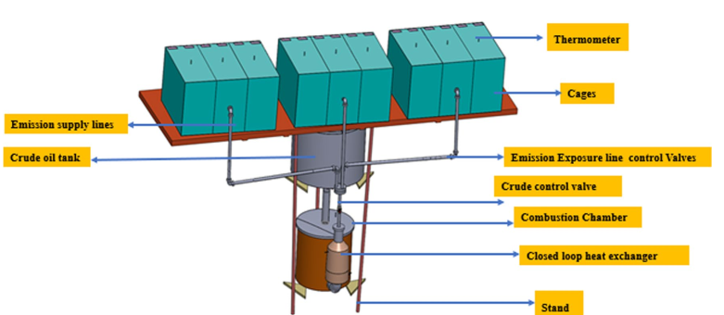

**Figure 1:** Isometric model of locally fabricated artisanal refinery combustion chamber

**Carbon Soot Particulate Matter Exposure System**

The whole-body exposure system was used. The apparatus for the Carbon Soot Particulate matter inhalation system consists of a sample of Carbon soot Particulate matter, A Particulate matter concentration analyzer and Quantifier (PM sensor and Meter), Three Inhalation exposure cages, A circulatory machine (Installed fan) and a thermometer was installed to monitor the temperature of the system.

**Animal Grouping/Exposure to Soot**

Thirty-two (32) Wistar strain healthy adult (age of 7 – 8weeks) male of 160 – 180g body weight were kept in the Animal house of the Faculty of Basic Medical Sciences. The rats were grouped into eight (8) animals per group. The animals were kept and nurtured under laboratory conditions, temperature, humidity, and light, and were allowed free access to food and water ad libitum.

TABLE 1 Experimental groups based on treatment conditions

|  |  |  |
| --- | --- | --- |
| **Group** | **Identification** | **Treatment** |
| A | General control | Rats in this group were not exposed to Carbon Soot Particulate Matter |
| B | Exposure Group 1 | Were exposed to an average concentration of 1.221±0.169 mg/m³ of Carbon Soot Particulate Matter (PM2.5) |
| C | Exposure Group 2 | Were exposed to an average concentration of 1.290±0.214 mg/m³ of Carbon Soot Particulate Matter (PM2.5) |
| D | Exposure Group 3 | Rats in this group were exposed to an average concentration of 1.282±0.235 mg/m³ of Carbon Soot Particulate Matter (PM2.5) |

The exposure of animals was conducted for 28 days. Four (4) animals from each group were sacrificed on day 3 and day 28 during the exposure to the soot.

**Animal Sacrifice and Processing of Tissues**

On day 3 and day 28, after exposure to soot, some rats were sacrificed. The rats were anesthetized with diethyl ether and incision made in the thoracic region to expose the heart. The right atrium cut to drain the blood immediately followed by trans-cardiac perfusion using 0.9% saline and then 10ml of 4% paraformaldehyde (PFA) solution through the left ventricle of the heart. The brain was extracted, post fixed overnight in 4% paraformaldehyde at 4°C. tissues were prepared histologically for microscopy.

**Histopathological Examination**

The brain tissues were processed through various stages, including fixation, dehydration, clearing, impregnation, embedding, sectioning, and staining with hematoxylin and eosin (H&E), followed by mounting. These standard processing methods were described by Baker (1945), and Isirima and Uahomo (2023).

**Method of Data Analysis**

Since no numerical data were generated in this study, the analysis was based on qualitative histological assessment. The histological slides were examined under a light microscope to evaluate tissue architecture, cellular integrity, and morphological changes in the brain samples. Observations were compared across experimental groups to identify structural alterations. Representative photomicrographs were captured for documentation and interpretation of findings.

**Ethics Approval**

The study was carried out in adherence to ethical guidelines set by the National Institute of Health (NIH) for the ethical treatment of animals in research. The study was approved by the Research Ethics Committee of the University of Port Harcourt, Rivers State, Nigeria before commencement of the study.

**RESULTS**

**Cytoarchitecture of the Cerebral Cortex for day 3 post exposure to Soot**

The result of the cytoarchitecture of the H&E-stained Cerebral Cortex for day 3 post exposure to Soot is shown in Figure 2. The result of Group A, B, C and D are represented, using 1, 2, 3, and 4 on the micrographs. It was observed that, there were intact neurons with large nuclei and prominent nucleoli in the Group A (general control group). Observe the hypoperfusion induced marked congestion of blood vessels (HCBV), excessive degeneration of neuronal cells (DN), excessive vacuolation (EV), Pyknosis and necrosis of neural cells in the group B, C and Group D.

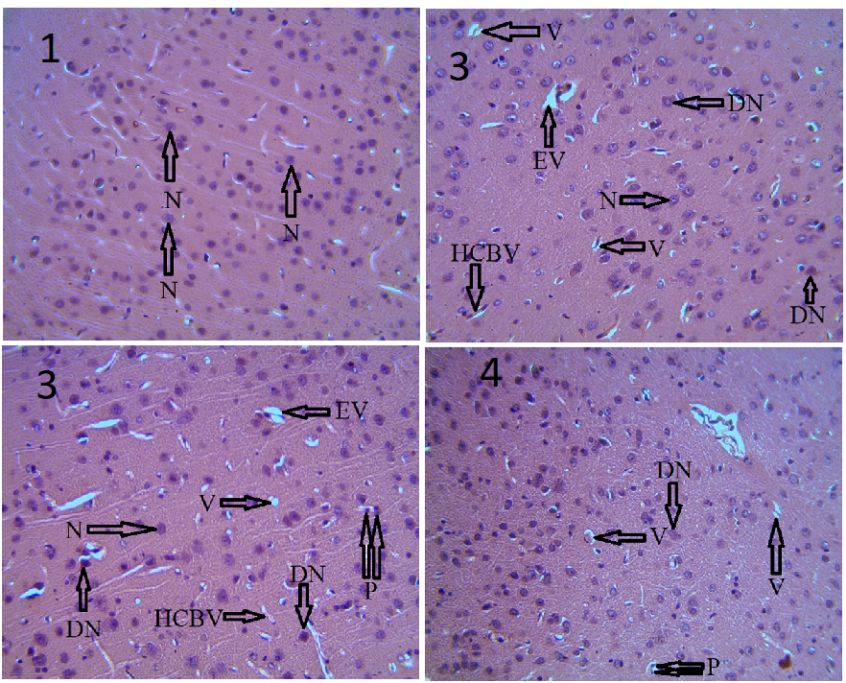

**Figure 2:** Representative photomicrograph of the cytoarchitecture of Cerebral Cortex for group A (General control), Group B, Group C and Group D, for day 3 post exposure to Soot. H&E stain, Magnification: ×400. Group A, B, C and D are represented by 1, 2, 3 and 4. (N- intact neurons, HCBV-hypoperfussion induced marked congestion of blood vessels, DN-excessive degeneration of neurons, EV-excessive vacuolation, P-Pyknosis and karyorrhexis, MD- Mild degeneration of neuronal cells, MV-mild vacuolation).

**Cytoarchitecture of the Cerebral Cortex for day 28 post exposure to Soot**

The cytoarchitecture of the H&E-stained Cerebral Cortex for day 28 post exposure to Soot is shown in Figure 3. The result of Group A, B, C and D are represented, using 1, 2, 3, and 4 on the micrographs. It was observed that, there were intact neurons with large nuclei and prominent nucleoli in the Group A (general control group). Observe the hypoperfusion induced marked congestion of blood vessels (HCBV), excessive degeneration of neuronal cells (DN), excessive vacuolation (EV), Pyknosis and necrosis of neural cells in the group B, C and Group D.

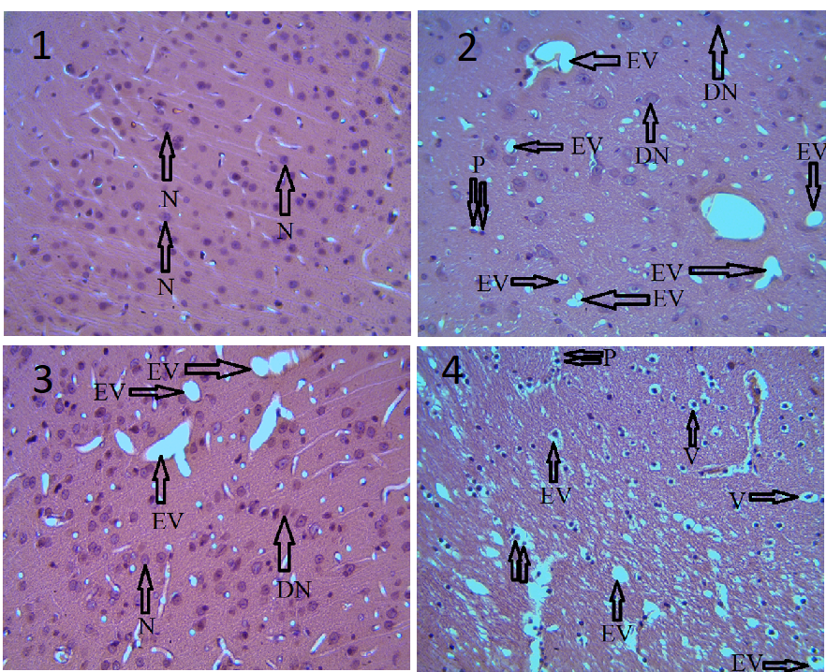

**Figure 3:** Representative photomicrograph of the cytoarchitecture of Cerebral Cortex for group A (General control), Group B, Group C and Group D, for day 28 post exposure to Soot. H&E stain, Magnification: ×400. Group A, B, C and D are represented by 1, 2, 3 and 4. (N- intact neurons, HCBV-hypoperfusion induced marked congestion of blood vessels, DN-excessive degeneration of neurons, EV-excessive vacuolation, P-Pyknosis and karyorrhexis, MD- Mild degeneration of neuronal cells, MV-mild vacuolation)

**DISCUSSION**

Soot is a widely found substance in hydrocarbon industries as well as in some homes following domestic usage of hydrocarbon substances such as kerosene. The extensive availability in the atmosphere can lead to high rates of contamination and exposure. Therefore, public health questions for its adverse effects on non-target organisms have been raised (Shetty *et al*., 2023). The response to its exposure varies between experimental studies and case reports. It depends mainly on the duration and the level of exposure as well as the route of exposure. In this current study, we focused on investigating the possible effect on the cerebral cortex following exposure of Wistar rats to soot via inhalation. Cerebral cortex has vital functions in the fine motor control, motion fractionation and sensory motor incorporation (Jawabri *et al*., 2025).

There is a well-established association between exposure to particulate matter (PM) and numerous adverse cardiac health effects. Particulate exposure has been implicated in the possible development of neurological conditions such as Alzheimer’s and idiopathic Parkinson’s disease (Gotz *et al*., 2004; Kovacs, 2004; Linse *et al*., 2007). Although extensive efforts have been directed toward understanding particle fate and cell–particle interactions in cardiovascular targets, those mechanisms and pathways through which inhaled PM may act on the central nervous system are just now becoming more fully explored. PM may have enhanced entry to the brain from the systemic circulation by crossing the blood-to-brain endothelial barrier, perhaps via exposure-related changes in endothelial membrane permeability. Another possibility is PM may bypass the blood–brain barrier by entering the brain directly via uptake by olfactory sensory neurons (OSNs), which have a direct connection to the olfactory epithelial lining of the nasal cavity with extension of their axons directly to the region of the olfactory bulb of the brain (Mombaerts, 2006). Ambient particulates in polluted air can consist of a multifaceted mixture of highly diverse chemical entities, including hydrocarbons, sulfates, nitrates, metals, soot, and a combination of other organic and inorganic compounds (Kumar and Gill, 2009). Combustion-derived PM commonly contains transition metals, with iron being the predominant metal found in the ultrafine size fraction (Hughes and Cass 1998). The effects of Iron–Soot Exposure and Nose-to-brain Transport of Inhaled Ultrafine Particles has been studied (Hopkins *et al.,* 2018). They observed in their study that there was an increase in microglial cell activation and neural inflammation. The report of Hopkins *et al*. (2018) confirms inhaled ultrafine iron oxide can reach the brain via olfactory nerve fascicles. In their study, there were evidences of inflammatory changes in the olfactory bulb following exposure to ultrafine iron–soot particles which provides further support to the concept that long-term exposure to ambient PM may play a role in neurological disease in humans. The present study is an inhalation study which has shown an oxidative damage of the cerebral cortex. Oxidative damage has an adverse effect on the CNS and has been shown in the brain (Bromberg, 2016; Martinez-Lazcano *et al.*, 2013). Reactive oxygen and nitrogen species (RONS) are formed as a result of Soot. Biological molecules of the body can be destroyed as a result of the diffusion of RONS into the bloodstream (Rivas-Arancibia *et al.*, 2010; Li *et al.*, 2013). Millions of people today, have health challenges as a result of oxidative and inflammatory activities (Kurt *et al.*, 2016). Oxidative damage, inflammation of neurons and apoptosis can be caused by RONS which can be caused by Soot inhalation (Rivas-Arancibia *et al.*, 2010; Martinez-Lazcano *et al.*, 2013; Rodriguez-Martinez *et al.*, 2016). This is because; the brain demands a high level of oxygen and energy. The presence of a very high level of transition metals in neurons enables catalysis that leads to the formation of reactive hydroxyl radical (Gandhi & Abramov, 2012). The cerebral cortex of an animal is highly sensitive to oxidative damage (Sender *et al.*, 2019). Mitra *et al.* (2015) stated that, the striatum and substantia nigra are also sensitivity to oxidative damage. Leuner & Gould (2010) reported that, sensitivity to oxidative damage on the hippocampus is highly increased in the CA regions and the dentate gyrus. In the present study, it was observed that, the cytoarchitecture of the H&E-stained Cerebral Cortex for day 3 post exposure to Soot showed intact neurons with large nuclei and prominent nucleoli in the general control group (Group A). The experimental group: Group B, C and Group D showed hypoperfusion induced marked congestion of blood vessels (HCBV), excessive degeneration of neuronal cells (DN), excessive vacuolation (EV), Pyknosis and necrosis of neural cells. It was also observed that the level of neurodegeneration was increased on day 28 post exposure to Soot.

**CONCLUSION**

The present study documented the ability of soot to induce tissue reaction and neuropathology in the cerebral cortex of adult male albino rats upon their exposure to soot. Tissue reaction appear histopathologically as hypoperfusion induced marked congestion of blood vessels, excessive degeneration of neuronal cells, excessive vacuolation, pyknosis and necrosis of neural cells. This result should be taken seriously in order to protect industrial and medical field workers from possible soot induced cerebral related hazards. Knowledge gained from this study will be useful to the Neuroscientist, Anatomists and the Clinician.

**CONFLICT OF INTEREST**

The authors declare no conflict of interest.

**COMPETING INTERESTS DISCLAIMER**:

Authors have declared that they have no known competing financial interests OR non-financial interests OR personal relationships that could have appeared to influence the work reported in this paper.

**REFERENCES**

Aderinto, N., Ajagbe, A. O., Olatunji, G., *et al*. (2025). Correction: The impact of air pollution on neurodegenerative diseases: A narrative review of current evidence. Egyptian Journal of Internal Medicine, 37, 41. <https://doi.org/10.1186/s43162-025-00427-8>

Baker, J. R. (1945). *Cytological technique* (2nd ed.). Methuen.

Bendtsen, K. M., Bengtsen, E., Saber, A. T., & Vogel, U. (2021). A review of health effects associated with exposure to jet engine emissions in and around airports. *Environmental health : a global access science source*, *20*(1), 10. <https://doi.org/10.1186/s12940-020-00690-y>

Bromberg P. A. (2016). Mechanisms of the acute effects of inhaled ozone in humans. *Biochimica et biophysica acta*, *1860*(12), 2771–2781. <https://doi.org/10.1016/j.bbagen.2016.07.015>

Gambari, S. A., Erameh, T. O., Ugbomoiko, D. O., Ibrahim, A. O., Adegboye, A. A., & Omonijo, A. (2023). Comparison of the Efficacy of Haematoxylin & Eosin (H&E) and Periodic Acid Schiff (PAS) Staining Techniques in the Diagnosis of Typhoid Intestinal Perforation (TIP) among Patients Attending Federal Medical Centre, Keffi Nasarawa State, Nigeria. International Journal of TROPICAL DISEASE & Health, 44(18), 15–22. <https://doi.org/10.9734/ijtdh/2023/v44i181474>

Gandhi, S., & Abramov, A. Y. (2012). Mechanism of oxidative stress in neurodegeneration. *Oxidative medicine and cellular longevity*, *2012*, 428010. <https://doi.org/10.1155/2012/428010>

Gerber, L. S., de Leijer, D. C. A., Rujas Arranz, A., Lehmann, J. M. M. L., Verheul, M. E., Cassee, F. R., & Westerink, R. H. S. (2024). In vitro neurotoxicity of particles from diesel and biodiesel fueled engines following direct and simulated inhalation exposure. *Environment international*, *184*, 108481. <https://doi.org/10.1016/j.envint.2024.108481>

Götz, J., Schild, A., Hoerndli, F., & Pennanen, L. (2004). Amyloid-induced neurofibrillary tangle formation in Alzheimer's disease: insight from transgenic mouse and tissue-culture models. *International journal of developmental neuroscience : the official journal of the International Society for Developmental Neuroscience*, *22*(7), 453–465. <https://doi.org/10.1016/j.ijdevneu.2004.07.013>

Guo, Q., Jin, Y., Chen, X., Ye, X., Shen, X., Lin, M., Zeng, C., Zhou, T., & Zhang, J. (2024). NF-κB in biology and targeted therapy: new insights and translational implications. *Signal transduction and targeted therapy*, *9*(1), 53. <https://doi.org/10.1038/s41392-024-01757-9>

Hopkins, L. E., Laing, E. A., Peake, J. L., Uyeminami, D., Mack, S. M., Li, X., Smiley-Jewell, S., & Pinkerton, K. E. (2018). Repeated Iron-Soot Exposure and Nose-to-brain Transport of Inhaled Ultrafine Particles. *Toxicologic pathology*, *46*(1), 75–84. <https://doi.org/10.1177/0192623317729222>

Hughes, L. S., Cass, G. R., Gone, J., Ames, M., & Olmez, I. (1998). Physical and Chemical Characterization of Atmospheric Ultrafine Particles in the Los Angeles Area. Environmental Science and Technology, 32(9), 1153–1161. <https://doi.org/10.1021/es970280r>

Isirima, J. C., & Uahomo, P. O. (2023). *Acalypha wilkesiana* exhibits antihyperglycemic potentials and ameliorates damages to pancreas and spleen of diabetic rat model. *Saudi Journal of Biomedical Research, 8*(7), 83-94. <https://doi.org/10.36348/sjbr.2023.v08i07.001>

Jawabri KH and Sharma S. (2025): Physiology, Cerebral Cortex Functions. In: StatPearls [Internet]. Treasure Island (FL): StatPearls Publishing.

Kovács T. (2004). Mechanisms of olfactory dysfunction in aging and neurodegenerative disorders. *Ageing research reviews*, *3*(2), 215–232. <https://doi.org/10.1016/j.arr.2003.10.003>

Kumar, V., & Gill, K. D. (2009). Aluminium neurotoxicity: neurobehavioural and oxidative aspects. *Archives of toxicology*, *83*(11), 965–978. <https://doi.org/10.1007/s00204-009-0455-6>

Kurt, O. K., Zhang, J., & Pinkerton, K. E. (2016). Pulmonary health effects of air pollution. *Current opinion in pulmonary medicine*, *22*(2), 138–143. <https://doi.org/10.1097/MCP.0000000000000248>

Leuner, B., & Gould, E. (2010). Structural plasticity and hippocampal function. *Annual review of psychology*, *61*, 111–C3. <https://doi.org/10.1146/annurev.psych.093008.100359>

Li, Z., Tighe, R. M., Feng, F., Ledford, J. G., & Hollingsworth, J. W. (2013). Genes of innate immunity and the biological response to inhaled ozone. *Journal of biochemical and molecular toxicology*, *27*(1), 3–16. <https://doi.org/10.1002/jbt.21453>

Linse, S., Cabaleiro-Lago, C., Xue, W. F., Lynch, I., Lindman, S., Thulin, E., Radford, S. E., & Dawson, K. A. (2007). Nucleation of protein fibrillation by nanoparticles. *Proceedings of the National Academy of Sciences of the United States of America*, *104*(21), 8691–8696. <https://doi.org/10.1073/pnas.0701250104>

Martínez-Lazcano, J. C., González-Guevara, E., del Carmen Rubio, M., Franco-Pérez, J., Custodio, V., Hernández-Cerón, M., Livera, C., & Paz, C. (2013). The effects of ozone exposure and associated injury mechanisms on the central nervous system. Reviews in the neurosciences, 24(3), 337–352. <https://doi.org/10.1515/revneuro-2012-0084>

Milani, C., Farina, F., Botto, L., Massimino, L., Lonati, E., Donzelli, E., Ballarini, E., Crippa, L., Marmiroli, P., Bulbarelli, A., & Palestini, P. (2020). Systemic Exposure to Air Pollution Induces Oxidative Stress and Inflammation in Mouse Brain, Contributing to Neurodegeneration Onset. International journal of molecular sciences, 21(10), 3699. <https://doi.org/10.3390/ijms21103699>

Mitra, S., Siddiqui, W. A., & Khandelwal, S. (2015). Differential susceptibility of brain regions to tributyltin chloride toxicity. *Environmental toxicology*, *30*(12), 1393–1405. <https://doi.org/10.1002/tox.22009>

Mombaerts P. (2006). Axonal wiring in the mouse olfactory system. *Annual review of cell and developmental biology*, *22*, 713–737. <https://doi.org/10.1146/annurev.cellbio.21.012804.093915>

Portugal, J., Bedia, C., Amato, F., Juárez-Facio, A. T., Stamatiou, R., Lazou, A., Campiglio, C. E., Elihn, K., & Piña, B. (2024). Toxicity of airborne nanoparticles: Facts and challenges. *Environment international*, *190*, 108889. <https://doi.org/10.1016/j.envint.2024.108889>

Ritchie, G. D., Still, K. R., Alexander, W. K., Nordholm, A. F., Wilson, C. L., Rossi, J., 3rd, & Mattie, D. R. (2001). A review of the neurotoxicity risk of selected hydrocarbon fuels. *Journal of toxicology and environmental health. Part B, Critical reviews*, *4*(3), 223–312. <https://doi.org/10.1080/109374001301419728>

Rivas-Arancibia, S., Guevara-Guzmán, R., López-Vidal, Y., Rodríguez-Martínez, E., Zanardo-Gomes, M., Angoa-Pérez, M., & Raisman-Vozari, R. (2010). Oxidative stress caused by ozone exposure induces loss of brain repair in the hippocampus of adult rats. *Toxicological sciences : an official journal of the Society of Toxicology*, *113*(1), 187–197. <https://doi.org/10.1093/toxsci/kfp252>

Rodríguez-Martínez, E., Nava-Ruiz, C., Escamilla-Chimal, E., Borgonio-Perez, G., & Rivas-Arancibia, S. (2016). The Effect of Chronic Ozone Exposure on the Activation of Endoplasmic Reticulum Stress and Apoptosis in Rat Hippocampus. Frontiers in aging neuroscience, 8, 245. <https://doi.org/10.3389/fnagi.2016.00245>

Shetty, S. S., D, D., S, H., Sonkusare, S., Naik, P. B., Kumari N, S., & Madhyastha, H. (2023). Environmental pollutants and their effects on human health. *Heliyon*, *9*(9), e19496. <https://doi.org/10.1016/j.heliyon.2023.e19496>