**MARKOV CHAIN ANALYSIS OF YEARLY PRECIPITATION AMOUNT OVER THE SOUTH-SOUTH REGION IN NIGERIA**

ABSTRACT

|  |
| --- |
| **Aims:** Markov chain analysis was employed to examine the pattern and distribution of yearly precipitation amount in Akwa Ibom, Bayelsa, Rivers, Cross River, Edo and Delta states in Nigeria.  **Duration of Study**: Twenty-one (21) years data (1990-2020) on daily precipitation amount was obtained from National Aeronautic and Space Administration (NASA) metrological center.  **Method** The outcome of the standardized anomalies was used to rank yearly precipitation amount into different Markov Chain states for ease analysis. A seven-state (*1: Wet, 2: Moderately wet, 3: Slightly wet, 4: Near normal, 5: Slightly dry, 6: Moderately dry and 7: Dry).*  **Results:** Markov chain was used to describe the behavior of precipitation occurrences in the study locations. Findings revealed that Rivers state had the highest amount of precipitation in 2007, while Edo had the lowest amount in 1999 over the study period. The standardized anomalies shows major positive departure in Rivers compared to other regions in the South-South. There is a 48%, 33%, 38%, 33%, 35% and 38% chance of precipitation amount been normal (*state 4*) on any given year regardless of previous weather conditions in Akwa Ibom, Bayelsa, Edo, Rivers, Cross river and Delta respectively.  **Conclusion:** Understanding the transition from one Markov chain state of precipitation amount to another state is necessary for future planning in areas like agriculture, hydrological studies and the entire planning of the South-South region. |

*Keywords:* Markov chain, Standardized anomalies, Rivers, Nigeria, Precipitation amount.

1. INTRODUCTION

Precipitation occurs when hydrometeors (liquid and ice particles that form in the atmosphere) are large and heavy enough to fall to the Earth’s surface. Itis the universal term for rainfall, snowfall, and other forms of frozen or liquid water falling from clouds and it varies from year to year, and changes in intensity, frequency, amount and type.The microphysics of precipita­tion particle formation is affected by super-satura­tion, nucleation, diffusion, and collision. Collision between two hydrometeors allows them to combine into larger precipitation particles which are much larger than cloud particles. Clouds colder than 0°C, ice nuclei trigger ice crystals to grow. Ice crystals can exist in the air along with supercooled liquid drops. Because of the difference between liquid and ice saturation hu­midities, the ice can grow at the expense of evap­orating liquid droplets. If the ratio of water to ice hydrometeors is about a million to one, then most of the water will be transferred to ice crystals, which are then heavy enough to fall as precipitation [1]. The unique demand for precipitation to life has made its study a major concern in our society.

Changes in precipitation patterns have substantial effects on humans, ecosystems, agriculture and so on [2-4]. The potential impacts of low or heavy precipitation include crop damage, soil erosion, and an increase in flood risk [5]. It is well established that precipitation patterns are certain to be affected by global warming, because sea and air temperatures and sea-level atmospheric pressure, which are the underlying forces behind these patterns, are already changing [4]. Precipitation exhibits a strong variability in time and space across the globe. Thus, its stochastic modeling is necessary for the prevention of natural disaster. A stochastic model is preferred if the process has a strong element of randomness, complexity and involves many discrete events. The choice of using a model depends on the nature of the process to be modeled.

The analysis of precipitation patterns behavior particularly in terms of amount of rainfall, frequency, intensity, duration and distribution has been studied extensively [6-9]. [10] demonstrated the potential benefits of using Stochastic Processes for modeling and interpreting historical rainfall occurrence in Kurdufan State Sudan using Markov Chains as the driving mechanism. [11] employed the Markov Chain model in modeling the sequence of positive and negative maximum air temperature anomaly in Port Harcourt (Rivers), Nigeria. [12] applied the Markov Chain Rainfall distribution in Uyo (Akwa Ibom) metropolis of Nigeria using 15 years (1995-2009) rainfall data. They discovered that the Monsoon period with a WC of 5 days, the expected length of dry, wet and rainy days were 2 days, 1 day and 2days while for the Post-Monsoon period with a WC of 8 days, the expected length of dry, wet and rainy days were 6 days, 1 day and 2days respectively. The present study applies the Markov Chain in modeling the precipitation patterns in Akwa Ibom, Bayelsa, Rivers, Cross River, Edo and Delta Nigeria which is rare. A Markov chain is a stochastic model that describes a sequence of possible events or transitions from one state to another of a system and only requires the information of the present state to predict the future states. This property of forgetting past events is known as the memory less property. The findings from this work would provide a useful information for design of water supply management, agriculturists and knowledge of precipitation pattern and its distributions over the South-South region in Nigeria.

2. methodology

**2.1 Study Area and Data**

This research focuses on the six (6) states in the South-South geopolitical zone of Nigeria which includes; Akwa Ibom, Bayelsa, Cross River, Delta, Edo and Rivers states. This geopolitical zone lies between Latitudes 4050/N and 7010/N and Longitudes 6040/E and 8030/E. The South-South zone has a total of 123 Local Government Areas and covers a total area of 78,612Km2, about 8.5 percent of Nigeria’s total land mass. It accounts for a total population of (16,381,729) about sixteen million people. This zone is the major location of crude oil and natural gas deposits in Nigeria. Also, the core oil palm belt of the nation is found in this zone. Crops such as rubber, cocoa, cassava, yam, plantain, banana, maize and timber are mostly grown in large quantity in this region. The inhabitants are mainly the; Efiks, Annangs, ibibios, ijaws, Itsekiris, Urhobos and Binis among others. They are engaged in different forms of economic activities such as; commerce, hospitality, industries and tourism.

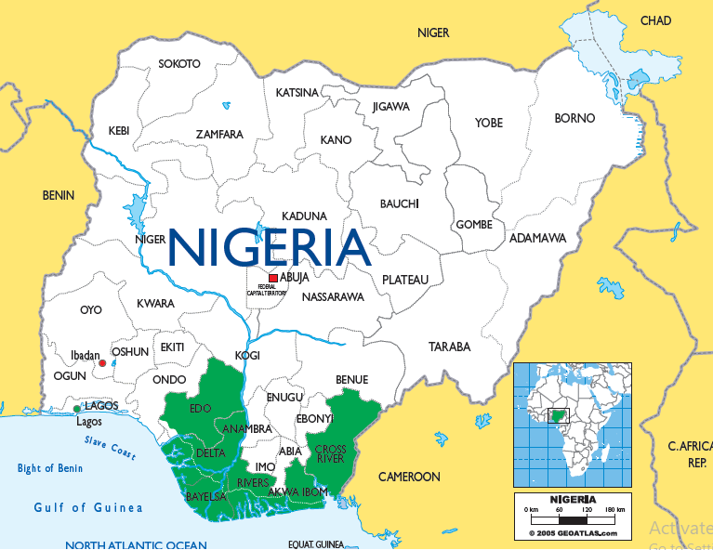

Fig. 1: Map of Nigeria showing the six South-South states.

Data on daily precipitation over Akwa Ibom, Bayelsa, Rivers, Cross River, Edo and Delta states, Nigeria for twenty-one years from January1, 1990 to December 31, 2020 were obtained from National Aeronautic and Space Administration (NASA) metrological center. There were no missing observations in the entire daily precipitation data recorded.

**2.2 Methods**

1. **Standardized Anomalies**

The precipitation yearly standardized anomalies were computed for the six South-South states in Nigeria. [13] suggested that standardized anomalies is a useful tool in predicting extreme multiday rainfall events in the northern Sierra range, [14] used normalized departures from climatology to objectively rank synoptic-scale events. The standardized anomalies “*N*” (normalized departure) of any meteorological variable can be defined by:

$N=\frac{X-μ}{σ}$ (1)

Where *X* is the actual precipitation amount, $μ$ is the average precipitation amount and $σ$ is the Standard deviation for each study location. The outcome of the standardized anomalies could be negative (below average) or positive (above average) and this was used to rank yearly precipitation amount into different Markov Chain states for ease analysis.

1. **Markov Chains**

Markov chains was introduced in 1906 by Andrei Andreyevich Markov (1856–1922) and named in his honor. A Markov chain is a stochastic model describing a sequence of possible events in which the probability of each event depends only on the state attained in the previous event (Markovian property). A stochastic process {*Xn*} is said to have the Markovian property if

$$P\left\{X_{n+1}= j | X_{n} = i, X_{n-1} ={ i}_{n-1},. . . , X_{1}={ i}_{1},X_{0} = i_{0}\right\}$$

$= P\left\{X_{n+1}= j | X_{n} = i\right\}= P_{ij}$ (2)

For all states $i_{0}, i_{1}, . . ., i, j$ and $n ≥ 0$.

For a first-order Markov chain, the future state $X_{n+1}$ is independent of the previous states $X_{0}, X_{1},. . . .., X_{n-1}$ and depends only on the present state $X_{n}$ [15]. A stochastic process {*Xn*} (*n* = 0, 1 . . .) is a Markov chain if it has the Markovian property*.*

The conditional probabilities *P* {*Xn+1 =j*/*Xn = i*} for a Markov chain are called (one-step) transition probabilities. A Markov chain transition matrix is a square array describing the probabilities of the chain transiting from one state to another. This transition probability $P_{ij}$ is given as [16]:

 (3)

The elements  are also called stationary probabilities. Stationary transition probabilities implies that the transition probabilities do not change over time.

For any value of $\left( n=2, 3…\right),$ the *nth* power of the matrix *P* specifies the probabilities $p_{ij}^{n}$ that the chain will move from state $x_{i}$ to $x_{j}$ is called the n-step probability matrix. This is based on the Chapman Kolmogorov equation, which states as follows [17];

For any $r≤n,$

$P_{n}={\left(P_{ij}\right)}_{n}=P^{\left(n\right)}=\sum_{k=0}^{∞}{P_{ik}^{r}}P_{kj}^{n-r}$ (4)

where $P_{n}$ denotes the matrix of n-step transition probability.

A seven-state Markov chain was used to describe the behavior of precipitation occurrences in the study locations. The seven-state space, as considered were; 1: Wet, 2: Moderately wet, 3: Slightly wet, 4: Near normal, 5: Slightly dry, 6: Moderately dry and 7: Dry. The conditions of precipitation occurrence for the seven states were defined using the standardize anomaly as follows*: state 1*: Wet-if precipitation is greater or equals to 2, *state 2*: Moderately wet – if precipitation lies between 1.00 to 1.99, *state 3*: Slightly wet– if precipitation lies between 0.50 to 0.99, *state 4*: Near normal– if precipitation lies between 0.49 to -0.49, *state 5*: Slightly dry– if precipitation lies between -0.50 to -0.99, *state 6*: Moderately dry– if precipitation lies between -1.00 to -1.99 and *state 7*: Dry– if precipitation is less or equals to -2 as shown below.

$States=\left\{\begin{matrix}≥2 1:Wet \\ 1.00 to 1.99 2:Moderately wet \\ \begin{matrix}0.50 to 0.99 3:Slightly wet \\ 0.49 to-0.49 4:Near normal \\ \begin{matrix}-0.50 to-0.99 5:Slightly dry \\ -1.00 to-1.99 6:Moderately dry \\ ≤-2 7:Dry\end{matrix}\end{matrix}\end{matrix}\right.$**(5)**

The current year precipitation amount was expected to depend only on that of the preceding year; hence, the observed frequency of years of being in a particular atmospheric state *“j”* (*j* = 1…7) having just left atmospheric state *“i”* (*i* = 1…7)*,* are presented in Table 1 while the associated transition probability matrix is presented in Table 2.

Table 1: Frequency of years of being in atmospheric state *“j”* preceded by atmospheric state *“i”*

|  |  |  |  |  |  |  |  |  |
| --- | --- | --- | --- | --- | --- | --- | --- | --- |
|  |  | Current Year | | | | | | |
|  | States | Wet (1) | Moderately wet (2) | Slightly wet (3) | Near normal (4) | Slightly dry (5) | Moderately dry (6) | Dry (7) |
| Previous Year | Wet (1) | N11 | N12 | N13 | N14 | N15 | N16 | N17 |
| Moderately wet (2) | N21 | N22 | N23 | N24 | N25 | N26 | N27 |
| Slightly wet (3) | N31 | N32 | N33 | N34 | N35 | N36 | N37 |
| Near normal (4) | N41 | N42 | N43 | N44 | N45 | N46 | N47 |
| Slightly dry (5) | N51 | N52 | N53 | N54 | N55 | N56 | N57 |
| Moderately dry (6) | N61 | N62 | N63 | N64 | N65 | N66 | N66 |
| Dry (7) | N71 | N72 | N73 | N74 | N75 | N76 | N77 |

Where

N11: Number of wet years preceded by wet years.

N12: Number of wet years preceded by moderately wet years

N71: Number of dry years preceded by wet years

N77: Number of dry years preceded by dry years, and so on

The probability of precipitation being in a particular state was computed based on the Markov chain assumption that attaining a state is hinge on the immediate preceding state only.

Table2: Transition probability matrix of the seven state Markov Chain.

|  |  |  |  |  |  |  |  |  |
| --- | --- | --- | --- | --- | --- | --- | --- | --- |
|  |  | Current Year | | | | | | |
|  | States | Wet (1) | Moderately wet (2) | Slightly wet (3) | Near normal (4) | Slightly dry (5) | Moderately dry (6) | Dry (7) |
| Previous Year | Wet (1) | P11 | P12 | P13 | P14 | P15 | P16 | P17 |
| Moderately wet (2) | P21 | P22 | P23 | P24 | P25 | P26 | P27 |
| Slightly wet (3) | P31 | P32 | P33 | P34 | P35 | P36 | P37 |
| Near normal (4) | P41 | P42 | P43 | P44 | P45 | P46 | P47 |
| Slightly dry (5) | P51 | P52 | P53 | P54 | P55 | P56 | P57 |
| Moderately dry (6) | P61 | P62 | P63 | P64 | P65 | P66 | P66 |
| Dry (7) | P71 | P72 | P73 | P74 | P75 | P76 | P77 |

Where

P11 = P (): Probability of a wet year preceded by a wet year

P21 = P (): Probability of a moderately wet day preceded by a wet year

P77 = P (): Probability of a dry year preceded by a dry year; and so on, subject to the condition that the sum of probabilities of each row equals to one. That is;

P11 + P12 + P13 + P14 + P15 + P16 + P17 =1 (6)

The Markov chain transition probabilities matrices, simulated trajectories of the Markov Chain and the Unconditional probability vectors plot against step over study locations shall be determined in the analysis using the computed yearly precipitation amount.

3. results and discussion

The precipitation amounts over Akwa Ibom, Bayelsa, Rivers, Cross River, Edo and Delta for the period of 1990-2020 ranged from 1498 to 3660 mm, 1280 to 3854 mm, 1516 to 3918 mm, 1400 to 3501 mm. 962 to 3164 mm and 1083 to 3514 mm respectively. The lowest value of precipitation amounts over Akwa Ibom, Bayelsa, Rivers, Cross River, Edo and Delta 413.2 mm was recorded in 2014, 2014, 1991, 2014, 1999 and 1999, while the highest amount was recorded in 2000, 2020, 2007, 2007, 2000 and 2000 respectively (Figure 2). Rivers had the highest amount of precipitation in 2007, while Edo had the lowest amount in 1999 over the study period.

Figure 2: Yearly Precipitation amount in South-South region from 1990-2020.

The standardized precipitation anomaly analysis over the South-South regions is presented in Figure 3. The analysis shows normal (average), positive (above average) and negative (below average) departure of yearly precipitation from 1990-2020. The Standardized precipitation anomaly of 2.9, 1.8, 1.9, 2.9, 2.3 and 2.7 over Akwa Ibom, Bayelsa, Rivers, Cross River, Edo and Delta placed the year 2000, 2020, 2007, 2007, 2000 and 2000 respectively as the wettest year in the South-South region since 1990 to 2020 (Figure 3). Furthermore, the years 1992, 1994, 1995, 1996, 2000, 2007, 2017 and 2020 was above average (wet), while 1990, 1991, 1999, 2008 and 2014 was below average (dry) across study locations. The analysis shows major positive departure in Rivers compared to other South-South states considered in this work.

1. Akwa Ibom
2. Bayelsa
3. Rivers
4. Cross River
5. Edo
6. Delta

Figure 3: Standardize Precipitation Anomaly from 1990-2020

The first order transition probabilities were obtained for Akwa Ibom, Bayelsa, Edo, Rivers, Cross river and Delta as presented in Table 3. The transition probabilities occurred from state 1-6 (Edo, Delta and Akwa Ibom), state 2-7 (Cross River), state 1-5 (Rivers) and lastly state 2-6 (Bayelsa). The states space *1: Wet, 2: Moderately wet, 3: Slightly wet, 4: Near normal, 5: Slightly dry, 6: Moderately dry,* occurred in Edo, Delta and Akwa Ibom; States *1: Wet, 2: Moderately wet, 3: Slightly wet, 4: Near normal, 5: Slightly dry* in Rivers; States *2: Moderately wet, 3: Slightly wet, 4: Near normal, 5: Slightly dry, 6: Moderately dry* in Bayelsa and lastly, States *2: Moderately wet, 3: Slightly wet, 4: Near normal, 5: Slightly dry, 6: Moderately dry, 7: Dry* in Cross River.

**Table 3: Transition probabilities matrix across locations in South-South region.**

|  |  |  |  |  |  |  |  |  |  |  |  |  |  |  |  |
| --- | --- | --- | --- | --- | --- | --- | --- | --- | --- | --- | --- | --- | --- | --- | --- |
| Loc. | States | 1 | 2 | 3 | 4 | 5 | 6 | Loc. | States | 2 | 3 | 4 | 5 | 6 | 7 |
| Edo | 1 | *0.00* | *0.00* | *0.00* | *0.00* | *1.00* | *0.00* | Cross River | 2 | *0.25* | *0.25* | *0.00* | *0.50* | *0.00* | *0.00* |
| 2 | *0.00* | *0.00* | *0.00* | *0.67* | *0.00* | *0.33* | 3 | *0.29* | *0.29* | *0.29* | *0.13* | *0.00* | *0.00* |
| 3 | *0.00* | *0.67* | *0.33* | *0.00* | *0.00* | *0.00* | 4 | *0.13* | *0.25* | *0.36* | *0.13* | *0.13* | *0.00* |
| 4 | *0.00* | *0.00* | *0.22* | *0.34* | *0.22* | *0.22* | 5 | *0.00* | *0.20* | *0.20* | *0.40* | *0.00* | *0.20* |
| 5 | *0.00* | *0.14* | *0.00* | *0.58* | *0.14* | *0.14* | 6 | *0.00* | *0.50* | *0.25* | *0.00* | *0.00* | *0.25* |
| 6 | *0.17* | *0.00* | *0.00* | *0.17* | *0.33* | *0.33* | 7 | *0.00* | *0.00* | *1.00* | *0.00* | *0.00* | *0.00* |
| Delta | 1 | *0.00* | *0.00* | *0.00* | *0.00* | *1.00* | *0.00* |  |  | 1 | 2 | 3 | 4 | 5 |  |
| 2 | *0.00* | *0.25* | *0.50* | *0.00* | *0.00* | *0.25* | Rivers | 1 | *0.33* | *0.50* | *0.00* | *0.17* | *0.00* |  |
| 3 | *0.00* | *0.50* | *0.25* | *0.25* | *0.00* | *0.00* | 2 | *0.50* | *0.13* | *0.12* | *0.13* | *0.12* |  |
| 4 | *0.00* | *0.00* | *0.20* | *0.60* | *0.00* | *0.20* | 3 | *0.00* | *0.17* | *0.50* | *0.17* | *0.16* |  |
| 5 | *0.00* | *0.20* | *0.00* | *0.60* | *0.20* | *0.00* | 4 | *0.17* | *0.17* | *0.33* | *0.33* | *0.00* |  |
| 6 | *0.20* | *0.00* | *0.00* | *0.20* | *0.40* | *0.20* | 5 | *0.00* | *0.50* | *0.50* | *0.00* | *0.00* |  |
| Akwa Ibom | 1 | *0.00* | *1.00* | *0.00* | *0.00* | *0.00* | *0.00* |  |  | 2 | 3 | 4 | 5 | 6 |  |
| 2 | *0.00* | *0.00* | *0.33* | *0.33* | *0.34* | *0.00* | Bayelsa | 2 | *0.50* | *0.33* | *0.00* | *0.00* | *0.17* |  |
| 3 | *0.00* | *0.33* | *0.00* | *0.67* | *0.00* | *0.00* | 3 | *0.50* | *0.25* | *0.25* | *0.00* | *0.00* |  |
| 4 | *0.00* | *0.08* | *0.08* | *0.53* | *0.23* | *0.08* | 4 | *0.13* | *0.13* | *0.25* | *0.13* | *0.36* |  |
| 5 | *0.17* | *0.00* | *0.00* | *0.66* | *0.00* | *0.17* | 5 | *0.17* | *0.00* | *0.33* | *0.33* | *0.17* |  |
| 6 | *0.33* | *0.00* | *0.00* | *0.00* | *0.33* | *0.34* | 6 | *0.00* | *0.00* | *0.80* | *0.20* | *0.00* |  |

The probability of precipitation in state 1 (wet) transiting into state 5 (slightly dry) is 1.00 (Edo and Delta). In Akwa Ibom and Cross river, the chance probability remain 1.00 transiting from state 1 (wet) to state 2 (moderately wet) and state 7 (Dry) to state 4 (near normal) respectively. The transition probabilities of precipitation in any states transiting into state 1(wet) is very low as shown in Table 1.

The five to seven possible states for precipitation pattern to occur in Akwa Ibom, Bayelsa, Edo, Rivers, Cross River and Delta are represented by the nodes (circles) in the diagram (Figure 4). The arrows show the possible transitions from one state to another, or sometimes from a state back to itself. The number next to each arrow gives the probability of that particular transition occurring next when the precipitation is in the state at the base of the arrow.

1. Akwa Ibom

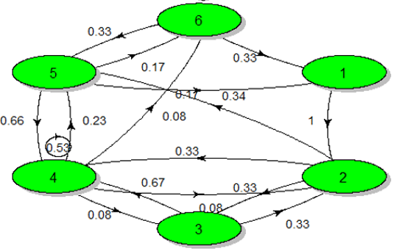

1. Bayelsa

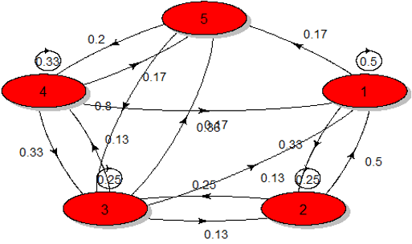

1. Rivers

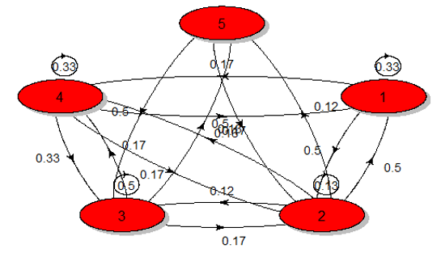

1. Cross River

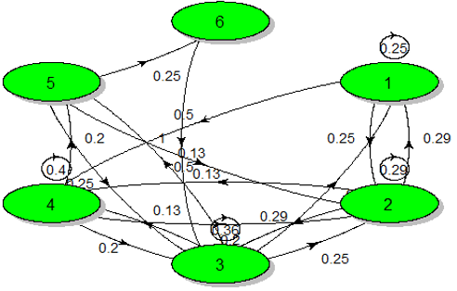

1. Edo

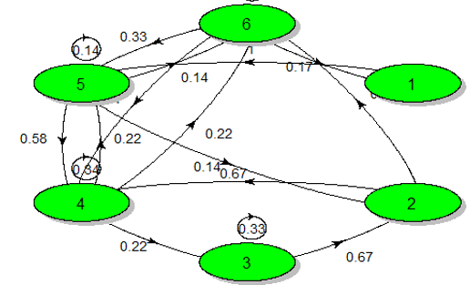

1. Delta

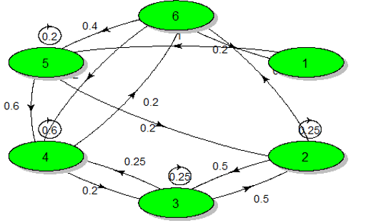

Figure 4: Pictorial representation of the Markov Chain transition probabilities over study locations.

The transition diagram is a single weighted directed graph, where each vertex represents a state of the Markov chain and there is a directed edge from vertex *j* to vertex *i* if the transition probability P*ij* >0; this edge has the probability of P*ij*. States 1: Wet, 2: Moderately wet, 3: Slightly wet, 4: Near normal, 5: Slightly dry, 6: Moderately dry, occurred in Edo, Delta and Akwa Ibom; States 1: Wet, 2: Moderately wet, 3: Slightly wet, 4: Near normal, 5: Slightly dry in Rivers; States 1: Moderately wet, 2: Slightly wet, 3: Near normal, 4: Slightly dry, 5: Moderately dry in Bayelsa and lastly, States 1: Moderately wet, 2: Slightly wet, 3: Near normal, 4: Slightly dry, 5: Moderately dry, 6: Dry in Cross River (Figure 4).

The loop from state 4 to state 4 has probability 0.53 for Akwa Ibom and 0.60 for Delta while the edge from state 3 to state 4 has probability 0.67 for Akwa Ibom and 0.60 for Delta. An edge sequence of length n is an ordered sequence of edges e*1*, e*2*, …, e*n*, where e*i* and e*i*+1 are adjacent edges for all i = 1, 2,…, n-1 and the probability of an edge sequence equals a product of the probabilities of its edges. The loop from state 2 to state 2 has probability 0.29 for Cross River and the edge from state 1 to state 2 has probability 0.29 while the loop from state 1 to state 1 has probability 0.50 for Bayelsa and the edge from state 2 to state 1 has probability 0.50. Lastly, the loop from state 4 to state 4 has probability 0.34 and the edge from state 2 to state 4 has probability 0.67 for Edo (Figure 4).

The system keeps bouncing from one state to another state as presented by the simulated trajectories in Figure 5. It was observed that the system bounces from 1 to 5 or 6 and back indefinitely across all the South-South states in Nigeria. The unconditional probability vectors plot against step over study locations (Figure 6) depicts the various probabilities associated with the Markov Chain seven states (1: Wet, 2: Moderately wet, 3: Slightly wet, 4: Near normal, 5: Slightly dry, 6: Moderately dry and 7: Dry), albeit with some oscillation in the case of certain states. In the case of Akwa Ibom, the probabilities associated with state 4 and 2 rises gradually and reaches 0.48 and 0.28 before step 10, whereas the other states all level off before 0.5 as presented in Figure 6(a) indicating that there is a 48% chance of precipitation amount been normal on any given year regardless of previous weather conditions. Also, there is a 33%, 38%, 33%, 35% and 38% chance of precipitation amount been normal in Bayelsa, Edo, Rivers, Cross river and Delta respectively regardless of any previous Markov chain states. Unconditional probability plays a crucial role in determining the stationary distribution of a Markov chain.

1. Akwa Ibom

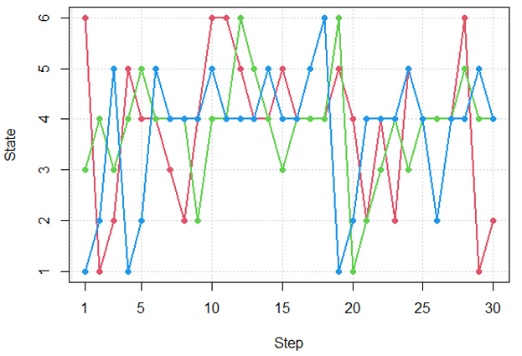

Bayelsa

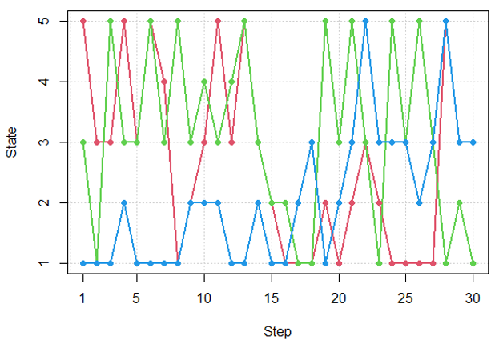

1. Rivers

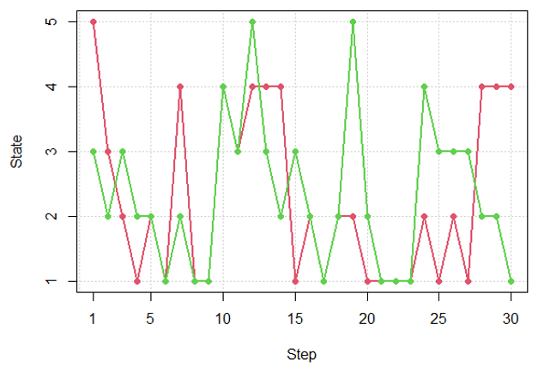

1. Cross River

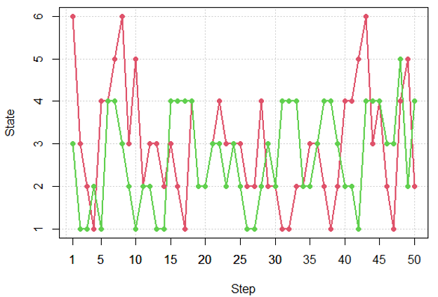

1. Edo

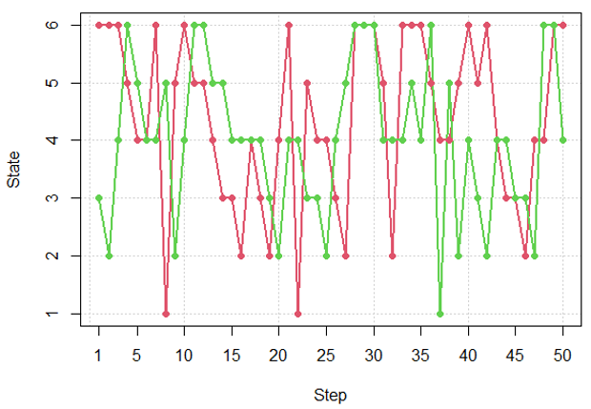

1. Delta

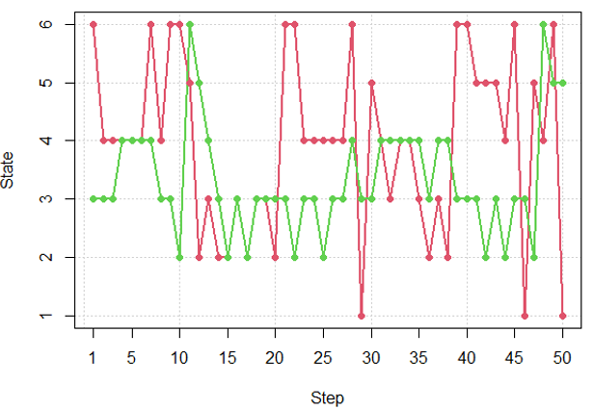

Figure 5: Simulated trajectories of the Markov Chain

1. Akwa Ibom

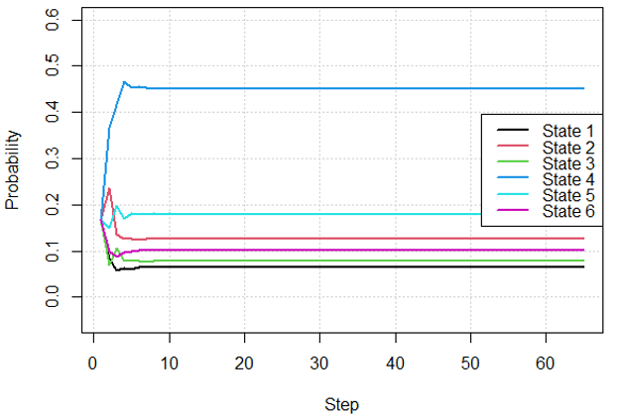

1. Bayelsa

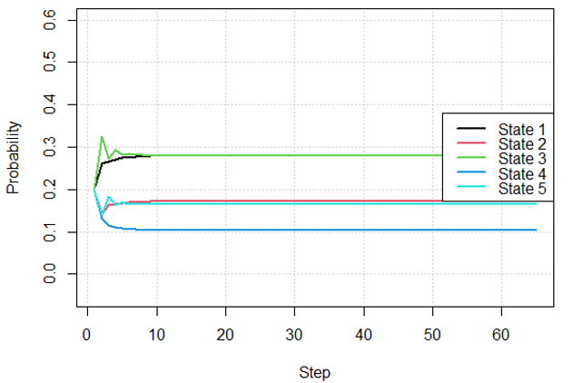

1. Rivers

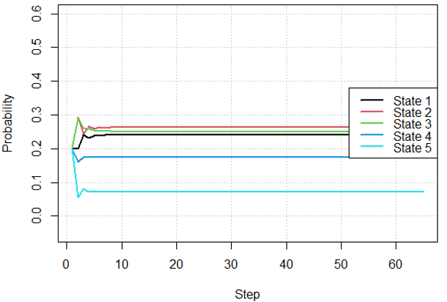

1. Cross River

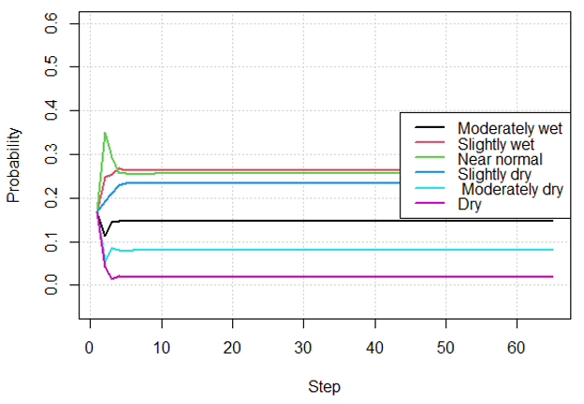

1. Edo

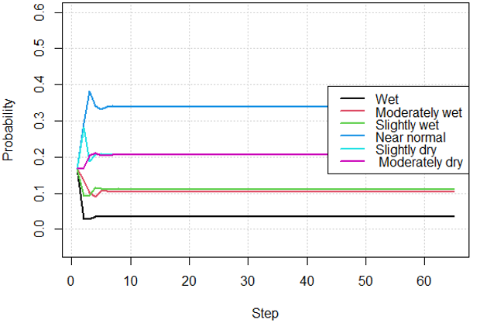

1. Delta

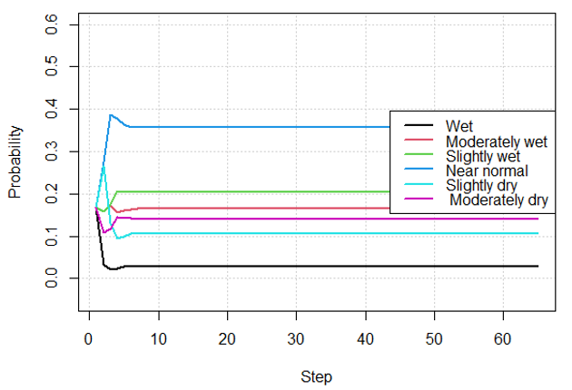

Figure 6: Unconditional probability vectors plot against Step over study locations.

4. Conclusion

This research has revealed that precipitation amount varies yearly across study locations in the South-South region of Nigeria. Findings from this work shows major positive departure in Rivers state compared to other South-South states indicating extreme precipitation amount yearly. The transition probabilities of precipitation in any states transiting into state 1(wet) is very low across study locations. The seven-state Markov chain observed in this study depict that even though the South-South region experience heavy rainfall almost throughout the year because of its location in rain forest, the region still experience dry spell. Proper applications of the results from this work would help organizations, farmers and government in future planning and policy formulations because of its influence on agricultural activities and other aspects of human lives.

References

[1] R. B. Stull “An Introduction to Boundary Layer Meteorology” Kluwer Academic Publisher Dordrecht 1988. https://doi.org/10.1017/50016756800022433

[2] M. H. I. Dore “Climate change and changes in global precipitation patterns” Environment International 31 (2005) 1167-1181. https://doi.org/10.1016/j.envint.2005.03.004

[3] P. Y. Groisman, R. W. Knight, D. R. Easterling, T.R. Karl, G. C. Hegerl, & V. N. Razuvaev “Trends in intense Precipitation in the Climate Record” American Meterorological Society (2005) 1326-1350. https://doi.org/10.1175/JCLI3339.1

[4] M. Tettey, F. T. Oduro, D. Adedia, & D. A. Abaye “Markov Chain analysis of the rainfall patterns of five geographical locations in the South Eastern coast of Ghana” Earth Perspectives.4(2017) 1-11. https://doi.org/10.1186/s40322-017-0042-6

[5] S.W. Duan, & S. S. Kaushal “Warming increases carbon and nutrient flux­es from sediments in streams across land use” Biogeosciences 10 (2013) 1193–1207. https://doi.org/10.5194/bg-10-1193-2013

[6] A. A. Sabziparvar, S. Movahedi, H. Asakereh, Z. Maryanaji & S. A. Masoodian “Geographical factors affecting variability of precipitation regime in Iran” Theoretical and Applied Climatology 120 (2015), 367–376. https://doi.org/10.1007/s00704-014-1174-3

[7] G. F. Lin, M. J. Chang, & J. T. Wu “A hybrid statistical downscaling method based on the classification of rainfall patterns” Water Resources Management 31(2017) 377–401. https://doi.org/10.1007/s11269-016-1532-2

[8] A. Gupta, T. Kamble & D. Machiwal “Comparison of ordinary and Bayesian kriging techniques in depicting rainfall variability in arid and semi-arid regions of north-west India” Environmental Earth Sciences 76 (2017) 512. https://doi.org/10.1007/s12665-017-6814-3

[9] H. A. Haines & J. M. Olley “The implications of regional variations in rainfall for reconstructing rainfall patterns using tree rings” Hydrological Processes 31(2017) 2951–2960. https://doi.org/10.1002/hyp.11238

[10]R. Y. Adam “Stochastic Model for Rainfall Occurrence Using Markov Chain Model in Kurdufan State, Sudan” American Scientific Research Journal for Engineering, Technology, and Sciences (ASRJETS) 17 (2016) 272-286. https://asrjetsjournal.org/index.php/American_Scientific_Journal/article/view/1454

[11] P. O. Agada, I. O. Agada, & W. D. Annongu “A Model for the Sequence of Positive and Negative Maximum Air temperature Anomaly in Port Harcourt, Nigeria” Int. J. Comp. Theo.Stat. 3 (2016)101-110. https://journals.uob.edu.bh/IJCTS/about

[12] M. A.Raheem, W. B. Yahya, & K. O.Obisesan “A Markov Chain Approach on Pattern of Rainfall Distribution” Journal of Environmental Statistics 7(2015) 1-13.http://www.jenvstat.org

[13] N.W. Junker, R. Grumm, R. Hart & L. Bosart, “Use of Normalized Anomaly Fields to Anticipate Extreme Rainfall in the Mountains of Northern California” Weather and Forecasting 23 (2008). https://doi.org/10.1175/2007WAF2007013.1

[14] R. H. Grumm & R. Hart “Standardized Anomalies Applied to Significant Cold Season Weather Events: Preliminary Findings” Weather and Forecasting 16(2001) 736-754. https://doi.org/10.1175/1520-0434(2001)016<0736:SAATSC>2.0.CO;2

[15] S. Ross “Introduction to Probability Models” Academic Press California, 10th edition, (2010).

[16] H. Balzter “Markov chain models for vegetation dynamics” Ecological Modelling 126(2000) 139-154. https://dx.doi.org/10.1016/S0304-3800(00)00262-3

[17] A. Udom, “Element of Applied Mathematical Statistics” ICIDR Publishing House (2010).