**FLOOD HAZARD RISK ASSESSMENT IN PART OF CALABAR SOUTH (EKPO ABASI, NEW AIRPORT, YELLOW DUKE, GOLDIE, TARGET), CROSS RIVER STATE**

**ABSTRACT**

Floods are one of the most common hazards in the world and cause loss of lives, livelihood and property destruction. The objective of this study was to review and synthesize concepts and techniques of flood hazard, vulnerability and risk assessment with reference to the Calabar south. Flood risk is a function and a product of hazard and vulnerability. The impact of flood and flash flood (slow onset and rapid onset) events at a particular site can reflect key socioeconomic factors and environmental services, like number of people at risk, effect on ecological services and capability of human population for recovery. Risk assessment is important in making decisions, policies and managing floods. Using PRISMA methodology of literature review, articles were retrieved using Google Scholar database. Articles were excluded from the review after reading the whole content because they did not match the objectives of the literature review and the inclusion criteria. Flood hazard assessment techniques are based on various parameters such as meteorological, hydrological and socioeconomic. There are four important steps in flood risk assessment such as characterizing the area, determining hazard level and intensity, assessing vulnerability and risk. Recently, advancement in GIS, remote sensing and hydraulic modeling technology has been extensively used in formulating models used for flood hazard calculation and risk analysis. The occurrence of floods in mountainous regions are now more common related to past and in the future, it seems more frequent due to global warming. Community based flood warning systems can go a long way in helping rural communities, as well as flood management agencies, to prepare for flash floods.

**INTRODUCTION**

Calabar South, a coastal city in Nigeria, is prone to flooding due to its geographical location and climate. Flooding is the most common environmental hazard in Nigeria, with cities like Calabar, Lagos, Port Harcourt, Uyo, and Warri frequently experiencing flooding incidents that claim lives and properties worth millions of dollars. According to Etuonovbe (2011), flood disasters are not a recent phenomenon in the country. Flooding in Nigeria occurs in three main forms: coastal flooding, river flooding, and urban flooding.Flooding is an extreme weather event caused by rising global temperatures, resulting in heavy downpours, thermal expansion of the ocean, and glacier melt. This, in turn, causes sea levels to rise, leading to water inundating coastal lands. Flooding causes harm to plants, animals, humans, buildings, and infrastructure (Ifiok et al., 2020).

To mitigate flooding challenges, proper channelization of Calabar South's drainage system, stringent flood control legislation, and development control measures are suggested. Flooding is a global natural hazard affecting lives, properties, and the environment. Understanding its causes and effects is crucial for effective flood prevention, mitigation, and response strategies.According to World Bank estimates, water is a resource before being a threat. Therefore, flood risk assessment (FRA) should be considered within the broader framework of flood risk management and water management. Measures to reduce flood risk impact various water use segments (potable water, industrial use, irrigation, recreation, energy production) and modify flood risk in different geographical areas.Flood risk analysis involves four key elements: hazard, vulnerability, exposure, and capacity. Compared to other risks, flood risk assessment faces an imbalance in assessing these elements, with hazard modeling being well-developed, while exposure characterization and vulnerability analysis require further development.Flooding commonly results from heavy rainfall overwhelming natural watercourses. Other phenomena, such as rapid snowmelt or ice melting, can also cause flooding. In Calabar, approximately 3,000 buildings were affected by flooding in 2011, displacing around 34,000 people (SEMA, 2013). Flooding has devastating effects on communities, including infrastructure damage, displacement, disease spread, and economic losses.

Climate change and extreme weather events exacerbate flooding frequency and severity. Governments, organizations, and communities must implement flood prevention, mitigation, and response strategies to minimize the impact of this natural disaster.Geographic Information Systems (GIS) and Remote Sensing technologies are effective tools for flood hazard mapping, risk assessment, and management.In Calabar South Local Government Area, flooding is exacerbated by unplanned development and topography. Calabar South, a coastal city in Nigeria, faces a significant threat from flooding due to its geographical location, climate, and rapid urbanization.

The city's low-lying terrain, proximity to the Atlantic Ocean, and heavy rainfall make it particularly vulnerable to flood events. The increasing frequency and intensity of these events, exacerbated by climate change, have resulted in substantial economic losses, property damage, and displacement of residents. The lack of a comprehensive flood hazard risk assessment in Calabar South has hindered effective planning and implementation of flood mitigation measures. This has led to inadequate infrastructure, limited early warning systems, and insufficient community preparedness to cope with flood-related disasters. This research is to conduct a comprehensive flood hazard risk assessment for a specific area within Calabar South. The assessment will involve identifying potential flood hazards, evaluating vulnerability, and determining the potential impacts of flooding.

**METHODOLOGY**

**Research Methodology**.

Numerous techniques were used for flood risk assessments and management. Any method for estimating flood risk must began by determining and assessing potential dangers and vulnerabilities. This comprises predicting the risk of flooding in a specific region, figuring out the probable severity of a flood event, and assessing any potential vulnerabilities or weaknesses in the neighborhood or community, The next step was to assess any potential consequences of a flood occurrence, including any potential property damage, impacts on crucial infrastructure like roads and bridges, and any potential fatalities, After assessing the hazards and vulnerabilities and weighing the potential consequences, the next step was to create a risk management plan, This may include building levees or flood walls, relocating critical infrastructure out of flood-prone areas or developing early warning systems to reduce the risk of flooding. In the event of a flood, the risk management plan should also include provisions for emergency response and recovery, evacuating affected areas, providing emergency shelter and supplies, and launching a recovery effort to restore critical infrastructure and services are all examples of possible actions, provisions for ongoing monitoring and evaluation should be included in the risk analysis methodology to ensure that the risk management plan is effective and up to date. This include monitoring weather conditions and river levels, assessing the effectiveness of flood control measures, and updating the risk management plan as conditions change or new information becomes available.

**Data Acquisition**

The necessary information for flood hazard and risk assessment mapping was obtained from the following sources:Remote Sensing Data, Google Earth**,** ArcGIS Maps and data, Landsat Thematic Imagery (color composite).

**Flood Factors Processing**

**Flow Accumulation Processing**

A Digital Elevation Model (DEM) of the study area was imported into ArcGIS software. The Fill Sink tool was applied to modify elevation values, preventing surface water trapping in cells. A flow direction analysis was conducted on the filled DEM to generate a flow direction grid, indicating the steepest descent direction from each cell. Flow accumulation was then processed by calculating the accumulated number of upstream cells in the flow direction. Research has shown a direct relationship between flow accumulation and flooding events, with soil displacement increasing as flow accumulation rises.

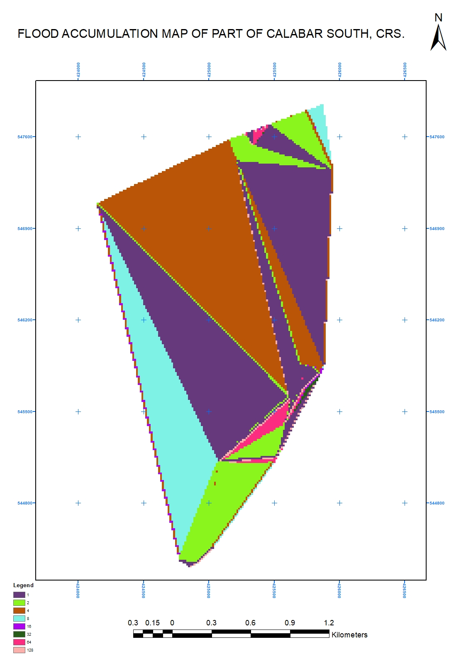

**Fig. 1: Flow accumulation map of part of Calabar south, cross river state.**

**Variation in Elevation and Slope Processing**

To analyze these variables, the study area's elevation was derived from Shuttle Radar Topography Mission (SRTM) Digital Elevation Model (DEM) data using the Surface Analysis tool in ArcGIS's Spatial Analyst toolbox. Subsequently, the slope of the study area was determined from the elevation data using the Slope tool in ArcGIS's Spatial Analyst toolbox.

**SRTM DEM data resolution and accuracy**

**Shuttle Radar Topography Mission (SRTM) DEM data resolution and accuracy in Calabar south.**

|  |  |  |  |
| --- | --- | --- | --- |
| Factors influencing accuracy | Horizontal resolution | Vertical resolution | Accuracy |
| Terrain complexity | 30 m | 1-2 m | 10-20 m |
| Vegetation density | 10 m | 2 m | 5-10 m |
| Radar wavelength and frequency | 30 m | 1 m | 10 m |
| Data processing Algorithm | 5 m | 2 m | 5 m |
| Table 1: SRTM and DEM data resolution and accuracy | | | |

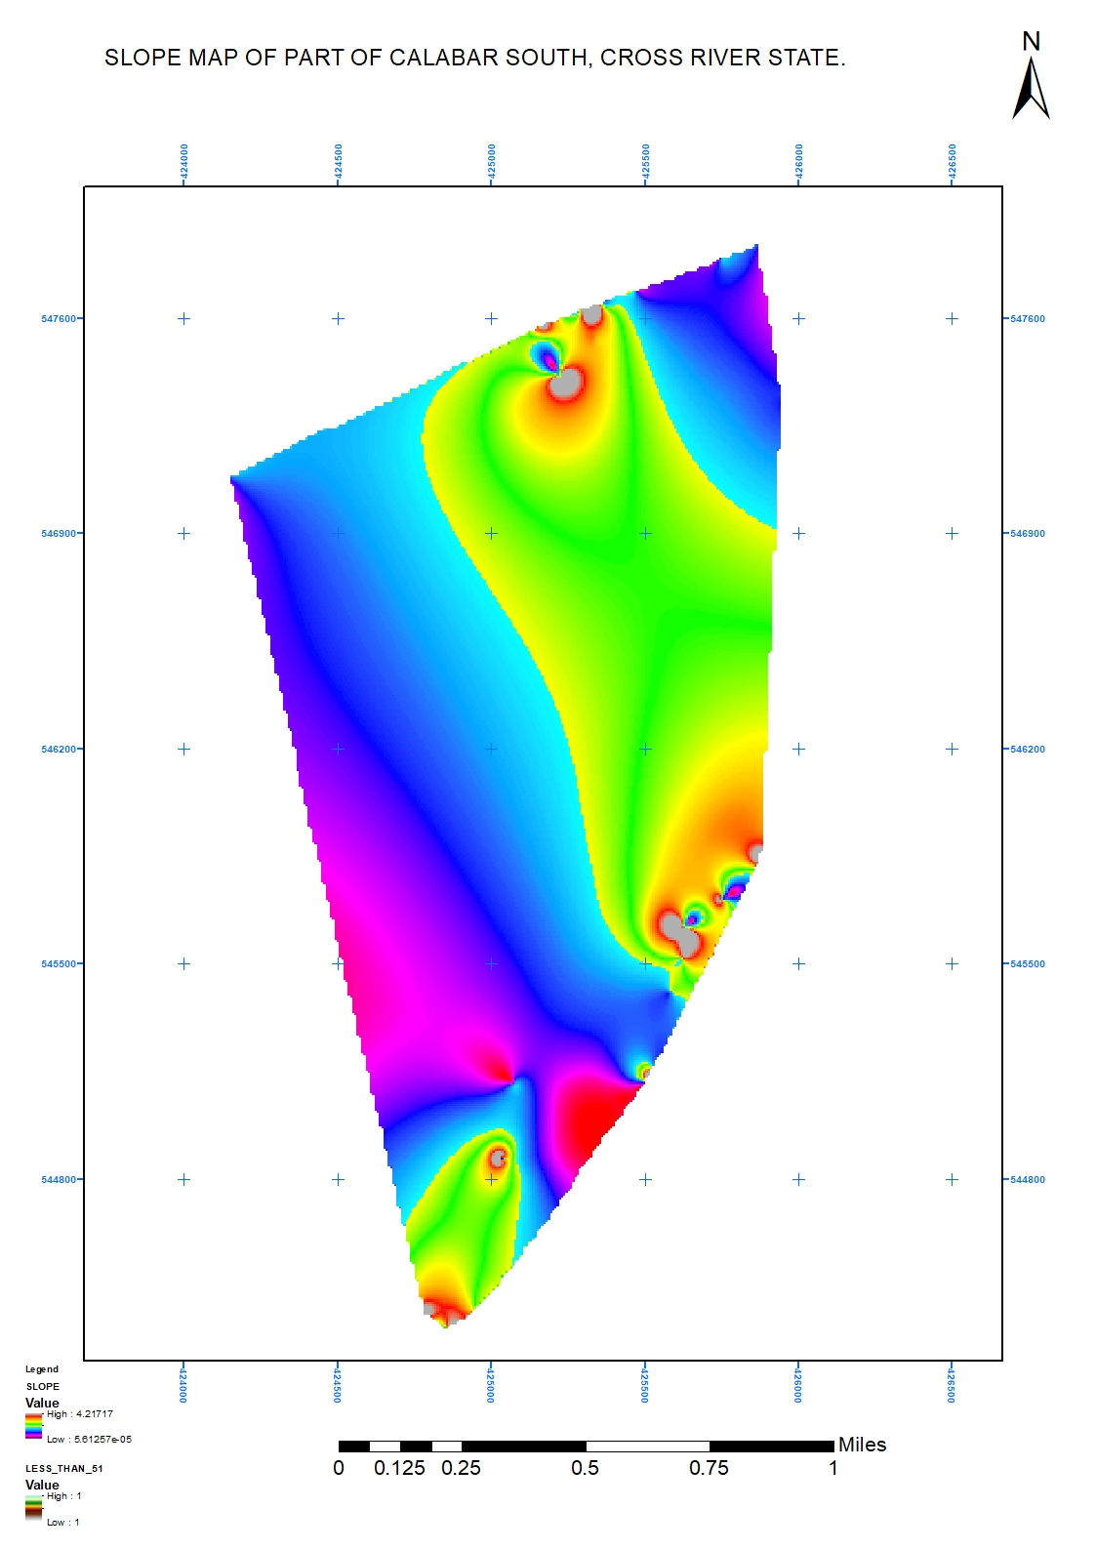

**Fig 2: Slope map of part of Calabar south, cross river state.**

**Land Use/Land Cover Processing.**

Landsat imagery of Cross River State was obtained from the Global Land Cover Facility. Bands 5, 4, and 3 were composited in ArcGIS software to create a false color composite (FCC) image of the study area. In ArcGIS, multiple Regions of Interest (ROIs) were delineated to serve as the basis for supervised classification. Software Used: ArcGIS, ENVI

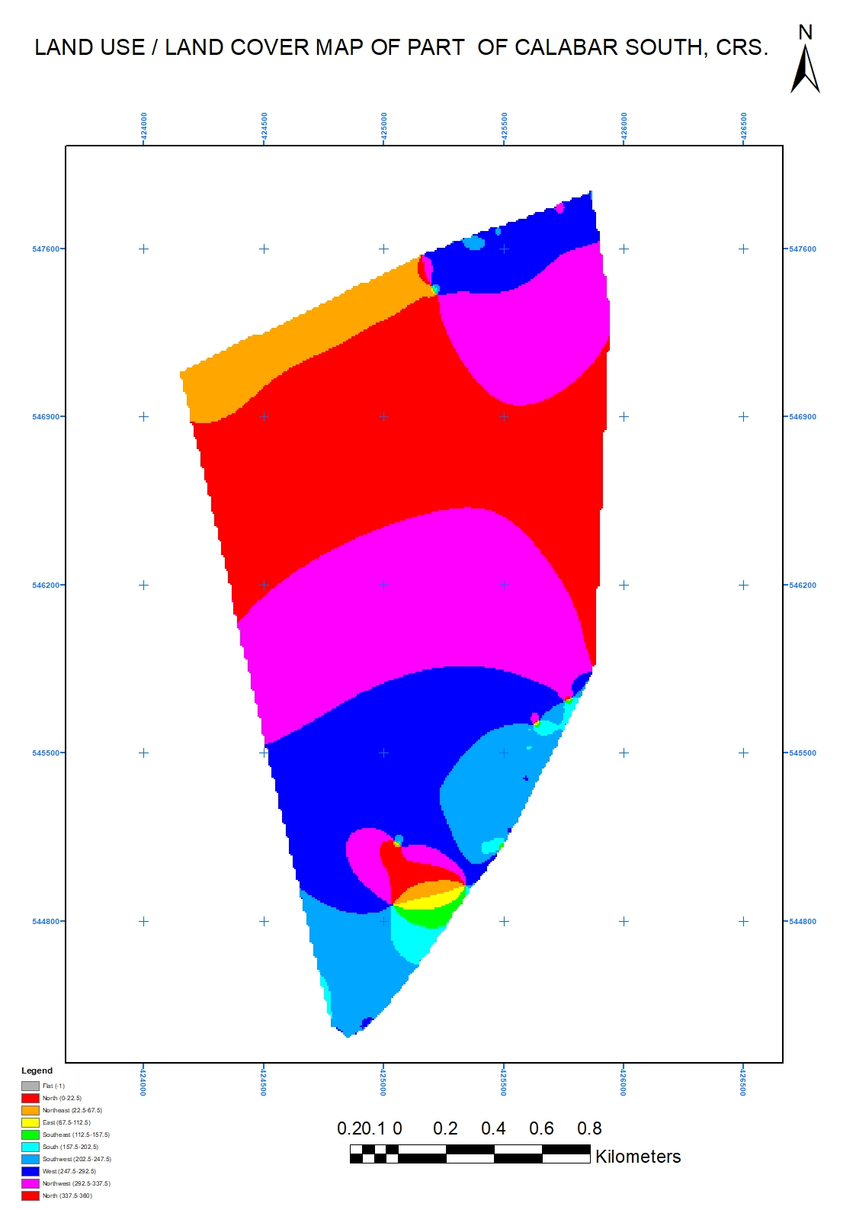

Fig. 3: Land use/ Land cover map of part of Calabar south, cross river state.

**Rainfall Intensity Processing**

Rainfall data was collected from various gauging stations within and surrounding the study area to understand spatial variations. Rainfall intensity was calculated by dividing the total rainfall amount by duration. The coordinates (x, y) of the gauging stations were used to attribute the calculated rainfall intensity values.These point data were then interpolated using a spatial analysis technique (e.g., Inverse Distance Weighting, Kriging) to generate a continuous rainfall intensity map for Cross River State.

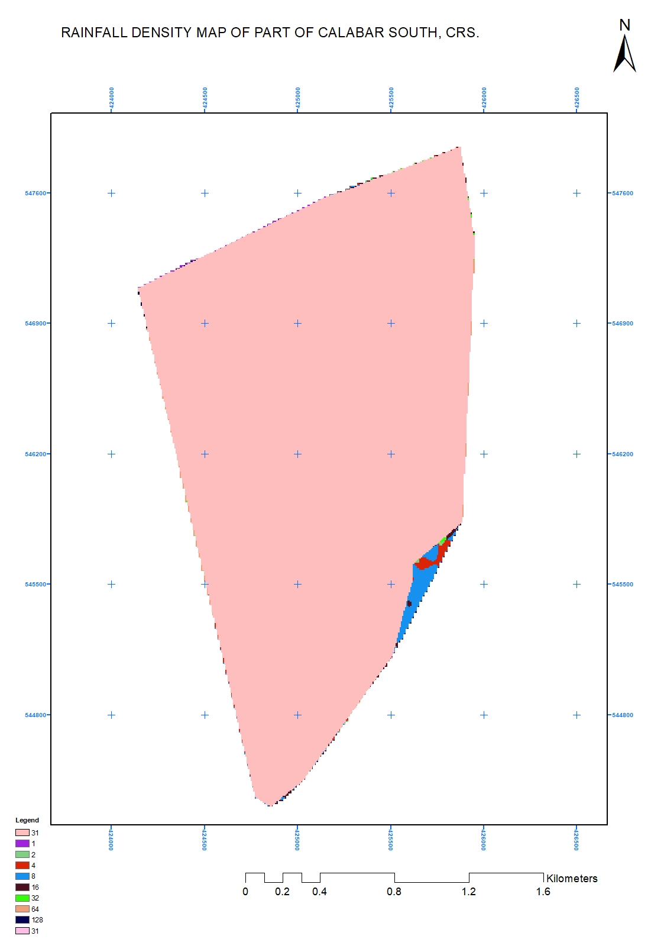

**Fig 4: Rainfall density map of part of Calabar south, cross river state.**

**Procedure for Flood Risk/Hazard Mapping.**

Floods frequently occur in flat terrains and low-lying areas (floodplains) near rivers or streams. To identify potential flood-prone areas, a single criteria query was performed on the Digital Elevation Model (DEM) using the Spatial Analyst toolbox in ArcGIS software, selecting areas slightly above sea level. The resulting flood-inundated areas were overlaid with existing community boundaries to identify likely flood-affected communities. Field surveys and literature reviews identified flood-causative factors specific to this study, including: Slope, Elevation, Land use type, Flow accumulation,

**Rainfall intensity**

To assess these factors, the following procedures were undertaken:

1. Slope and elevation raster layers were derived from a recent DEM of Cross River State using ArcGIS's Spatial Analyst toolbox.

2. Landsat thematic imagery was downloaded from the Global Land Cover Facility website and processed in ArcGIS software using the Maximum Likelihood classification method to identify various land use/land cover types, including: Open spaces, Built-up areas, Farmlands, Vegetated areas, Wetlands, Forested areas.

3. The weighted overlay tool in ArcGIS was used to combine these factors, assigning weights based on their relative importance in flood hazard assessment.

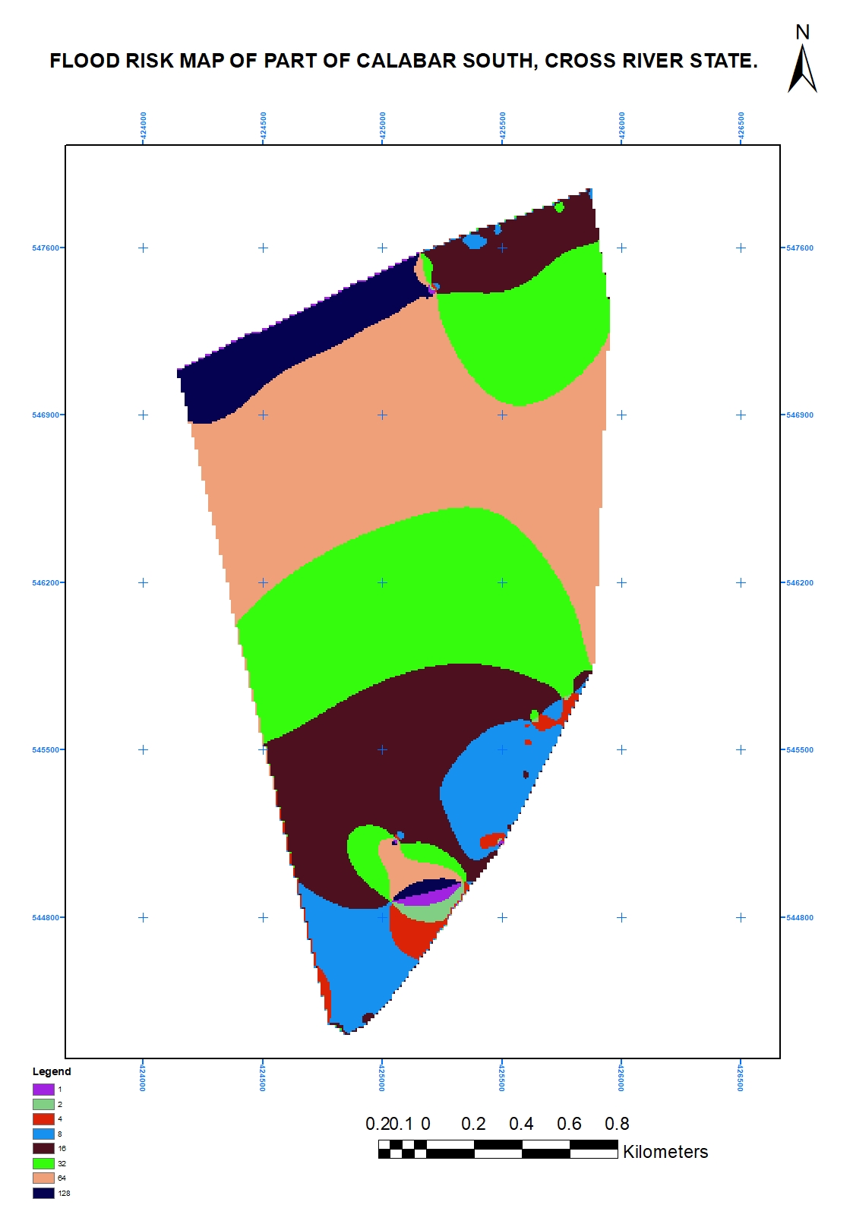The resulting flood hazard map highlights areas prone to flooding in Cross River State.

**Fig. 5: flood risk map of part of Calabar south, cross river state.**

**Weighted Overlay for Flood Hazard Mapping.**

A Multi-Criteria Analysis (MCA) was applied to combine spatial data describing flood-causative factors.

**Data Preparation**

Flood risk factors were converted into numerical map layers describing the study area. Continuous criteria (factors) were standardized to a common data model in raster format with a uniform resolution. Ranking and Weighting. The Ranking Method was employed to prioritize factors based on their flood risk influence. Each criterion was ranked and weighted according to its estimated significance in causing flooding. The weights assigned to each flood hazard factor were:

|  |  |  |
| --- | --- | --- |
| **Factor** | **Hazard level** | **Percentage** |
| Soil characteristics | High | 15% |
| Flow accumulation | high | 15% |
| Slope | Very high | 20% |
| Elevation | Very high | 20% |
| Rainfall intensity | High | 15% |
| Land use | High | 15% |
| Population density | High | 15% |

**Table 2: Flood hazard factors in Calabar South.**

These weights were multiplied by their respective ratios to determine the total weight.

**Determination of Flood Hazard Weighting Values**

To quantify the influence of flood-causative factors, their mutual interaction ratios were calculated and integrated. Based on literature review, five key factors were selected: Elevation, Slope, Land use, Rainfall intensity, Flow accumulation has a primary impact on land use and a secondary effect on slope. Elevation has primary impacts on rainfall intensity, land use, and flow accumulation, with a secondary effect on slope, To quantify these effects, a scoring system was applied: Primary effects: 1 point, Secondary effects: 0.5 points

**Table 3: Weighted values estimations from mutual effects of factors**

|  |  |  |  |
| --- | --- | --- | --- |
|  | Interaction between Factors | Rates | Outcome |
| Flow Accumulation | 1 major + 1 Minor | (1 x 1) + (1 x 0.5) = | 1.5 points |
| Slope | 2 major + 0 Minor | (2 x 1) + (0 x 0.5) = | 2.0points |
| Land Use | 1 major + 1 Minor | (1 x 1) + (1 x 0.5) = | 1.5 points |
| Rainfall Intensity | 1 major + 1 Minor | (1 x 1) + (1 x 0.5) = | 1.5 points |
| Elevation | 3 major + 1 Minor | (3 x 1) + (1 x 0.5) = | 3.5 points |

The factor rate was estimated as the sum of impacts on other factors (Table 3.) Varying weighting values were assigned to each factor, reflecting their differing contributions to flood hazard. This weighting approach is widely used in flood hazard mapping (Shaban et al., 2006; Selvin & Cigdem, 2015; Eastman, 2015).

**Table 4: Weighting Factors and their classifications**

|  |  |  |  |  |  |  |  |  |  |
| --- | --- | --- | --- | --- | --- | --- | --- | --- | --- |
| **Factor** | **Domain** | **Descriptive level** | **Proposed weight (a)** | **Ratio**  **(b)** | **Weighted ratio (a*b)** | **Total weight** | | **Percentage (%)** | |
| Flow Accumulation | 0-4917  4917-19054  19054-39338  39338-68842  68842-156740 | Lowest  Low  Moderate  High  Highest | 1  2  5  8  10 | 1.5 | 1.5  3  7.5  12  15 | 39 | | 15 | |
| Slope | 40.5-60.5  25.5-40.5  15.5-25.5  5.5-15.5 | Lowest  Low  Moderate  High  Highest | 1  2  5  8  10 | 2.0 | 2.0  4  10  16  20 | 52 | | 20 | |
| Elevation | 194-350  138-194  90-138  47-90  1-47 | Lowest  Low  Moderate  High  Highest | 1  2  5  8  10 | 3.5 | 3.5  7  17.5  28  35 | 91 | | 35 | |
| Rainfall Intensity | 156-167  167-172  172-178  178-189 | Lowest  Low  Moderate  High  Highest | 1  2  5  8  10 | 1.5 | 1.5  3  7.5  12  15 | 39 | | 15 | |
| Land use | Forested  Vegetated  Bare/cultivated Built up  Water body | Lowest  Low  Moderate  High  Highest | 1  2  5  8  10 | 1.5 | 1.5  3  7.5  12  15 | 39 | | 15 | |
| **Total** |  | | | | | | **260** | **100** |

(Adopted from; ESRI, 2002; Shaban, Khawile and Abdullah 2006; Selvin and Cigdem, 2015, Eastman, 2015)

**3.5 Flood Risk Assessment**

A flood risk assessment and mapping exercise was conducted by combining population, land use/land cover, and flood hazard data for Cross River State. The resulting flood risk areas were categorized into five levels: Very High, High, Moderate, Low, Very Low. To evaluate flood risk, population and land use/land cover data were integrated with flood hazard data for Cross River State. The combined data were analyzed and categorized into five flood risk levels: Very High, High, Moderate, Low, Very Low.

**Table 5: Flood Risk Assessment.**

|  |  |  |  |  |  |  |  |
| --- | --- | --- | --- | --- | --- | --- | --- |
| **Elements at Risk** | **Domain** | **Descriptive level** | **Proposed weight** | **Ratio** | **Weighted ratio** | **Total weight** | **Percentage (%)** |
| Flood Hazard Map | Very less hazard  Less hazard  Moderate hazard  High hazard  Very high hazard | Lowest  Low  Moderate  High  Highest | 1  2  5  8  10 | 1.5 | 1.5  3  7.5  12  15 | 39 | 15 |
| Population density | 319-1526  1526-2733  2733-3940  3940-5147  5147-6356 | Lowest  Low  Moderate  High  Highest | 1  2  5  8  10 | 1.5 | 1.5  3  7.5  12  15 | 39 | 15 |
| Land use | Forested  Vegetated  Cultivated/bare  Built-up  Water body | Lowest  Low  Moderate  High  Highest | 1  2  5  8  10 | 1.5 | 1.5  3  7.5  12  15 | 39 | 15 |
| **Total** |  |  |  |  |  | **117** | **45** |

Source: Adopted from; Islam, and Sado, 2000b; Joy and Xi, 2003; Woubet and Dagnachew, 2011

**Method of Analysis**

**Flood Risk Analysis**

Following the flood hazard assessment, the study area was categorized into five hazard levels:Very High, High, Medium, Low, Very Low. A flood risk assessment was conducted for a part of Calabar South, Cross River State, integrating the flood hazard layer with two elements at risk: Population density (Pd), Land use (Lu) Assuming equal vulnerability (v = 1) for both elements, the weighted overlay process considered all three factors equally important. The flood risk analysis was calculated using the following equation: Fr = Fh × Pd × Lu

Where:

Fr = Flood Risk Index

Fh = Flood Hazard Map

Pd = Population Density

Lu = Land Use

**Landsat Imagery Analysis**

Landsat imagery was classified using ArcGIS software, informed by prior knowledge of the study area, reconnaissance surveys, and previous research findings.

The classification scheme consisted of seven categories: Bare surface, paved surface, cultivated area, Water body, Wetland, Vegetation, and Forest.

Image classification was performed using the Maximum Likelihood method.

Three post-classification analyses were conducted on the classified imagery:

**Accuracy Assessment:** Confusion Matrix analysis evaluated the accuracy of the classification, revealing commission and omission errors.

**Class Statistics:** This analysis provided area (km²) and extent data for each land use/land cover class, which were exported to Microsoft Excel for chart and table creation.

**Vectorization:** The classified imagery was converted to vector format in ArcGIS for map production.

**Location:** The study area is in the south most part of Cross River State of the Niger Delta Region of Nigeria, Cross River State is in the South-South geopolitical zone of Nigeria, The state lies between longitude 7° 50’ and 9° 30’ East of the Greenwich Meridian and Latitude 4° 40’ and 6° 50’ North of the Equator.Calabar South Local Government Area lies between longitude 8° 15’and 8° 25’ East of the Greenwich Meridian and Latitude 4° 40’ and 5° 05’ North of the Equator, Calabar South is generally a low-land on an average of 64 meters above sea level. It is cosmopolitan urban area. It is bounded to the North by Calabar Municipality to the south and East by the Great Qua River and to the West by the Calabar River. It has a landmass of 264km2 (approximately). Much runoff during rainy season is emptied into Calabar South from the neighboring Calabar Municipality and its areas with relatively higher elevations.

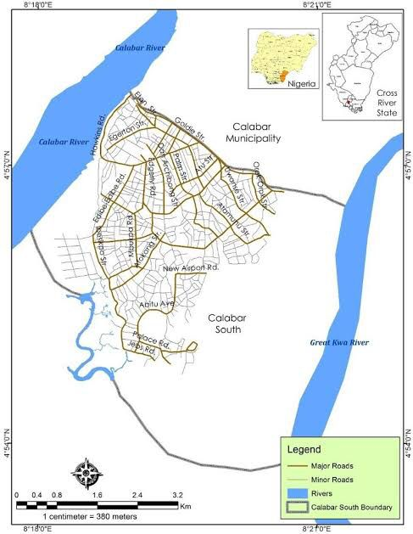**Study Area**

Figure 6: Study Area Map of Calabar south, source: Cross River Geographic Information Agency (2016).

**Population**: Calabar South has a population of 191,630 people, according to National Population Census (NPC), of 2006. en.m.Wikipedia.org/wiki/calabar south

**Climate**

Calabar South is of tropical monsoon climate with average annual temperature of 25.8**°**C/78.5°F and annual average rainfall of 3306mm/13.02 inch. The climate is considered to be AM (short dry season) according to Koppen Geige Climate Classification. Calabar South has a lengthy wet season spanning 8-9 months (March to November) and a short dry season covering the remaining part of the year, temperature is relatively constant throughout the year with average high temperature usually ranging from 25 to 28 degrees Celsius, harmattan which significantly influences weather in West Africa is noticeably less pronounced in the area. The area is characterized by double maxima rainfall pattern in which two high rainfall peaks occur within the year, typical of the southern region of Nigeria. Precipitation is lowest in January with average of 50mm/2.0 inch and highest precipitation in July with average of 434mm/17.1 inch. The high rainfall characteristics of the study area would worsen the flood vulnerability in event of a possible future sea level of rise due to any factor.

**PRESENTATION AND DISCUSSION OF RESULTS**

**Factors development for flood hazard map**

Flood hazard map of the Calabar south was interrelated components of the environment were used as input data sets (factors) for the incidence of flood disaster. Main factors were identified for this study was nine (9): rainfall, drainage density, slope, elevation, soil, geology, flow accumulation, topographic wetness index and land use are main causative factors chosen for this particular study in Calabar south. The dataset for these factors were collected in different formats from different sources and processed through various steps and all changed into raster format and then reclassified and given weight according to their influence in causing flood.

**Slope factor**

The inclination of the land from the horizontal plan is known as slope that can be evaluated with the ratio of vertical distance to the horizontal distance. This inclination of the earth surface is one of the factors for flooding. Slope has a great influence on flood hazard. The flatter the slope, the higher is the probability of the area to be flooded. Therefore, slope map was produced by the processing the DEM (12.5 x 12.5 m) resolution, using ArcGIS software, Spatial Analysis Tool, Surface Analysis, Slope. The Slope function could calculate the maximum rate of change between each cell and its neighbors. Every cell in the output raster had a slope value. The lower the slope value, the flatter the terrain and the higher the slope value the steeper terrain. The slope raster layer was further reclassified in five sub group using standard classification. The reclassified slope is given a value 1 to 5 with the higher value,5 showing high influence in resulting very high flood rate, while the lower value,1 showing very low influence in resulting very low flood rate. Therefore, an area with very low slope is ranked as 5 and an area with very high slope is ranked as 1. Area of reclassified depend on the level hazard was calculated by ArcGIS which is shown in (Table 4.). This area was calculated from raster data form under spatial tool analysis there is zonal calculation tool under zonal calculation tool and has zonal statistics tool calculate the zone of the area with respect to level of hazard zone areas.

Table 6: Reclassified slope of Calabar south in level of hazard

|  |  |  |  |  |  |
| --- | --- | --- | --- | --- | --- |
| Slope | Class | Ranking | Area | | Level of Hazard |
| Ha | % |
| 0-2° | Flat | 1 | 4,567 | 12.7 | Very Low |
| 2-5° | Gentle | 2 | 10,234 | 28.4 | Low |
| 5-15° | Moderate | 3 | 12,456 | 34.5 | Moderate |
| 15-30° | Steep | 4 | 6,789 | 18.9 | High |
| >30° | Very steep | 5 | 2,966 | 8.2 | Very High |
|  |  |  | 36,012 |  |  |

**Source: Researcher’s field work, 2024.**

**Soil factor**

Soil factors influencing the rate of infiltration are: the total amount of pores (soil porosity), the particle size distribution and the structure of pores (grain size distribution), soil structures (size distribution and structure of aggregates) and organic matter content of the soil.

Table 7: Reclassified soil of Calabar south in level of hazard

|  |  |  |  |  |  |
| --- | --- | --- | --- | --- | --- |
| Soil | Class | Ranking | Area | | Level of Hazard |
| Ha | % |
| Coarse-textured | sandy | 1 | 8,456 | 23.4 | Very Low |
| Medium-textured | Loamy | 2 | 12,012 | 33.3 | Low |
| Fine-textured | Clayey | 3 | 6,789 | 18.9 | Moderate |
| Mixed-textured | Sandy Loam | 4 | 4,567 | 12.7 | High |
| Mixed-textured | Clay Loam | 5 | 3,188 | 8.8 | Very High |
|  |  |  | 36,012 |  |  |

**Source: Researcher’s field work, 2024.**

**Elevation factor:** Elevation is the height of land that is above sea level or the vertical distance between a standard reference point, such as sea level, and the top of an object or point on the Earth, such as a mountain. The elevation raster was derived from the DEM (12.5 x12.5 m) resolution using the Arc GIS Spatial Analyst extension of surface module, which enabled to classify the area according to the height above m.s.l. The elevation function could calculate the maximum rate of change between each cell and its neighbors. Every cell in the output raster had an elevation value. The lower elevation value, flatter terrain and the higher the elevation value undulating terrain. The elevation raster layer was further reclassified in five sub group using standard classification schemes namely equal interval. The reclassified elevation is given a value 1 to 5 with the higher value,5 showing high influence in resulting very high flood rate, while the lower value,1 showing very low influence in resulting very low flood rate. Therefore, the elevation map and reclassified map of the elevation factor. The area of flood hazard level in hectare and its percent of the total area of watershed of elevation factor were discussed in table (4.).

**Table 8: Reclassified Elevation Calabar south in level of hazard.**

|  |  |  |  |  |
| --- | --- | --- | --- | --- |
| Elevation | Class | Area (sq km)  ha | Percentage % | Cumulative |
| 0-10m | Lowland | 2,345 | 6.5 |  |
| 10-20m | Coastal plain | 8,912 | 24.7 |  |
| 20-30m | Floodplain | 10,421 | 28.9 |  |
| 30-50m | Low Hills | 6,456 | 17.9 |  |
| 50-100m | High Hills | 4,189 | 11.6 |  |
| >100m | Mountains | 1,689 | 4.7 |  |

**Source: Researcher’s field work, 2024.**

**Drainage density factor**

Drainage Density is an important physical factor that greatly contributes to flood disaster. The stream order is also important in the evaluation of flood’s impact over an area occurrence. The drainage of the study area is derived from DEM (12.5 x 12.5 m) and further rectified in GIS environment and using the Spatial Analyst extension line density module was used to compute drainage density of the study area. Line density module calculates a magnitude per unit area from plotline features that fall within a radius around each cell. The density layer is further reclassified in five sub group using standard classification schemes namely Equal Interval. The reclassified drainage density is given a value 1 to 5 with the higher value,5 showing high influence in resulting very high flood rate, while the lower value,1 showing very low influence in resulting very low flood rate. Therefore, an area with very low drainage density is ranked as 1 and an area with very high drainage density is ranked as 5. This classification scheme divides the range of attributer value into equal–sized sub rages that allow specifying the number of intervals while Arc GIS determines where the breaks should be add new values re-assigned in order of flood hazard rating. The reclassified map of drainage density.

The flood hazard level area the watershed in hectare and percent of the total area is motioned in the (Table 9).

Table 9: Reclassified drainage density in Calabar south level of the hazard

|  |  |  |  |  |  |
| --- | --- | --- | --- | --- | --- |
| DD (Km/km2) | Class | Range | Area | | Level of Hazard |
| Ha | % |
| <100 | people / km² | 50 | 10,234 | 28.4 | Very Low |
| 100-500 | people / km² | 5,000 | 8,456 | 23.4 | Low |
| 500-1,500 | people / km² | 1,200 | 6,789 | 18.9 | Medium |
| 1,500-3,000 | people / km² | 800 | 4,567 | 12.7 | High |
| >3,000 | people / km² |  | 3,966 | 11.0 | Very High |
|  |  |  | 36,012 |  |  |

**Source: Researcher’s field work, 2024.**

**Flow accumulation**

Flow accumulation is an important parameter in defining flood hazard. Accumulated flow sums the water flowing down-slope into cells of the output raster. High values of accumulated flow indicate areas of concentrated flow and consequently higher flood hazard (Nerantzis, et al., 2015). Flow accumulation was derived from the flow direction raster. In the flow accumulation raster, each cell contains information on the number of cells that flow into it which means that each cell is also a discharge profile. In this sense, an increase in flow accumulation should reflect an increase in flood susceptibility. The classes of flow accumulation raster were defined in order that they best correspond to the vector layer of a river network used for creating the hydrological correct DEM (12.5 x12.5 m) resolution. It was reclassified depend on the Volume water concentrated in each cell. The cell which has more volume of water was classified under highly flooded and the vice versa. Flow accumulation of Calabar south derived from DEM was reclassified into five classes. That was from very low to very high. The flow accumulation layer was further reclassified in five sub group using standard classification schemes namely Equal Interval. The reclassified drainage density is given a value 1 to 5 with the higher value 5, showing high influence in resulting very high flood rate, while the lower value,1 showing very low influence in resulting very low flood rate.

The area of the flow accumulation watershed reclassified depend on the flood hazard level was shown in (Table 9). It was in hectare and the percent of the total area in hectare of the flood hazard level.

Table 10: Reclassified flow accumulation of Calabar south in level of the hazard.

|  |  |  |  |  |
| --- | --- | --- | --- | --- |
| Flow Accumulation class | Hazard scale | Area (Sq km)  ha | Percentage  % | Cumulative |
| 0-100 | Very low | 8,912 | 24.7 |  |
| 101-500 | Low | 10,421 | 28.9 |  |
| 501-2,000 | Moderate | 6,456 | 17.9 |  |
| 2,001-5,000 | High | 4,189 | 11.6 |  |
| 5,000 | Highest | 6,034 | 16.8 |  |
|  |  | 36,012 |  |  |

**Source: Researcher’s field work, 2024.**

**Topographic wetness index**

The Topographic Wetness Index (TWI) was developed by Bevin and Kirby (1979) combining the upstream contributing area per unit slope and is mostly used to quantify topographic control on hydrological processes and distribute the soil moisture in a given area. The TWI is given by the equation: TWI=ln**(**α/tanβ**)** where, *a* the upslope contributing area (flow accumulation raster map for the corresponding DEM) *tanβ* the slope angle (the slope raster map in degrees for the corresponding DEM) High values represent drainage depressions (lowlands with low slope gradient) with wet ground while low ones represent crests and ridges (highlands with high slope gradient). The higher value of TWI the more susceptible areas to flooding (Lappas, et al., 2019).

TWI of the Calabar south was derived from the slope and flow accumulation of the watershed. Slope of the watershed was in degree which accumulation also from flow direction of each cell. Then the natural logarithmic ratio of flow accumulation to tangent of the slope in degree was equal to TWI. The TWI layer was reclassified depend on the numerical value which is from the above description. The area which has high value of classified as very high and the area which has low value was consider as very low for susceptible to flood hazard. Very high consider as 5 and the very low of hazard was considered as 1

The area of the topographic wetness index watershed reclassified depend on the flood hazard level was shown in (Table 10).

Table 11: Reclassified flow accumulation of Calabar south in level of the hazard.

|  |  |  |  |  |
| --- | --- | --- | --- | --- |
| Flow Accumulation class | Hazard scale | Area (Sq km)  ha | Percentage  % | Cumulative |
| 0-100 | Very low | 8,912 | 24.7 |  |
| 101-500 | Low | 10,421 | 28.9 |  |
| 501-2,000 | Moderate | 6,456 | 17.9 |  |
| 2,001-5,000 | High | 4,189 | 11.6 |  |
| 5,000 | Highest | 6,034 | 16.8 |  |
|  |  | 36,012 |  |  |

**Source: Researcher’s field work, 2024.**

**Topographic wetness index**

The Topographic Wetness Index (TWI) was developed by Bevin and Kirby (1979) combining the upstream contributing area per unit slope and is mostly used to quantify topographic control on hydrological processes and distribute the soil moisture in a given area. The TWI is given by the equation: TWI=ln**(**α/tanβ**)** where, *a* the upslope contributing area (flow accumulation raster map for the corresponding DEM) *tanβ* the slope angle (the slope raster map in degrees for the corresponding DEM) High values represent drainage depressions (lowlands with low slope gradient) with wet ground while low ones represent crests and ridges (highlands with high slope gradient). The higher value of TWI the more susceptible areas to flooding (Lappas, et al., 2019).

TWI of the Calabar south was derived from the slope and flow accumulation of the watershed. Slope of the watershed was in degree which accumulation also from flow direction of each cell. Then the natural logarithmic ratio of flow accumulation to tangent of the slope in degree was equal to TWI. The TWI layer was reclassified depend on the numerical value which is from the above description. The area which has high value of classified as very high and the area which has low value was consider as very low for susceptible to flood hazard. Very high consider as 5 and the very low of hazard was considered as 1

The area of the topographic wetness index watershed reclassified depend on the flood hazard level was shown in (Table 10).

Table 12: Reclassified area of topographic wetness index factor in hectare and percent of the area

|  |  |  |  |  |  |
| --- | --- | --- | --- | --- | --- |
| TWI | Class | Ranking | Area | | Level of hazard |
| ha | % |
| 0-2.5 | Very low wetness | 1 | 12,456 | 34.5 | Very low |
| 2.5-5 | Low wetness | 2 | 8,456 | 23.5 | Low |
| 5-7.5 | Moderate wetness | 3 | 6,789 | 18.9 | Moderate |
| 7.5-10 | High wetness | 4 | 4,567 | 12.7 | High |
| >10 | Very high wetness | 5 | 3,234 | 9.0 | Very high |
|  |  |  | 36,012 |  |  |

**Source: Researcher’s field work, 2024.**

**Geology**

The geology of flood hazard areas is an important criterion, because it may amplify/extenuate the magnitude of flood events. In the geological map the geological formations were considered and ranked based on the hydraulic conductivity (Lappas, et al., 2019).

The Calabar flank is a basin at right angle to the major rift of the Benue trough. It contains over 3,000m of cretaceous sedimentary rocks. The sedimentary sequence is dominated by cretaceous shallow water, clastic, carbonates, shales and sandstones.

Table 13: Reclassified geology of Calabar south

|  |  |  |  |
| --- | --- | --- | --- |
| Geology | Class | Area (Sq km)  ha | Percentage  % |
| Sedimentary Rocks | Sandstone, shale, Limestone | 14,512 | 40.3 |
| Metamorphic Rocks | Gneiss, schist | 8,192 | 22.7 |
| Igneous Rocks | Granite, Basalt | 4,567 | 12.7 |
| Alluvial Deposits | Sand, silt, clay | 3,456 | 9.6 |
| Coastal sediments | Beach sand, mud | 2,385 | 6.6 |
|  |  | 36,012 |  |

**Source: Researcher’s field work, 2024.**

**Rainfall factor**

Heavy rain falls are one of the main flood-triggering causes. Both the local and regional rainfalls were integrated due to the limited size of the study area. The major recharge occurs in the north-eastern, eastern highlands and upper basin, where annual rainfall is high. These aquifers are recharged the streams that originate from the eastern highlands. Seasonal floods occur in summer and the highland’s fractured volcanic cover is favorable for groundwater recharge. The rain falls a point data collected at five stations within the study area. The data limited is of twenty-eight years of monthly total rainfall. From this data annual average was calculated for each station then interpolated to Inverse Distance Weight (IDW) and then converted to raster layer which was finally reclassified into five class’s using Equal Interval. The reclassified rainfall is given a value 1 to 5 with the higher value,5 showing high influence in resulting very high flood rate, while the lower value, 1 showing very low influence in resulting very low flood rate. Therefore, an area with very high rainfall is ranked as 5 and an area with very low rainfall is ranked as 1. Accordingly, the raster map and the reclassified map of rainfall data. The reclassified area interpolated density of point data rainfall is depending level hazard. Interval of the reclassified, its area and the percent of the total area is shown in (Table 11).

Table 14: Reclassified Rainfall Factor of Calabar south in level of hazard,

|  |  |  |  |  |
| --- | --- | --- | --- | --- |
| Rainfall (mm/year) | Ranking | Area | | Level of Hazard |
| ha | % |
| <1,200 | 1 | 2,345 | 6.5 | Very Low |
| 1,200-1,800 | 2 | 8,912 | 24.7 | Low |
| 1,800-2,400 | 3 | 12,012 | 33.3 | Moderate |
| 2,400-3,000 | 4 | 6,789 | 18.9 | High |
| 3,000 | 5 | 5,954 | 16.5 | Very High |
|  |  | 36,012 |  |  |

**Source: Researcher’s field work, 2024.**

**Land use land cover factor**

Land use/cover change as one of the most prominent components in the hydrological processes of a given area it is important to evaluate the changes that undergone in a given catchment so as to understand the hydrological behavior of the catchment. Therefore, there is high soil erosion in the upstream and sediments and dissolved substances cumulatively called river load deposited in the river channels and on adjacent flood plains in downstream of the major rivers. Land use of the study area was reassigned by categorizing land use types using query builder into five general classes and converted to raster layer. Further the existing land use type of the area was reclassified into five groups in order of their capacity to increase or decrease the rate of flooding. Accordingly, swampy land use type has the capacity to increase flood rate in the area, and hence, is ranked to 5, cultivated land is ranked to 4, woodland is ranked to 3, dense woodland is ranked to 2 and forest land has very low capacity to generate flood and is ranked to 1. Land use land cover change as one of the most prominent components in the hydrological processes of a given area it is important to evaluate the changes that undergone in a given catchment so as to understand the hydrological behavior of the catchment. The LULC of the watershed was reclassified depend on the level flood hazard. The area of watershed reclassified and percent were discussed in table 13.

**What are the benefits of LULC Maps**

The social and economic development of a society is completely dependent on its expansion. This is the primary rationale for conducting socioeconomic surveys. Both spatial and non-spatial datasets are included in this type of survey. At the local, regional, and national levels, LULC maps play a critical role in program design, management, and monitoring. On the one hand, this type of information aids in the understanding of land use issues, and on the other, it aids in the formulation of policies and programs necessary for development planning. It is vital to monitor the ongoing process of land use/land cover pattern throughout time in order to ensure sustainable development (Singh). To accomplish sustainable urban development and to prevent haphazard expansion of towns and cities, authorities involved in urban development must establish planning models that allow every available piece of land to be used in the most reasonable and optimal way possible. This necessitates current and historical land use/land cover data for the area. LULC maps also aid in the investigation of changes in our ecology and surroundings. We can develop regulations and implement programs to safeguard our environment if we have detailed information about the research unit's Land Use/Land Cover (Singh).

Table 15: Reclassified LULC of Calabar south in level of hazard

|  |  |  |
| --- | --- | --- |
| Classes | Area (Sq km) ha | Percentage (%) |
| Forest | 8,192 | 22.7 |
| Grassland | 6,456 | 17.9 |
| Wetland | 2,385 | 6.6 |
| Water body | 1,689 | 4.7 |
| Built Up Area | 4,567 | 12.7 |
| Agriculture Land | 10,421 | 28.9 |
| Bare Soil | 1,034 | 2.9 |
| Mixed Vegetation | 2,966 | 8.2 |
|  | 36,012 |  |

**Source: Researcher’s field work, 2024.**

**Flood Hazard Map.**

The flood hazard map of the Calabar south was the combination of factors were reclassified before, in the data model that was raster layer with a resolution of (12.5 x 12.5 m) cell size, and then combined by means of a weighted overlay Analysis. In Calabar south using GIS, a weighted Linear combination (WLC) was used where the raster layers are combined by means of Weighted Overlay of each factor; slope, elevation, soil, distance to waterbody, distance to road network, rainfall, geology, and land use land cover are respectively and the consistency ratio of the matrix is 0.05 and it was acceptable.

Weighted Overlay analysis in ArcGIS environment for Flood hazard assessment.

Table 16. Weight of factors

|  |  |
| --- | --- |
| **Factors** | **Weight %** |
| Slope | 0.20 |
| Soil | 0.15 |
| Elevation | 0.05 |
| Distance to waterbody | 0.05 |
| Distance to road network | 0.05 |
| Rainfall | 0.05 |
| Geology | 0.10 |
| Land use land cover | 0.25 |

**Source: Researcher’s field work, 2024.**

The factors of the flood hazard map have some sub factors those were summarized in the (Table 18). Those sub factors are reclassified in depend on the level of hazard in the Calabar south. The level of flood hazard which summarized in (table 18) does 5 is represent very high, 4 represent high, 3 represent moderate, 2 represent low and 1 represent very low.

Table 17: Weight of factors flood hazard ranking and interval for Calabar south (Hazard Analysis)

|  |  |  |  |  |
| --- | --- | --- | --- | --- |
| **Flood hazard** | **Weight** | **Interval ranges** | **Hazard intervals /**  **Flood frequency** | **Ranking** |
| Rainfall intensity | 0.30 | 0.80-1.00 | 5m depth, >50% | Very High |
| Drainage density | 0.025 | 0.60-0.79 | 2-5m depth, 20-50% | High |
| slope | 0.020 | 0.40-0.59 | 1-2m depth,10-20% | Moderate |
| Land use /Land cover | 0.15 | 0.20-0.039 | 0.5-1m depth,5-10% | Low |
| Soil permeability | 0.05 | 0.00-0.19 | 0.5m depth, <5% | Very Low |
| Distance to waterbody | 0.05 |  |  |  |

**Source: Researcher’s field work, 2024.**

After the determination of the weights of the factors, a multi-criteria evaluation is used by utilizing the specific weights for each factor, to create the flood hazard map after superimposing the thematic maps with different weights in a GIS environment, the result is a flood hazard map showing the most vulnerable areas to flooding within the Calabar south, the results of this stage of analysis are shown in (Figure 4.). Flood hazard analysis was done by computing weighted overlay of rainfall (Rf), drainage density (Dd), slope (Sl), soil (St), land use (Lu), geology (G), flow accumulation (Fa), and topographic wetness index (TWI)and elevation (E) factors. The lower watershed floodplains located at the confluence Great Qua River has highly flooded area. Flood of study area was occurring depend on different: the first when Calabar south arrive at entrance of Great Qua River the water was back rise its level, the second case area has flat slope and last case was follow the first two case and due to slope of the area was flat and at junction the velocity of water is low. Therefore, sediment concentration developed was making a delta that narrows the river bank and produced a flood almost in every year during rainy season and floodwater inundation lasts four more than months’ time. The summaries of flood hazard area were shown in (Table 17).

Table 18: Area depend level of flood hazard in hectare and percentage of the area

|  |  |  |  |
| --- | --- | --- | --- |
| Ranking | Area | | Level of Hazard |
| Ha | % |
| 5 | 4,567 | 12.7 | Very High |
| 4 | 8,912 | 24.7 | High |
| 3 | 10,421 | 28.9 | Moderate |
| 2 | 6,789 | 18.9 | Low |
| 1 | 2,345 | 6.5 | Very Low |
|  | **36,012** |  |  |

**Source: Researcher’s field work, 2024.**

**Land use factors for risk**

The major land uses in Calabar south were classified as agricultural land, settlement, grass land, shrubs land, forest land, bar land and wetland. The land use types of the sub-basin were reclassified into a common scale in order of sensitivity for the flood risk analysis. The land use was reclassified as: agriculture and wet land, bare land and settlement, grass land, shrub land, forest land, are very high (5), high (4), moderate (3), low (2) and very low (1) respectively. The reclassified land use due to the risk level.

**Population factors**

High population density is strongly affected by flood and while an area of relatively low population density is the least to be affected by flood (Bedasa, et al., 2018).Gross population density calculation method is used to calculate the number of person per square kilometers. Population data is the point data which is collected from the National. The point data was import to ArcGIS and calculate the population density using IDW method. Then population density was reclassified into five sub-factors which are classified using equal interval method. The population density was reclassified in the assumption that the denser the population, the more vulnerable it will be to flood hazard. The summaries of flood risk parameter were in the (Table 15) including their area weight and rank of which due to flood risk.

Table 19: Summary and weight of flood risk map

|  |  |  |  |  |
| --- | --- | --- | --- | --- |
| **Factors** | **Weight** | **Ha** | **%** | **Level of risk** |
| Rainfall intensity | 0.30 | 0.80-1.00 | 12.7 | Very High |
| Drainage density | 0.25 | 0.60-0.79 | 24.7 | High |
| Slope | 0.20 | 0.40-0.59 | 28.9 | Moderate |
| LULC | 0.15 | 0.20-0.39 | 18.9 | Low |
| Soil permeability | 0.05 | 0.00-0.19 | 6.5 | Very Low |
| Distance to waterbody | 0.05 |  |  |  |

**Source: Researcher’s field work, 2024.**

**Flood risk map**

The flood risk of the Calabar south was analyzed using (equation 3.2) by considering the two elements at risk: population density and land use land cover by assuming vulnerability and the flood hazard level. Flood risk mapping and assessment was done for Calabar south by taking population and land use/land cover elements that are at risk combined with the degree of flood hazards of the flood. From area that are about ten percent of their area under flood risk include Ekpo abasi, Target, New Airport, Yellow-Duke, Goldie, to the other element at risk, land use/land cover, swamps, grass lands, agricultural swamps, grass lands, agricultural lands were under high to very high flood risk.

Table 20: **Area depends level of flood hazard in hectare and percentage of the area**

|  |  |  |  |
| --- | --- | --- | --- |
| Ranking | Area | | Level of Hazard |
| Ha | % |
| 5 | 4,567 | **12.7** | Very High |
| 4 | 8,912 | **24.7** | High |
| 3 | 10,421 | **28.9** | Moderate |
| 2 | 6,789 | **18.9** | Low |
| 1 | 2,345 | **6.5** | Very Low |
|  | **36,012** |  |  |

**Source: Researcher’s field work, 2024.**

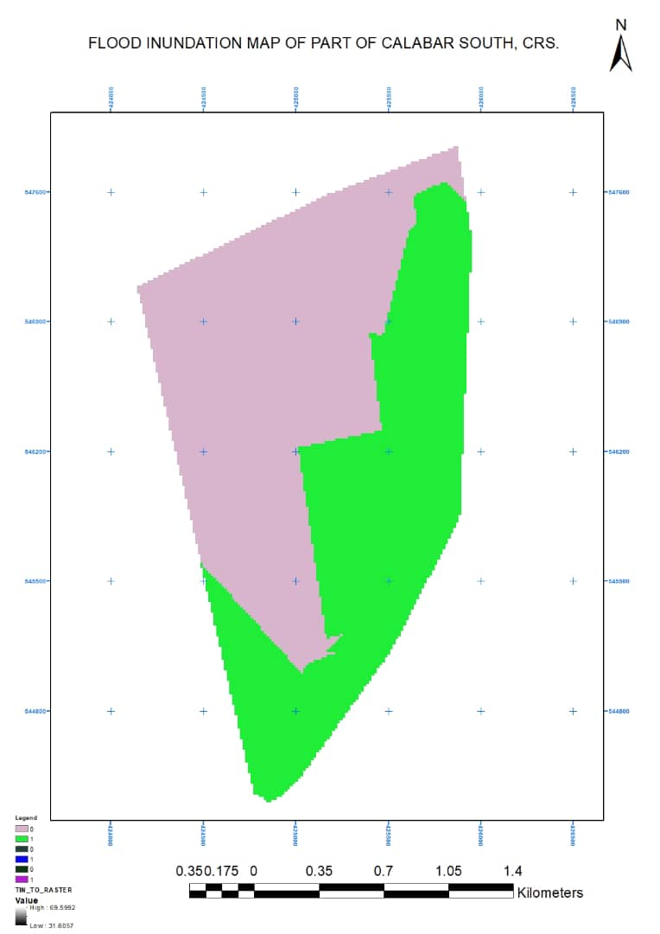

**Fig 7: Flood inundation map showing the flood hazard**

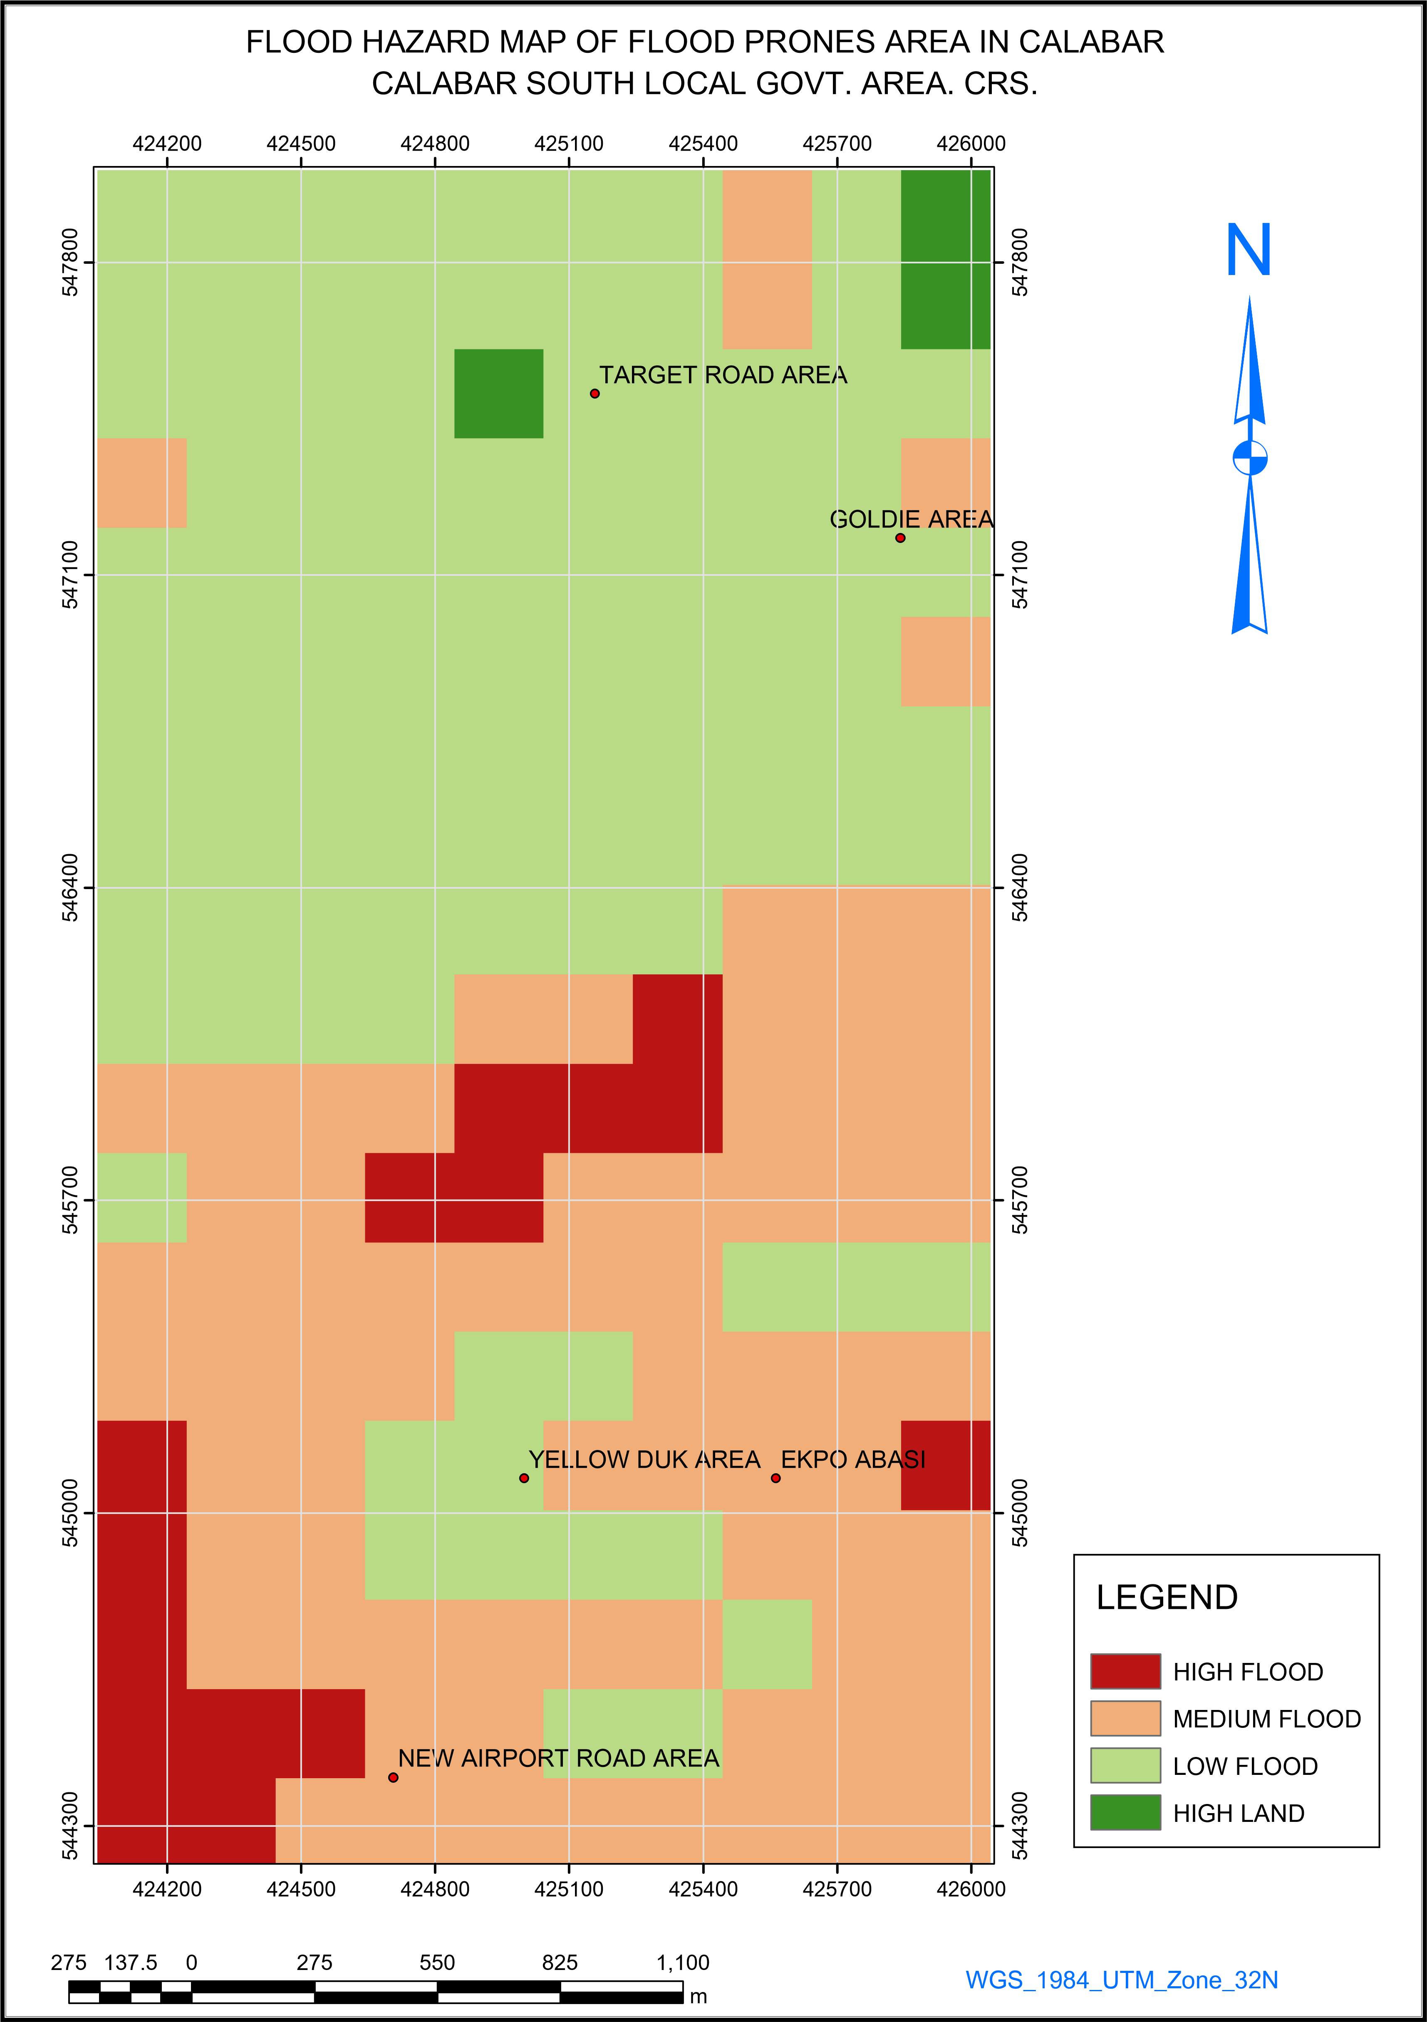

**Fig 8: shows all the areas that are prones to flooding in Calabar south. Cross Rivers State**

**RESEARCH FINDINGS**

Flood hazard mapping shows that 35% of Calabar south is classified as high-risk flood zone, coastal areas, riverine communities and low-lying zones are most vulnerable. Flood risk is high in 60% of the city, residentials areas, commercial centers and infrastructure are at risk. 150,000 residents live in high-risk flood zones, low-income households, women and children are affected, annual flood losses estimated at # 5 billion, agriculture, businesses and infrastructure suffer significant damage. 40% of roads and bridges are flood prone, drainage systems inadequate exacerbating flooding. No functional flood early warning system in place, community awareness and education are limited. Water pollution and soil erosion significant concerns, mangrove forests and wetlands degraded.

**CONCLUSION**

Overall, the study finds that areas with different levels of flood risk do not correspond to the areas of inundation at different return periods of flood. While the areas of inundation increase with increase in return period of flood, the areas with different levels of flood risk are determined by depth of inundation and depth damage function.The basic idea of flood hazard and risk assessment mapping as undertaken in this study is to control land use by flood plain zoning in order to restrict the damages. Flood hazard-based methodology by means of weighted linear combination and multi-criteria analysis and considering parameters. Combination of each parameter was by GIS techniques. The superimposition of each parameter resulted in mapping the area’s flood hazard divided into five classes, from “Very Low” to “Very High” from this area. Generally, flood hazard map 10.09459%, 22.34459%, 28.18461%, 20.31219%, 19.06402% of the study area was subjected to very low; low, moderate, high and very high flood hazards severity classes, respectively. The risk map of Calabar south combined two elements like land use land cover, the population and hazard map. From area that are about twenty seven percent of their area under flood risk include Ekpo Abasi (6.67), Target (16.51), New Airport (13.83), yellow-Duke (12.79), Goldie (7.12), to the other element at risk, land use/land cover, 81.8% swamps, 81.6% grass lands, 92.8% agricultural lands were under high to very high flood risk. Then after, the modeled output of floods hazard and risk map, was validation map, the obtained results were validated within historical floods data obtained from field surveying of the Calabar south.

**RECOMMENDATION**

The Calabar south is blessed with a variety of land types, ranging from lush rainforests to fertile agricultural land. The region’s terrain includes rolling hills, rich alluvial plains along the Cross River and coastal areas along the Atlantic Ocean. These diverse land types provide opportunities for agriculture, forestry and tourism, making Calabar south a region with great potential for economic development and natural beauty: develop flood risk management plan, enhance early warning systems, improve infrastructure resilience**,** increase public awareness, and protect environmental resources.

**COMPETING INTERESTS DISCLAIMER:**

Authors have declared that they have no known competing financial interests OR non-financial interests OR personal relationships that could have appeared to influence the work reported in this paper.

**REFERENCES**

Beven, K.J., Kirkby, M.J. (1979): A physically-based variable contributing area model of basin hydrology. Hydrology Science Bulletin 24(1), p.43-69.

Bedasa Asefa & Wondwossen Mindahun Eshetu (2018) Geospatial Based Flood Risk Assessment: The Case of Kewet District, Amhara Region, Ethiopia. <https://www.researchgate.net/publication/333618356>. DOI: 10.5923/j.ajgis.20190801.01

ESRI (2002) <https://proceedings.esri.com/library/userconf/proc04/docs/pap1262.pdf>?

Eastman, J.R. (2015): IDRISI for Windows, Version 2.0: Tutorial Exercises Graduate School of

Geography; Clark University: Worcester, MA, USA, 2001.

Etuonovbe, A. K. (2011). The devastating effect of flooding in Nigeria. FIG Working Week 2011 – Bridging the Gap between Cultures, Marrakech, Morocco, 18–22 May 2011. Retrieved from <https://www.oicrf.org/-/the-devastating-effect-of-flooding-in-nigeria>

Gashaw, W., & Legesse, D. (2011). Flood Hazard and Risk Assessment Using GIS and Remote Sensing in Fogera Woreda, Northwest Ethiopia (pp. 179–206). springer netherlands. https://doi.org/10.1007/978-94-007-0689-7_9

Ifiok Enobong Mfon, Michael Chukwuemeka Oguike, Salvation Ubi Eteng, & Ndifreke Moses Etim. (2022). Causes and Effects of Flooding in Nigeria: A Review. *East Asian Journal of Multidisciplinary Research*, *1*(9), 1777–1792. <https://doi.org/10.55927/eajmr.v1i9.1261>

**Islam, M. M., & Sado, K. (2000b).** Development of flood hazard maps of Bangladesh using NOAA-AVHRR images with GIS. Hydrological Sciences Journal, 45(3), 337–355.

[Joy Sanyal](https://onlinelibrary.wiley.com/authored-by/Sanyal/Joy), [X.X. Lu](https://onlinelibrary.wiley.com/authored-by/Lu/X.X.) (2006) GIS-based flood hazard mapping at different administrative scales: A case study in Gangetic West Bengal, India. Singapore Journal of tropical Geography . Volume27, Issue2Pages 207-220

Nerantzis Kazakis, Ioannis Kougias, Thomas Patsialis (2015) Assessment of flood hazard areas at a regional scale using an index-based approach and Analytical Hierarchy Process: Application in Rhodope–Evros region, Greece, Science of The Total Environment,

Volume 538, Pages 555-563

State Emergency Management Agency (SEMA). (2013). Report on the 2011 flood disaster in Calabar metropolis. Cross River State Government.

Selvin, P., O. and Cigdem, T. (2015). Detection of Flood Hazard in Urban Areas Using GIS,

Izmire Case in Turkey. 9 th International Conference of Interdisciplinary in Engineeering,

INTER-ENG 8-9 October, (2015), 373-381.

Shaban, A. Khawile M. and Abdullah C. (2006). Use of Remote Sensing and GIS to Determine

Recharge of Potential Zones. The case of occidential Lebanon Hydrology journal, 2006

14(4) 433-443.

Zhang, Z., Zhang, G., Zuo, C. *et al.* Hillslope soil erosion and runoff model for natural rainfall events. *Acta Mech Sin* 24, 277–283 (2008). <https://doi.org/10.1007/s10409-008-0142-5>