THERMODYNAMICS OF ADSORPTION OF LEAD(II) AND IRON (III) BY UNMODIFIED PALM FRUIT PEDUNCLE

ABSTRACT
The thermodynamics of the adsorption of Pb(II) and Fe(III) ions from aqueous solution on to unmodified oil palm peduncle was studied. Adsorption experiments were carried out using batch process with a fixed mass (0.2 g) of adsorbent and 10 mL of fixed adsorbate concentration of 10 ppm. Changes in concentration of the adsorbates during the adsorption process was analyzed by the use of Atomic Absorption Spectrophotometer. Thermodynamic parameters such as ΔH° and ΔS° were calculated from van’t Hoff’s plots. At the range of temperatures (30,40,50 and 60°C ) studied, ΔG° changed in the order -5.49, -4.39, -4.42 and -4.79 kJmol⁻¹ for Pb(II) and -2.83, -2.50, -2.58, and -1.99 kJmol⁻¹ for Fe(III).The values of ΔH° of Pb(II and ) were -11.97 and -10.19 kJmol⁻¹ respectively. The ΔS° values of Pb(II) and Fe(III) were 22 and 24.30 kJmol-1K⁻¹ respectively. The positive values of standard change(ΔS°) indicates the disorder (randomness) of the adsorbate particles over adsorbent surface. The negative values of standard Gibbs free energy change(ΔG°) and standard enthalpy change(ΔH°) indicate that the adsorption processes of both ions were exothermic and spontaneous. Spontaneity decreased as the temperature increased for both ions. The activation energy, Ea of the adsorption of P(II) and Fe(III) onto oil palm peduncle grind were 11.97 and -10.19 kJmol⁻¹ respectively. The adsorption processes were were therefore, physical(E_{a} < 40 kJmol⁻¹). The increase in adsorbent dosage reduced the adsorption capacity of the oil palm peduncle for the metal ions. The adsorption of Pb(II) and Fe(III) ions onto unmodified oil palm peduncle is thermodynamically feasible at low temperatures.

Keywords: Thermodynamics, Temperature, oil palm fruit, peduncle, Free energy change, enthalpy change, Entropy cnange

INTRODUCTION
The surge in industrial activities has led to diverse environmental issues, affecting land, sea, and air. These problems have degraded ecosystems due to the accumulation of pollutants, notably toxic heavy metals(Guo, Zhang, & Guo,2024; Liu et al., 2025) . Heavy metals are introduced into the environment through both natural and human activities, such as atmospheric particulate deposition, disposal of metal-enriched sewage sludge,aging metal infrastructure(Duderstadt, 2018) and effluents from metal mining processes (Abd Elnabi et al., 2023). Water bodies, being the primary receptacles for these emitted heavy metals, suffer significant pollution( Lupa & Cocheci, 2023). Both soil and water absorb heavy metals, which are then taken up by plants and animals, accumulating in tissues and entering the human food chain. Human exposure to toxic heavy metals poses severe health risks, as these metals can compromise the immune system. Lead (Pb) is recognized as one of the most hazardous substances, causing long-term health and environmental effects(Raj & Das,2023). While iron is essential for human life, concentrations above the maximum contaminant level (MCL) of 0.3 milligrams per liter (mg/L) in drinking water can result in aesthetic issues such as unpleasant taste, color, and odor, along with causing staining and a metallic taste (Lupa & Cocheci 2023).
The harmful and aesthetic impacts of heavy metals on humans and the environment necessitate their removal from industrial and domestic water sources. Currently, many physical, chemical and biological techniques(Zaimee, Sarjadi & Rahman, 2021) have been applied for effectively removing impurities from water, as the materials used in these techniques provide numerous sites for contaminant attachment (Raji et al., 2023). Adsorption, as a physical or biological method, is also a highly effective technique, and low-cost agricultural waste materials are particularly valuable for this purpose due to their abundance, economic viability, eco-friendliness, high adsorption capacity, and versatility(Kainth, Sharma & Pandey,2024).
While various adsorbents, such as activated carbon, clays, and biomass materials, have been explored for heavy metal adsorption, however, there is a need for more cost-effective and sustainable alternatives. The oil palm (Elaeis guineensis) industry, prevalent in many tropical regions, generates large quantities of biomass waste, including the fruit peduncle. The utilization of this waste material for environmental remediation aligns with the principles of waste valorization and sustainable resource management.
Previous studies (Almeida-Naranjo et al.,2023; Danish et al.,2016; Thoe, Surugau & Chong, 2019) on the adsorption capabilities of plant-based materials suggest that oil palm fruit peduncle, with its high lignocellulosic content and porous structure, could be an effective adsorbent for heavy metals. Its abundant availability and low cost make it an attractive material for large-scale applications.
This study aims to investigate the thermodynamics of adsorption of Pb(II) and Fe(III) by unmodified oil palm fruit peduncle.Thermodynamic investigation plays a crucial role in adsorption studies. It helps understand the mechanisms, determine the spontaneity and feasibility of adsorption processes, and assess the effects of temperature on adsorption capacity and efficiency, which are essential for optimization and predictive modeling. By exploring the thermodynamic properties and adsorption potential of unmodified oil palm fruit peduncle, this study aims to contribute to the development of sustainable and eco-friendly solutions for water purification. The findings could pave the way for utilizing agricultural waste materials in environmental remediation, ultimately promoting a circular economy and reducing the environmental footprint of the palm oil industry.
MATERIALS AND METHODS
Preparation of Adsorbents
The adsorbent material used for this work was oil palm(Elaeis guineensis) fruit peduncle which was collected from Amassoma forest. The raw sample was extensively washed to remove dirt and other particulate matter that might interact with adsorbed metal ions and then cut into chips of of about 4 cm2. These were sun-dried and ground to powder, and sieved with a mesh to particle sizes of 75 ,150,300 and 600 μm The ground samples were soaked in 0.01 M HCl for thirty-six (36) hours. The acid-soaked samples were washed with distilled water until a constant pH (6.65) was obtained. They were oven-dried at 60°C for two(2) days and were stored in air-tight plastic containers and subsequently used for adsorption studies.
Adsorbates and Instruments
Analytical grade chemicals were used throughout the study. Stock solutions of Pb(II) and Fe(III) were prepared from lead nitrate, Pb(NO₃)₂ and iron (III) chloride, FeCl₃ respectively . Fe(III) nitrate was obtained from Lab Chemicals Ltd, India; Lead (II) ions from analar grade lead (II) nitrate, was obtained BDH Poole, U.K. In each case, stock solution of 1000 mgdm⁻³ was prepared and from these, fresh dilutions were made for the working solutions using distilled water.
EXPERIENTAL METHODS
Determination of the effect of Temperature on Adsorption
Batch adsorption experiments were conducted for each metal by contacting 0.2 g of oil palm(Elaeis guineensis) fruit peduncle powder with 10 mL solutions containing metal ions of desired concentration (100 ppm) at the following temperatures: 30°C,40°C,50°C, and 60°C. The mixtures were then shaken in a water bath on a shaker (Max^{Q} 2000)at 120 rpm for 60 minutes. The mixtures were passed through filter papers and the filtrates were analyzed for residual metal ion concentration using Atomic Absorption Spectrophotometer(AAS).
Determination of the effect of Dosage on Adsorption
Different dosages of adsorbent consisting of 0.1, 0.2, 0.3, 0.4,and 0.5 g were weighed. The various weights of the adsorbent were singly shaken with 10 mL of 10 ppm of the working solutions of FeCl3 and Pb(NO3)2 for 60 minutes at 120 rpm on a speed shaker.The adsorption capacity and percentage adsorption were determined using equations 1 and 2.
DATA ANALYSIS
The metal uptake for the adsorption was determined using the equation 1
qe = $\frac{v}{m}(Co-Ce)$ (1)
Where, q_{e} = quantity adsorbed at equilibrium(mg/g), v = volume of adsorbate used( L), m = mass of adsorbent used(mg), C_{o} = Initial dye concentration(mg/L), C_{e} = Dye concentration at equilbrium
The percentage adsorbed at equilibrium was calculated from the equation 2
R (%A) = $\frac{Co - Ce}{Co} ×100$ (2)
Thermodynamic Analysis
Thermodynamic parameters of metal ion adsorption were calculated with the aid of equation
Linear sorption distribution coefficient K_{D} was calculate as in equation 3
(3)
Where C_{a} is the equilibrium adsorbate concentration on the asorbent(mg/L) and C_{e} is the equilibrium adsorbate concentration in solution (mg/L).
The standard free energy change of the adsorption was obtained from equation 4
(4)
Standard enthalpy change , ΔHº and standard entropy change ΔSº values were calculated from the slope and intercept of the linear variation of ln K_{D} versus 1/T plot of the van’t Hoff equation 5
(5)
Activation energy (E_{a}) was determined from the slope of potential sticking probability (S*) equation 6 and 6a by the plot of ln(1-θ)against 1/T
(6)
(6a)
The isosteric heat of adsorption was ΔH_{x}, was determined from Clausius-Clapeyron equation 7
(7)
RESULTS AND DISCUSSION
The results of the experiments at different temperatures and dosages are shhown in this section. The effects of temperature and dosage on adsorption capacity and thermodynamic parameters are evaluated and presented in th figures and tables.

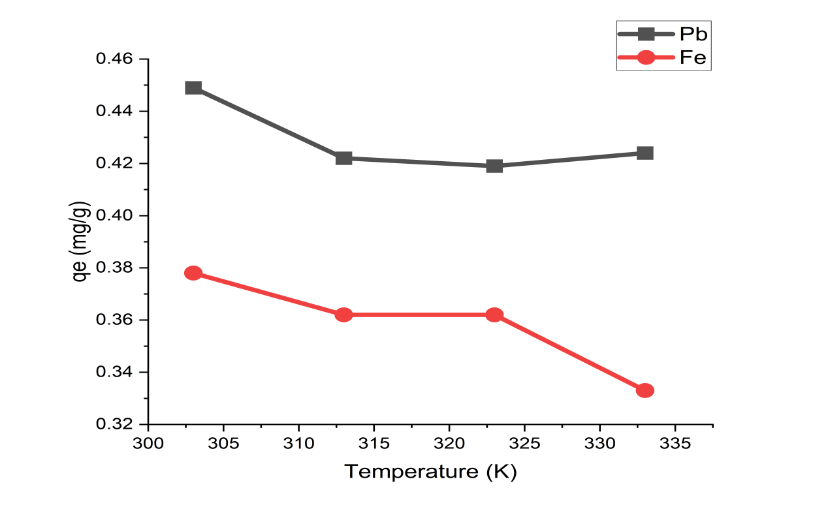
Figure 1: Effect of temperature on the adsorption of Pb(II) and Fe(III) on unmodified oil palm fruit peduncle.

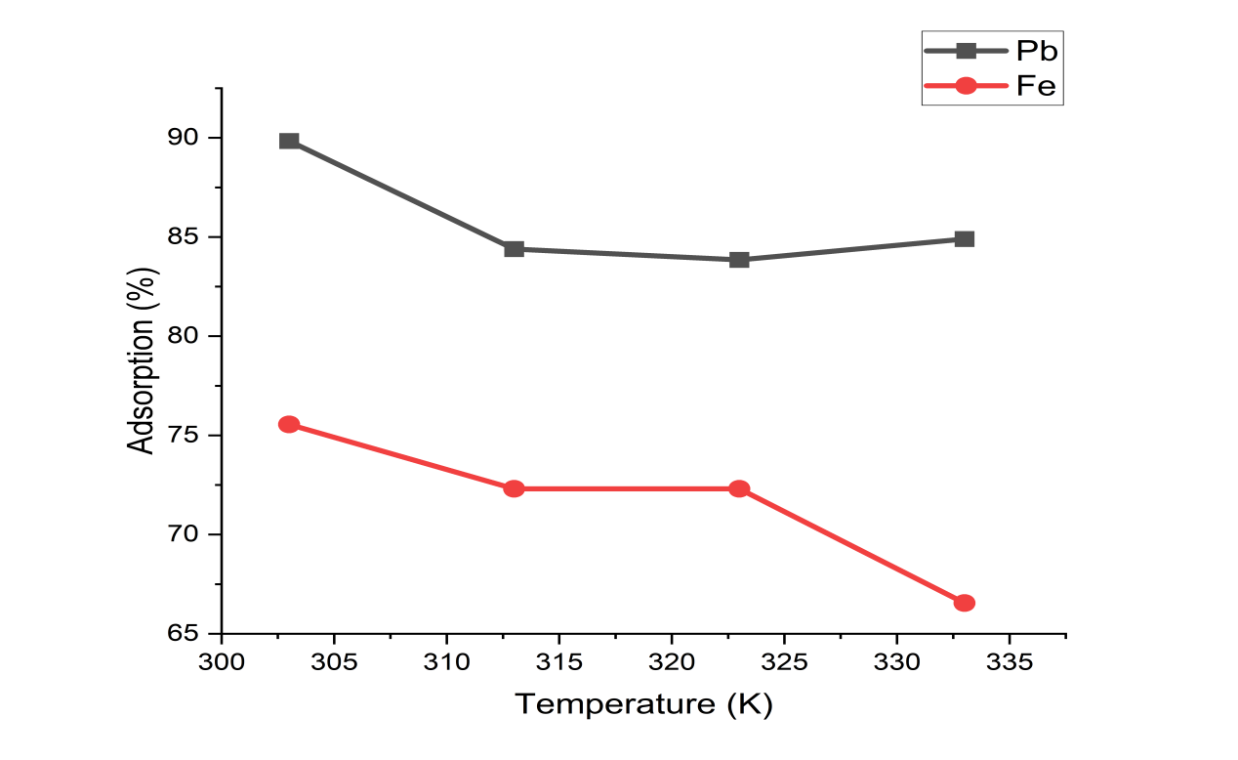
Figure 2: Effect of temperature on the percent adsorption of Pb(II) and Fe(III) on unmodified oil palm fruit peduncle.

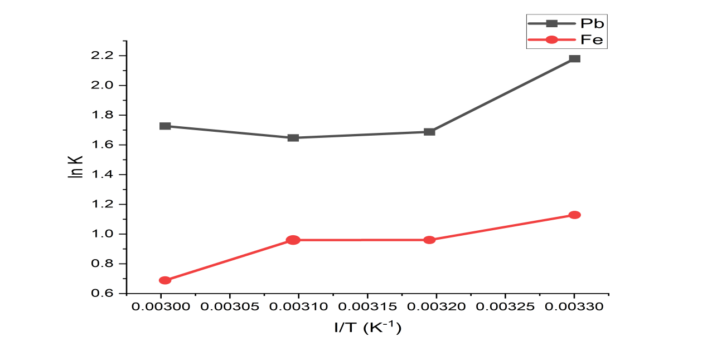

Figure 3: van’t Hoff plot for the adsorption of Pb(II) and Fe(III) on unmodified oil palm fruit peduncle.

Temperature plays a major role in the adsorption of metals on adsorbents because an upward change of it by some amounts imparts higher energies to adsorbate particles and thus increase diffusion rate across external boundary layer and into the internal pores of the adsorbent.
Figures 1 and 2 are graphical results of the the effect of temperature on the adsorption and percent adsorption of Pb(II) and Fe(III) ions by unmodified plantain fruit peduncle. It was observed that the uptake of Pb(II) and Fe(III) ions by the adsorbent were affected by temperature as seen in the maximum uptake capacity of 89% and 75.56% respectively. The quantities adsorbed of Pb(II) and Fe(III) ions decreased to 0.419 mg/g and 0.362 mg/g at 50°C. Then it began to rise to 0.424 mg/g as the temperature increased to 60°C in the case of Pb(II) ions, while it fell more drastically to 0.33 mg/g for Fe(III) ions at 60°C.The situation could suggest that there was a predominance of physical adsorption over chemical adsorption.

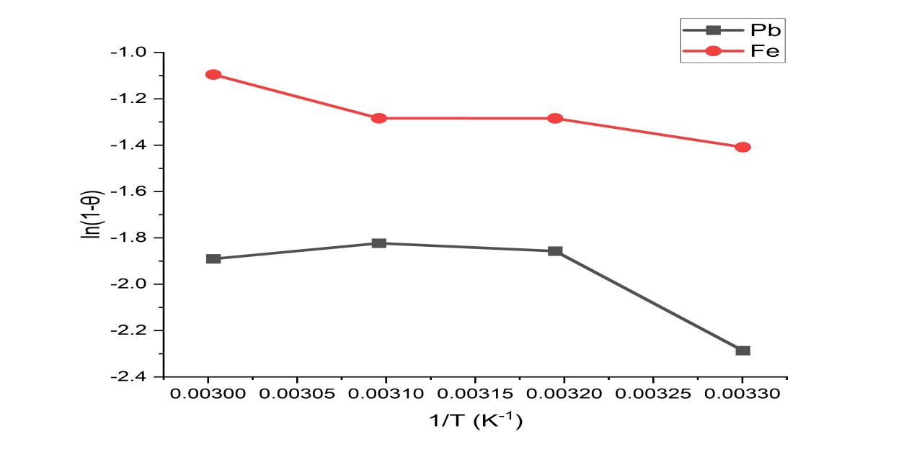
Figure 4: Potential sticking probability plot for adsorption of Pb(II) and Fe(III) ions on unmodified oil palm fruit peduncle.

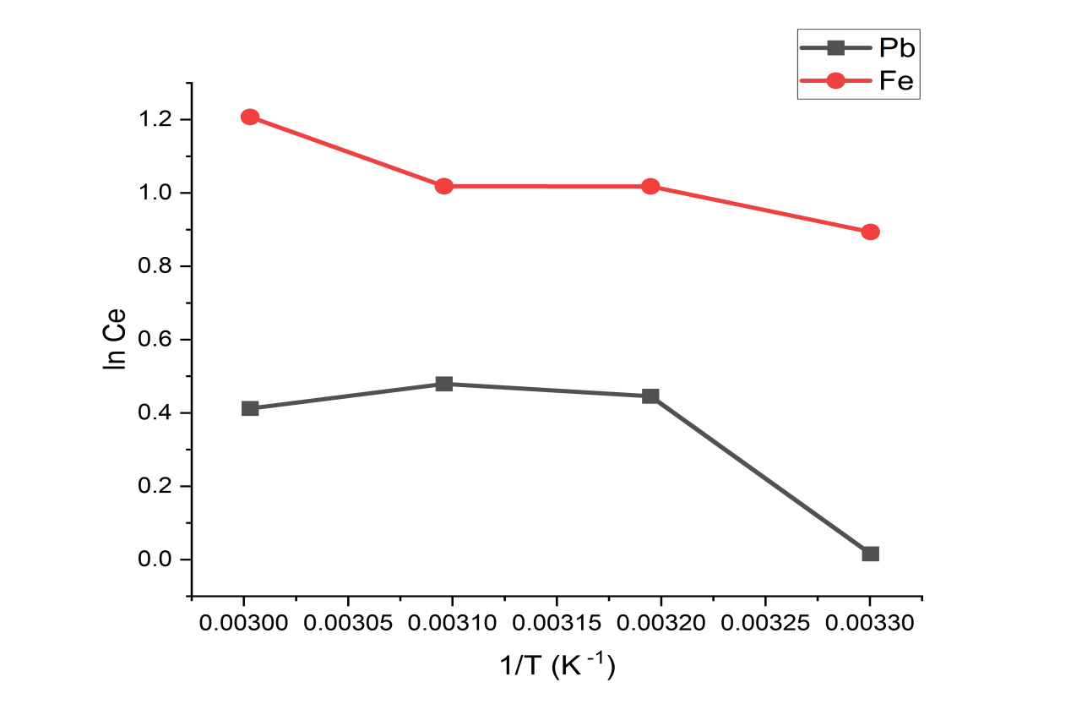
Figure 5: Isosteric heat of adsorption of Pb(II) and Fe(III) on unmodified oil palm fruit peduncle

Thermodynamic Parameters
Thermodynamic parameters such as standard Gibbs free energy change (ΔG°), standard enthalpy change (ΔH°), and standard entropy change (ΔS°) are crucial for assessing the spontaneity of the sorption process and determining whether it is endothermic or exothermic. The relevant data for these parameters, as presented in Table 1, show that the adsorption of Pb(II) and Fe(III) ions was spontaneous, based on the criterion of spontaneity, and exothermic. Notably, the negative enthalpy change (ΔH°) was greater for Pb(II) than for Fe(III) within the temperature range investigated. This enthalpy change may be related to electrostatic interactions between the adsorbate and the adsorbent (Zhao et al., 2011).
The observed differences in thermodynamic parameters for Pb(II) and Fe(III) ions can be attributed to variations in their molecular masses and charge densities. Since Fe(III) has a smaller ionic radius than Pb(II), it exhibits a higher charge density and effective nuclear charge. This leads to more restricted valence electron interactions compared to Pb(II) ions.
Entropy changes (ΔS°) are linked to the mobility of the adsorbate in the adsorption medium. In aqueous solutions, the mobility of metal ions is inversely proportional to their molecular masses (Verdaguer et al., 2008). Consequently, Fe(III) ions exhibit higher entropy changes due to their greater mobility (disorder) and weaker interactions with the adsorbent compared to Pb(II) ions (Bowes and Lenhoff, 2011).
The activation energy (Ea) values for Pb(II) and Fe(III) ions were -10.41 and -7.84 kJ/mol, respectively, indicating physical adsorption (Ea < 50 kJ/mol). The potential sticking probabilities (S*), reported in Table 2, were 0.002 and 0.0017 kJ/mol for Pb(II) and Fe(III) ions, respectively, suggesting Pb(II) ions had a greater likelihood of adhering to the adsorbent's surface than Fe(III) ions.
The isosteric heat of adsorption (ΔH_{x}) for Pb(II) and Fe(III) ions, as shown in Table 2, was 10.50 and 7.87 kJ/mol, respectively. The heat of adsorption depends on surface coverage, often reflecting both adsorbent-adsorbate and adsorbate-adsorbate interactions. Differences in ΔH_{x} suggest that Pb(II) ions may have more lateral interactions with other adsorbed ions than Fe(III) ions (Saha and Chowdhury, 2011).
Finally, as depicted in Figure 6, the negative ΔG° values decreased with increasing temperature, indicating that adsorption may become less favorable at higher temperatures.

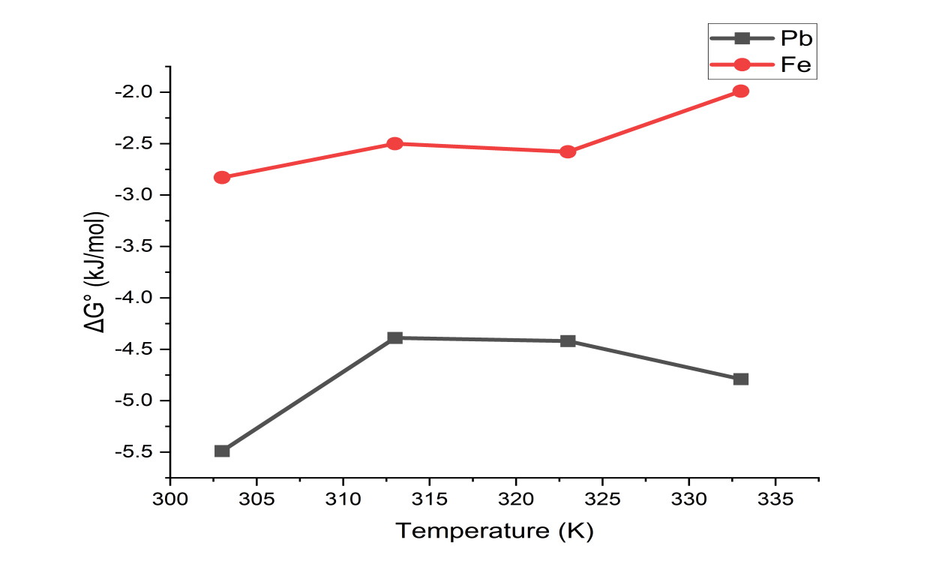
Figure 6.Pot of the variation of standard Gibbs free energy with temperature of adsorption Pb(II) and Fe(III) ions on unmodified oil palm fruit peduncle
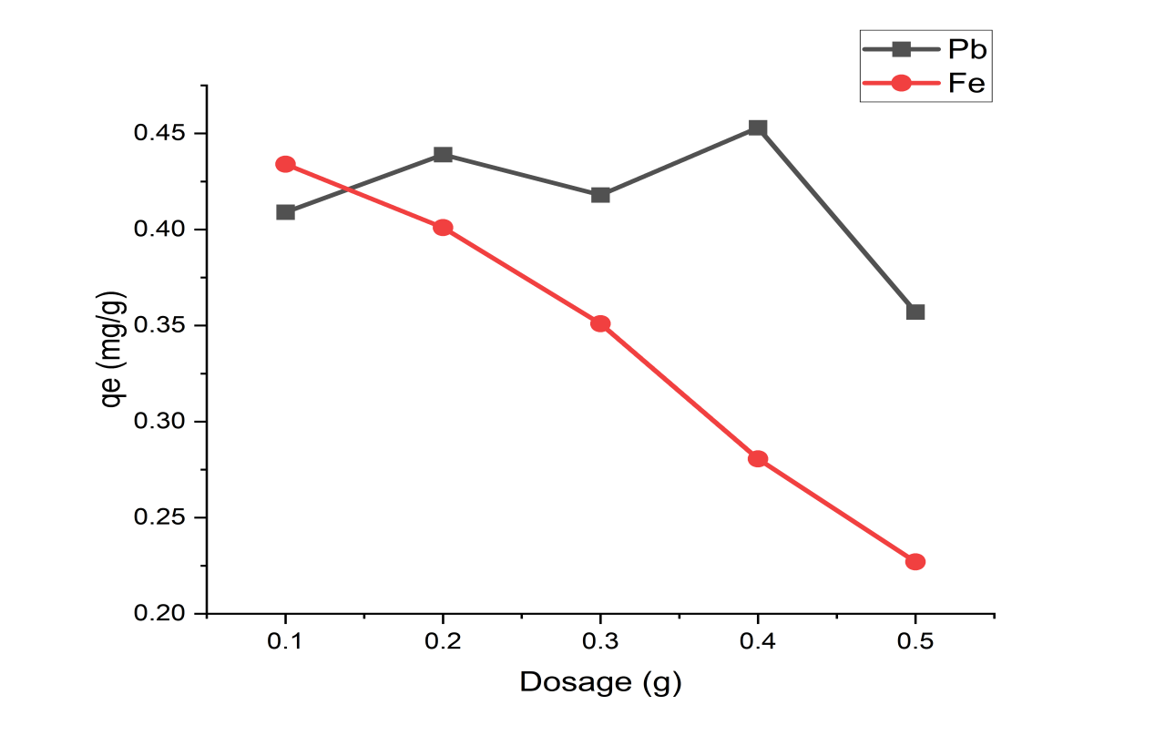
Figure 7: Effect of dosage on the adsorption of Pb(II) and Fe(III) ions on unmodified oil palm fruit peduncle

The dosage of the adsorbate plays a crucial role as it significantly influences the adsorbent's capacity at a given initial concentration of the adsorbate. As illustrated in Figure 7, increasing the dosage from 0.1 to 0.5 g led to a steady decline in uptake capacity for Fe(III), ranging from 0.434 mg/g to 0.226 mg/g. In contrast, the uptake capacity for Pb(II) showed fluctuating behavior between 0.1 and 0.3 g, reaching a peak of 0.452 mg/g (90.48%) at 0.4 g before dropping to 0.357 mg/g (71.31%) at 0.5 g. Adsorption capacities were generally higher at lower dosages, which can likely be attributed to insufficient surface coverage by adsorbate particles during the adsorption process. Similar trends have been reported in previous studies (Han et al., 2006; El-Latif & Ibrahim, 2009).

Table 1: Thermodynamic parameters of adsorption of Pb(II) and Fe(III) ions on unmodified oil palm fruit peduncle.
Temp. (K) | Pb (II) |  |  | Fe (III)
Temp. (K) | ΔG°  kJ/mol | ΔH°  kJ/mol | ΔS°  J/mol | ΔG°  kJ/mol | ΔH°  kJ/mol | ΔS°  J/mol
303 | - 5.490 | -11.97 | 22.62 | - 2.830 | - 10.19 | 24.300
313 | - 4.390 | -11.97 | 22.62 | - 2.500 | - 10.19 | 24.300
323 | - 4.420 | -11.97 | 22.62 | - 2.580 | - 10.19 | 24.300
333 | - 4.790 | -11.97 | 22.62 | - 1.990 | - 10.19 | 24.300

Table 2. Activation parameters of adsorption of Pb(II) and Fe(III) ions on unmodified oil palm fruit peduncle.
Parameters | Pb (II) | Fe(III)
E_{a} (kJ/mol) | - 10.41 | -7.81
ΔH_{x} (kJ/mol) | 10.50 | 7.87
S* (kJ/mol) | 0.002 | 0.0017

CONCLUSION
The study explored the influence of temperature and dosage on the adsorption of lead (II) and Fe (III) ions from aqueous solutions using an oil palm fruit peduncle as the adsorbent in a batch method. The findings indicate that the adsorption process was both spontaneous and exothermic, as evidenced by the negative values of standard Gibbs free energy (ΔG°) and standard enthalpy (ΔH°) at the temperatures tested. The positive standard entropy (ΔS°) values reflect increased randomness of the metal ions at the adsorbent's surface, suggesting effective mass transfer from the bulk solution to the adsorbent.
At ambient temperature (303K), adsorption capacity decreased with higher dosages of the adsorbent for both metal ions. Maximum uptake capacities of 89% for lead (II) and 75.56% for Fe (III) ions were observed under the tested conditions. The activation energy (Ea) for Pb(II) and Fe(III) ions was -10.41 and -7.84 kJ/mol, respectively, indicating that the adsorption was physical in nature (Ea < 50 kJ/mol). The potential sticking probabilities (S*) for Pb(II) and Fe(III) ions were calculated to be 0.002 and 0.0017 kJ/mol, respectively.
Overall, the adsorption efficiency decreased with increasing temperature and dosage, implying that lower temperature and dosage levels are more favorable for enhancing the uptake capacity of the oil palm fruit peduncle adsorbent in this study

REFERENCES
Guo, Y., Zhang, Z., & Guo, X. (2024). Recent research advances on heavy metals, microplastics, persistent organic pollutants, and solid waste in aquatic and terrestrial ecosystems. Frontiers in Environmental Science, 12, 1391614.

Liu, Y., Xu, F., Liu, W. Liu,X., & Wang, D. (2025). Characteristics, Sources, Exposure, and Health Effects of Heavy Metals in Atmospheric Particulate Matter. Curr Pollution Rep 11, 16 . https://doi.org/10.1007/s40726-025-00344-y

Duderstadt, Eric. (2018). Water well corrosion: Types, effects, and resolutions. Water Well Journal 72, 12: 24-28.

Abd Elnabi, M. K., Elkaliny, N. E., Elyazied, M. M., Azab, S. H., Elkhalifa, S. A., Elmasry, S., Mouhamed, M. S., Shalamesh, E. M., Alhorieny, N. A., Abd Elaty, A. E., Elgendy, I. M., Etman, A. E., Saad, K. E., Tsigkou, K., Ali, S. S., Kornaros, M., & Mahmoud, Y. A.-G. (2023). Toxicity of Heavy Metals and Recent Advances in Their Removal: A Review. Toxics, 11(7), 580. https://doi.org/10.3390/toxics11070580

Lupa, L., & Cocheci, L. (2023). Heavy metals removal from water and wastewater. Heavy Metals-Recent Advances.

Raj, K., & Das, A. P. (2023). Lead pollution: Impact on environment and human health and approach for a sustainable solution. Environmental Chemistry and Ecotoxicology, 5, 79-85.

Zaimee, M. Z. A., Sarjadi, M. S., & Rahman, M. L. (2021). Heavy Metals Removal from Water by Efficient Adsorbents. Water, 13(19), 2659. https://doi.org/10.3390/w13192659

Raji, Z., Karim, A., Karam, A., & Khalloufi, S. (2023). Adsorption of heavy metals: mechanisms, kinetics, and applications of various adsorbents in wastewater remediation—a review. In Waste (Vol. 1, No. 3, pp. 775-805). MDPI.

Kainth, S., Sharma, P., & Pandey, O. P. (2024). Green sorbents from agricultural wastes: A review of sustainable adsorption materials. Applied Surface Science Advances, 19, 100562.

Almeida-Naranjo, C. E., Gallegos, E., Domínguez, E., Gutiérrez, P., Valle, V., Aguilar, A. D., Debut, A., & Vasco, C. (2023). From Renewable Biomass to Water Purification Systems: Oil Palm Empty Fruit Bunch as Bio-Adsorbent for Domestic Wastewater Remediation and Methylene Blue Removal. Water, 15(23), 4116. https://doi.org/10.3390/w15234116

Danish, M., Ahmad, T., Hashim, R., Hafiz, M. R., Ghazali, A., Sulaiman, O., & Hiziroglu, S. (2016). Characterization and adsorption kinetic study of surfactant treated oil palm (Elaeis guineensis) empty fruit bunches. Desalination and Water Treatment, 57(20), 9474-9487.

Thoe, J. M. L., Surugau, N., & Chong, H. L. H. (2019). Application of oil palm empty fruit bunch as adsorbent: A review. Transactions on Science and Technology, 6(1), 9-26.

Zhao, G.; Wu, X. & Tan,X. (2011). Sorption of Heavy metal ions from aqueous Solutions: A Review. The Open Colloid Science Journal, 4, 19-31

Verdaguer, A., Segura, J. J., Fraxedas, J., Bluhm, H., & Salmeron, M. (2008). Correlation between charge state of insulating NaCl surfaces and ionic mobility induced by water adsorption: a combined ambient pressure X-ray photoelectron spectroscopy and scanning force microscopy study. The Journal of Physical Chemistry C, 112(43), 16898-16901.

Bowes, B. D., & Lenhoff, A. M. (2011). Protein adsorption and transport in dextran-modified ion-exchange media. III. Effects of resin charge density and dextran content on adsorption and intraparticle uptake. Journal of Chromatography A, 1218(40), 7180-7188.

Saha, P., & Chowdhury, S. (2011). Insight into adsorption thermodynamics. Thermodynamics, 16, 349-364.

Han, R., Zhang, J., Zou, W., Xiao, H., Shi, J., & Liu, H. (2006). Biosorption of copper (II) and lead (II) from aqueous solution by chaff in a fixed-bed column. Journal of Hazardous materials, 133(1-3), 262-268.

Abd El-Latif, M. M., & Ibrahim, A. M. (2009). Adsorption, kinetic and equilibrium studies on removal of basic dye from aqueous solutions using hydrolyzed oak sawdust. Desalination and Water Treatment, 6(1-3), 252-268.

