Original Research Article

PHYSICO-CHEMICAL AND MORPHOLOGICAL CHARACTERIZATION OF CLAY EXTRACTED FROM THE SUBSOIL OF THE CITY OF DALOA (WEST OF IVORY COAST).

Abstract
This work is part of the valorization of clay, one of the natural and abundant resources in the regions of Ivory Coast, particularly in Daloa. The objective of this work was to characterize a clay from the city of Daloa for its future use in the field of liquid effluent treatment. Analysis were carried out using X – ray diffraction and scanning electron microscopy (SEM) coupled with energy dispersive X – ray spectroscopy (EDX). The results reveal that this clay is compose dot dickite – 2M1 and halloysite – 7 Å, with significant quantities of quartz, and traces of titanium dioxide, iron oxide an aluminium. EDX analysis showed the presence of the chemical elements O, Al, Si, Fe, P and Ti.
Key Words : clay, charactterisation, X – ray diffraction, scanning electron microscopy (SEM/EDX).

- INTRODUCTION
The interest shown in recent years in the study of clays by many laboratories around the world is justified by their abundance in nature, their low cost (Ibtissem, 2022), the presence of electrical charges on their surface and especially the exchangeability of inter-foliar cations (Bey, 2015), (Gourouza and al., 2013). Clays are involved in several areas of life. They are used in a significant number of scientific and technological fields, including medicine, pharmacy, cosmetics; chemistry, civil engineering works, etc. (Kouassi, 2021). This makes clays a material at the crossroads of several sciences and technologies. They are produced from the alteration of rocks and therefore consist of a mixture of clay minerals with various other minerals in nature (Kouassi, 2021). Consequently, their composition is very varied (Bouhoreira, 2018). Thus, we distinguish between clays rich in silica and alumina (kaolinite, dickite, halloysite, etc.), clays rich in silica and magnesium (sepiolite, antigorite, etc.) and clays rich in silica and iron (Nontronite, glauconite, etc.). Clays are therefore omnipresent in the Earth's crust (Jalil and al., 2013).
In chemistry, clays are of particular interest in many fields, including environmental remediation as an adsorbent or catalyst. The effect of clay/pollutant interaction (Andriantsiferana and al., 2014), and semiconductor/clay interaction (Liang and al., 2017) and (Mishra and al., 2018) has been the subject of particular investigation in recent years. Due to its layered structure, clay is a good natural adsorbent. Clay is also used for disinfection, sanitation, toxin neutralization, remineralization, softening and cleaning. Several studies have already been conducted, including adsorption on clay (Andriantsiferana and al., 2014), (Belghazi and al., 2022), the use of clay as a support for titanium dioxide (TiO2) in the field of heterogeneous photocatalysis (Liang and al., 2017), (Mishra and al., 2018). Indeed, clays are promising supports for TiO2 thanks to their good chemical and mechanical stability, good cost-effectiveness, good adsorption capacity (Mishra and al., 2018), (Oliveira and al., 2020). Clay provides a large specific surface area, high porosity and a large quantity of active sites on the surface (Mishra and al., 2018). The morphology and texture of the adsorbent are therefore factors on which its surface activities depend (Mishra and al., 2018).
The objective of this work was to characterize the clay by X-ray diffraction (XRD) and scanning electron microscopy coupled with energy dispersive X-ray spectroscopy (SEM / EDX) in order to determine its morphology and texture.
- MATERIALS AND METHODS
  - Materials
    - Clay Materials
The clay used as a TiO2 support in this work comes from the Haut-Sassandra region. It was taken from a borehole at a depth of approximately 4 m in the town of Daloa located in the center-west, 383 km from Abidjan (Kouamé and al., 2020) (Latitude: 6°53; Longitude: 6°27 (Yao, 2021), the economic capital of Côte d’Ivoire in Figure 1.
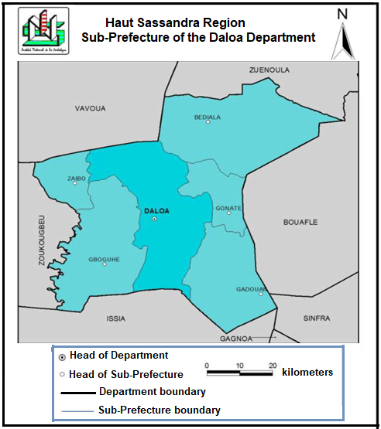

Figure 1 : localisation de la ville de Daloa (Kouamé and al., 2020)
  - Methods
    - Pre-treatment of clay
First, the selected clay underwent a preliminary treatment to remove impurities that could affect its catalytic adsorbent properties. Thus, the raw clay was ground in a porcelain mortar. The powder obtained was then sieved with a sieve made up of seven sieves with diameters between 45 µm and 2 mm, brand ANALYS SENEWEB – RETSCH -AS 200. Finally, the powder with a diameter of less than 45 µm was retained and dried in a MEMMERT oven at a temperature of T = 60°C for 6 hours at constant weight for the production of clay balls. The clay balls were made by making a homogeneous paste from a mixture of 100 g of the finest clay powder and 40 mL of ultrapure water. The resulting paste made it possible to make balls with a diameter of approximately 0.3 mm. These balls were then dried at 105°C in a MEMMERT oven for 24 hours. Finally, the dried balls were fired at 550°C in a NABERTHERM oven to make them water-resistant and remove any traces of residual organic matter.
    - X-ray Diffraction (XRD) Analysis
X-ray diffraction is a powerful technique that provides information on the constituent networks and the degree of crystallinity of clay. The diffractograms were obtained from a Brucker -AXS D 5005 Debye -Sherrer type apparatus using CuKα radiation (λKα = 1.54056 Å) and a graphite back monochromator. The angular range of analysis is between 5° and 100° (2θ). The acquisition time is two second with a step of 0.04 (2θ). The crystalline phases present in the analyzed materials are identified by comparing them with the PDF (Powder Diffraction Files) standards of the ICDD (International Center for Diffraction Data).
    - X-ray analyses coupled with SEM/EDX of clay powder
The principle of SEM/EDX is based on the combination of two techniques: scanning electron microscopy (SEM) and energy-dispersive X-ray spectroscopy (EDX). This combination of these two techniques provides images of the surface of the clay sample as well as information on its chemical composition.
The scanning electron microscope used for this analysis was a Quanta FEG 250 equipped with an EDX detector. Images were obtained with an accelerating voltage of 10 kV.
The mass and atomic percentage of atoms in a sample analyzed by SEM-EDX was calculated using the following equations:

- Mass Percentage (%) =
- Atomic Percentage (%) =
- RESULTS AND DISCUSSION
  - X-ray diffraction (XRD)
Radio crystallographic analysis of the clay sample using X-rays allows the identification of the different mineralogical phases contained in the clay studied. The results obtained are shown in the diffractogram in Figure 2.
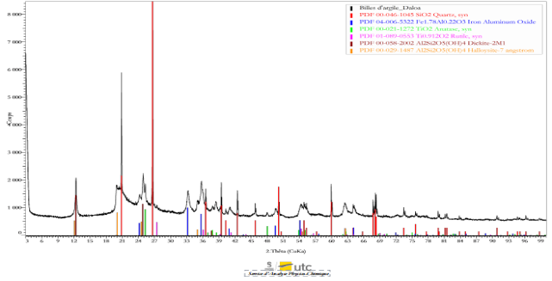

Figure 2: Pure clay diffractogram
Figure 2 shows relatively intense and broad diffraction peaks at low 2θ angle values, and less intense and less broad peaks at high 2θ values. It also shows that the analyzed clay is made up of several mineralogical phases such as:

- Quartz (SiO2) [PDF 00-046-1045] which is the most abundant and thus the main phase of this clay with the main characteristic peaks 2θ à : 20.9°; 26.6°; 36.5°; 39.4°; 40.2°; 42.45°; 45.90°; 50.1°; 54.9°; 55.30°; 59.95°; 67.60°;68.2°; 68.4°; 73.48°; 75.6°; 77.7°; 78.9°; 79°; 81.2°; 81.4°; 83.85°; 90.8°; 94.75°; 95.20°; 96.20°; 98.75°;
- Iron aluminum oxide (Fe1,78Al0,22O3) [PDF 04 – 006 – 5322] observed at 24.2°; 33.2°; 35.7°; 40.90°; 49.5°; 54.15°; 64.15°;
- Titanium dioxide TiO2 [PDF 00 – 021 – 1272] at 25.35° ; 48° and rutile [PDF 01 – 089 – 0553] at ( 27.5°) ;
- Dickitis -2M1 (Al2Si2O5(OH)4) [PDF 00 – 058 – 2002] at 12.4°, 24.90° ; 37.7°;
- Halloysite -7Ǻ (Al2Si2O5(OH)4) [PDF 00 – 029 – 1487] at 12.2° ;19.10° ; 24.60° ; 35° ; 62.7°.
DRX analysis showed that the clay studied is composed of abundant quartz, followed by iron and aluminum oxide, and in trace amounts, anatase, rutile, dickitis and halloysite. These minerals present in this clay are commonly found in kaolinite (Cases and al., 1982), (Charles and al., 2018), therefore of the kaolinite family.
Indeed, studies carried out by Razkaoui, (1995) and Kouassi, (2021) have shown that halloysite is a hydrated kaolinite, with water molecules inserted between the layers that constitute it. In addition, dickite is also a kaolinite but monoclinic (Hénin, 1956). Furthermore, the lines observed are mostly wide, characteristic of crystalline disorder (Khireddine, 2016). This clay studied is therefore a disordered kaolinite due to the presence of iron (Mestdagh and al., 1982), containing a large quantity of quartz, and presenting two polymorphic forms which are dickite (better crystallized form) and halloysite (poorly crystallized form) (Charles and al., 2018), (Kra and al.,., 2016). Dickite is an extreme term used to designate disordered kaolinites (Mestdagh and al., 1982). In summary, the clay studied is therefore composed of quartz, iron, and aluminum oxide with anatase, rutile, dickite and halloysite in trace amounts.
3.2. Characterization using SEM/EDX
After DRX, SEM allowed to determine the surface morphology of the elements of the clay studied in order to obtain information on the texture of the grains. It gave the images in Figure 3. Images (a), (b), (c) and (d) represent the surface of the clay scanned and magnified respectively (100x), (500x), (1000x) and (2500x) to allow an analysis of the structure and composition of the clay at smaller scales in order to obtain more detailed information on the texture of its surface, its microstructure and its chemical composition.
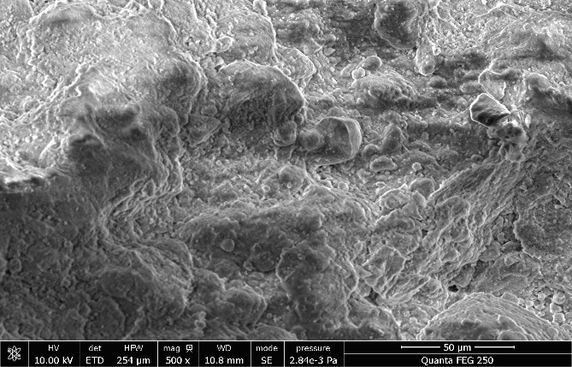
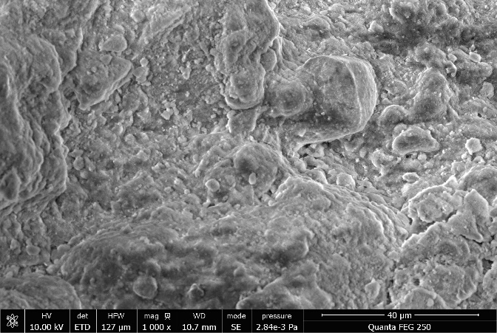
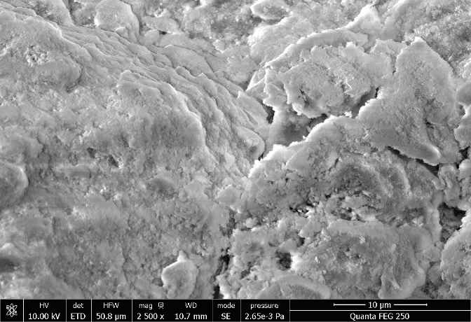
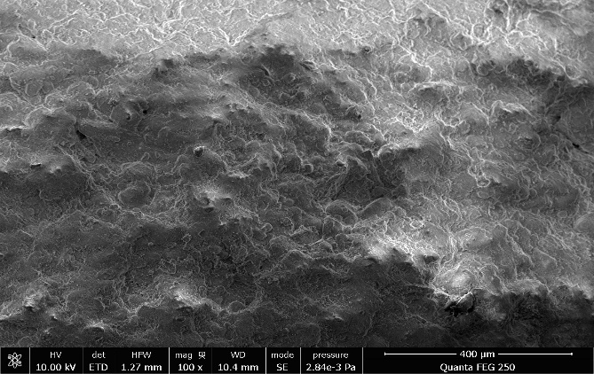
.

(b)
(c)
(d)
(a)
Figure 3: Morphology of clay under scanning electron microscope (SEM). (a), (b), (c) and (d) Magnification respectively 100x; 500x; 1000x and 2500x
The BEM image in Figure 3-(a) shows a stratified agglomerate, with a concretionary appearance that drowns the residual minerals, without any particular shape with some cracks on the observed surface. This observation is more marked when the magnification of this surface successively increases (500x), (1000x) and (2500x) respectively in Figure 3 (b), (c) and (d). These images show a superposition of flattened sheets made up of pseudo-hexagonal geometry platelets stacked on top of each other. This morphology was observed by Ibtissem (2022) and is characteristic of the texture of a poorly crystallinized kaolinite (Kouadio, 2023), (Taupinard, 1976). Indeed, kaolinite has a hexagonal geometrically shaped layered structure presenting defects when it is poorly crystallinized (Cases and al., 1982) or when it is rich in iron (Kouadio, 2023). This irregular shape of kaolinite crystallites is also due to the heat treatment of the clay (Méité, 2019).
Energy dispersive X-ray spectroscopy (EDX) analysis of the sample was carried out in parallel with the SEM results in order to identify the chemical composition of the analyzed clay and the nature of the mineral fillers. Table I and Figure 4 present respectively on the one hand the results of the mass and atomic percentages of the elemental composition of the clay and on the other hand the energy dispersive spectrum (EDX) of the pure clay. The analysis of the results in Table 1 revealed that oxygen, aluminum, silicon, iron, phosphorus and titanium were the chemical elements present in this pure clay sample with the mass and atomic percentages recorded in Table I.
Table I: Mass and atomic percentages of the elemental composition of clay

Elements | O | Al | Si | Fe | P | Ti | C
Masse Percentage (%) | 50,07 | 20,58 | 18,28 | 7,52 | 2,62 | 0,93 | 00,00
Atomic Percentage (%) | 65,44 | 15,95 | 13,61 | 2,82 | 1,77 | 0,41 | 00,00

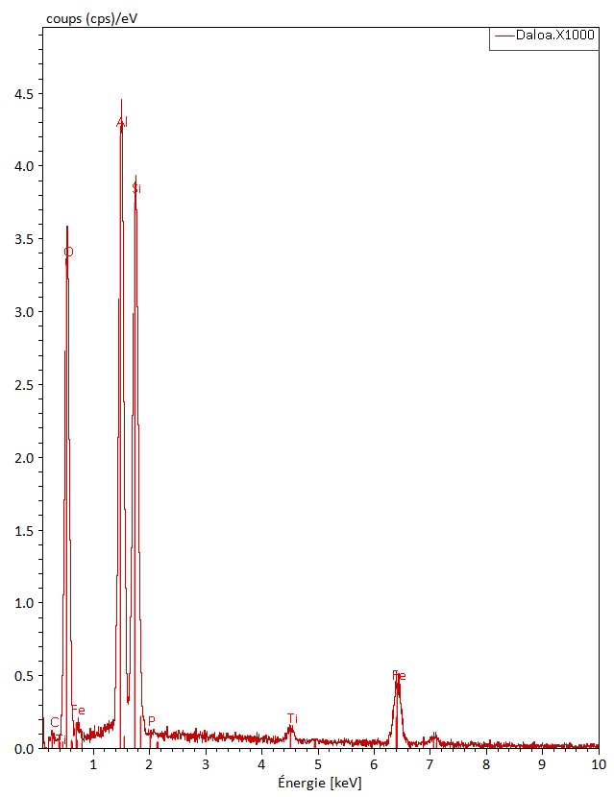
Figure 4: Energy dispersion spectrum (EDX) of pure clay.
As for the spectrogram analysis (Figure 4), it showed that the EDX spectrum of this sample has three large peaks corresponding to the peaks of the elements aluminum (Al), oxygen (O) and silicon (Si). The aluminum peak being the highest. In addition, kaolinite whose basic formula is 2SiO2, Al2O3, 2H2O has a high alumina (Al2O3) content that can reach 35 to 38% when it is of good quality (Moulay and al., 2022). However, the mass percentages of these elements in Table 1 are respectively 18.28%, 50.07% and 20.58%. As well as the graphs constructed from these values ​​show the high content of this clay in these elements. The high percentage value of oxygen is probably due to the presence of water molecules in the interlayer spaces of halloysite (Millogo, 2008), (Kouassi, 2021).
(a) | (b)
Figure 5: Mass percentages (a) and atomic percentages (b) of the constituent elements of the clay sample.
However, the phosphorus revealed by EDX does not appear in the result obtained with DRX. This could be due to a dispersion of phosphorus in the analyzed clay matrix or the phosphorus is present in a non-crystalline form and therefore undetectable by X-ray diffraction. Since X-ray diffraction provides information on the crystalline structure and mineral composition of the clay while EDX identifies the chemical elements present in the sample, without giving information on their structure or oxidation state. The SEM / EDX results, thus corroborating those of X-ray diffraction, show that this clay studied is a kaolinic clay containing several impurities such as high quantities of quartz, iron, titanium and phosphorus.

- Conclusion
The experimental techniques used made it possible to determine the different mineralogical phases, phyllosilicates and the chemical composition of the clay studied. Thus, we were able to establish that this clay is a kaolinic clay represented by its resulting phases of its alteration such as halloysite which is a hydrated kaolinite and dickitis, a monoclinic kaolinite. These results also highlighted the high quartz content of this clay with a high proportion of silica and that the clay is of low porosity with significant quantities of quartz and potentially illite containing iron minerals and traces of other minerals. The preliminary study of this clay was therefore essential before any application in the treatment of effluents and environmental decontamination.

Références
Andriantsiferana, C., Mohamed, E. F., & Delmas, H. (2014). Photocatalytic degradation of an azo-dye on TiO2/activated carbon composite material. Environmental technology, 35(3), 355-363.
Belghazi, A., & Zourgui, B. (2022). Adsorption of methylene blue by chemically modified illite-montmorillonite clay from the Naima region - Tiaret - Algeria [Master's degree]. University of Tissemsilt.
Bey, W. (2015). Preparation and characterization of a nickel/montmorillonite-based catalyst. [Master's thesis]. Saad Dahleb University - Blida.
Bouhoreira, H. (2018). Valorization of clay from the Témacine region in the decontamination of wastewater from the city of Ouargla [Master's thesis]. Kasdi Merbah University - Ouargla.
Cases, J.-M., Liétard, O., Yvon, J., & Delon, J.-F. (1982). Study of the crystallochemical, morphological, and surface properties of disordered kaolinites. Bulletin de Minéralogie, 105(5), 19. https://doi.org/10.3406/bulmi.1982.7566
Charles, N., Collin, S., Gutierrez, T., & Lefebvre, G. (2018). Kaolin and Kaolinic Clays Handbook (BRGM/RP-67334-FR Report 44; p. 93). Geosciences for a Sustainable Earth.
Gourouza, M., Zanguina, A., Natatou, I., & Boos, A. (2013). Characterization of a Mixed Clay from Niger. Rev. CAMES – Sciences Struct. Mat, 1(1), 29 39.
Hénin, S. (1956). Classification of Clay Minerals. Bulletin of the French Clay Group, 8(3), 29-35. https://doi.org/10.3406/argil.1956.932
Ibtissem, S. (2022). Development of a mesoporous MS material from DD3 kaolin. Application to the adsorption of Acid Red (AR 337) and the treatment of a real industrial effluent of the textile type [Thesis]. University of Guelma, May 8, 1945.
Jalil, Ma. E. R., Vieira, R. S., Azevedo, D., Baschini, M., & Sapag, K. (2013). Improvement in the adsorption of thiabendazole by using aluminum pillared clays. Applied Clay Science, 71, 53-63. http://dx.doi.org/10.1016/j.clay.2012.11.005
Khireddine, O. (2016). Study of clay materials and their impact on the adsorption of certain pollutants. [Thesis]. BADJI Mokhtar University, Annaba.
Kouadio, L. M. (2023). Contribution to the assessment of water and soil contamination levels in illegal gold mining sites and elimination of metals (Hg, Pb, Cd) and arsenic from polluted water using clays from Côte d'Ivoire [Thesis]. Félix Houphouët-Boigny University of Cocody, Abidjan, Côte d'Ivoire,
Kouamé, Y. A., Konan, A. S., Kouassi, K., & Koffi, G. R. Y. (2020). Street Food and Health Risks in Daloa (Côte d'Ivoire). Journal of Space, Territories, Societies and Health, 3(5), 25-40.
Kouassi, K. P. (2021). Study of Clayey Sands from Southern Côte d'Ivoire Used in Road Construction: Influence of Treatments with Lime and Cement Mixtures [Thesis]. Félix Houphouët-Boigny National Polytechnic Institute
Kra, A. C., Assalé, F. Y. P., Yao, N. J.-P., Monde, S., Aka, K. (2016). Sedimentological and mineralogical characterization of Tertiary-Quaternary formations in the Anyama region of southern Côte d’Ivoire. European Scientific Journal, 12(3), 251-265. https://doi.org/10.19044/esj.2016.v12n3p251
Liang, H., Wang, Z., Liao, L., Chen, L., Li, Z., Feng, J. (2017). High performance photocatalysts: Montmorillonite supported-nano TiO2 composites. Optik, 136, 44-51.
Méité, N. (2019). Contribution to the development and physicochemical characterization of cassava starch-based bioplastics reinforced with kaolinitic clay [thesis]. FELIX Houphouët-Boigny University.
Mestdagh, M. M., Herbillon, A.-J., Rodrique, L., & Rouxhet, P. G. (1982). Evaluation of the role of structural iron on the crystallinity of kaolinites. Bulletin de Minéralogie, 105(5), 457-466. https://doi.org/10.3406/bulmi.1982.7567
Millogo, Y. (2008). Geotechnical, chemical and mineralogical study of clay and lateritic raw materials from Burkina Faso improved with hydraulic binders: Application to civil engineering (building and road) [Thesis]. University of Ouagadougou
Mishra, A., Mehta, A., Basu, S. (2018). Clay supported TiO2 nanoparticles for photocatalytic degradation of environmental pollutants: A review. Journal of environmental chemical engineering, 6(5), 6088 6107.
Oliveira, W. V. de, Morais, A. I. S., Hororio, L. M. C., Trigueiro, P. A., Almeida, L. C., Garcia, R. R. P., Viana, B. C., Furtini, M. B., Silva - Filho, E. C., & Osajima, J. A. (2020). TiO2 Immobilized on Fibrous Clay as Strategies to Photocatalytic Activity. Materials Research, 23(1), 110.
Razkaoui, A. (1995). Physical and technological study of a hydrated Kaolinite: Halloysite [Thesis]. University of Limoges.
Taupinard, J. (1976). Comparative morphological characteristics of montmorillonite, kaolinite, illite, and gibbsite examined by scanning electron microscopy. Bulletin of the French Society of Mineralogy and Crystallography, 99(4), 246-250.
Yao, K. E. (2021). Spatial dynamics of the city of Daloa (Center-West, Ivory Coast). Specialized scientific journal in Geography, 005, 235-248.

