**Green synthesis, characterization of tetrazole derivatives, and evaluation of bacterial and fungal activity**

**Abstract**

The study involved the use of microwaves to react the prepared hydrazone with sodium azide to form various heterocyclic tetrazole-derived pentacyclics using THF as a solvent. In addition to measuring the prepared compounds' melting points, physical and spectroscopic techniques, including FT-IR spectroscopy, proton spectroscopy, and carbon nuclear magnetic resonance (1H-NMR) and (13C-NMR), were used to verify the synthesis' efficacy and accuracy.Two bacterial isolates were examined to see how the synthesized compounds affected their growth: Staphylococcus aureus, a Gram-positive (G+) bacterium, and E. coli, a Gram-negative (G-) bacterium. Control samples were antibiotics like amoxicillin, and several of the compounds that were made had strong inhibitory action against the bacterial species that were employed.It was also investigated how some of the produced chemicals affected the development of the fungus Candida albicans. Some of the synthesized compounds demonstrated good inhibitory efficacy against the utilized fungus when tested against control samples of medicines like fluconazole.

**Keywords**: heterocyclic , Tetrazoles , bacterial bioactivity , fungal bioactivity .

**1. Introduction**

Due to its importance in pharmacology, the subject of heterocyclic compounds has garnered a lot of interest in recent years [1,2]. In the fields of industrial chemistry, synthetic organic chemistry, and medicine, nitrogenous heterocyclic molecules appear to be especially intriguing vectors [3]. Furthermore, society expects chemists to create more sustainable and environmentally friendly chemical processes. Tetrazoles are significant heterocyclic compounds with five members, consisting of four nitrogen atoms and one carbon atom. Although the study of heterocyclic chemistry has advanced, applied chemistry continues to pay attention to the various uses of tetrazole heterocycles. Tetrazoles were originally synthesized by Bladin in 1855, and since then, there has been an annual growth in the number of articles devoted to their synthesis and uses [4]. Tetrazoles also have a higher heat of formation because they have a higher percentage of nitrogen-nitrogen and carbon-nitrogen bonds. Due to their low ratio of C and H bonds, tetrazoles are extremely resistant to shock, impulse, and electrostatic discharge [5]. The tetrazole ring has been crucial in the development of several bioactive compounds that combat illnesses caused by microorganisms and viruses [6]. Tetrazoles serve as spacers and substitutes for carboxylic acids in pharmaceutical chemistry [7]. Tetrazoles have been used in the development of energy materials. Furthermore, tetrazoles offer the ideal framework for executing synthetic procedures to produce the required heterocyclic units. Furthermore, a key pharmacophore fragment that has been used in the creation of possible anti-cancer drugs is tetrazole, which contains five-membered heterocyclic molecules. Numerous substances have been discovered as promising, including coordination compounds and naturally occurring compounds containing a tetrazole moiety[8]. Previous studies have also shown that the tetrazole ring has high antibacterial activity[9]. This study aims to use alternative and environmentally friendly methods to prepare a number of tetrazole compounds by reacting hydrazones with sodium azide to form pentacycles and to test the sensitivity of these compounds against two types of Gram-positive and Gram-negative bacteria and to test the sensitivity of the compounds against Candida albicans fungus.

**2. Materials and methods**



**2.2. Preparation of Tetrazoles** **derivatives (SU7-SU11) [10,11]**

Equimolar amounts (0.001 mol) of the prepared hydrazone were mixed with sodium azide in 20 ml of THF, and the mixture was heated in a microwave oven at 80°C and 400 W for 8–13 min. The reaction was confirmed using TLC, and the solution was then cooled, filtered, and recrystallized from ethanol, as shown in Table 1.



|  |  |  |  |  |  |
| --- | --- | --- | --- | --- | --- |
| Color | Yield% | m.p. °C | Molecular formula | R | Comp. No. |
| Whit | 80 | 208-210 | C14H15N7O3S2 | OH | SU7 |
| Light Brown | 83 | 223-225 | C14H14N8O4S2 | NO2 | SU8 |
| Orange | 78 | 196-198 | C14H14ClN7O2S2 | Cl | SU9 |
| Yellow | 78 | 227-229 | C16H20N8O2S2 | N(CH3)2 | SU10 |
| Dark Yellow | 85 | 215-217 | C14H15N7O2S2 | H | SU11 |

**2.3. Evaluation of bacterial bioactivity**

Two different bacterial strains were isolated from the Advanced Microbiology Research Laboratory, Department of Life Sciences, College of Pure Science Education, Tikrit University, and used to evaluate the effectiveness of the various prepared compounds. These strains contain a Gram-negative bacteria called Escherichia coli and a Gram-positive bacteria called Staphylococcus aureus[12,13]. Chemical solutions of the prepared compounds were prepared using dimethyl sulfoxide (DMSO) as a solvent for each component at three different concentrations (0.01, 0.001, and 0.0001) mg/ml for each of these solid derivatives[14,15].

**2.4. Evaluation of fungal bioactivity**

One type of fungal isolate was evaluated and obtained from the Advanced Mycological Research Laboratory of the Department of Biology. This isolate was Candida albicans. The fungal suspension was prepared by taking a portion of the pure colony using a sterile loop of Candida aspersa from the plate into a test tube containing 5 ml of distilled water. The tube was incubated at 37°C for 24 hours[16]. The saprophytic culture medium was created by taking 30 g of it and diluting it in 1 liter of water by distillation. The material was disintegrated by heat and movement with the help of a magnetic stirrer. It was sterilized using an autoclave that reached a temperature of 121°C and a pressure of 1.5 bar for 15 minutes. It was reduced to a temperature of 50°C and then placed in Petri dishes and left to solidify at room temperature[17]. Chemical solutions of the prepared compounds were created using DMSO as a solvent for each component at three different concentrations (0.01, 0.001, and 0.0001) mg/ml for each of these solid derivatives[18].

**3. Results and discussion**

Triazole activators were prepared using the microwave method by reacting equal moles of the prepared hydrazines with sodium azide in the presence of THF as a solvent.





**3.1. Characterization of Tetrazole** **derivatives (SU7-SU11)**

In the (FT-IR) spectrum of the prepared compounds (SU7-SU11), it was shown that the (C=N) band, which belongs to hydrazone, disappeared, and two bands appeared at (3310-3279 & 3272-3223) cm-1 for (NH2), a band at (3188-3157) cm-1 for (NH), a band at (3065-3032) cm-1 for (Ar-CH), and two bands at (2955-2918 & 2892-2842) cm-1 for the aliphatic (CH), two bands at (1539-1521 & 1495-1478) cm-1 for (Ar-C=C), a band at (1451-1437) cm-1 for (N=N) indicating the formation of the tetrazole ring, a band at (1108-1091) cm-1 for (C=S)[19,20]. as in Table 2 and Figure 1,2



|  |  |  |  |  |  |  |  |  |  |
| --- | --- | --- | --- | --- | --- | --- | --- | --- | --- |
| **Others** | **ν(C=S)** | **ν(N=N)** | **ν(C=C)**  **Arom.** | **ν(C-H)**  **Aliph.** | **ν(C-H)**  **Arom** | **ν(N-H)** | **ν( NH2)** | **R** | **Comp. No.** |
| ν (OH)3380 | 1108 | 1451 | 1529,1495 | 2950,2889 | 3047 | 3166 | 3310,3258 | OH | SU7 |
| ν (NO)1278,1510 | 1096 | 1448 | 1521,1478 | 2930,2867 | 3056 | 3157 | 3279,3223 | NO2 | SU8 |
| ν (C-Cl)761 | 1091 | 1437 | 1539,1491 | 2918,2842 | 3037 | 3188 | 3306,3255 | Cl | SU9 |
| (C-N) 1243 | 1098 | 1445 | 1533,1484 | 2937,2892 | 3065 | 3170 | 3287,3272 | N(CH3)2 | SU10 |
| -- | 1105 | 1440 | 1512,1480 | 2955,2881 | 3032 | 3176 | 3298,3248 | H | SU11 |

The H-NMR spectrum of [SU7] showed a signal in (11.64) ppm to (OH), two signals in (9.65, 8.70) ppm to the extra-ring amide (NH), multiple signals in (6.88-8.08) ppm to the aromatic ring protons, a signal in (6.26) ppm to (NH2), a signal in (4.86) ppm to (CH), and a signal in (2.08-ppm to (NH) tetrazole, as in Figure 3.

The H-NMR spectrum of [SU9] showed two signals in (8.00, 9.72) ppm to the extra-ring amide (NH), multiple signals in (6.99–7.87) ppm to the aromatic ring protons, a signal in (6.09) ppm to (NH2), a signal in (5.18) ppm to (CH), and a signal in (2.15) ppm to (NH) tetrazole. As shown in Figure 4,

the 13C-NMR spectrum of [SU7] showed a signal in (180.00) ppm to (C=S), signals in (123.32–153.87) ppm to the benzene rings, and a signal in (95.97) ppm to (CH) tetrazole. As shown in Figure 5,

the 13C-NMR spectrum of [SU9] shows a signal in (183.06) ppm to (C=S), signals in (122.77-148.95) ppm to the benzene rings, and a signal in (96.56) ppm to (CH) tetrazole. As shown in Figure 6.





















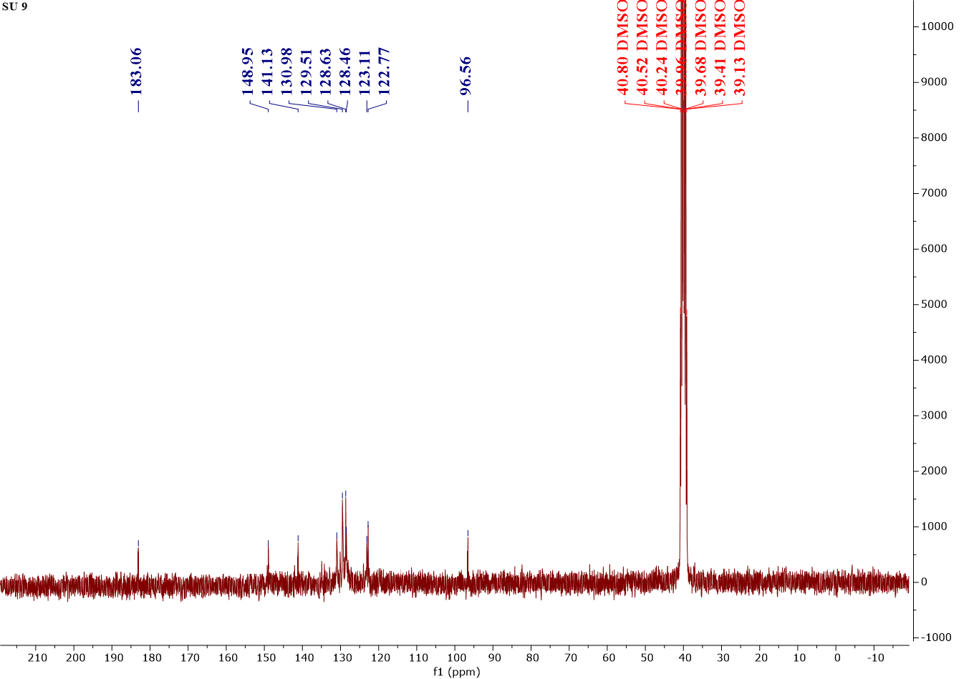



**3.2. Bacterial susceptibility to prepared compounds**

Mueller-Hinton agar (MHA) medium was coated with a sterile cotton ball after inserting it into tubes containing diluted bacterial cultures. The ball was then removed by pressing it against the inner walls of the tube. The culture medium was then rubbed in three different directions to spread the inoculum evenly. The plates were left for 10-15 minutes to absorb the culture and dry the medium. The plates were then incubated at 37°C for 24 hours[21,22]. The results were then read after 24 and 48 hours to demonstrate the sensitivity of the compounds used, which is based on the apparent diameter of the inhibitory zone around the holes used. Increasing the inhibitory zone increases the biological efficacy of the prepared compounds[23,24]. Compared to the diameter of the inhibitory zone of standard antibiotics such as amoxicillin, the compounds showed a lack of efficacy against E. coli bacteria, which reached 10 mm in diameter for most compounds at a concentration of 10 mg/ml. As for Staphylococcus aureus, the compounds showed high activity comparable to antibiotics, indicating their potential use as pharmaceutical compounds. Compound (SU7) showed the highest activity, reaching 30 mg/ml at its highest concentration[25,26], as shown in Table 3, Scheme 2, and Figures 7 and 8.

Table 3- antibacterial activity of the synthesized compounds (inhibition zone in mm)

|  |  |  |  |  |  |  |
| --- | --- | --- | --- | --- | --- | --- |
| **Comp**  **No.** | **E.coli mg/ml** | | | **Staph. aureus mg/ml** | | |
| **0.01** | **0.001** | **0.0001** | **0.01** | **0.001** | **0.0001** |
| SU7 | 10 | 10 | 10 | 30 | 25 | 18 |
| SU8 | 10 | 5 | 5 | 20 | 16 | 10 |
| SU9 | 10 | 10 | 5 | 15 | 10 | 5 |
| SU10 | 5 | 5 | 0 | 25 | 20 | 13 |
| SU11 | 10 | 5 | 5 | 20 | 10 | 5 |
| Amoxicillin | 20 | 15 | 15 | 35 | 30 | 25 |







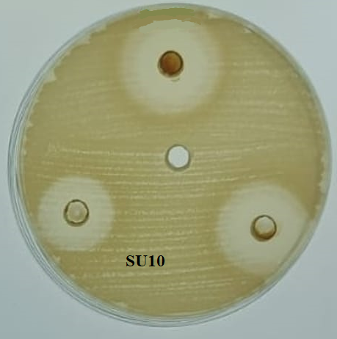



**3.3. fungal susceptibility to prepared compounds :**

Using the agar diffusion method, the efficacy of the synthesized compounds on the fungus was evaluated, and the types and amounts of bonds that were formed with amino acid residues at the active site were evaluated. A 6 mm diameter cork drill was used to create holes in Petri plates using the cylindrical metric technique after the culture media had been inoculated with an isolated Candida albicans fungus[27]. 20–100 μL of the synthesized compounds in three concentrations were added to each well. For a whole week, the Petri plates were kept in an incubator set at 37°C. The sensitivity of the utilized derivative, which is dependent on the inhibitory diameter observable in the Petri dish around the used well, was determined by reading the findings after 7–14 days[28]. When compared to the inhibitory substance, a greater bioavailability of the produced compound is shown by a rise in the inhibitory diameter. the typical antibiotics' diameter. Depending on the antibiotic being used, several common antibiotics in solution form, including fluconazole quinate, were employed as controls. According to tests conducted by the World Health Organization and the Ministry of Health, the inhibitory impact is stronger at doses of 0.0001 mg/ml and weaker at 0.01 and 0.001 mg/ml[28]. as shown in Table 4 and Figure 9.



|  |  |  |  |
| --- | --- | --- | --- |
| **Comp**  **No.** | ***Candida albicans mg/ml*** | | |
| **0.01** | **0.001** | **0.0001** |
| SU7 | 15 | 10 | 5 |
| SU8 | 8 | 4 | 2 |
| SU9 | 14 | 5 | 2 |
| SU10 | 7 | 4 | 0 |
| SU11 | 10 | 4 | 3 |
| Fluconazole | 39 | 28 | 17 |





**4. Conclusions**

The reaction of the azomethine group in hydrazones with sodium azide always forms pentacyclic rings derived from tetrazole. The use of microwave in the synthesis of compounds is safer than the traditional method and has a lower economic cost and faster production time compared to traditional methods, as well as a high yield rate; the prepared compounds showed high purity, especially in NMR and IR spectra, and the prepared compounds showed high activity against Staph. Staph. Aureus and moderate efficacy against E. coli, the prepared compounds showed good efficacy at high concentrations against Candida albicans.

**References**

1. Cabrele, C., & Reiser, O. (2016). The modern face of synthetic heterocyclic chemistry. *The Journal of Organic Chemistry*, *81*(21), 10109-10125.‏
2. Morjan, R. Y., Al-Attar, N. H., Abu-Teim, O. S., Ulrich, M., Awadallah, A. M., Mkadmh, A. M., ... & Gardiner, J. M. (2015). Synthesis, antibacterial, and QSAR evaluation of 5-oxo and 5-thio derivatives of 1, 4-disubstituted tetrazoles. *Bioorganic & medicinal chemistry letters*, *25*(18), 4024-4028.‏
3. Bommagani, S., Penthala, N. R., Balasubramaniam, M., Kuravi, S., Caldas-Lopes, E., Guzman, M. L., ... & Crooks, P. A. (2019). A novel tetrazole analogue of resveratrol is a potent anticancer agent. *Bioorganic & medicinal chemistry letters*, *29*(2), 172-178.‏
4. Benson, F. R. (1947). The chemistry of the tetrazoles. *Chemical Reviews*, *41*(1), 1-61.‏
5. Gao, H., & Shreeve, J. N. M. (2011). Azole-based energetic salts. *Chemical reviews*, *111*(11), 7377-7436.‏
6. Malik, M. A., Wani, M. Y., Al-Thabaiti, S. A., & Shiekh, R. A. (2014). Tetrazoles as carboxylic acid isosteres: chemistry and biology. *Journal of Inclusion Phenomena and Macrocyclic Chemistry*, *78*, 15-37.‏
7. Wittenberger, S. J. (1994). Recent developments in tetrazole chemistry. A review. *Organic Preparations and Procedures International*, *26*(5), 499-531.‏
8. Manzoor, S., Yin, X., & Zhang, J. G. (2021). Nitro-tetrazole based high performing explosives: Recent overview of synthesis and energetic properties. *Defence Technology*, *17*(6), 1995-2010.‏
9. Abdul Wahed Abdul, S. T., Mohammed Jwher, S., & Jamil Nadhem, S. (2024). Preparation, Characterisation and Study of the Molecular Docking of Some Derivatives of the Tetrazole Ring and Evaluation of their Biological Activity. *World of Medicine: Journal of Biomedical Sciences*, *1*(7), 15-23.‏
10. Adil Hussein, D., Mohammed, J. S., & Jamil Nadhem, S. (2024). Green synthesis, characterization, and multifaceted evaluation of thiazolidinone derivatives: A study on biological and laser efficacy. *European Journal of Modern Medicine and Practice*, *4*(7), 155-168.‏
11. Alasadi, Y. K., Jumaa, F. H., Dalaf, A. H., Shawkat, S. M., & Mukhlif, M. G. (2022). Synthesis, Characterization, and Molecular Docking of New Tetrazole Derivatives as Promising Anticancer Agents. *Journal of Pharmaceutical Negative Results*, *13*(3), 513-522.‏
12. Khairallah, B. A., Muhammad, F. M., Saleh, J. N., & Saleh, M. J. (2024). Preparation, Characterization, Biological Activity Evaluation, and Liquid Crystallography Study of New Diazepine Derivatives. *World of Medicine: Journal of Biomedical Sciences*, *1*(7), 65-76.‏
13. Mohammed Jwher Saleh, Jamil Nadhem Saleh, Khalid Al-Badrany, Adil Hussein Dalaf, Reem Suhail Najm, & Abdul Wahed Abdul Sattar Talluh. (2024). Preparation And Evaluation Of The Biological Activity Of A 2- Amino Pyran Ring Using A Solid Base Catalyst. *Central Asian Journal of Medical and Natural Science*, *5*(4), 130 - 138.
14. Talluh, A. W. A. S., Saleh, M. J., Saleh, J. N., Al-Badrany, K., & mohammed saleh Al-Jubori, H. (2024). Preparation, characterization, and evaluation of the biological activity of new 2, 3-dihydroquinazoline-4-one derivatives. *EUROPEAN JOURNAL OF MODERN MEDICINE AND PRACTICE*, *4*(4), 326-332.‏
15. Talluh, A. W. A. S., Najm, R. S., Saleh, M. J., & Saleh, J. N. (2024). Synthesis, Characterization, and Evaluation of the Biological Activity of Novel Oxazepine Compounds Derived From Indole-5-Carboxylic Acid. *American Journal of Bioscience and Clinical Integrity*, *1*(8), 10-19.‏
16. Rasheed, M. K., Al-rifaie, D. A., & Madab, D. I. (2021). Synthesis and evaluation of antibacterial and antifungal activity of new 1, 5-benzodiazepine derivatives contain cyclic Imides and mannich bases. *Int. J. Pharm. Res.*, *13*, 2175.‏
17. AbdAlkreem Al-Rifaie, D., & Rasheed, M. K. . (2022). Synthesis and Characterization of Some Nano Composites of Derivations Benzimidazole and Study its activity anti bacteria and antifungal. *Samarra Journal of Pure and Applied Science*, *4*(2), 83–106.
18. Rasheed, M. K., & Al-Rifaie, D. A. (2020). Synthesis some of thiazolidinoneand tetrazole compounds derived from acriflavine and evaluation of their antimicrobial, antifungal and antioxidant activity. *Systematic Reviews in Pharmacy*, *11*(12), 1889-1895.‏
19. Dalal, M. J., & Mekky, A. H. (2022). Synthesis, Characterization and Antioxidant Evaluation of Some Tetrazole Derivatives. *Indonesian Journal of chemistry*, *22*(6), 1596-1604.‏
20. Khurshid, M. N., Jumaa, F. H., & Jassim, S. S. (2022). Synthesis, characterization, and evaluation of the biological activity of tetrazole compounds derived from the nitrogenous base uracil. *Materials Today: Proceedings*, *49*, 3630-3639.‏
21. Sattar Talluh, A. W. A., Saleh, J. N., Saleh, M. J., & Saleh Al-Jubori, H. M. (2024). Preparation and Characterization of New Imidazole Derivatives Derived From Hydrazones and Study of their Biological and Laser Efficacy. *Central Asian Journal of Theoretical and Applied Science*, *5*(4), 202-211.
22. Rasheed, M. K., Al-Rifaie, D. A., & Alsammarraie, H. J. M. (2021). Synthesis of fused pyrimidines derivatives and mannich bases and assess of their antibacterial activity, laser efficacy and molecular docking, Biochem. *Cell. Arch*, *21*(2), 4847-4854.‏
23. Saleh, M. M., Saleh, J. N., Rokan, F. F., & Saleh, M. J. (2024). Synthesis, Charactarizit and evaluation of bacterial efficacy and study of molecular substrates of cobalt (II) complex [Co (2-(benzo [d] thiazol-2-yloxy) acetohydrazide)(H2O)(Cl2)]. *Central Asian Journal of Medical and Natural Science*, *5*(4).‏
24. Talluh, A. W. A. S., Saleh, M. J., Saleh, J. N., & Al-Jubori, H. M. S. (2024). Synthesis and Characterization of Some New Imine Graphene Derivatives and Evaluation of Their Biological Activity. *Central Asian Journal of Medical and Natural Science*, *5*(4), 272-290.
25. Abdul Wahed, A. S. T. (2024). Preparation and Evaluation of Bacterial Activity and Study of the Crystalline Properties of Some 1, 3-Oxazepine-4, 7-Dione Derivatives. *Central Asian Journal of Theoretical and Applied Sciences*, *5*(2), 15-26.‏
26. NAJM, R. S. (2019). Synthesis and biological activity evaluation of some new pyrazole derivatives. *International Journal of Pharmaceutical Research*, *11*(1).‏
27. Huang, M., Duan, W. G., Lin, G. S., & Li, B. Y. (2021). Synthesis, antifungal activity, 3D-QSAR, and molecular docking study of novel menthol-derived 1, 2, 4-triazole-thioether compounds. *Molecules*, *26*(22), 6948.‏
28. Yin, X., Wang, L., Liu, S., & Li, Y. (2023). Design, synthesis, and antifungal activity of novel 2-Ar-1, 2, 3-triazole derivatives. *Journal of Agricultural and Food Chemistry*, *71*(43), 15963-15970.‏
29. Guzel, E., Acar Çevik, U., Evren, A. E., Bostancı, H. E., Gul, U. D., Kayış, U., ... & Kaplancıklı, Z. A. (2023). Synthesis of benzimidazole-1, 2, 4-triazole derivatives as potential antifungal agents targeting 14α-demethylase. *ACS omega*, *8*(4), 4369-4384.‏