**THERMAL ANALYSIS OF SOME OXIMINO COMPLEXES TO CONFIRM THE COMPLEX FORMATION THROUGH DECOMPOSITION PATTERNS**

**Abstract**

The preparation and characterization of L1= malon-di-anilide oxime (HINMAO), L2= malon-di-(p-toluidide) oxime (HINM-p-TO), L3= malon-di-(o-anisidide) oxime (HINM-o-ANISO), and L4= malon-di-(p-anisidide) oxime (HINM-p-ANISO), along with their complexes with copper(II) acetate, copper(II) nitrate, uranyl(II) nitrate, manganese(II) chloride, and lead(II) acetate in the solid state have been communicated.

The copper(II) complexes -Cu(INMAO)ac, Cu(INMAO)NO3, Cu(INM-p-TO)ac, Cu(INM-p-TO)NO3, Cu(INM-o-ANISO)ac, Cu(INM-o-ANISO)NO3, Cu(INM-p-ANISO)ac, and Cu(INM-p-ANISO)NO3; the uranyl complexes UO2(INMAO)2, UO2(INM-p-TO)2, UO2(INM-o-ANISO)2, UO2(INM-p-ANISO)2; the manganese(II) complexes Mn(INMAO)2, Mn(INM-p-TO)2, Mn(INM-o-ANISO)2, Mn(INM-p-ANISO)2; the lead(II) complexes Pb(INMAO)2, Pb(INM-p-TO)2, Pb(INM-o-ANISO)2, Pb(INM-p-ANISO)2 are all subjected to thermal analysis, including thermogravimetric (TG), differential thermal (DTA), and differential thermogravimetric (DTG) methods. Kinetic parameters such as reaction order, activation energy, heat changes, and thermal stabilities -were calculated using Freeman-Carroll equations and the “peak-and-area” method. Confirmation of the complex formation with these metal complexes is established with the decomposition reaction patterns observed in the trends from the thermal decompositions.

**Keywords:** Freeman and Carroll equation; peak and area method, thermal reaction patterns, kinetic parameters, reaction order and activation energy.

**1.0 Introduction**

We have recently published (1) our work (2) focusing on the synthesis and characterization of malon-di-(α-naphthyl)amide-oxime(isonitroso-malon-di-(α-naphthyl)amineoxime, abbreviated as HINMANAP) with a detailed discussion on the oximes and its complexes with Cu(II), Ni(II), Fe(II), Co(III), Zn(II), Cd(II), and Hg(II). These complexes were isolated in solid form, using solution studies for determining the metal-to-ligand ratios. Their structures were analyzed using magnetic measurements, infrared, electronic, reflectance, ESR and PMR spectroscopy. A similar, extension of work on oximes (3) is communicated with the preparation and characterization of L1= malon-di-anilide oxime (HINMAO), L2= malon-di-(p-toluidide) oxime (HINM-p-TO), L3= malon-di-(o-anisidide) oxime (HINM-o-ANISO), and L4= malon-di-(p-anisidide) oxime (HINM-p-ANISO), along with their complexes with copper(II) acetate, copper(II) nitrate, uranyl(II) nitrate, manganese(II) chloride, and lead(II) acetate in the solid state, with magnetic and spectroscopic studies (4). Presently, the thermal analysis for these complexes is outlined in the following discussion.

**2.0 Experimental methods**

All chemicals, including cupric chloride, cupric nitrate, uranyl nitrate, manganese chloride, lead acetate, nickel chloride, cobalt chloride, zinc sulphate, cadmium bromide, ferrous ammonium sulphate, benzene, acetone, chloroform, and pyridine, were of AR or LR grade. LR-grade chemicals were purified prior to use. Double-distilled conductivity water was used throughout. Ethyl alcohol was filtered and fractionally distilled at 77–78 °C over anhydrous calcium oxide; ether was distilled and dried over sodium metal; pyridine was distilled at 114–118 °C over sodium hydroxide pellets; ethyl acetate at 77–78 °C; chloroform at 65 °C over anhydrous calcium chloride; and acetone was distilled. Buffers for solution studies included N/20 potassium hydrogen phthalate (pH 4) and N/100 sodium tetraborate (pH 9.2) for pH meter calibration (3), and sodium acetate-acetic acid buffers for pH 6–7.5. Glass apparatus, including burettes, pipettes, and standard flasks, were calibrated by standard methods (3).

**2.1 Equipment used are:**

An analytical balance with 0.1 mg sensitivity was calibrated using the method described by Scott (3). Ultraviolet absorption measurements were performed on a Systronic MK II 106 spectrophotometer, calibrated with 0.004% K₂CrO₄ solution in 0.05M potassium hydroxide and 0.0062% potassium permanganate solution. The observed spectra aligned well with reported literature values (3). Reflectance spectra of solid complexes were recorded using a CZ VSU 2-P spectrophotometer from Germany, calibrated with a standard magnesium carbonate block. Infrared spectra were obtained in KBr using a Beckman IR 20 spectrophotometer from USA. pH measurements were made using a Model LI-10 pH meter of ELICO Pvt Ltd., Hyderabad, India with glass and calomel electrodes. Conductivity was measured using a Magic Eye conductivity bridge supplied by Toshniwal. CHN were estimated by microanalytical method. Magnetic susceptibility measurements by Gouy’s method (3). Thermal analysis of complexes was carried out on Mettler thermoanalyser using Al2O3 as a reference material, heating rate of 10 0C/min was employed for all the samples (4).

**2.2 Preparation of reagents:**

L1= Malon-di-anilide oxime (HINMAO), L2= Malon-di-(p-toludide) oxime (HINM-p-TO), L3= Malon-di-(o-anisidide) oxime (HINM-o-ANISO) and L4= Malon-di-(p-anisidide) oxime (HINM-p-ANISO). These reagents are prepared according to the procedure described in the literature (3). These mesoximes are prepared in two stages: (i) preparation of an amide and (ii) Converting an amide into an oxime. They were all characterized by analytical and spectral methods of analysis (3), Table 1 and Table 2 give the relevant data and are reproduced below.

**Table 1: Analytical data for the reagents synthesized**

|  |  |  |  |  |  |  |  |  |  |  |
| --- | --- | --- | --- | --- | --- | --- | --- | --- | --- | --- |
| **Oxime** | | **Molecular formula** | **C%** | | **H%** | | **N%** | | **M pt** | |
| **Found** | **Expt.** | **Found** | **Expt** | **Found** | **Expt** | **0C** |
| L1 | HINMAO | C5H13N3O3 | 62.70 | 63.60 | 4.60 | 4.90 | 15.10 | 14.70 | 124 |
| L2 | HINM-p-TO | C17H17N3O3 | 65.90 | 65.70 | 5.90 | 5.40 | 13.20 | 13.50 | 124 |
| L3 | HINM-o-ANISO | C17H17N3O5 | 59.50 | 59.48 | 5.10 | 4.95 | 12.10 | 12.25 | 189 |
| L4 | HINM-p-ANISO | C17H17N3O5 | 59.40 | 59.48 | 5.10 | 4.96 | 12.30 | 12.25 | 177 |

**Table 2: Electronic and Infrared data for the reagents synthesized**

|  |  |  |  |  |  |  |  |
| --- | --- | --- | --- | --- | --- | --- | --- |
| **Oxime** | | **Electronic spectra** **cm-1** | **Infra Red spectra cm-1** | | | | |
| free -OH group | NH Vibration | Free C=O | C=N stretching | N-O stretching |
| L1 | HINMAO | 24,200 | 3360 | 3020 | 1680 | 1590 | 1240 |
| L2 | HINM-p-TO | 23,500 | 3320 | 3010 | 1670 | 1590 | 1240 |
| L3 | HINM-o-ANISO | 25,000 | 3340 | 3030 | 1660 | 1590 | 1250 |
| L4 | HINM-p-ANISO | 25,000 | 3320 | 3020 | 1660 | 1580 | 1240 |

**3.0 Thermal methods of analysis:**

All the eight green Cu(II) complexes, four yellow UO2(II) complexes, four red Mn(II) complexes and four yellow Pb(II) complexes were subjected to Thermogravimetric analysis (TGA), Differential thermal analysis (DTA) and Differential thermal gravimetry (DTG) (5-9).

The loss in weight due to thermal decomposition as observed at different temperatures in TGA was calculated and plotted against the temperatures respectively for each of the complexes, Tables 3-18. The thermograms (these look very similar to the thermograms shown in reference 5) (Figs 1 to 36) of the metal complexes indicates the nature of the decomposition involved, which could be classified broadly into two categories **(a) successive reaction and (b) simultaneous reaction**. All the metal complexes except uranyl(II) exhibit successive reaction whereas UO2(II) complexes exhibit simultaneous reaction.

It is observed that all the eight Cu(II) (Figs 1,3,5,7,9,11,13,15), four Mn(II) (Figs17,19,21,23), four Pb(II) (Figs 25,27,29,31) and four UO2(II) (33,34,35,36) complexes do not show any loss up to 2000C indicating that these complexes do not contain water of hydration. This is in agreement with the finding of infrared spectral data which do not show any band in the region 3600-3300 cm-1.

It is observed that metal complexes of L1=HINMAO (ac, NO3) are more stable as compared to L2=HINM-p-TO (ac, NO3) and L3=HINM-o-ANISO (ac, NO3) and L4=HINM-p-ANISO (ac, NO3) complexes because steric hindrance due to comparatively bulky -CH3 and -OCH3 cause strain in chelate ring resulting in decrease in thermal stability.

**3.1 Evaluation of kinetic parameters**

1) Energy of activation and

2) Order of reaction

The determination of kinetic parameters from TGA have been widely reviewed (8,9). The difference differential method of Freeman and Carroll (10,11) is most widely used to evaluate these parameters from the kinetic analysis of TGA data. This method gives us equation:

{(Δ log dw/dT)/(Δ log Wr)} = { – (Ea/2.303R) x [(Δ 1/T)/(Δ log Wr)] + n}

From the above equation a plot of (Δlog dw/dT)/(Δlog Wr) vs (Δ(1/T)/Δ log Wr) provides a linear relationship whose slop will afford the value of Ea/2.303R and whose intercept on x-axis, the value of n. Thus, the values of kinetic parameters for all the eight green Cu(II) , four Mn(II), four Pb(II) complexes in which the decomposition are found to follow successive reactions were evaluated. All graphs look exactly like the ones that are given in reference 5.

The method of evaluation of activation energy and order of reaction is given as follows: (Figs 2,4,6,8,10,12,14,16,18,20,22,24,26,28,30,32)

First graph ‘a’ was plotted as dw, that is, weight loss at different points against the corresponding temperature, dT in Kelvin scale. The slop values were taken at each point. The logarithm of slop value that is Δlog dw/dT was plotted against the logarithm values of Wr [Δlog of (final weight loss-corresponding weight loss) at each point in graph ‘b’. The slope values were evaluated for these points. The graph ‘c’ was obtained by plotting Δ1/T vs Δ log Wr; slope values at each point were also obtained. The slop values of graph ‘b’ vs the slop values of graph ‘c’ were plotted in graph ‘d’ which shows a linear relationship. The slop values of this graph is used to calculate the Ea and the intercept on the x axis gives the order of reaction (n).

By integrating the area under the peak, one can determine quantitatively, the heat absorbed or released during the event, which is crucial for understanding the material's thermal behaviour. All the complexes decompose exothermically, the first exothermic decomposition supplies heat to the system hence second and third step follow over a narrow temperature range.

Enthalpy changes of Cu(II), Mn(II) and Pb(II) complexes were evaluated by ‘peak and area’ method as recommended by Murphy (12). These enthalpy changes are for gases decomposition process involving different bond making and breaking. Therefore, no definite trend could be obtained from this data. It would be essential to know details of each individual process.

**Table 3: Statement showing coordinates of graphs required for Freeman and Carroll equation for Cu(L1)ac complex for evaluation of kinetic parameters. Ea = 22.07 Kcal/mole; n = 0.78; (Δ log dw/dT)/(Δ log Wr) = - Ea/2.303R [(Δ 1/T)/(Δ log Wr)] + n**

|  |  |  |  |  |  |  |  |  |
| --- | --- | --- | --- | --- | --- | --- | --- | --- |
| **Temperature T K** | **Weight loss (dw)** | **Slope values dw/dT** | **Δ log dw/dT\*** | **Wr = (Wc-W)** | **Δ log Wr\*** | **Slope values 4 vs 6** | **Δ 1/T x 10-4** | **Slope values Δ 1/T vs Δ log Wr** |
| 573 | 0.6010 | - | - | 12.95 | $\overline{1}$.1123 | - | 17.45 | - |
| 648 | 7.55 | 0.048 | $\overline{2}$.6812 | 6.01 | 0.7789 | 3.0 | 15.43 | 1.2 |
| 723 | 9.70 | 0.020 | $\overline{2}$.3010 | 3.86 | 0.5866 | 0.7 | 13.83 | 1.0 |
| 798 | 10.38 | 0.018 | $\overline{2}$.2553 | 3.18 | 0.5024 | 0.6 | 12.53 | 0.8 |
| 873 | 11.93 | 0.015 | $\overline{2}$.1761 | 1.63 | 0.2122 | 0.5 | 11.45 | 0.6 |
| 948 | 12.96 | 0.012 | $\overline{2}$.0792 | 0.60 | $\overline{1}$.7782 | 0.3 | 10.54 | 0.4 |
| 1023 | 13.56 | 0.008 | - | - | - | - | 9.77 | - |

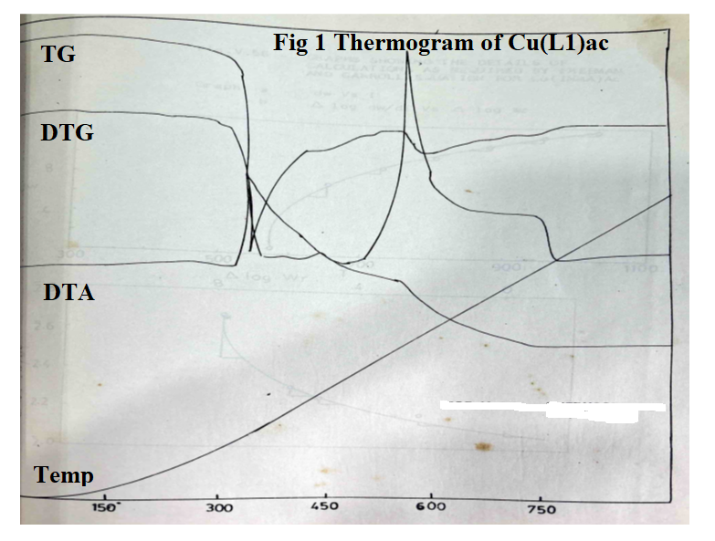

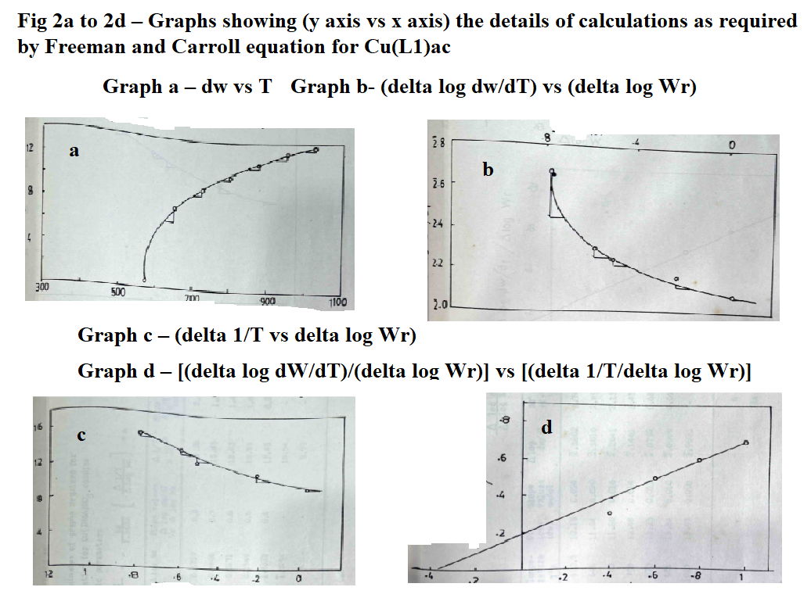

**Table 4: Statement showing coordinates of graphs required for Freeman and Carroll equation for Cu(L1)NO3 complex for evaluation of kinetic parameters. Ea = 11.03 Kcal/mole; n = 0.8; (Δ log dw/dT)/(Δ log Wr) = - Ea/2.303R [(Δ 1/T)/(Δ log Wr)] + n**

|  |  |  |  |  |  |  |  |  |
| --- | --- | --- | --- | --- | --- | --- | --- | --- |
| **Temperature T K** | **Weight loss (dw)** | **Slope values dw/dT** | **Δ log dw/dT\*** | **Wr = (Wc-W)** | **Δ log Wr\*** | **Slope values 4 vs 6** | **Δ 1/T x 10-4** | **Slope values Δ 1/T vs Δ log Wr** |
| 610.5 | 10.19 | 0.024 | $\overline{2}$.3802 | 3.74 | 0.5727 | 0.8 | 16.38 | 2.0 |
| 648 | 11.04 | 0.020 | $\overline{2}$.3010 | 2.89 | 0.4608 | 0.7 | 15.45 | 1.8 |
| 723 | 11.80 | 0.016 | $\overline{2}$.2041 | 2.13 | 0.3271 | 0.6 | 13.83 | 1.4 |
| 798 | 12.48 | 0.014 | $\overline{2}$.1461 | 1.45 | 0.1599 | 0.5 | 12.53 | 1.0 |
| 873 | 13.25 | 0.012 | $\overline{2}$.0792 | 0.68 | $\overline{1}$.8325 | 0.4 | 11.45 | 0.8 |
| 948 | 13.84 | 0.010 | $\overline{2}$.0000 | 0.09 | $\overline{1}$.9294 | - | 10.54 | - |
| 1023 | 13.93 | 0.008 | 3.9031 | - | - | - | 9.77 | - |

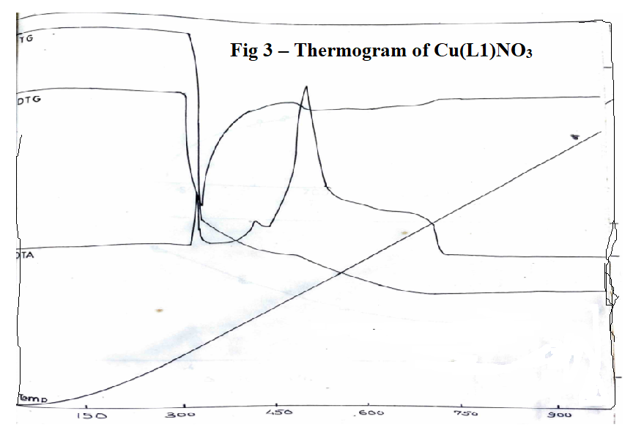

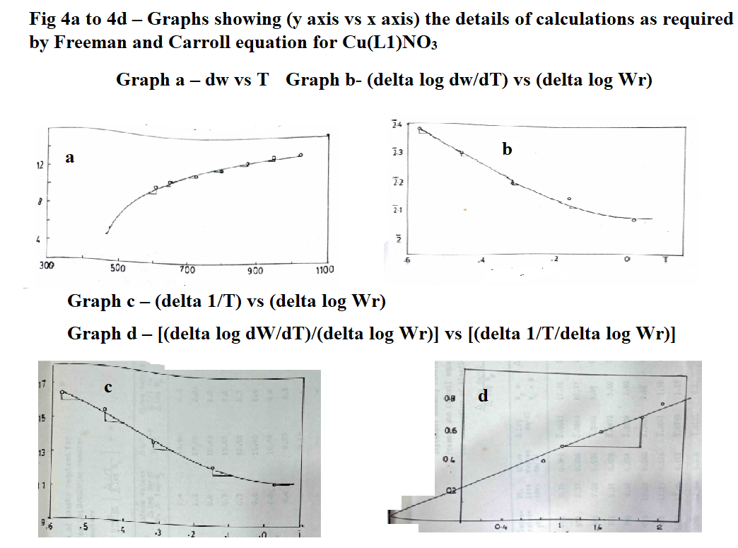

**Table 5: Statement showing coordinates of graphs required for Freeman and Carroll equation for Cu(L2)ac complex for evaluation of kinetic parameters. Ea = 20.96 Kcal/mole; n = 0.15; (Δ log dw/dT)/(Δ log Wr) = - Ea/2.303R [(Δ 1/T)/(Δ log Wr)] + n**

|  |  |  |  |  |  |  |  |  |
| --- | --- | --- | --- | --- | --- | --- | --- | --- |
| **Temperature T K** | **Weight loss (dw)** | **Slope values dw/dT** | **Δ log dw/dT\*** | **Wr = (Wc-W)** | **Δ log Wr\*** | **Slope values 4 vs 6** | **Δ 1/T x 10-4** | **Slope values Δ 1/T vs Δ log Wr** |
| 498 | 0.76 | 0.040 | $\overline{2}$.6021 | 12.38 | $\overline{1}$.0927 | 1.4 | 20.80 | 4.0 |
| 573 | 2.37 | 0.036 | $\overline{2}$.5563 | 10.77 | $\overline{1}$.0304 | 1.2 | 17.45 | 2.2 |
| 648 | 7.20 | 0.032 | $\overline{2}$.5051 | 5.94 | 0.7738 | 0.8 | 15.43 | 1.0 |
| 723 | 8.14 | 0.028 | $\overline{2}$.4472 | 5.00 | 0.6990 | 0.7 | 13.83 | 0.8 |
| 798 | 9.24 | 0.024 | $\overline{2}$.3802 | 3.90 | 0.5911 | 0.7 | 12.53 | 0.7 |
| 873 | 10.26 | 0.020 | $\overline{2}$.3010 | 2.88 | 0.4594 | 0.6 | 11.45 | 0.6 |
| 948 | 11.19 | 0.016 | $\overline{2}$.2041 | 1.95 | 0.2900 | 0.5 | 10.54 | 0.4 |
| 1023 | 11.95 | 0.012 | $\overline{2}$.0792 | 1.19 | 0.0755 | 0.4 | 9.77 | 0.3 |
| 1098 | 12.63 | 0.008 | 3.9031 | 0.51 | $\overline{1}$.7076 | - | 9.10 | - |
| 1173 | 13.14 | - | - | - | - | - | - | - |

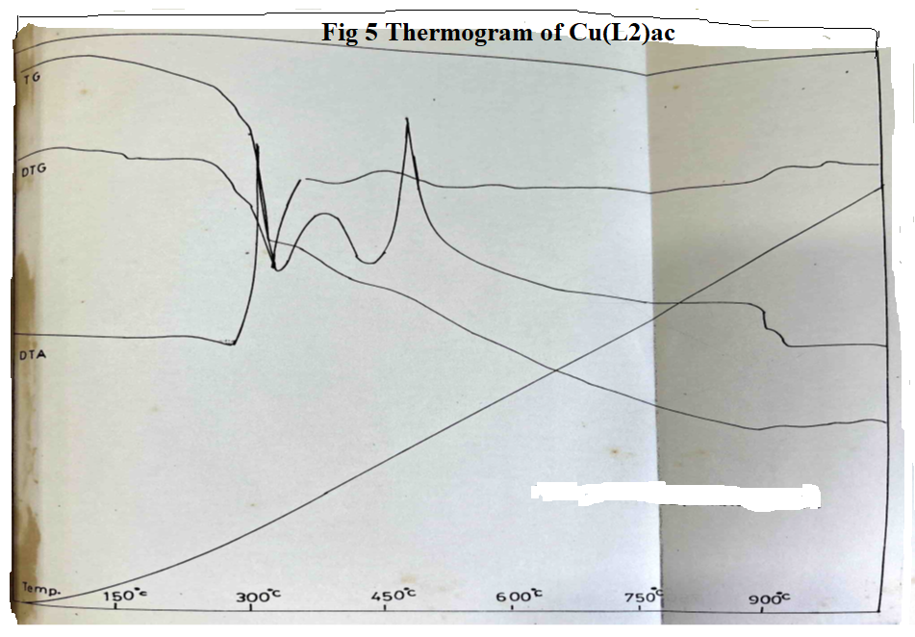

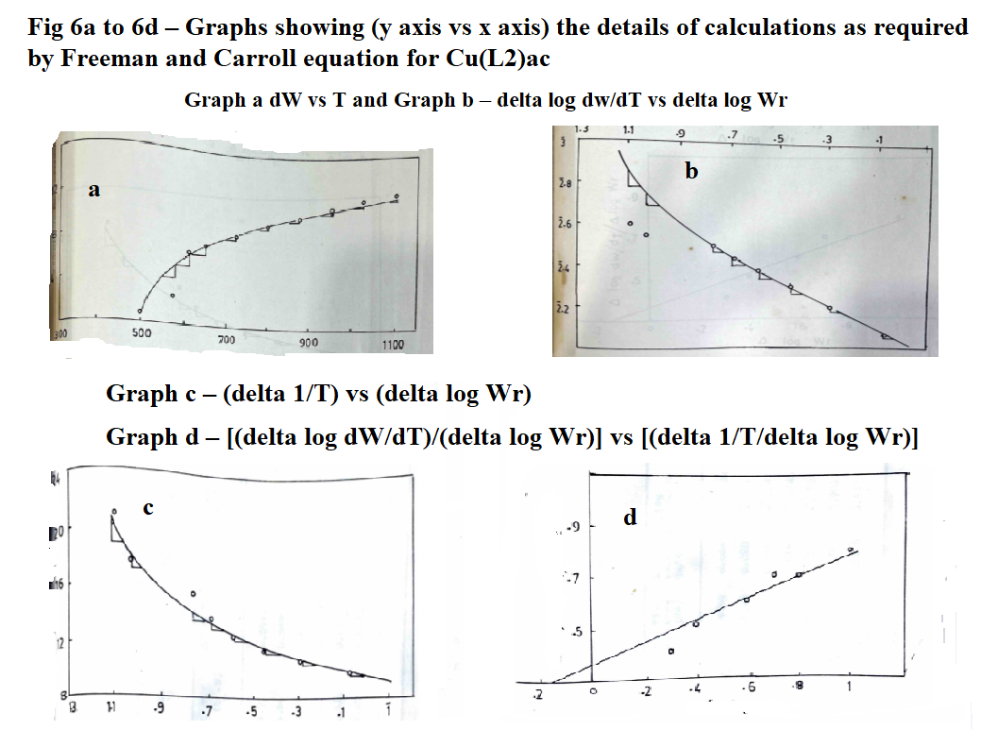

**Table 6: Statement showing coordinates of graphs required for Freeman and Carroll equation for Cu(L2)NO3 complex for evaluation of kinetic parameters. Ea = 19.42 Kcal/mole; n = 0.7; (Δ log dw/dT)/(Δ log Wr) = - Ea/2.303R [(Δ 1/T)/(Δ log Wr)] + n**

|  |  |  |  |  |  |  |  |  |
| --- | --- | --- | --- | --- | --- | --- | --- | --- |
| **Temperature T K** | **Weight loss (dw)** | **Slope values dw/dT** | **Δ log dw/dT\*** | **Wr = (Wc-W)** | **Δ log Wr\*** | **Slope values 4 vs 6** | **Δ 1/T x 10-4** | **Slope values Δ 1/T vs Δ log Wr** |
| 610.5 | 9.92 | 0.024 | $\overline{2}$.3802 | 3.90 | 0.5911 | 2.0 | 16.38 | 3.0 |
| 648 | 10.28 | 0.020 | $\overline{2}$.3010 | 3.54 | 0.5490 | 1.2 | 15.45 | 2.0 |
| 723 | 10.81 | 0.016 | $\overline{2}$.2041 | 3.01 | 0.4771 | 0.8 | 13.83 | 1.0 |
| 798 | 11.25 | 0.015 | $\overline{2}$.1761 | 2.57 | 0.4099 | 0.6 | 12.53 | 0.8 |
| 873 | 12.41 | 0.012 | $\overline{2}$.0791 | 1.41 | 0.1461 | 0.2 | 11.48 | 0.6 |
| 948 | 13.47 | 0.008 | 3.9031 | 0.35 | $\overline{1}$.5441 | - | 10.54 | - |
| 1023 | 13.82 | 0.0028 | 3.4471 | - | - | - | 9.77 | - |

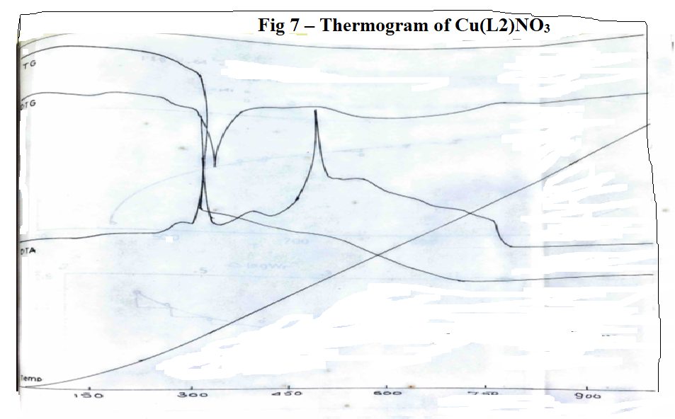

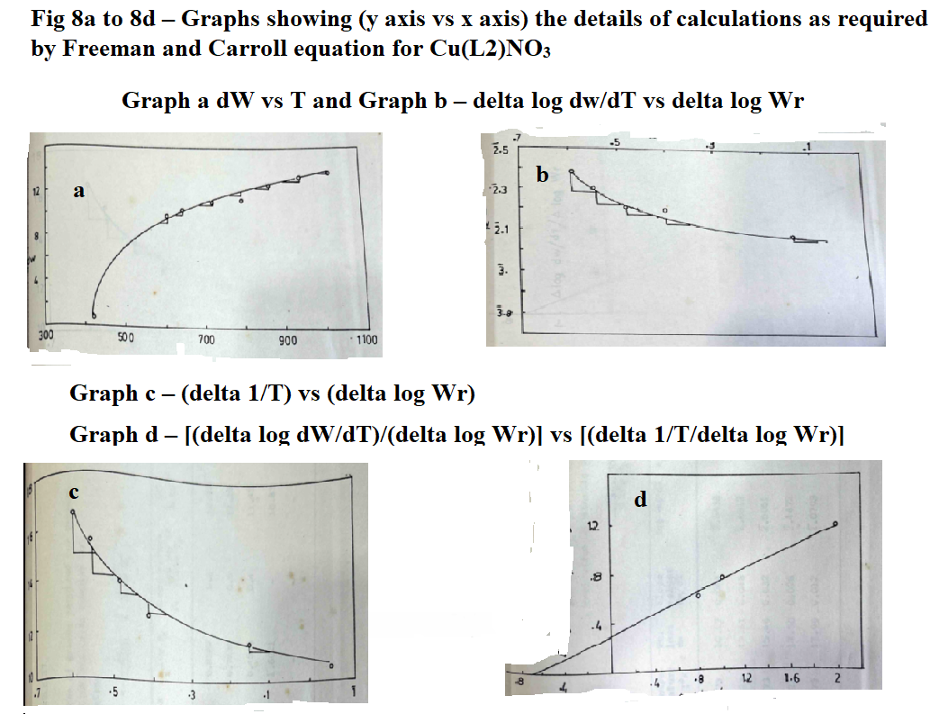

**Table 7: Statement showing coordinates of graphs required for Freeman and Carroll equation for Cu(L3)ac complex for evaluation of kinetic parameters; (Δ log dw/dT)/(Δ log Wr) = - Ea/2.303R [(Δ 1/T)/(Δ log Wr)] + n**

|  |  |  |  |  |  |  |  |  |
| --- | --- | --- | --- | --- | --- | --- | --- | --- |
| **Temperature T K** | **Weight loss (dw)** | **Slope values dw/dT** | **Δ log dw/dT\*** | **Wr = (Wc-W)** | **Δ log Wr\*** | **Slope values 4 vs 6** | **Δ 1/T x 10-4** | **Slope values Δ 1/T vs Δ log Wr** |
| 773 | 10.17 | 0.044 | $\overline{2}$.6438 | 7.73 | 0.8882 | 0.6 | 12.93 | 0.8 |
| 823 | 12.61 | 0.048 | $\overline{2}$.6812 | 5.29 | 0.7235 | 0.5 | 12.15 | 0.4 |
| 873 | 15.46 | 0.032 | $\overline{2}$.5051 | 2.85 | 0.4548 | 0.4 | 11.45 | 0.2 |
| 923 | 17.50 | 0.028 | $\overline{2}$.4472 | 0.40 | $\overline{1}$.6021 | - | 10.83 | - |
| 973 | 17.90 | 0.012 | $\overline{2}$.0793 | - | - | - | - | - |

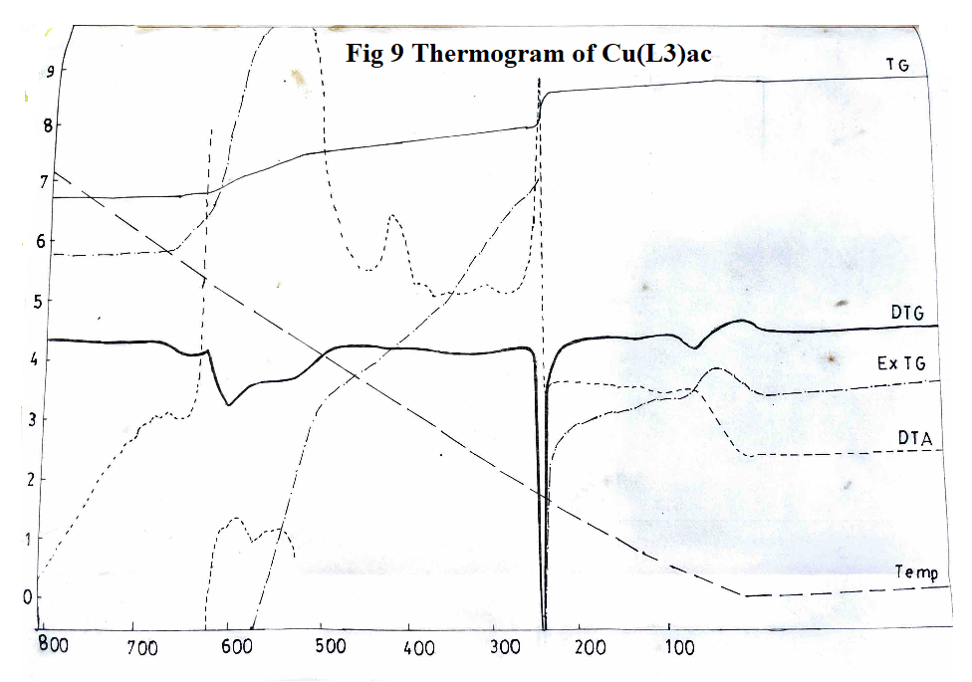

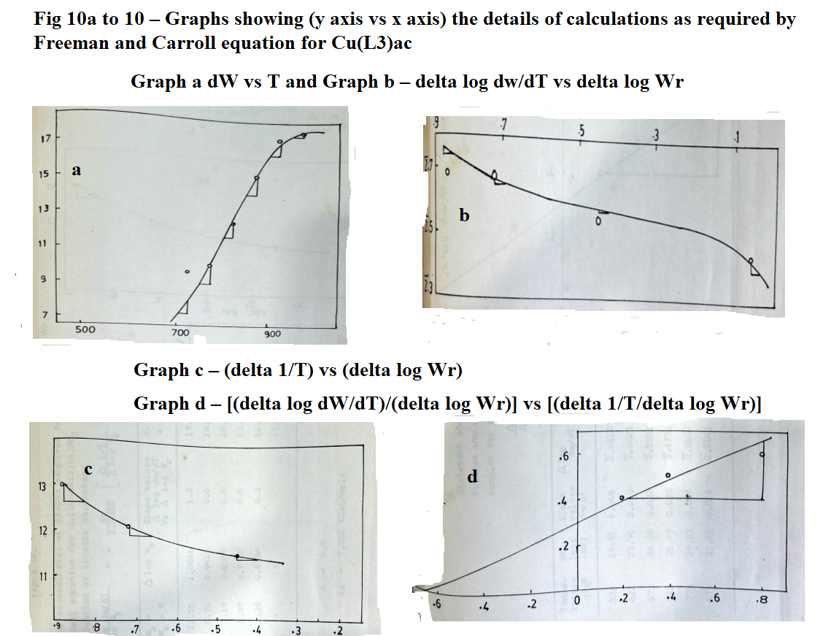

**Table 8: Statement showing coordinates of graphs required for Freeman and Carroll equation for Cu(L3)NO3 complex for evaluation of kinetic parameters Ea = 7.062 Kcal/mole; n = 0.4; (Δ log dw/dT)/(Δ log Wr) = - Ea/2.303R [(Δ 1/T)/(Δ log Wr)] + n**

|  |  |  |  |  |  |  |  |  |
| --- | --- | --- | --- | --- | --- | --- | --- | --- |
| **Temperature T K** | **Weight loss (dw)** | **Slope values dw/dT** | **Δ log dw/dT\*** | **Wr = (Wc-W)** | **Δ log Wr\*** | **Slope values 4 vs 6** | **Δ 1/T x 10-4** | **Slope values Δ 1/T vs Δ log Wr** |
| 573 | 19.91 | 0.048 | $\overline{2}$.6812 | 11.55 | $\overline{1}$.0626 | 1.2 | 17.45 | 3.2 |
| 623 | 22.70 | 0.040 | $\overline{2}$.6021 | 8.76 | 0.9425 | 0.6 | 16.05 | 2.0 |
| 673 | 24.29 | 0.032 | $\overline{2}$.5051 | 7.17 | 0.8555 | 0.5 | 14.85 | 1.2 |
| 723 | 25.49 | 0030 | $\overline{2}$.4771 | 5.97 | 0.7760 | 0.4 | 14.83 | 0.8 |
| 773 | 29.07 | 0.024 | $\overline{2}$.3802 | 2.39 | 0.3784 | 0.3 | 12.93 | 0.4 |
| 673 | 31.46 | 0.016 | $\overline{2}$.2041 | - | - | - | 11.45 | - |

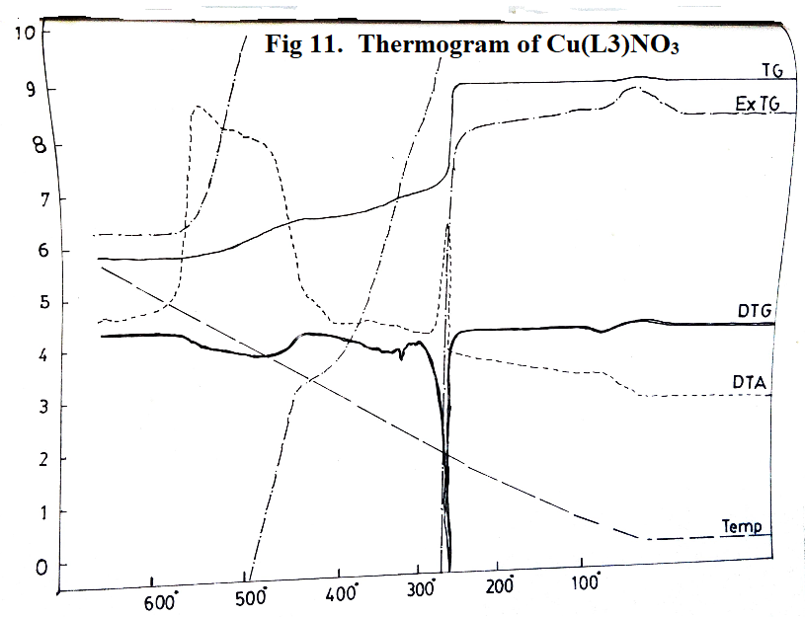

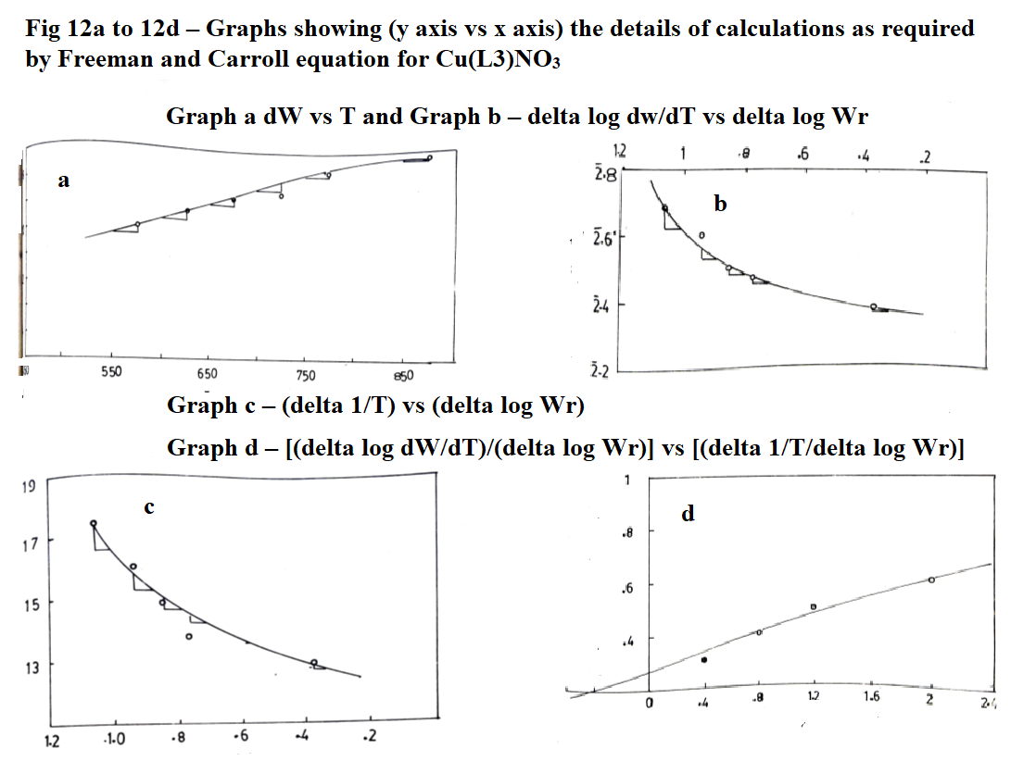

**Table 9: Statement showing coordinates of graphs required for Freeman and Carroll equation for Cu(L4)ac complex for evaluation of kinetic parameters Ea = 22.01 Kcal/mole; n = 0.44; (Δ log dw/dT)/(Δ log Wr) = - Ea/2.303R [(Δ 1/T)/(Δ log Wr)] + n**

|  |  |  |  |  |  |  |  |  |
| --- | --- | --- | --- | --- | --- | --- | --- | --- |
| **Temperature T K** | **Weight loss (dw)** | **Slope values dw/dT** | **Δ log dw/dT\*** | **Wr = (Wc-W)** | **Δ log Wr** | **Slope values 4 vs 6** | **Δ 1/T x 10-4** | **Slope values Δ 1/T vs Δ log Wr** |
| 525 | 24.56 | 0.16 | 1.2041 | 63.05 | $\overline{1}$.7996 | 1.10 | 19.04 | 2.4 |
| 625 | 43.61 | 0.14 | 1.1461 | 44.02 | $\overline{1}$.6437 | 0.45 | 16.00 | 1.4 |
| 725 | 55.51 | 0.16 | 1.2041 | 32.12 | $\overline{1}$.5068 | 0.35 | 13.79 | 0.8 |
| 825 | 66.22 | 0.14 | 1.1461 | 21.41 | $\overline{1}$.3306 | 0.30 | 12.12 | 0.6 |
| 925 | 78.91 | 0.12 | 1.0792 | 8.72 | 0.9400 | 0.20 | 10.81 | 0.4 |
| 1025 | 84.85 | 0.08 | $\overline{2}$.9031 | 2.78 | 0.4440 | - | 9.75 | 0.2 |
| 1075 | 87.63 | 0.04 | $\overline{2}$.6021 | - | - | - | 9.32 | - |

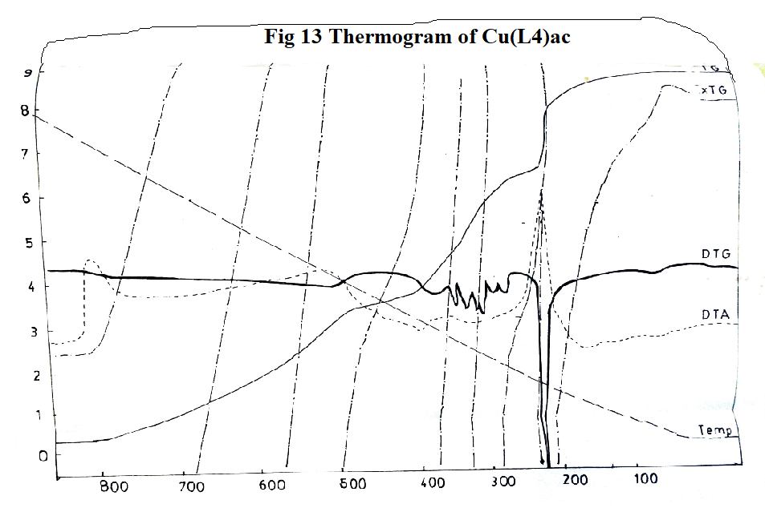

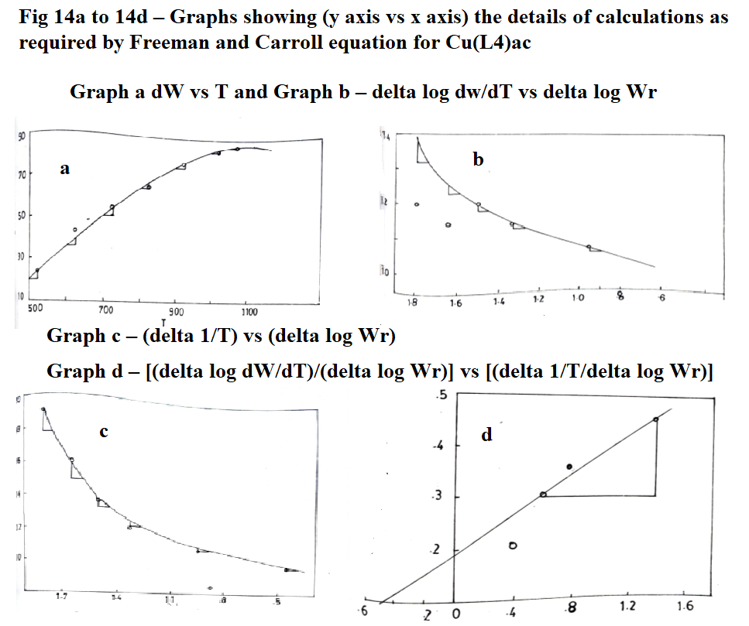

**Table 10: Statement showing coordinates of graphs required for Freeman and Carroll equation for Cu(L4)NO3 complex for evaluation of kinetic parameters; (Δ log dw/dT)/(Δ log Wr) = - Ea/2.303R [(Δ 1/T)/(Δ log Wr)] + n**

|  |  |  |  |  |  |  |  |  |
| --- | --- | --- | --- | --- | --- | --- | --- | --- |
| **Temperature T K** | **Weight loss (dw)** | **Slope values dw/dT** | **Δ log dw/dT\*** | **Wr = (Wc-W)** | **Δ log Wr** | **Slope values 4 vs 6** | **Δ 1/T x 10-4** | **Slope values Δ 1/T vs Δ log Wr** |
| 423 | 1.58 | 0.052 | $\overline{2}$.7160 | 22.75 | $\overline{1}$.3570 | 1.6 | 23.64 | 4.4 |
| 473 | 2.37 | 0.040 | $\overline{2}$.6021 | 21.96 | $\overline{1}$.3416 | 0.9 | 21.14 | 1.8 |
| 523 | 22.94 | 0.032 | $\overline{2}$.5051 | 1.39 | 0.1430 | 0.1 | 19.12 | 0.2 |
| 573 | 24.33 | 0.024 | $\overline{2}$.3802 | - | - | - | 17.45 | - |

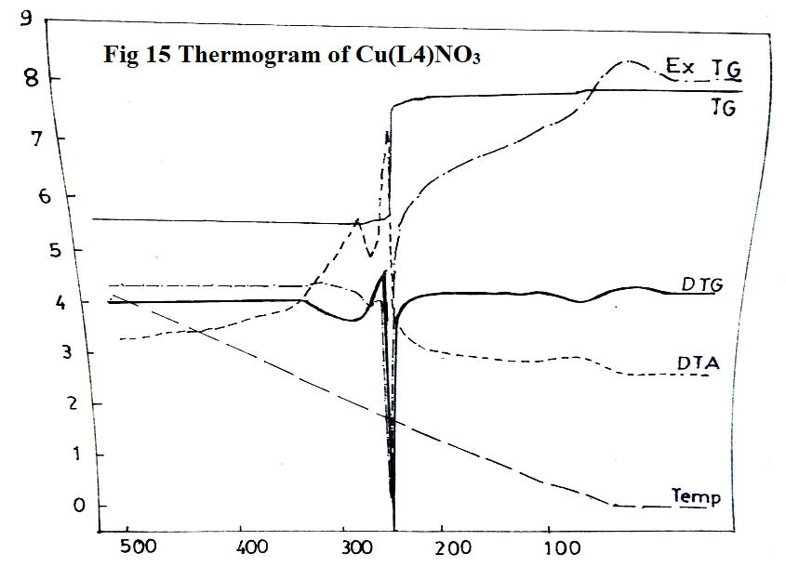

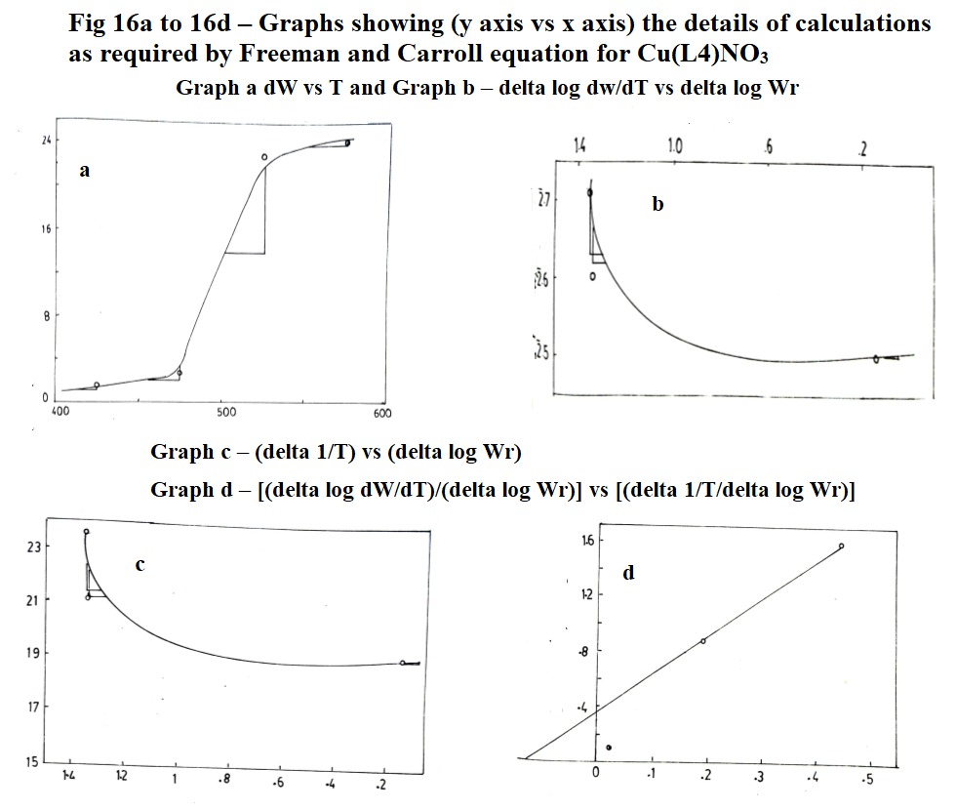

**Table 11: Statement showing coordinates of graphs required for Freeman and Carroll equation for Mn(L1)2 complex for evaluation of kinetic parameters Ea = 22.07 Kcal/mole; n = 0.4; (Δ log dw/dT)/(Δ log Wr) = - Ea/2.303R [(Δ 1/T)/(Δ log Wr)] + n**

|  |  |  |  |  |  |  |  |  |
| --- | --- | --- | --- | --- | --- | --- | --- | --- |
| **Temperature T K** | **Weight loss (dw)** | **Slope values dw/dT** | **Δ log dw/dT\*** | **Wr = (Wc-W)** | **Δ log Wr\*** | **Slope values 4 vs 6** | **Δ 1/T x 10-4** | **Slope values Δ 1/T vs Δ log Wr** |
| 573 | 18.81 | 0.072 | $\overline{2}$.8573 | 13.61 | $\overline{1}$.1338 | 0.45 | 17.45 | 0.80 |
| 623 | 28.62 | 0.068 | $\overline{2}$.8325 | 8.80 | 0.9448 | 0.50 | 16.05 | 0.90 |
| 673 | 26.42 | 0.064 | $\overline{2}$.8062 | 6.00 | 07786 | 0.60 | 14.85 | 1.00 |
| 723 | 29.22 | 0.048 | $\overline{2}$.6812 | 3.20 | 0.5059 | 0.70 | 13.83 | 1.20 |
| 773 | 31.62 | 0.032 | $\overline{2}$.5051 | 0.80 | $\overline{1}$.9036 | 0.80 | 12.93 | - |
| 823 | 32.42 | 0.012 | $\overline{2}$.0792 | - | - | - | 12.15 | - |

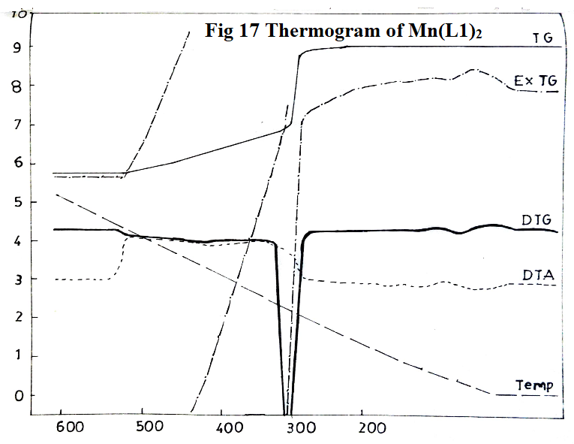

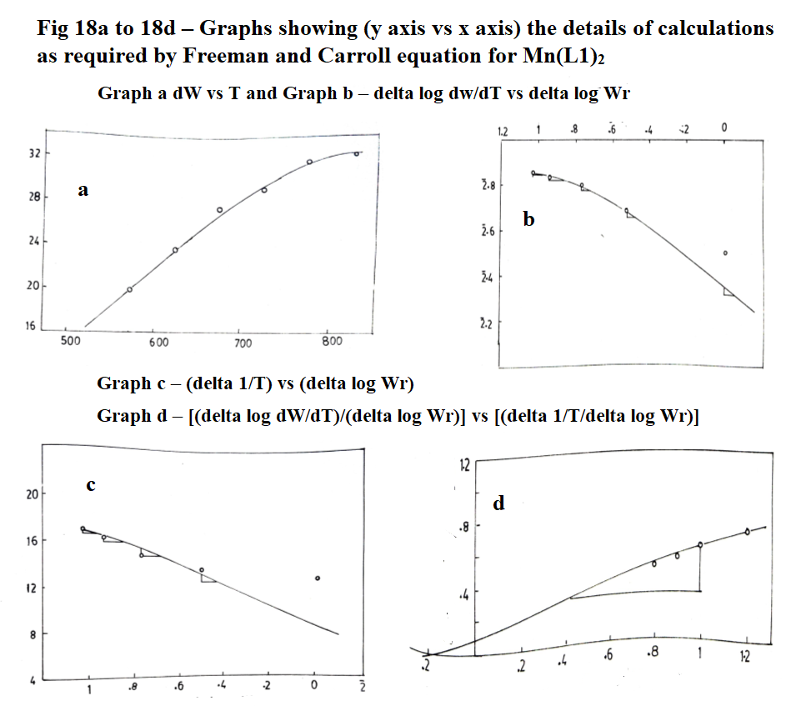

**Table 12: Statement showing coordinates of graphs required for Freeman and Carroll equation for Mn(L2)2 complex for evaluation of kinetic parameters Ea = 22.07 Kcal/mole; n = 0.39; (Δ log dw/dT)/(Δ log Wr) = - Ea/2.303R [(Δ 1/T)/(Δ log Wr)] + n**

|  |  |  |  |  |  |  |  |  |
| --- | --- | --- | --- | --- | --- | --- | --- | --- |
| **Temperature T K** | **Weight loss (dw)** | **Slope values dw/dT** | **Δ log dw/dT\*** | **Wr = (Wc-W)** | **Δ log Wr\*** | **Slope values 4 vs 6** | **Δ 1/T x 10-4** | **Slope values Δ 1/T vs Δ log Wr** |
| 573 | 15.34 | 0.112 | $\overline{1}$.0492 | 13.77 | $\overline{1}$.1388 | 1.3 | 17.45 | 1.2 |
| 623 | 19.27 | 0.072 | $\overline{2}$.8573 | 9.84 | 0.9930 | 0.9 | 16.05 | 0.8 |
| 673 | 22.03 | 0.056 | $\overline{2}$.7482 | 7.08 | 0.8500 | 0.5 | 14.85 | 0.6 |
| 723 | 24.78 | 0.048 | $\overline{2}$.6812 | 4.33 | 0.6365 | 0.4 | 13.83 | 0.4 |
| 773 | 27.53 | 0.040 | $\overline{2}$.6021 | 1.58 | 0.1987 | 0.35 | 12.93 | 0.3 |
| 823 | 28.72 | 0.032 | $\overline{2}$.5051 | 039 | $\overline{1}$.5911 | 0.3 | 12.15 | 0.2 |
| 873 | 29.11 | 0.016 | - | 0 | 0 | 0 | 11.45 | - |

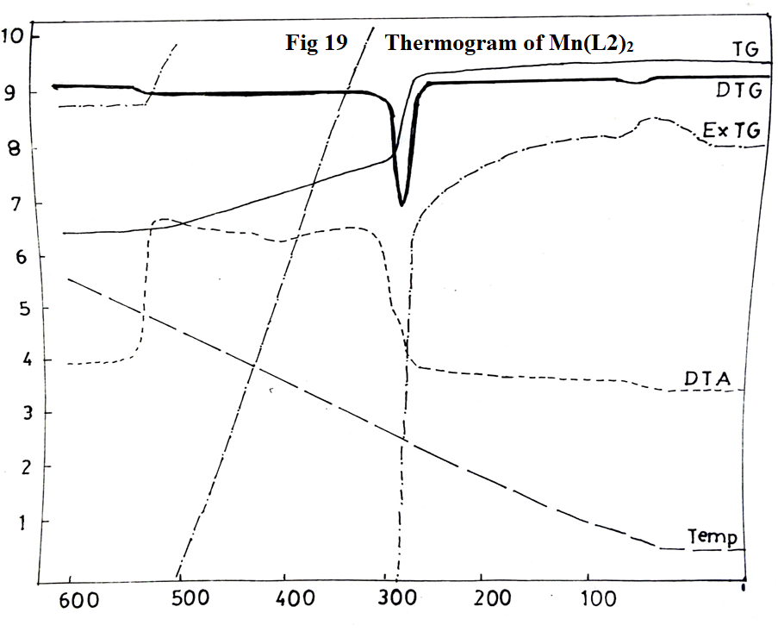\

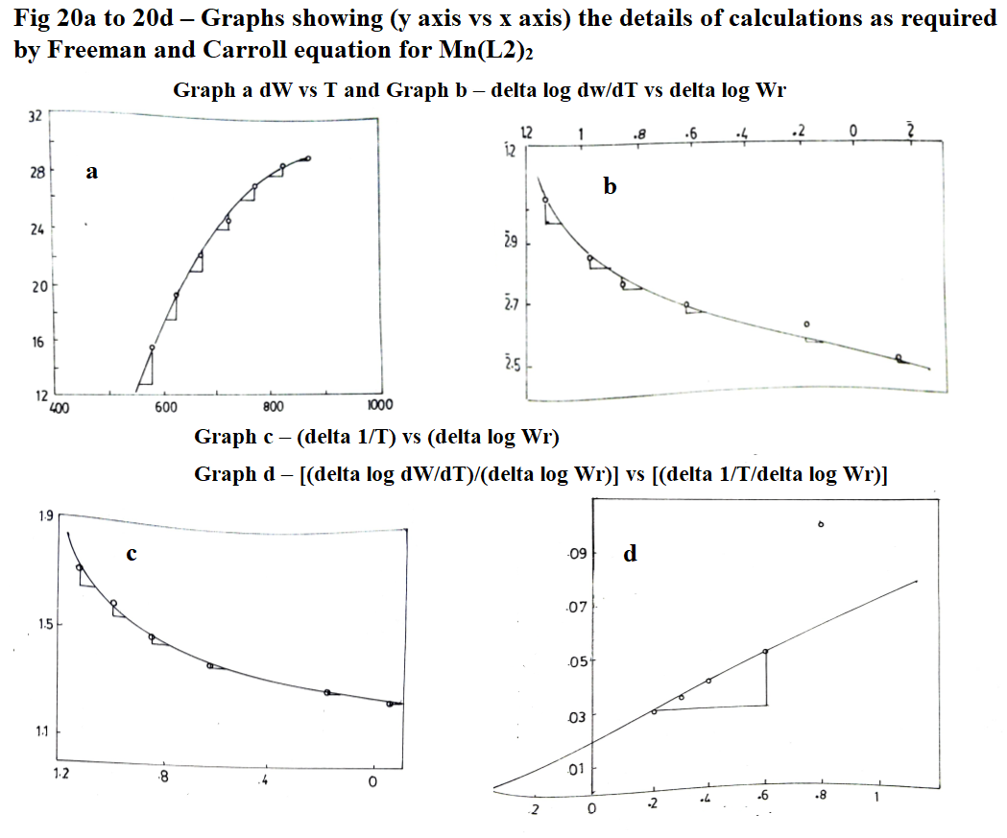

**Table 13: Statement showing coordinates of graphs required for Freeman and Carroll equation for Mn(L3)2 complex for evaluation of kinetic parameters Ea = 22.07 Kcal/mole; n = 0.25; (Δ log dw/dT)/(Δ log Wr) = - Ea/2.303R [(Δ 1/T)/(Δ log Wr)] + n**

|  |  |  |  |  |  |  |  |  |
| --- | --- | --- | --- | --- | --- | --- | --- | --- |
| **Temperature T K** | **Weight loss (dw)** | **Slope values dw/dT** | **Δ log dw/dT\*** | **Wr = (Wc-W)** | **Δ log Wr** | **Slope values 4 vs 6** | **Δ 1/T x 10-4** | **Slope values Δ 1/T vs Δ log Wr** |
| 623 | 29.58 | - | - | 13.59 | $\overline{1}$.1332 | - | 16.05 | 1.2 |
| 673 | 31.98 | 0.080 | $\overline{2}$.9031 | 11.19 | $\overline{1}$.0487 | 0.6 | 14.85 | 0.8 |
| 723 | 35.57 | 0.072 | $\overline{2}$.8573 | 7.60 | 0.8808 | 0.5 | 13.83 | 0.6 |
| 773 | 38.77 | 0.064 | $\overline{2}$.8062 | 4.40 | 0.6435 | 0.3 | 12.93 | 0.3 |
| 823 | 41.17 | 0.048 | $\overline{2}$.6812 | 2.00 | 0.3010 | 0.2 | 12.15 | 0.2 |
| 873 | 43.17 | 0.032 | $\overline{2}$.5052 | - | - | - | 11.45 | - |

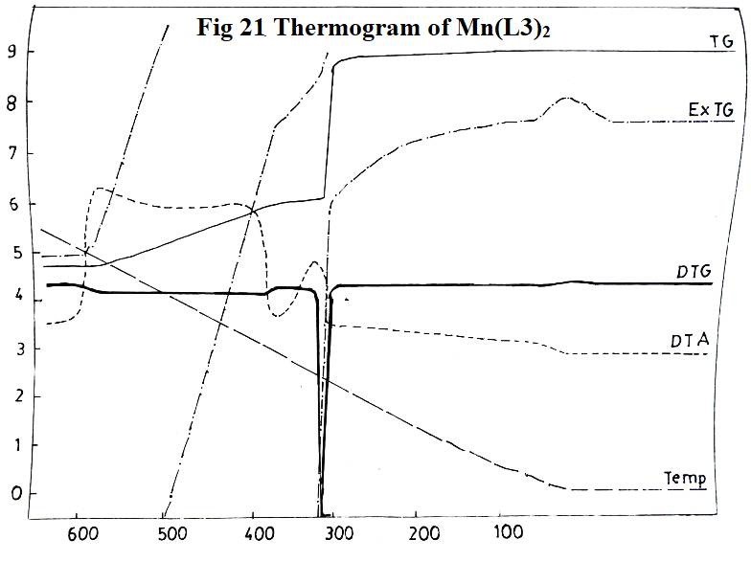

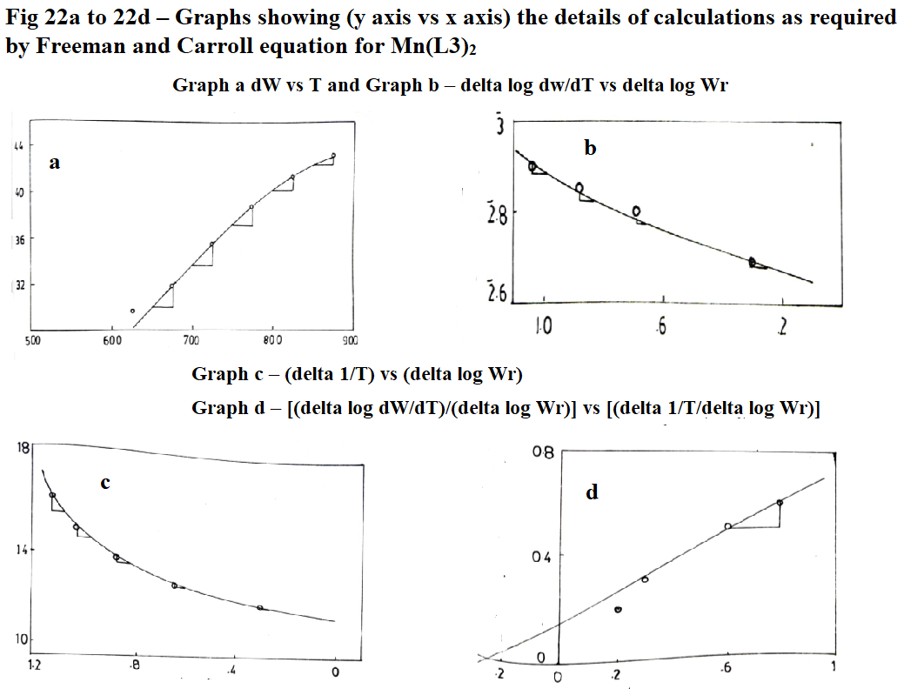

**Table 14: Statement showing coordinates of graphs required for Freeman and Carroll equation for Mn(L4)2 complex for evaluation of kinetic parameters Ea = 11.035 Kcal/mole; n = 0.66; (Δ log dw/dT)/(Δ log Wr) = - Ea/2.303R [(Δ 1/T)/(Δ log Wr)] + n**

|  |  |  |  |  |  |  |  |  |
| --- | --- | --- | --- | --- | --- | --- | --- | --- |
| **Temperature T K** | **Weight loss (dw)** | **Slope values dw/dT** | **Δ log dw/dT\*** | **Wr = (Wc-W)** | **Δ log Wr** | **Slope values 4 vs 6** | **Δ 1/T x 10-4** | **Slope values Δ 1/T vs Δ log Wr** |
| 523 | 3.36 | 0.072 | $\overline{2}$.8573 | 14.30 | $\overline{1}$.1553 | 0.6 | 19.12 | 1.0 |
| 573 | 10.51 | 0.056 | $\overline{2}$.7482 | 7.15 | 0.8543 | 0.8 | 17.45 | 1.6 |
| 623 | 11.77 | 0.052 | $\overline{2}$.7160 | 5.89 | 0.7701 | 1.0 | 16.05 | 1.8 |
| 673 | 13.87 | 0.044 | $\overline{2}$.6435 | 3.79 | 0.5786 | 1.2 | 14.85 | 2.4 |
| 723 | 16.40 | 0.032 | $\overline{2}$.5051 | 1.26 | 0.1004 | 1.2 | 13.83 | - |
| 773 | 17.66 | - | - | - | - | - | - | - |

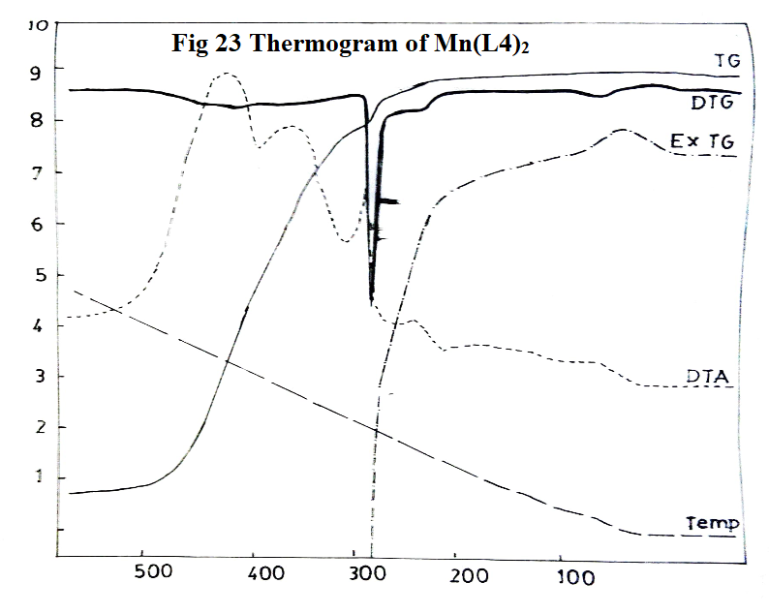

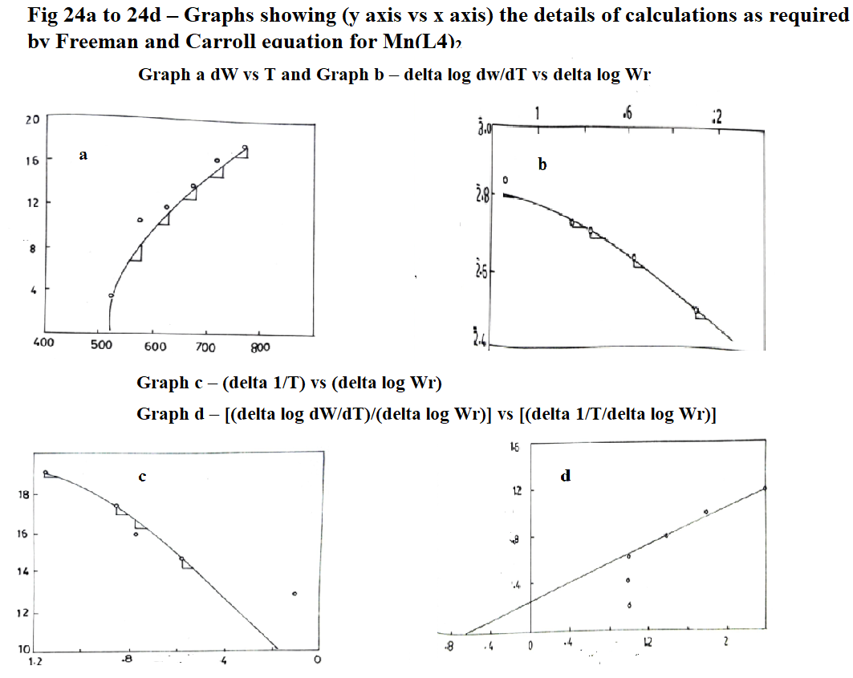

**Table 15: Statement showing coordinates of graphs required for Freeman and Carroll equation for Pb(L1)2 complex for evaluation of kinetic parameters Ea = 13.24 Kcal/mole; n = 0.38; (Δ log dw/dT)/(Δ log Wr) = - Ea/2.303R [(Δ 1/T)/(Δ log Wr)] + n**

|  |  |  |  |  |  |  |  |  |
| --- | --- | --- | --- | --- | --- | --- | --- | --- |
| **Temperature T K** | **Weight loss (dw)** | **Slope values dw/dT** | **Δ log dw/dT\*** | **Wr = (Wc-W)** | **Δ log Wr** | **Slope values 4 vs 6** | **Δ 1/T x 10-4** | **Slope values Δ 1/T vs Δ log Wr** |
| 523 | 10.38 | 0.052 | $\overline{2}$.7160 | 915 | 0.9614 | 0.40 | 19.12 | 0.44 |
| 573 | 12.05 | 0.048 | $\overline{2}$.6812 | 7.48 | 0.8739 | 0.50 | 17.45 | 0.60 |
| 623 | 13.71 | 0.040 | $\overline{2}$.6021 | 5.83 | 0.7657 | 0.60 | 16.05 | 0.80 |
| 673 | 15.37 | 0.036 | $\overline{2}$.5563 | 4.16 | 0.6191 | 0.76 | 14.85 | 1.00 |
| 723 | 16.20 | 0.032 | $\overline{2}$.5051 | 3.33 | 0.5224 | 0.80 | 13.83 | 1.30 |
| 773 | 16.83 | 0.030 | $\overline{2}$.4771 | 2.70 | 0.4314 | 1.00 | 12.93 | 1.60 |
| 823 | 18.49 | 0.016 | $\overline{2}$.2041 | 1.040 | 0.0170 | - | 12.15 | 2.00 |
| 873 | 19.53 | 0.028 | $\overline{2}$.4472 | - | - | - | - | 2.22 |

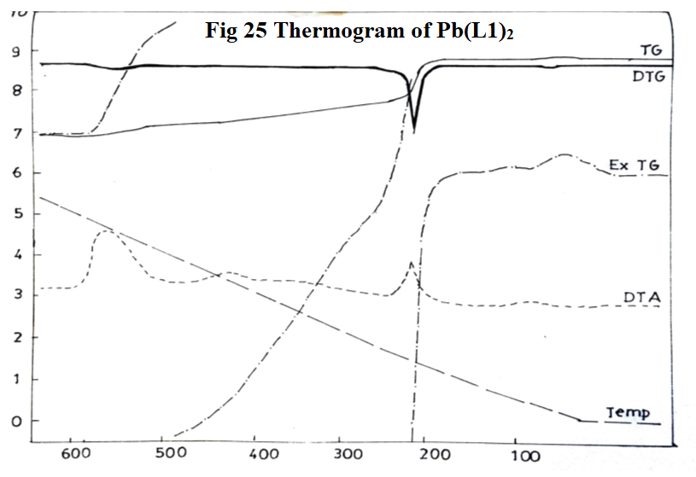

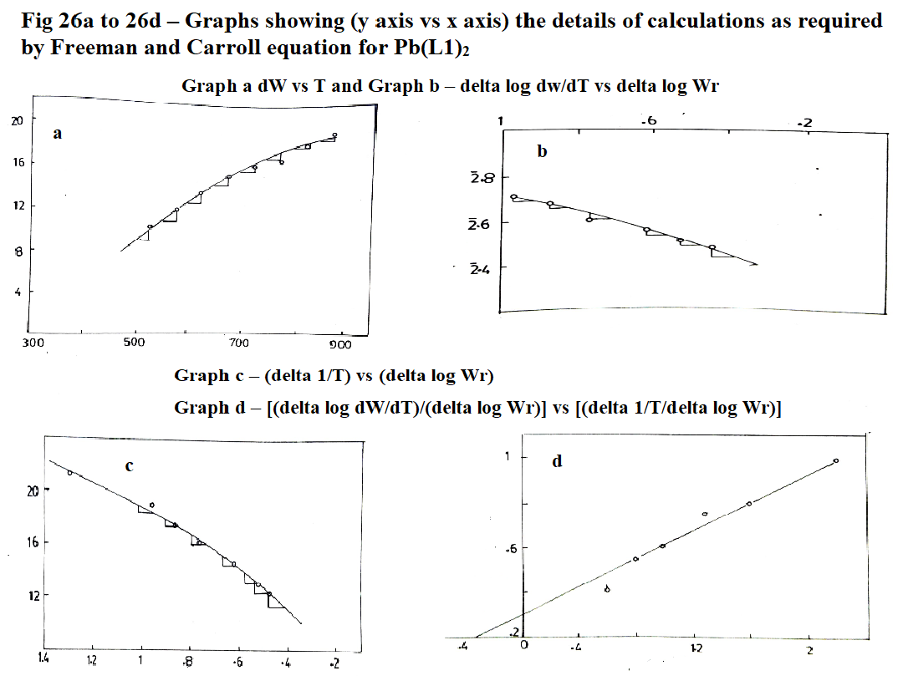

**Table 16: Statement showing coordinates of graphs required for Freeman and Carroll equation for Pb(L2)2 complex for evaluation of kinetic parameters Ea = 11.47 Kcal/mole; n = 0.62; (Δ log dw/dT)/(Δ log Wr) = - Ea/2.303R [(Δ 1/T)/(Δ log Wr)] + n**

|  |  |  |  |  |  |  |  |  |
| --- | --- | --- | --- | --- | --- | --- | --- | --- |
| **Temperature T K** | **Weight loss (dw)** | **Slope values dw/dT** | **Δ log dw/dT\*** | **Wr = (Wc-W)** | **Δ log Wr** | **Slope values 4 vs 6** | **Δ 1/T x 10-4** | **Slope values Δ 1/T vs Δ log Wr** |
| 523 | 13.22 | 0.080 | $\overline{2}$.9031 | 12.22 | $\overline{1}$.0871 | 0.40 | 19.12 | 1.2 |
| 573 | 15.22 | 0.056 | $\overline{2}$.7462 | 10.22 | $\overline{1}$.0096 | 0.70 | 17.45 | 1.6 |
| 623 | 17.23 | 0.040 | $\overline{2}$.6021 | 8.21 | 0.9143 | 0.75 | 16.05 | 1.8 |
| 673 | 18.43 | 0.036 | $\overline{2}$.5563 | 7.01 | 0.8457 | 0.80 | 14.85 | 2.0 |
| 723 | 19.63 | 0.032 | $\overline{2}$.5051 | 5.61 | 0.7490 | 0.90 | 13.83 | 2.4 |
| 773 | 21.03 | 0.028 | $\overline{2}$.4472 | 4.41 | 06444 | 1.00 | 12.93 | 2.8 |
| 823 | 24.44 | 0.024 | $\overline{2}$.3802 | 1.00 | 0.0000 | - | 12.15 | - |
| 873 | 25.44 | 0.020 | $\overline{2}$.3010 | - | - | - | - | - |

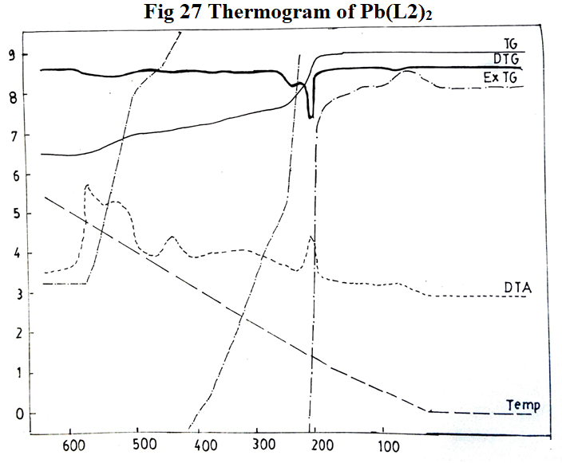

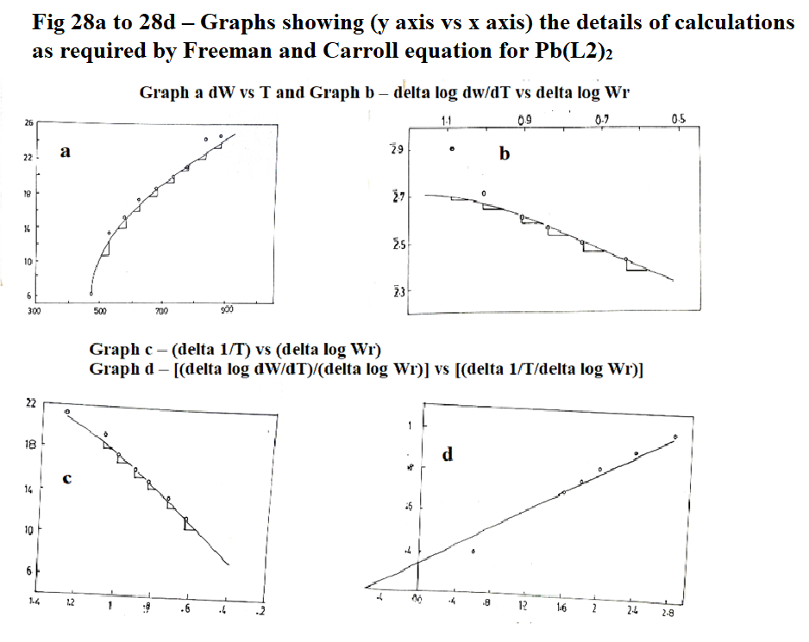

**Table 17: Statement showing coordinates of graphs required for Freeman and Carroll equation for Pb(L3)2 complex for evaluation of kinetic parameters Ea = 15.00 Kcal/mole; n = 0.32; (Δ log dw/dT)/(Δ log Wr) = - Ea/2.303R [(Δ 1/T)/(Δ log Wr)] + n**

|  |  |  |  |  |  |  |  |  |
| --- | --- | --- | --- | --- | --- | --- | --- | --- |
| **Temperature T K** | **Weight loss (dw)** | **Slope values dw/dT** | **Δ log dw/dT\*** | **Wr = (Wc-W)** | **Δ log Wr\*** | **Slope values 4 vs 6** | **Δ 1/T x 10-4** | **Slope values Δ 1/T vs Δ log Wr** |
| 523 | 8.54 | 0.052 | $\overline{2}$.7160 | 6.91 | 0.8395 | 2.4 | 19.12 | 3.2 |
| 573 | 10.16 | 0.040 | $\overline{2}$.4021 | 5.29 | 0.7235 | 1.4 | 17.45 | 2.6 |
| 623 | 10.77 | 0.024 | $\overline{2}$.3874 | 4.68 | 0.6702 | 1.2 | 16.05 | 1.8 |
| 673 | 11.59 | 0.020 | $\overline{2}$.3010 | 3.86 | 0.5866 | 1.0 | 14.85 | 1.2 |
| 723 | 11.99 | 0.016 | $\overline{2}$.2041 | 3.46 | 0.5391 | 08 | 13.83 | 1.0 |
| 773 | 12.81 | 0.014 | $\overline{2}$.1461 | 2.64 | 0.4216 | 0.6 | 12.93 | 0.6 |
| 823 | 14.84 | 0.012 | $\overline{2}$.0792 | 0.61 | $\overline{1}$.7853 | - | 12.15 | - |
| 873 | 15.45 | 0.008 | - | - | - | - | 11.48 | - |

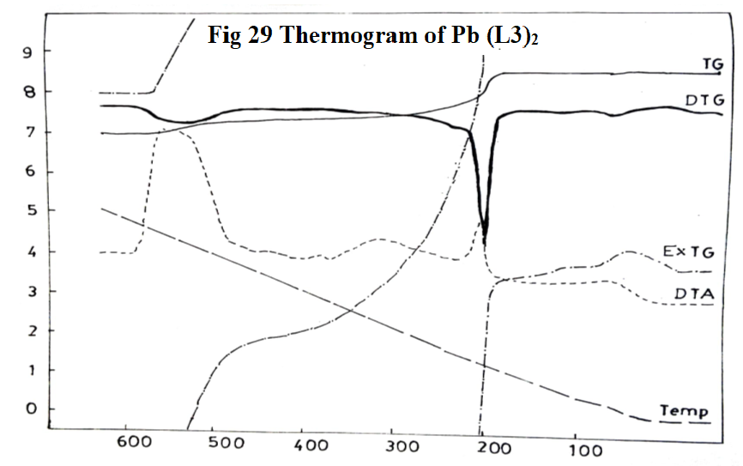

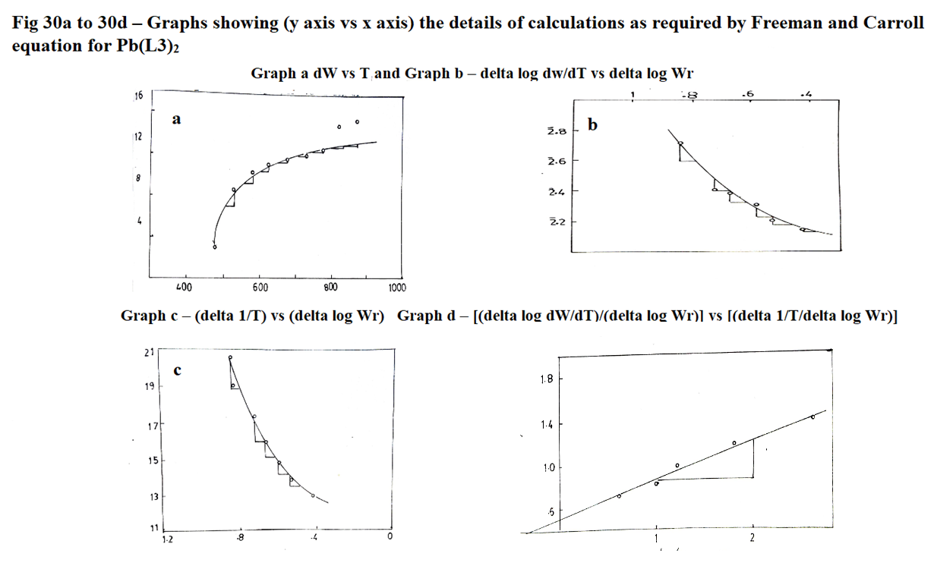

**Table 18: Statement showing coordinates of graphs required for Freeman and Carroll equation for Pb(L4)2 complex for evaluation of kinetic parameters; (Δ log dw/dT)/(Δ log Wr) = - Ea/2.303R [(Δ 1/T)/(Δ log Wr)] + n**

|  |  |  |  |  |  |  |  |  |
| --- | --- | --- | --- | --- | --- | --- | --- | --- |
| **Temperature T K** | **Weight loss (dw)** | **Slope values dw/dT** | **Δ log dw/dT\*** | **Wr = (Wc-W)** | **Δ log Wr\*** | **Slope values 4 vs 6** | **Δ 1/T x 10-4** | **Slope values Δ 1/T vs Δ log Wr** |
| 523 | 12.65 | 0.044 | $\overline{2}$.6435 | 10.24 | $\overline{1}$.0103 | 0.8 | 19.12 | 2.2 |
| 573 | 15.01 | 0.036 | $\overline{2}$.5573 | 7.88 | 0.8955 | 0.7 | 17.45 | 1.8 |
| 623 | 16.03 | 0.032 | $\overline{2}$.5051 | 6.86 | 0.8363 | 0.6 | 16.05 | 1.4 |
| 673 | 17.01 | 0.028 | $\overline{2}$.4472 | 5.88 | 0.7694 | 0.5 | 14.85 | 1.2 |
| 723 | 17.81 | 0.024 | $\overline{2}$.3802 | 5.08 | 0.7059 | 0.4 | 13.83 | 1.0 |
| 773 | 19.01 | 0.020 | $\overline{2}$.3010 | 3.88 | 0.5888 | 0.4 | 12.93 | 0.8 |
| 823 | 21.99 | 0.016 | $\overline{2}$.2041 | 0.90 | $\overline{1}$.9542 | - | 12.15 | - |
| 873 | 22.89 | 0.008 | - | - | - | - | 11.48 | - |

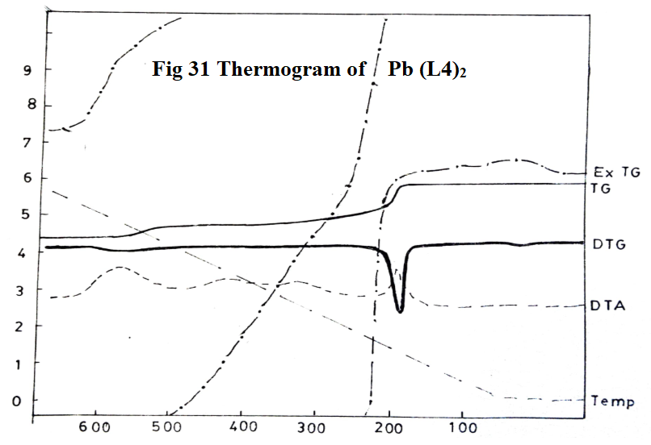

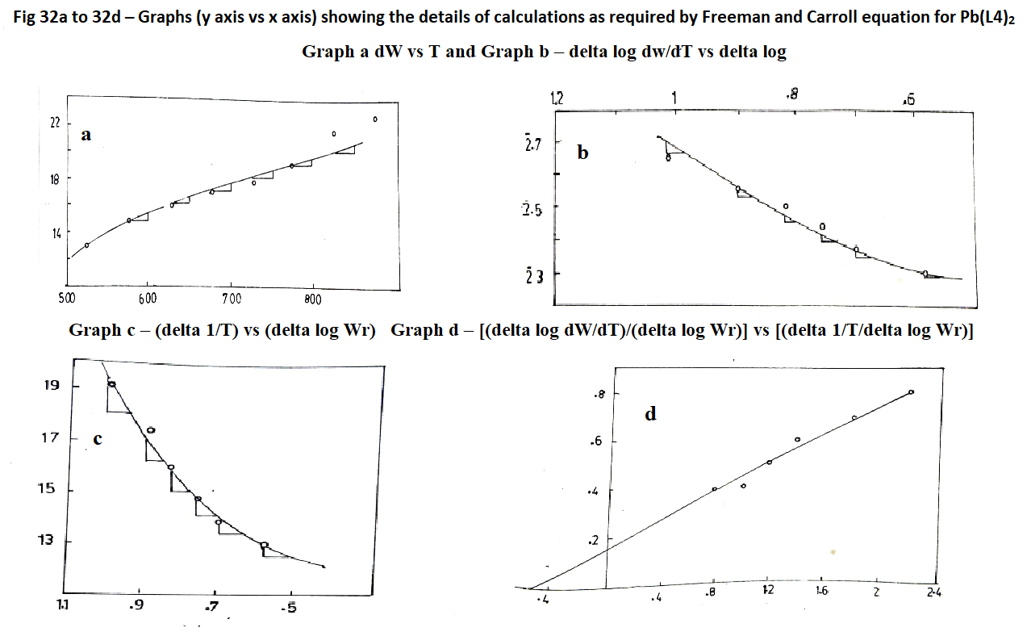

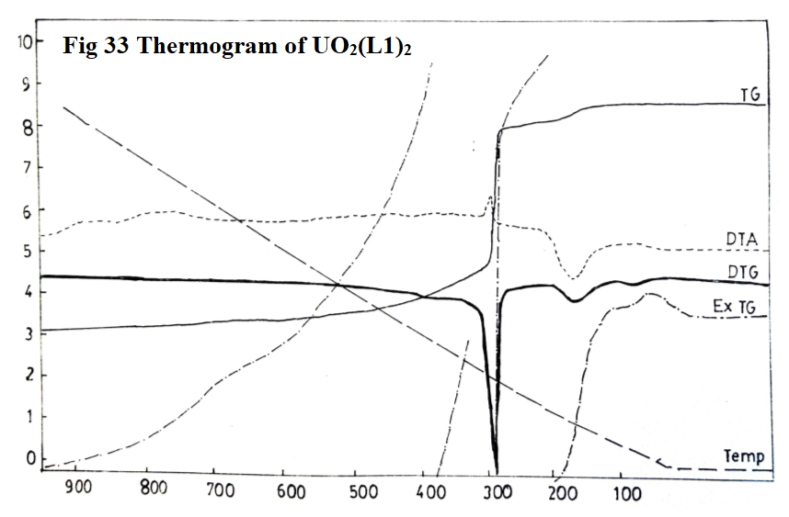

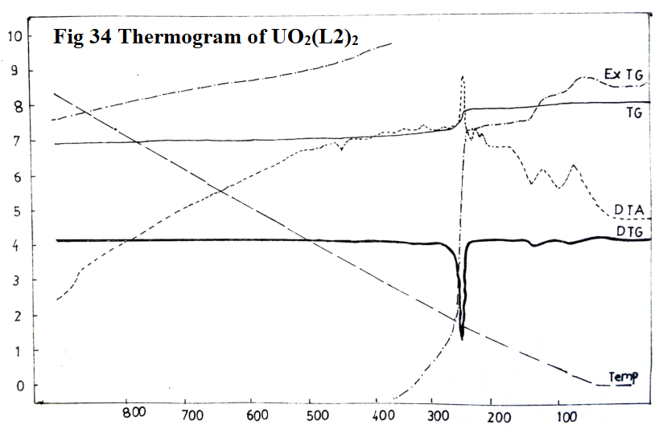

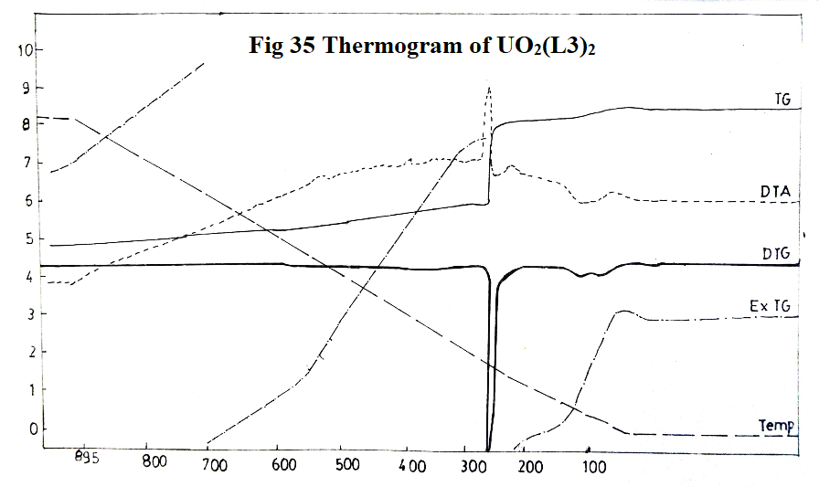

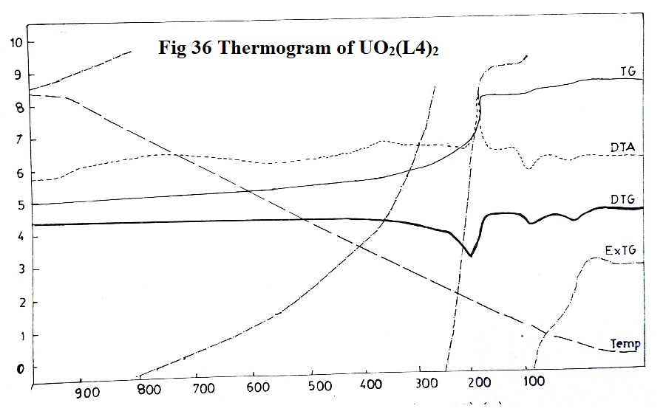

**3.3.1.1 Copper (II) complexes:**

All the eight green Cu(II) complexes are found to be thermally stable up to 2000C, indicating them to be not hydrates as confirmed from infrared spectra of Cu(II) complexes which does not exhibit any band in the region 3600-3300 cm-1. The thermal stability of Cu(II) complexes, temperature, % of decomposition, corresponding group decomposed as well as kinetic parameters are given in Table 19.

**Table 19: Statement showing temperature range, % decomposition and corresponding group decomposed of copper(II) complexes, thermal stability, Ea the activation energy, n the order of reaction and ΔH the change in enthalpy = peak area x calibration factor (K = 0.62 cal/sq.cm)/sample wt.**

|  |  |  |  |  |  |  |  |
| --- | --- | --- | --- | --- | --- | --- | --- |
| **Complex** | **Decomposition** | | | **Thermal stability**  **0C** | **Ea Kcal/**  **mole** | **n** | **ΔH** |
| **Temperature 0C** | **%** | **Corresponding group** |
| Cu(L1)ac | 250-300  525-575 | 29.16  49.67 | R-NH-C=O  R-NH-C=O & C6H5 | 300 | 22.07 | 0.78 | -330.15 |
| Cu(L1)NO3 | 270-300 | 47.84 | R-NH-C=O  R-NH-C=O & C6H5 | 310 | 11.03 | 0.8 | -263.65 |
| Cu(L2)ac | 250-300  525-575 | 31.25  52.01 | R-NH-C=O  R-NH-C=O & C6H5CH3 | 225 | 20.96 | 0.15 | -286.24 |
| Cu(L2)NO3 | 270-300 | 50.21 | R-NH-C=O  R-NH-C=O & C6H5CH3 | 200 | 19.42 | 0.7 | -58.64 |
| Cu(L3)ac | 250-300  525-575 | 30.18  58.46 | R-NH-C=O  R-NH-C=O & C6H5OCH3 | 240 | 19.12 | 0.65 | -9.15 |
| Cu(L3)NO3 | 270-300 | 53.06 | R-NH-C=O  R-NH-C=O & C6H5OCH3 | 255 | 7.062 | 0.4 | -12.43 |
| Cu(L4)ac | 250-300  525-575 | 31.44  59.80 | R-NH-C=O  R-NH-C=O & C6H5OCH3 | 225 | 22.07 | 0.44 | -172.17 |
| Cu(L4)NO3 | 270-300 | 55.25 | R-NH-C=O  R-NH-C=O & C6H5OCH3 | 200 | 19.50 | 0.18 | -1800 |

The thermal stability of Cu(II) complexes shows that Cu(L1)NO3 complex is the most stable while Cu(L2)NO3 and Cu(L4)NO3 complexes are the least stable. Copper(II) acetate complexes are most stable than corresponding nitrate complexes ΔHC-O> ΔHN-O.

DTA curve indicates that Cu(II) complexes decompose in three exothermic steps - first exothermic decomposition supplies heat to the system and hence, the second and third steps follow over a narrow temperature range.

**3.3.1.2 Mn (II) complexes:**

All the four Mn(II) complexes, Mn(L1)2, Mn(L2)2, Mn(L3)2, Mn(L4)2 are found to be thermally stable up to 2500C. The thermal stability of Mn(II) complexes, temperature, % of decomposition, corresponding group decomposed as well as kinetic parameters are given in Table 20.

**Table 20: Statement showing temperature range, % decomposition and corresponding group decomposed of manganese(II) complexes, thermal stability, Ea the activation energy, n the order of reaction and ΔH the change in enthalpy = peak area x calibration factor (K = 0.62 cal/sq.cm)/sample wt.**

|  |  |  |  |  |  |  |  |
| --- | --- | --- | --- | --- | --- | --- | --- |
| **Complex** | **Decomposition** | | | **Thermal stability**  **0C** | **Ea Kcal/**  **mole** | **n** | **ΔH** |
| **Temperature 0C** | **%** | **Corresponding group** |
| Mn(L1)2 | 280-315  420-430  460-480 | 49.47  58.94  57.00 | R, R-NH, R-NH two C=O | 291 | 22.07 | 0.40 | -10.66 |
| Mn(L2)2 | 280-315  420-430  460-480 | 53.48  60.63  70.93 | R, R-NH, R-NH two C=O | 275 | 22.07 | 0.39 | -41.58 |
| Mn(L3)2 | 280-315  420-430  460-480 | 59.67  66.14  73.38 | R, R-NH, R-NH two C=O | 317 | 22.07 | 0.25 | -109.23 |
| Mn(L4)2 | 280-315  420-430  460-480 | 57.10  65.50  74.10 | R, R-NH, R-NH two C=O | 240 | 11.03 | 0.66 | -29.04 |

The thermal stability of these complexes up to 2500C clearly indicates that they do not contain any water molecule, in agreement with the infrared spectral data, which do not show any band in the region 3360-3300 cm-1. The order of thermal stability of the four Mn(II) complexes is found to be Mn(L3)2>Mn(L1)2>Mn(L2)2>Mn(L4)2 as their decomposition temperature ranges from 317, 291, 275, 240 oC respectively. The order of thermal stability indicates that Mn(L2)2 complex is found to be more stable than other Mn(II) complexes whereas Mn(L4)2 complex is the least stable. However, these four complexes are more stable than Mn(II) complexes of 2- hydroxy-1-naphthalodoxime and salicylaldoxime reported earlier (13).

DTA curve indicates that these complexes decompose in three exothermic steps, first exothermic decomposition of these complexes supply heat to the system, and hence the second and third steps follow over a narrow temperature range.

**3.3.1.3 Lead(II) complexes:**

Thermogravimetric analysis of yellow Pb(II) complexes indicate that these are thermally stable up to 1900C . Thermal stability of these complexes indicates that they are not hydrates as confirmed from the infrared spectra. The order of thermal stability is found to be Pb(L1)2>Pb (L2)2>Pb(L3)2(O)>Pb(L4)2. The thermal stability of Pb(II) complexes, temperature, % of decomposition, corresponding group decomposed as well as kinetic parameters are given in Table 21.

**Table 21: Statement showing temperature range, % decomposition and corresponding group decomposed of lead(II) complexes, thermal stability, Ea the activation energy, n the order of reaction and ΔH the change in enthalpy = peak area x calibration factor (K = 0.62 cal/sq.cm)/sample wt.**

|  |  |  |  |  |  |  |  |
| --- | --- | --- | --- | --- | --- | --- | --- |
| **Complex** | **Decomposition** | | | **Thermal stability**  **0C** | **Ea Kcal/ mole** | **n** | **ΔH** |
| **Temperature 0C** | **%** | **Corresponding group** |
| Pb(L1)2 | 250-300  325-350  375-400 | 40.62  46.87  54.68 | R, R-NH, R-NH two C=O | 225 | 13.24 | 0.38 | -117.62 |
| Pb(L2)2 | 250-300  325-350  375-400 | 43.52  51.76  58.82 | R, R-NH, R-NH two C=O | 210 | 11.47 | 0.62 | -84.14 |
| Pb(L3)2 | 250-300  325-350  375-400 | 47.61  53.8  61.81 | R, R-NH, R-NH two C=O | 200 | 15.00 | 0.32 | -76.51 |
| Pb(L4)2 | 250-300  325-350  375-400 | 46.82  52.9  60.8 | R, R-NH, R-NH two C=O | 190 | 13.24 | 0.54 | -80.28 |

The order of thermal stability indicates that Pb(L1)2 complex is found to be most stable whereas Pb(L4)2 complex is found to be least stable.

DTA curve exhibits that these complexes decompose in three different exothermic steps. The first exothermic decomposition supplies heat to the system and hence the second and third step follow over a narrow range of temperature. Residue in each case was found to be PbO.

**3.3.1.4 UO2(II) complexes:**

In case of all four complexes, the decomposition is found to be continued over a range from 2000C to 9000C. Freeman and Carroll equation is not applicable to calculating any of the kinetic parameters in decomposition involving simultaneous type of reactions. However, the order of thermal stability is found to be UO2(L2)2>UO2(L4)2>UO2(L1)2>UO2(L3)2.

**4.0 CONCLUSION**

Cu(II), UO2(II), Mn(II) and Pb(II) acetate and nitrate complexes of L1 = Malon-di-anilide oxime (HINMAO), L2 = Malon-di-(p) toluidide oxime (HINM-p-TO), L3 = Malon-di-(o) anisidide oxime (HINM-o-ANISO), and L4 = Malon-di-(p) anisidide oxime (HINM-p-ANISO) were prepared in solid state and their spectral and magnetic properties were determined to confirm their structures and are communicated.

All the above metal complexes were subjected to thermogravimetric analysis. Thermal studies were carried out by - Thermogravimetric analysis (TG); Differential Thermal Analysis (DTA) and Differential Thermogravimetric (DTG) techniques. These thermal degradation data have been used to evaluate kinetic parameters such as: order of reaction, activation energy, heat changes and thermal stabilities.

The decomposition curves were obtained as dynamic curves with a linear increase of temperature with heating rate of 10 0C/min except UO2(II) complexes all the metal complexes exhibit successive reactions. These decomposition properties in the four successive reactions are discussed in detail in the light of Freeman and Carrol equation. This difference-differential method was utilised for evaluation of kinetic parameters like order of reaction and activation of energy. Thermal stabilities of the complexes were found, and the enthalpy changes were evaluated using “peak and area” method.

**REFERENCES:**

1. Shrivastava, Mukesh, Swarnabala G, Khatavkar S. B., Sadana G. S., and Anahita Bharadwaj. 2024. “Structural Investigations of Some Metal Complexes of Malon-Di-(α-Naphthyl) Amide-Oxime”. Asian Journal of Chemical Sciences 14 (6):154-80, <https://doi.org/10.9734/ajocs/2024/v14i6342> and references therein,
2. Mukesh Dinesh Shrivatsava, Structural investigations of some metal complexes of malon-di-α-naphthyl amide oxime, April 1981, Master of Science in Chemistry, Department of Chemistry, G N Khalsa College, Matunga, The University of Bombay, Bombay – 400019 and references therein in introduction from 6-55.
3. Shrivastava Mukesh, Swarnabala G., Khatavkar S. B., Sadana G. S. and Bharadwaj Anahita, Synthesis and characterization of some oximino metal complexes using magnetic and spectral data predicting approximate geometry – Part 1, Asian J of Chem Sci., Submitted.
4. Mukesh Kumar Dinesh Shrivatsava, Structural investigations of some oximino metal complexes, Aug 1985, PhD in Chemistry, Department of Chemistry, G N Khalsa College, Matunga, The University of Bombay, Bombay – 400019 and references therein in.
5. Swarnabala, G., S. B. Khatavkar, G. S. Sadana, and Anahita Bharadwaj. 2022. “Physico-Chemical Characterization of Some Metal Complexes Formed by Substituted Thiourea”, Asian Journal of Chemical Sciences 12 (2):50-89. <https://doi.org/10.9734/ajocs/2022/v12i2218> and references therein.
6. Chatwal and Anand, Instrumental Methods of Analysis, 1st Ed, Himalaya Publishing House, 1979
7. Daniels, T. (1973) Thermal Analysis, Kogan Page, Wiley, London.
8. Wendlandt W.W. Thermal Methods of Analysis, Interscience, Wiley, New York (1964), p 29
9. Coats, A. W., & Redfern, J. P. (1963). Thermogravimetric analysis. A review. The Analyst, 88(1053), 906*.* <https://doi.org/10.1039/an9638800906>
10. Freeman, E. S., & Carroll, B. (1958). The Application of Thermoanalytical Techniques to Reaction Kinetics: The Thermogravimetric Evaluation of the Kinetics of the Decomposition of Calcium Oxalate Monohydrate. The Journal of Physical Chemistry, 62(4), 394–397*.* <https://doi.org/10.1021/j150562a003>
11. Liu, N. A., & Fan, W. C. (1999), Critical consideration on the Freeman and Carroll method for evaluating global mass loss kinetics of polymer thermal degradation. Thermochimica Acta, 338(1-2), 85–94 <https://doi.org/10.1016/s0040-6031(99)00197-5>
12. C B Murphy, Treatise on analytical chem, Part I, Vol B P 5449, InterScience Publishers N Y (1968)
13. Ramesh A, Seshadri N R and Raghava N R, Studies on Cu(II), Ni(II), Co(II), Mo(II) & Zn(II) Complexes with 2-Hydroxy-l-naphthaldoxime, Indian J Chem, Vol 19A, 1133-1135 (1980), <http://nopr.niscpr.res.in/handle/123456789/51076>

………………………………………xxxxxxxxxxxxxxxxxxxxx………………………………