***Original Research Article***

***Klebsiella pneumoniae e* isolated from the nasal cavity of** **BBIBP-CorV vaccinated recipients**

**ABSTRACT**

COVID-19 brought about new medical challenges, which, together with nosocomial bacterial infections, resulted in an enormous burden for the healthcare system. Nasal swab samples were collected from 60 individuals, including 38 males and 22 females with age ranges ranging from 18 to 22 years, from the beginning of October 2021 to the end of March 2022. Specimens have been collected with the authorization of the Basrah vaccination center, south of Iraq, from BBIBP-CorV vaccinated recipient individuals who show no COVID-19-like symptoms. The nasal swab was cultured in brain-heart infusion broth for 24 hours, then streaked on blood agar and MacConkey agar, and then DNA extraction was done for the recovered pure isolate, and the 16SrRNA gene was amplified using universal primers and sent for sequencing at the Macrogen Company in Korea. Antibiotic sensitivities were done for the isolated bacteria. The result shows that out of 55 isolates, 15 of them belong to *Klebsiella pneumoniae* species, and the result of antibiotic sensitivity shows that 86.66% of *K. pneumoniae* were sensitive to Amikacin and Gentamicin as well as 80% sensitive to Tobramycin, Piperacillin/Tazobactam, Azteronam, Cefepime, Ceftazidime, and Ciprofloxacin. The highest sensitivity was 93.33% for carbapenems, and the highest resistance was in the penicillins, so that ticarcillin was 66.66% and piperacillin was 46.66%.

**Keywords: *Klebsiella pneumonia, nasal cavity, BBIBP-CorV, COVID-19***

**1. Introduction**

Several [viral outbreaks](https://www.sciencedirect.com/topics/immunology-and-microbiology/viral-outbreaks) have occurred in the recent past, including Ebola, influenza, Zika, SARS-CoV-1, and MERS-CoV. The outbreak of COVID-19, caused by SARS-CoV-2, started toward the end of 2019. As of November 2022, over 600 million people have been infected, with a huge loss of life worldwide (WHO: https://covid19.who.int/). The emergence of new variants, such as [Omicron](https://www.sciencedirect.com/topics/immunology-and-microbiology/omicron-coronavirus-variant) and Delta, is an ongoing threat (Yasir et al., 2023). Microbiota determine the susceptibility and severity of the disease. Microbiota can confer some level of protection on the host against some diseases by creating a unique microbial ecosystem that enhances resistance against the manifestation of respiratory tract infection caused by bacterial, fungal, and/or viral pathogens. It also serves as markers of disease and the regulation of local and systemic immunity in the nasopharyngeal tract, thereby influencing COVID-19 susceptibility and clinical outcome (Fowora et al., 2024). As high-throughput sequencing-based investigations into the diversity and composition of the human microbiota have focused almost exclusively on bacteria, particularly on the phyla Bacteroidetes and Firmicutes, which are predominant in the majority of the anatomical areas explored, these microorganisms have been the most studied components of the human microbiota. (Candel et al., 2023).

COVID-19 has a wide spectrum of presentations, with respiratory problems, fever, and sore throats predominating; it can even remain asymptomatic. According to the WHO, 80% of patients with COVID-19 have mild symptoms and no complications, 15% progress to hospitalization requiring oxygen therapy, and 5% need to be treated in an Intensive Care Unit (ICU). According to Che Yusof et al. (2023). Antibiotic resistance can happen naturally from the bacterial ability to adapt. The indiscriminate use of antimicrobials allows greater exposure to bacteria and provides opportunities for the acquisition of resistance mechanisms. Antimicrobial resistance has become a public health problem worldwide. High levels of bacterial resistance to gentamicin, imipenem, meropenem, cefepime, ciprofloxacin, levofloxacin, aztreonam, and piperacillin + tazobactam were observed (Chagas et al., 2024). Respiratory viruses are major contributors to the burden of pneumonia in general and disease caused by pneumococcus specifically. Respiratory syncytial virus (RSV), human metapneumovirus (hMPV), influenza viruses (flu), and parainfluenza viruses (PIV) have been associated with both community-acquired alveolar pneumonia (CAAP; considered mostly bacterial, in particular pneumococcal), and invasive pneumococcal disease (IPD). However, for other common viruses, such as adenoviruses (AdV) and rhinoviruses (RhV), there is little evidence of a causal association with pneumonia or pneumococcal disease in young children (Dagan et al., 2023). COVID-19 may be linked to bacterial coinfections, particularly *Klebsiella pneumoniae*, a Gram-negative bacterium that colonizes the gastrointestinal tract and nasopharynx. These strains persist in hospitals and cause infections in debilitated patients, leading to multidrug resistance (Chagas et al., 2024).

**2. MATERIAL AND METHODS**

### **2.1. Isolation of Bacteria**

Nasal swabs of 60 samples were dipped in BHIB overnight at 37 °C to enrich bacterial growth. Next, microbial growth was cultured on BA and MA by streaking and then incubated at 37 °C for 24 hr. A single colony for each positive bacterial growth was cultured on slant media of BHIA for bacteria short-term storage. For long-term storage, bacterial isolates were stored in 5 ml of BHIB at 37 °C for 24 h, then 700 µl of the bacterial suspension was mixed with 300 µl of sterilized glycerol in a 1.5 ml Eppendorf tube to store at -20 °C. Bacterial isolates were stained with Gram’s stain.

### **2.2. Identification of Bacterial Isolates**

#### **2.2.1. Microscopic Examination**

Growing axenic bacterial isolates were diagnosed according to their morphological characteristics on BA and MA based on colony shape, color, edge shape, and texture. A single colony from the culture was carefully transferred using a sterile loop and mixed with a drop of normal saline placed on a clean glass microscope slide. The mixture was allowed to air-dry before being heat-fixed using dry heat. Subsequently, the slide was stained using the Gram staining technique for visualization. The slides were examined using a light microscope (Olympus) with oil immersion at 100X.

#### **2.3. Molecular Identification**

##### **2.3.1. DNA Extraction**

For molecular identification of bacterial isolates, genomic DNA was extracted from a single isolated bacterial colony. The colony was activated by inoculation into 6 ml of BHIB and incubated at 37°C for 24 hr. for both Gram-negative and Gram-positive bacterial cells. DNA extraction was performed following the protocol of the Presto™ Mini gDNA bacteria kit (Cat. No. GBB100/101) provided by the Geneaid Company, China. The protocol of bacterial gDNA extraction was done as illustrated in Figure .1, following the steps below:

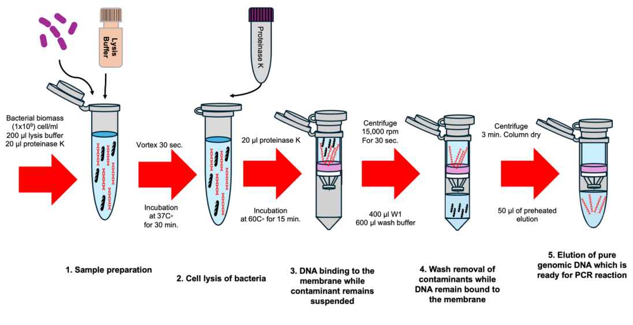

**Fig. 1. Illustrated diagram for bacterial DNA extraction protocol**

#### **2.3.2. DNA Detection by** **Gel electrophoresis**

Three reagents were used to perform electrophoresis, including TBE buffer and ethidium bromide in addition to agarose, according to Sambrook and Russell (2001). The 0.8% agarose gel was prepared in 25 ml of 1X TBE buffer and heated until the mixture became clear. About 0.2 µl of ethidium bromide was added to the agarose solution around 45 °C. Bacterial DNA (5 µl) was mixed with 1 µl of DNA loading dye. The DNA mixture was loaded for each well carefully. Electrophoresis was run at 70 V, 200 mA, and 80 watts for 45 min. The gel was visualized under a UV trans-illuminator to detect DNA bands.

**2.3.3. Bacterial *16SrRNA* Gene Amplification by PCR**

For molecular identification, the bacterial *16SrRNA* gene was amplified by conventional PCR using universal primers 27F (5′-AGA GTT TGA TCC TGG CTC AG-3′) and 1492R (5′ TAC GGY TAC CTT GTT ACG ACT T-3′) according to Miyoshi (2005). The reagents to amplify bacterial *16SrRNA* 25 µl as working volume) was shown in **Table 1.** The PCR condition were indicated in **Table 2**.

**Table 1*.*** Reagents of PCR amplification of the *16SrRNA* gene for working reaction

|  |  |
| --- | --- |
| **Reagent** | **Volume (µl)** |
| Solo Taq blue master mix | 10 |
| Band dector | 2 |
| DNA template | 5 |
| Primer forward | 1 |
| Primer reverse | 1 |
| Nuclease free water | 6 |
| **Total volume** | **25** |

**Table 2.** PCR program of *16SrRNA* amplification.

|  |  |  |  |  |
| --- | --- | --- | --- | --- |
| **Stage** | **Temperature** | **Time** | **Cycles** | **Product Size** |
| Initial denaturation | 95 ° C | 5 min | 1 |
| Denaturation | 95° C | 30 sec | 40 | 1500 bp |
| Annealing | 55° C | 40 sec |
| Extension | 72° C | 1 min |
| Final extension | 72° C | 5 min | 1 |

#### **2.3.4. Detection of 16SrRNA Gene PCR Product**

For detection, PCR amplification of the *16SrRNA* gene, using the same electrophoresis procedure described previously, was followed with some modifications. Agarose gel (1.5%) in 1× TBE buffer was prepared instead of 0.8%. As a volume, 5 µl of PCR product was loaded and 4 µl of 100 bp DNA ladder. Positive amplified PCR products were stored at -20° C until sending for sequencing.

#### **2.3.5. Sequencing Analysis**

Approximately 15 µl of positive PCR products from 55 bacterial isolates were labelled, sealed, and sent to Macrogen Company in South Korea for sequencing of the 16S rRNA gene. The company handled the purification of the products prior to sequencing. Out of the 60 samples, only 55 bacterial isolates were successfully identified using the Basic Local Alignment Search Tool (BLAST) provided by the National Center for Biotechnology Information (NCBI) at <http://www.ncbi.nlm.nih.gov>. After proofreading, the nucleotide sequences were copied and pasted into BLAST, which identified bacterial species by comparing the sequences with those in its database. Evolutionary analysis of the identified bacterial species was performed using MEGA X software, incorporating validated nucleotide sequences alongside those obtained in the current study.

**2.4. Determination of the Minimum Inhibitory Concentration (MICs)**

In order to determine the MIC notes for *K. pneumoniae* isolates, the Vitek® 2 compact system was used. *K. pneumoniae* isolates are cultured on MacConkey agar plates to obtain pure colonies, and plates are incubated at 37 °C overnight. Then, in a test tube (polystyrene) containing 3 ml of sterile saline solution, a sufficient amount of pure colonies was picked using a disposable plastic loop and mixed by vortex to obtain the proper turbidity of the bacterial suspension. The turbidity must be between 0.5 and 0.6, which was measured using DensiCHEK™ Plus McF. A test tube containing the bacterial suspension is placed into a special rack (cassette), and the AST (Gram Negative) card is placed in the neighboring slot. The filled cassette is placed manually (Vitek2) into a vacuum chamber station, then the cassette is manually transferred to the loading door to complete the examination process, as they are incubated at a temperature of 37 °C for 6-12 h, during which the result is given in the form of a report containing determined values for MICs of antibiotics to bacteria(McPherson & Pincus, 2017).

**3. RESULTS**

## **3.1. Bacterial Isolation**

Out of 60 nasal swabs of Sinopharm BBIBP-CorV, they were cultured on blood agar and MacConkey agar. After 24 hours of incubation at 37°C, 15 bacterial colonies were recovered. Gram staining result showed the occurrence of Gram-negative cocobacilli (Figure 2).

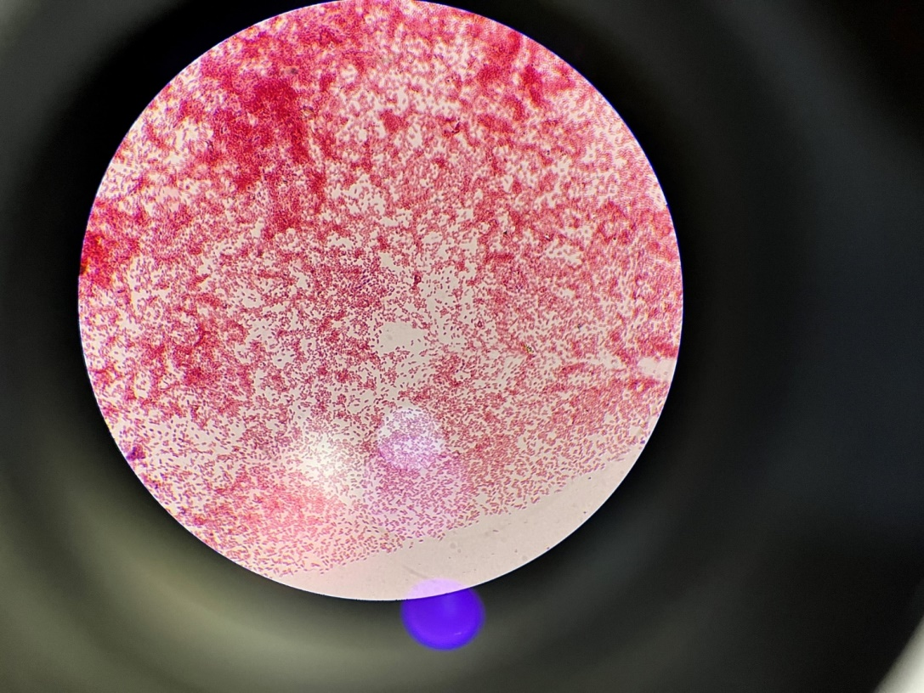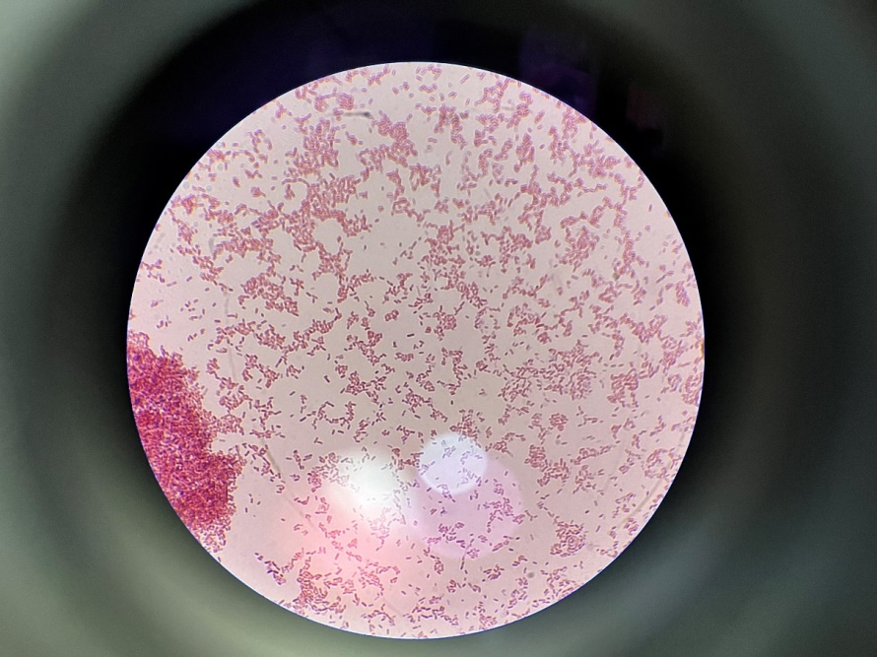

**Fig. 2. Bacterial isolate under the compound microscope oil emersion (100X). Shaw gram** **negative coccobacilli.**

**3.2. Molecular Identification of Isolated Bacteria**

#### **3.2.1. Genomic DNA Extraction**

The genomic DNA extracted from 55 bacterial isolates was analyzed using   
1% agarose gel electrophoresis. The DNA bands were visualized under UV light using a transilluminator, as shown in **Figure 3**. The presence of these bands confirms the successful extraction of genomic DNA.

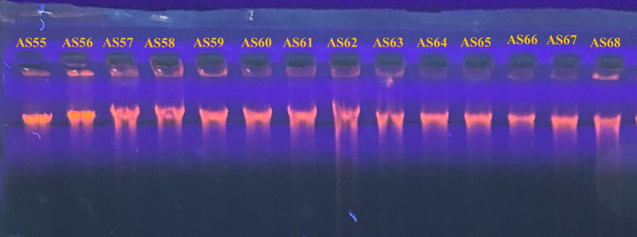

**Fig.‎ 3.** The agarose gel electrophoresis (1%) showed the bacterial isolate genomic DNA extracted from bacterial isolates recovered from nasal swabs

#### **3.2.2. 16SrRNA Gene Amplification**

The *16SrRNA* genes of 55 bacterial isolates were amplified by PCR, resulting in DNA bands approximately 1500 bp in size (**Figure 4)**.

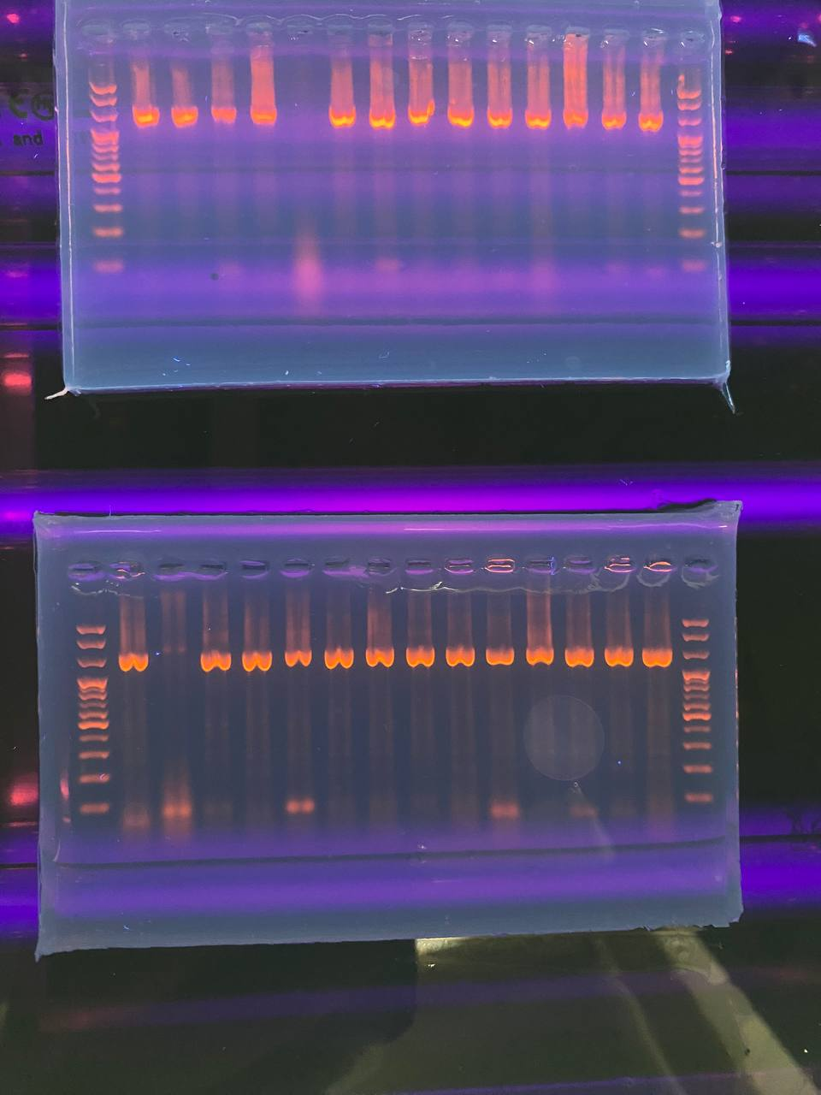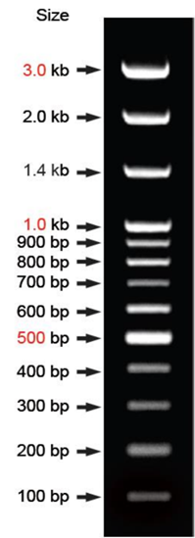

**Fig. 4. Agarose gel electrophoresis of amplified 16S rRNA gene for isolated bacteria.**

#### **3.2.3. DNA Sequencing and Analysis of Isolated Bacteria**

The 15 amplified PCR products of the 16SrRNA gene were sent for DNA sequencing. PCR products were successfully purified and sequenced; 15 isolates were revealed from nasal swabs of vaccinated participants and were identified molecularly through *16SrRNA* sequencing. Phylogenetic analysis revealed that *K. pneumoniae* was the most prevalent species, accounting for 15 out of 55 isolates (27.26%) **(Table 3)**.

**Table 3*.*** *K. pneumoniae* isolates recovered from nasal swabs of BBIBP-CorV vaccinated group volunteers based on 16SrRNA gene nucleotide sequencing and identity with GenBank strains.

|  |  |  |  |  |
| --- | --- | --- | --- | --- |
| **No.** | **ID** | **Similarity (%)** | **Identification Based on 16S rRNA Sequencing** | **Accession No.** |
| 1 | A03 | 98.84 | *Klebsiella pneumoniae* (MT444988.1) | *PV052642* |
| 2 | B06 | 98.32 | *Klebsiella pneumoniae* (PP563795.1) | *PV052655* |
| 3 | C02 | 98.48 | *Klebsiella pneumoniae* (MT444988.1) | *PV052660* |
| 4 | C07 | 99.38 | *Klebsiella pneumoniae* (PP563795.1) | *PV052664* |
| 5 | C08 | 99.11 | *Klebsiella pneumoniae* (MT265059.1) | *PV052665* |
| 6 | E01 | 99.73 | *Klebsiella pneumoniae* (MT444988.1) | *PV052679* |
| 7 | F01 | 99.74 | *Klebsiella pneumoniae* (MT265059.1) | *PV052688* |
| 8 | F02 | 98.36 | *Klebsiella pneumoniae* (PP563795.1) | *PV052689* |
| 9 | F04 | 98.80 | *Klebsiella pneumoniae* (MN400097.1) | *PV052690* |
| 10 | F07 | 99.26 | *Klebsiella pneumoniae* (MT444988.1) | *PV052693* |
| 11 | G01 | 99.23 | *Klebsiella pneumoniae* (MT265059.1) | *PV052698* |
| 12 | G02 | 99.47 | *Klebsiella pneumoniae* (OM066753.1) | *PV052699* |
| 13 | H01 | 99.83 | *Klebsiella pneumoniae* (MT265059.1) | *PV052709* |
| 14 | H05 | 98.79 | *Klebsiella pneumoniae* (MT444988.1) | *PV052713* |
| 15 | H06 | 97.92 | *Klebsiella pneumoniae* (MT444988.1) | *PV052714* |

**3.3. Antibiotics sensitivity**

 For clinical K. pneumoniae isolates, the Vitek2 system was used to determine the sensitivity and resistance of bacteria toward a broad range of antibiotics, and the minimum inhibition concentration (MIC) of each antibiotic was measured against *K. pneumoniae*. (Table 4.) Showed MIC values to 13 antibiotics against 15 isolates, which were used [Ticarcillin (TI), Ticarcillin/Clavulanic acid (TIM), Piperacillin (PRL), Piperacillin/Tazobactam (TZP), Ceftazidime (CAZ), Cefepime (FEP), Imipenem (IMP), Meropenem (MEM), Amikacin (AK), Gentamicin (GN), Tobramycin (TOB), Ciprofloxacin (CIP), and Aztreonam (AZM)].

he result of antibiotic sensitivity shows that 86.66% of *K. pneumoniae* were sensitive to Amikacin and Gentamicin as well as 80% sensitive to Tobramycin, Piperacillin/Tazobactam, Azteronam, Cefepime, Ceftazidime, and Ciprofloxacin. The highest sensitivity was 93.33% for carbapenems, and the highest resistance was in the penicillins, so that ticarcillin was 66.66% resistant and piperacillin was 46.66% resistant.

**Table 4.** Shows Minimum inhibition concentration (MIC) to 13 antibiotics against *K. pneumoniae* , using Vitek 2.

|  |  |  |  |  |  |  |  |  |  |  |  |  |  |
| --- | --- | --- | --- | --- | --- | --- | --- | --- | --- | --- | --- | --- | --- |
| **CIP** | **TOB** | **CN** | **AK** | **IMP** | **MEM** | **AZM** | **FEP** | **CAZ** | **TZP** | **PRL** | **TIM** | **TI** | **Antibiotic**  **Isolates** |
| ≤0.25  S | ≤ 1  S | ≤ 1  S | ≤ 2  S | ≤0.25 S | ≤0.25  S | ≤ 1  S | ≤ 1  S | ≤ 1  S | ≤ 4  S | ≤ 4  R | ≤ 8  S | ≥128  R* | AS55 |
| ≤0.25  S | ≤1  S | ≤1  S | ≤ 2  S | ≤0.25 S | ≤0.25  S | ≤ 1  S | ≤ 1  S | ≤ 1  S | ≤4  S | ≤4  R | ≤ 8  S | ≥128  R | AS56 |
| ≤0.25  S | ≤1  S | ≤1  S | ≤2  S | ≤0.25 S | ≤0.25  S | ≤ 1  S | ≤1  S | ≤ 1  S | ≤4  S | ≤4  R | ≤ 8  S | ≥128  R | AS57 |
| ≥ 4  R | ≥16  R | ≥16  R | 32  I | ≤0.25 S | ≤0.25  S | ≥64  R | ≥64  R | ≥64  R | ≥128  R | ≥128  R | ≥128  R | ≥ 128  R | AS58 |
| ≥0.25  R | ≥16  R | ≥1  S | ≥2  S | ≤0.25  S | ≤0.25  S | ≤ 1  S | ≥2  S | 4  S | ≥ 128  R | ≥ 64  R | ≥ 64  R | ≥ 64  R | AS59 |
| ≤0.25  S | ≤1  S | 2  S | 2  S | ≤0.25  S | ≤0.25  S | ≤1  S | ≤1  S | ≤1  S | ≤1  S | ≤4  S | ≤4  S | ≤4  S | AS60 |
| ≤0.25  S | ≤1  S | ≤1  S | ≤2  S | ≤0.25  S | ≤0.25  S | ≤1  S | ≤1  S | ≤1  S | ≤4  S | ≤4  S | ≤ 8  S | ≥128  R | AS61 |
| ≥4  R | ≥16  R | 8  I | 32  I | ≥16  R | ≥16  R | ≥64  R | ≥64  R | ≥64  R | ≥128  R | ≥128  R | ≥128  R | ≥128  R | AS62 |
| ≤0.25  S | ≤1  S | 2  S | 2  S | ≤0.25  S | ≤0.25  S | ≤1  S | ≤1  S | ≤1  S | ≤1  S | ≤4  S | ≤4  S | ≤4  S | AS63 |
| ≤0.25  S | ≤1  S | 2  S | 2  S | ≤0.25  S | ≤0.25  S | ≤1  S | ≤1  S | ≤1  S | ≤1  S | ≥ 64  R | ≤4  S | ≥ 64  R | AS64 |
| ≤0.25  S | ≤1  S | 2  S | 2  S | ≤0.25  S | ≤0.25  S | ≤1  S | ≤1  S | ≤1  S | ≤1  S | ≤4  S | ≤4  S | ≤4  S | AS65 |
| ≤0.25  S | ≤1  S | 2  S | 2  S | ≤0.25  S | ≤0.25  S | ≥64  R | ≥ 64  R | 4  *I | ≤4  S | ≤4  S | ≥ 128  R | ≥ 128  R | AS66 |
| ≤0.25  S | ≤1  S | ≤1  S | ≤2  S | 1  S | 2  S | ≤1  S | ≤1  S | 2  S | 8  S | ≤4  S | 16  S | >32  S | AS67 |
| ≤0.25  S | ≤1  S | 2  S | 2  S | ≤0.25  S | ≤0.25  S | ≤1  S | ≤1  S | ≤1  S | ≤1  S | ≤4  S | ≤4  S | ≤4  S | AS68 |
| ≤0.25  S | ≤1  S | 2  S | 2  S | ≤0.25  S | ≤0.25  S | ≤1  S | ≤1  S | ≤1  S | ≤1  S | ≤4  S | ≥ 128  R | ≥ 128  R | AS69 |

**\*S (sensitive to antibiotic), *R (resistant to antibiotic), *I (intermediate).**

**Table 5. shows antibiotic categories against K. pneumoniae isolated from the nasal cavity of SARS-CoV-2 Sinopharm vaccine recipients using the Vitek 2 compact system.**

|  |  |  |  |  |
| --- | --- | --- | --- | --- |
| **isolates Resistant** | **isolates Intermediate** | **isolates Sensitive** | **Antibiotics** | **Categories** |
| 0 | 2 (13.33%) | 13 (86.66%) | Amikacin | Aminoglycosides |
| 1 (6.66%) | 1 (6.66%) | 13 (86.66%) | Gentamicin |
| 3 (20%) | 0 | 12 (80%) | Tobramycin |
| 3 (20%) | 0 | 12 (80%) | Piperacillin / tazobactam | Beta-lactam/beta-lactamase inhibitor |
| 10 (66.66%) | 0 | 5 (33.33%) | Ticarcillin/Clavulanic acid |
| 3 (20%) | 0 | 12 (80%) | Azteronam |
| 1 (6.66%) | 0 | 14 (93.33%) | Imipenem | Carbapenems |
| 1 (6.66%) | 0 | 14 (93.33%) | Meropenem |
| 3 (20%) | 0 | 12 (80%) | Cefepime | Cephalosporin's |
| 2 (13.33%) | 1 (6.66%) | 12 (80%) | Ceftazidime |
| 3 (20%) | 0 | 12 (80%) | Ciprofloxacin | Fluoroquinolones |
| 10 (66.66%) | 0 | 5 (33.33%) | Ticarcillin | Penicillin's |
| 7 (46.66%) | 0 | 8 (53.33%) | Piperacillin |
| 0.000 | 0.000 | 0.00 | P value = | |

**4. Discussion**

Vaccination represents one of the medical procedures with the highest impacts on public health in the history of medicine; currently, available vaccines are expected to save 2–3 million lives annually (Nandi *and* Shet, 2020).

The mucosal environments that are associated with the immune system are colonized by a tremendous number of microorganisms, collectively termed the microbiome (Sender *et al*., 2016). The nose, nasal associated lymphoid tissue (NALT), is an important site of microbial colonization. The outermost segment of the nose, the nostrils or anterior nares, is a transition zone from the outer environment to the windpipe and the respiratory organs (Habibi *et al*., 2021). The relationship between commensal microbiota, particularly bacteria, and the development and function of the human immune system involves complex, multifaceted interactions that influence both homeostasis and disease (Acosta *and* Alonzo, 2023). This intimate relationship requires the proper functioning of host immunity to prevent commensals from over-exploiting host resources while maintaining immune tolerance to innocuous stimuli. However, any impairment of the host microbiome or the immune system can result in systemic dissemination of commensal microorganisms (Zheng *et al*., 2020).

The results of this study reveal significant differences in the diversity and prevalence of bacterial genera recovered from vaccinated individuals who received the Sinopharm BBIBP-CorV Sinopharm COVID-19 vaccine.

 Klebsiella was the higher prevalence genus recovered from the nasal cavity of vaccine recipients, and K. pneumoniae was the most recurrent species (27.27%). Globally, Klebsiella species are well known as opportunistic bacteria and are associated with healthcare-associated infections (Mohd Asri *et al*., 2021).

In healthy humans, *K. pneumoniae* is a commensal bacterium that can colonize the intestinal tract and nasal passage without causing disease. However, during illness and immunosuppression, *K. pneumoniae* can cause opportunistic infections. Common infections caused by *K. pneumoniae* include abscesses, pneumonia, urinary tract infections, and septicemia (Braun et al., 2024).

*K. pneumoniae* can resist penicillin antibiotics through several mechanisms. One of the primary ways is by producing enzymes β-lactamases, which can break down the β-lactam ring found in penicillins and other β-lactam antibiotics. These enzymes render the antibiotics ineffective. Extended-spectrum β-lactamases (ESBLs) and carbapenemases are examples of such enzymes, and cephalosporins have the same mechanism (Huy, 2024). Another mechanism involves changes in the bacterial cell membrane that reduce the permeability of the antibiotic, preventing it from entering the bacterial cell. Additionally, *K. pneumoniae* can use efflux pumps to actively expel the antibiotic from the cell, further reducing its effectiveness, according to [www.who.int](http://www.who.int). The recovered isolates were resistant to ticarcillin/clavulanic acid, which is one of the β-lactam family. β-lactam antibiotics are commonly subdivided into first, second, third, fourth, and fifth-generation antibiotics based on their spectrum of activity and sensitivity to enzymes produced by bacteria.

The β-lactam family of antibiotics are bactericidal and act by targeting peptidoglycan, an essential component of the cell wall of most bacteria. They enter Gram-negative bacteria, including *K. pneumoniae*, by passing through outer-membrane water filled channels called porins before exerting their activity in the periplasm (Braun et al., 2024).  The isolates showed moderate resistance rates to aminoglycoside agents, so that *K. pneumoniae* can resist aminoglycoside antibiotics through several mechanisms. One of the primary ways is by acquiring resistance genes that encode aminoglycoside-modifying enzymes (AMEs). These enzymes can modify the antibiotic, rendering it ineffective. For example, the armA gene is known to confer high-level resistance to aminoglycosides. Another mechanism involves the presence of plasmids, which are small DNA molecules that can be transferred between bacteria. These plasmids often carry multiple resistance genes, including those for aminoglycosides. In some cases, a single plasmid can carry several copies of resistance genes, further enhancing the bacteria's ability to resist antibiotics (Zhang et al., 2021).

One of the most alarming nosocomial threats was carbapenem-resistant *K. pneumoniae* (CRKP). Monitoring CRKP incidence and antimicrobial resistance globally and locally is vitally important (Ficik et al., 2023). Bacteria can resist antibiotics through different mechanisms *K. pneumoniae* can develop resistance through mutations in its own genetic material, which can alter the target sites of the antibiotics, making them less effective (Yang et al., 2023).

**5. CONCLUSIONS**

COVID-19 presents with respiratory problems, fever, and sore throat, with 80% of patients having mild symptoms and no complications. Antibiotic resistance, caused by bacterial adaptation, has become a global public health problem. COVID-19 may also be linked to bacterial coinfections, particularly *Klebsiella pneumoniae*, leading to multidrug resistance.

**References**

Acosta, I. C., & Alonzo, F. (2023). The Intersection between Bacterial Metabolism and Innate Immunity. *Journal of Innate Immunity*, *15*(1), 782–803. https://doi.org/10.1159/000534872

Braun, H. G., Perera, S. R., Tremblay, Y. D., & Thomassin, J.-L. (2024). Antimicrobial resistance in Klebsiella pneumoniae: An overview of common mechanisms and a current Canadian perspective. *Canadian Journal of Microbiology*, *70*(12), 507–528. https://doi.org/10.1139/cjm-2024-0032

Candel, S., Tyrkalska, S. D., Álvarez-Santacruz, C., & Mulero, V. (2023). The nasopharyngeal microbiome in COVID-19. *Emerging Microbes & Infections*, *12*(1), e2165970. https://doi.org/10.1080/22221751.2023.2165970

Chagas, A. de L. das, Araújo, J. C. da S., Serra, J. C. P., Araújo, K. M. de, Cunha, M. de O., Correia, A. dos R., Gonçalves, L. M. B., & Carneiro, L. C. (2024). Co-Infection of SARS-CoV-2 and Klebsiella pneumoniae: A Systematic Review and Meta-Analysis. *Diagnostics*, *14*(11), Article 11. https://doi.org/10.3390/diagnostics14111149

Che Yusof, R., Norhayati, M. N., & Mohd Azman, Y. (2023). Bacterial coinfection and antibiotic resistance in hospitalized COVID-19 patients: A systematic review and meta-analysis. *PeerJ*, *11*, e15265. https://doi.org/10.7717/peerj.15265

Dagan, R., van der Beek, B. A., Ben-Shimol, S., Greenberg, D., Shemer-Avni, Y., Weinberger, D. M., & Danino, D. (2023). The COVID-19 pandemic as an opportunity for unravelling the causative association between respiratory viruses and pneumococcus-associated disease in young children: A prospective study. *eBioMedicine*, *90*, 104493. https://doi.org/10.1016/j.ebiom.2023.104493

Ficik, J., Andrezál, M., Drahovská, H., Böhmer, M., Szemes, T., Liptáková, A., & Slobodníková, L. (2023). Carbapenem-Resistant Klebsiella pneumoniae in COVID-19 Era—Challenges and Solutions. *Antibiotics*, *12*(8), 1285. https://doi.org/10.3390/antibiotics12081285

Fowora, M. A., Aiyedogbon, A., Omolopo, I., Tajudeen, A. O., Olanlege, A.-L., Abioye, A., Akintunde, G. B., & Salako, B. L. (2024). Effect of nasal carriage of Bacillus species on COVID-19 severity: A cross-sectional study. *Microbiology Spectrum*, *12*(2), e01843-23. https://doi.org/10.1128/spectrum.01843-23

Habibi, N., Mustafa, A. S., & Khan, M. W. (2021). Composition of nasal bacterial community and its seasonal variation in health care workers stationed in a clinical research laboratory. *PLoS ONE*, *16*(11), e0260314. https://doi.org/10.1371/journal.pone.0260314

Huy, T. X. N. (2024). Overcoming Klebsiella pneumoniae antibiotic resistance: New insights into mechanisms and drug discovery. *Beni-Suef University Journal of Basic and Applied Sciences*, *13*(1), 13. https://doi.org/10.1186/s43088-024-00470-4

McPherson, R. A., & Pincus, M. R. (2017). *Henry’s Clinical Diagnosis and Management by Laboratory Methods E-Book*. Elsevier Health Sciences.

Miyoshi, K., Tsukumo, H., Nagami, T., Siomi, H., & Siomi, M. C. (2005). Slicer function of Drosophila Argonautes and its involvement in RISC formation. *Genes and Development*, *19*(23), 2837–2848. https://doi.org/10.1101/gad.1370605

Mohd Asri, N. A., Ahmad, S., Mohamud, R., Mohd Hanafi, N., Mohd Zaidi, N. F., Irekeola, A. A., Shueb, R. H., Yee, L. C., Mohd Noor, N., Mustafa, F. H., Yean, C. Y., & Yusof, N. Y. (2021). Global Prevalence of Nosocomial Multidrug-Resistant Klebsiella pneumoniae: A Systematic Review and Meta-Analysis. *Antibiotics*, *10*(12), 1508. https://doi.org/10.3390/antibiotics10121508

Nandi, A., & Shet, A. (2020). Why vaccines matter: Understanding the broader health, economic, and child development benefits of routine vaccination. *Human Vaccines & Immunotherapeutics*, *16*(8), 1900–1904. https://doi.org/10.1080/21645515.2019.1708669

Pincus, D. H. (2017). MICROBIAL IDENTIFICATION USING THE BIOMÉRIEUX VITEK® 2 SYSTEM. *bioMérieux, Inc. Hazelwood, MO, USA*, *5*(1), 1–34.

Sambrook, J., & Russell, D. W. (2001). *Molecular Cloning: A Laboratory Manual, Third Edition* (Lab Manual edition). Cold Spring Harbor Laboratory Pr.

Sender, R., Fuchs, S., & Milo, R. (2016). Are We Really Vastly Outnumbered? Revisiting the Ratio of Bacterial to Host Cells in Humans. *Cell*, *164*(3), 337–340. https://doi.org/10.1016/j.cell.2016.01.013

Yang, J., Zhang, K., Ding, C., Wang, S., Wu, W., & Liu, X. (2023). Exploring multidrug-resistant Klebsiella pneumoniae antimicrobial resistance mechanisms through whole genome sequencing analysis. *BMC Microbiology*, *23*(1), 245. https://doi.org/10.1186/s12866-023-02974-y

Yasir, M., Al-Sharif, H. A., Al-Subhi, T., Sindi, A. A., Bokhary, D. H., El-Daly, M. M., Alosaimi, B., Hamed, M. E., Karim, A. M., Hassan, A. M., AlShawdari, M. M., Alawi, M., El-Kafrawy, S. A., & Azhar, E. I. (2023). Analysis of the nasopharyngeal microbiome and respiratory pathogens in COVID-19 patients from Saudi Arabia. *Journal of Infection and Public Health*, *16*(5), 680–688. https://doi.org/10.1016/j.jiph.2023.03.001

Zhang, X., Li, Q., Lin, H., Zhou, W., Qian, C., Sun, Z., Lin, L., Liu, H., Lu, J., Lin, X., Li, K., Xu, T., Zhang, H., Li, C., & Bao, Q. (2021). High-Level Aminoglycoside Resistance in Human Clinical Klebsiella pneumoniae Complex Isolates and Characteristics of armA-Carrying IncHI5 Plasmids. *Frontiers in Microbiology*, *12*. https://doi.org/10.3389/fmicb.2021.636396

Zheng, D., Liwinski, T., & Elinav, E. (2020). Interaction between microbiota and immunity in health and disease. *Cell Research*, *30*(6), 492–506. https://doi.org/10.1038/s41422-020-0332-7