Original Research Article

Effectiveness of Modified Smead Jones Technique over Conventional Mass Closure for Midline Incision in Emergency Laparotomy.

Abstract
Background:
One of the major complications of emergency laparotomy is wound dehiscence, which is the separation of the abdominal wall layers after surgery. Wound dehiscence can lead to evisceration, infection, sepsis even death and requires second surgical intervention and prolonged hospitalization. This study compared effectiveness of modified Smead Jones closure in emergency midline laparotomy with peritonitis and to compare the incidence of wound infection, wound dehiscence, burst abdomen, wound sinus and incisional hernia with conventional techniques.

Materials and Methods: This quasi experimental study was conducted at department of surgery, Mymensingh Medical College and Hospital, over twelve months (March, 2022 to February, 2023), on patients who underwent laparotomy with generalized peritonitis and allocated into two groups: one with conventional midline closure and other with modified Smead Jones technique. Postoperative complications like surgical site infection, wound dehiscence, burst abdomen, wound sinus and incisional hernia were recorded. Demographic and clinical data were collected by semi structured case record form and analysis was done with the help of SPSS (Statistical Package for Social Science) version-27.

Results: The study encompassed total 152 participants, 76 in Group A (conventional closure) and 76 in Group B (Modified Smead Jones closure). Mean BMI values were 25.9±2.62 for Group A and 25.6±2.89 for Group B. Postoperative complications showed that the rates of surgical site infection (23.7% in Group A vs. 21.1% in Group B, p = 0.697), wound dehiscence 15.8% in Group A and 7.9% in Group B (p = 0.132), burst abdomen (9.2% in Group A vs. 5.3% in Group B, p = 0.348) and the rates of wound sinus (1.3% in Group A vs. 3.9% in Group B, p = 0.311) were not statistically significant. The most notable result was the significantly lower incidence of incisional hernia in Group B compared to Group A (9.2% in Group A vs. 1.3% in Group B, p = 0.029). Pain severity was predominantly mild, with 75.0% in Group A and 71.1% in Group B. The mean duration of hospital stay was significantly shorter in Group B (5.13 ± 2.10 days) compared to Group A (6.29 ± 3.07 days), with significant p value (p = 0.007).

Conclusion: The Modified Smead Jones closure demonstrated statistically significant advantage in terms of a shorter hospital stay and reducing the incidence of incisional hernia compared to conventional closure. These findings underscore the promising aspects of the Modified Smead Jones technique and suggest its consideration in emergency laparotomies.

Key Wards: Modified Smead Jones technique, Conventional Mass Closure, Emergency Laparotomy.

Introduction:
Emergency laparotomy is a surgical procedure that involves opening the abdomen to treat life-threatening conditions such as intestinal obstruction, perforation, burst appendix or intra-abdominal abscess. Following emergency laparotomy there is high morbidity and mortality rates, ranging from 10% to 40%, depending on the indication, patient condition, and quality of care (Selvaraj et al., 2022). One of the major complications of emergency laparotomy is wound dehiscence, which is the separation of the abdominal wall layers after surgery. Wound dehiscence can lead to evisceration, infection, sepsis even death and requires second surgical intervention and prolonged hospitalization. The incidence of wound dehiscence after emergency laparotomy is reported to be between 1% and 15%, depending on the type of wound, diagnosis, and risk factors (Metawee et al., 2023).
Acute wound dehiscence is post-operative separation of the abdominal musculoaponeurotic layers within 30 days after operation (Murtaza et al., 2010). Between 6th-9th post-operative days chance of wound dehiscence is highest and it require some form of intervention usually before discharge (Nitin et al., 2020). Many factors are responsible for this condition, like wound sepsis, hypoalbuminaemia, anemia, immunosuppression, renal failure, uncontrolled diabetes mellitus, malignancies, steroid therapy and obesity (Dhamnaskar et al., 2016). Other factors like size and type of suture material used (mono filament versus poly filament, absorbable versus non-absorbable, natural versus synthetic) play a crucial role in preventing post-operative wound dehiscence.
One of the factors that may influence the risk of wound dehiscence is the technique of abdominal wall closure. The most common technique for closing midline incision is the conventional mass closure (CMC), which involves a continuous suture of entire abdominal wall using a monofilament non-absorbable or slowly absorbable suture material (Bharti et al.2020). However, this technique has some drawbacks, such as the risk of tissue ischemia, suture breakage, and knot slippage, which can increase the risk of wound dehiscence and incisional hernia (Aghara et al., 2020).
An alternative technique for closing the midline incision is modified Smead Jones technique, (MSJ)which involves closure of the fascia in interrupted manner, using a monofilament non-absorbable or slowly absorbable suture material, with a far-near-near-far pattern (Nitin et al., 2020). The MSJ technique is claimed to have some advantages over the conventional mass closure technique, such as reducing the tension on the wound edges, increasing the tissue holding capacity, decreasing the suture material consumption and preventing the suture cutting through the fascia.
Numerous clinical trials have been observed for conventional mass closure for abdomen (Hasan et al.2020)). Some studies have shown an increased incidence of burst abdomen and incisional hernia with layered closure and some studies shows no difference, but no studies demonstrate an advantage of layered over mass closure (Sringeri et al., 2017). Conventional method of closure which include mass fascial closure, subcutaneous closure followed by skin closure is commonly used (Badgurjar, et al., 2020). In continuous suturing an even distribution of tension over entire suture line due to see-saw or hacksaw effect, which makes it prone to cut through the linea alba. But MSJ technique causes more secure approximation of fascial edges without losing much elasticity or compliance. This increased tension between two loops, is distributed in such a way that wound edges remain well approximated without sutures cutting through, so less chance of wound dehiscence and incisional hernia as compared to conventional mass closure. This study compared effectiveness of MSJ closure in emergency midline laparotomy with peritonitis and to compare the incidence of wound infection, wound dehiscence, burst abdomen, wound sinus and incisional hernia between those techniques.

Materials and method:
This quasi experimental study was conducted at department of surgery, Mymensingh Medical College and Hospital, over twelve months (March, 2022 to February, 2023), on patients who underwent laparotomy with generalized peritonitis and allocated into two groups: one with conventional midline closure and other with modified Smead Jones technique. Postoperative complications like surgical site infection, wound dehiscence, burst abdomen, wound sinus and incisional hernia were recorded.
After admission to the surgery department of Mymensingh Medical College and Hospital, patients with generalized peritonitis were identified. After adequate resuscitation, operations were performed by consultants and experienced surgeons. Patients who underwent conventional mass closure were included in Group-A, while patients who underwent "modified Smead Jones" technique closure were included in Group-B.
Conventional mass closure(CMC): It was performed using number 1 polypropylene suture, care being taken to place each bite 1-1.5 cm from the cut edge of linea alba and successive bites being taken 1cm away from each other. The edges of linea alba were gently approximated without strangulation with an attempt to keep a suture to wound length ratio of 4:1 (Ahi et al., 2020).
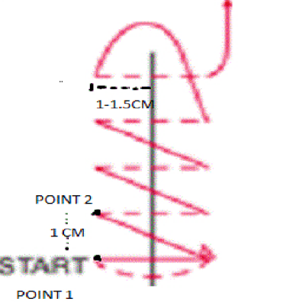
Figure -1: Continuous suture technique (Ahi et al., 2017).

Modified Smead Jones technique (MSJ): This comprised a far bite starting at 1 cm on the edge of linea from outside-in and then taking a near bite of 0.5 cm on the other side inside-out- a near bite on the same side outside-in and then a far bite on the other side inside-out. The suture was next converted to a horizontal mattress by taking a far bite 1 cm above or below the previous bite on the other side near bite on the same side, near bite on the other side, and finally a far bite on the same side. The two ends of the suture were tied to approximate the edges of the linea alba (Aghara et al.,2020). Successive bites being taken 1 cm away from each other.
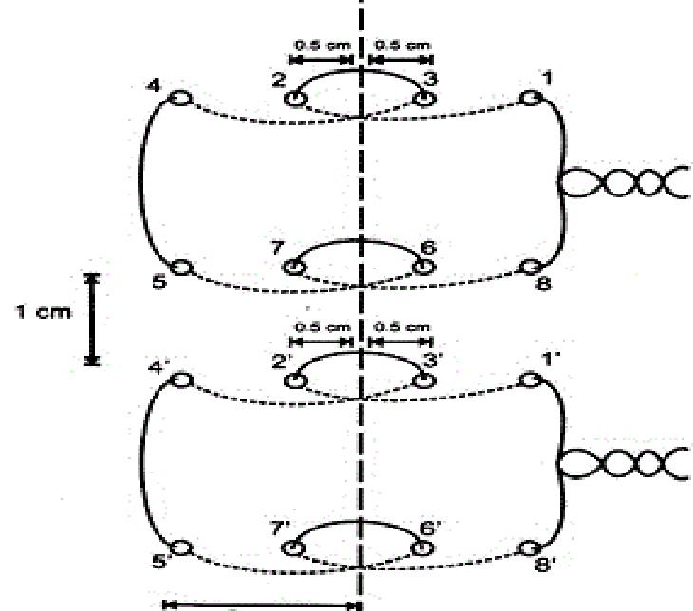

1 cm

Figure 2: Modified Smead Jones technique (Ahi et al., 2017).

Check dressing was done on 3rd post-operative day, if any signs of infection, wound discharge (pus or serous) found, the corresponding site skin stapler was removed and all the pus or collection was drained and regular dressing was given. If the wound found healthy, then skin stapler was removed on 10th postoperative day for both groups. Drain tube was removed in every cases when collection is below 25 ml/day and serous or serosanguinous in nature. Patients were discharged from the hospital if there were no signs of local or systemic inflammation, wound discharge or wound swelling. Follow-up was provided on 3rd, 7th, 10th, 20th, 30th and 90th post-operative day, respectively, to search for any surgical site infection, wound sinus, wound dehiscence, burst abdomen and incisional hernia. If any complications aroused it was managed accordingly. All the data were collected using a semi-structured case record form containing all the variables of interest. Then, a comparative study was conducted between two groups.
All patients were given intravenous antibiotic (injection Cefuroxime and Metronidazole) before induction. Definitive surgical procedure was performed as well as thorough peritoneal toileting was done using normal saline and abdominal drain was placed for each cases. Both groups fascia were closed by using same suture material (polypropylene 1 cutting body needle). After closing linea alba thorough wound wash was given using normal saline as well as gloves,

mobs were changed. Closer of sub-cutaneous layer was done on all patients followed by stapled skin closer. Same group of antibiotic was given on both groups post-operatively which changed according to wound swab culture sensitivity report if required.
After collection of all the required data were checked and verified for consistency and tabulated using the SPSS software. Statistical significance was set as 95% confidence level at 5% acceptable error level. Differences were considered significant when p value was < 0.05 for all tests. The data were expressed as means ± SD for continuous variables and as frequencies (%) for categorical variables. Student’s t -test was used in quantitative variables and Chi-square test was used to see the association in between two qualitative variable. Data were analyzed by the SPSS version 27 for windows. (IBM, Armonk, New York).

Results:
A total number of 152 patients were included in the study and allocated into two groups each having 76 patients. The mean age in Group A is 36.9 ± 15.5 years, and in Group B, it is 38.3 ± 16.20 years. The age groups demonstrate no statistically significant differences (p = 0.613). Most of the patients were males(78.3%)
In Group A, the indications for laparotomy were burst appendix (39.5%), duodenal ulcer perforation (31.6%), ileal ulcer perforation (9.2%), gastric ulcer perforation (7.9%), sigmoid volvulus (3.9%), intestinal obstruction due to mesenteric vascular occlusion (5.3%) and burst liver abscess (2.6%). In Group B, the indications for laparotomy were burst appendix (46.1%), duodenal ulcer perforation (30.3%), ileal ulcer perforation (6.6%), gastric ulcer perforation (6.6%), sigmoid volvulus (5.3%), intestinal obstruction due to mesenteric vascular occlusion (1.3%) and burst liver abscess (3.9%). Based on this data, it seems that there is no significant difference in the distribution of indications for laparotomy between the two groups (p = 0.812). (Table 1)

Table-1: Distribution by indication of laparotomy between Group A and Group B (N=152)

Indication for laparotomy | Group A  (n=76) | Group B  (n=76)
 | n (%) | n (%)
Burst appendix | 30(39.5) | 35(46.1)
Duodenal ulcer perforation | 24(31.6) | 23(30.3)
Ileal ulcer perforation | 7(9.2) | 5(6.6)
Gastric ulcer perforation | 6(7.9) | 5(6.6)
Sigmoid volvulus | 3(3.9) | 4(5.3)
Intestinal obstruction due to Mesenteric vascular occlusion | 4(5.3) | 1(1.3)
Burst liver abscess | 2(2.6) | 3(3.9)
Total | 76(100.0) | 76(100.0)

In the comparative analysis of postoperative complications between Group A and Group B shows that no significant differences were observed in surgical site infection rates (23.7% in Group A vs. 21.1% in Group B, p = 0.697) and burst abdomen rates (9.2% in Group A vs. 5.3% in Group B, p = 0.348). The incidence of wound dehiscence was not showing significant differences (15.8% in Group A vs. 7.9% in Group B, p = 0.132). Wound sinus rates were 1.3% in Group A and 3.9% in Group B (p = 0.311), with no significant difference. The occurrence of incisional hernia was significantly lower in Group B (1.3%) compared to Group A (9.2%, p = 0.029). (Table 2)
Table-2 Distribution by surgical site related complications between Group A and Group B (N=152)
Surgical site related complications | Group A  (n=76)  n (%) | Group B  (n=76)  n (%) | p-value
Surgical site infection | 18(23.7) | 16(21.1) | 0.697
Wound dehiscence | 12(15.8) | 6(7.9) | 0.132
Burst abdomen | 7(9.2) | 4(5.3) | 0.348
Wound sinus | 1(1.3) | 3(3.9) | 0.311
Incisional Hernia | 7(9.2) | 1(1.3) | 0.029

In Group A, total 18 patients developed surgical site infection, among them superficial surgical site infection was 6 (33.3%), Deep surgical site infection was 8 (44.4%) and organ space infection was 4 (22.2%). In Group B, total 16 patients developed surgical site infection, among them superficial surgical site infection was 10 (62.5%), Deep surgical site infection was 5 (31.3%) and organ space infection was 1 (6.3%). (Figure-3)

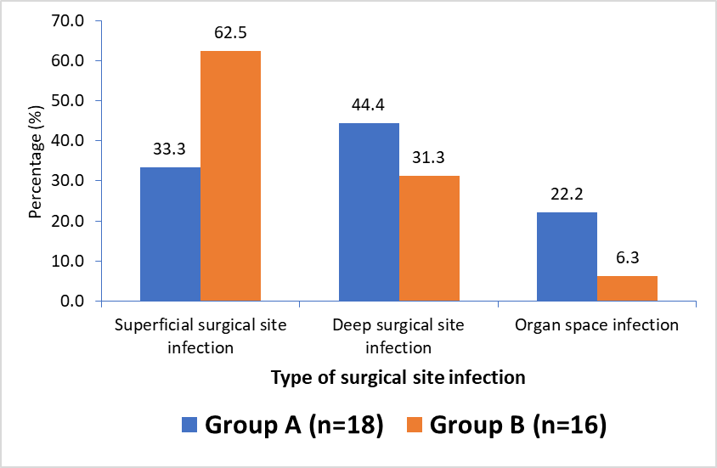
Figure-3: Bar diagram showing type of surgical site infection in both Groups.

The majority of patients in both groups experienced mild annoying pain, with 75.0% in Group A and 71.1% in Group B. The percentages for the other pain severity levels were relatively similar between the two groups, with no statistical significant difference between the two groups. The mean pain severity scores were 2.42±1.07 for Group A and 2.61±1.28 for Group B which was not statistically significant.(p>0.05)

Table-3: Distribution by pain severity between Group A and Group B (N=152)
Pain severity | Group A  (n=76)  n (%) | Group B  (n=76)  n (%) | p-value
Mild annoying pain | 57(75.0) | 54(71.1)
Nagging uncomfortable troublesome pain | 16(21.1) | 15(19.7)
Distressing miserable intense pain | 2(2.6) | 4(5.3)
Dreadful, horrible pain | 0(0.0) | 3(3.9)
Worst possible unbearable, excruciating Pain | 1(1.3) | 0(0.0)
Total | 76(100.0) | 76(100.0)
Mean ± SD | 2.42±1.07 | 2.61±1.28 |  | 0.377

The mean duration of hospital stay was 6.29±3.07 days with range 4-16 days for Group A and 5.13±2.10 days with range 4-12 days for Group B. There was statistically significant difference in the duration of hospital stay between the two groups (p = 0.007). The majority of patients in both groups did not require readmission, 5.3% in Group A and 3.9% in Group B were readmitted for surgical site related complications. There was no statistically significant difference between the two groups (p = 0.699).

Discussion:

The purpose of the study is to compare the effectiveness of Modified Smead Jones technique (Group B) and conventional mass closure (Group A) in emergency midline incision in presence of generalized peritonitis.
This study found that the mean age of patients in Group A (conventional closure group) was 36.9±15.5 years, while in Group B (Modified Smead Jones closure group), it was 38.3±16.20 years. The gender distribution in both groups showed a higher proportion of male patients, with 82.9% in Group A and 73.7% in Group B. There was no statistically significant difference in age and sex distribution between the two groups (p > 0.05). These findings are consistent with a study conducted by Ullah et al. (2021),
The incidence of surgical site infection was 23.7% in Group A and 21.1% in Group B, with a non-significant p-value of 0.697, suggesting that MSJ Technique may not provide a significant advantage over CMC in reducing the occurrence of surgical site infections. In a study by Joshi et al. (2021), the comparison between Group A (Modified Smead Jones closure) and Group B (conventional continuous closure) in emergency laparotomy with generalized peritonitis revealed significant differences in some postoperative complications
The incidence of wound dehiscence was 15.8% in Group A and 7.9% in Group B, with a non-significant p-value of 0.132, indicating a trend towards a higher incidence of wound dehiscence in Group A. This raises concerns about the efficacy of the MSJ technique in preventing wound dehiscence compared to CMC. In a study by Aghara et al. (2020), Group B had a higher incidence of wound dehiscence (14%) compared to Group A (2%), suggesting a potential drawback of the conventional continuous technique in this aspect. Similarly, Sringeri et al. (2017) reported a significant difference in wound dehiscence, with 14.9% in Group A and 1% in patients of Group B (p = 0.01).
In our study, the mean duration of hospital stay was 6.29±3.07 days for CMC group and 5.33±2.10 days for MSJ closure group. Statistically significant shorter hospital stays in MSJ closure group. In agreement with our study Tahil et al (2018) reported that group A (MSJ) had a considerably shorter hospital stay than group B. (conventional closure) (P value < 0.001). Nitin et al. (2020) reported that the mean hospital stay in group A (using the MSJ technique) was 9.86 days and in group B (using the CMC technique) was 14.68 days.
This study showed that there was no significant difference in pain severity between the two groups. The mean pain score was slightly higher in Group B, but the difference was not significant (p = 0.377). These findings suggest that the use of MSJ technique over CM closure for midline incision in emergency laparotomy with generalized peritonitis did not have a significant impact on the severity of postoperative pain experienced by patients. Similar findings observed by Metawee et al. (2023).
In the present study, the occurrence of incisional hernia was 9.2% in Group A and 1.3% in Group B, with a statistically significant p-value of 0.029. This result suggests that the CMC may be associated with a higher risk of incisional hernia compared to MSJ Technique, highlighting a potential drawback of the CMC technique in this aspect. In line with these findings, Raghuveer, et al. (2023) reported a significantly decreased rate of incisional hernia formation (12.50%) in the MSJ group compared to the CMC group (37.50%). The modified version of the Smead Jones method of abdominal closure with prolene loop suture was found to be advantageous in sequential closure with even distribution of suture tension, thereby efficacious in the prevention of abdominal dehiscence and later incisional hernias (Badgurjaret al 2021). Based on their findings, the MSJ of closure can be considered as a preferential method of abdominal wall closure in all midline emergency laparotomy incisions, even in cases more prone to abdominal dehiscence due to patient factors such as abdominal sepsis.
There are several limitations to consider in this study. The study focused on immediate and short term post-operative outcomes and did not assess long-term outcomes. Besides, randomization was not done in our study.

Conclusion:
The present study demonstrated there were no significant differences post-operative complications like surgical site infection, wound dehiscence, burst abdomen, wound sinus and pain severity between the two groups. Notably, the MSJ closure demonstrated a significant advantage in terms of a shorter hospital stay and reducing the incidence of incisional hernia compared to conventional closure. Further large scale multicenter study is required for better understanding of these two techniques.

CONSENT:
Patient’s informed written consent was taken to publish her/his case for academic purpose.

ETHICAL APPROVAL:
As per international standards or university standards written ethical approval has been collected from Institutional ethical committee and preserved by the authors.

DISCALIMER (ARTIFICIAL INTELLEGENCE):
Author(s) hereby declare that NO generative AI technologies such as Large Language Models (ChatGPT, COPILOT, etc.) and text-to-image generators have been used during the writing or editing of this manuscript.

References:
Aghara, C.B., Rajyaguru, A.M. and Bhatt, J.G., 2020. Prospective comparative study of modified Smead Jones versus conventional continuous method of fascial closure in emergency midline laparotomy. International Surgery Journal, 7(11), pp.3713-3717.
Ahi, K.S., Khandekar, S.M., Mittal, S.K., Chaudhary, V., Sharma, A., Jain, A. et al., 2017. Prevention of burst abdomen by interrupted closure: a comparative study of conventional continuous versus interrupted-X-type versus hughes far-and-near interrupted abdominal fascial closure in surgical patients. IOSR JOURNALS, 16(2), pp.21-30.
Badgurjar, M.K., Thakor, P., Saxena, P., Parihar, S., Prajapati, G. and Lakhanpal, V., 2021. Management and outcome of abdominal wall closure in emergency laparotomy at a tertiary care centre. International Journal of Medical and Biomedical Studies, 5(12), pp.105-109.
Bharti, S.V. and Sharma, A. 2020. A Prospective Study Comparing Continuous Versus Interrupted Suture Techniques in Midline Abdominal Wound Closure. Journal of Nepalgunj Medical College, 18(1), pp.63-66.
Dhamnaskar, S.S., Sawarkar, P.C., Vijayakumaran, P. and Mandal, S., 2016. Comparative study of efficacy of modified continuous smead-jones versus interrupted method of midline laparotomy fascial closure for contaminated cases. International Surgery Journal, 3(4), pp.1751-1756.
Hasan, K.M., Islam, S., Huq, M.A.U., Huque, M.M., Karim, S.M.R., Azam, M.S., et al., 2020. Outcomes of Layered versus Mass Closure in Transverse Incision during Emergency Laparotomy in Children. Journal of Biosciences and Medicines, 8(08), pp.180-193.
Joshi, D., Varandani, N. and Vaidya, M., 2021. Study of Different Methods of Midline Laparotomy Incision Closure and their Outcomes. MVP Journal of Medical Sciences, 8(2), pp.249-252.
Metawee, A.K., Abdelhamid, H.F. and Aldardeer, A.K., 2023. Comparison between conventional and modified Smead Jones method for abdominal mass closure in emergency midline laparotomy. International Journal of Health Sciences, 1(3), pp.96-104.
Murtaza, B., Khan, N.A. and Sharif, M.A., 2010. Modified midline abdominal wound closure technique in complicated/ high risk laparotomies. Journal of the College of Physicians and Surgeons Pakistan, 20(1), pp.37-41.
Raghuveer, M.N., Kumar,C.R., Hubballi, V., 2023. Comparing the efficacy of modified continuous Smead-jones versus conventional closure of midline laparotomy wound. International Journal of Advanced Research, 11(05), pp. 1635-1646.
Selvaraj, V., Saravanan, C., Karthik, S., 2022. Comparative study of conventional closure versus smead jones technique of closure of midline Laparatomy Wounds After Emergency Midline Laparatomies. IOSR Journal of Dental and Medical Sciences, 21(01), pp.30-40.
Sringeri, R. and Vasudeviah, T., 2017. Comparison of conventional closure versus “re-modified Smead Jones” technique of single layer mass closure with Polypropylene (prolene) loop suture after midline laparotomy in emergency cases. International Surgery Journal, 4(9), pp.3058-3061.
Tahir, A., Sajid, M., Ansari, M.S.H. and Khan, A.W., 2018. Comparison of continuous and interrupted closure of wound dehiscence in emergency midline laparotomy incision. The Professional Medical Journal, 25(8), pp.1143-1146.
Ullah, K., Uddin, S., Shoib, A. and Yaseen, M.D., 2021. Comparison of outcome of interrupted versus continuous closure technique of rectus sheath in emergency laparotomies patients in terms of wound dehiscence. The Professional Medical Journal, 28(04), pp.455-458.

